1 ALFAISAL UNIVERSITY LIBRARY - (Kingdom of Saudi Arabia, KSA)
http://alfaisal.summon.serialssolutions.com/search?s.q=dislessia+e+riabilitazione#!/search?ho=f&l=en&q=dislessia%20e%20riabilitazione
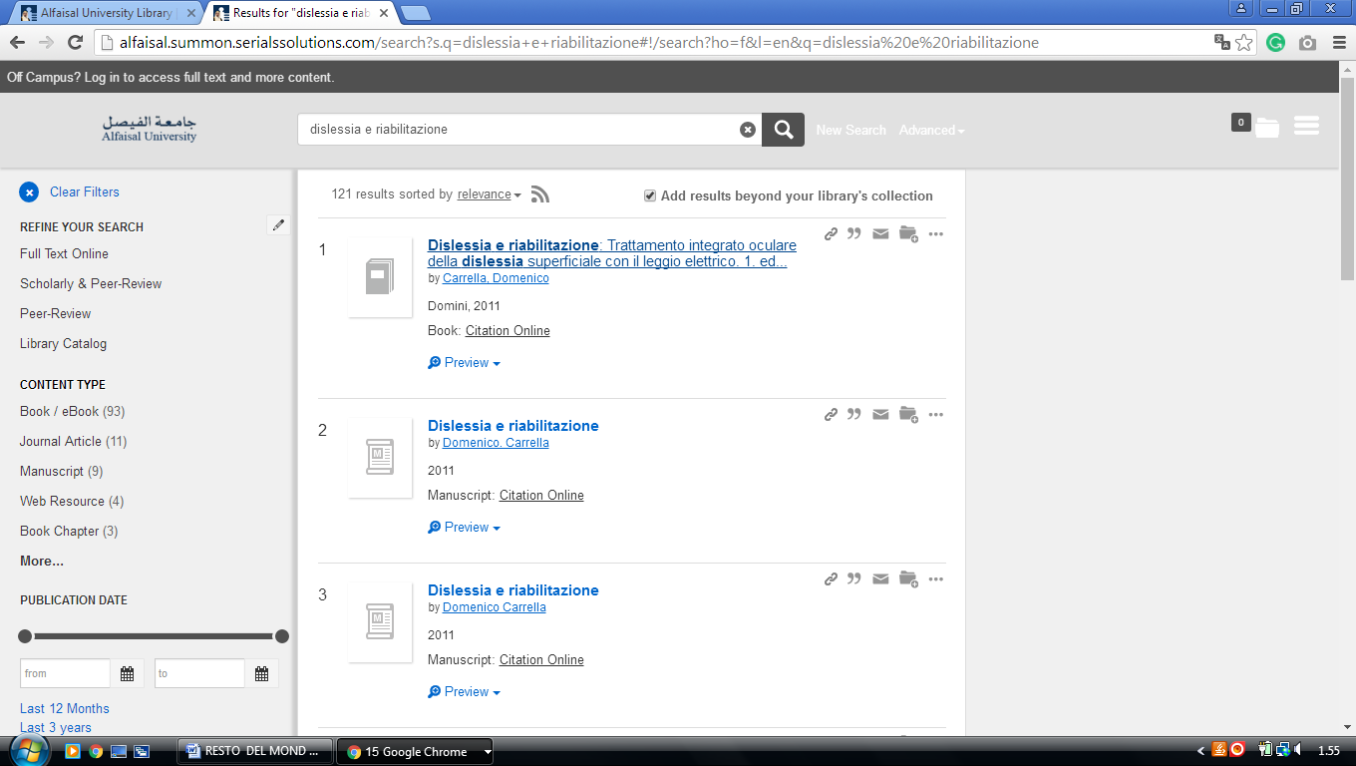

2 LIBRARY KING ABDULLAH UNIVERSITY OF SCIENCE AND TECHNOLOGY (Kaust)
https://koral.summon.serialssolutions.com/#!/search?ho=f&l=en&q=DISLESSIA%20E%20RIABILITAZIONE
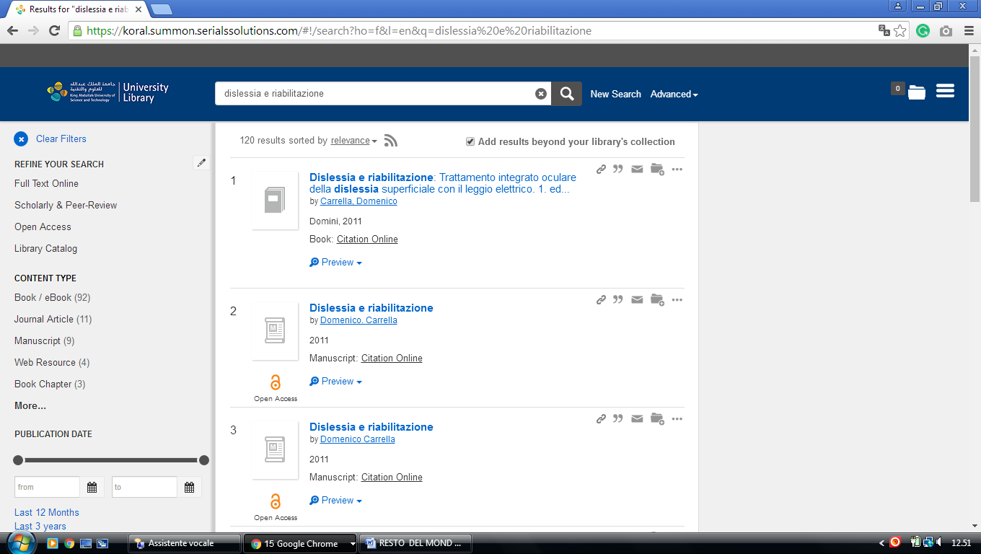

3. Bibliothèque King Abdullah University of Science and Technology (KAUST)

https://koral.summon.serialssolutions.com/#!/search?ho=f&l=en&q=dislessia%20e%20riabilitazione
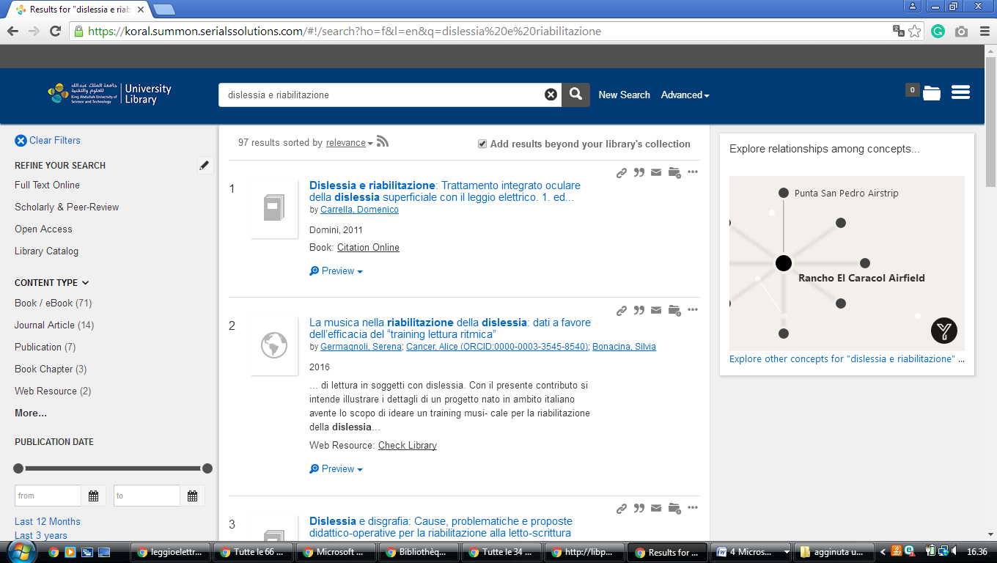

4. Saudi Digital Library - المكتبة الرقمية السعود4 Jazan University, Arabia SAUDITA

http://eds.a.ebscohost.com/eds/results?vid=1&sid=72200209-0265-4b04-aeec-20d8d2c150be%40sessionmgr4006&bquery=dislessia+e+riabilitazione&bdata=JnR5cGU9MCZzZWFyY2hNb2RlPUFuZCZzaXRlPWVkcy1saXZl
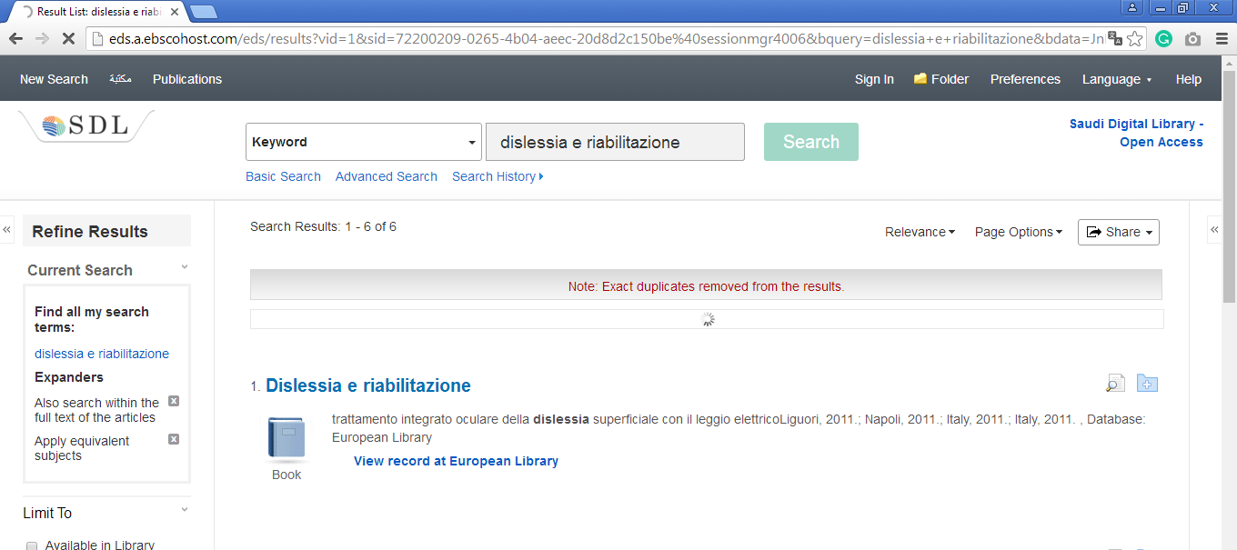

5. king saud university, Saudi Digital Library - المكتبة الرقمية
Open acces
http://eds.a.ebscohost.com/eds/results?vid=1&sid=c27f6802-8a40-4cd5-80a0-5db432522d61%40sessionmgr4008&bquery=dislessia+e+riabilitazione&bdata=JnR5cGU9MCZzZWFyY2hNb2RlPUFuZCZzaXRlPWVkcy1saXZl
