1 AUA'S AGBU PAPAZIAN LIBRARY - AMERICAN UNIVERSITY OF ARMENIA, (Armenia)
https://aualibrary.on.worldcat.org/search?sortKey=BEST_MATCH&databaseList=&queryString=DISLESSIA+E+RIABILITAZIONE&changedFacet=scope&scope=&scope=sz%3A36210&scope=wz%3A48498&format=all&database=all&author=all&year=all&yearFrom=&yearTo=

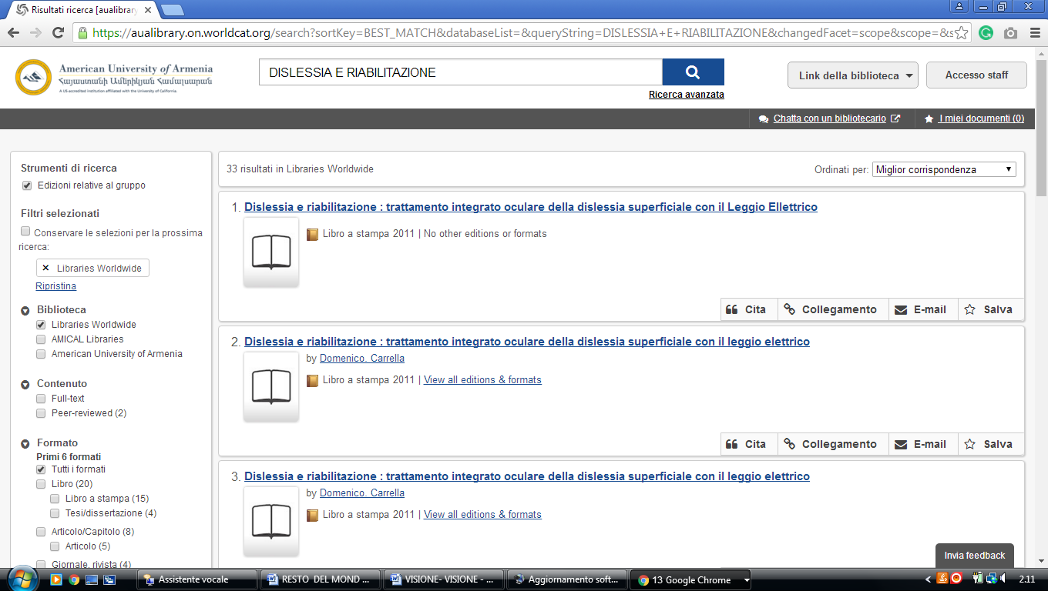

2 NATIONAL LIBRARY OF ARMENIA - THE EUROPEAN LIBRARY (Armenia)
http://www.nla.am/arm/index.php

