1 UNIVERSITY OF ADELAIDE LIBRARY - (Adelaide, Australia)
http://adelaide.hosted.exlibrisgroup.com/primo_library/libweb/action/search.do?ct=facet&pcAvailabiltyMode=true&pcAvailClicked=true&vl(31766897UI0)=any&query=any%2Ccontains%2Cdislessia%20e%20riabilitazione&indx=1&fn=search&search_scope=Everything&dscnt=0&scp.scps=scope%3A(61ADELAIDEU)%2Cscope%3A(DSpace)%2Cprimo_central_multiple_fe&vl(1UIStartWith0)=contains&vid=SUA&ct=search&institution=61ADELAIDEU&tab=default_tab&vl(freeText0)=dislessia%20e%20riabilitazione&dstmp=1518081412485&fromDL

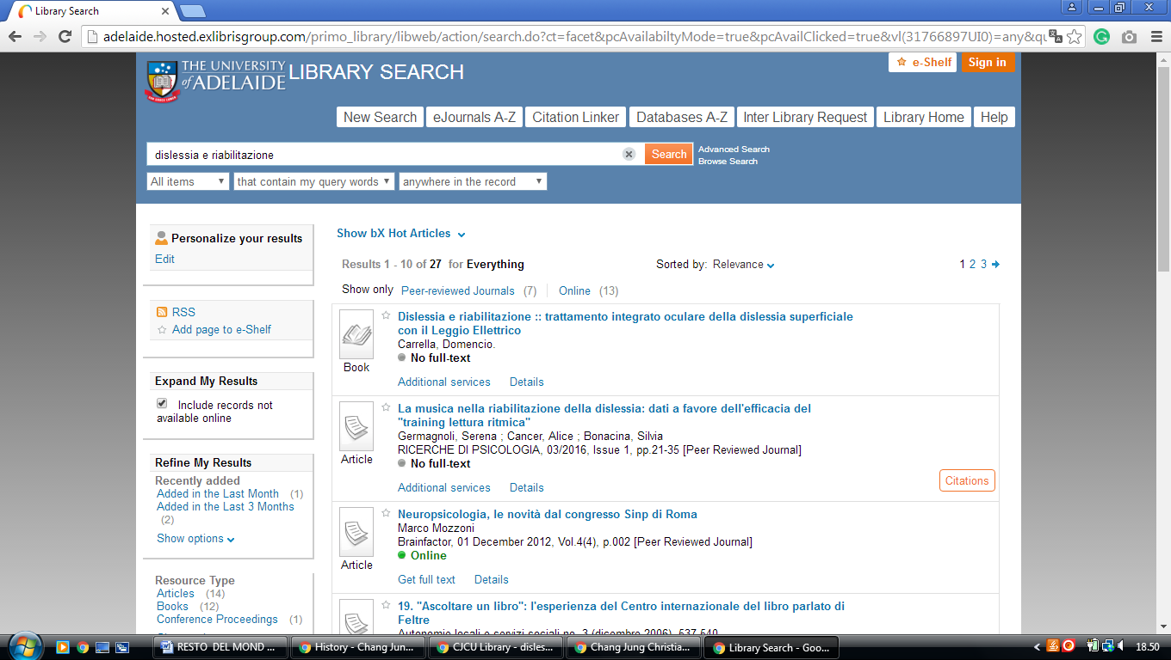

2 AUSTRALIAN NATIONAL UNIVERSITYLIBRARY - (Collection Canberra, Australia)
https://anu.summon.serialssolutions.com/search?q=dislessia+e+riabilitazione&button3=GO#!/search?ho=f&l=en&q=dislessia%20e%20riabilitazione&button3=GO
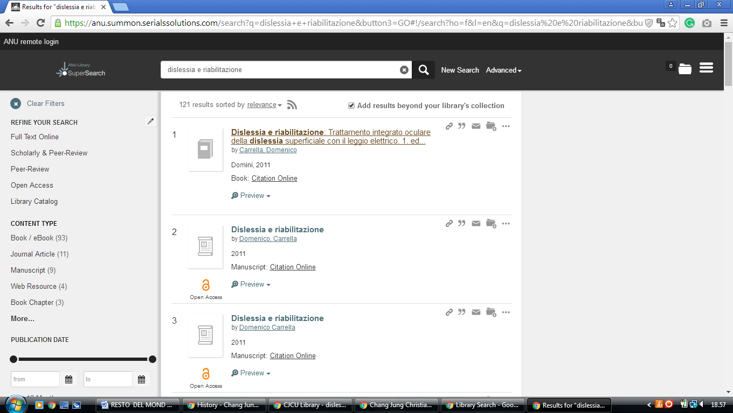

3 CUNNINGHAM LIBRARY - AUSTRALIAN COUNCIL FOR EDUCATIONAL RESEARCH – (Melbourne, Australia)
http://eds.a.ebscohost.com/eds/results?vid=0&sid=c759e645-5204-44a8-8bed-e079f83d5ac7%40sessionmgr4006&bquery=dislessia+e+riabilitazione&bdata=JnR5cGU9MCZzaXRlPWVkcy1saXZl

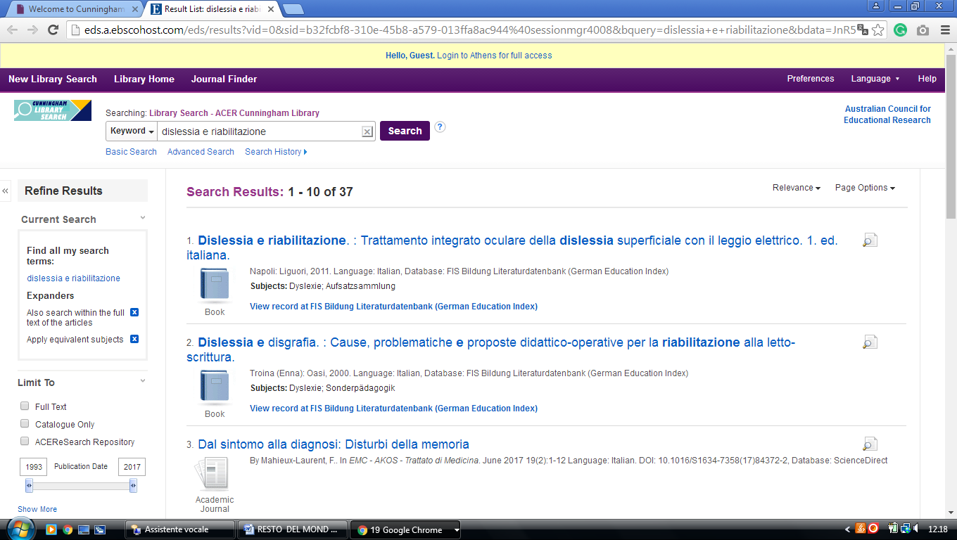

4 ACT HEALTH LIBRARY - (Australian Capital Territory, Canberra, Australia)
https://canberra-hospital-primo.hosted.exlibrisgroup.com/primo-explore/search?institution=61CHO&vid=61CHO&query=any,contains,dislessia%20e%20riabilitazione&displayMode=full&mode=Basic&bulkSize=10&highlight=true&dum=true&displayField=all&pcAvailabiltyMode=false&tab=default_tab&search_scope=default_scope&a2af7bb3e73de262587bd275fd56345d=&a2af7bb3e73de262587bd275fd56345d=&queryTemp=dislessia%20e%20riabilitazione&sortby=rank&pcAvailability=true
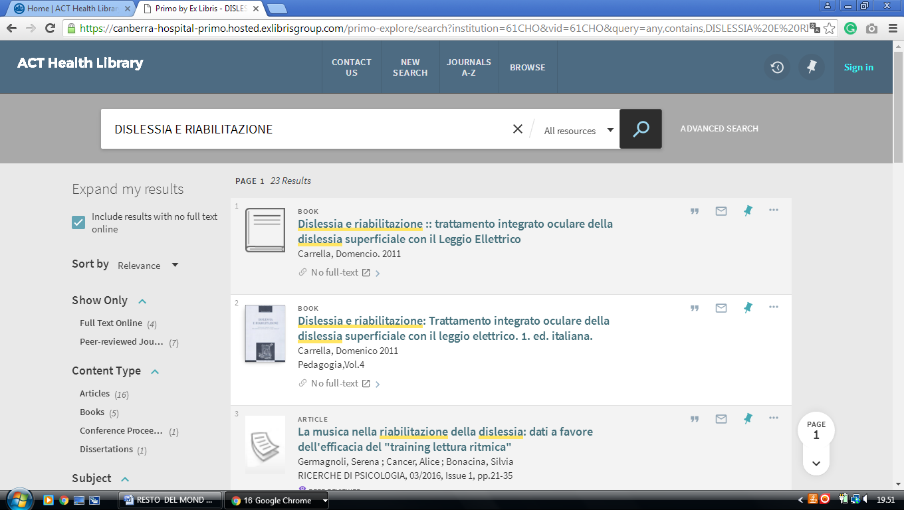

5 UNIVERSITY OF CANBERRA LIBRARY – (Canberra, Australia)
https://canberra.primo.exlibrisgroup.com/discovery/search?institution=61ARL_CNB&vid=61ARL_CNB:61ARL_CNB&tab=Everything&search_scope=MyInst_and_CI&mode=Basic&displayMode=full&bulkSize=10&highlight=true&dum=true&query=any,contains,dislessia%20e%20riabilitazione&displayField=all&pcAvailabiltyMode=true&sortby=rank&pcAvailability=true

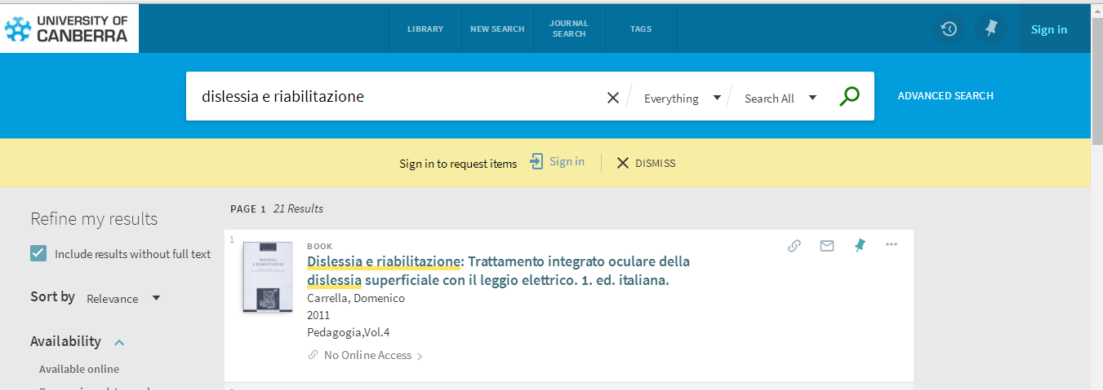

6 CQUNIVERSITY AUSTRALIA LIBRAY – (Central Queensland University
Australia)
https://cqu-primo.hosted.exlibrisgroup.com/primo-explore/search?query=any,contains,dislessia%20e%20riabilitazione&tab=61cqu_library&search_scope=61CQU_Library&vid=61CQU&lang=en_US&offset=0&sortby=rank&pcAvailability=true

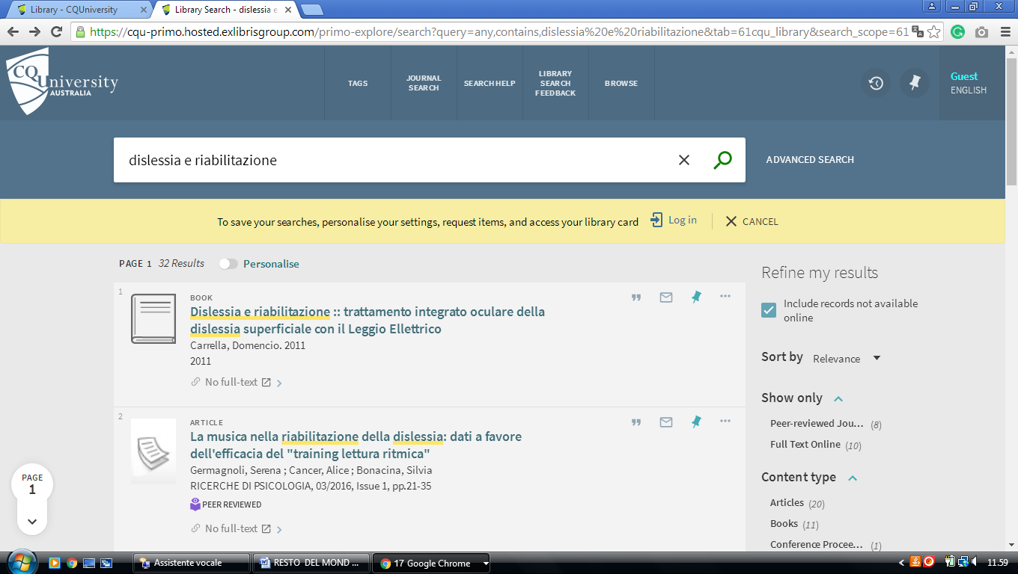

7 CSU LIBRARY - PRIMO SEARCH – UNILINC - (Charles Sturt University, Bathurst, Australia)
http://primo.unilinc.edu.au/primo_library/libweb/action/search.do?ct=facet&pcAvailabiltyMode=true&pcAvailClicked=true&frbg=&&fn=search&indx=1&dscnt=0&vl(1UIStartWith0)=contains&scp.scps=scope%3A(DTL_CSU_UNLOCKED)%2Cscope%3A(2520)%2Cscope%3A(CSU)%2Cscope%3A(CSU_DTL_OPEN)%2Cscope%3A(CSU_EQUELLA)%2Cprimo_central_multiple_fe&vid=CSU&mode=Basic&ct=search&vl(96177725UI0)=any&srt=rank&tab=default_tab&dum=true&vl(freeText0)=DISLESSIA%20E%20RIABILITAZIONE&dstmp=1518090309684

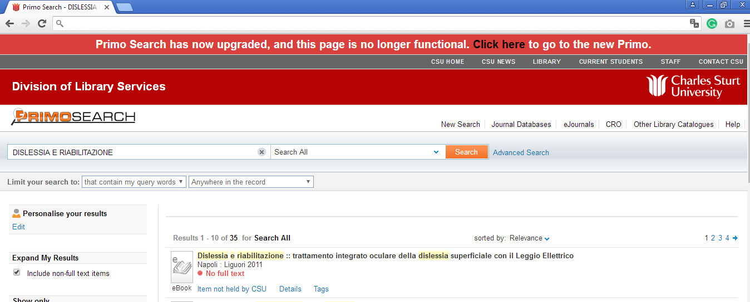

8 GRIFFITH.SUMMON.SERIALSSOLUTIONS.COM - (Library Griffith University
Brisbane, Australia)
http://griffith.summon.serialssolutions.com/#!/search?ho=f&l=en-AU&q=dislessia%20e%20riabilitazione

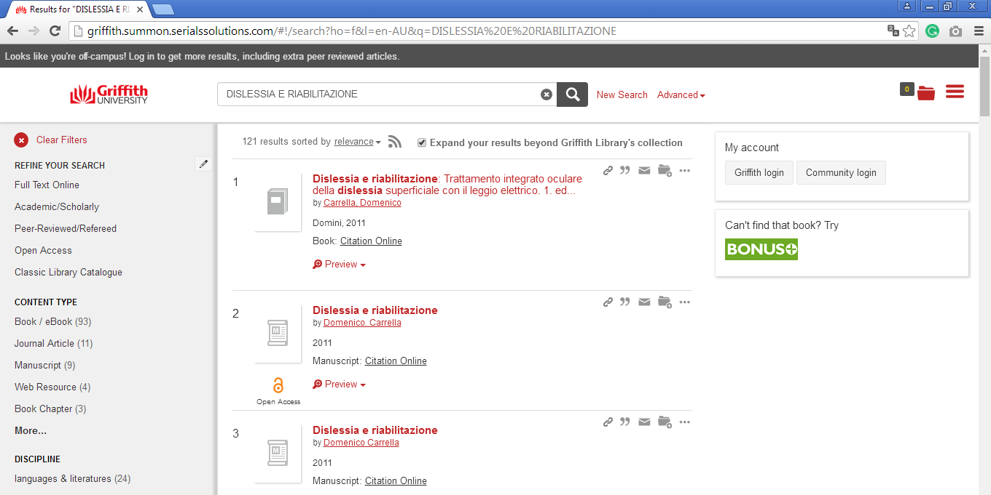

9 LIBRARY | MURDOCH UNIVERSITY – (Perth, Western Australia)
http://murdoch.summon.serialssolutions.com/?#!/search?ho=f&l=en&q=dislessia%20e%20riabilitazione

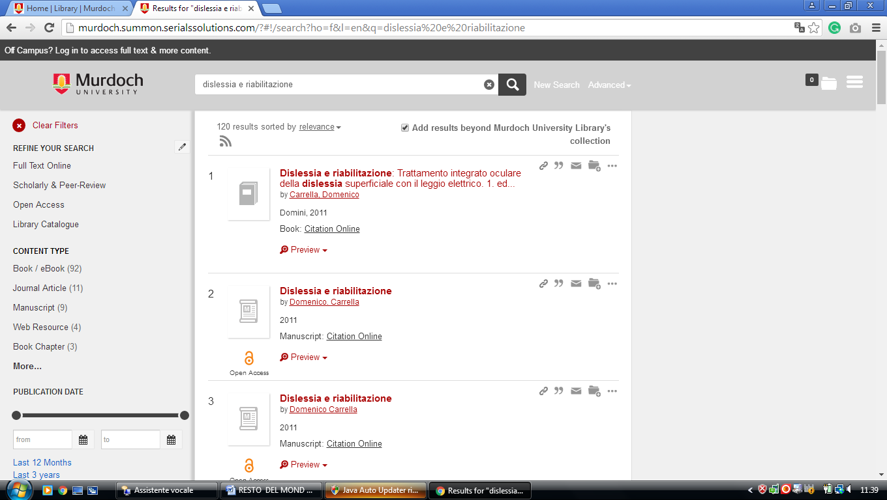

10 UNIVERSITY LIBRARY AT NOTRE DAME AUSTRALIA - (Fremantle, Australia)
https://ndaus.summon.serialssolutions.com/?#!/search?ho=f&fvf=ContentType,Newspaper%20Article,t&l=en-AU&q=dislessia%20e%20riabilitazione

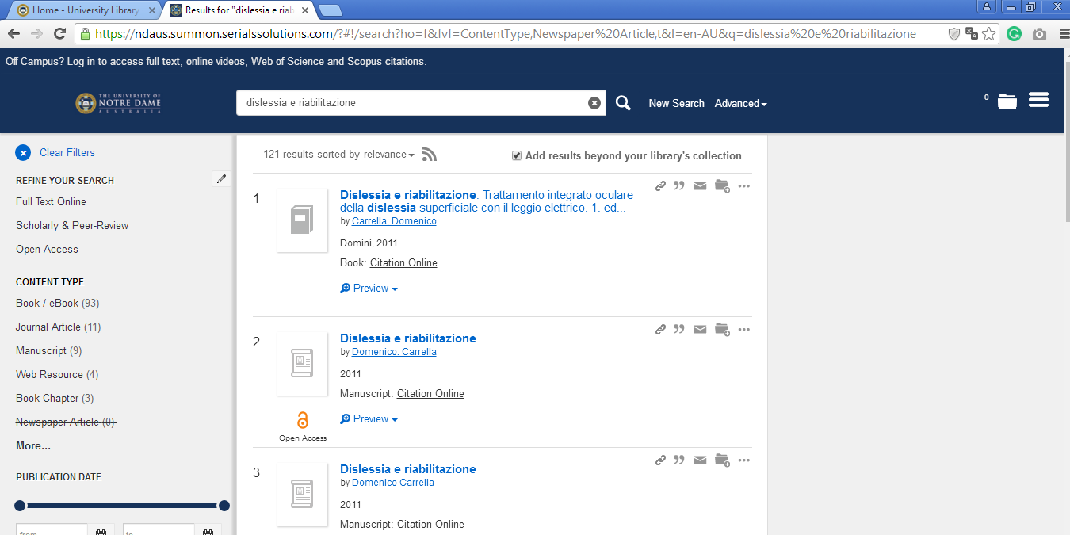

11 ROYAL MELBOURNE INSTITUTE OF TECHNOLOGY LIBRARY (MELBOURNE, Australia)
https://primo-direct-apac.hosted.exlibrisgroup.com/primo-explore/search?institution=RMITU&vid=RMITU&tab=default_tab&search_scope=Books_articles_and_more&mode=Basic&displayMode=full&bulkSize=10&highlight=true&dum=true&query=any,contains,dislessia%20e%20riabilitazione&displayField=all&pcAvailabiltyMode=false&sortby=rank&pcAvailability=true

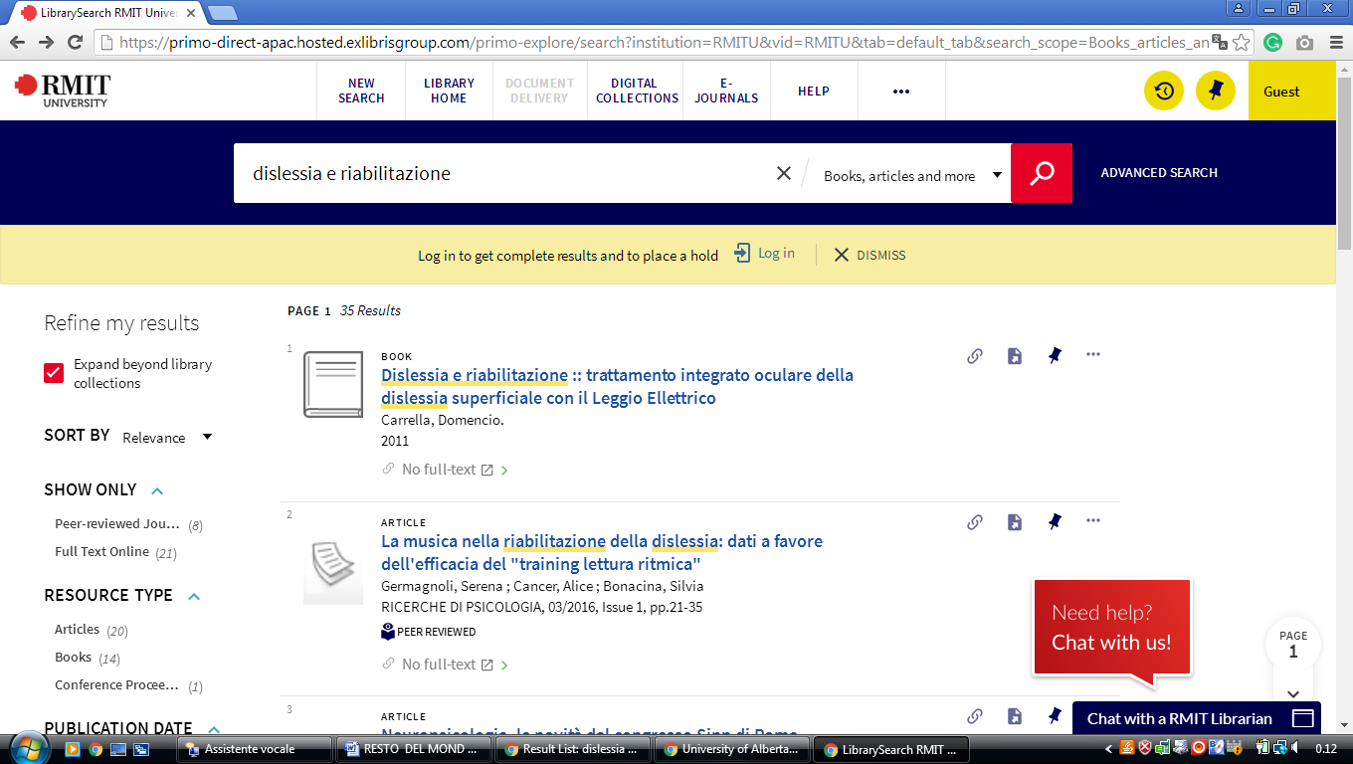

12 USQ LIBRARY - (University Of Southern Queensland Library, Australia)
https://usq.summon.serialssolutions.com/search?s.q=dislessia+e+riabilitazione&s.fvf%5B%5D=ContentType%2CBook+Review%2Ct&s.fvf%5B%5D=ContentType%2CNewspaper+Article%2Ct#!/search?ho=f&fvf=ContentType,Book%20Review,t%7CContentType,Newspaper%20Article,t&l=it-IT&q=dislessia%20e%20riabilitazione

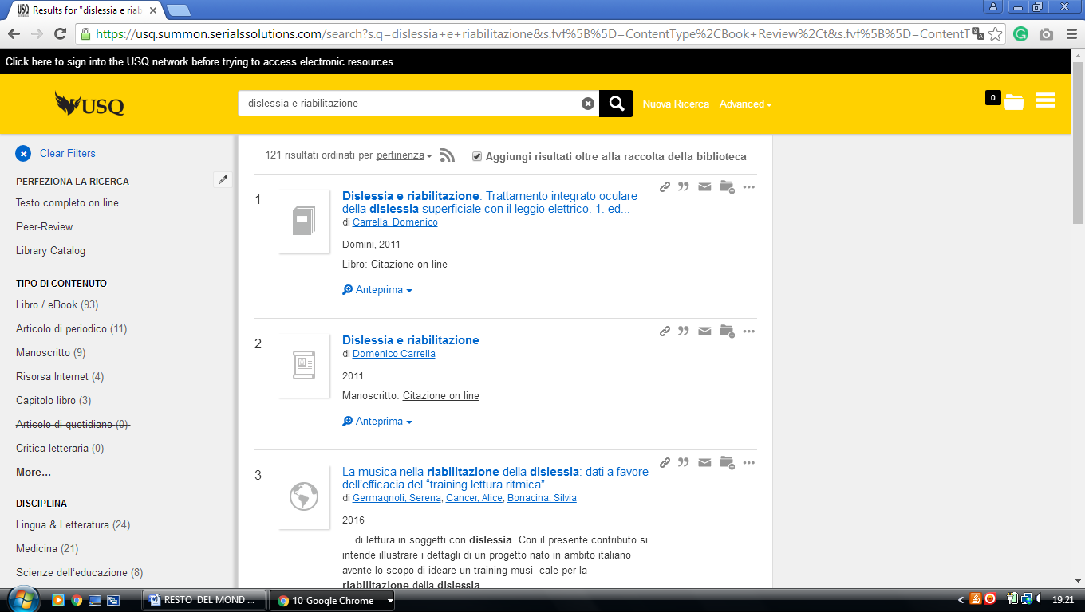

13 STATE LIBRARY OF QUEENSLAND LIBRARY – (South Brisbane, Australia)
http://onesearch.slq.qld.gov.au/primo_library/libweb/action/search.do?ct=facet&pcAvailabiltyMode=true&pcAvailClicked=true&vl(D45500790UI0)=any&query=any%2Ccontains%2C%20dislessia%20e%20riabilitazione&fn=search&indx=1&dscnt=0&search_scope=SLQ_PCI_EBSCO&vl(1UIStartWith0)=contains&scp.scps=scope%3A(BLOGS)%2Cscope%3A(SLQEC)%2Cscope%3A(FH_COMBINED)%2Cscope%3A(SAW)%2Cscope%3A(IC)%2Cscope%3A(SLQ)%2Cscope%3A(DT)%2Cscope%3A(QS)%2Cprimo_central_multiple_fe&onCampus=false&vid=SLQ&ct=search&institution=SLQ&tab=default_tab&vl(freeText0)=%20dislessia%20e%20riabilitazione&group=Guest&dstmp=1518131939970&fromDL

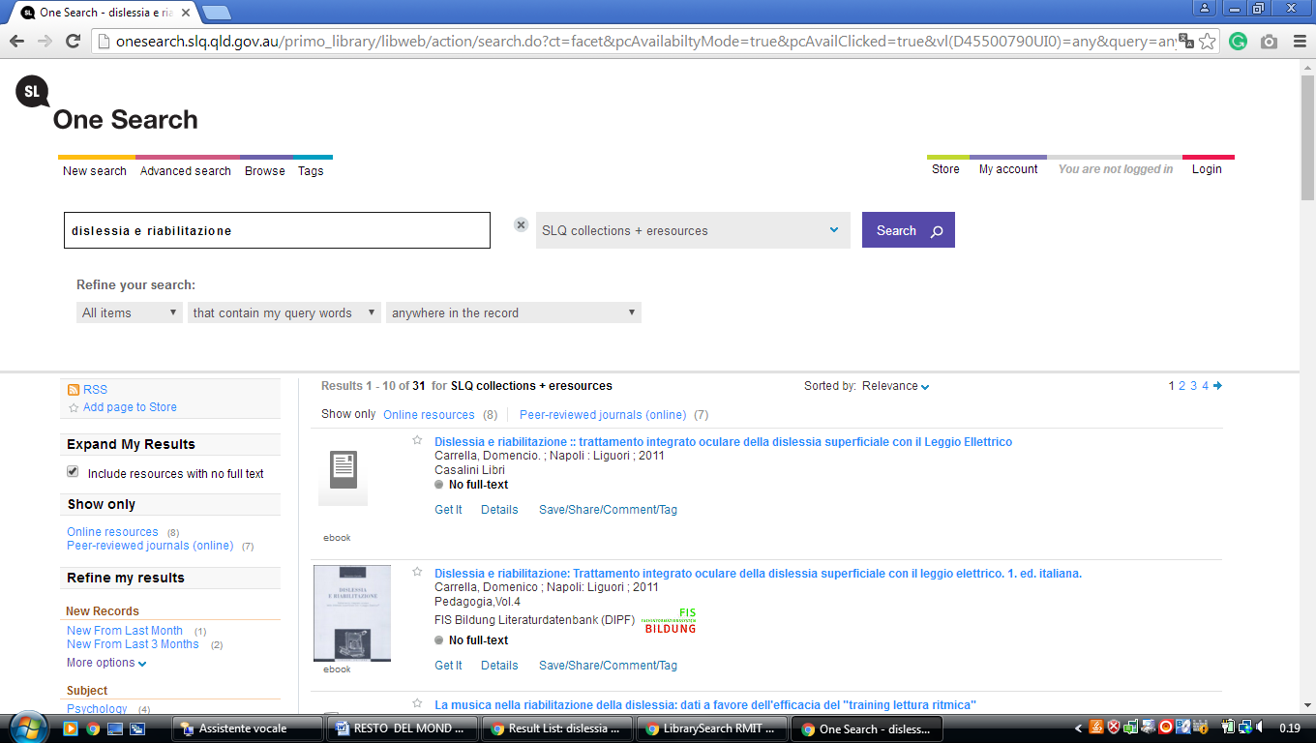

14 UWA LIBRARY - THE UNIVERSITY OF WESTERN AUSTRALIA
(Perth, Western Australia, Australia)

https://onesearch.library.uwa.edu.au/discovery/search?query=any,contains,dislessia%20e%20riabilitazione&tab=WorldCat&search_scope=WorldCat&vid=61UWA_INST:UWA&offset=0&pcAvailability=true

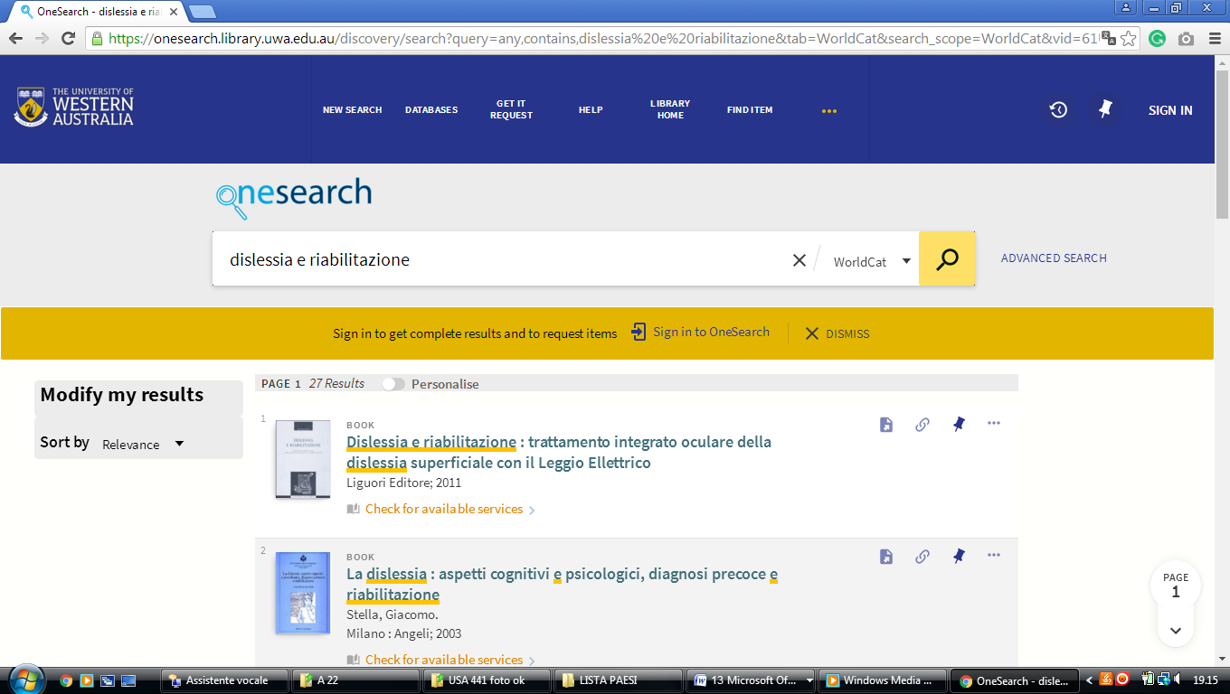

RMIT Universityl ibrary
https://primo-direct-apac.hosted.exlibrisgroup.com/primo-explore/search?query=any,contains,dislessia%20e%20riabilitazione&tab=default_tab&search_scope=Books_articles_and_more&vid=RMITU&offset=0&pcAvailability=true

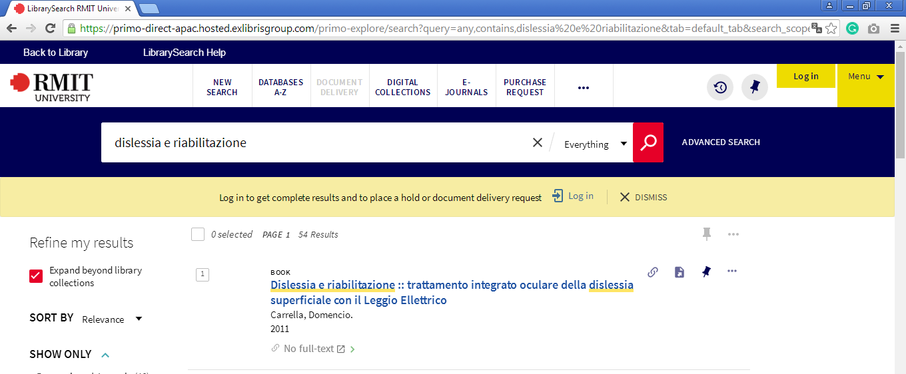

New Search - University of Melbourne library catalogue
http://eds.a.ebscohost.com/eds/results?vid=0&sid=bacfd2b7-9c2e-4dd1-a9c8-f5259264980a%40sessionmgr4008&bquery=dislessia%2Be%2Briabilitazione&bdata=JnR5cGU9MCZzZWFyY2hNb2RlPVN0YW5kYXJkJnNpdGU9ZWRzLWxpdmU%3d
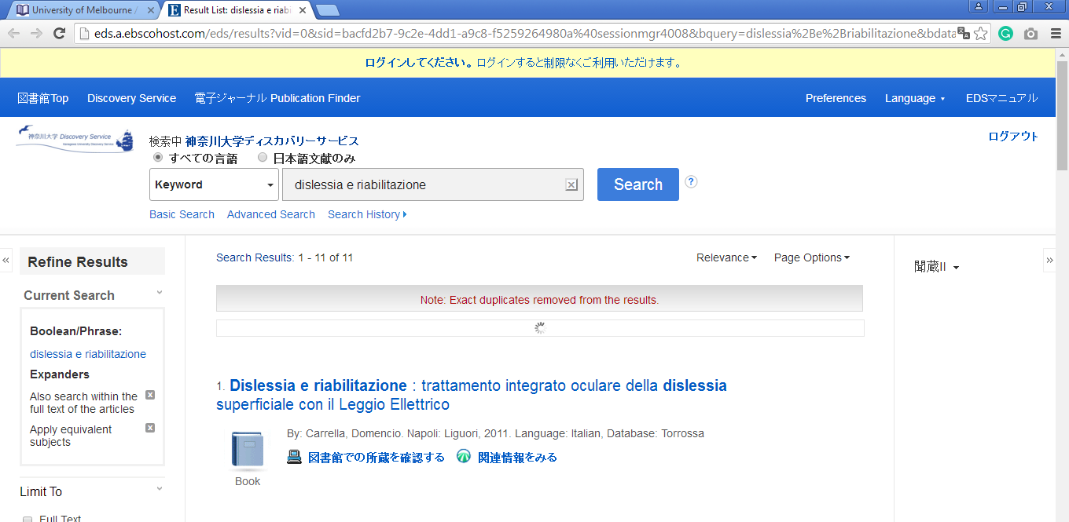

ANU library -libraryLibrary
https://anu.summon.serialssolutions.com/search?q=dislessia+e+riabilitazione+trattamento+integrato+oculare+della+dislessia+su&button3=GO#!/search?ho=f&l=en&q=dislessia%20e%20riabilitazione%20trattamento%20integrato%20oculare%20della%20dislessia%20su&button3=GO

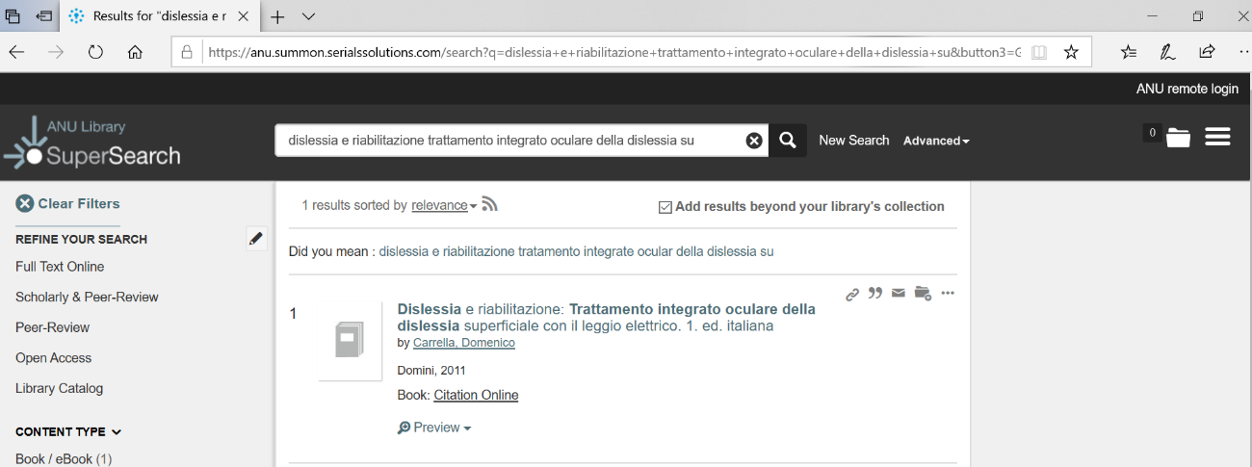

University of Queensland, Gatton (J.K. Murray) Library (Highly ...
https://search.library.uq.edu.au/primo-explore/search?query=any,contains,dislessia%20e%20riabilitazione&tab=61uq_all&search_scope=61UQ_All&sortby=rank&vid=61UQ&offset=0&facet=rtype,exclude,newspaper_articles&facet=rtype,exclude,reviews&pcAvailability=true
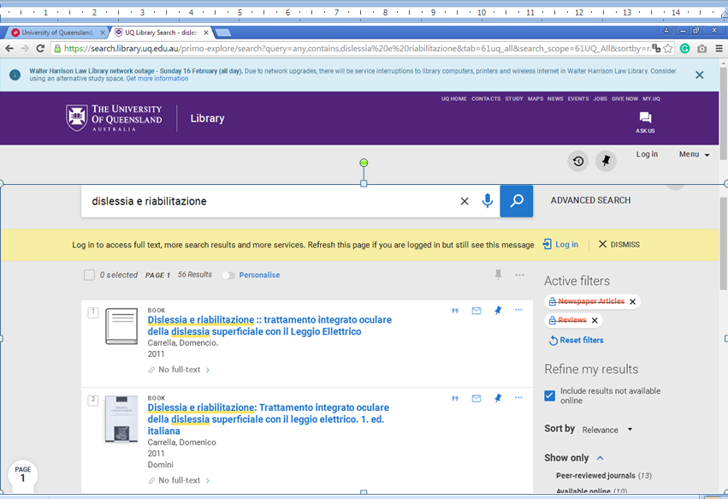

University Library - UWA

https://onesearch.library.uwa.edu.au/discovery/search?query=any,contains,dislessia%20e%20riabilitazione&tab=WorldCat&search_scope=WorldCat&sortby=rank&vid=61UWA_INST:UWA&offset=0&search_text=dislessia%20e%20riabilitazione
