1 WELCOME TO THE BU LIBRARIES! » BU LIBRARIES | BOSTON UNIVERSITY - (Belgio)
https://buprimo.hosted.exlibrisgroup.com/primo-explore/search?query=any,contains,dislessia%20e%20riabilitazione&tab=worldcat&search_scope=WorldCat&vid=BU&lang=en_US&offset=0
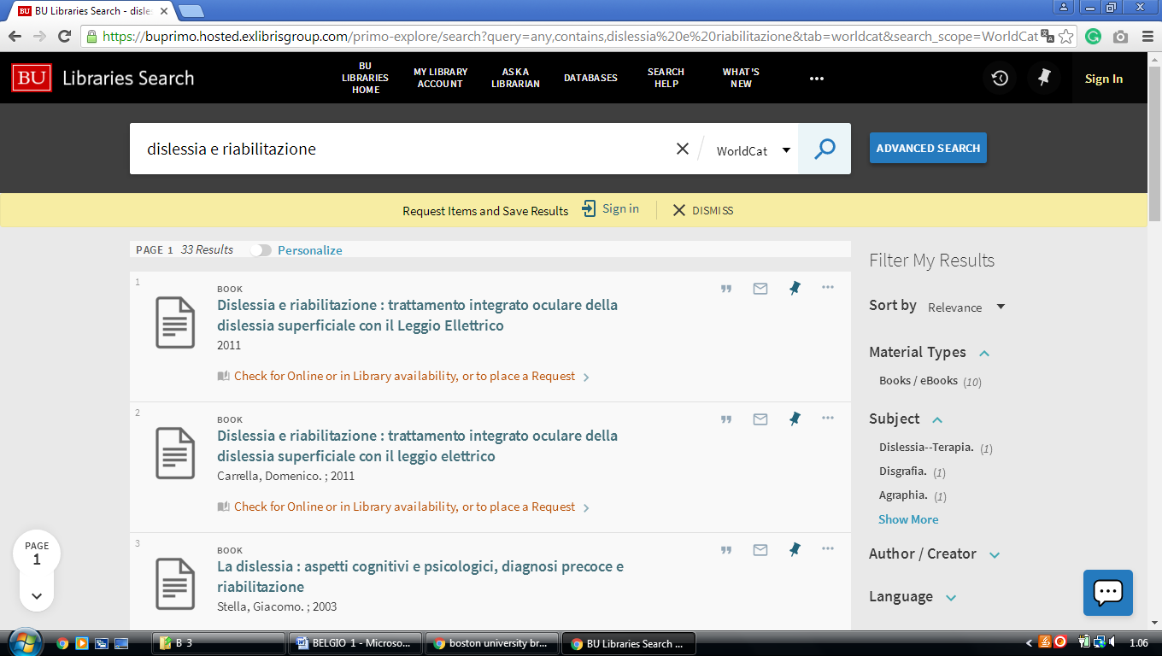

2 EUROPEAN COMMISSION CENTRAL LIBRARY – (Brussels, Belgio)
https://ec-europa-finder.hosted.exlibrisgroup.com/primo-explore/search?query=any,contains,%20dislessia%20e%20riabilitazione&search_scope=default_scope&sortby=rank&vid=32EUC_VU1&lang=en_US&pcAvailability=true

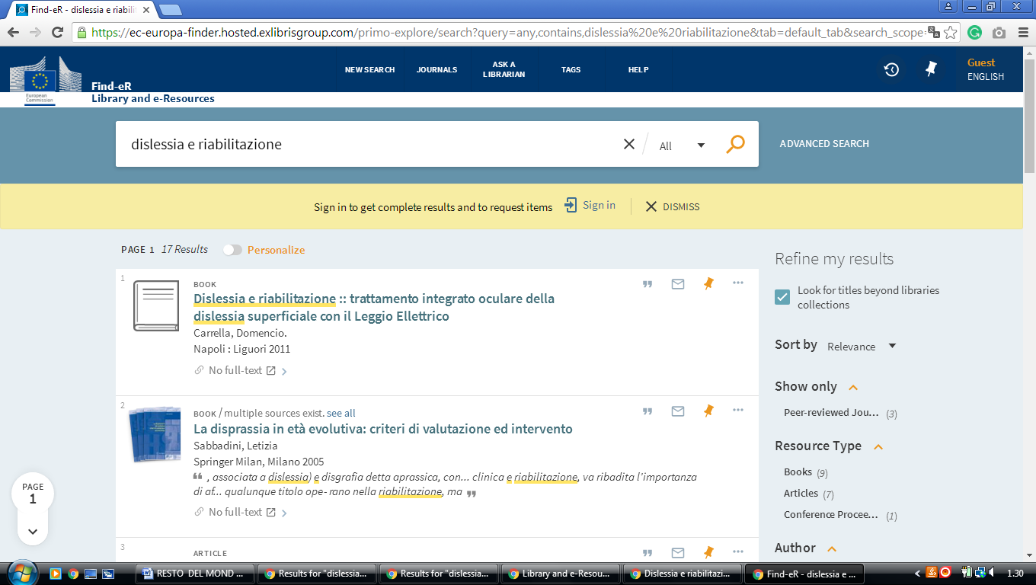

3 GHENT UNIVERSITY LIBRARY - THE EUROPEAN LIBRARY - (Belgio)
http://www.theeuropeanlibrary.org/tel4/contributor/P01378

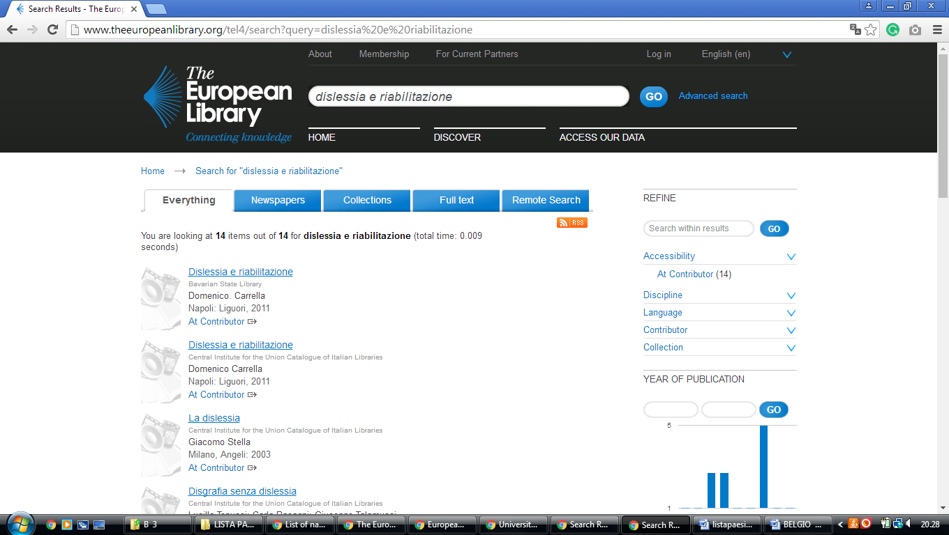

UHasselt | University Library

https://uha.summon.serialssolutions.com/?#!/search?ho=f&l=en&q=dislessia%20e%20riabilitazione

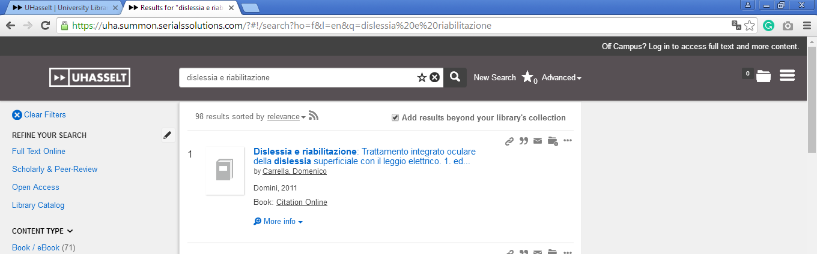

Bibliotheek van het Federaal Parlement Belgian Parliament

https://limo.libis.be/primo-explore/search?query=any,contains,dislessia%20e%20riabilitazione&tab=all_content_tab&search_scope=ALL_CONTENT&vid=KULeuven&lang=en_US&offset=0&pcAvailability=true

