UNIVERSITY LIBRARY, Yangon, BIRMANIA

Library | University of Yangon
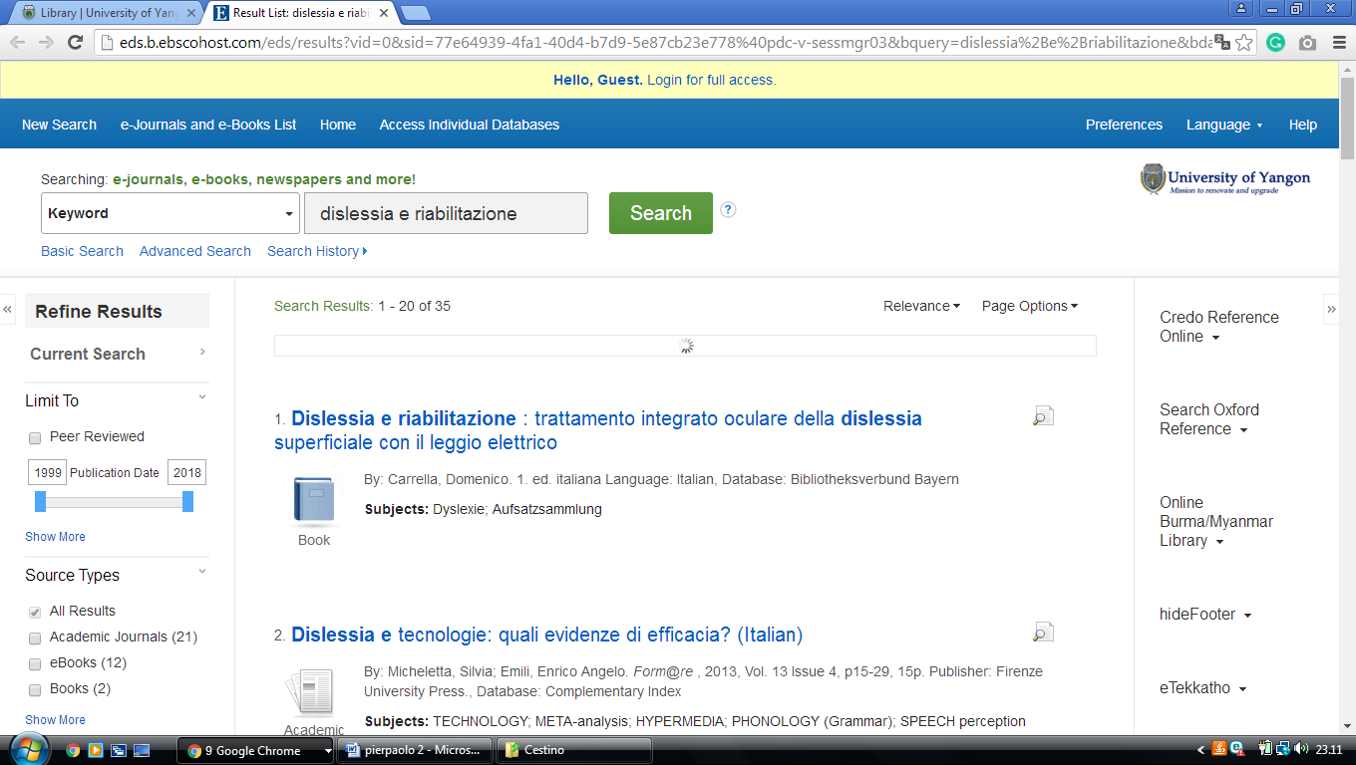

University Of Yangon | BIRMANIA

University Of Yangon Library |
http://eds.b.ebscohost.com/eds/results?vid=0&sid=77e64939-4fa1-40d4-b7d9-5e87cb23e778%40pdc-v-sessmgr03&bquery=dislessia%2Be%2Briabilitazione&bdata=JnR5cGU9MCZzZWFyY2hNb2RlPUFuZCZzaXRlPWVkcy1saXZl

