1 BRITISH COLUMBIA INSTITUTE OF TECHNOLOGY LIBRARY – (Burnaby, Canada)
https://bcit.summon.serialssolutions.com/search?s.q=dislessia+e+riabilitazione&spellcheck=true&keep_r=true#!/search?ho=f&l=en&q=dislessia%20e%20riabilitazione

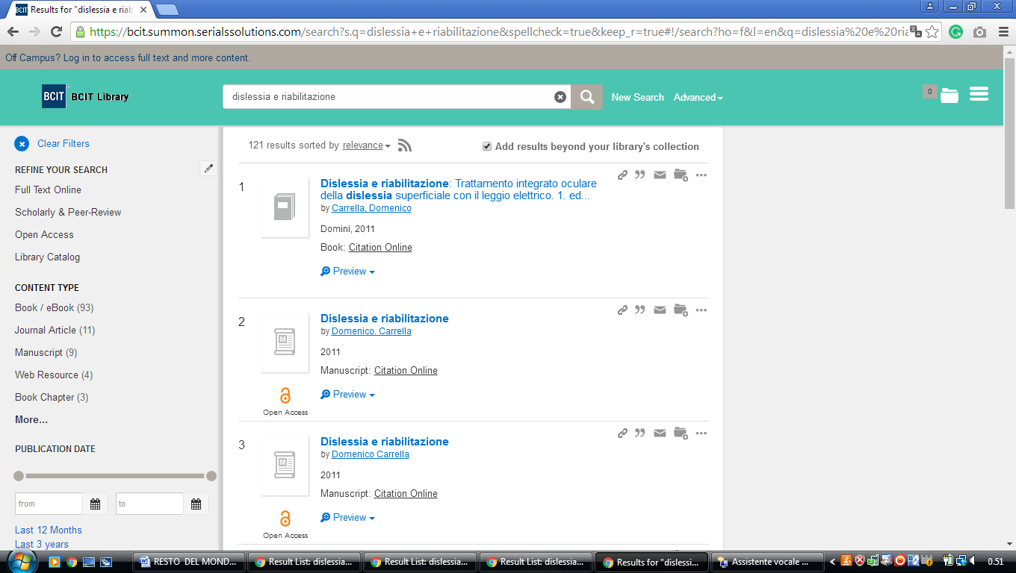

2 UNIVERSITY OF BRITISH COLUMBIA LIBRARY – (Vancover In British Colombia, Canada)
http://ubc.summon.serialssolutions.com/search?spellcheck=true&s.q=dislessia+e+riabilitazione#!/search?ho=f&l=en&q=dislessia%20e%20riabilitazione

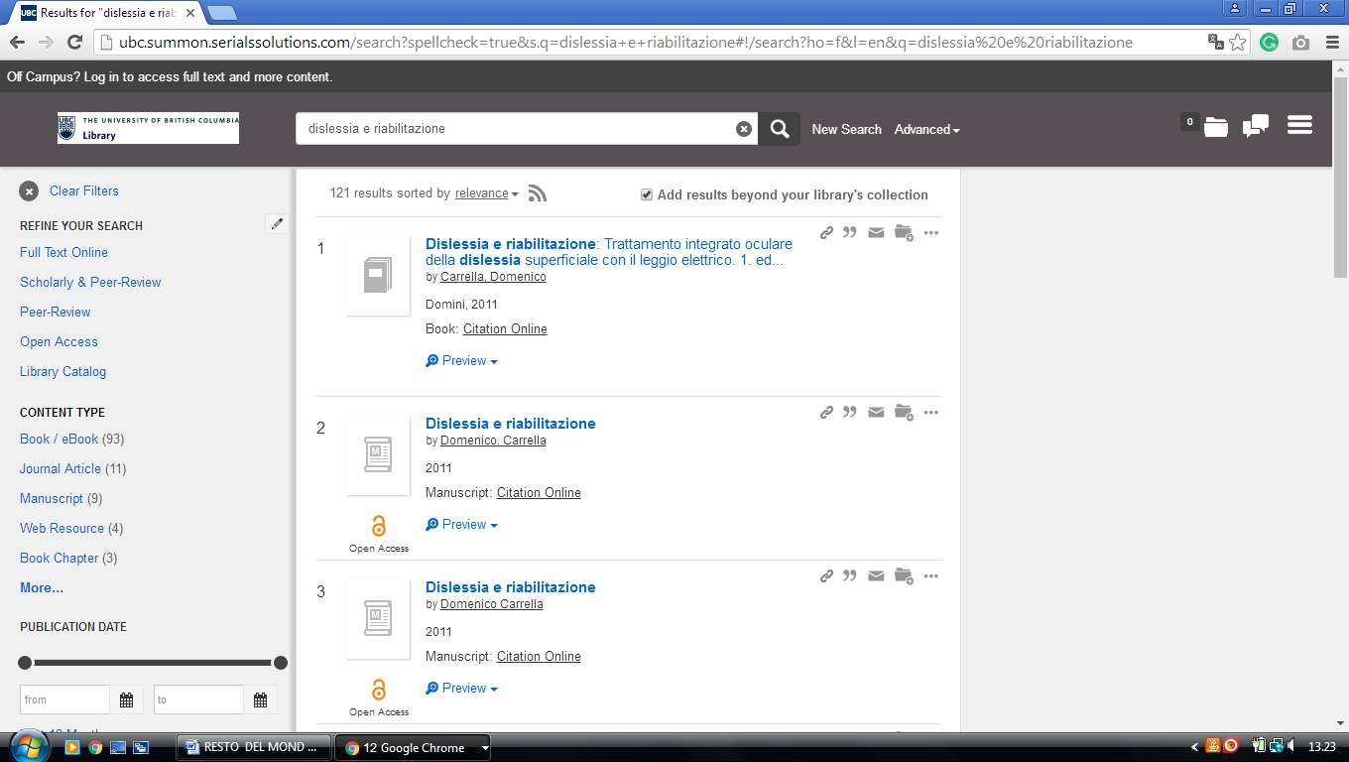

3 GEOFFREY R. WELLER LIBRARY - (Prince George, British Columbia, Canada)
http://unbc.summon.serialssolutions.com/search?s.q=dislessia+e+riabilitaziones.fvf[]=ContentType,CNewspaper+Article,t&s.fvf[]=ContentType,Book+Review,t&keep_r=true#!/search?ho=f&fvf=ContentType,Newspaper%20Article,t%7CContentType,Book%20Review,t&l=en&q=dislessia%20e%20riabilitazione

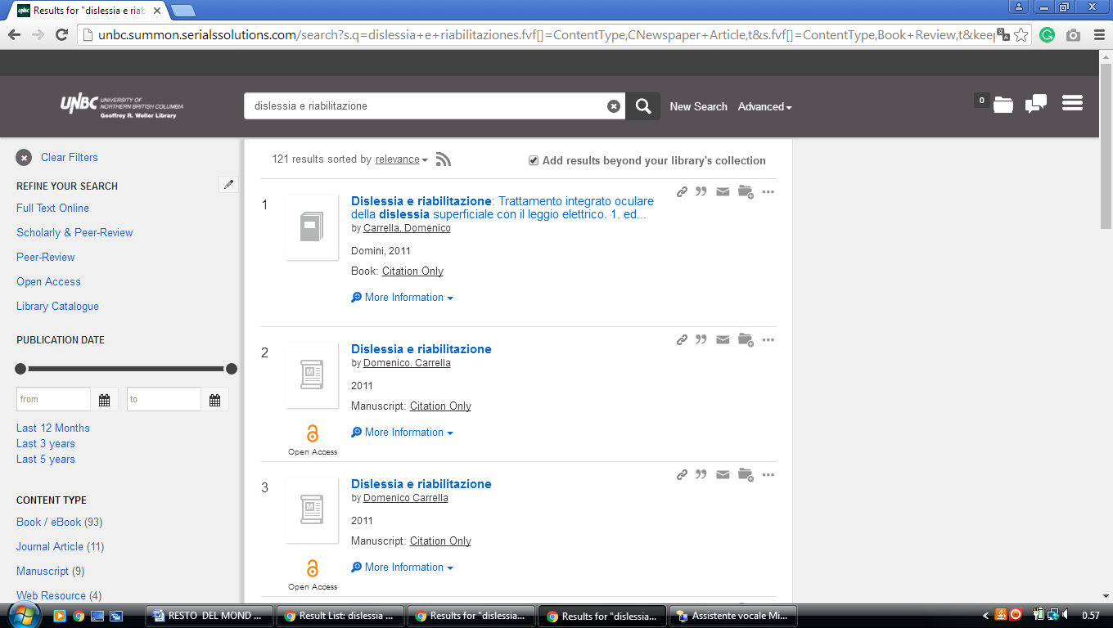

4 UNIVERSITY OF LETHBRIDGE LIBRARY – (Alberta, Canada)
https://uleth.summon.serialssolutions.com/?#!/search?ho=f&l=en-UK&q=dislessia%20e%20riabilitazione

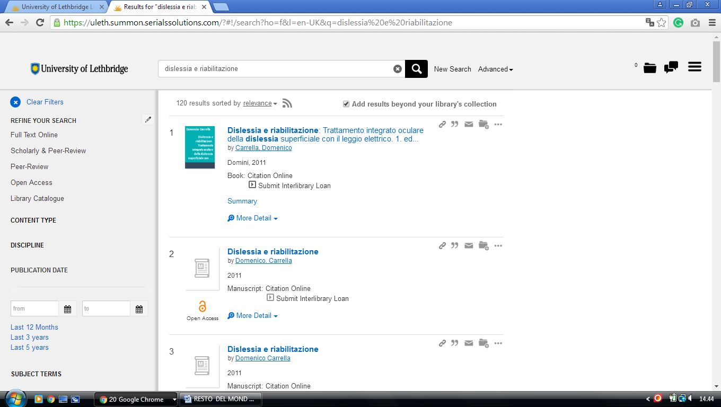

5 OKANAGAN COLLEGE LIBRARY – (Kelowna, British Columbia, Canada)
http://eds.b.ebscohost.com/eds/results?vid=3&sid=1aa623ac-e021-414e-947b-f008c1c88f27%40sessionmgr120&bquery=(dislessia+AND+e+AND+riabilitazione)&bdata=JnR5cGU9MCZzaXRlPWVkcy1saXZlJnNjb3BlPXNpdGU%3d

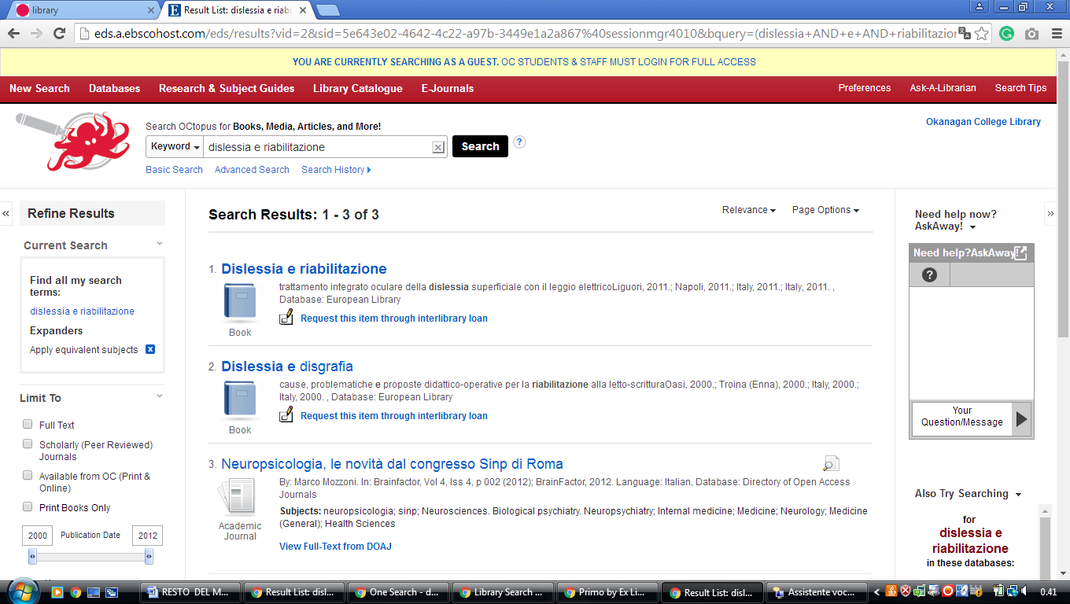

6 RRU LIBRARY – (Victoria, British Columbia, Canada)
https://royalroads.on.worldcat.org/search?sortKey=BEST_MATCH&databaseList=&queryString=dislessia+e+riabilitazione&changedFacet=scope&scope=&scope=wz%3A26145&format=all&database=all&author=all&year=all&yearFrom=&yearTo=

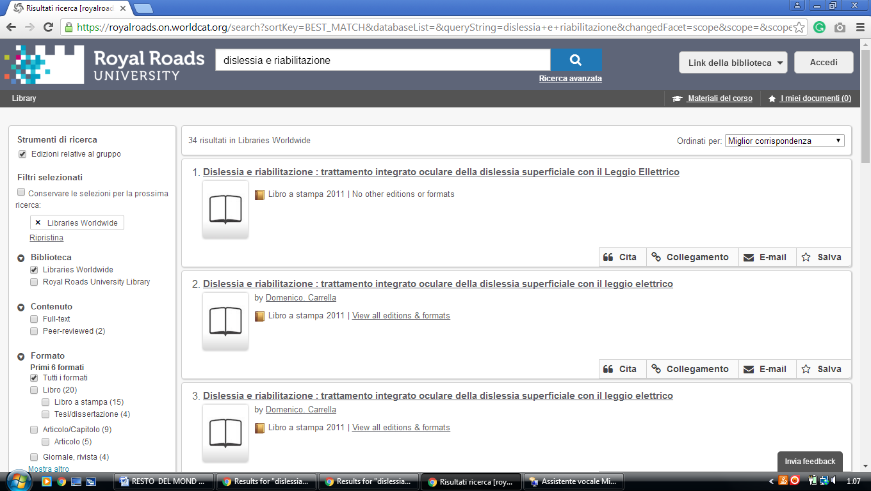

7 VANCOUVER ISLAND UNIVERSITY LIBRARY – (Nanaimo, British Columbia, Canada)
http://viu.summon.serialssolutions.com/search?s.q=dislessia+e+riabilitazione&s.fvf%5B%5D=ContentType%2CBook+Review%2Ct&x=9&y=15#!/search?ho=f&fvf=ContentType,Book%20Review,t&l=en&q=dislessia%20e%20riabilitazione

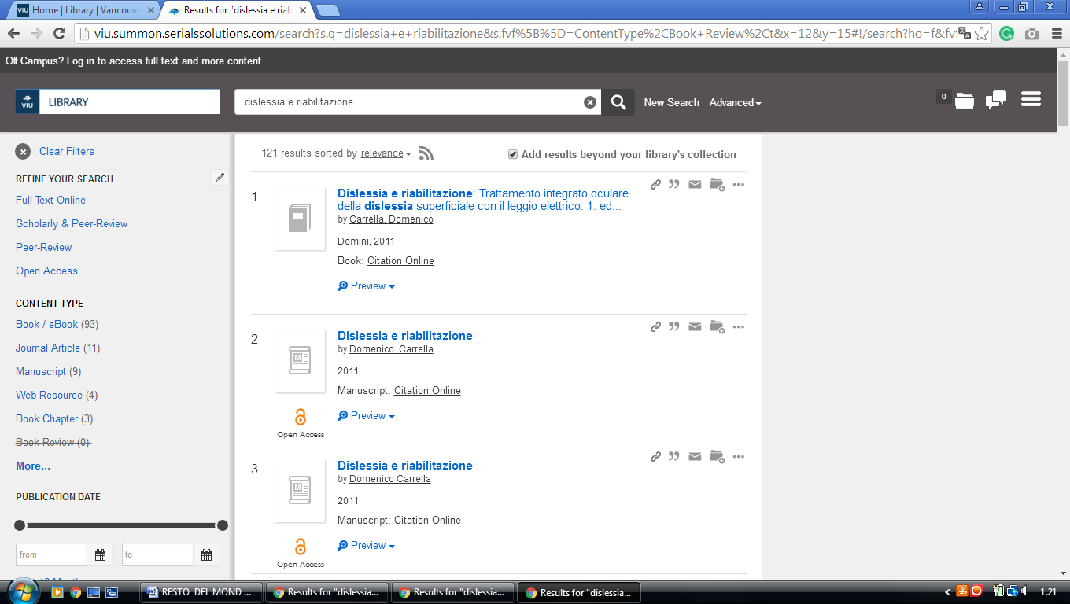

8 UNIVERSITY OF VICTORIA LIBRARIES - (Victoria, British Columbia, Canada)
http://uvic.summon.serialssolutions.com/#!/search?ho=f&l=en&q=dislessia%20e%20riabilitazione

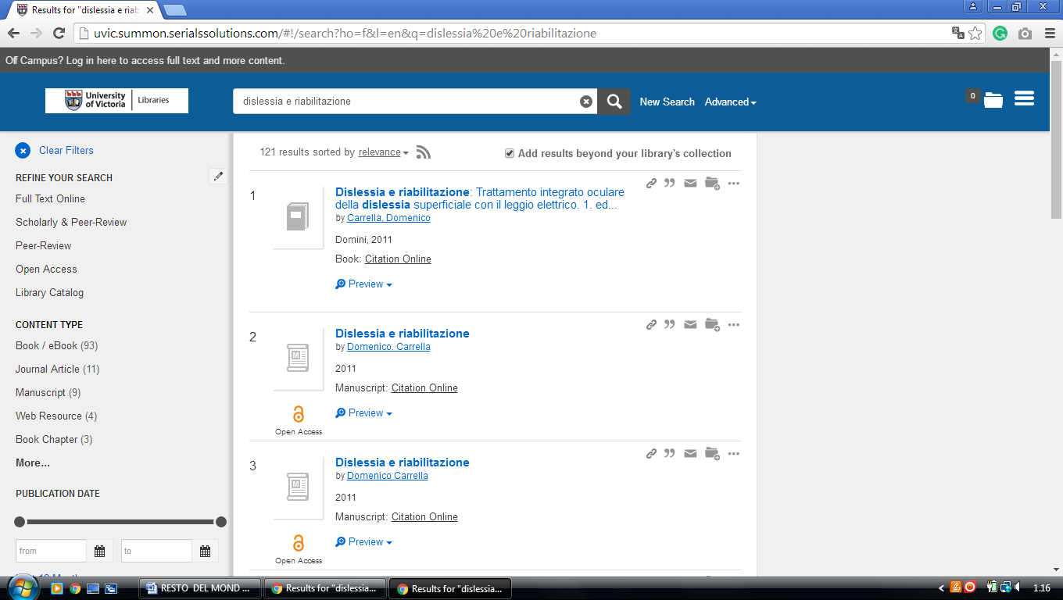

9 KWANTLEN UNIVERSITY COLLEGE LIBRARY – (Surrey, British Columbia, Canada)
http://kwantlen.summon.serialssolutions.com/?spellcheck=true&s.q=dislessia+e+riabilitazione#!/search?ho=f&l=en&q=dislessia%20e%20riabilitazione

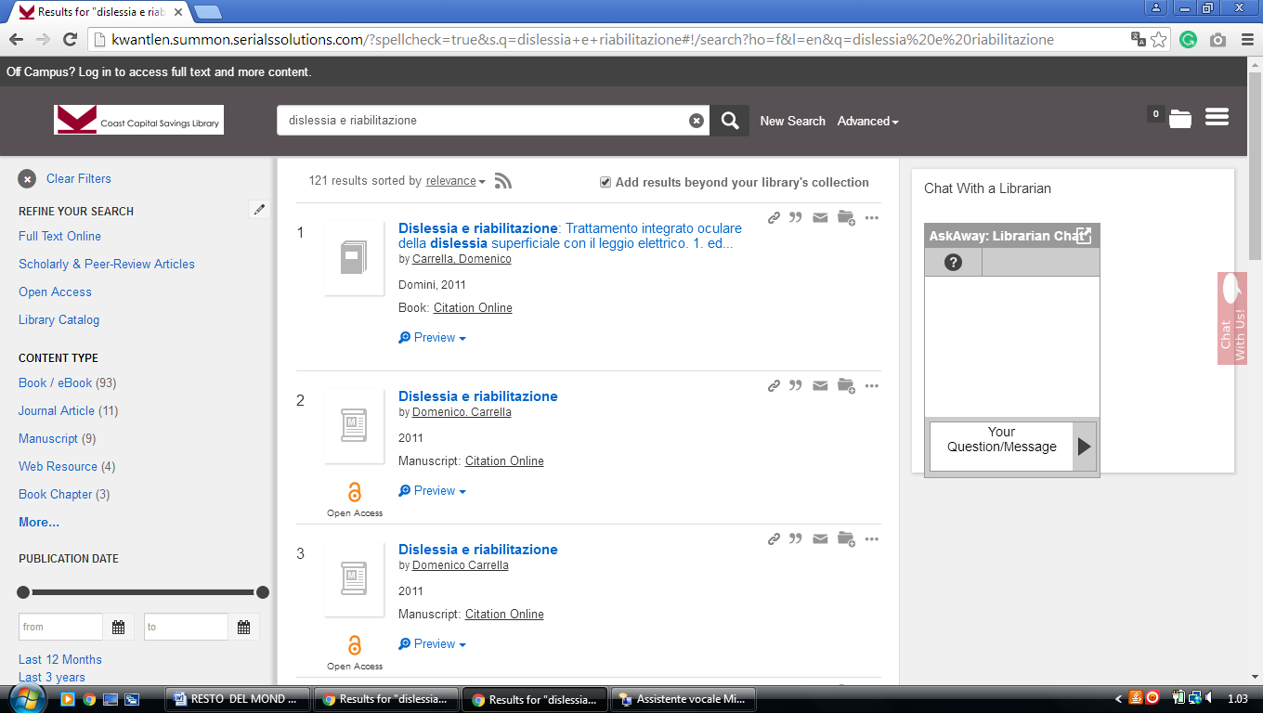

10 LIBRARY - CONCORDIA UNIVERSITY OF EDMONTON - (Edmonton Canada)
https://concordia.on.worldcat.org/search?sortKey=LIBRARY&databaseList=&queryString=dislessia+e+riabilitazione&changedFacet=scope&scope=&scope=sz%3A32485&format=all&database=all&author=all&year=all&yearFrom=&yearTo=&language=all

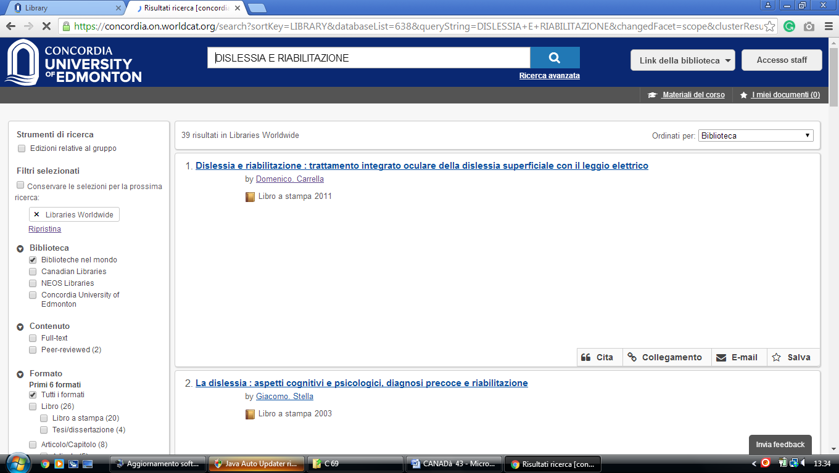

11 LIBRARY AT UNIVERSITY OF CALGARY – (Alberta, Canada)

https://ucalgary.summon.serialssolutions.com/search?q=dislessia+e+riabilitazione#!/search?ho=f&l=en&q=dislessia%20e%20riabilitazione

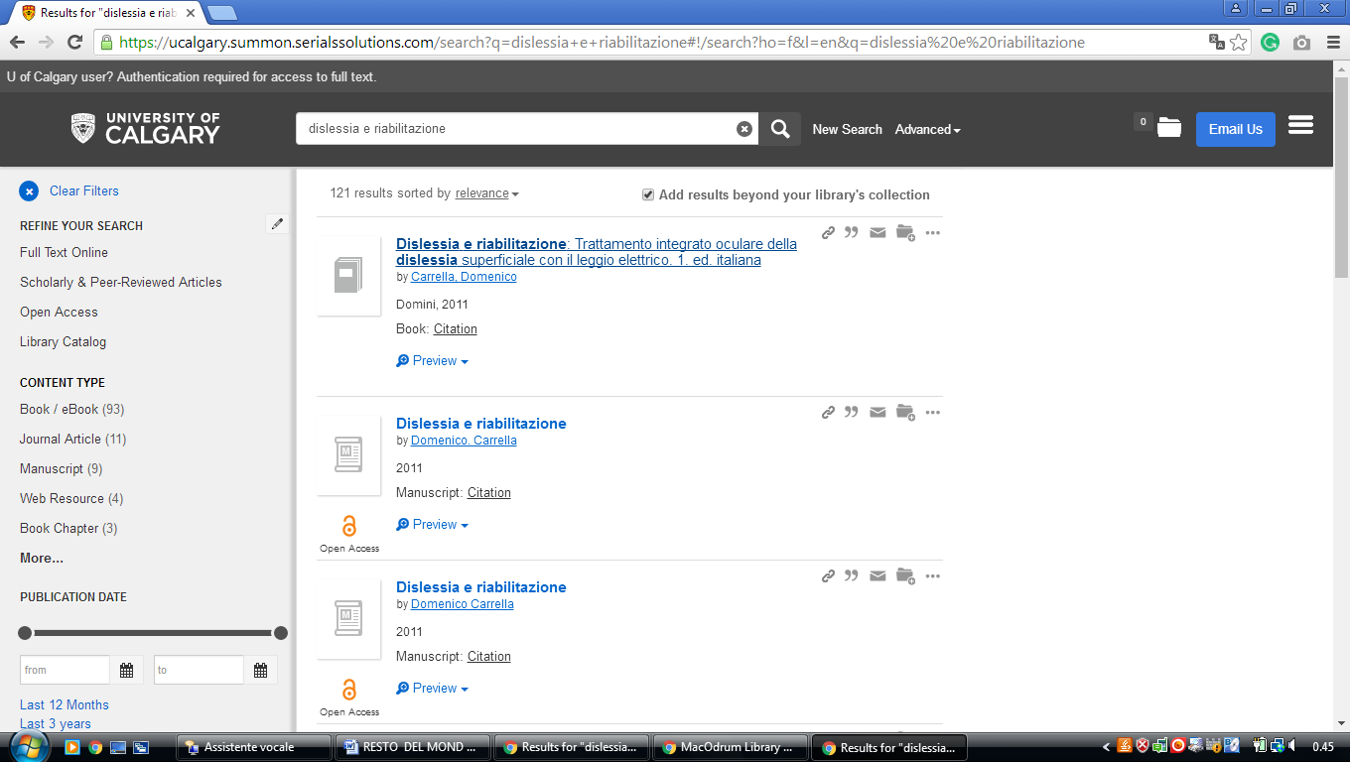

12 CENTENNIAL COLLEGE LIBRARIES – (Ontario, Canada)
http://centennial.summon.serialssolutions.com/search?s.q=dislessia+e+riabilitazione#!/search?ho=f&l=it-IT&q=dislessia%20e%20riabilitazione

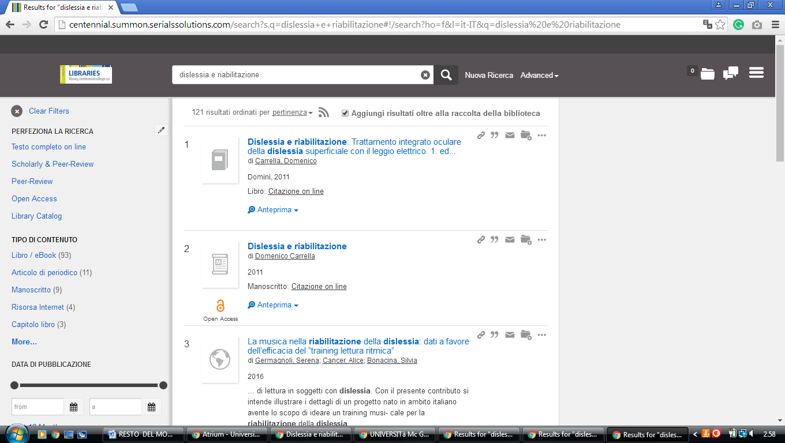

13 GEOFFREY R. WELLER LIBRARY - UNIVERSITY OF NORTHERN BRITISH

COLUMBIA - (Prince George, British Columbia, Canada)
http://unbc.summon.serialssolutions.com/search?s.q=dislessia+e+riabilitaziones.fvf[]=ContentType,CNewspaper+Article,t&s.fvf[]=ContentType,Book+Review,t&keep_r=true#!/search?ho=f&fvf=ContentType,Newspaper%20Article,t%7CContentType,Book%20Review,t&l=en&q=dislessia%20e%20riabilitazione

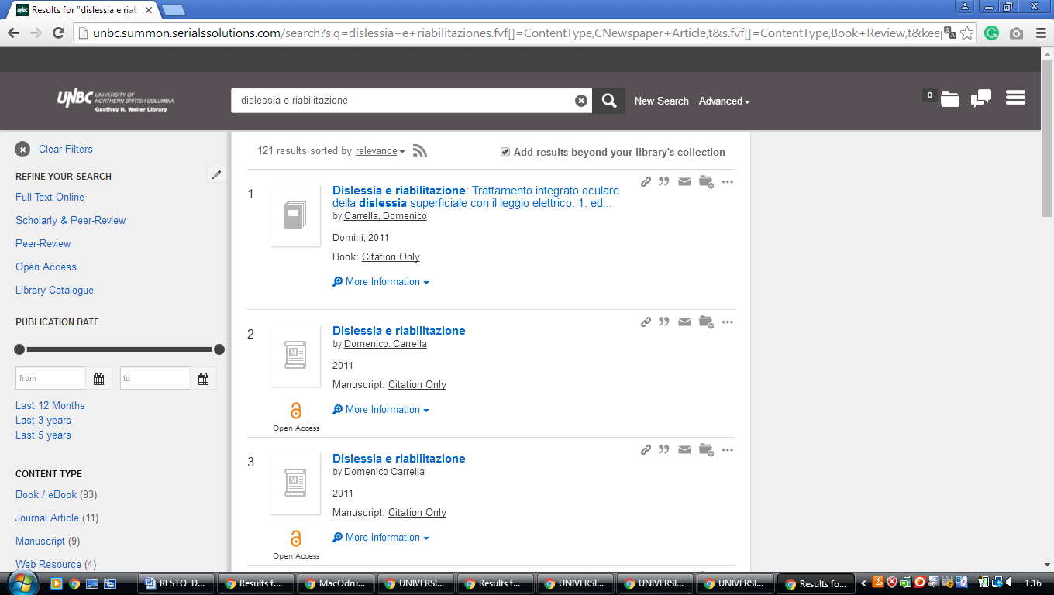

14 MEDICINE HAT COLLEGE,LIBRARIES – (Medicine Hat, Alberta, Canada)
https://mhc.on.worldcat.org/external-search?queryString=dislessia+e+riabilitazione

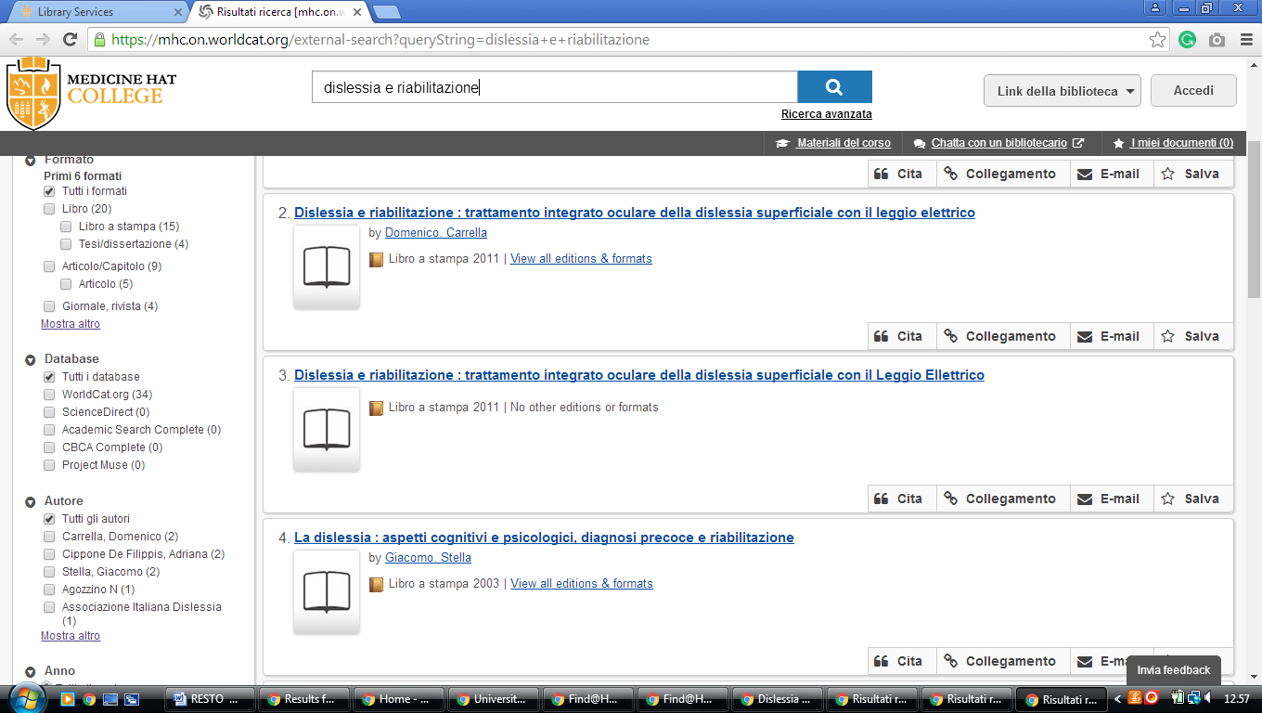

15 UNIVERSITY OF LETHBRIDGE LIBRARY – (Alberta, Canada)
https://uleth.summon.serialssolutions.com/?#!/search?ho=f&l=en-UK&q=dislessia%20e%20riabilitazione

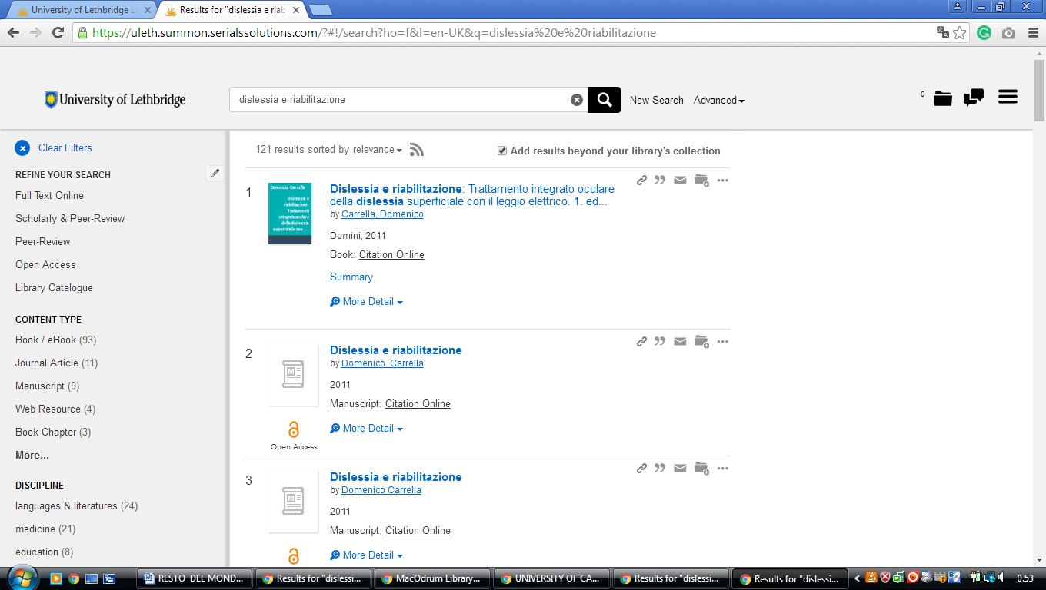

16 MACODRUM LIBRARY CARLETON UNIVERSITY – (Ottawa, Canada)
https://carletonu.summon.serialssolutions.com/?q=dislessia%20e%20riabilitazione#!/search?ho=f&l=en&q=dislessia%20e%20riabilitazione

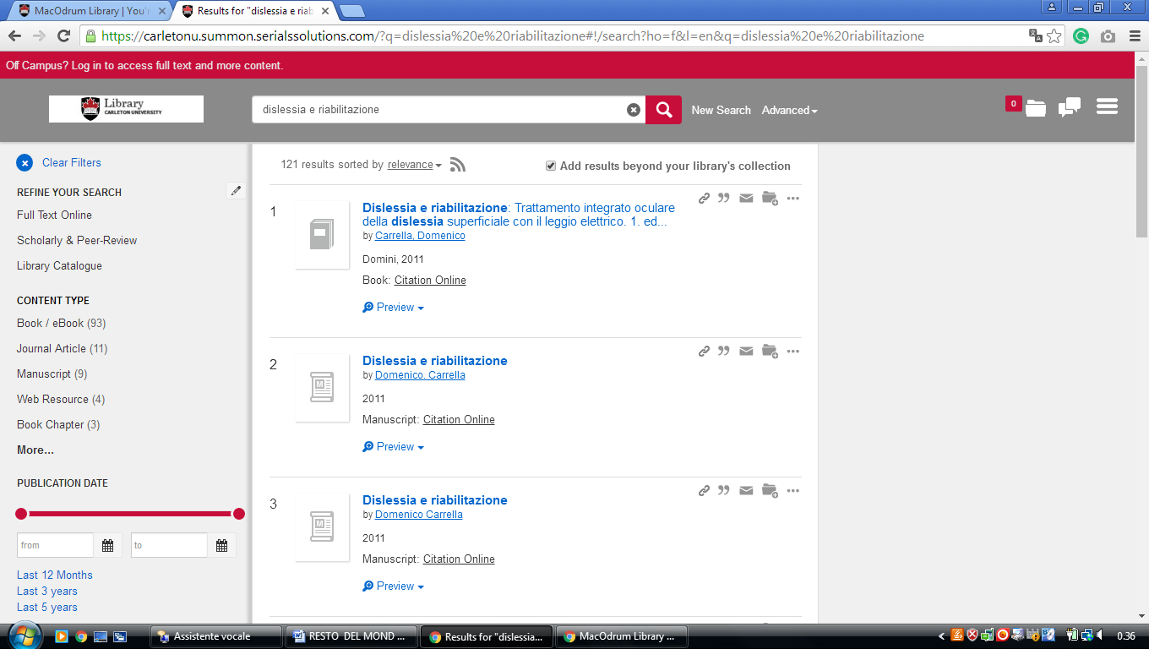

17 MCGILL LIBRARY - MCGILL UNIVERSITY - (Montreal Canada)
http://mcgill.worldcat.org/title/dislessia-e-riabilitazione-trattamento-integrato-oculare-della-dislessia-superficiale-con-il-leggio-elettrico/oclc/878784487&referer=brief_results

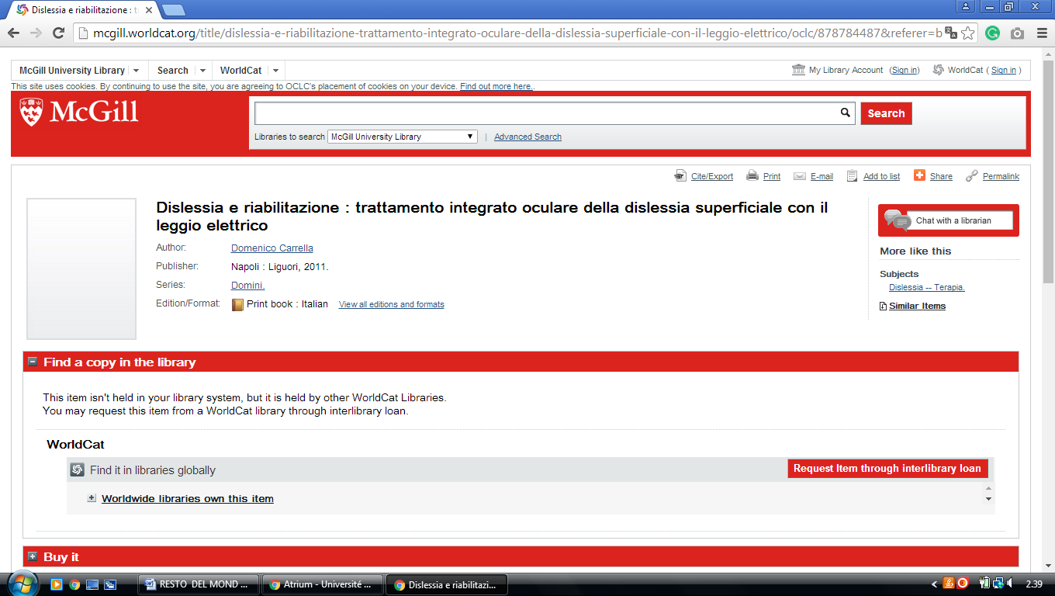

18 UNIVERSITY IN MONTREAL LIBRARY – (Quebec, Montreal)
http://atrium.umontreal.ca/primo-explore/search?query=any,contains,DISLESSIA%20E%20RIABILITAZIONE&tab=tout_plus_articles&search_scope=Tout&vid=UM&lang=fr_FR&offset=0&sortby=rank&pcAvailability=true

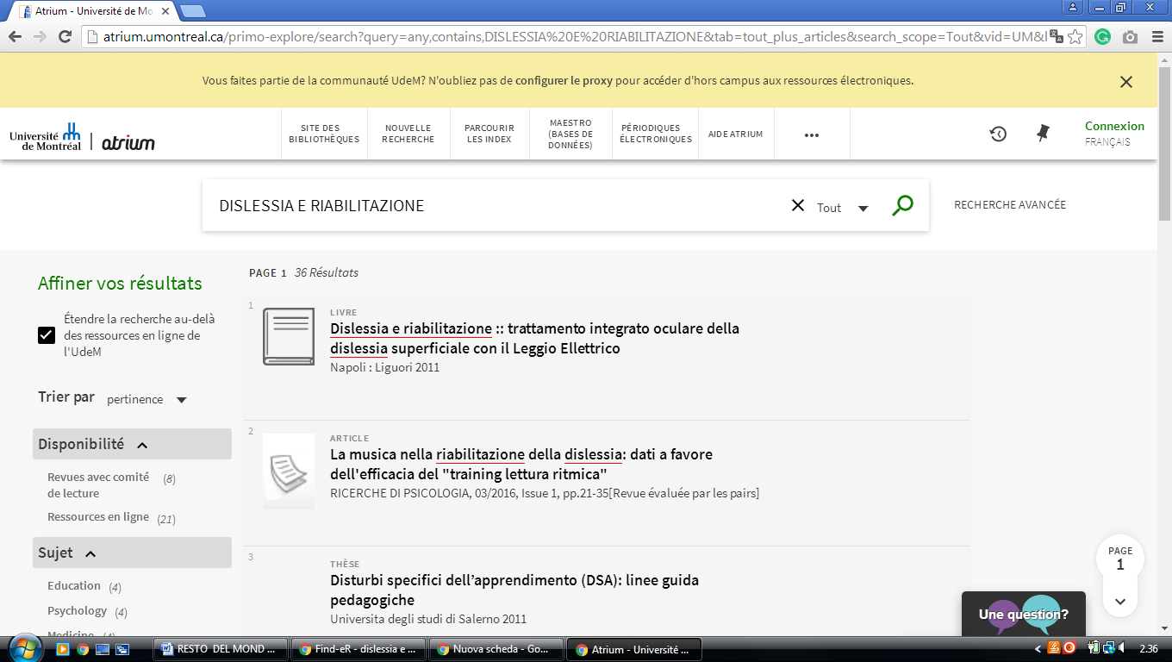

19 MOUNT ROYAL COLLEGE LIBRARY - (Calgary, Alberta, Canada)
https://mtroyal.summon.serialssolutions.com/?fvf=ContentType%2CNewspaper+Article%2Ct&fvf=ContentType%2CBook+Review%2Ct&q=dislessia+e+riabilitazione#!/search?ho=f&fvf=ContentType,Newspaper%20Article,t%7CContentType,Book%20Review,t&l=en&q=dislessia%20e%20riabilitazione

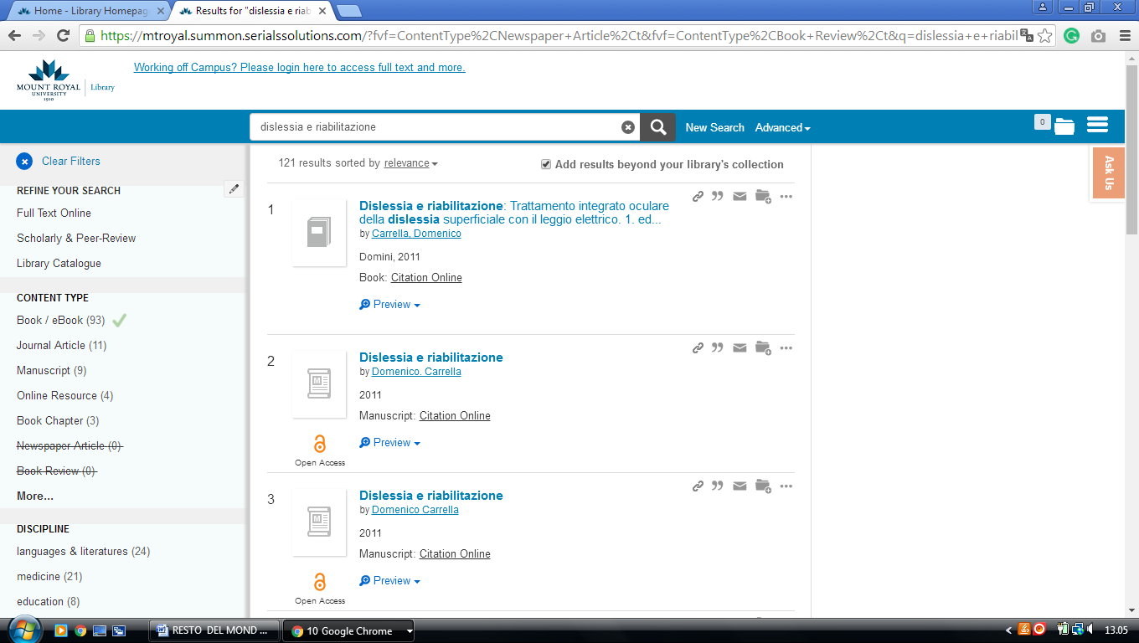

20 UNIVERSITY OF MANITOBA LIBRARIES – (Winnipeg, Canada)
http://primo-pmtna01.hosted.exlibrisgroup.com/primo_library/libweb/action/search.do?ct=facet&pcAvailabiltyMode=true&pcAvailClicked=true&query=any%2Ccontains%2C%20dislessia%20e%20riabilitazione&fn=search&indx=1&search_scope=UManitoba&dscnt=0&scp.scps=scope%3A(UMB)%2Cscope%3A(UMB_CR)%2Cscope%3A(UMB_MSPACE)%2Cscope%3A(UMB_LibGuides_OAI)%2Cprimo_central_multiple_fe&displayMode=full&vl(189744081UI0)=any&mode=Basic&onCampus=true&vid=UMB&queryTemp=%20dislessia%20e%20riabilitazione&institution=UMB&ct=search&highlight=true&tab=default_tab&displayField=all&vl(freeText0)=%20dislessia%20e%20riabilitazione&group=GUEST&dstmp=1518220758793&fromDL

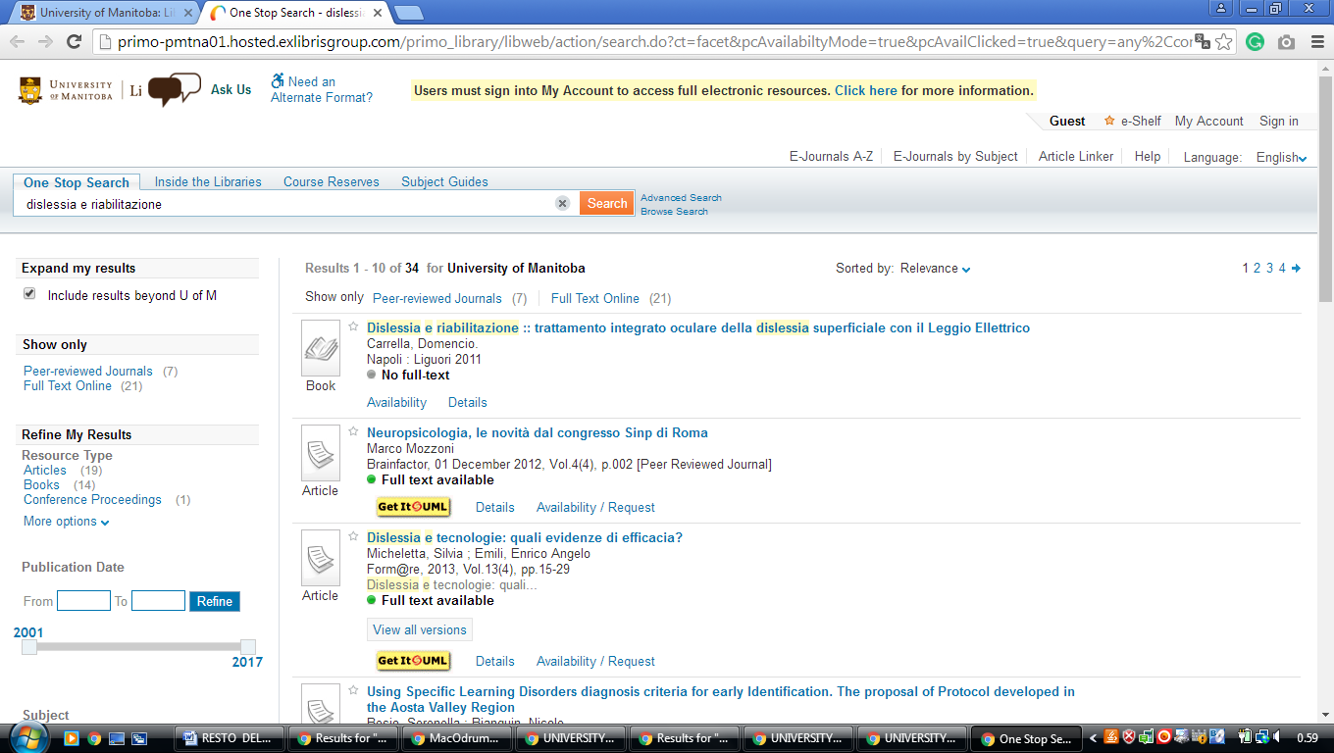

21 LIBRARY - UNIVERSITY OF ONTARIO INSTITUTE OF TECHNOLOGY
(Oshawa, Ontario, Canada)
https://uoit.summon.serialssolutions.com/search?s.q=dislessia+e+riabilitazione&s.fvf%5B%5D=ContentType%2CBook+Review%2Ct&s.fvf%5B%5D=ContentType%2CNewspaper+Article%2Ct&spellcheck=true&keep_r=true#!/search?ho=f&fvf=ContentType,Book%20Review,t%7CContentType,Newspaper%20Article,t&l=en&q=dislessia%20e%20riabilitazione
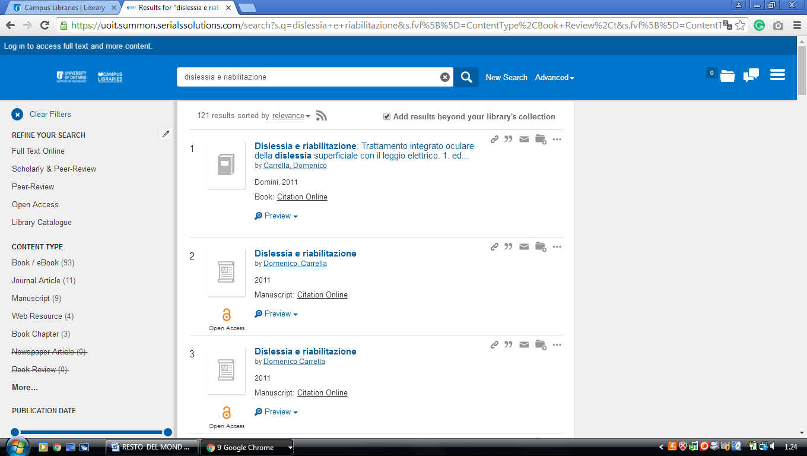

22 QUEEN'S UNIVERSITY LIBRARY – (Kingston, Ontario, Canada)
http://queensu.summon.serialssolutions.com/search?s.q=dislessia+e+riabilitazione&submit=Search#!/search?ho=f&l=en&q=dislessia%20e%20riabilitazione

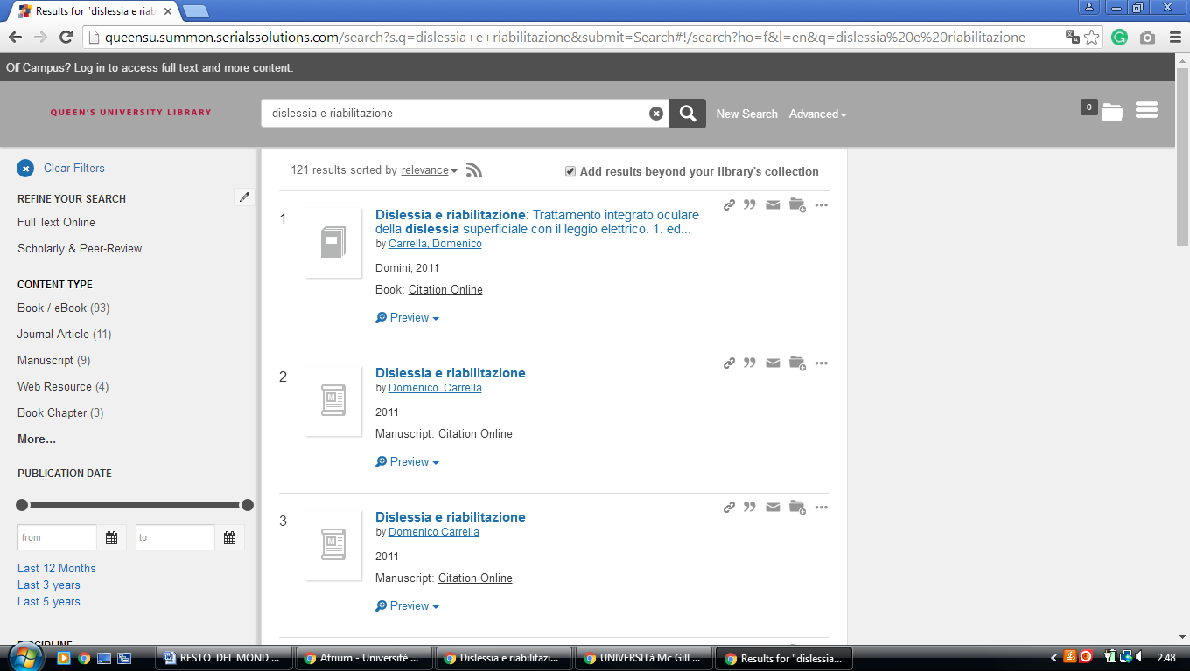

-----------------------------------------------------------------------------------------------------------------------------

23 UNB LIBRARIES, University Of New Brunswick - (Fredericton and Saint
John, NB, Canada)
https://unb.worldcat.org/title/dislessia-e-riabilitazione-trattamento-integrato-oculare-della-dislessia-superficiale-con-il-leggio-elettrico/oclc/878784487&referer=brief_results

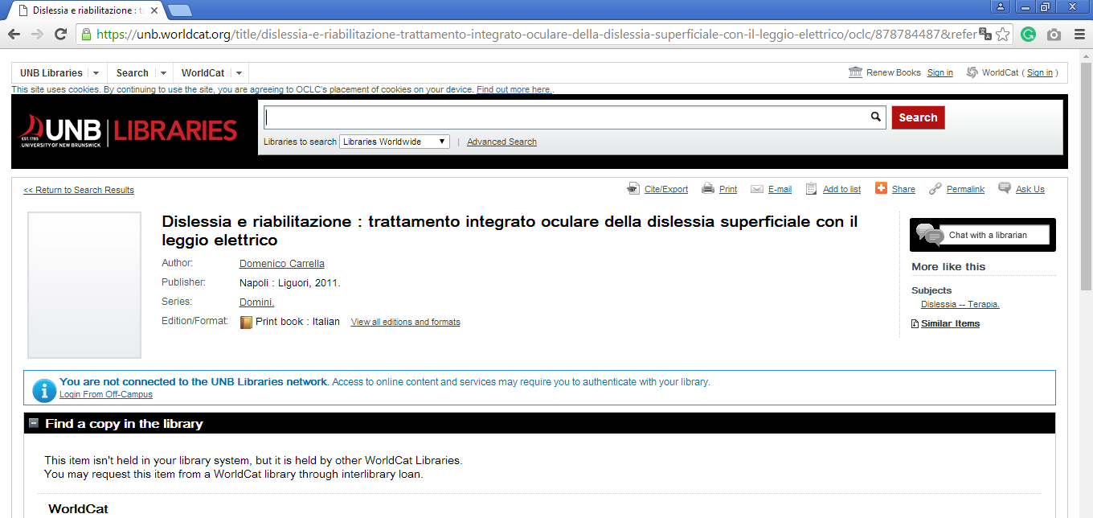

24 LIBRARIES - UNIVERSITY OF VICTORIA - UVIC – (Columbia Britannica

Canada)
http://uvic.summon.serialssolutions.com/#!/search?ho=f&l=en&q=dislessia%20e%20riabilitazione

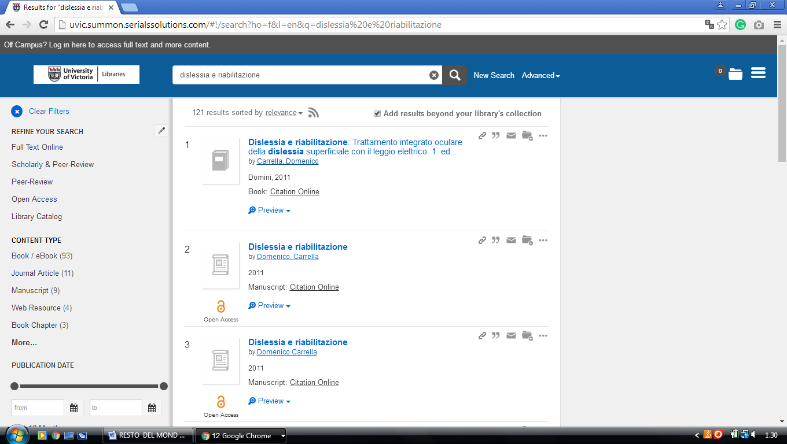

25 UNIVERSITY OF WESTERN ONTARIO LIBRARY – (Richmond St, London, Canada)
https://uwo.summon.serialssolutions.com/search?s.q=dislessia+e+riabilitazione&s.cmd=addFacetValueFilters%28ContentType%2CNewspaper+Article%3At%29&spellcheck=true&keep_r=true#!/search?ho=f&fvf=ContentType,Newspaper%20Article,t&l=en-UK&q=dislessia%20e%20riabilitazione

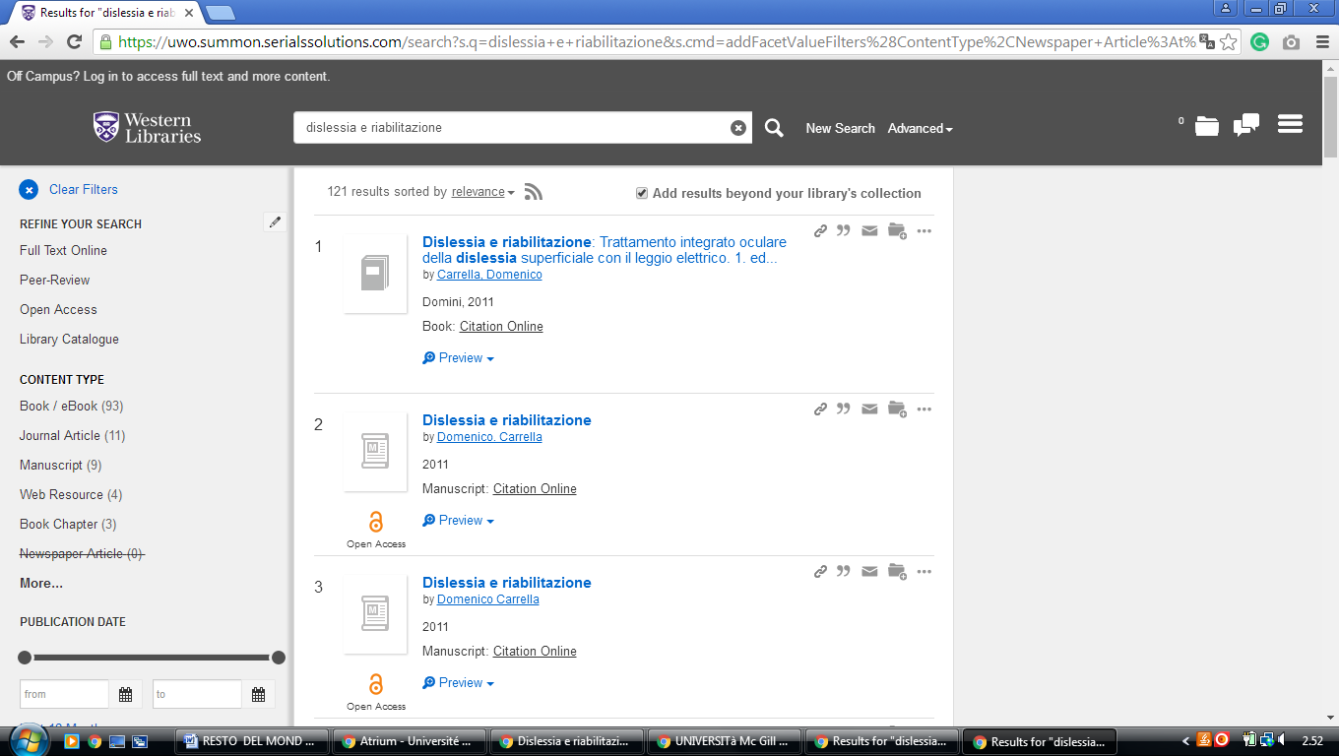

26 KINGS UNIVERSITY COLLEGE LIBRARY - (London, ON, Canada)
https://uwo.summon.serialssolutions.com/search?s.q=dislessia+e+riabilitazione&s.cmd=addFacetValueFilters%28ContentType%2CNewspaper+Article%3At%29&spellcheck=true#!/search?ho=f&fvf=ContentType,Newspaper%20Article,t&l=en-UK&q=dislessia%20e%20riabilitazione
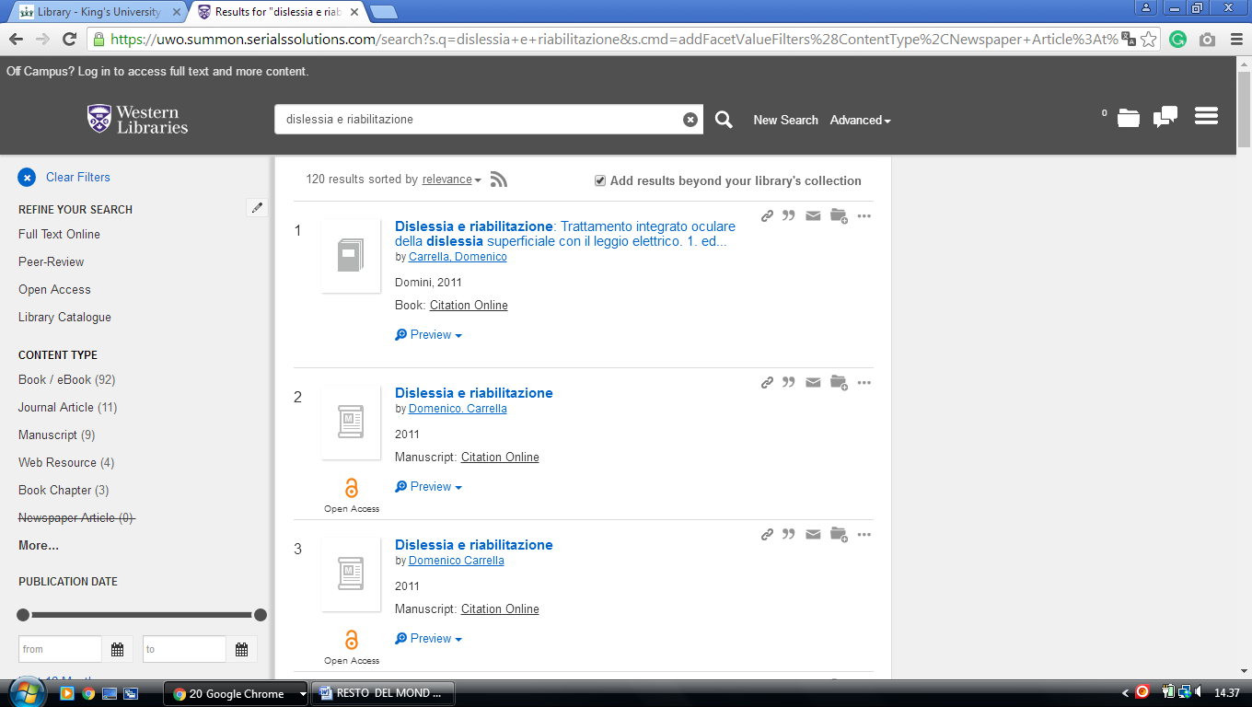

27 UNIVERSITY OF WINNIPEG LIBRARY - (Winnipeg, Manitoba, Canada)
https://uwinnipeg.on.worldcat.org/external-search?queryString=dislessia+e+riabilitazione

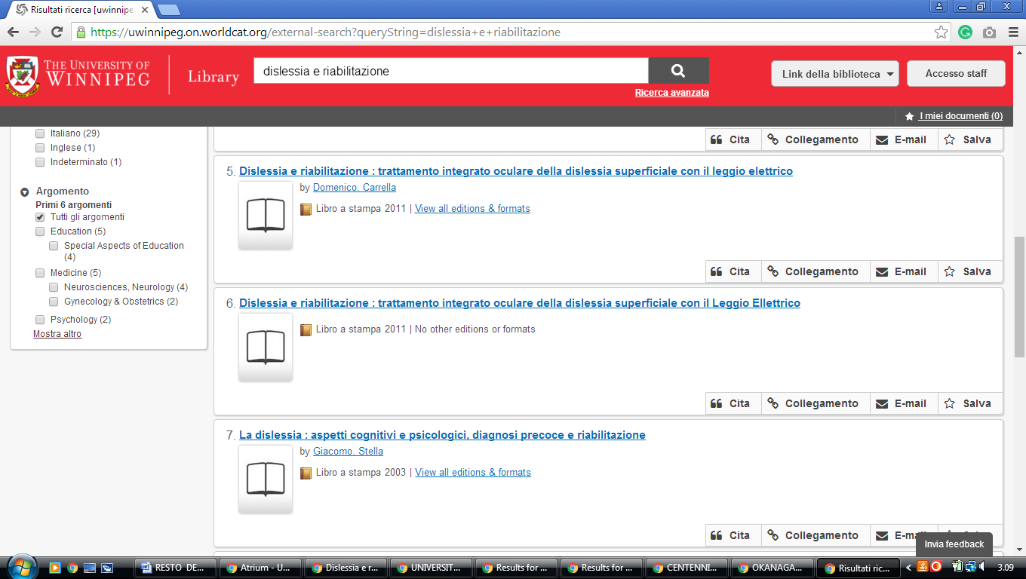

28 UNIVERSITY OF MANITOBA LIBRARIES – (Winnipeg, Manitoba, Canada)
https://www.google.it/search?q=MOHAMMED+VI+LIBRARY&rlz=1C1CHIK_itIT460IT464&oq=MOHAMMED+VI+LIBRARY&aqs=chrome..69i57.609740j0j7&sourceid=chrome&ie=UTF-8

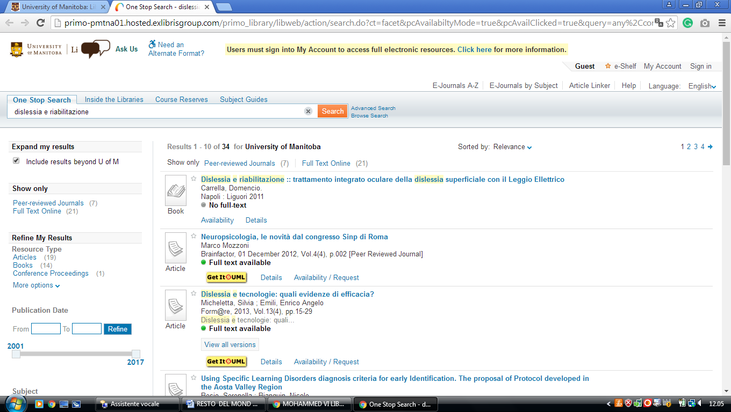

29 LIBRARY UNIVERSITY OF NEW BRUNSWICK – (Fredericton, Canada)
https://unb.on.worldcat.org/search?sortKey=&databaseList=2375%2C2572%2C3384%2C1931%2C2668%2C1953%2C1875%2C2623%2C1697%2C3336%2C2268%2C2587%2C3313%2C2267%2C1672%2C3036%2C239%2C638%2C2507%2C1834%2C2221%2C2264%2C2263%2C2262%2C1271%2C2261%2C2260%2C2281%2C1842%2C1941%2C2237%2C2259%2C2897%2C2236%2C2233%2C2277%2C1708&queryString=dislessia+e+riabilitazione&changedFacet=scope&scope=&format=all&database=all&author=all&year=all&yearFrom=&yearTo=&language=all#/oclc/941217209

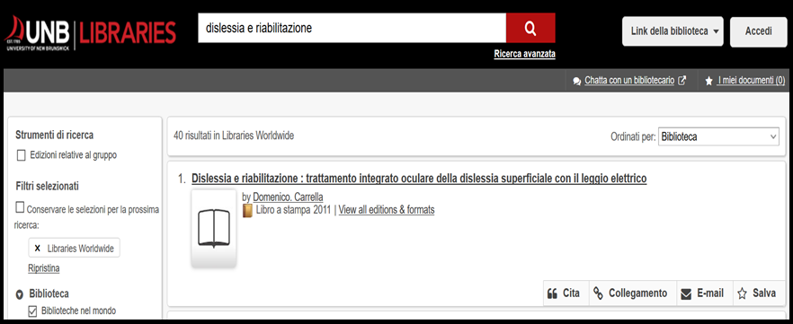

30 VAUGHAN MEMORIAL LIBRARY - (Wolfville, Nova Scotia, Canada)
https://acadiau.on.worldcat.org/search?queryString=DISLESSIA%20E%20RIABILITAZIONE&databaseList=1875,2236,1708,1719,638,1271,1834&page=1&queryType=search#/oclc/878784487

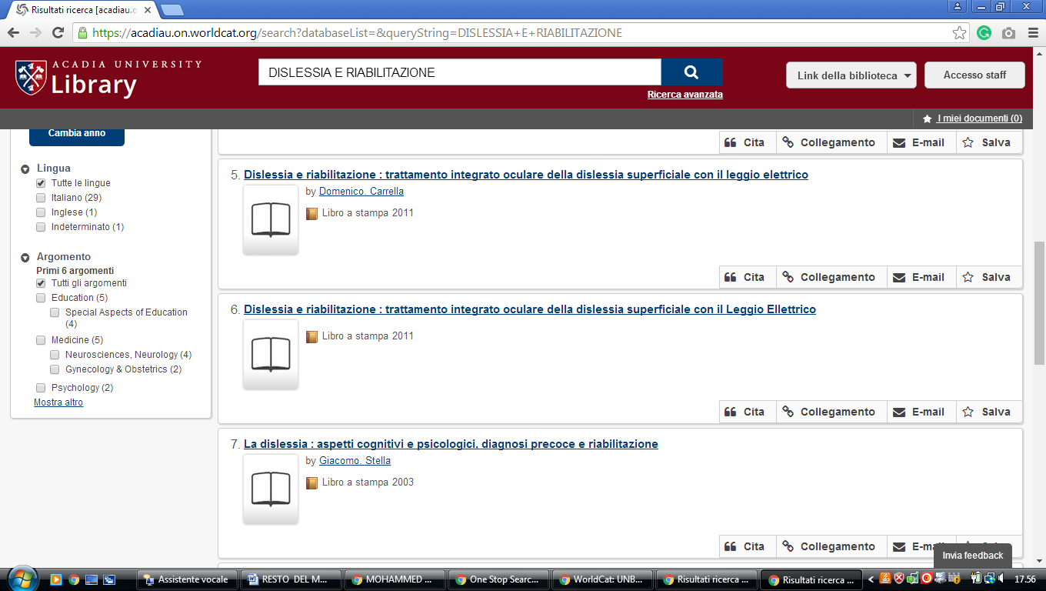

31 NATIONAL SCIENCE LIBRARY CANADA – (Ottawa, Ontario, Canada)
http://fsl-bsf.summon.serialssolutions.com/en/search?q=dislessia+e+riabilitazione&ho=t&l=en&wb-srch-sub=&fvf=SourceType%2CLibrary+Catalog%2Cf%7CLibrary%2CNRC-CNRC%2Cf#!/search?ho=f&l=en&q=dislessia%20e%20riabilitazione

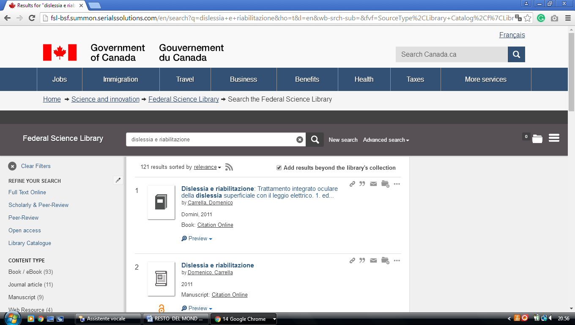

32 DOROTHY H. HOOVER LIBRARY – (Toronto, Ontario, Canada)
https://ocadu.summon.serialssolutions.com/search?q=dislessia+e+riabilitazione&submit=Search#!/search?ho=f&l=it-IT&q=dislessia%20e%20riabilitazione&submit=Search

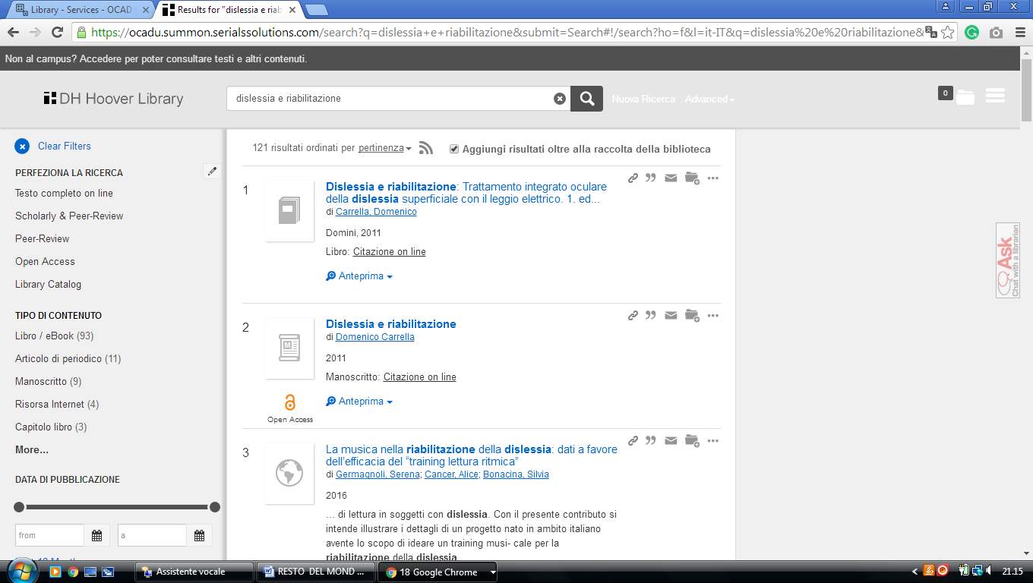

33 HUMBER LIBRARIES - HUMBER COLLEGE - (Toronto, Ontario, Canada)
http://humber.summon.serialssolutions.com/#!/search?ho=f&l=en&q=DISLESSIA%20E%20RIABILITAZIONE

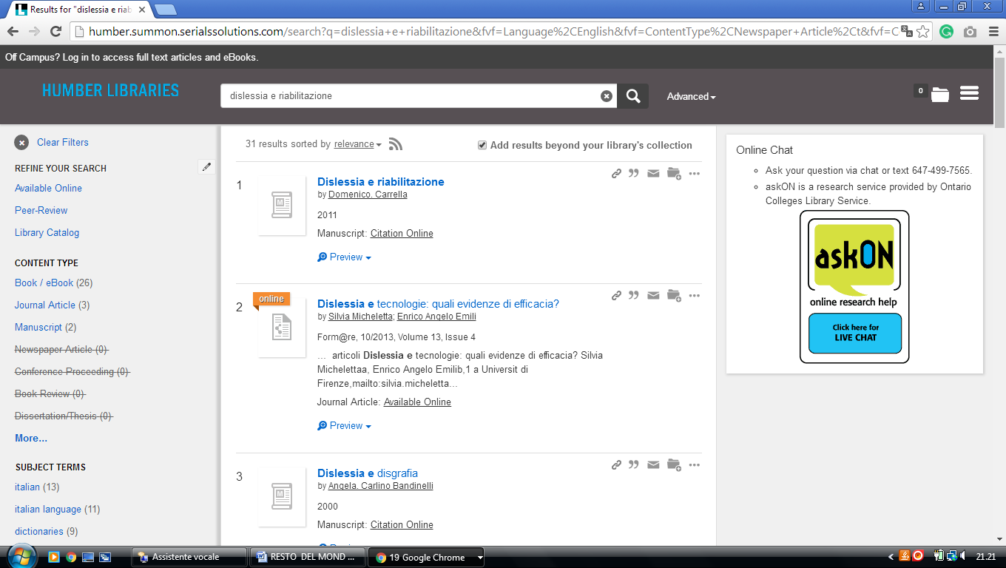

-------------------------------------------------------------------------------------------------------------------------------

34 MACODRUM LIBRARY – (Ottawa, Ontario, Canada)
https://carletonu.summon.serialssolutions.com/?q=dislessia%20e%20riabilitazione#!/search?ho=f&l=en&q=dislessia%20e%20riabilitazione

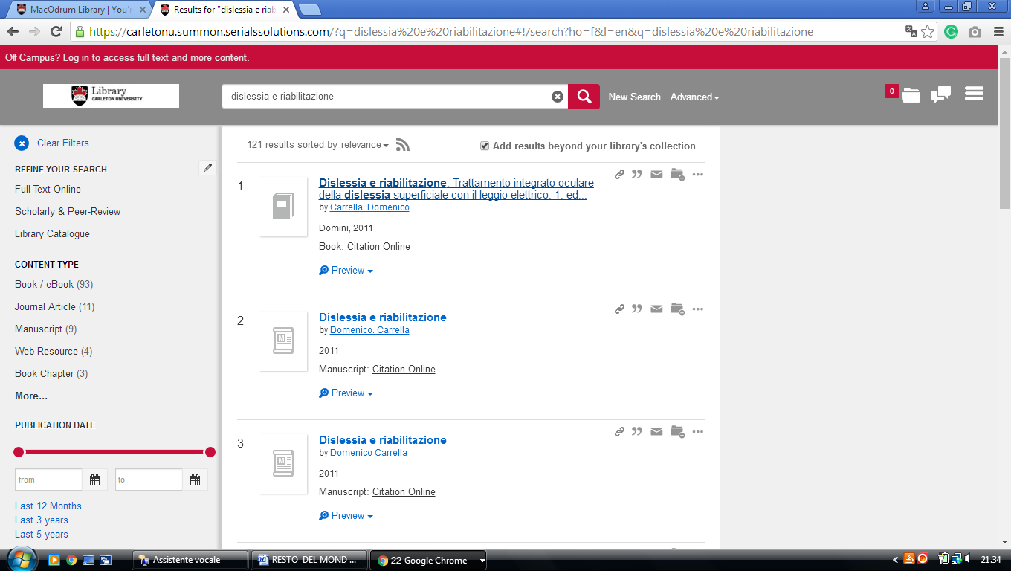

35 RYERSON UNIVERSITY LIBRARY & ARCHIVES – (Toronto, Ontario, Canada)
https://ryerson.summon.serialssolutions.com/search?q=DISLESSIA+E+RIABILITAZIONE&fvf=ContentType%2CBook+Review%2Ct&spellcheck=true#!/search?ho=f&fvf=ContentType,Book%20Review,t&l=en&q=DISLESSIA%20E%20RIABILITAZIONE

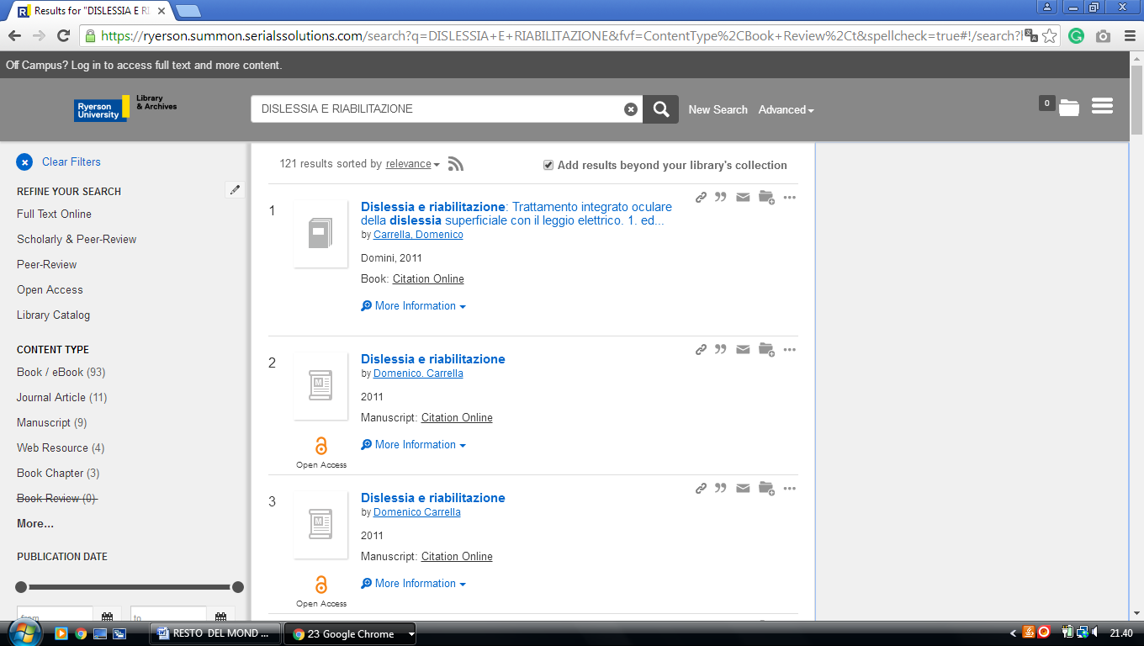

36 LIBRARY UNIVERSITY OF ONTARIO INSTITUTE OF TECHNOLOGY -(Oshawa, Ontario, Canada)
https://uoit.summon.serialssolutions.com/search?s.q=dislessia+e+riabilitazione&s.fvf%5B%5D=ContentType%2CBook+Review%2Ct&s.fvf%5B%5D=ContentType%2CNewspaper+Article%2Ct&spellcheck=true&keep_r=true#!/search?ho=f&fvf=ContentType,Book%20Review,t%7CContentType,Newspaper%20Article,t&l=en&q=dislessia%20e%20riabilitazione

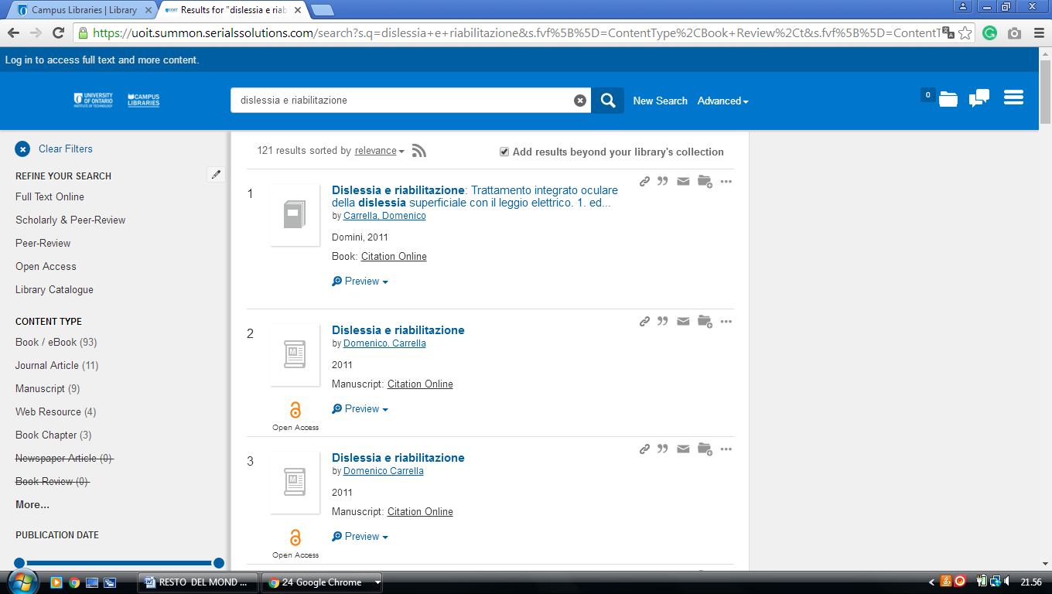

37 JOHN BASSETT MEMORIAL LIBRARY - LIBRARY - BISHOP'S UNIVERSITY
(Lennoxville, Québec, Canada)
https://ubishops.summon.serialssolutions.com/?q=dislessia+e+riabilitazione#!/search?ho=f&l=en&q=dislessia%20e%20riabilitazione

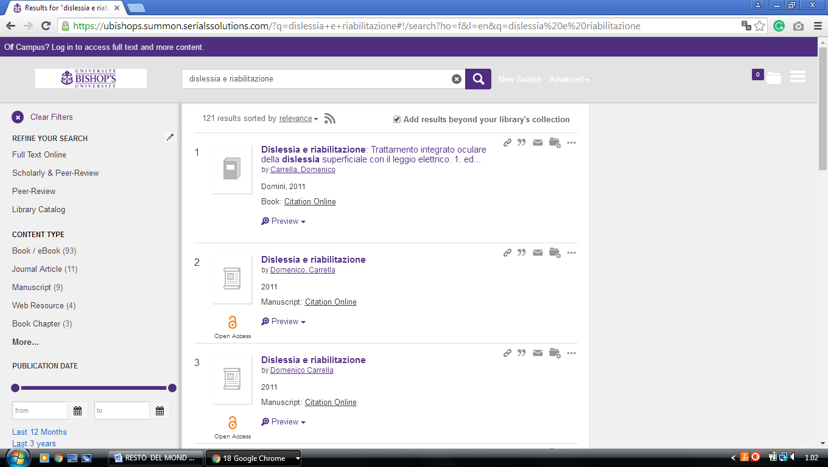

2

38 LIBRARY HEC MONTRÉAL - (Montréal , Québec, Canada)
http://hec.summon.serialssolutions.com/en/search?fvf=ContentType%2CBook+Review%2Ct%7CContentType%2CNewspaper+Article%2Ct&q=dislessia+e+riabilitazione#!/search?ho=f&fvf=ContentType,Book%20Review,t%7CContentType,Newspaper%20Article,t&l=en&q=dislessia%20e%20riabilitazione

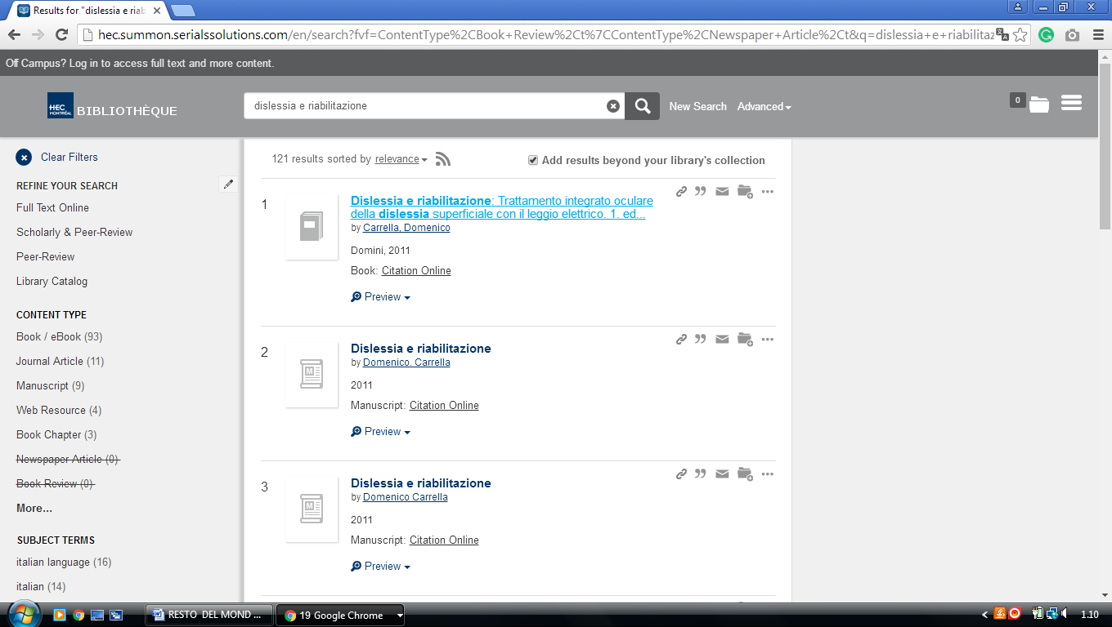

39 LIBRARY - POLYTECHNIQUE MONTRÉAL - (Québec, Canada)
https://polymtl.summon.serialssolutions.com/search?q=dislessia+e+riabilitazione&x=27&y=15&fvf=ContentType%2CBook+Review%2Ct%7CContentType%2CNewspaper+Article%2Ct#!/search?ho=f&fvf=ContentType,Book%20Review,t%7CContentType,Newspaper%20Article,t&l=fr-CA&q=dislessia%20e%20riabilitazione&x=27&y=15
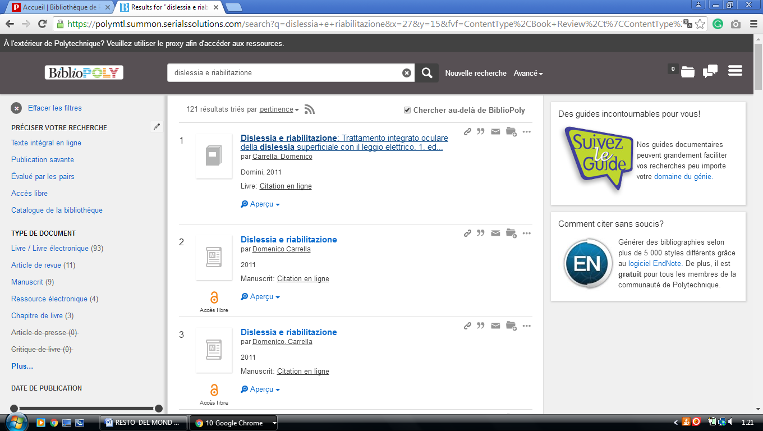

40 UNIVERSITY OF MONTRÉAL LIBRARY – (Montréal, Québec, Canada)
http://atrium.umontreal.ca/primo-explore/search?query=any,contains,DISLESSIA%20E%20RIABILITAZIONE&tab=articles&search_scope=Articles_seulement&vid=UM&lang=fr_FR&offset=0&sortby=rank&pcAvailability=true

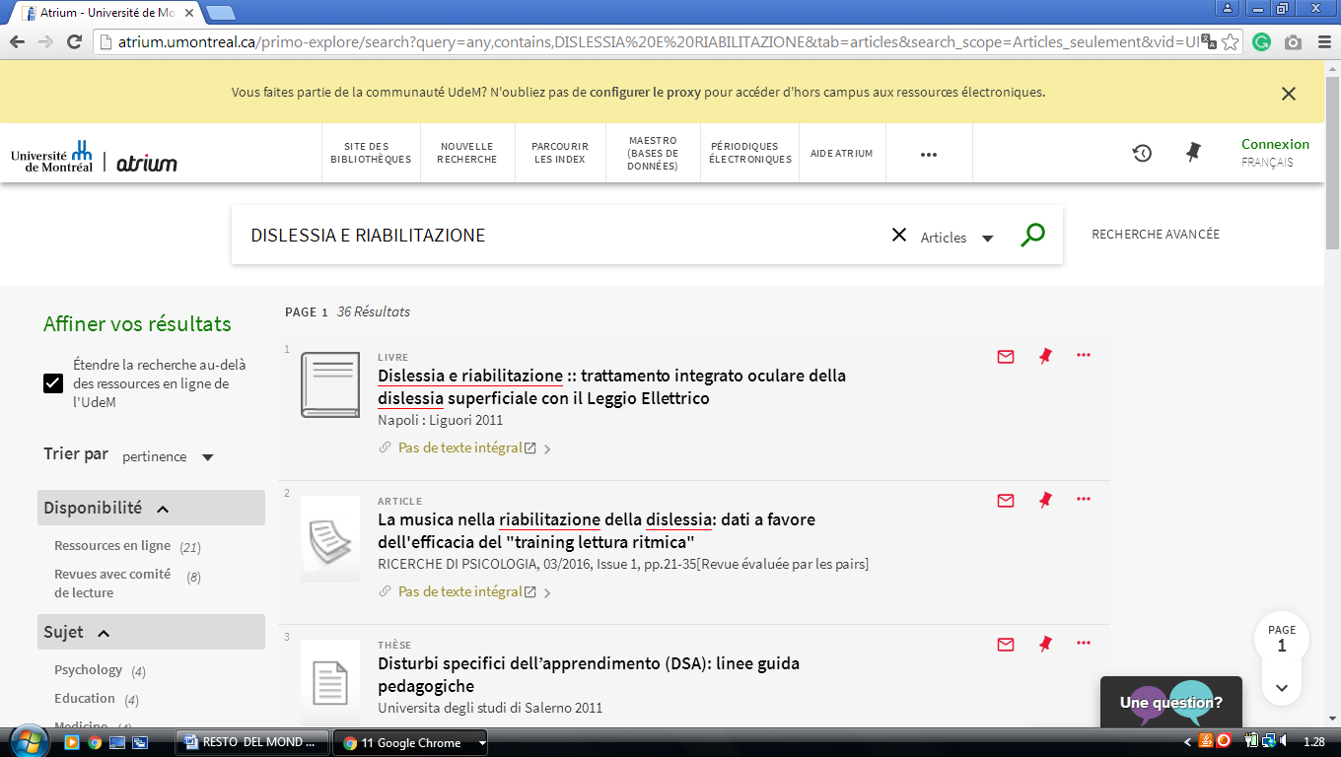

41 HEALTH SCIENCES LIBRARY MCMASTER UNIVERSITY – (Ontario Canada)
http://mcmasteruniversity.worldcat.org/search?q=dislessia%20e%20riabilitazione

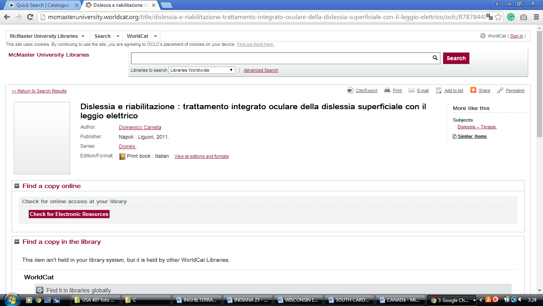

42 BIBLIOTHÈQUE HEC MONTRÉAL – (Montreal, Canada)
http://hec.summon.serialssolutions.com/?fvf=ContentType%2CBook+Review%2Ct%7CContentType%2CNewspaper+Article%2Ct&q=dislessia+e+riabilitazione#!/search?ho=f&fvf=ContentType,Book%20Review,t%7CContentType,Newspaper%20Article,t&l=fr-CA&q=dislessia%20e%20riabilitazione
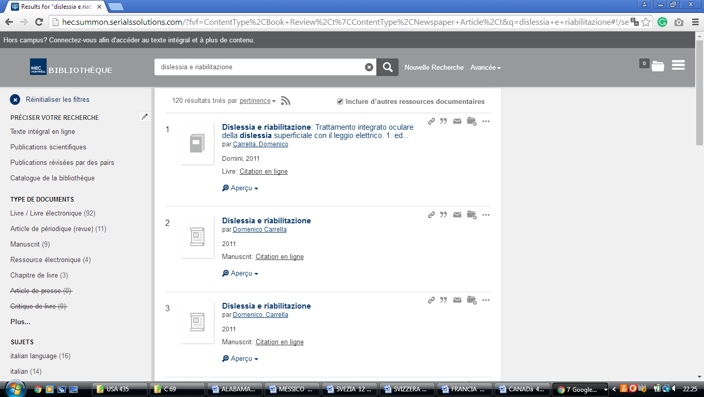

KPU Library | KPU.ca - Kwantlen Polytechnic University

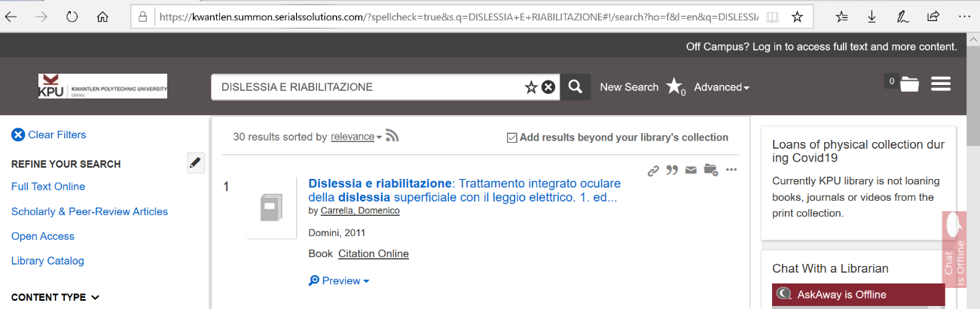

VANCOUVER ISLAND UNIVERSITY
VANCOUVER ISLAND UNIVERSITY

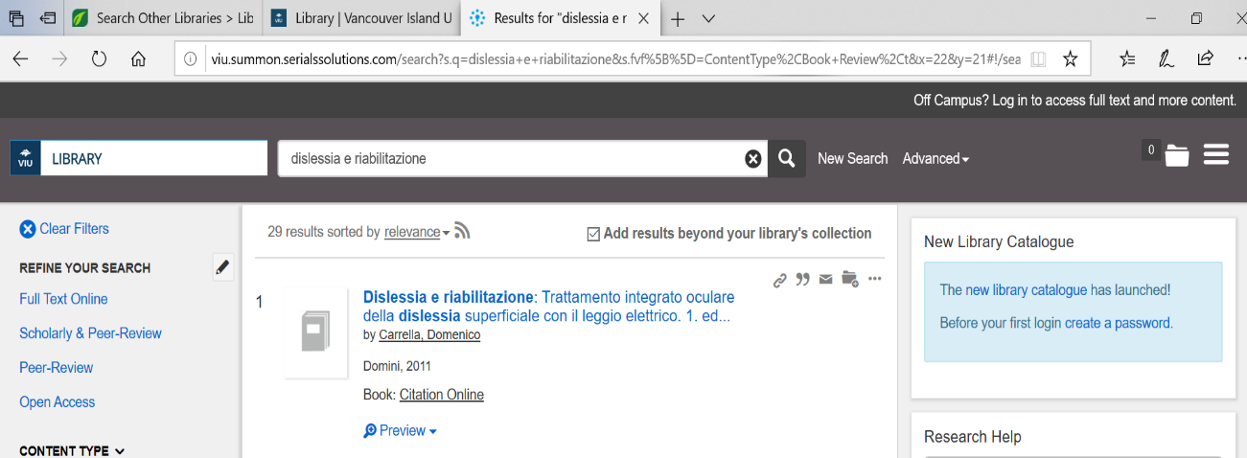
viu.summon.serialssolutions.com/

