1 Baidu (百度=Bǎidù) - (Il Più Grande Motore Di Ricerca Cinese)
http://xueshu.baidu.com/s?wd=paperuri:(0b9870f01c53503cee8ceb15bc57551f)&filter=sc_long_sign&sc_ks_para=q%3DDislessia+e+riabilitazione+%3A+trattamento+integrato+oculare+della+dislessia+superficiale+con+il+Leggio+Ellettrico&tn=SE_baiduxueshu_c1gjeupa&ie=utf-8&sc_us=641842458683849525
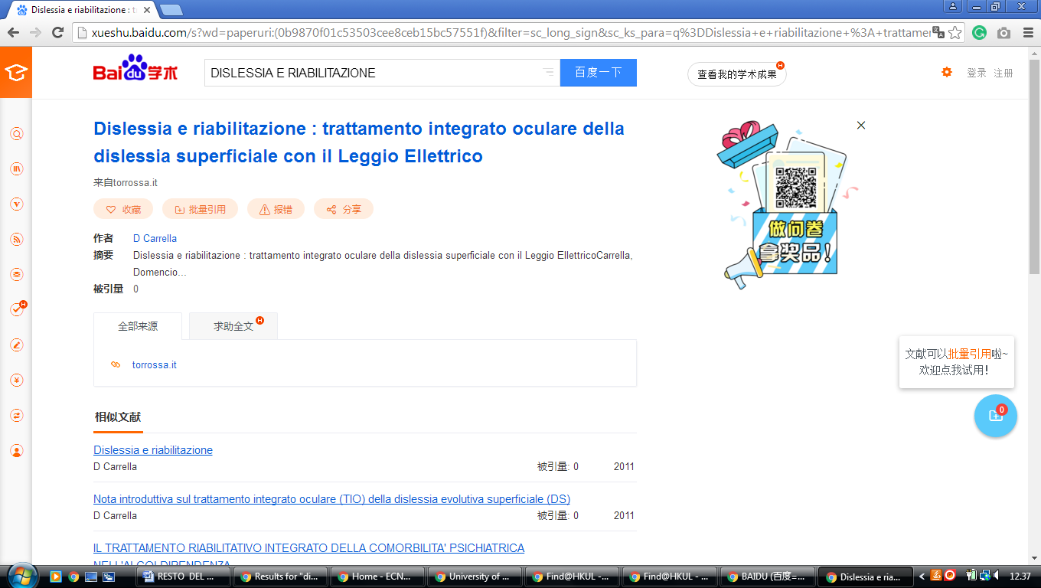

2 Lib.Shisu.Edu.Cn – (Shanghai International Studies University Library China)
http://s.lib.shisu.edu.cn/primo_library/libweb/action/dlSearch.do?institution=SHISU&vid=shisu&search_scope=default_scope&onCampus=false&group=GUEST&prefLang=en_US&query=any,contains,dislessia%20e%20riabilitazione&pcAvailabiltyMode=true&bulkSize=20
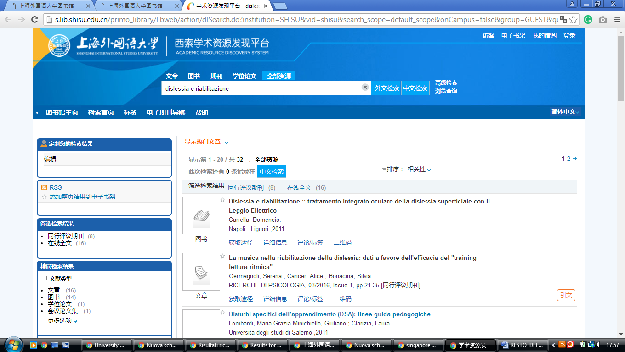

3 The Library - Peking University Library – (China)
http://pku.summon.serialssolutions.com/en/search?s.q=DISLESSIA++E+RIABILITAZIONE#!/search?ho=f&l=en&q=DISLESSIA%20%20E%20RIABILITAZIONE

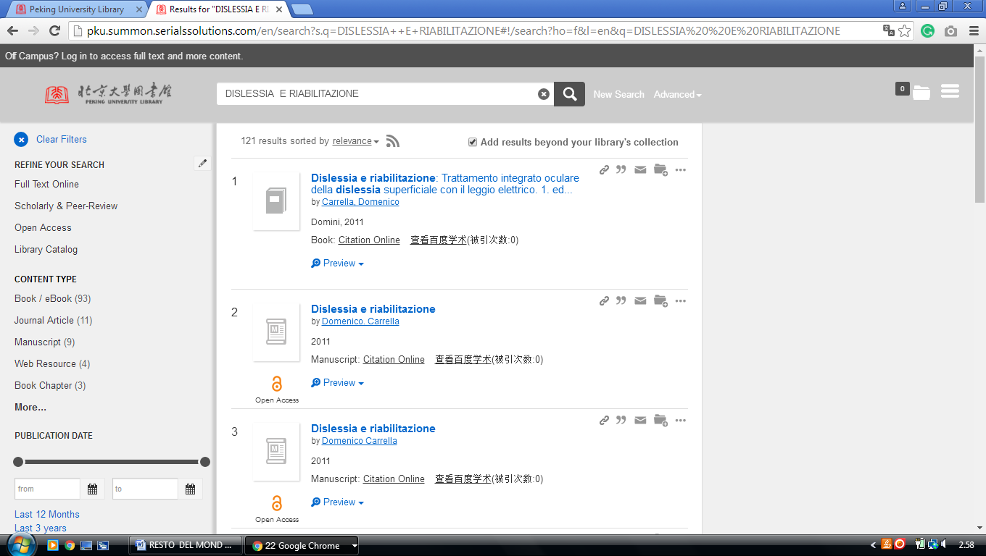
http://pku.summon.serialssolutions.com/search?s.q=dislessia+e+riabilitazione#!/search?ho=f&l=zh-CN&q=dislessia%20e%20riabilitazione
-------------------------------------------------------------------------------------------------------------------------------

4 En.Shl.Findplus.Cn – (Library Shanghai, China)
http://en.shl.findplus.cn/?h=search_list&query=DISLESSIA%20E%20RIABILITAZIONE&action[addexpander][]=fulltext

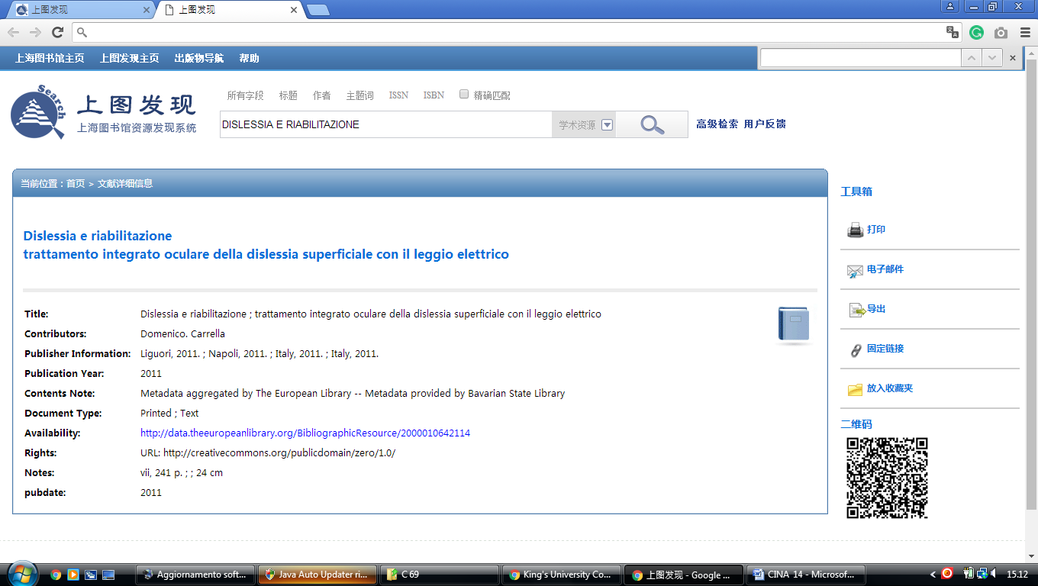

5 Library Zhejiang University – (Hangzhou, China)
http://zju.summon.serialssolutions.com/en/search?s.q=dislessia+e+riabilitazione&search_options=on#!/search?ho=f&l=en&q=dislessia%20e%20riabilitazione
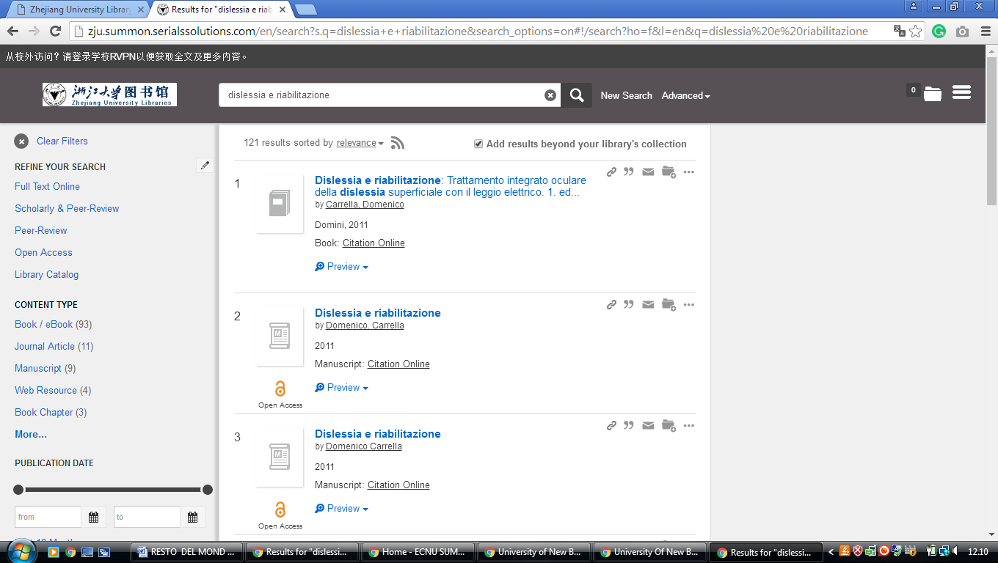

6 China University Of Geosciences Library – (Wuhan, China)
http://cug.summon.serialssolutions.com/search?but1=&q=dislessia+e+riabilitazione#!/search?ho=f&l=en&q=dislessia%20e%20riabilitazione

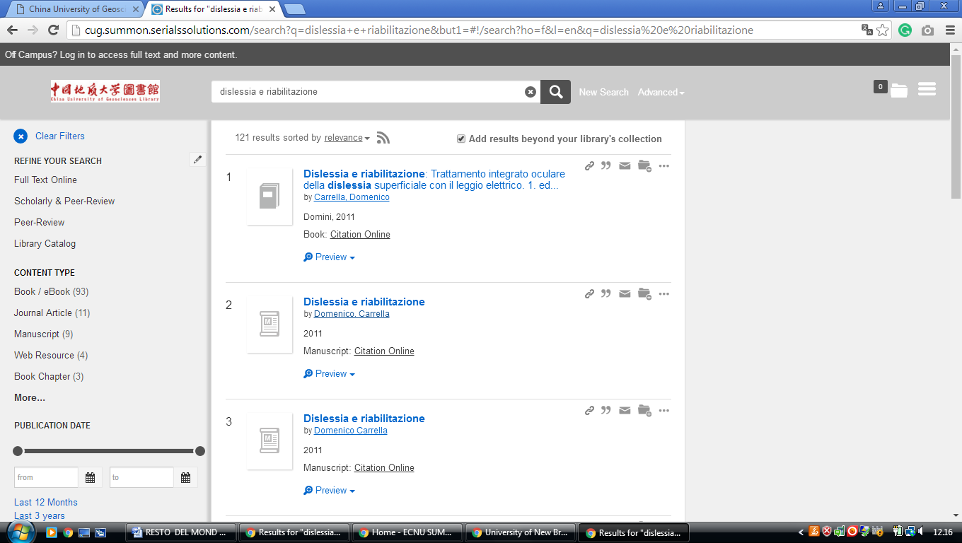

7 National Chengchi University Library – (Taipei, Republic Of China)
http://primo2.lib.nccu.edu.tw/primo_library/libweb/action/search.do;jsessionid=797CF83A842266EA7D228F0CACACA49C?vl(freeText0)=dislessia%20e%20riabilitazione&dscnt=0&tab=default&mode=Basic&vid=NCCU&fn=search&backFromPreferences=true

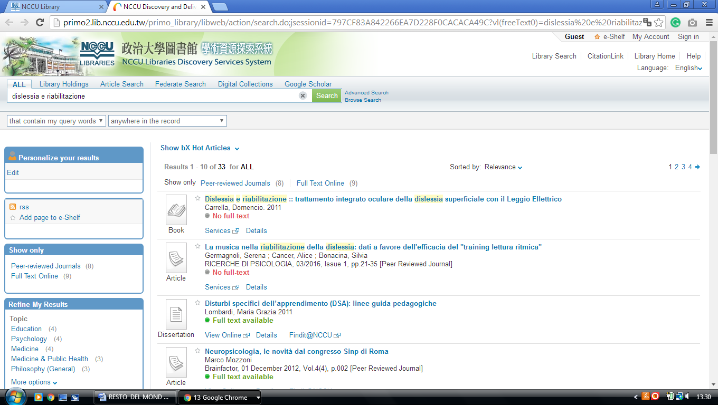

8 Chang Jung Christian University Library - (Guiren,Tainan,Taiwan China)
http://discovery.lib.cjcu.edu.tw/primo_library/libweb/action/search.do?ct=facet&pcAvailabiltyMode=true&dscnt=0&dum=true&indx=1&frbg=&tab=ils_pc&dstmp=1518079492258&srt=rank&vl(freeText0)=dislessia%20e%20riabilitazione&vid=CJCU&fn=search&mode=Basic

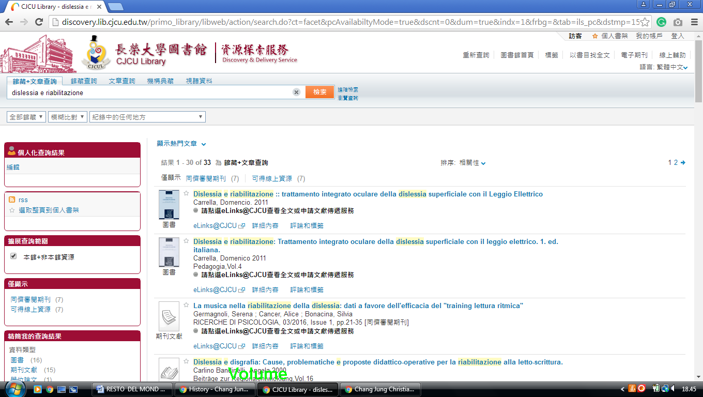

9 Shanghai International Studies University Library - 上海外国语大学, - China
http://s.lib.shisu.edu.cn/primo_library/libweb/action/dlSearch.do?institution=SHISU&vid=shisu&search_scope=default_scope&onCampus=false&group=GUEST&prefLang=en_US&query=any,contains,dislessia%20e%20riabilitazione&pcAvailabiltyMode=true&bulkSize=20

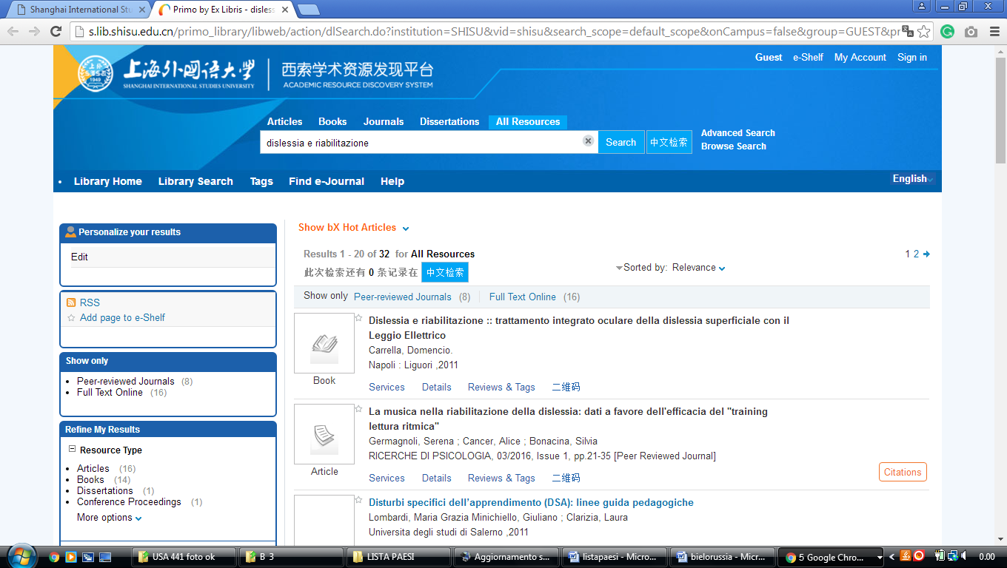

10 Tsinghua University Library - China
https://tsinghua-primo.hosted.exlibrisgroup.com/primo-explore/search?query=any,contains,dislessia%20e%20riabilitazione&tab=default_tab&search_scope=default_scope&vid=86THU&lang=en_US&offset=0&sortby=rank&pcAvailability=true
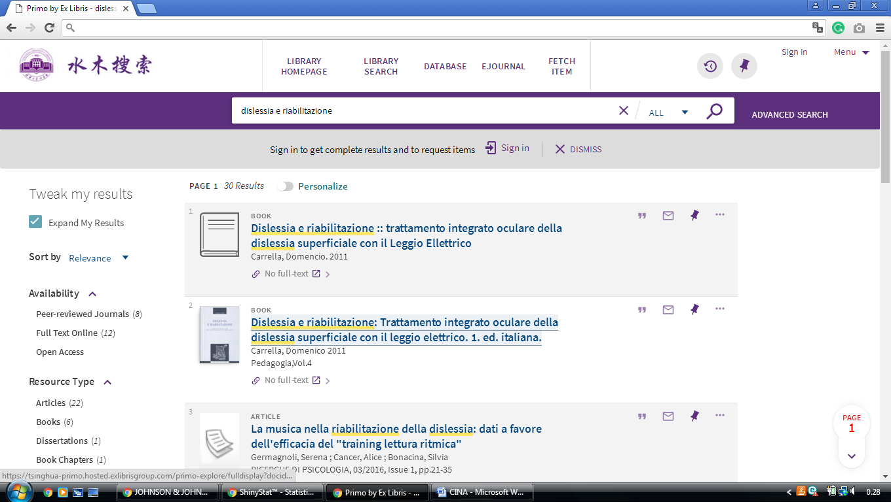

11 Http://En.Cmu.Findplus.Cn
http://en.cmu.findplus.cn/?h=search_list&query=dislessia+e+riabilitazione&action[addexpander][]=fulltext
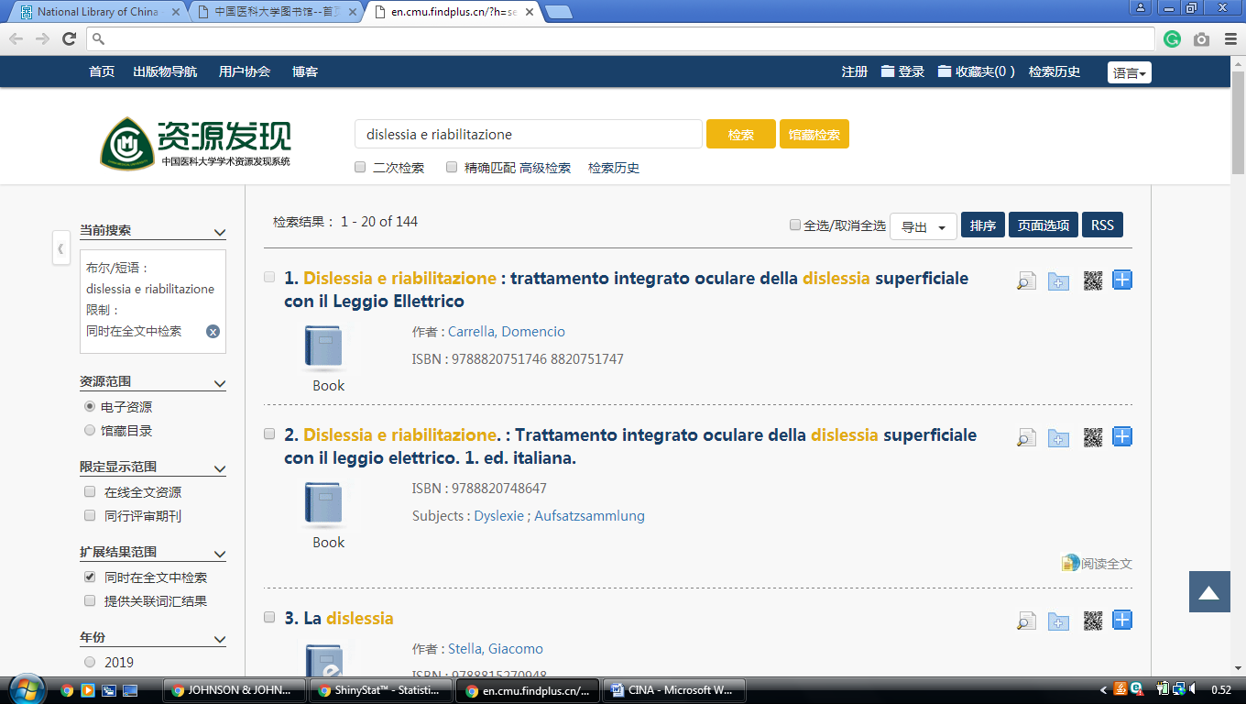

12 Northeast Forestry University Library
http://nefu.summon.serialssolutions.com/search?s.q=dislessia+e+riabilitazione#!/search?ho=f&l=zh-CN&q=dislessia%20e%20riabilitazione

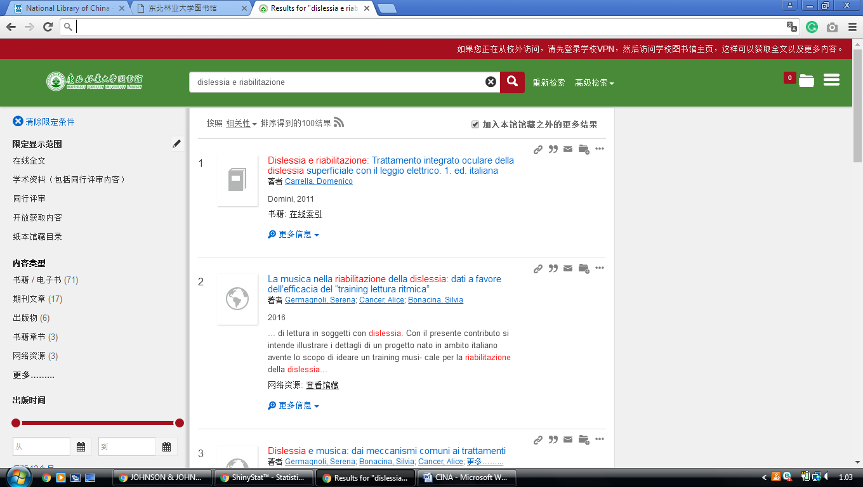


13 Fudan University Library Resource Discovery Sistem
http://discovery.fudan.edu.cn/primo_library/libweb/action/search.do?fn=search&ct=search&initialSearch=true&mode=Basic&tab=digital_tab&indx=1&dum=true&srt=rank&vid=fdu&frbg=&tb=t&vl%28freeText0%29=++DISLESSIA+E+RIABILITAZIONE&scp.scps=ZhiZhenArticle%2Cprimo_central_multiple_fe
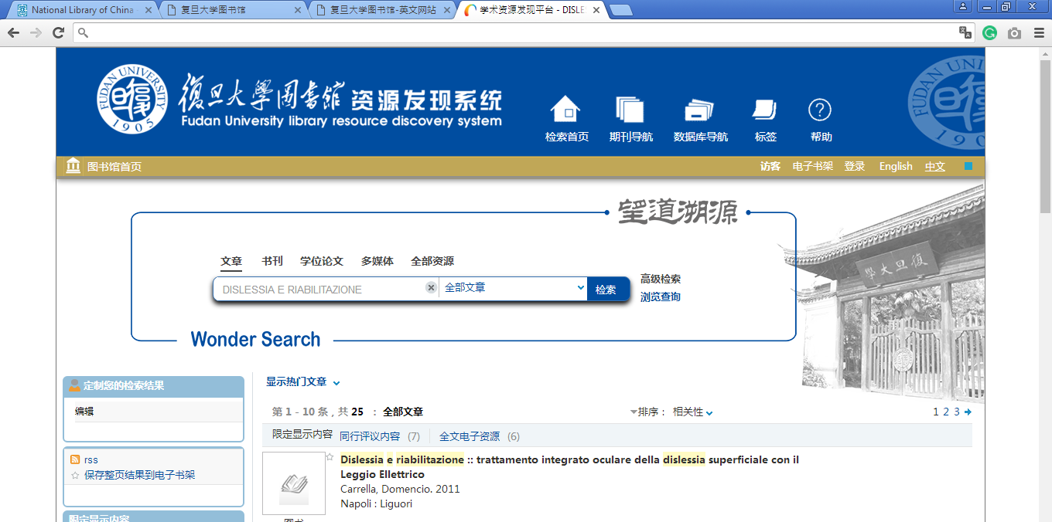

14 South China University Of Tecnology
http://scut.summon.serialssolutions.com/search?s.q=dislessia+e+riabilitazione#!/search?ho=f&l=zh-CN&q=dislessia%20e%20riabilitazione

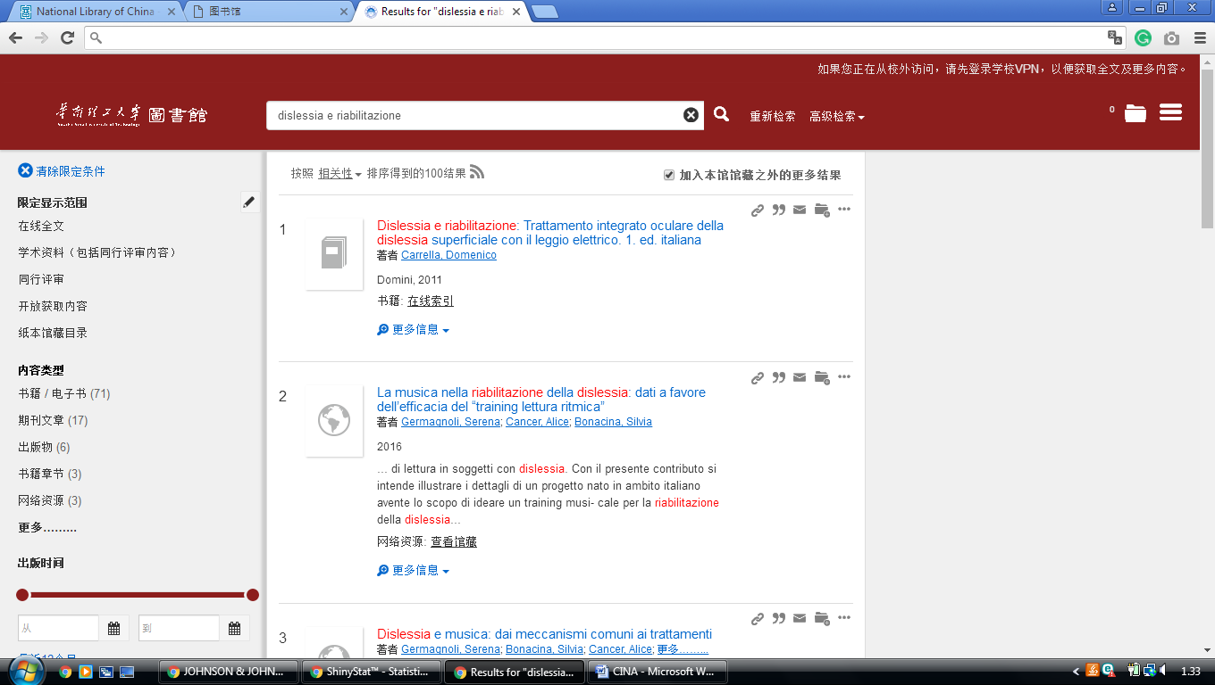

15 China Università Of Geosciences Library
http://cug.summon.serialssolutions.com/search?pn=1&ho=t&l=za&q=dislessia+e+riabilitazione#!/search?ho=f&l=za&q=dislessia%20e%20riabilitazione
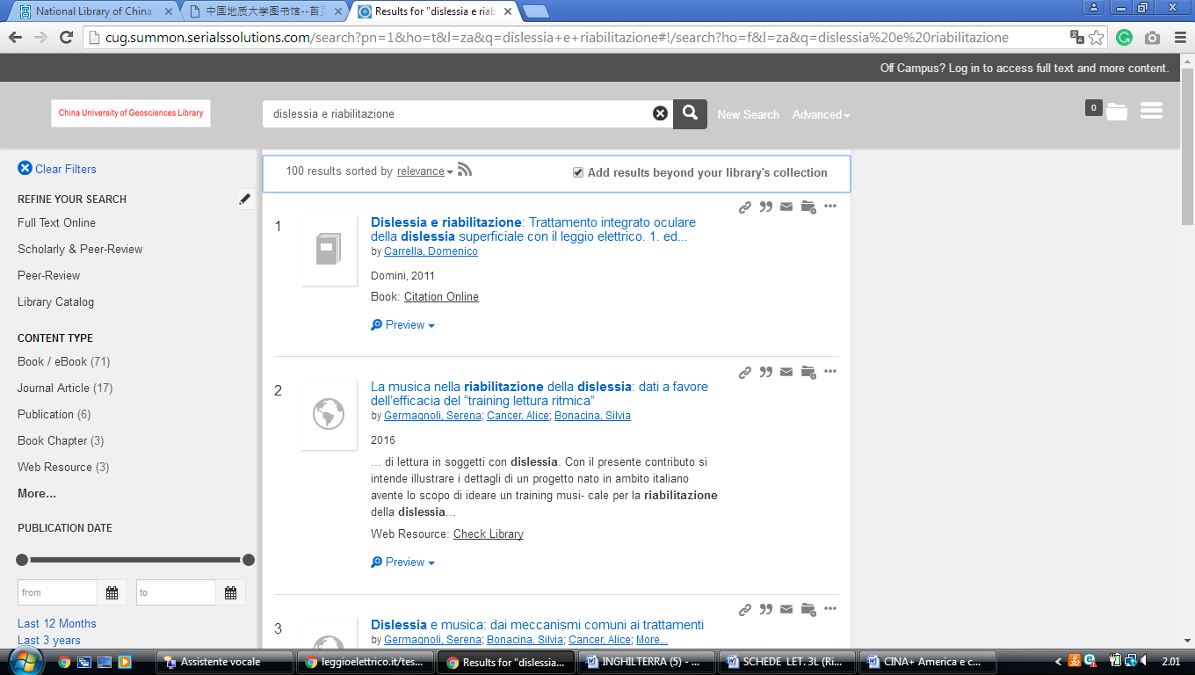

16 Sichuan University Library
http://discovery.scu.edu.cn/primo-explore/search?query=any,contains,dislessia%20e%20riabilitazione&tab=all_tab&search_scope=all_resource&sortby=rank&vid=scu2&lang=zh_CN&offset=0
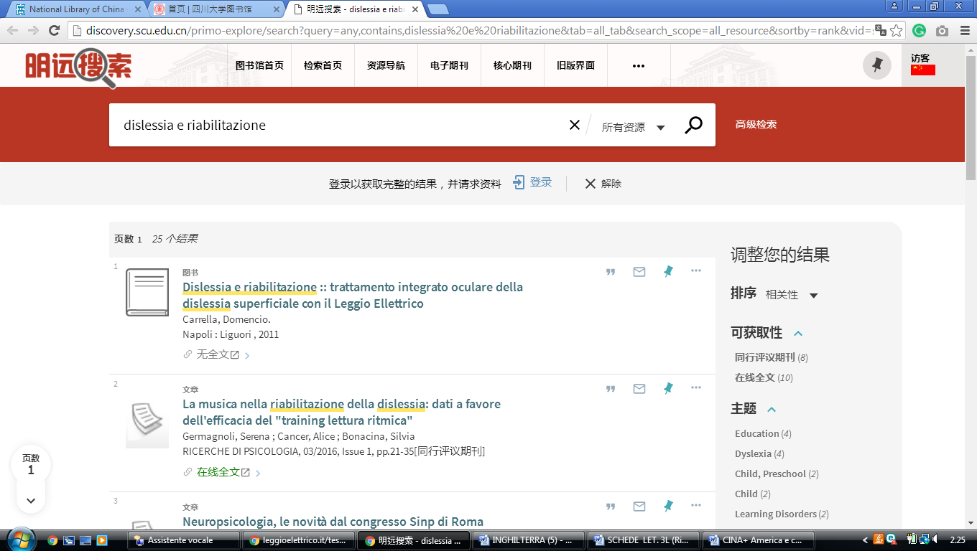

17 Library Of China University Of Geosciences
http://cug.summon.serialssolutions.com/search?pn=1&ho=t&l=za&q=dislessia+e+riabilitazione#!/search?ho=f&l=za&q=dislessia%20e%20riabilitazione

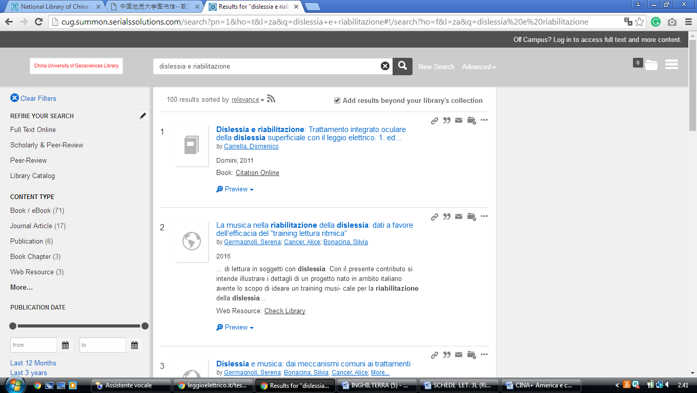

18 Tongji University Library
http://tongji.summon.serialssolutions.com/zh-CN/search?s.q=dislessia%20e%20riabilitazione#!/search?ho=f&l=zh-CN&q=dislessia%20e%20riabilitazione

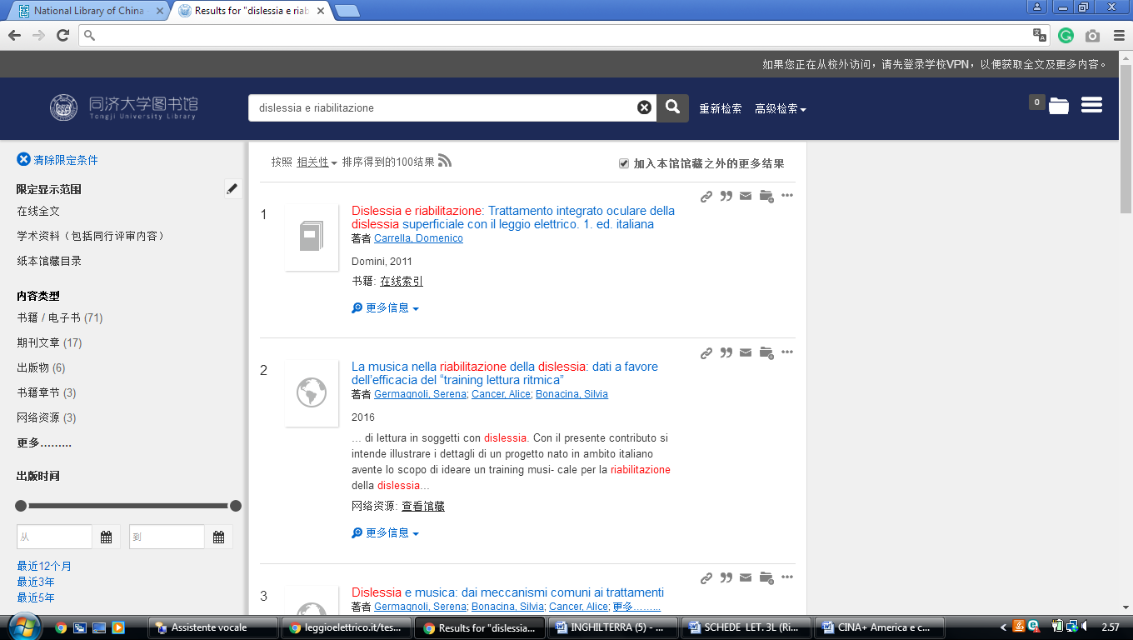

19 Soochow University Library
http://suda.summon.serialssolutions.com/search?s.q=dislessia%20e%20riabilitazione#!/search?ho=f&l=zh-CN&q=dislessia%20e%20riabilitazione

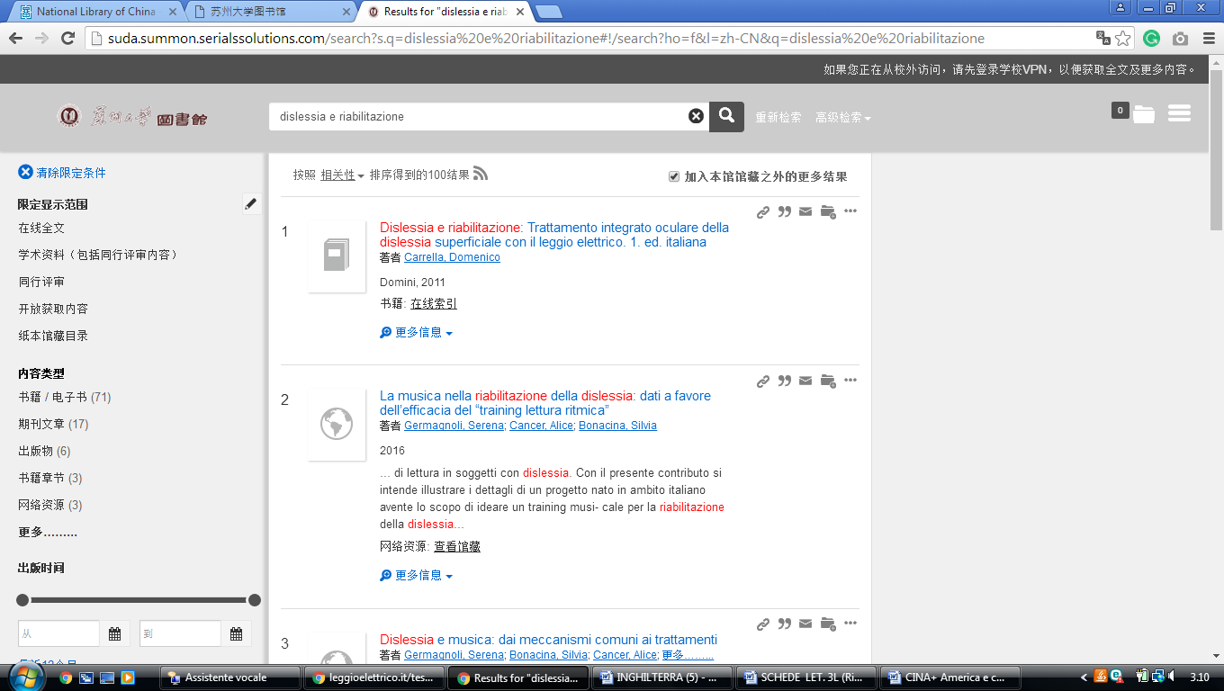

20 Shandong University Library
https://sducn.summon.serialssolutions.com/#!/search?ho=f&l=zh-CN&q=dislessia%20e%20riabilitazione

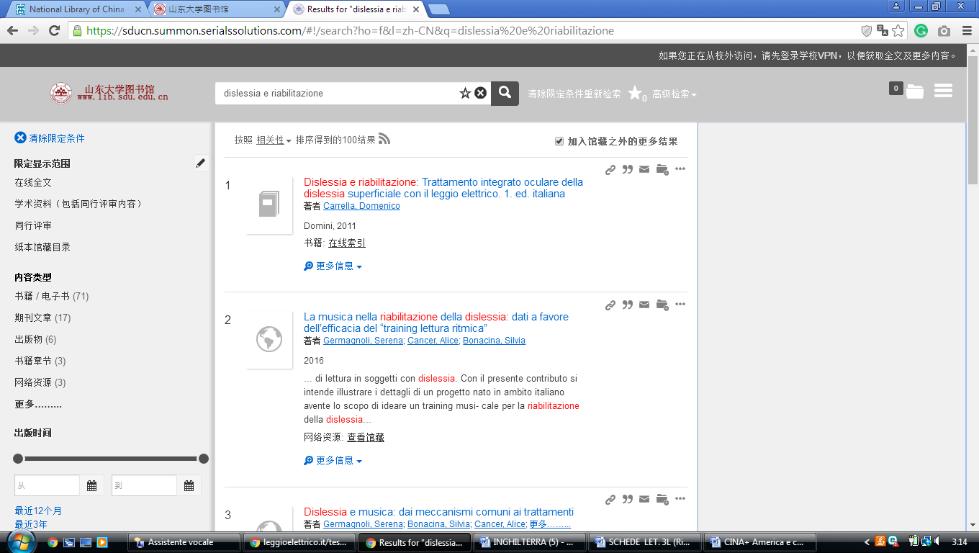

21 The Library of Shandong Normal University
https://sdnu.summon.serialssolutions.com/search?s.q=dislessia+e+riabilitazione#!/search?ho=f&l=zh-CN&q=dislessia%20e%20riabilitazione

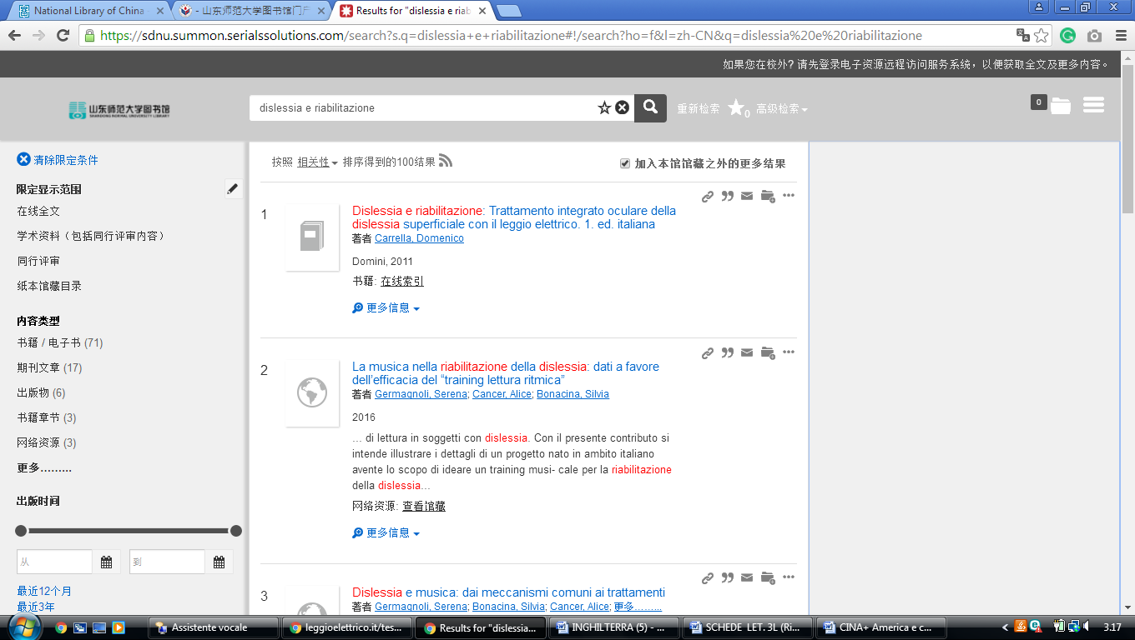

22 Huazhong Agricultural University Library
http://eds.b.ebscohost.com/eds/results?vid=0&sid=07d9226a-590c-440e-804c-beb196e01e76%40pdc-v-sessmgr01&bquery=dislessia%2Be%2Briabilitazione&bdata=Jmxhbmc9emgtY24mdHlwZT0wJnNlYXJjaE1vZGU9QW5kJnNpdGU9ZWRzLWxpdmU%3d

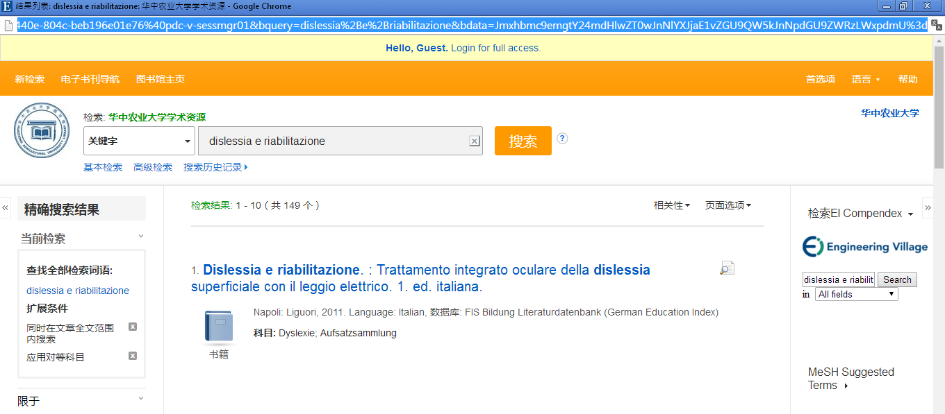

23 Lanzhou University Library
http://lzu.summon.serialssolutions.com/search?s.q=dislessia+e+riabilitazione#!/search?ho=f&l=zh-CN&q=dislessia%20e%20riabilitazione

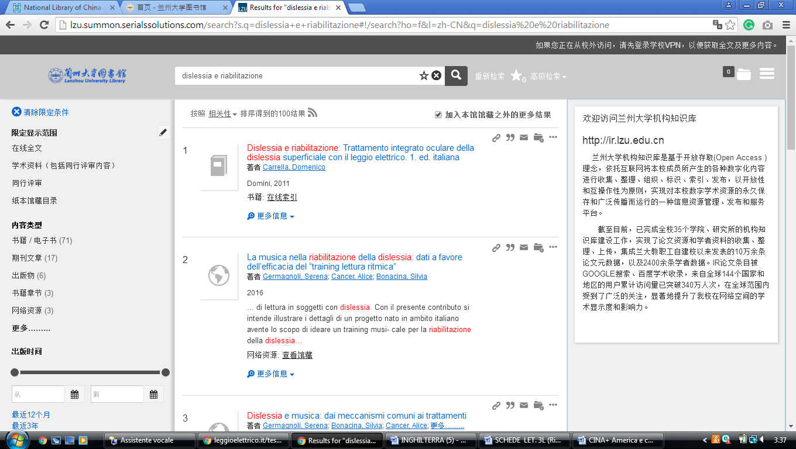

24 Sichuan Normal University Library
http://sicnu.summon.serialssolutions.com/search?s.q=dislessia+e+riabilitazione#!/search?ho=f&l=en&q=dislessia%20e%20riabilitazione

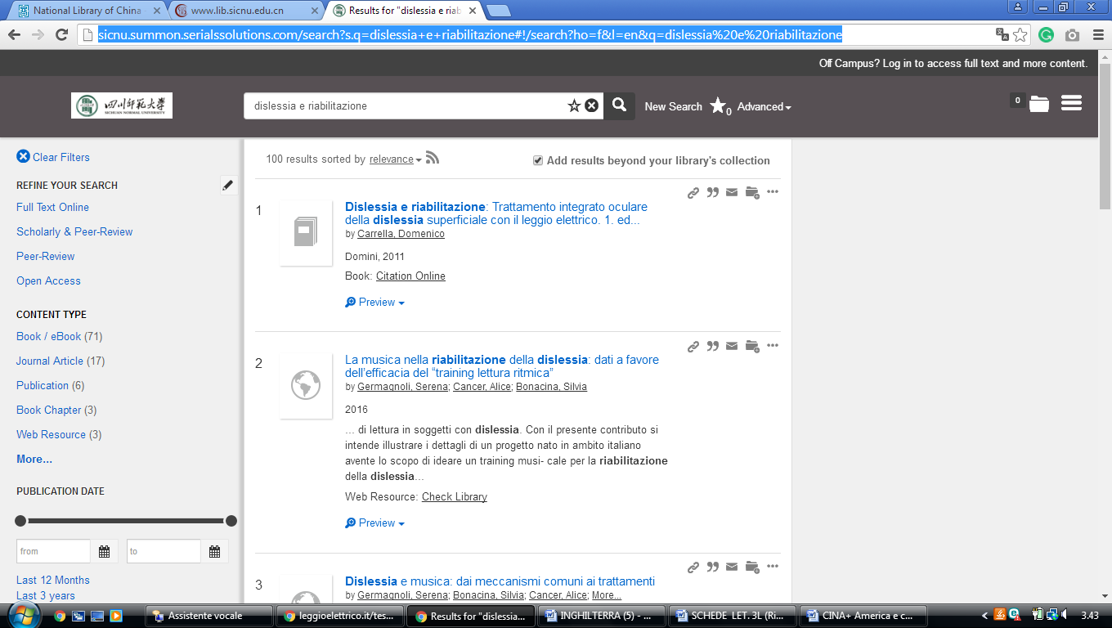

25 Heilongjiang University Library
http://china-3.summon.serialssolutions.com/search?ho=t&l=en&q=dislessia+e+riabilitazione#!/search?ho=f&l=en&q=dislessia%20e%20riabilitazione

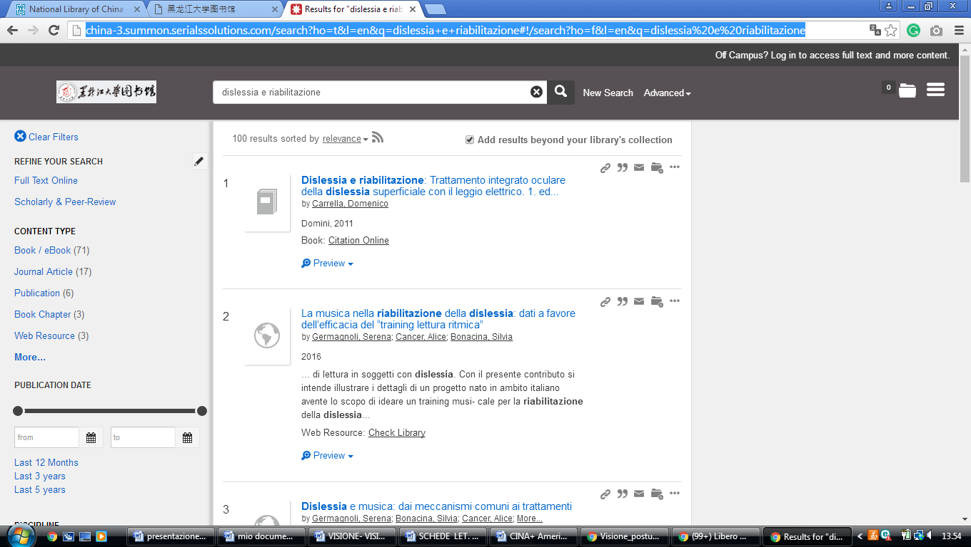

26 Harbin Institute of Technology Library
http://eds.b.ebscohost.com/eds/results?vid=0&sid=e49051ea-3cae-45c8-91fc-2dd2bc1e9b66%40sessionmgr102&bquery=dislessia%2Be%2Briabilitazione&bdata=Jmxhbmc9emgtY24mdHlwZT0wJnNlYXJjaE1vZGU9QW5kJnNpdGU9ZWRzLWxpdmU%3d
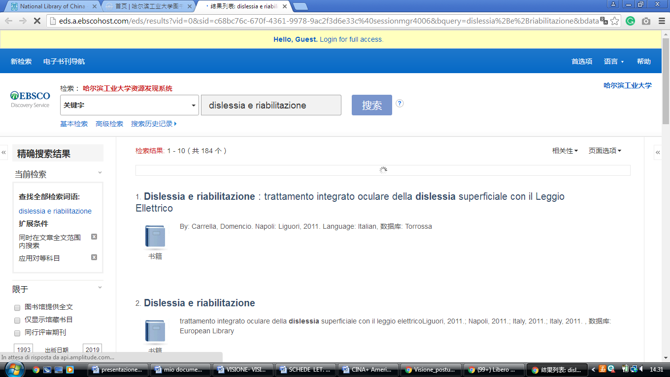

27 Tianjin Normal University Library
http://en.tjnu.findplus.cn/?h=search_list&query=dislessia%20e%20riabilitazione&action[addexpander][]=fulltext
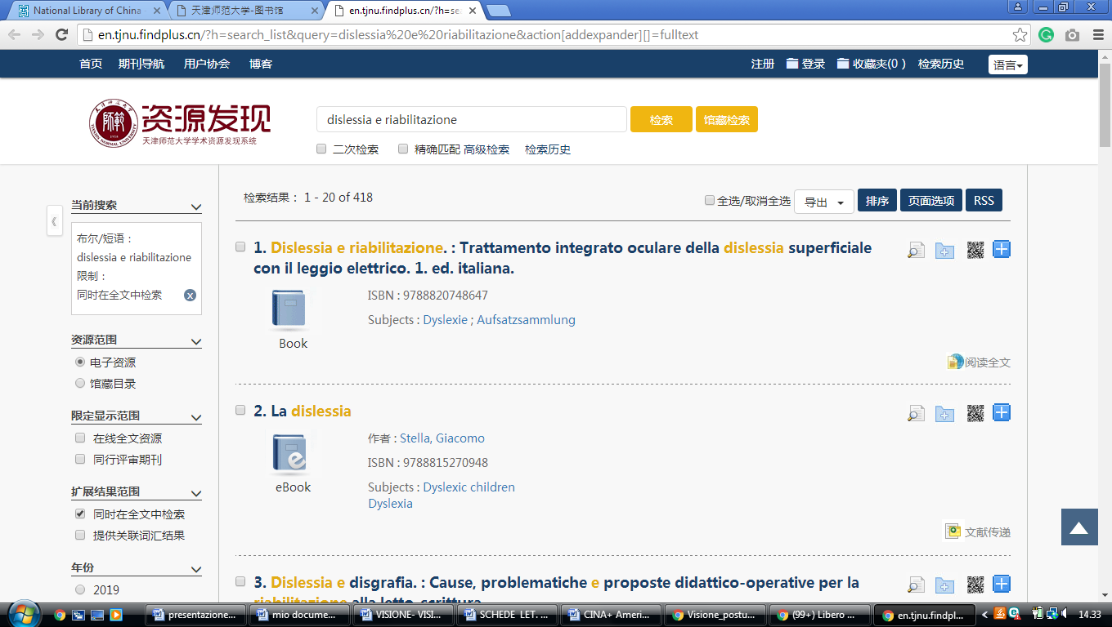

27 South China Agricultural University Library
http://scau.summon.serialssolutions.com/search?s.q=dislessia%20e%20riabilitazione#!/search?ho=f&l=zh-CN&q=dislessia%20e%20riabilitazione

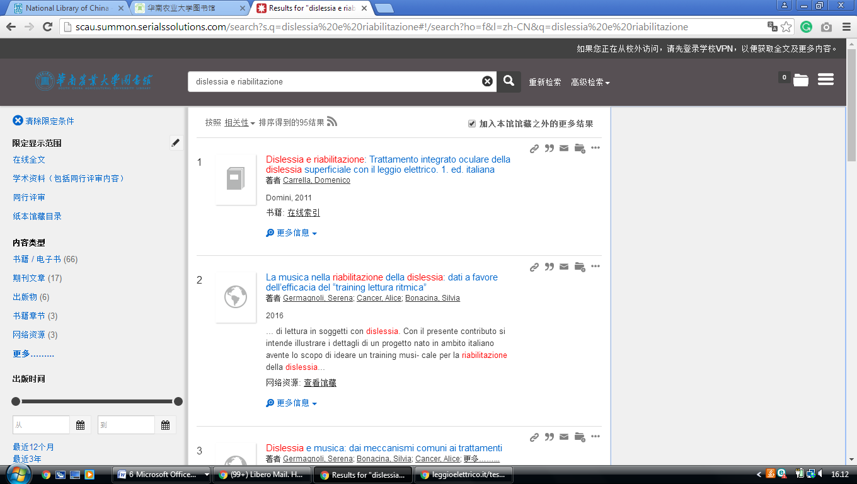

28 Seton Hall University Libraries
https://setonhall.worldcat.org/search?q=dislessia+e+riabilitazione&qt=notfound_page&scope=0&oldscope=2&search=Chercher
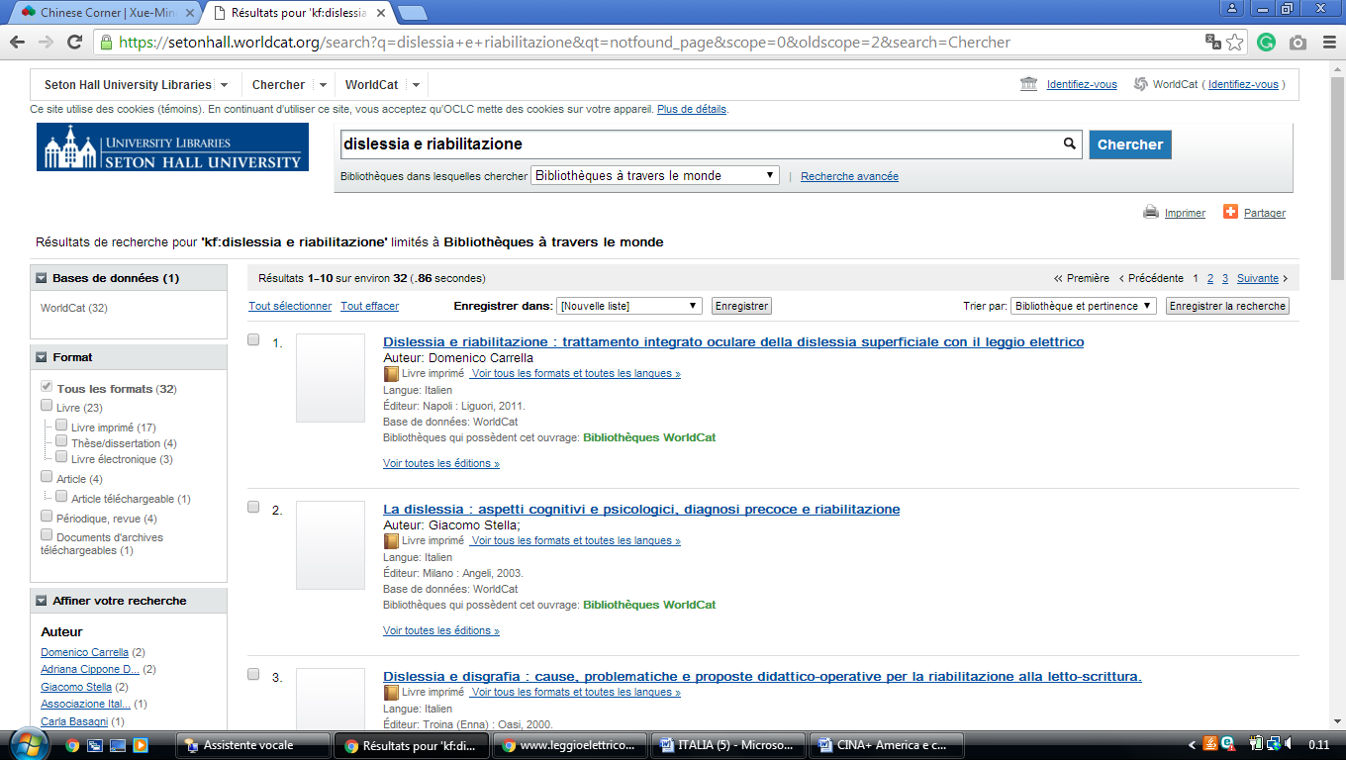

29 The Medical Library Of Shanghai Jiao Tong University
http://xueshu.baidu.com/usercenter/paper/show?paperid=d30858067c08627b6134cab38ca7534e&site=xueshu_se&hitarticle=1

http://xueshu.baidu.com/s?wd=dislessia+e+riabilitazione

http://xueshu.baidu.com/s?wd=dislessia+e+riabilitazione&rsv_bp=0&tn=SE_baiduxueshu_c1gjeupa&rsv_spt=3&ie=utf-8&f=8&rsv_sug2=1&sc_f_para=sc_tasktype%3D%7BfirstSimpleSearch%7D
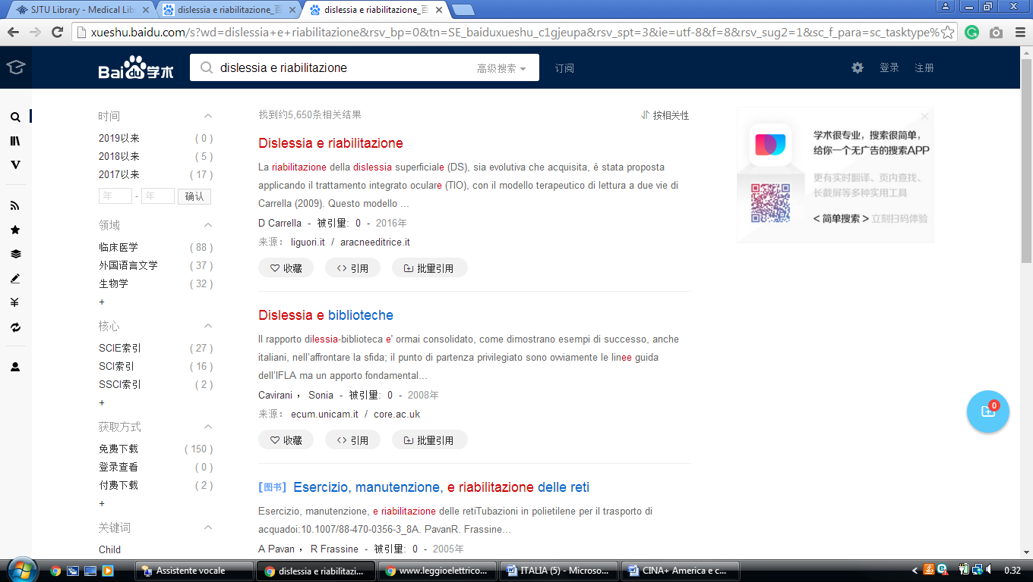

30 University of Macau (CINA)
https://umac-primo.hosted.exlibrisgroup.com/primo-explore/search?institution=853UOM&vid=853UOM&tab=default_tab&search_scope=default_scope&mode=basic&displayMode=full&bulkSize=10&highlight=true&dum=true&query=any,contains,dislessia%20e%20riabilitazione&displayField=all&pcAvailabiltyMode=true&sortby=rank&lang=en_US&pcAvailability=true

