1 SISTEMA DE BIBLIOTECAS - ESPAÑOL - UNIVERSIDAD DE LOS ANDES
(Bogotá, Colombia)
https://univdelosandes.on.worldcat.org/search?sortKey=LIBRARY&databaseList=&queryString=kw%3ADISLESSIA+E+RIABILITAZIONE&changedFacet=scope&scope=&scope=wz%3A34246&format=all&database=all&author=all&year=all&yearFrom=&yearTo=#/oclc/941217209

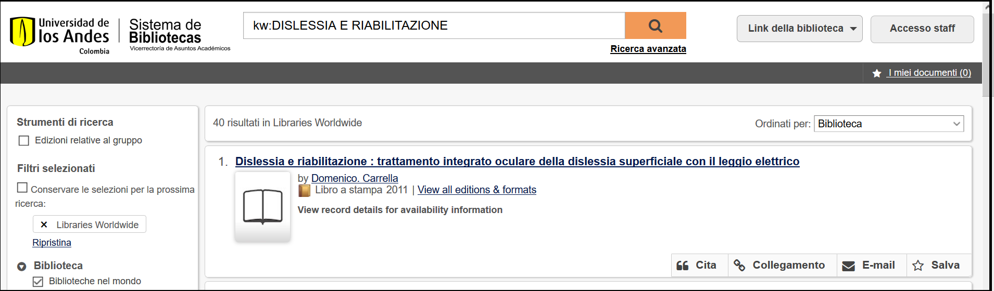

2 UNIVERSIDAD DEL VALLE DIVISION DE BIBLIOTECAS – (Colombia)
http://eds.b.ebscohost.com/eds/detail/detail?vid=1&sid=dbc04007-20ae-44c6-a1c5-22dd4585cfd6%40sessionmgr120&bdata=Jmxhbmc9ZXMmc2l0ZT1lZHMtbGl2ZQ%3d%3d#AN=EDSBVB.BV039611798&db=edsbvb
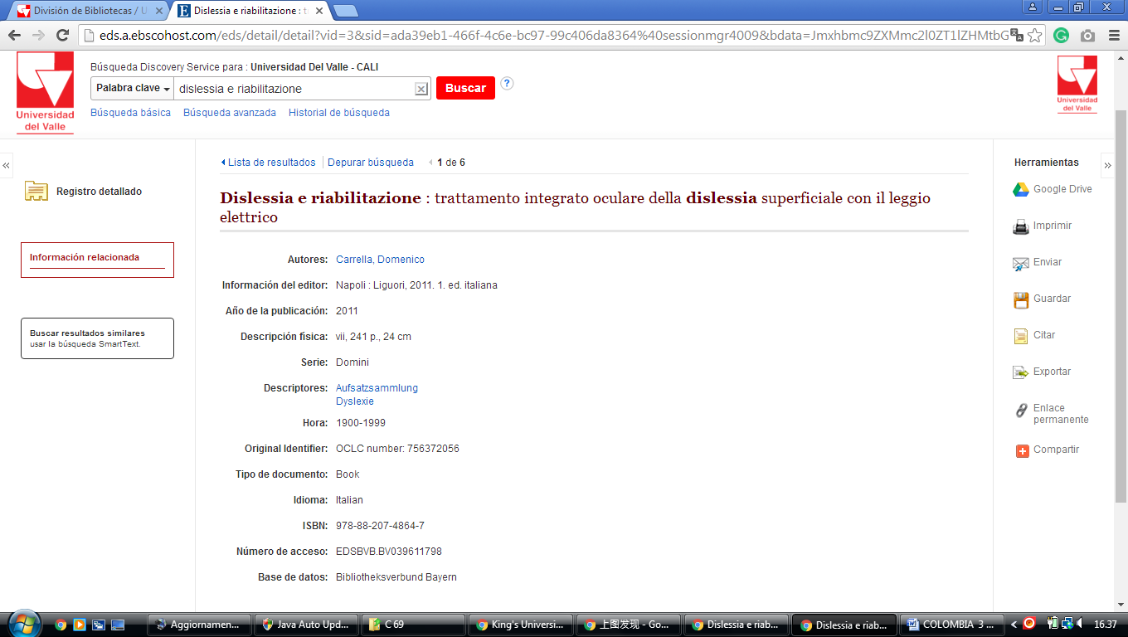

3 BIBLIOTECA UNIMINUTO De DIOS - (Bogotà, Colombia)

http://uniminuto.summon.serialssolutions.com/search?fn=go&vl%28182972193UI1%29=all_items&s.q=dislessia+&ct=search&indx=0&dum=true#!/search?ho=f&l=es-ES&q=dislessia%20e%20riabilitazione
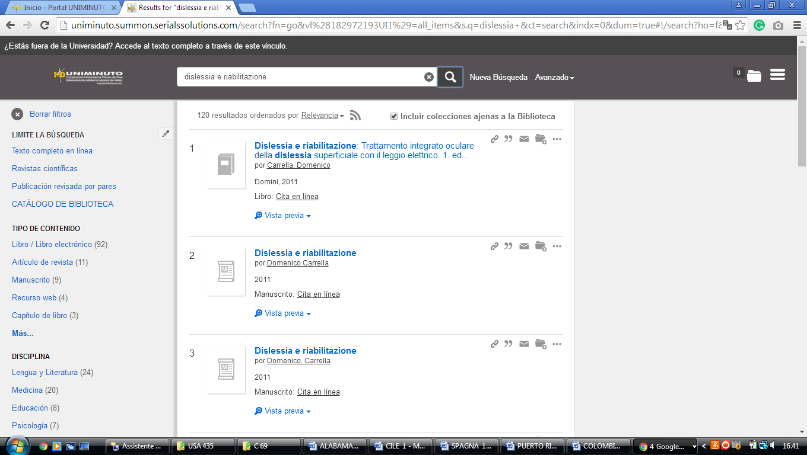

4 CENTRO BIBLIOTECA JORGE ROA MARTÍNEZ - (Colombia)
https://utp.on.worldcat.org/search?queryString=kw%3Adislessia+e+riabilitazione&subformat=

