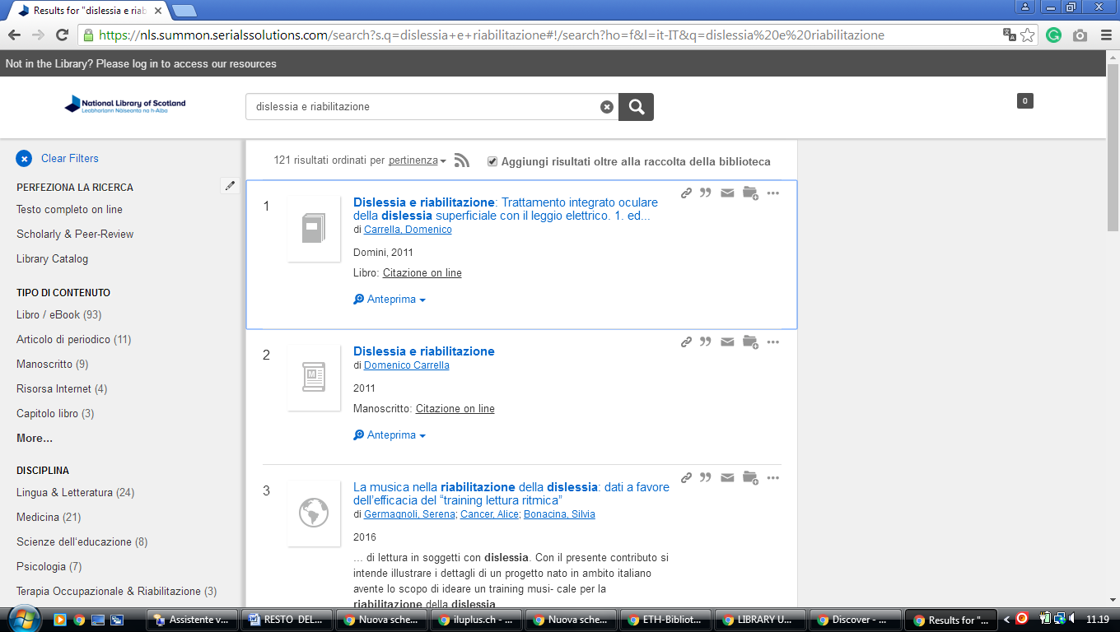
1 AJOU UNIVERSITY LIBRARY - (Suwon, South Korea)
http://ajou.summon.serialssolutions.com/en/#!/search?ho=f&l=en&q=DISLESSIA%20E%20RIABILITAZIONE

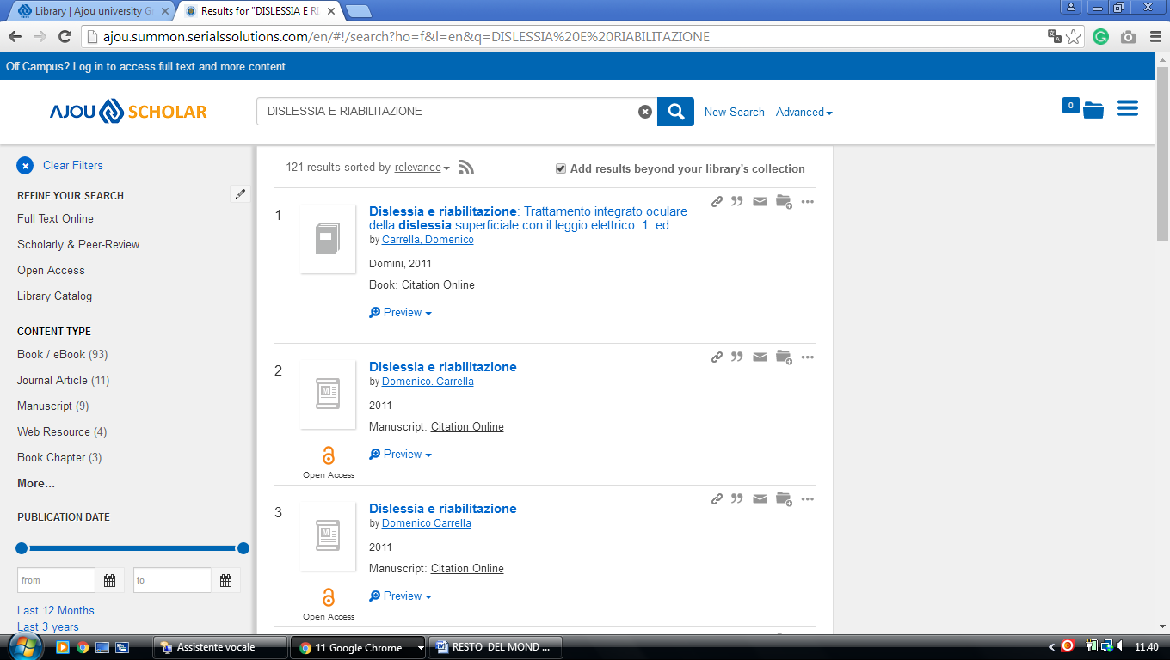

2 KYUNGSUNG UNIVERSITY LIBRARY – (Pusan, South Korea)
http://kyungsung-primo.hosted.exlibrisgroup.com/primo_library/libweb/action/display.do?tabs=viewOnlineTab&ct=display&fn=search&doc=TN_casalini_libriit02503952&indx=1&recIds=TN_casalini_libriit02503952&recIdxs=0&elementId=0&renderMode=poppedOut&displayMode=full&frbrVersion=&frbg=&pcAvailabiltyMode=true&dscnt=0&scp.scps=scope%3A%28KSU_SFX%29%2Cscope%3A%28KSU%29%2Cprimo_central_multiple_fe&tb=t&vid=KSU&mode=Basic&tab=default_tab&srt=rank&dum=true&vl(freeText0)=DISLESSIA%20E%20RIABILITAZIONE&dstmp=1498182096743

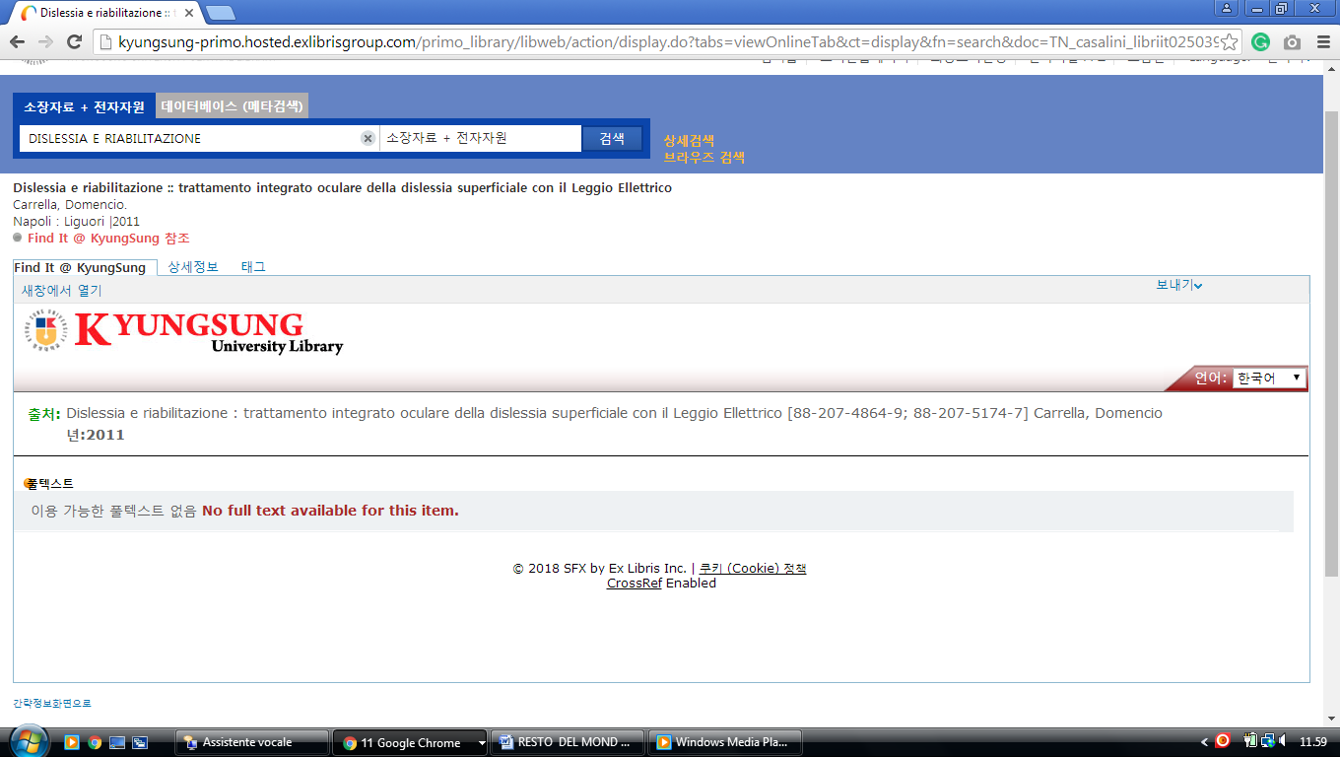

3 KHIS.SUMMON.SERIALSSOLUTIONS.COM – (Khu Library Korea)
http://khis.summon.serialssolutions.com/?q=dislessia+e+riabilitazione#!/search?ho=f&l=en&q=dislessia%20e%20riabilitazione

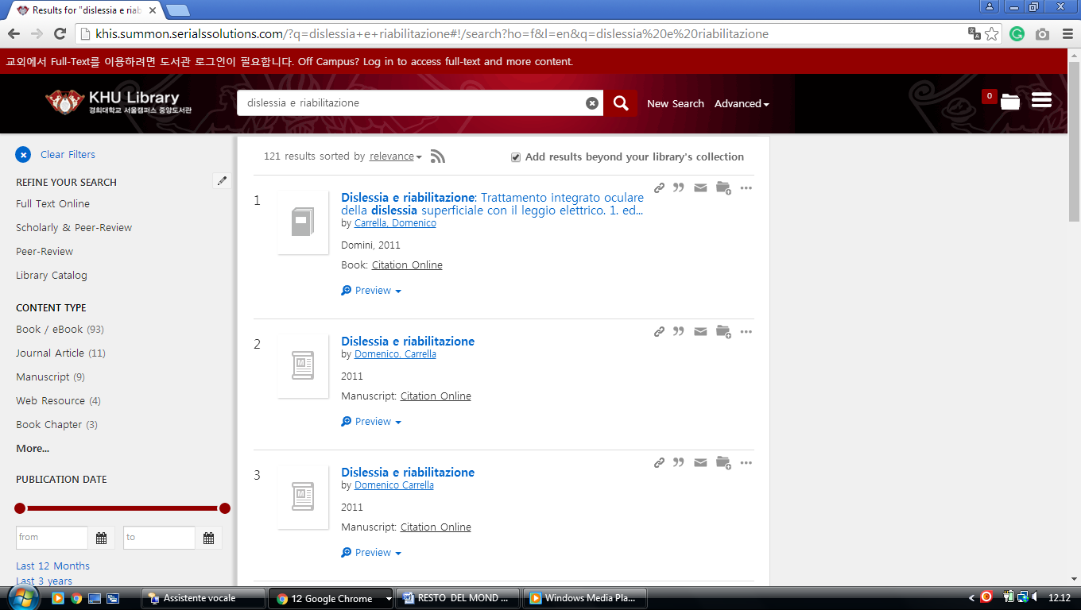

4 LIBRARY.YONSEI.AC.KR/EN - (University, Seodaemun-Gu, Seoul,South Korea)
http://yonsei.summon.serialssolutions.com/?q=DISLESSIA+E+RIABILITAZIONE&x=17&y=38#!/search?ho=f&l=it-IT&q=DISLESSIA%20E
%20RIABILITAZIONE&x=17&y=38
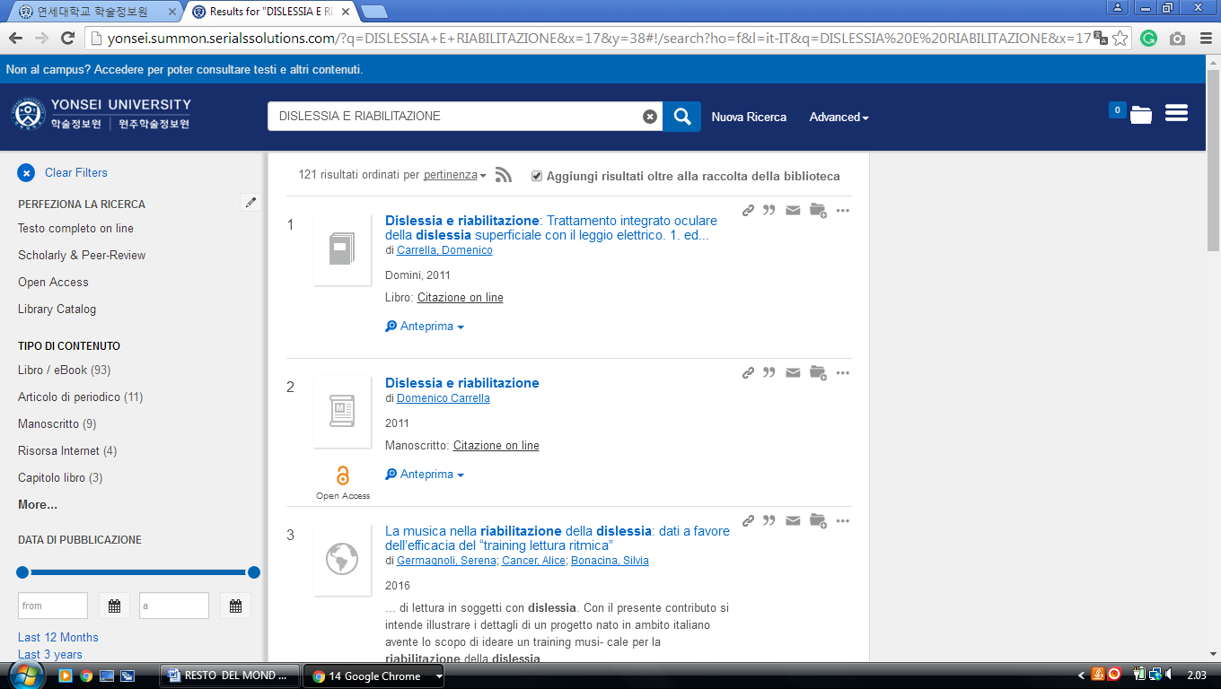

5 KYUNGPOOK NATIONAL UNIVERSITY LIBRARY - 경북대학교 도서관
(Repubblica di Corea)
http://knu.summon.serialssolutions.com/search?s.q=+++dislessia+e+riabilitazione#!/search?ho=f&l=en&q=%20%20%20dislessia%20e%20riabilitazione

