1 BIBLIOTECA DO INSTITUTO RUDJER BOSKOVIC – (Croazia)
http://eds.b.ebscohost.com/eds/detail/detail?vid=1&sid=41e62c25-85c9-479e-b0fb-cc01fddcb4b8%40sessionmgr102&bdata=Jmxhbmc9aHImc2l0ZT1lZHMtbGl2ZQ%3d%3d#db=edsbvb&AN=EDSBVB.BV039611798

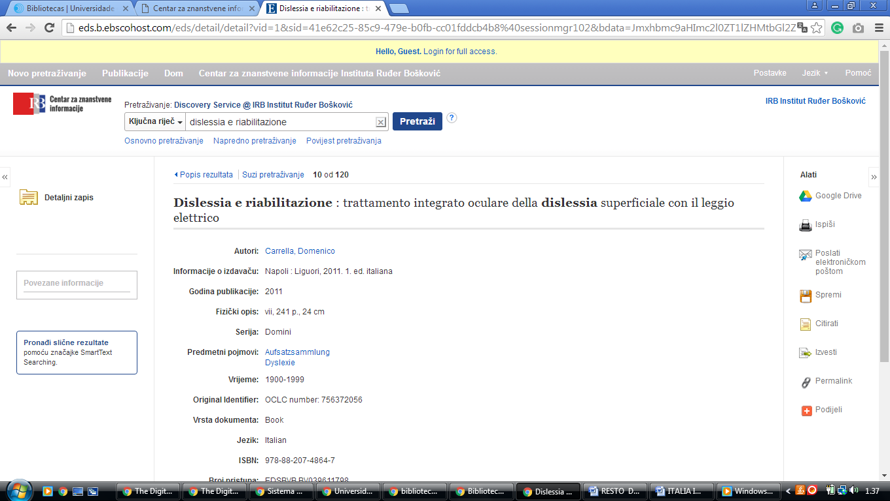

2 NACIONALNA I SVEUČILIŠNA KNJIŽNICA U ZAGREBU – (Croazia)
http://haw.nsk.hr/
http://www.theeuropeanlibrary.org/tel4/search?query=dislessia%20e%20riabilitazione

