1 RIZAL LIBRARY – (Quezon City, Filippine)
http://eds.b.ebscohost.com/eds/results?vid=0&sid=7ca7c488-4ec4-48dc-8790-5f612e8e0797%40sessionmgr104&bquery=dislessia+e+riabilitazione&bdata=JnR5cGU9MCZzY29wZT1zaXRl
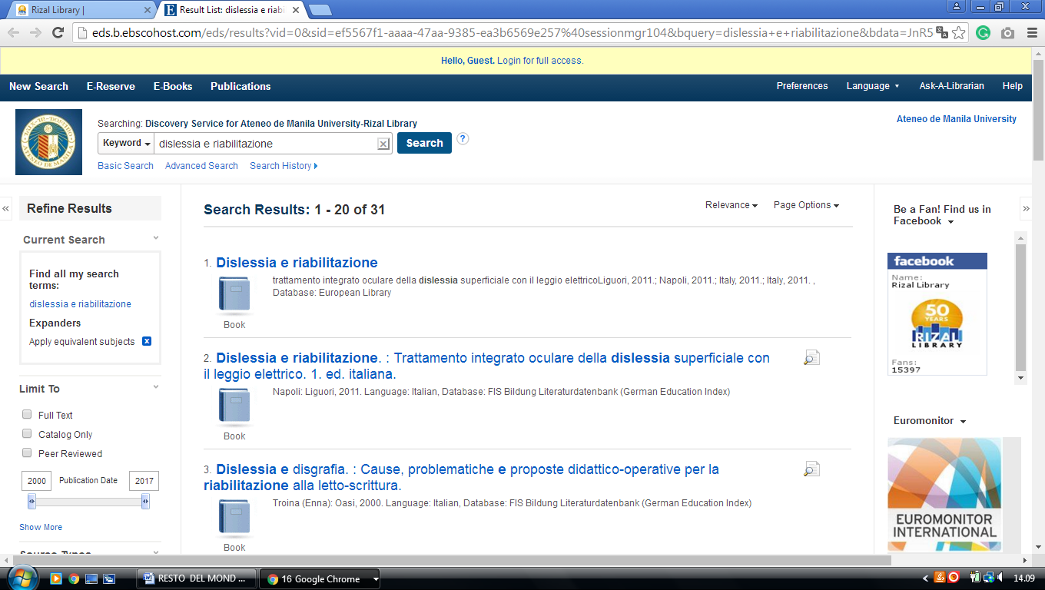

2 UNIVERSITY OF THE PHILIPPINES LOS BAÑOS UNIVERSITY LIBRARY, (Filippine)
http://eds.a.ebscohost.com/eds/results?vid=0&sid=54668f69-e203-4ba3-afc1-c87917214c9c%40sessionmgr4006&bquery=dislessia+e+riabilitazione&bdata=JnR5cGU9MCZzaXRlPWVkcy1saXZl

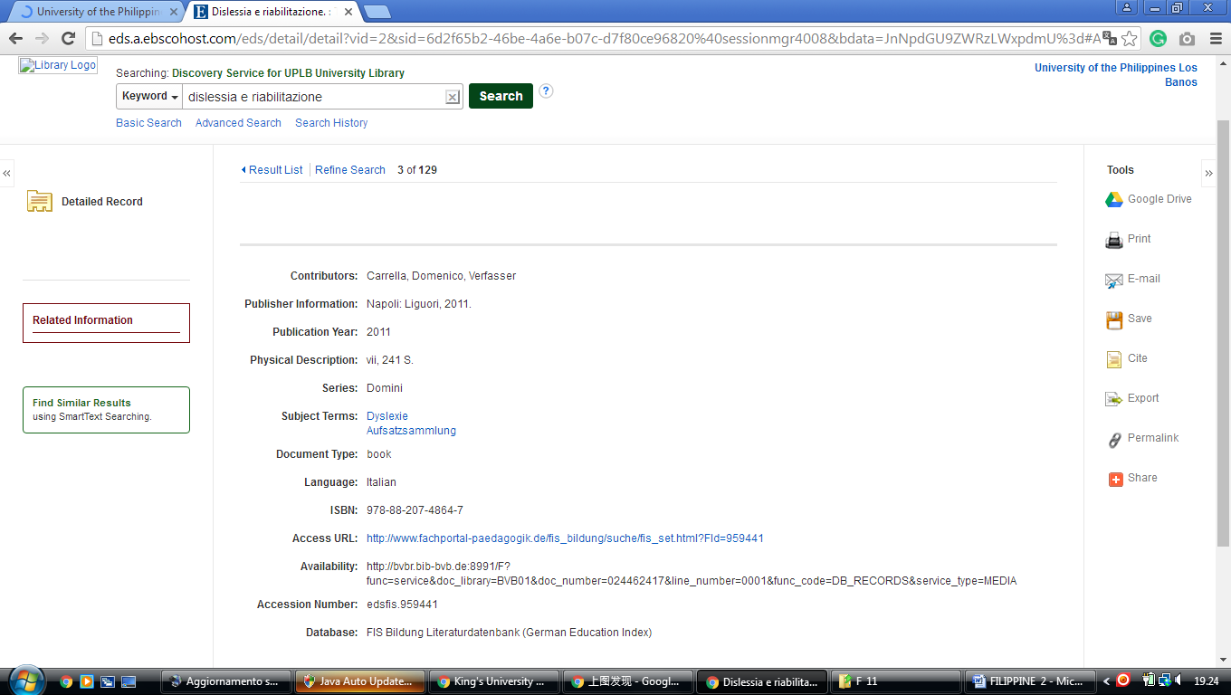

City of Dasmariñas Cavite, Romeo P. Ariniego MD Library - Academics … Philippines
Romeo P. Ariniego MD Library - De La Salle …
http://www.dlshsi.edu.ph/academics/romeo-p-ariniego-md-library/
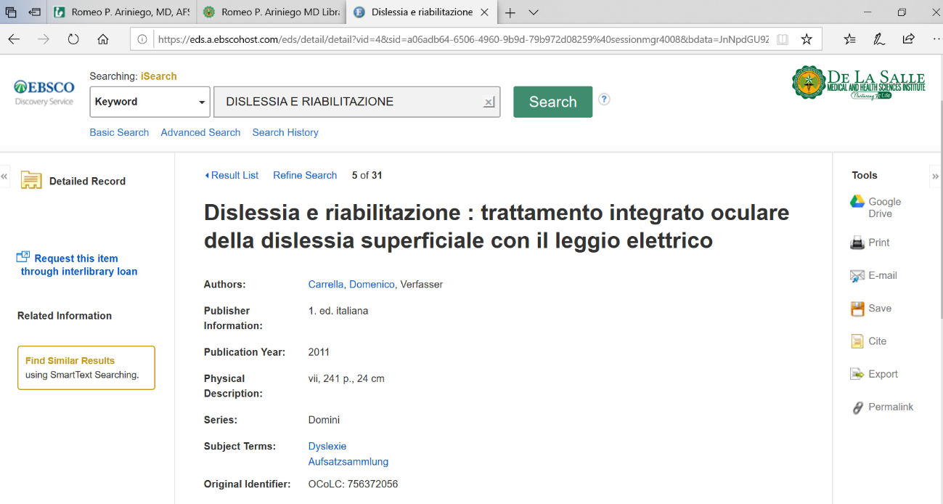

University Library, Diliman, University Of The FILIPPINE
http://eds.b.ebscohost.com/eds/results?vid=3&sid=828493ec-a0a1-4853-b605-50cbd4792138%40pdc-v-sessmgr06&bquery=dislessia+e+riabilitazione&bdata=JnR5cGU9MCZzZWFyY2hNb2RlPUFuZCZzaXRlPWVkcy1saXZl
