1 THE NATIONAL LIBRARY FINLAND – (Helsinki, Finlandia)
https://kansalliskirjasto.finna.fi/PrimoRecord/pci.casalini_libriit02503952

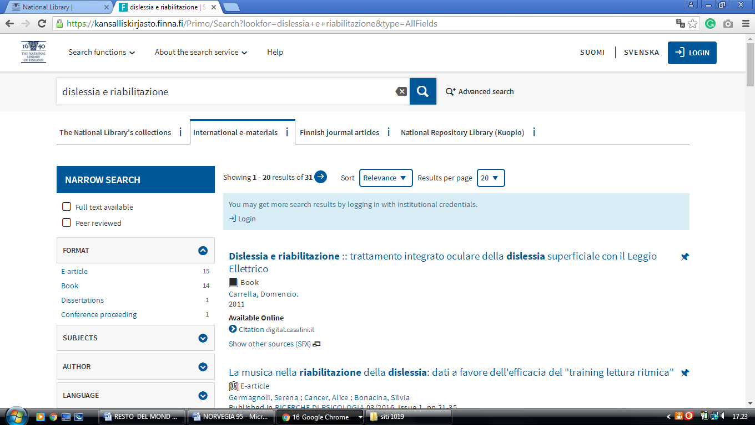

2 TAMPERE UNIVERSITY LIBRARY – (Tampere, Finland)
http://utafi.summon.serialssolutions.com/en-UK/#!/search?ho=f&l=en-UK&q=dislessia%20e%20riabilitazione

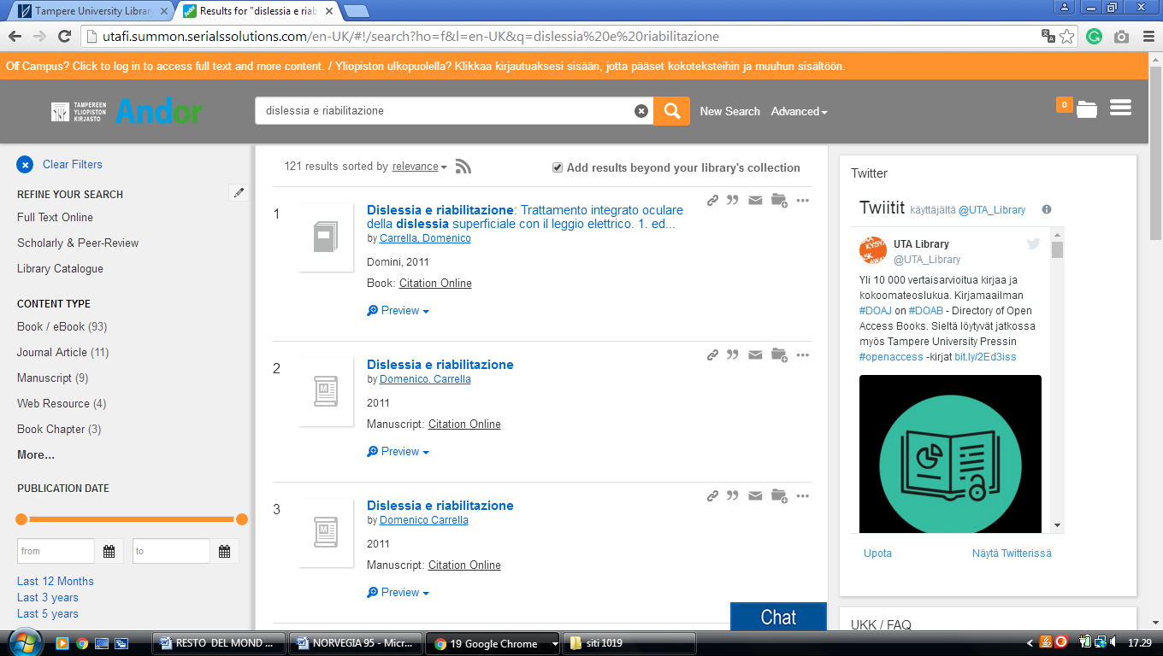

3 HELSINKI UNIVERSITY OF TECHNOLOGY – (Espoo, Finland)
https://aalto.finna.fi/Primo/Search?lookfor=dislessia+e+riabilitazione&type=AllFields

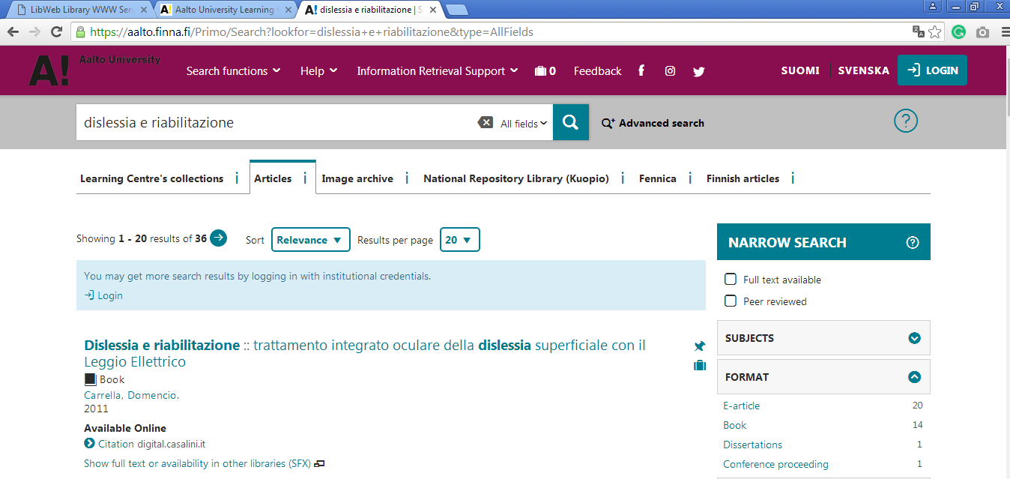

4 OULU UNIVERSITY LIBRARY - OULUN YLIOPISTO - (Finlandia)
https://oula.finna.fi/Primo/Search?lookfor=dislessia+e+riabilitazione&type=AllFields

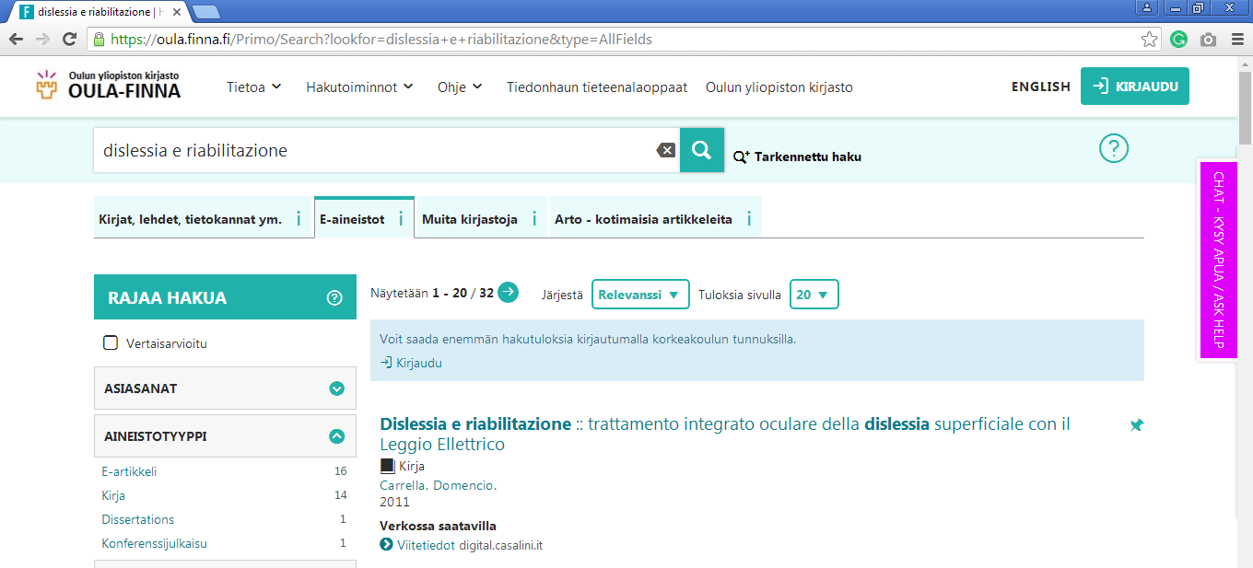

5 LIBRARY - TURUN YLIOPISTO - (Turku, Finlandia)
https://utu.finna.fi/Primo/Search?lookfor=dislessia+e+riabilitazione&type=AllFields

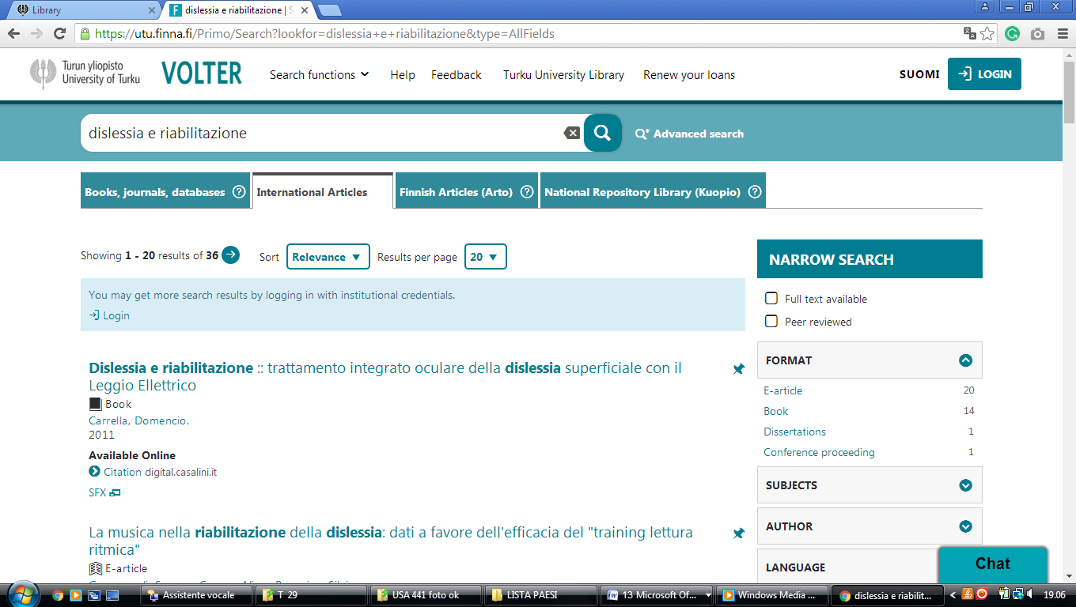

Helsinki University Library - Helka - Finna
https://helka.finna.fi/Primo/Search?lookfor=dislessia+e+riabilitazione&type=AllFields
