1 UNIVERSITY OF EVRY VAL D’ESSONNE LIBRARY – (Evry, France)
https://focus.universite-paris-saclay.fr/primo-explore/search?tab=default_tab&search_scope=default_scope&vid=33PUP_VU1&lang=fr_FR&query=any,contains,dislessia%20e%20riabilitazione&sortby=rank&pcAvailability=true

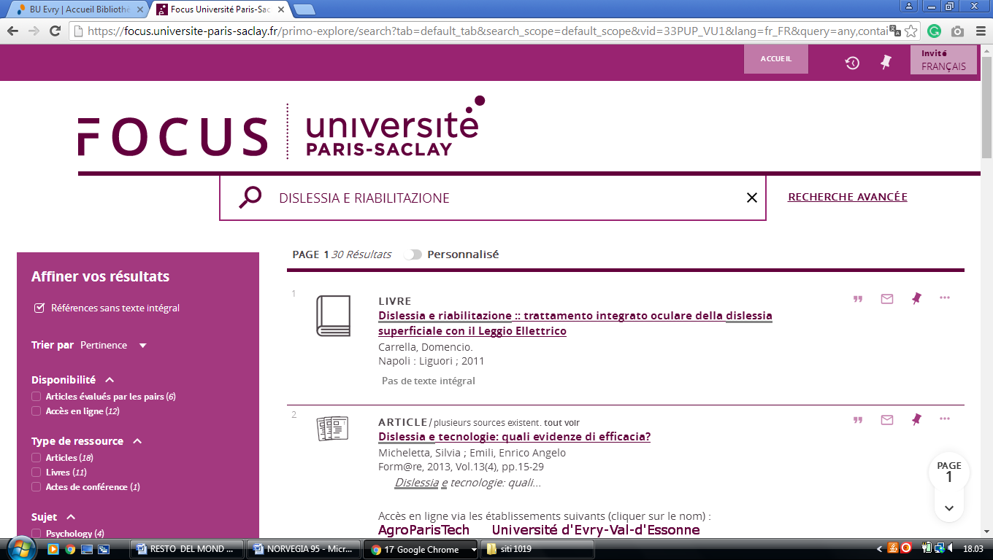

2 UNILIM.SUMMON.SERIALSSOLUTIONS.COM – (Universite De Limoges, France)
http://unilim.summon.serialssolutions.com/?#!/search?ho=f&l=it-IT&q=DISLESSIA%20E%20RIABILITAZIONE

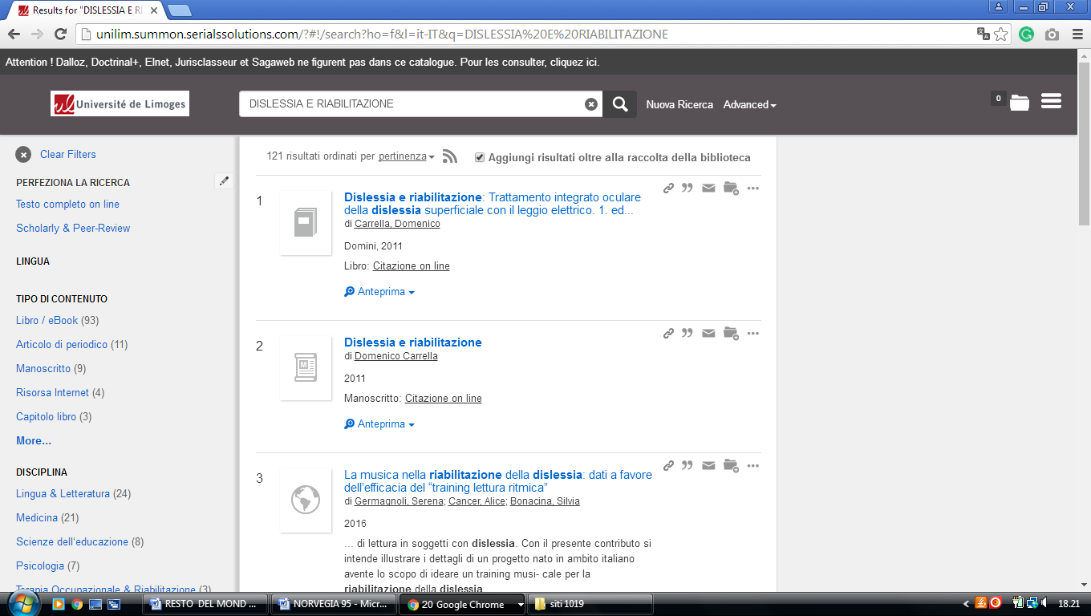

3 CATALOGUES - BU LYON-3 - ( Lyon, France)
http://lyon3.summon.serialssolutions.com/?q=dislessia+e+riabilitazione#!/search?ho=f&l=it-IT&q=dislessia%20e%20riabilitazione

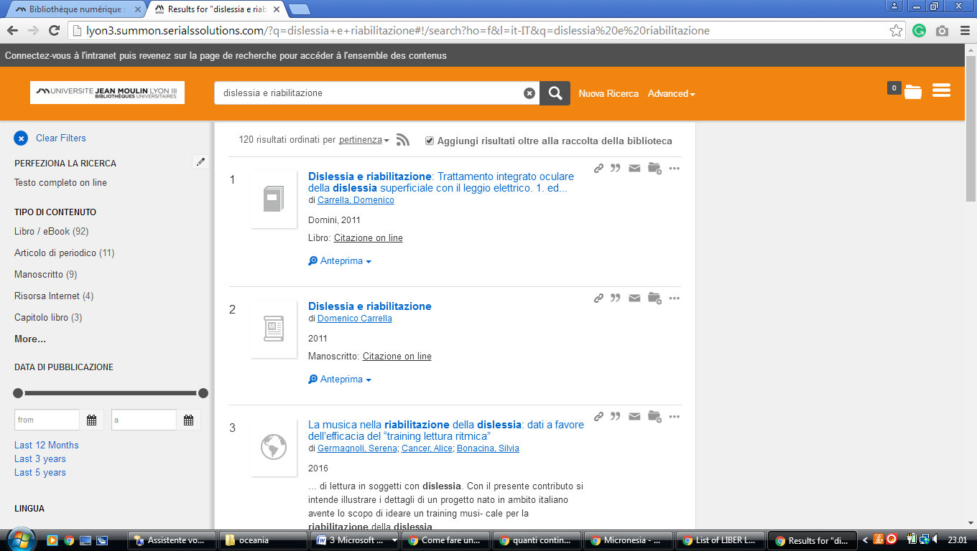

4 UNIVERSITÉ LYON 2 - BIBLIOTHÈQUES – (Francia)
https://lyon2.summon.serialssolutions.com/search?q=dislessia+e+riabilitazione#!/search?ho=f&l=it-IT&q=dislessia%20e%20riabilitazione

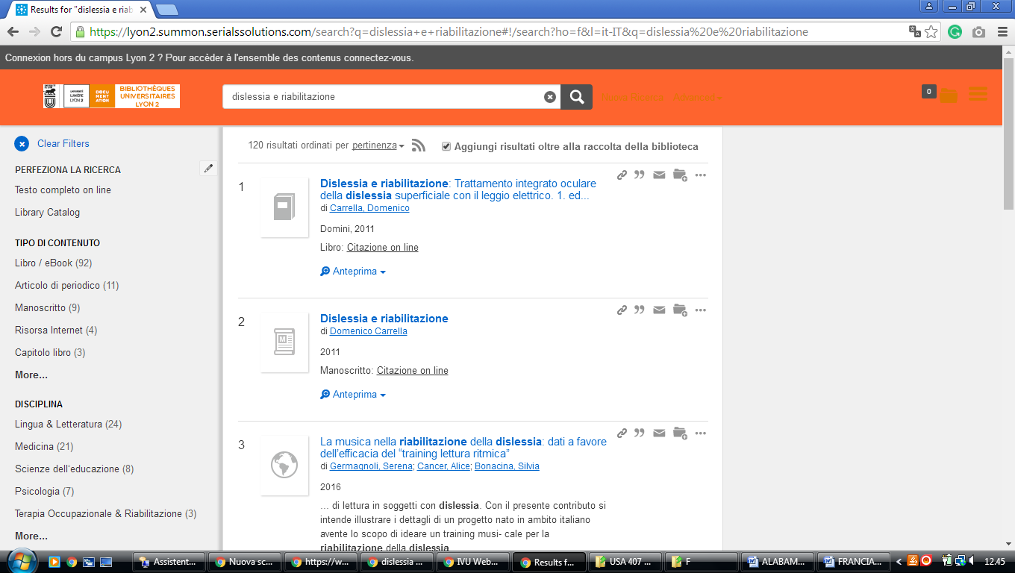

5 HEC PARIS BIBLIOTHÈQUE - (Parigi, Francia)
http://eds.a.ebscohost.com/eds/results?vid=1&sid=bbff9dfd-c371-4ec1-945c-5f61c1d6504a%40sessionmgr4006&bquery=(dislessia+AND+e+AND+riabilitazione)&bdata=JnR5cGU9MCZzaXRlPWVkcy1saXZlJnNjb3BlPXNpdGU%3d

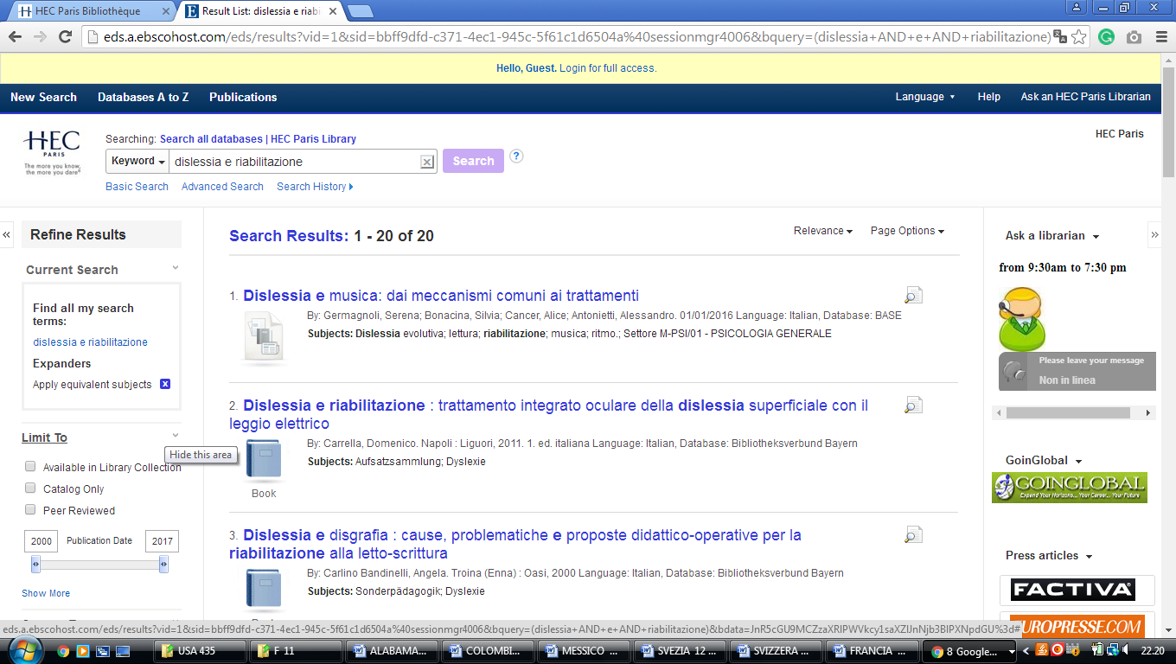

6 BU - UNIVERSITÉ DE LA RÉUNION – (Saint-Denis, Francia)

http://optimus.univ-reunion.fr:1701/primo_library/libweb/action/display.do?tabs=detailsTab&ct=display&fn=search&doc=TN_dipf959441&indx=1&recIds=TN_dipf959441&recIdxs=0&elementId=0&renderMode=poppedOut&displayMode=full&frbrVersion=&dscnt=0&tab=remote_tab&dstmp=1521073510427&pcAvailabiltyMode=true&vl(freeText0)=dislessia+e+riabilitazione&vid=URN&mode=Basic

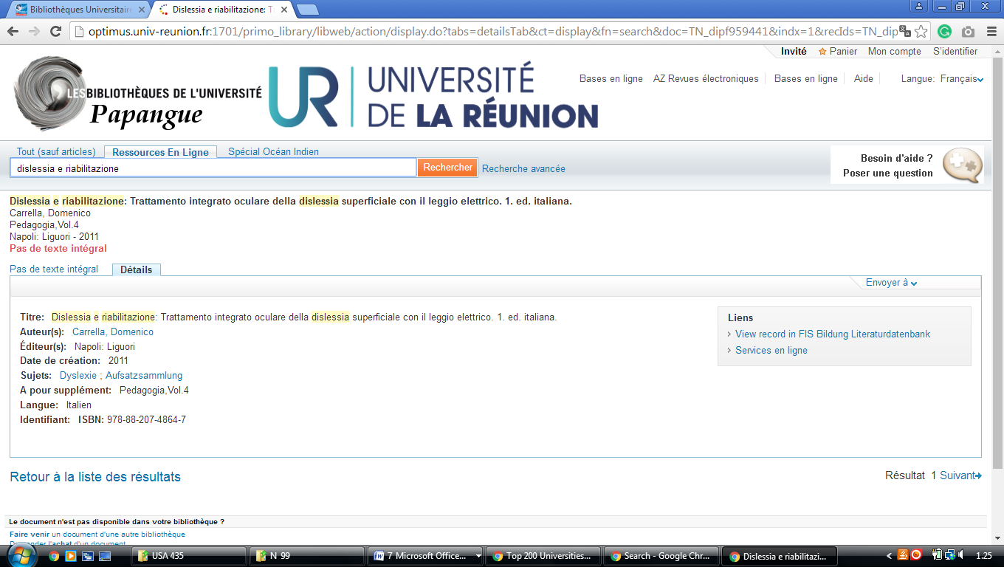

7 SCD - UNIVERSITÉ DE LILLE - (De Lille, Francia)
http://eds.a.ebscohost.com/eds/detail/detail?vid=2&sid=84ff1830-3291-4a74-a208-5eb02e43f0b5%40sessionmgr4006&bdata=JkF1dGhUeXBlPWlwLHVpZCZsYW5nPWZyJnNpdGU9ZWRzLWxpdmUmc2NvcGU9c2l0ZQ%3d%3d#AN=edsfis.959441&db=edsfis
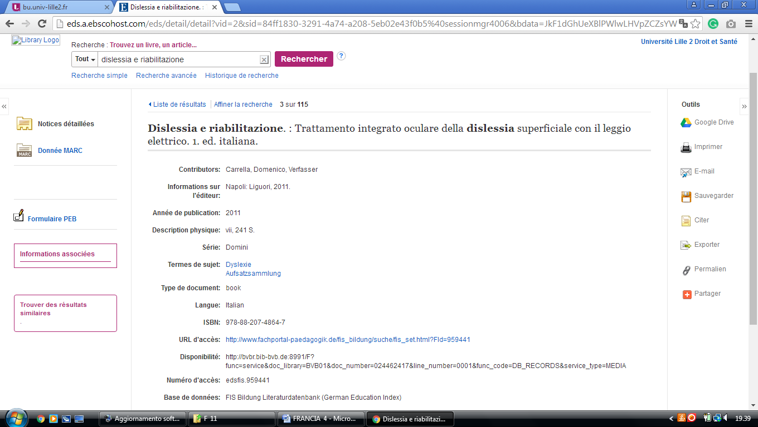

8 Saint Francis University - Francia
https://stfrancisuniversity.on.worldcat.org/search?queryString=dislessia+e+riabilitazione
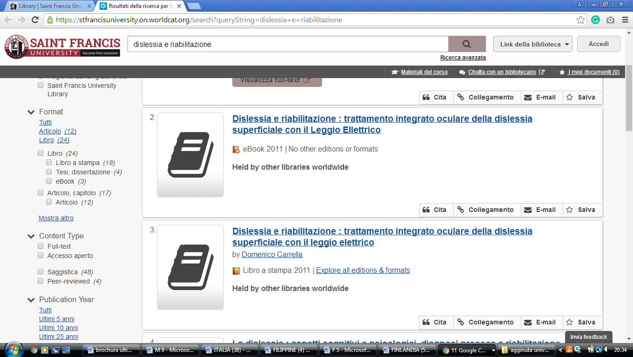

University of Lorraine Libraries
https://udl.primo.exlibrisgroup.com/discovery/search?vid=33UDL_INST:UDL&tab=Everything&search_scope=MyInst_and_CI&mode=basic&displayMode=full&bulkSize=10&highlight=true&dum=true&query=any,contains,dislessia%20e%20riabilitazione&displayField=all&pcAvailabiltyMode=true&lang=fr&pcAvailability=true

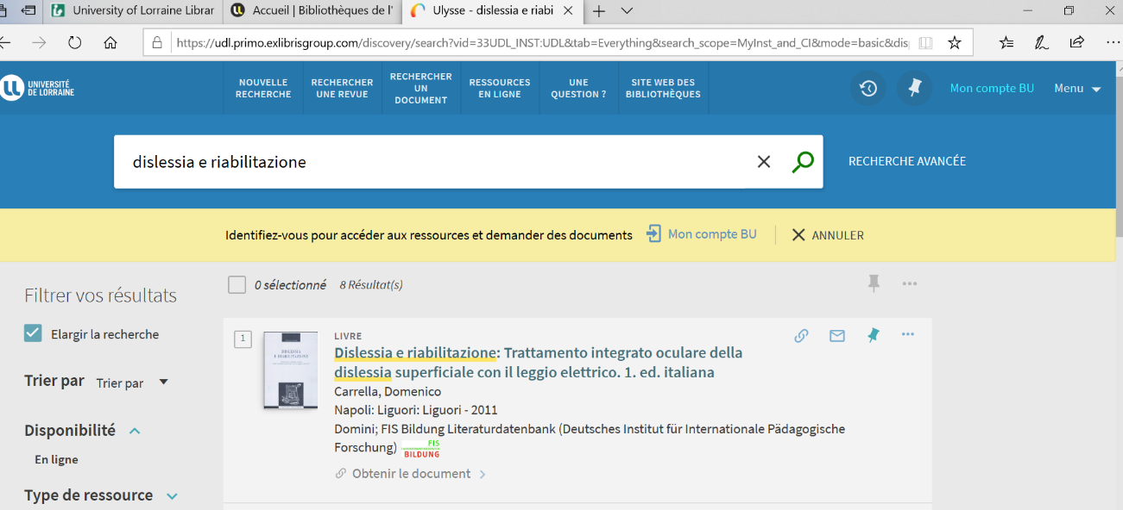

Bibliothèque La Pérouse
https://ifremer.on.worldcat.org/
