1 NATIONAL AND PARLIAMENTARY LIBRARY OF GEORGIA - THE EUROPEAN LIBRARY
http://www.theeuropeanlibrary.org/tel4/contributor/P01248
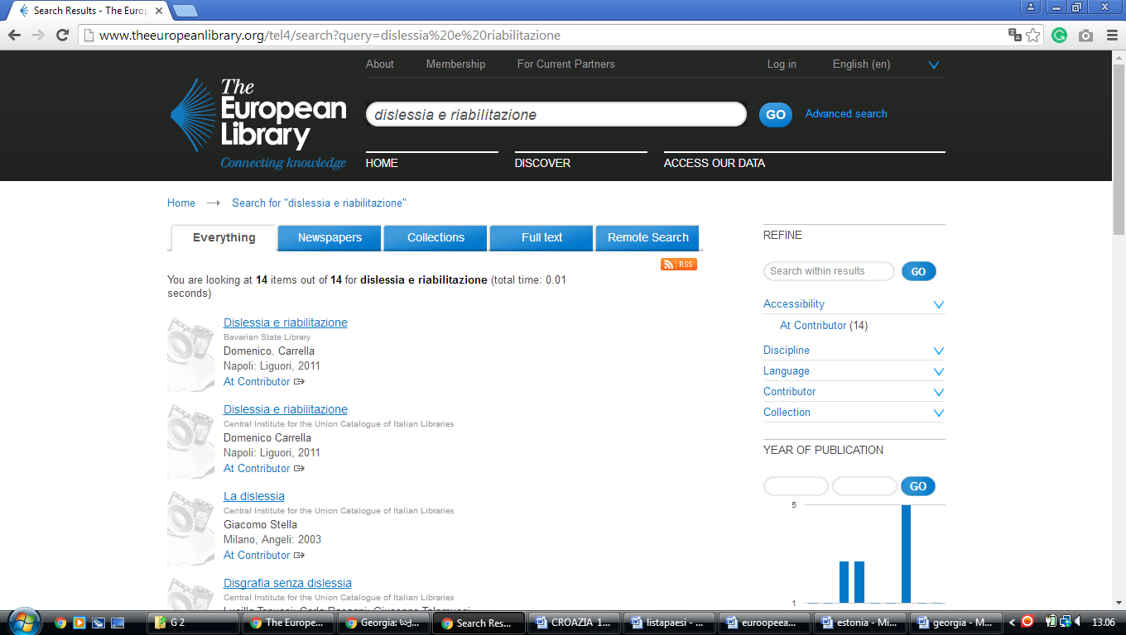

Philadelphia College of Osteopathic Medicine – Georgia campus

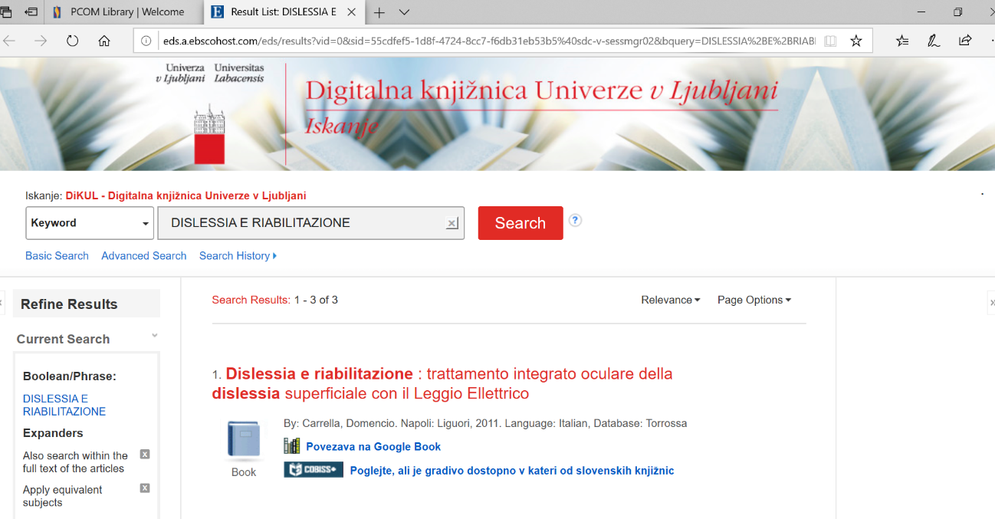

University Libraries, Georgia
https://eds.a.ebscohost.com/eds/results?vid=0&sid=46ce7a7e-9e5a-4d51-b6a3-ba2339594c13%40sdc-v-sessmgr01&bquery=dislessia%2be%2briabilitazione&bdata=JkF1dGhUeXBlPWlwLHNoaWImY2xpMD1GVDEmY2x2MD1ZJnR5cGU9MCZzZWFyY2hNb2RlPUFuZA%3d%3d

