Athens, National Library of GRECIA

Εθνική Βιβλιοθήκη της Ελλάδος | National Library of Greece
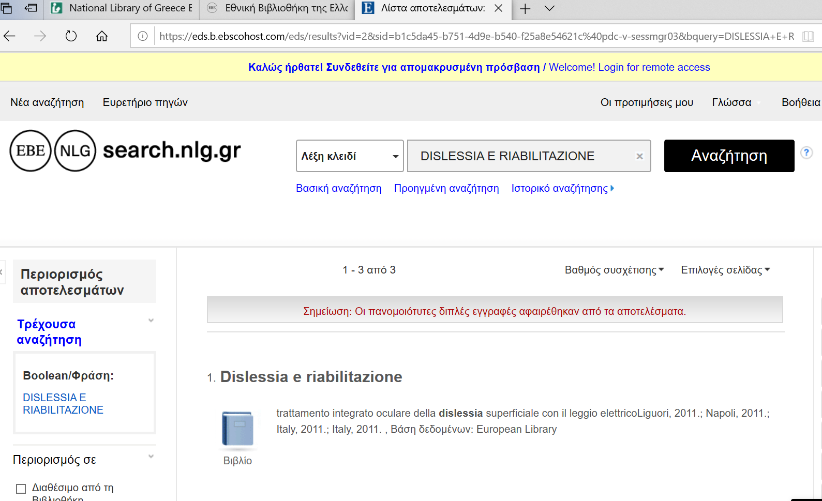

National and Kapodistrian University of Athens

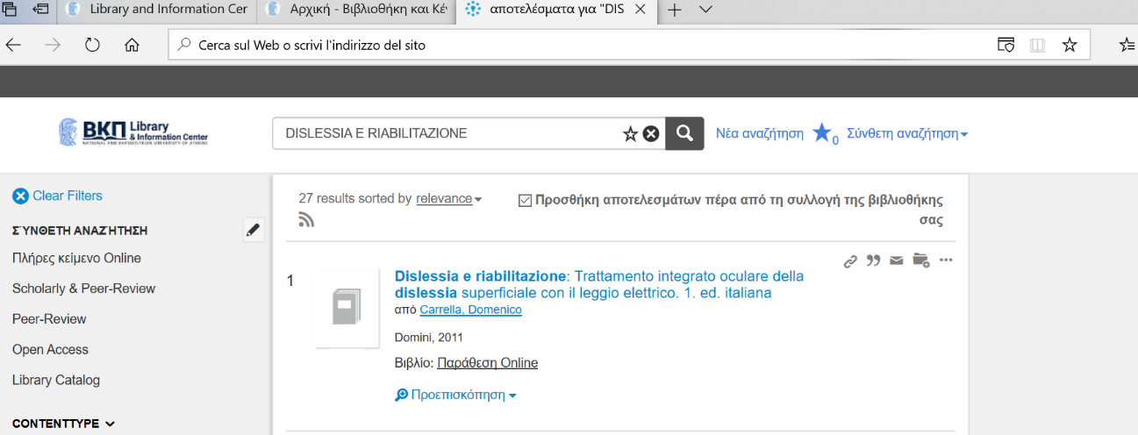
https://nkua.summon.serialssolutions.com/gr-GR/search?ho=t&q=DISLESSIA%20E%20RIABILITAZIONE#!/search?ho=f&l=gr-GR&q=DISLESSIA%20E%20RIABILITAZIONE

The American College of Greece | Library

https://acg.on.worldcat.org/search?queryString=DISLESSIA%20E%20RIABILITAZIONE&databaseList=1080,2375,2175,3384,1082,1910,1931,1996,1875,2007,2006,2069,2267,2784,1672,3036,638,1913,10874,4162,2264,2263,2483,2262,2482,2261,1271,2260,10008,3548,2513,1842,2259,1621,2237,2277,1609,1708,3643&sortKey=BEST_MATCH&clusterResults=true&scope=&format=Book&format=Audiobook&page=1

