1 CAMBRIDGE UNIVERSITY LIBRARY - (Cambridge, Inglilterra)
https://idiscover.lib.cam.ac.uk/primo-explore/search?vid=44CAM_PROD&lang=en_US&search_scope=default_scope&tab=default_tab&sortby=rank&query=any,contains,dislessia%20e%20riabilitazione

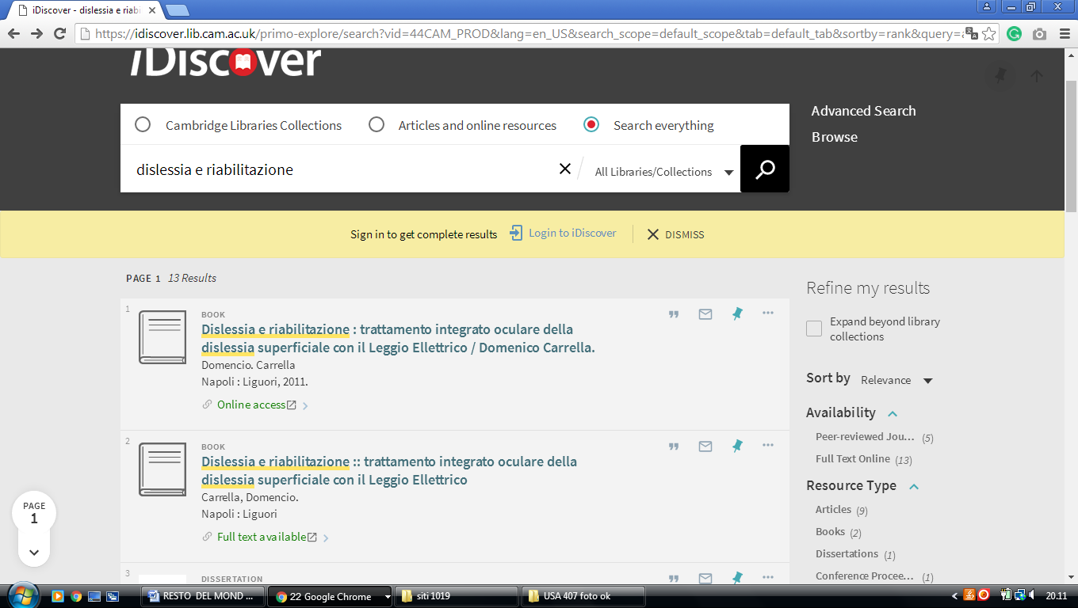

2 UNIVERSITY OF OXFORD BODLEIAN LIBRARIES - THE EUROPEAN

LIBRARY - (Oxford, England)
http://www.theeuropeanlibrary.org/tel4/contributor/P01374
http://www.theeuropeanlibrary.org/tel4/search?query=dislessia%20e%20riabilitazione

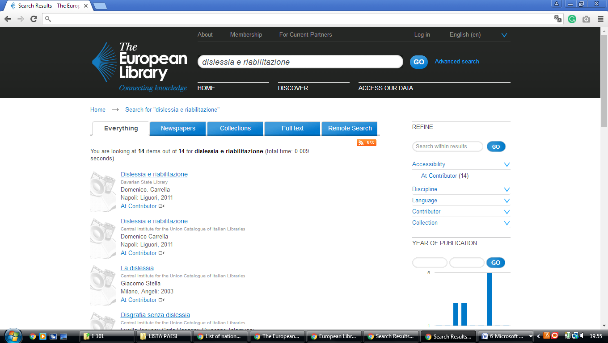


3 KING’S COLLEGE LONDON LIBRARY - (London, England)
https://librarysearch.kcl.ac.uk/primo_library/libweb/action/search.do;jsessionid=E017A2AE93F5CDC78B8819E747602A7E?ct=facet&pcAvailabiltyMode=true&pcAvailClicked=true&frbg=&&indx=1&fn=search&dscnt=0&scp.scps=scope%3A(44KCL_ALEPH_LIBGUIDES_DATABASES)%2Cscope%3A(44KCL_ALEPH_DS)%2Cscope%3A(44KCL_SFX_DS)%2Cscope%3A(44KCL_PURE_MODS)%2Cscope%3A(44KCL_ARCHIVES_DS)%2Cscope%3A(44KCL_PURE_DS)%2Cscope%3A(44KCL_ALEPH_RDM_DS)%2Cprimo_central_multiple_fe&mode=Basic&vid=kings_v1&ct=search&srt=rank&tab=default_tab&vl(freeText0)=%20dislessia%20e%20riabilitazione&dum=true&dstmp=1494862263580
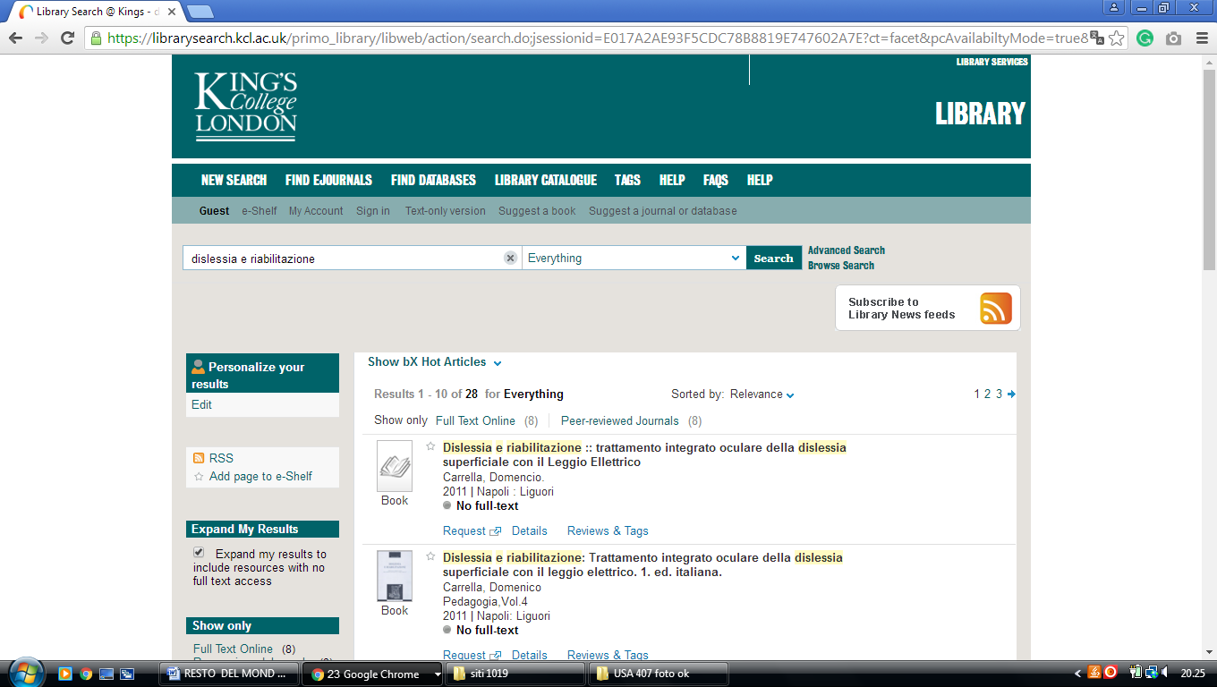

4 LIBRARY, DE MONTFORT UNIVERSITY DMU - (Leicester, England)
https://dmu.summon.serialssolutions.com/?q=dislessia+e+riabilitazione#!/search?ho=f&l=it-IT&q=dislessia%20e%20riabilitazione

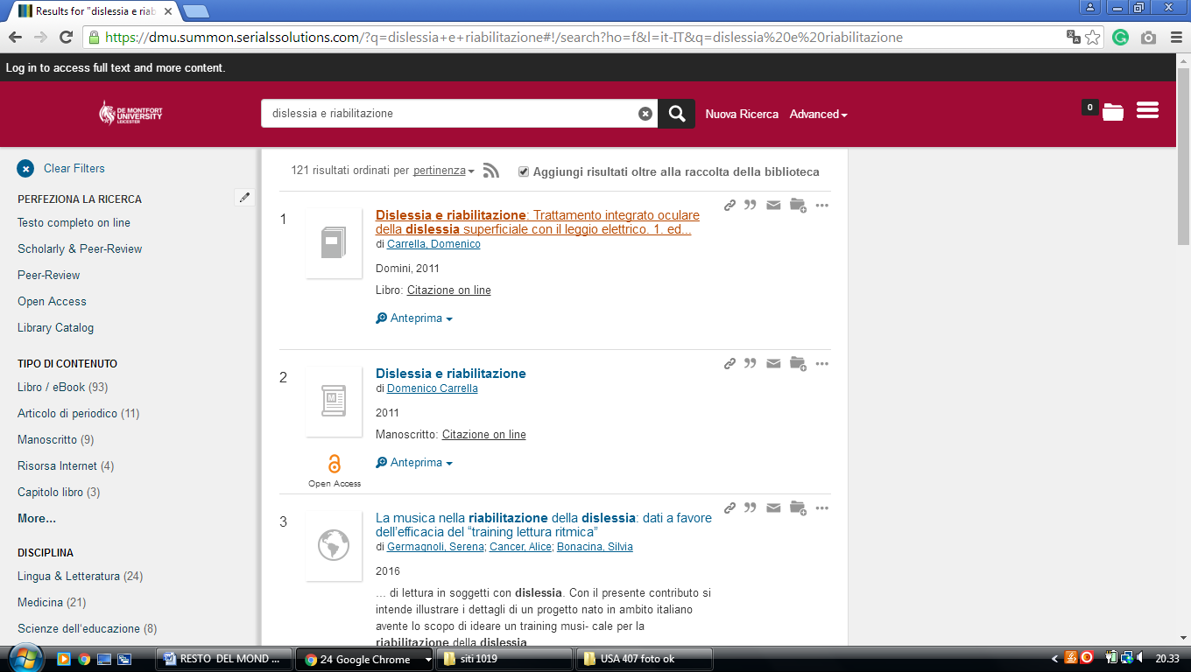

5 UNIVERSITY OF LEEDS IT LIBRARY - (Leeds, England)
https://leeds.summon.serialssolutions.com/?q=+DISLESSIA+E+RIABILITAZIONE++++++&fvf=ContentType%2CBook+Review%2Ct#!/search?ho=f&fvf=ContentType,Book%20Review,t&l=en&q=%20DISLESSIA%20E%20RIABILITAZIONE%20%20%20%20%20%20

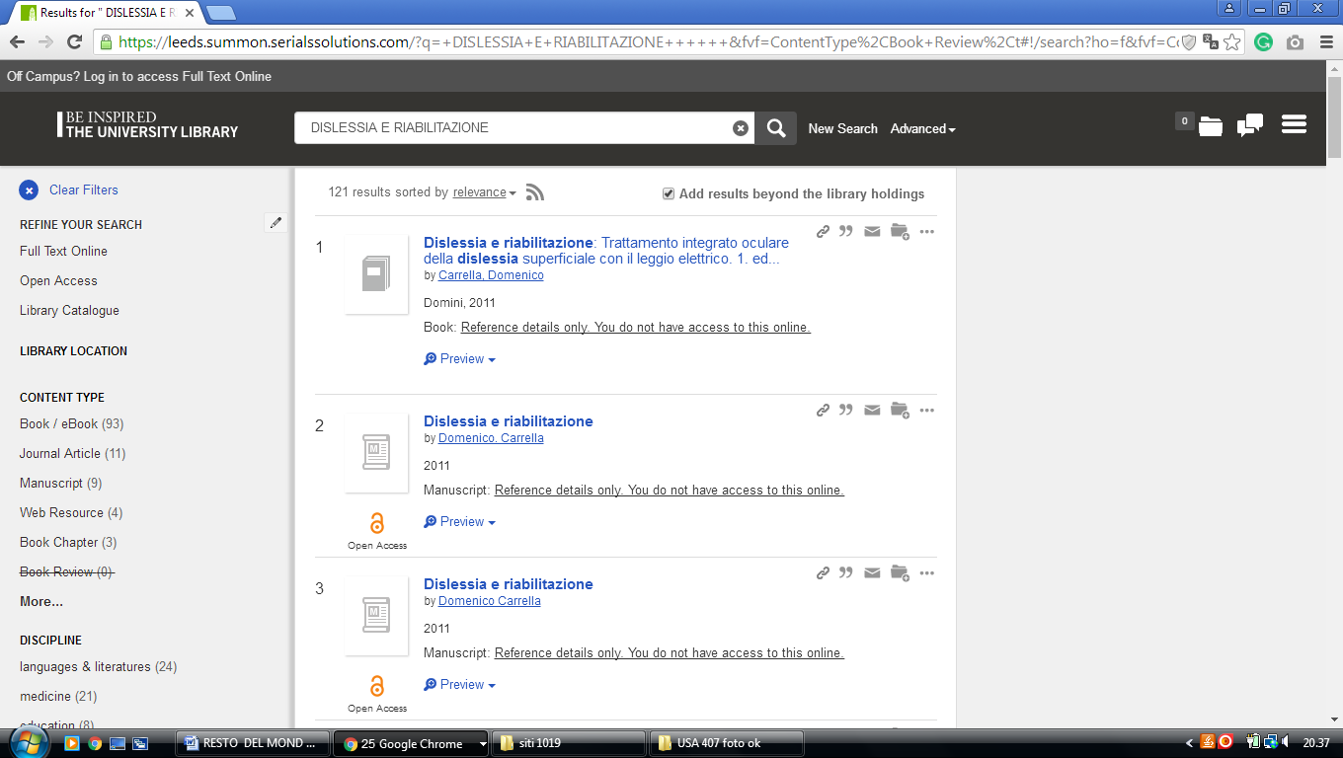

6 EDGE HILL UNIVERSITY LIBRARY – (Ormskirk, England)
https://edgehill.summon.serialssolutions.com/search?fvf=ContentType%2CNewspaper+Article%2Ct%7CContentType%2CBook+Review%2Ct&q=dislessia+e+riabilitazione&type=everything#!/search?ho=f&fvf=ContentType,Newspaper%20Article,t%7CContentType,Book%20Review,t&l=en&q=dislessia%20e%20riabilitazione&type=everything

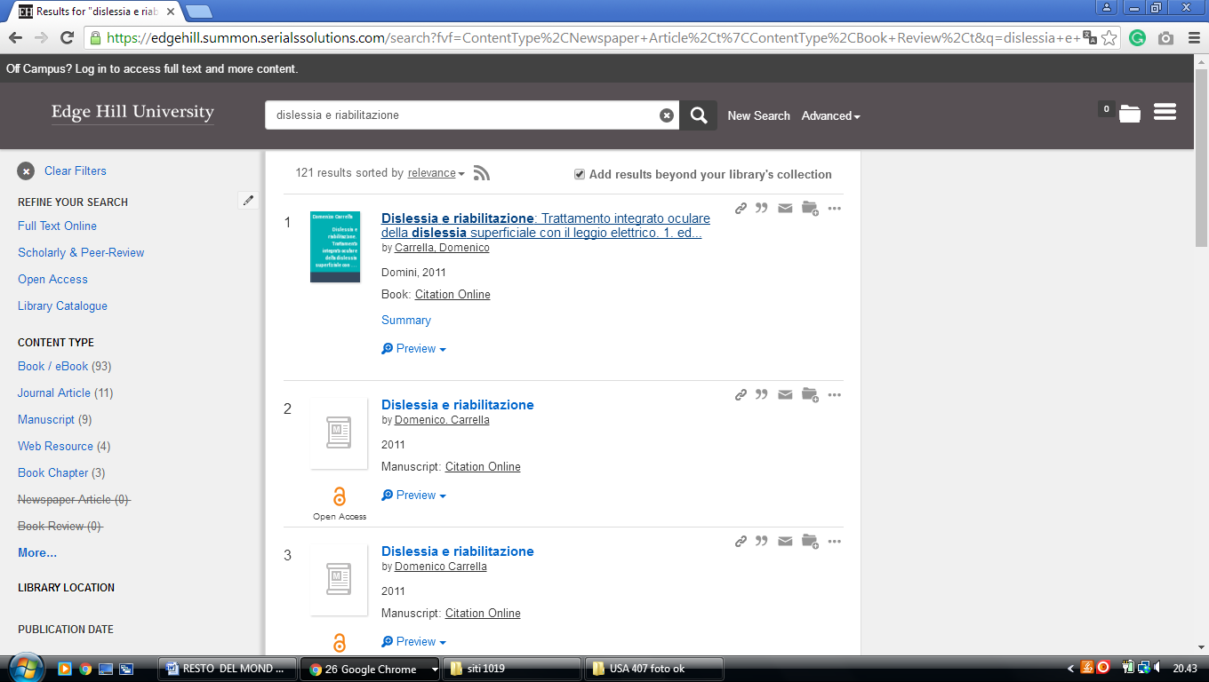

7 MANCHESTER METROPOLOITAN UNIVERSITY LIBRARY – (Manchester, England)
https://mmulibrary.summon.serialssolutions.com/search/?spellcheck=true&keep_r=true&s.q=dislessia+e+riabilitazione&s.cmd=#!/search?ho=f&l=en-UK&q=dislessia%20e%20riabilitazione

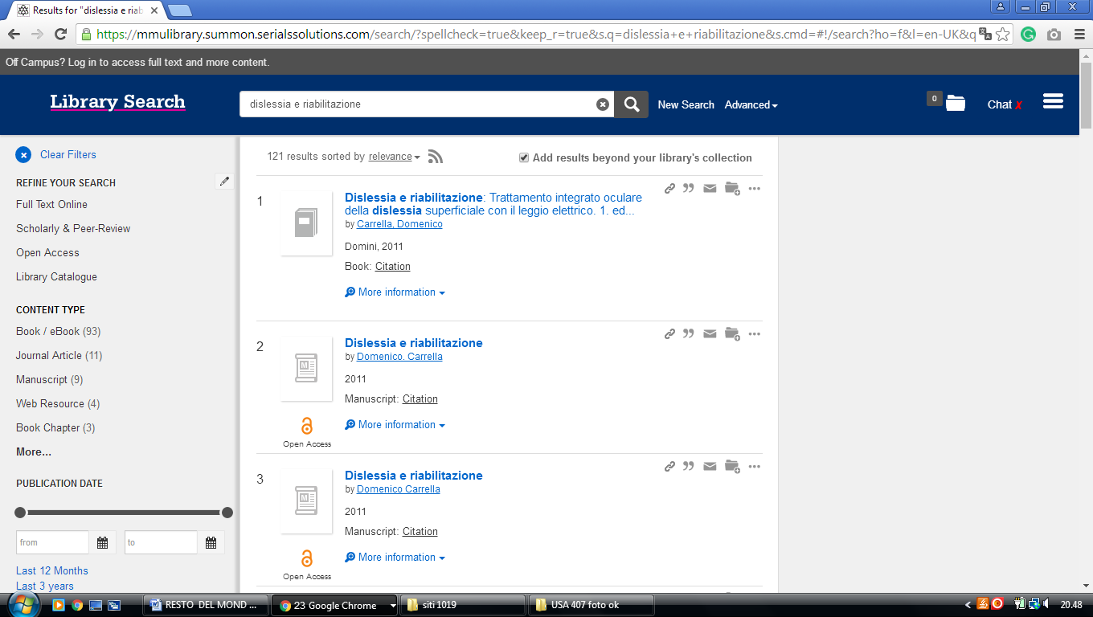
-------------------------------------------------------------------------------------------------------------------------------

8 TEESSIDE UNIVERSITY LIBRARY – (Middlesbrough, England)
http://tees.summon.serialssolutions.com/search?q=dislessia+e+riabilitazione&spellcheck=true&keep_r=true#!/search?ho=f&l=en-UK&q=dislessia%20e%20riabilitazione

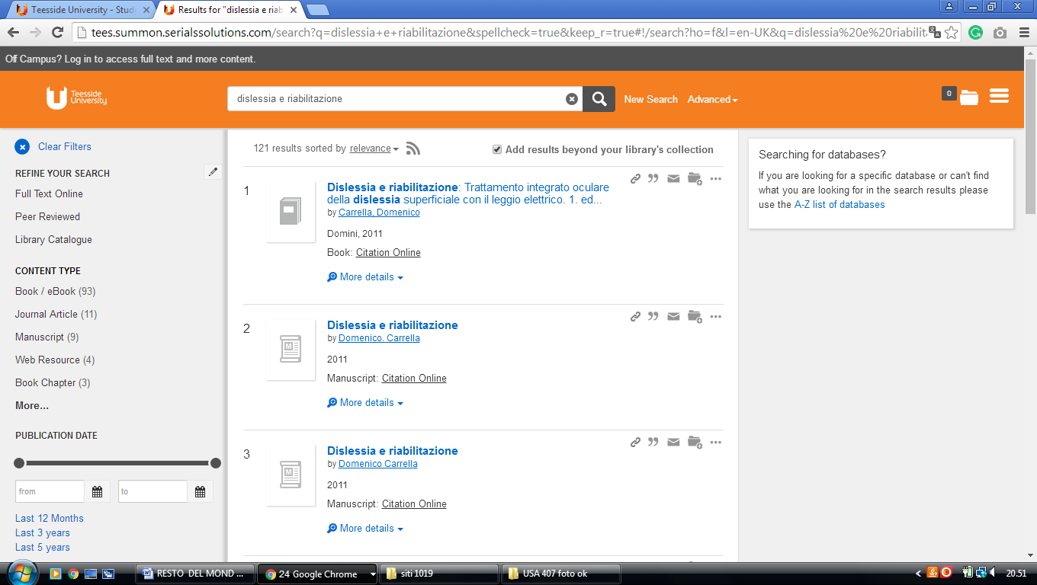

9 UNIVERSITY OF BATH LIBRARY - (Bath, England)
http://bath-ac-primo.hosted.exlibrisgroup.com/primo_library/libweb/action/search.do?ct=facet&pcAvailabiltyMode=true&pcAvailClicked=true&vid=44BAT_VU1&fn=search&indx=1&dscnt=0&vl(freeText0)=dislessia%20e%20riabilitazione&dstmp=1518292456793

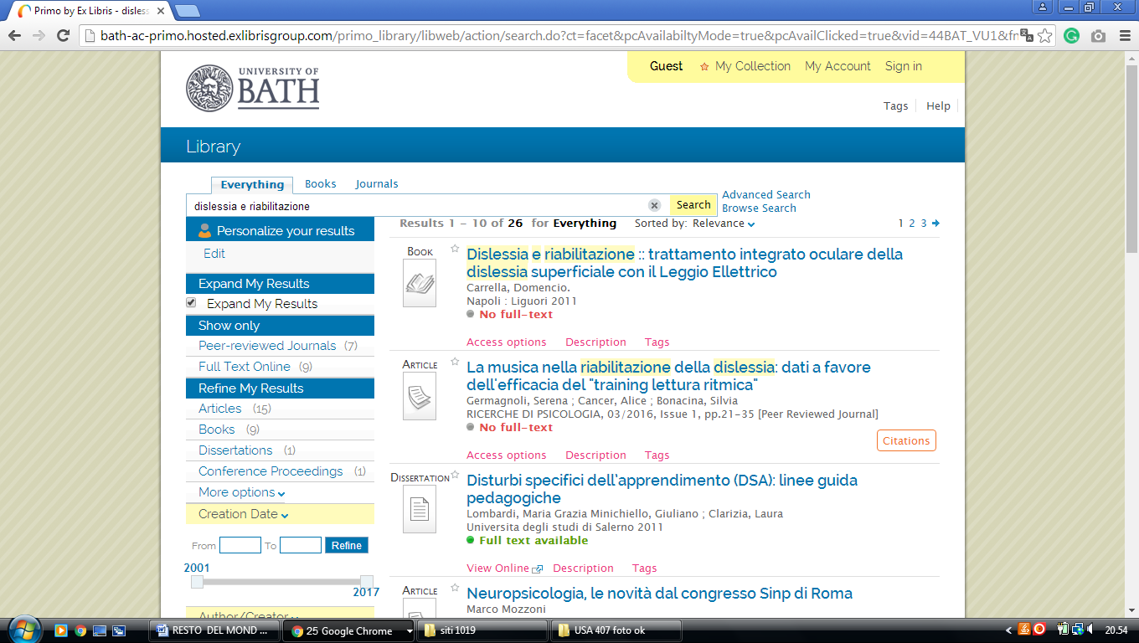

10 LIBRARY CATALOGUE UNIVERSITY OF BRIGHTON, ONE SEARCH

(Brighton, England)
https://brighton.summon.serialssolutions.com/?#!/search?ho=f&l=en-UK&q=DISLESSIA%20E%20RIABILITAZIONE

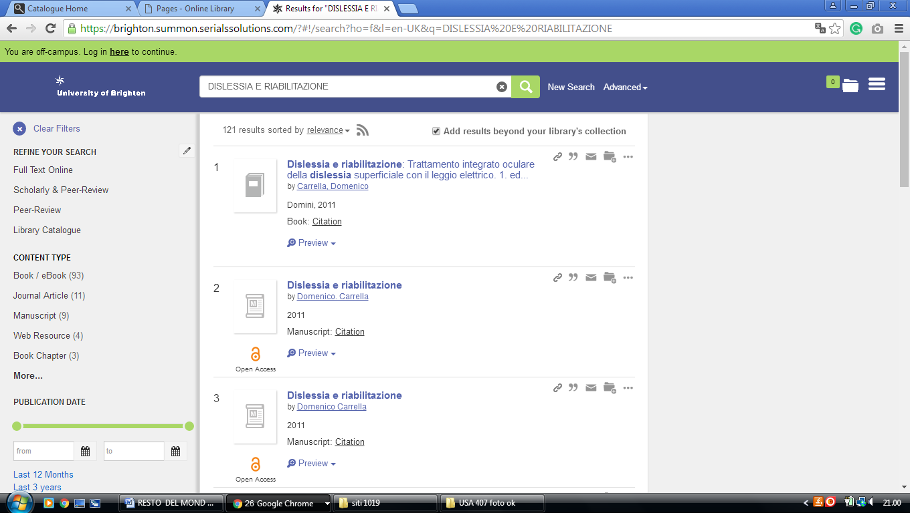

11 HULL.SUMMON.SERIALSSOLUTIONS.COM - (University Of Hull
Library, Hull, England)
http://hull.summon.serialssolutions.com/search/results?s.fvf%5B%5D=ContentType%2CNewspaper+Article%2Ct&s.fvf%5B%5D=ContentType%2CBook+Review%2Ct&s.fvf%5B%5D=IsFullText%2Ctrue&s.q=dislessia+e+riabilitazione&spellcheck=true#!/search?ho=f&fvf=ContentType,Newspaper%20Article,t%7CContentType,Book%20Review,t&l=en&q=dislessia%20e%20riabilitazione

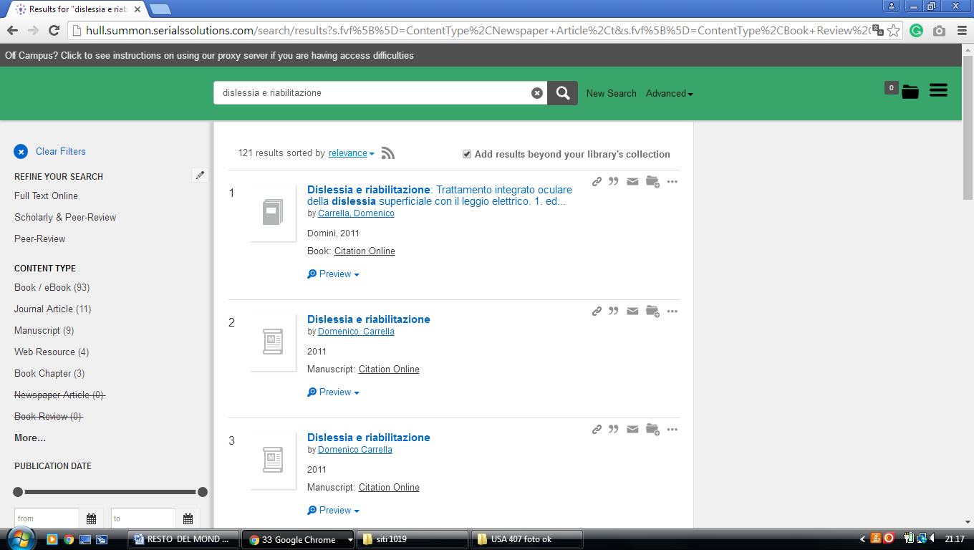

12 UNIVERSITY OF LONDON - ROYAL HOLLOWAY LIBRARY EGHAM -(England)
http://librarysearch.rhul.ac.uk/primo_library/libweb/action/search.do?ct=facet&pcAvailabiltyMode=true&pcAvailClicked=true&query=any%2Ccontains%2Cdislessia%20e%20riabilitazione&indx=1&fn=search&dscnt=0&search_scope=LSCOP_44ROY_ALL&scp.scps=scope%3A(44ROY)%2Cprimo_central_multiple_fe%2C44ROY_EbscoLocal&vid=44ROY_VU2&onCampus=false&ct=search&institution=44ROY&bulkSize=10&highlight=true&tab=tab1&d_query=dislessia%20e%20riabilitazione&displayField=title&dym=true&vl(656868514UI0)=any&vl(freeText0)=dislessia%20e%20riabilitazione&fromLogin=true&dstmp=1518294209472&fromDL

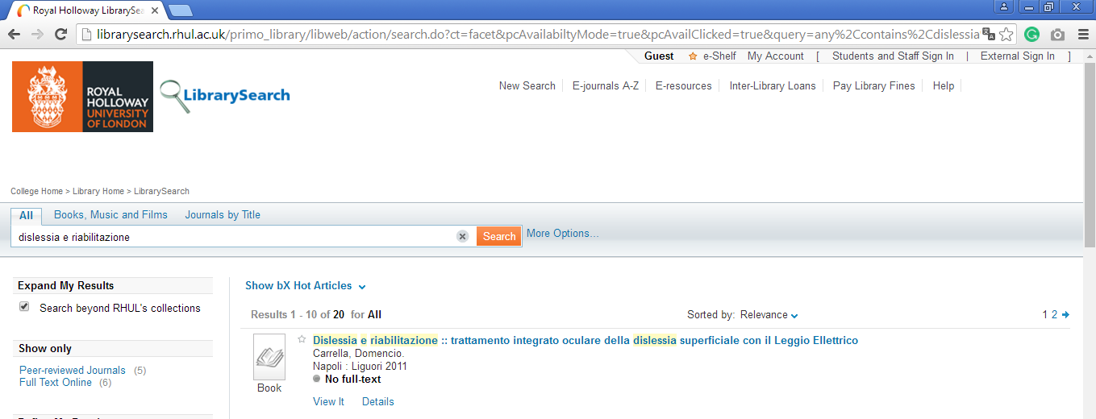

13 LIBRARY – UNIVERSITY OF READING - (England)
http://reading.summon.serialssolutions.com/?keep_r=true&s.fvf%5B%5D=IsFullText%2Ctrue&s.q=dislessia+e+riabilitazione&utf8=%E2%9C%93#!/search?ho=f&l=en&q=dislessia%20e%20riabilitazione

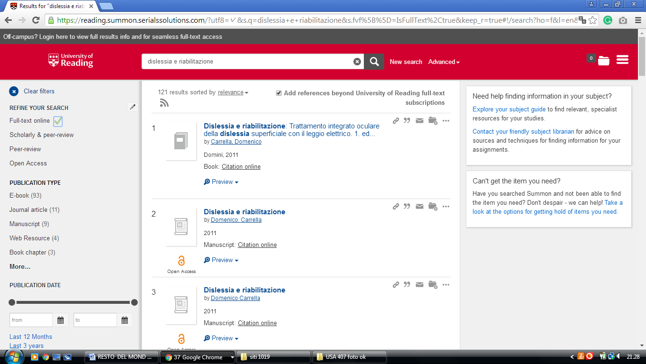

14 ANGLIA RUSKIN UNIVERSITY LIBRARY - (Cambridge, England)
https://primo.anglia.ac.uk/primo-explore/search?query=any,contains,dislessia%20e%20riabilitazione&tab=default_tab&search_scope=CSCOP_APU_DEEP&vid=ANG_VU1&offset=0&sortby=rank&pcAvailability=true

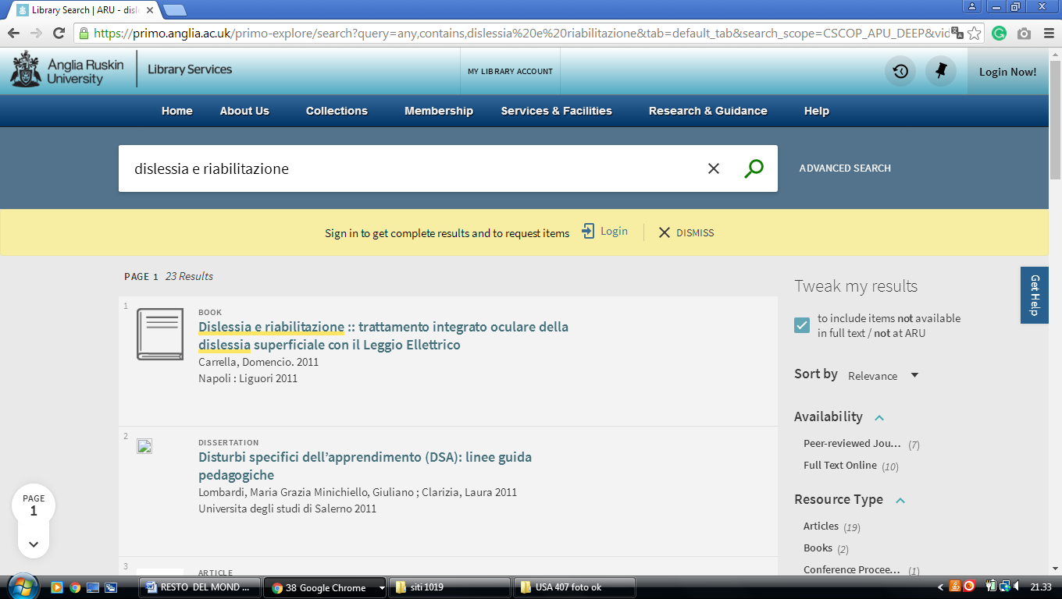

15 Library | Brunel University London – (England)
http://brunel.summon.serialssolutions.com/search?spellcheck=true&s.q=dislessia+e+riabilitazione#!/search?ho=f&l=en-UK&q=dislessia%20e%20riabilitazione

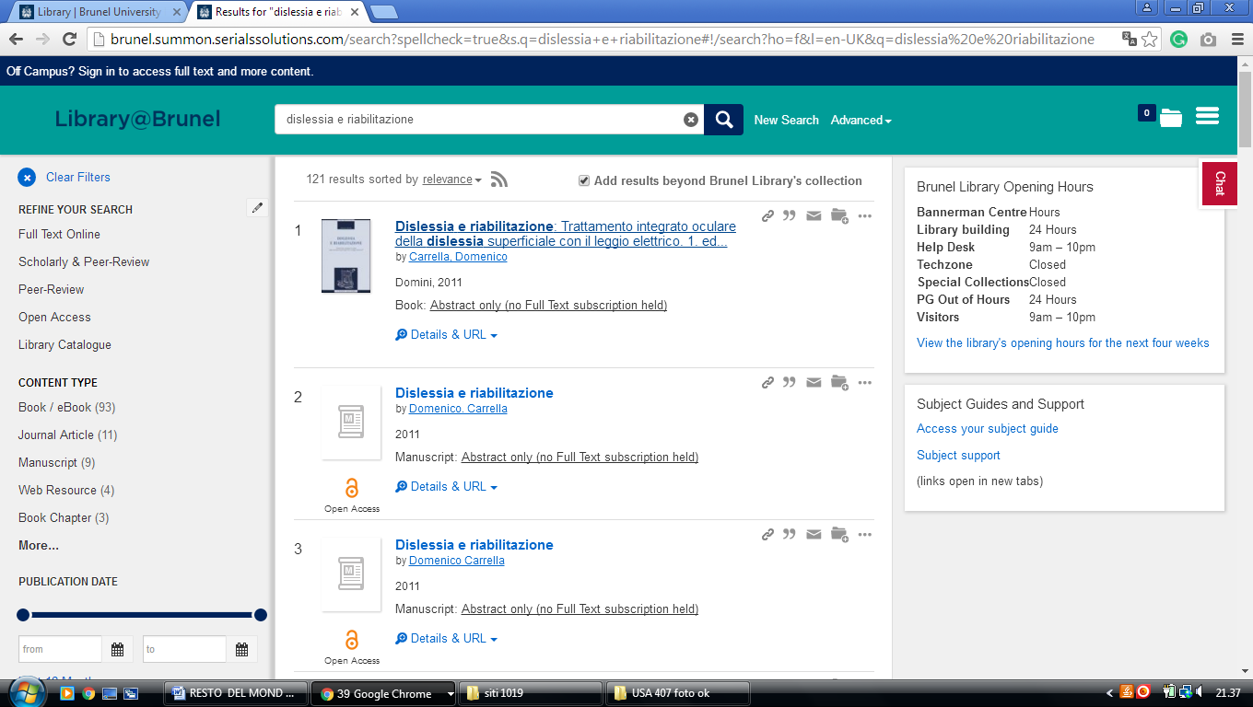

16 CITY UNIVERSITY LIBRARY – (London, England)
https://city.summon.serialssolutions.com/?s.q=dislessia+e+riabilitazione&s.cmd=&s.cmd=addFacetValueFilters%28ContentType%2CBook+Review%3At%29&s.cmd=addFacetValueFilters%28ContentType%2CNewspaper+Article%3At%29#!/search?ho=f&fvf=ContentType,Book%20Review,t%7CContentType,Newspaper%20Article,t&l=en-UK&q=dislessia%20e%20riabilitazione

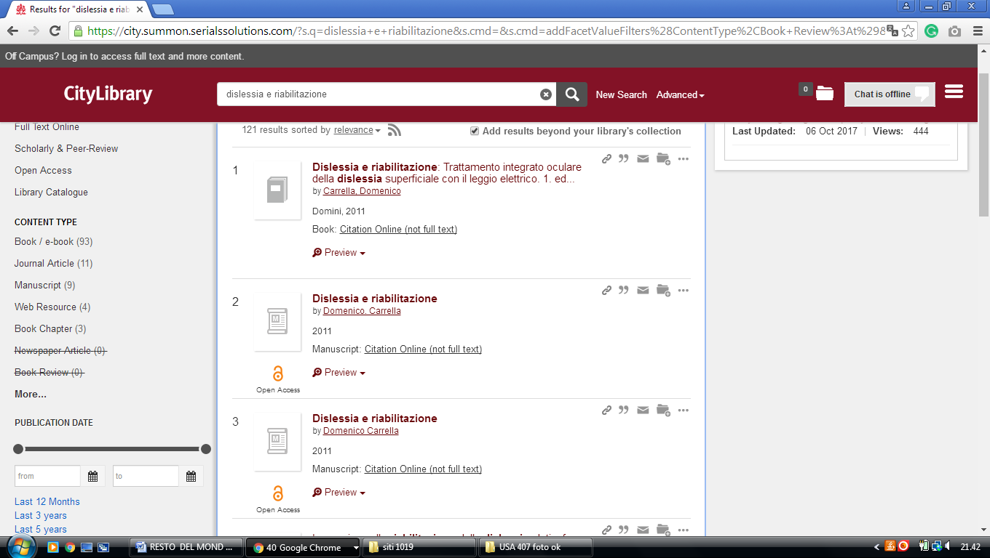

17 DE MONTFORT UNIVERSITY LIBRARY - (Leicester, England)
https://dmu.summon.serialssolutions.com/?q=dislessia+e+riabilitazione#!/search?ho=f&l=it-IT&q=dislessia%20e%20riabilitazione

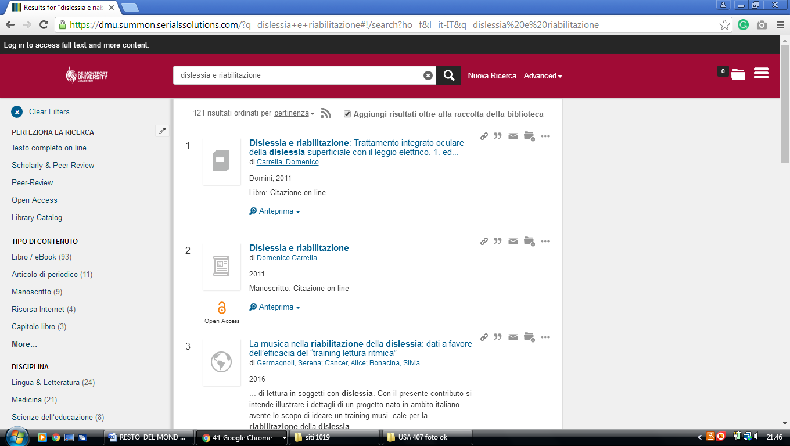

18 LIBRARY LIBRARY - QUEEN MARY UNIVERSITY OF LONDON – (England)
http://qmul.summon.serialssolutions.com/search?utf8=%E2%9C%93&s.q=DISLESSIA+E+RIABILITAZIONE#!/search?ho=f&l=en-UK&q=DISLESSIA%20E%20RIABILITAZIONE

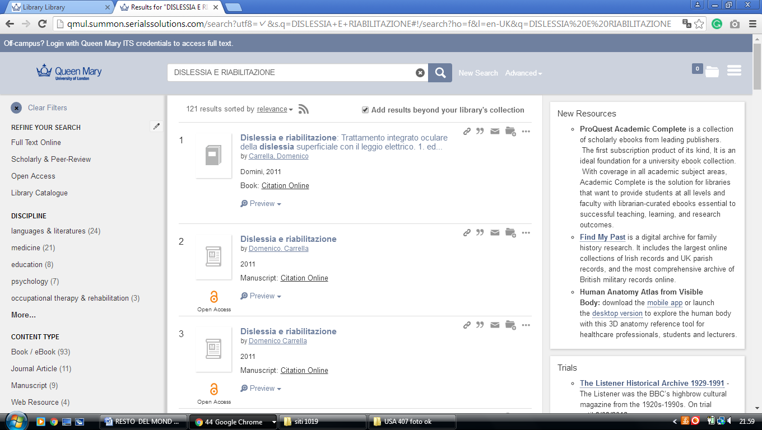
-------------------------------------------------------------------------------------------------------------------------------

19 MANCHESTER METROPOLITAN UNIVERSITY LIBRARY - (Manchester,
England)
https://mmulibrary.summon.serialssolutions.com/search/?spellcheck=true&keep_r=true&s.q=dislessia+e+riabilitazione&s.cmd=#!/search?ho=f&l=en-UK&q=dislessia%20e%20riabilitazione

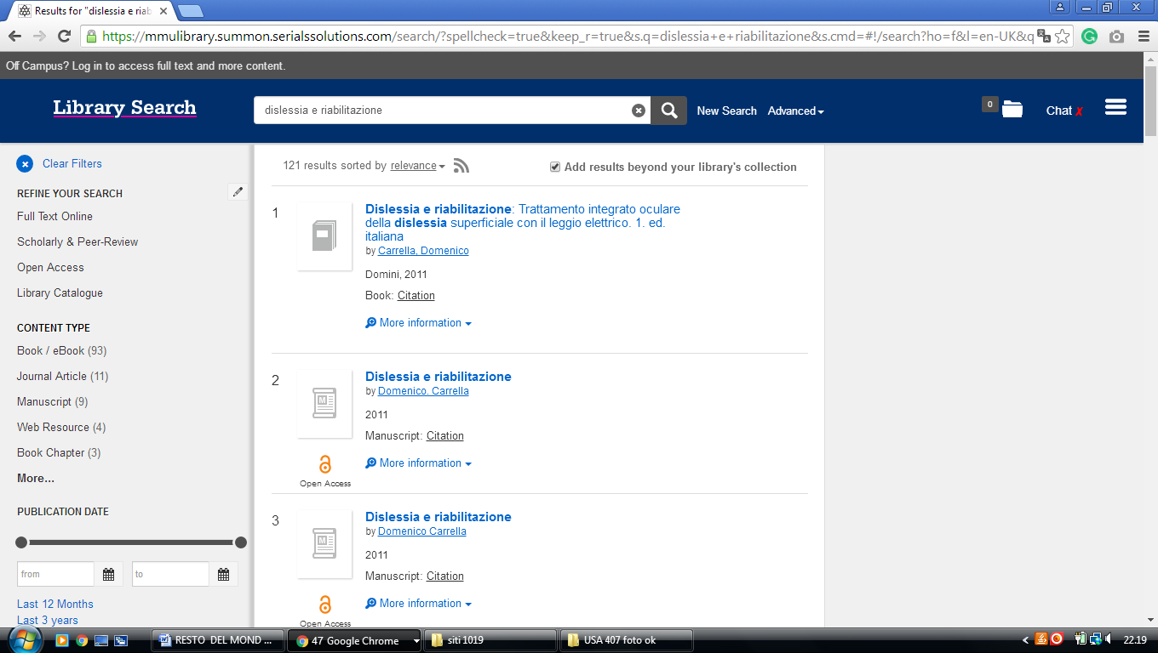

20 STAFFORDSHIRE UNIVERSITY LIBRARY – (Stoke on Trent, England)
https://staffs.summon.serialssolutions.com/search?s.q=dislessia+e+riabilitazione&spellcheck=true&keep_r=true&suggest=true&popup=true#!/search?ho=f&l=en-UK&q=dislessia%20e%20riabilitazione

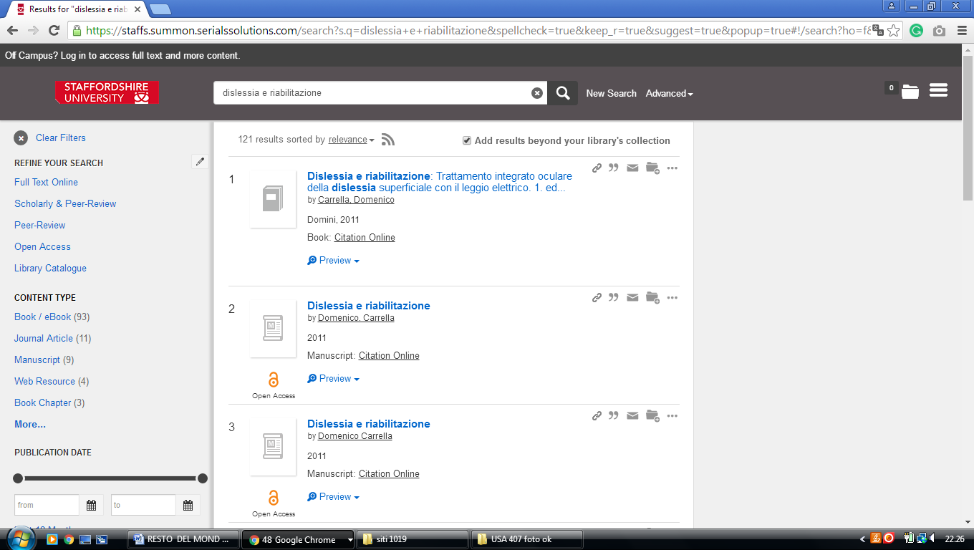

21 TEESSIDE UNIVERSITY LIBRARY – (Middlesbrough, England)
http://tees.summon.serialssolutions.com/search?q=dislessia+e+riabilitazione&spellcheck=true&keep_r=true#!/search?ho=f&l=en-UK&q=dislessia%20e%20riabilitazione

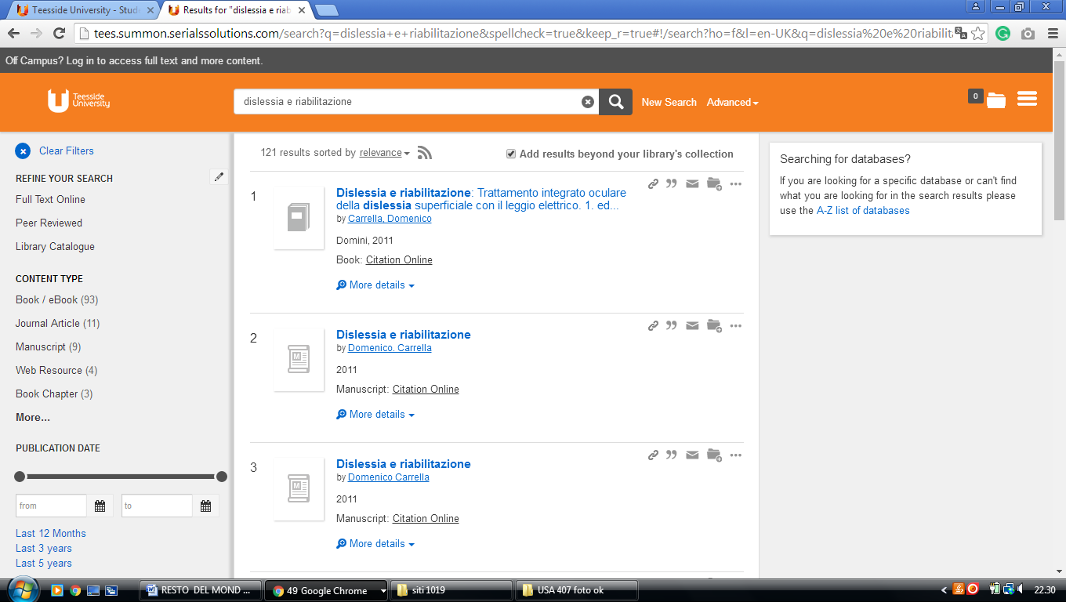

22 UNIVERSITY OF BRADFORD LIBRARY - (Bradford, England)
https://bradford.summon.serialssolutions.com/search?q=dislessia%20e%20riabilitazione#!/search?ho=f&l=en-UK&q=dislessia%20e%20riabilitazione

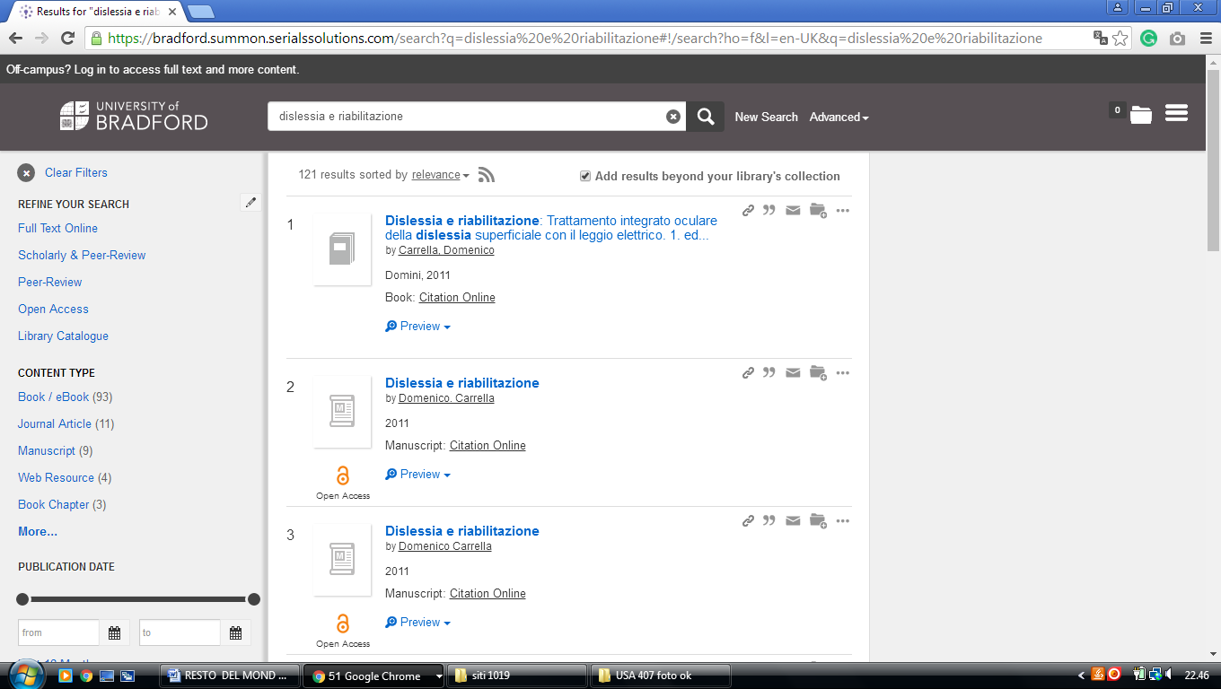

23 UNIVERSITY OF EAST ANGLIA LIBRARY – (Norwich, England)
http://eds.a.ebscohost.com/eds/results?vid=0&sid=3883324c-26f4-49f6-ac10-33db62868029%40sessionmgr4006&bquery=(dislessia+e+riabilitazione)&bdata=JmNsaTA9RlQxJmNsdjA9WSZ0eXBlPTAmc2l0ZT1lZHMtbGl2ZSZzY29wZT1zaXRl

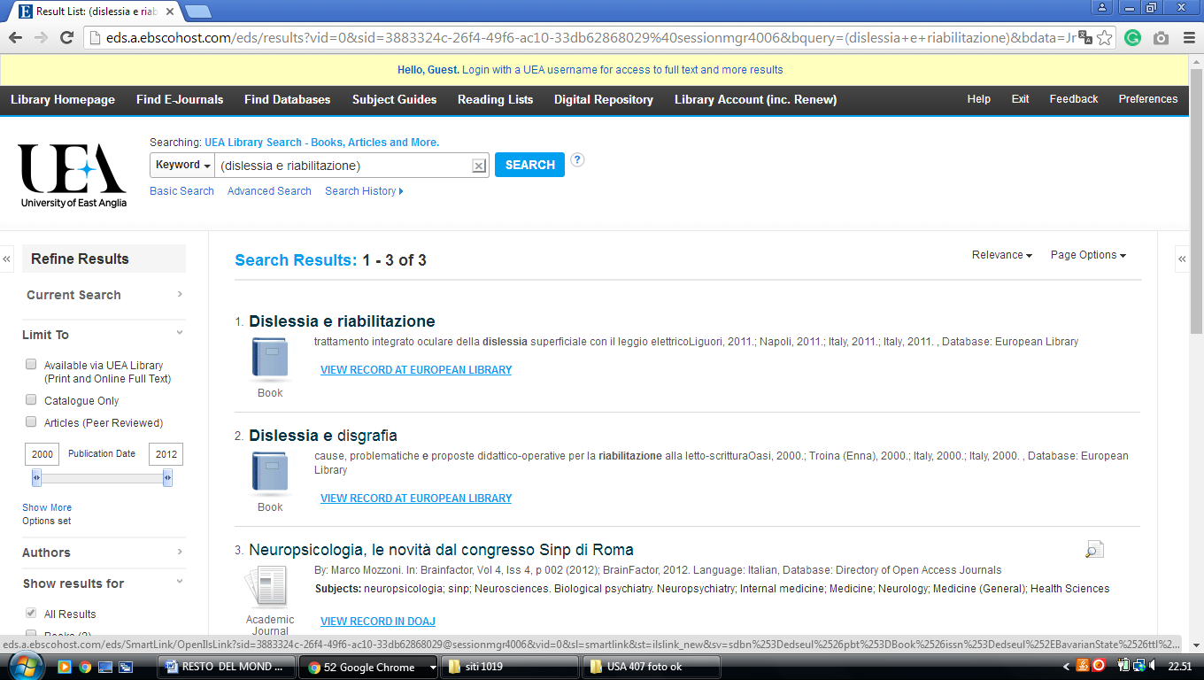

24 HULL.SUMMON.SERIALSSOLUTIONS.COM – (Library University
of Hull, England)
http://hull.summon.serialssolutions.com/search/results?s.fvf%5B%5D=ContentType%2CNewspaper+Article%2Ct&s.fvf%5B%5D=ContentType%2CBook+Review%2Ct&s.fvf%5B%5D=IsFullText%2Ctrue&s.q=dislessia+e+riabilitazione&spellcheck=true#!/search?ho=f&l=en&q=dislessia%20e%20riabilitazione

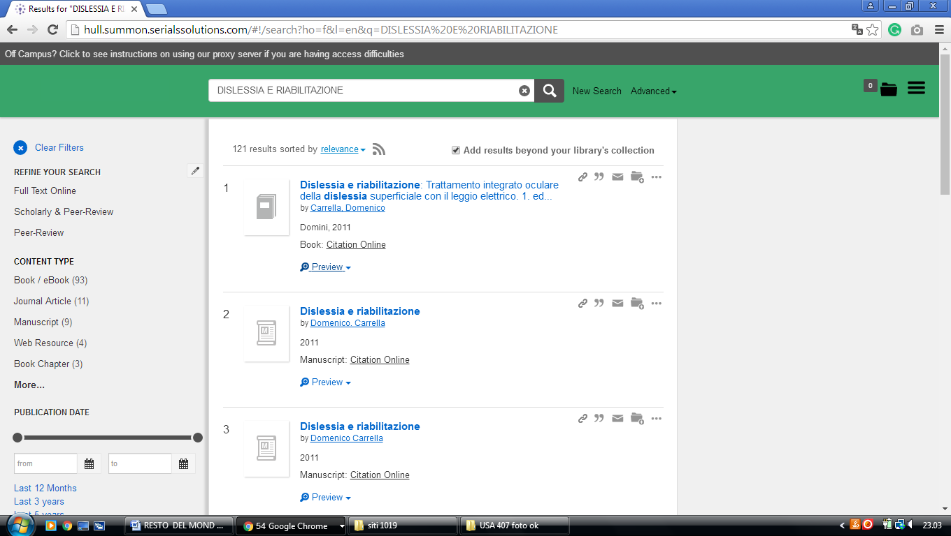

25 LIBRARY UNIVERSITY OF LONDON - ROYAL HOLLOWAY - (Egham,
England)
http://librarysearch.rhul.ac.uk/primo_library/libweb/action/search.do?ct=facet&pcAvailabiltyMode=true&pcAvailClicked=true&query=any%2Ccontains%2Cdislessia%20e%20riabilitazione&indx=1&fn=search&dscnt=0&search_scope=LSCOP_44ROY_ALL&scp.scps=scope%3A(44ROY)%2Cprimo_central_multiple_fe%2C44ROY_EbscoLocal&vid=44ROY_VU2&onCampus=false&ct=search&institution=44ROY&bulkSize=10&highlight=true&tab=tab1&d_query=dislessia%20e%20riabilitazione&displayField=title&dym=true&vl(656868514UI0)=any&vl(freeText0)=dislessia%20e%20riabilitazione&fromLogin=true&dstmp=1518301041536&fromDL
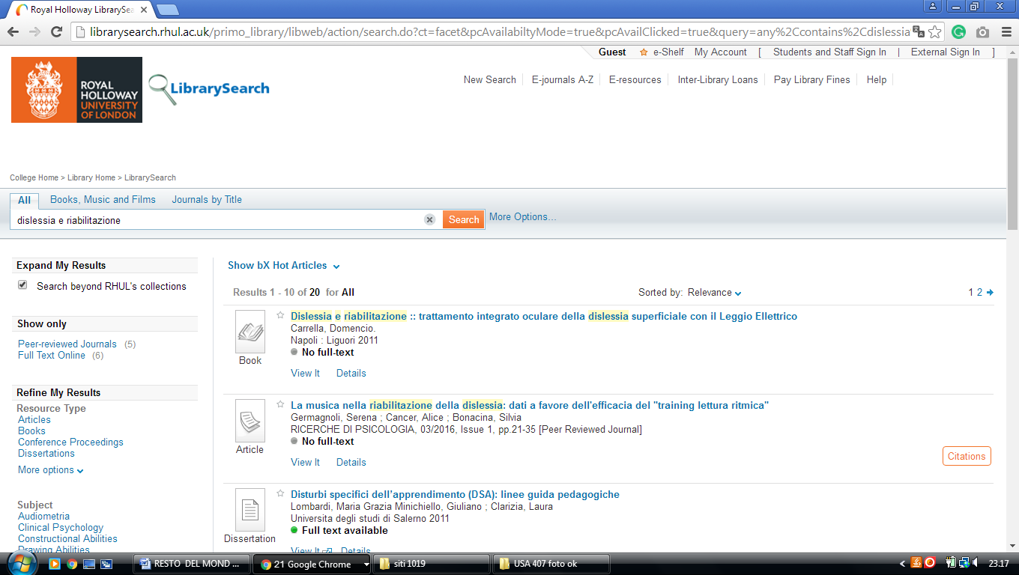

26 LIBRARY UNIVERSITY OF THE WEST OF ENGLAND – (Bristol, England)
http://uwe.summon.serialssolutions.com/search?q=dislessia+e+riabilitazione#!/search?ho=f&l=en-UK&q=dislessia%20e%20riabilitazione

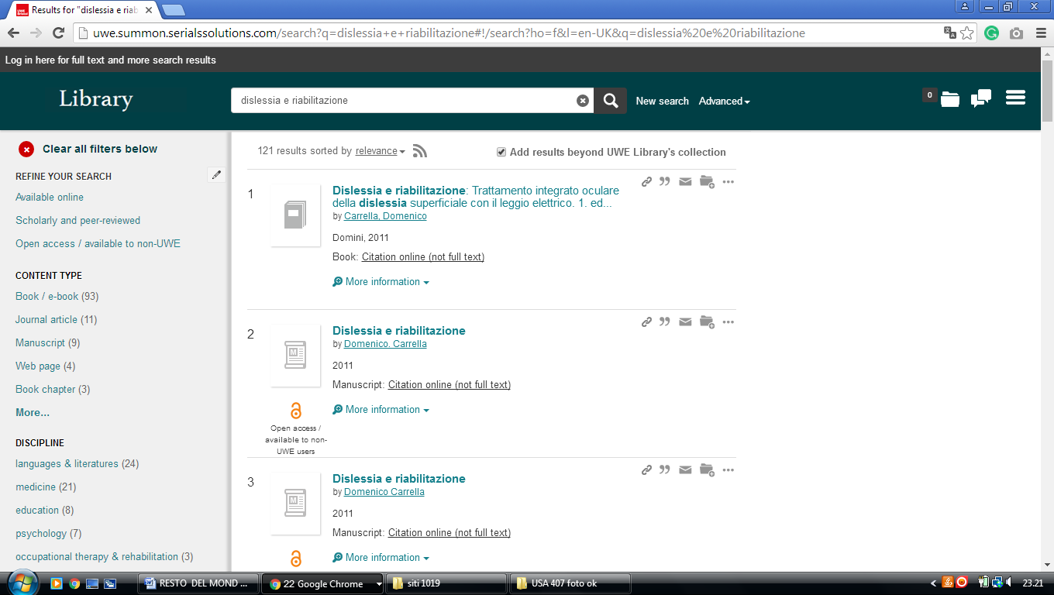


UNIVERSITY OF WOLVERHAMPTON LIBRARY
Wolverhampton, England

27 LIBRARY UNIVERSITY OF BRADFORD, UK - (Bradford, West Yorkshire, England)
https://bradford.summon.serialssolutions.com/search?q=dislessia%20e%20riabilitazione#!/search?ho=f&l=en-UK&q=dislessia%20e%20riabilitazione

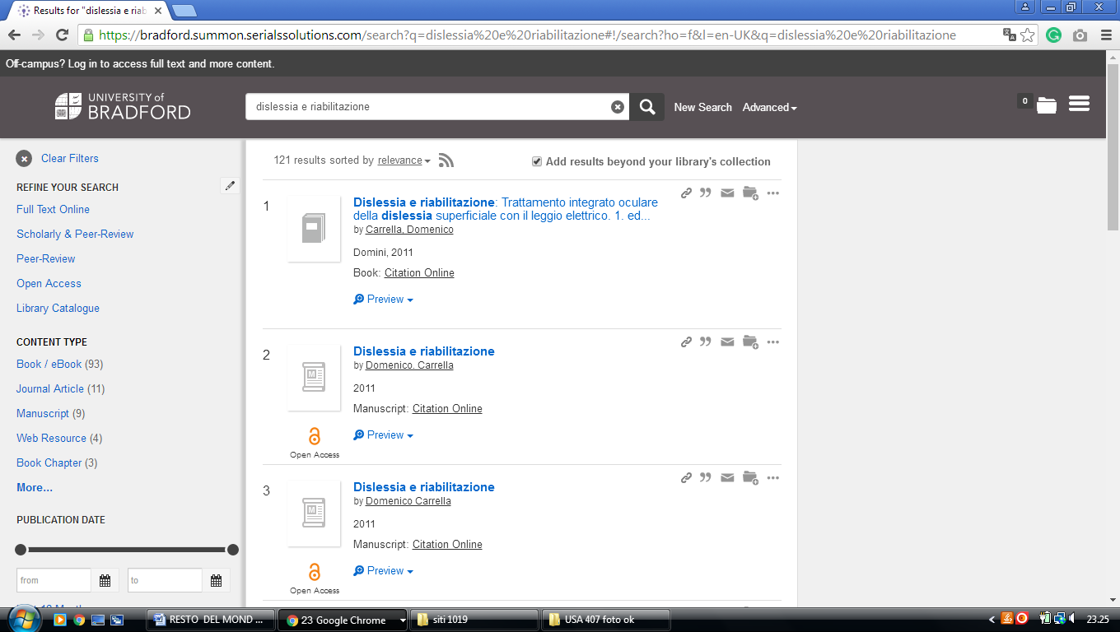

28 LIBRARY | THE UNIVERSITY OF EDINBURGH (England)
https://discovered.ed.ac.uk/primo-explore/search?institution=44UOE&vid=44UOE_VU2&search_scope=default_scope&query=any,contains,dislessia%20e%20riabilitazione&pcAvailabiltyMode=true&sortby=rank&pcAvailability=true

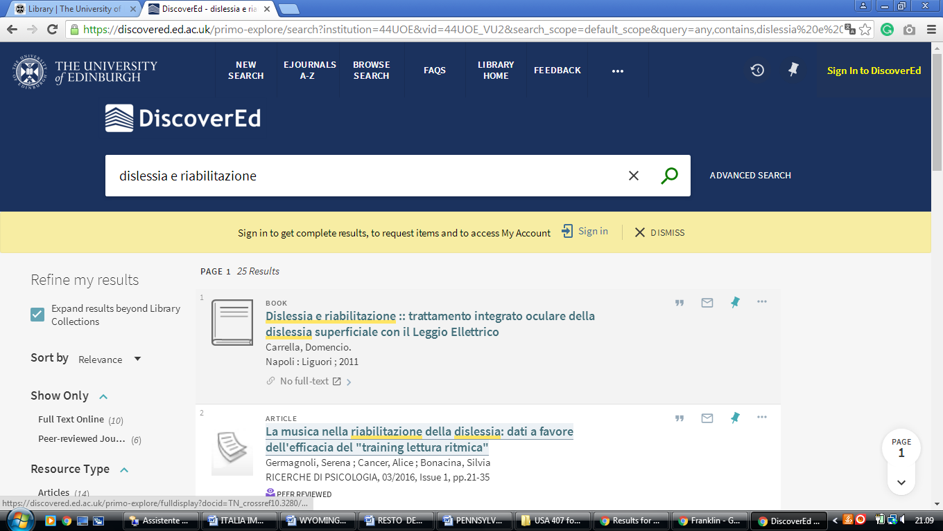

29 WELCOME TO THE LIBRARY | UNIVERSITY OF BOLTON - (England)
http://bolton.summon.serialssolutions.com/#!/search?ho=f&l=en-UK&q=dislessia%20e%20riabilitazione
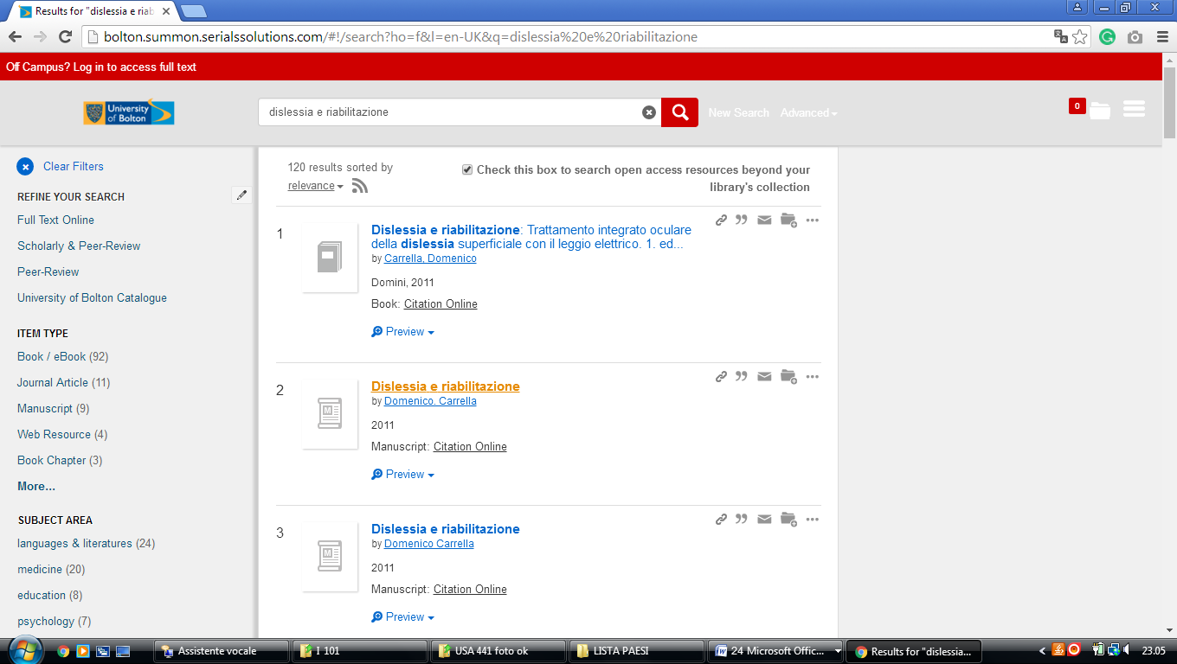

30 UNIVERSITY COLLEGE LONDON - THE EUROPEAN LIBRARY- (England)
http://www.theeuropeanlibrary.org/tel4/contributor/P01376
http://www.theeuropeanlibrary.org/tel4/search?query=dislessia%20e%20riabilitazione

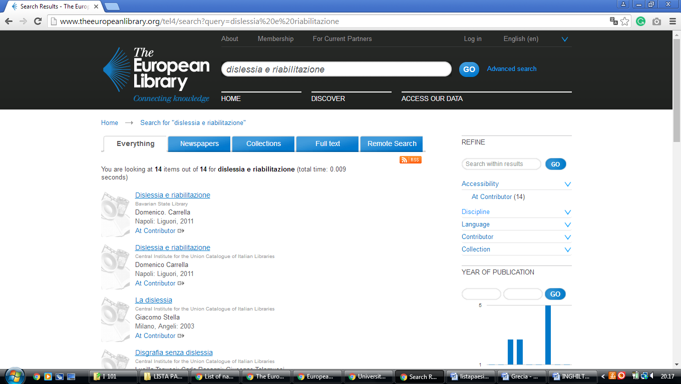

31 LIBRARY HOMEPAGE - LIBRARY – UNIVERSITY OF READING – (Reading England)
https://reading.summon.serialssolutions.com/?utf8=%E2%9C%93&s.q=dislessia+e+riabilitazione&s.fvf%5B%5D=IsFullText%2Ctrue&keep_r=true#!/search?ho=f&l=en&q=dislessia%20e%20riabilitazione
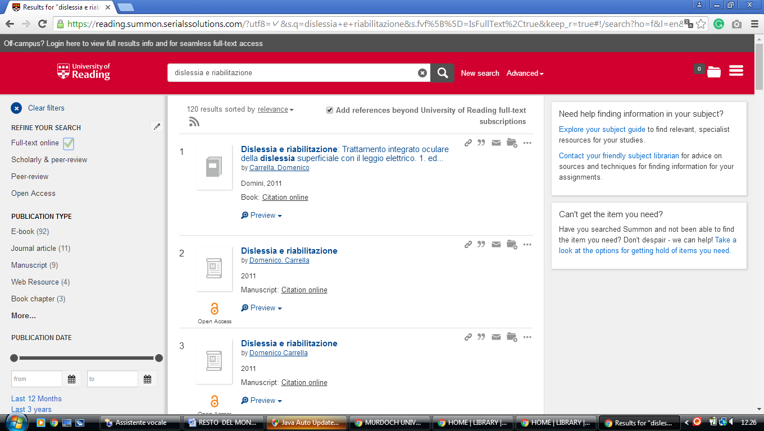

32 UNIVERSITY OF BOLTON - RAS AL KHAIMAH ACADEMIC CENTRE – (England)
https://bolton.summon.serialssolutions.com/#!/search?ho=f&l=en-UK&q=dislessia%20e%20riabilitazione
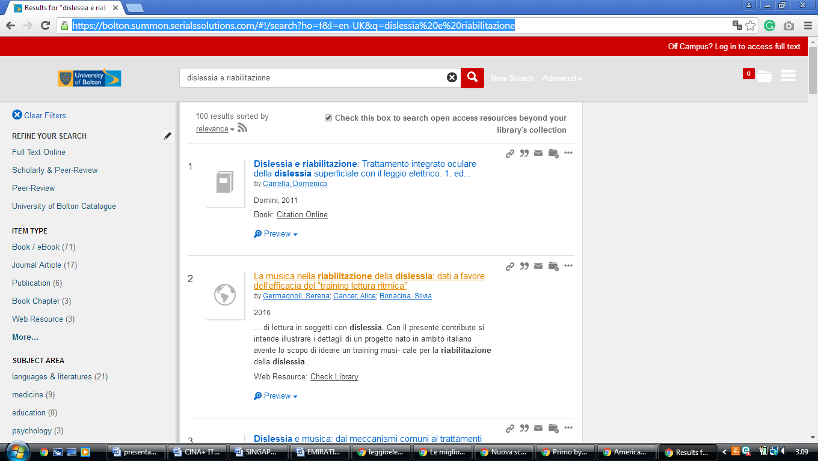

University of Hull Library

University of Hull
https://hull.summon.serialssolutions.com/search/results?spellcheck=true&s.q=&button=#!/search?ho=f&l=en&q=dislessia%20e%20riabilitazione

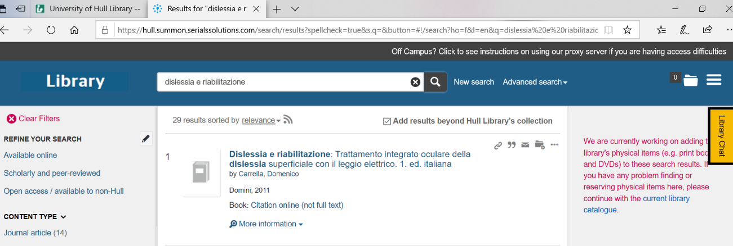

University Of Glasgow Library
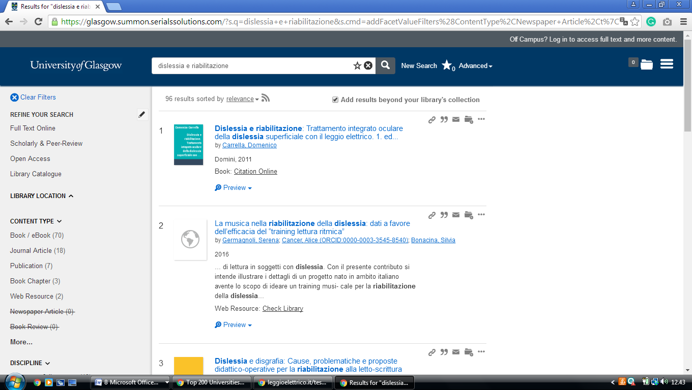
https://glasgow.summon.serialssolutions.com/?s.q=dislessia+e+riabilitazione&s.cmd=addFacetValueFilters%28ContentType%2CNewspaper+Article%2Ct%7CContentType%2CBook+Review%2Ct%29#!/search?ho=f&fvf=ContentType,Newspaper%20Article,t%7CContentType,Book%20Review,t&l=en-UK&q=dislessia%20e%20riabilitazione

Library Home - University of Wolverhampton
https://librarysearch.wlv.ac.uk/discovery/search?query=any,contains,dislessia%20e%20riabilitazione&tab=ALL&search_scope=MyInst_and_CI&vid=44UOWO_INST:MAIN&offset=0&pcAvailability=true
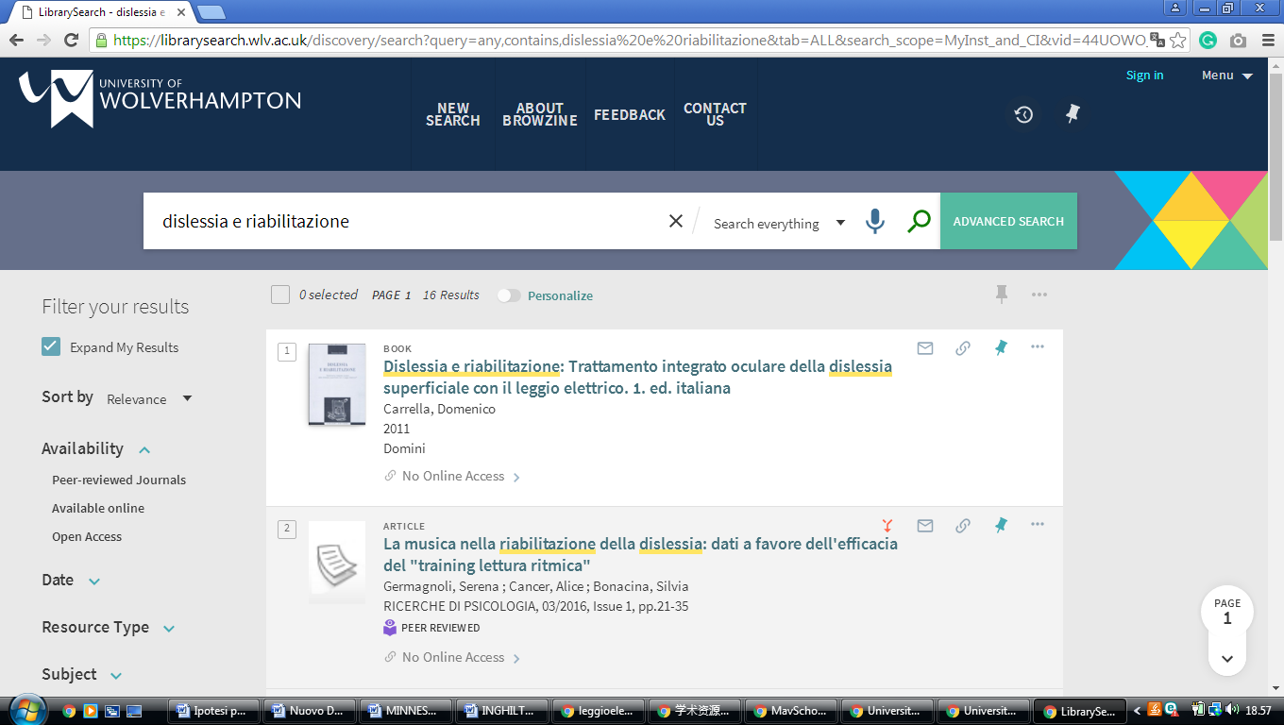

Wiggins Memorial Library

Campbell University
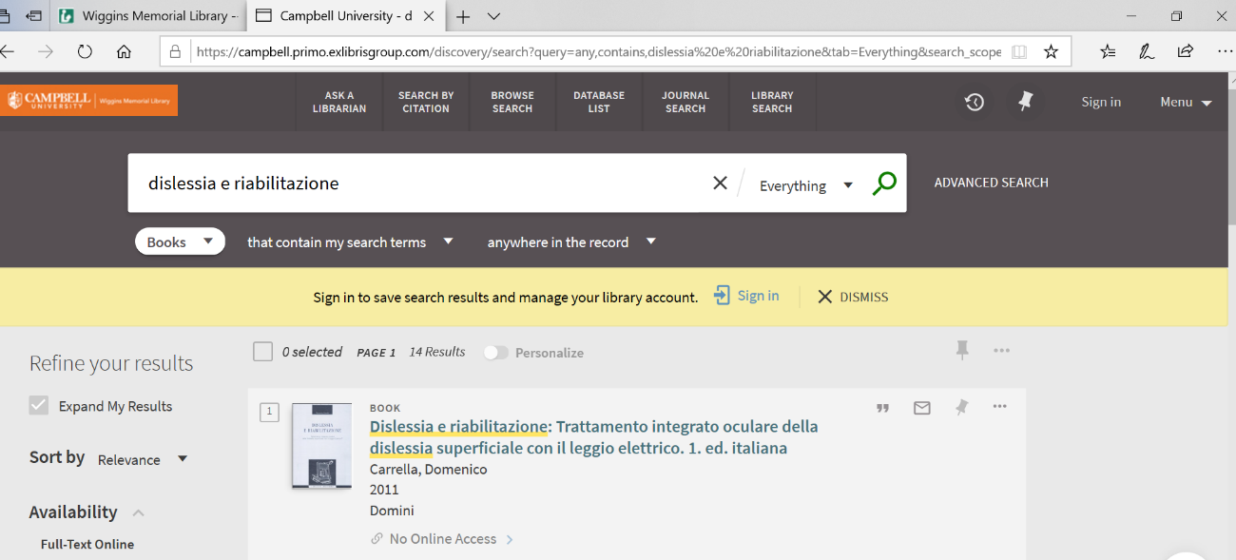
https://campbell.primo.exlibrisgroup.com/discovery/search?query=any,contains,dislessia%20e%20riabilitazione&tab=Everything&search_scope=MyInst_and_CI&vid=01CAMPBELL_INST:01CAMPBELL&offset=0&pcAvailability=true

