1 HOME - UCC LIBRARY HOME - UCC LIBRARY AT UNIVERSITY COLLEGE CORK – (Irlanda)
http://ucc.summon.serialssolutions.com/?q=dislessia+e+riabilitazione#!/search?ho=f&l=it-IT&q=dislessia%20e%20riabilitazione
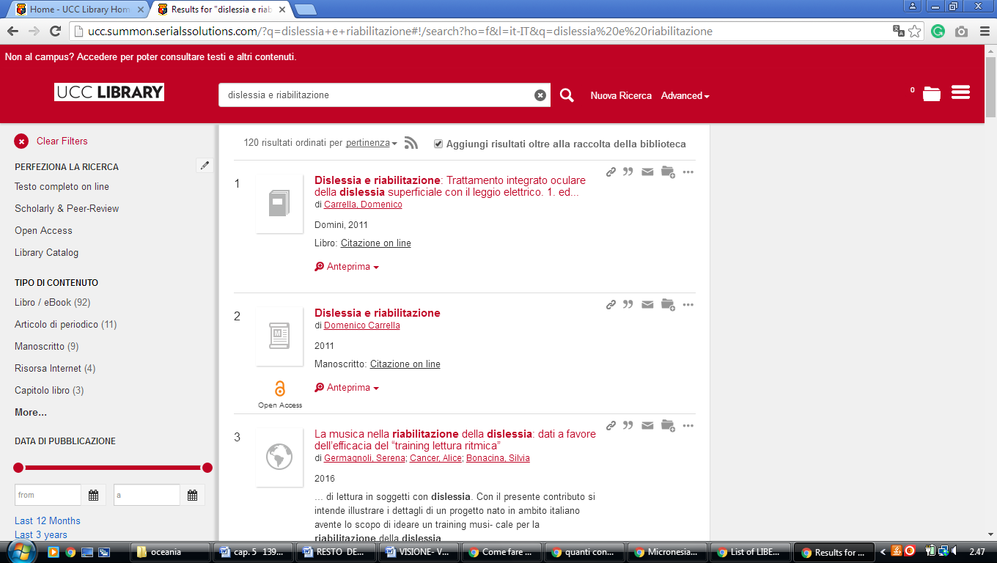

2 CORK INSTITUTE OF TECHNOLOGY LIBRARY – (Bishopstown, Ireland)
https://cit.summon.serialssolutions.com/search?SORT=%2BZ&sortdropdown=-&searchlimits=&page=search&searchMethod=2&idx=kw&q=dislessia+e+riabilitazione#!/search?ho=f&l=en&SORT=%2BZ&sortdropdown=-&page=search&searchMethod=2&idx=kw&q=dislessia%20e%20riabilitazione
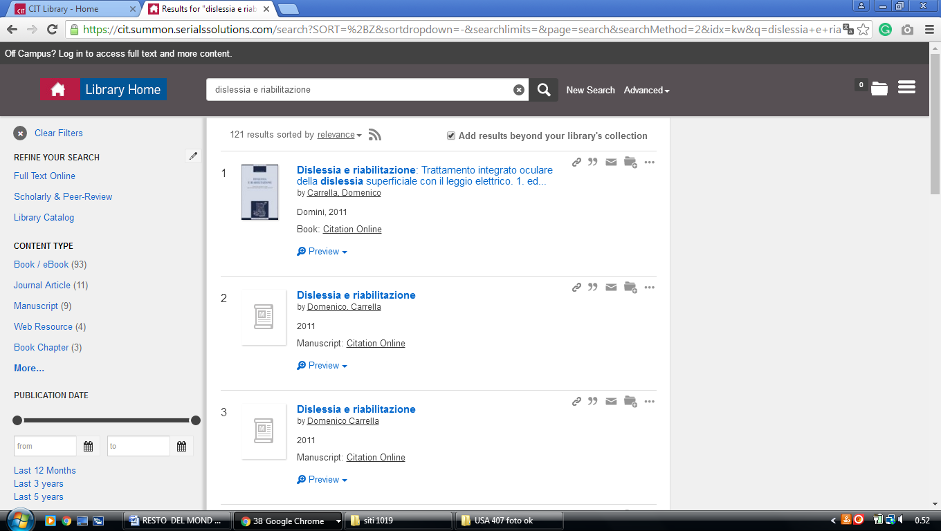

3 LIBRARY | MAYNOOTH UNIVERSITY – (Ireland)
http://nuim.summon.serialssolutions.com/search?ho=t&keep_r=true&s.q=dislessia+e+riabilitazione&spellcheck=true#!/search?ho=f&l=en&q=dislessia%20e%20riabilitazione

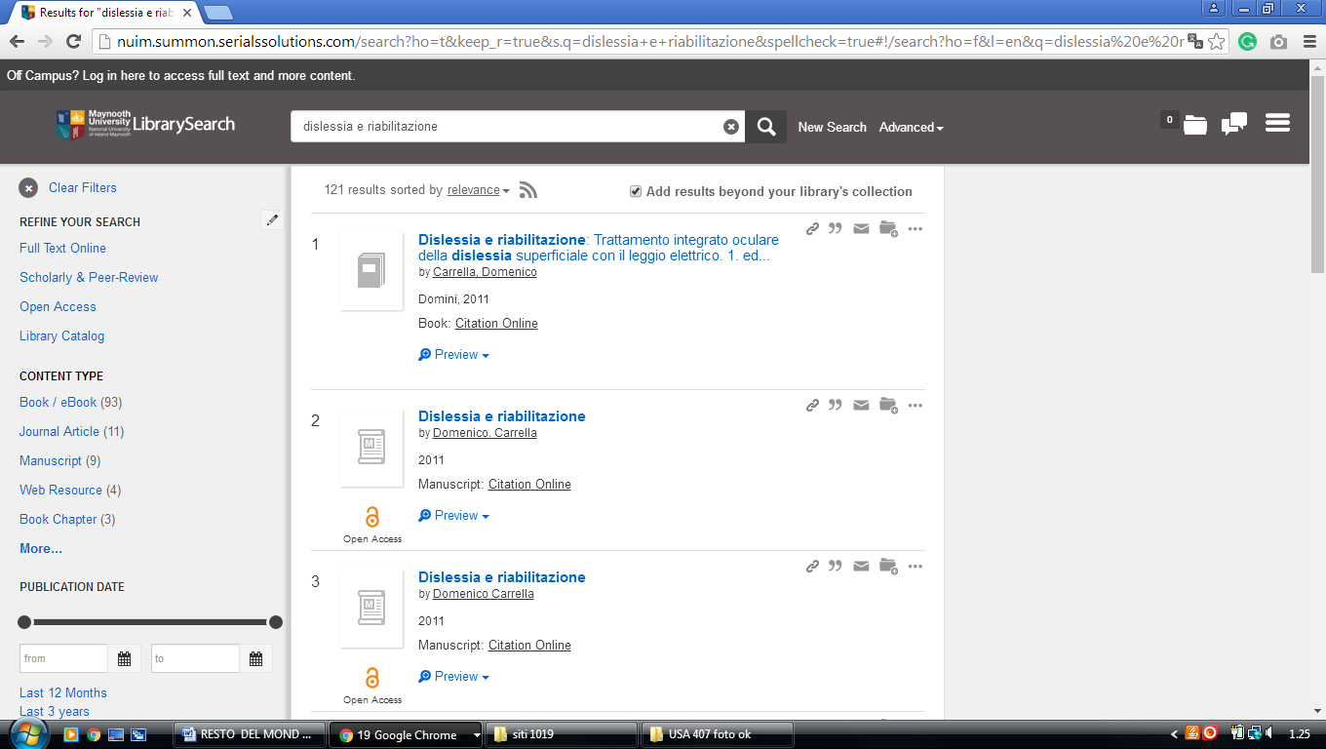

4 UCD LIBRARY – (Dublin, Ireland)
http://ucd.summon.serialssolutions.com/?formids=target&lang=eng&suite=def&s.fvf%5B%5D=ContentType%2CBook+Review%2Ct&reservedids=lang%2Csuite&submitmode=&submitname=&s.q=dislessia+e+riabilitazione&button=#!/search?ho=f&fvf=ContentType,Book%20Review,t&l=en&q=dislessia%20e%20riabilitazione

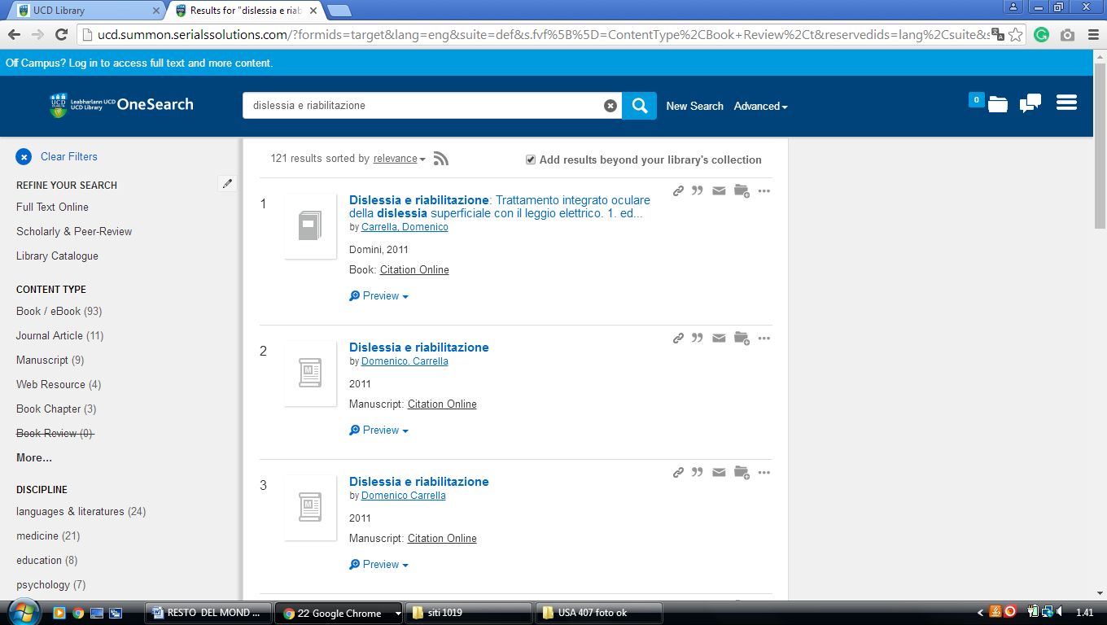

5 LIBRARY UNIVERSITÀ OF LIMERICK – (Limerick, Ireland)
https://ul-ie-primo.hosted.exlibrisgroup.com/primo-explore/search?tab=tab1&search_scope=CSCOP_EVERYTHING&vid=353UOL_VU1&lang=en_US&offset=0&query=any,contains,DISLESSIA%20E%20RIABILITAZIONE&sortby=rank&pcAvailability=true

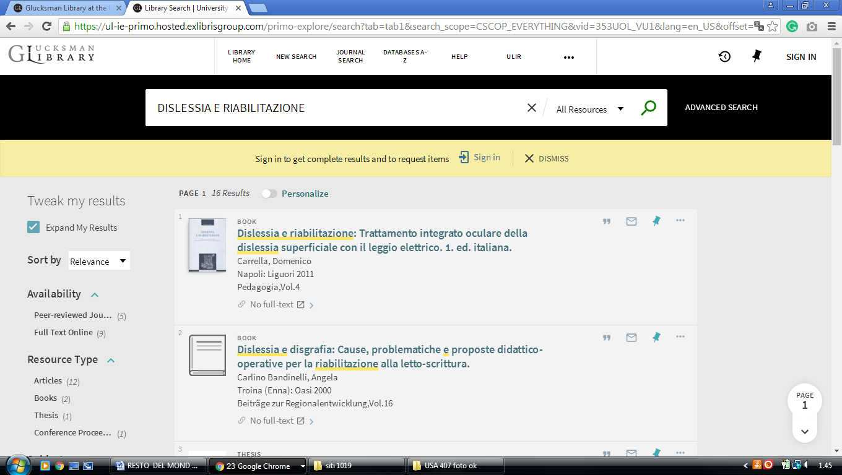

6 LIBRARY QUEEN’S UNIVERSITY OF BELFAST – (Belfast, Northern Ireland)
http://eds.a.ebscohost.com/eds/results?vid=0&sid=3ba45317-e1e7-4c67-baf4-22e3d4c8abc9%40sessionmgr4010&bquery=dislessia+e+riabilitazione&bdata=JmNsaTA9RlQmY2x2MD1ZJnR5cGU9MCZzaXRlPWVkcy1saXZlJnNjb3BlPXNpdGU%3d

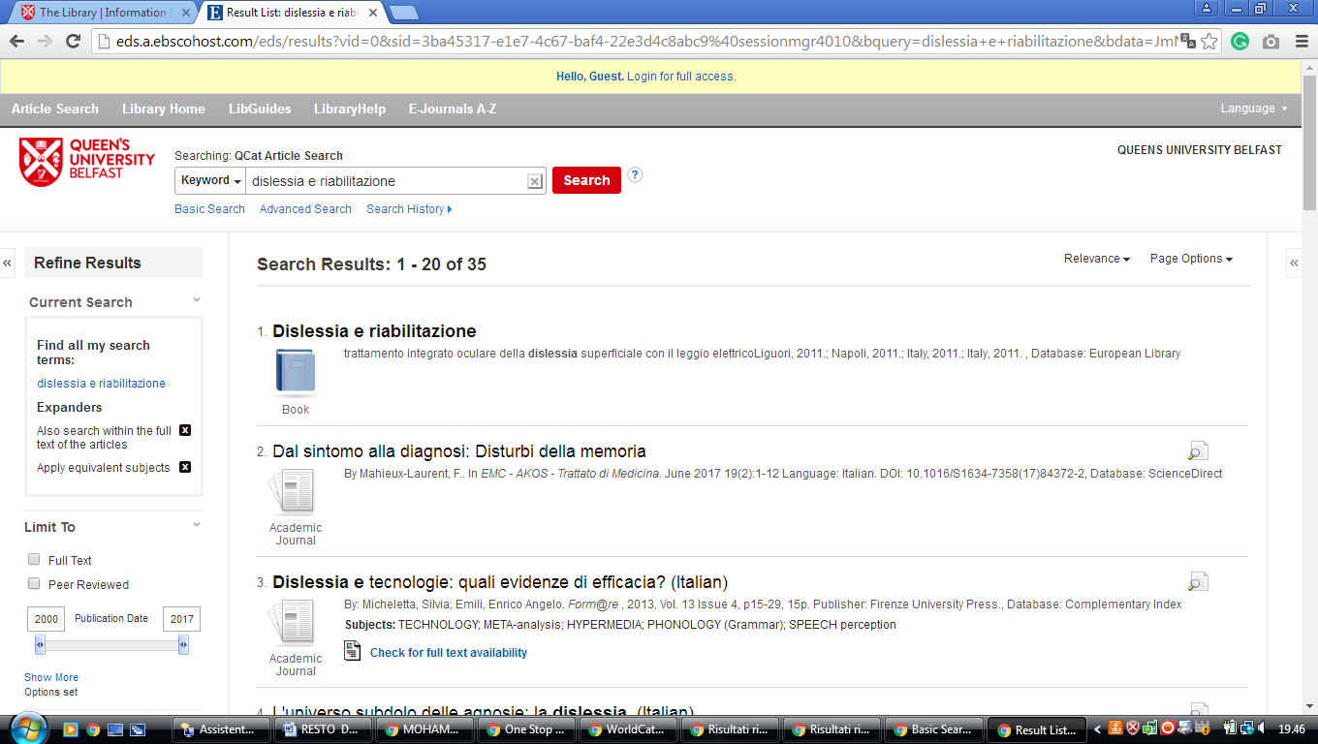

7 TRINITY COLLEGE DUBLIN - THE EUROPEAN LIBRARY- (Dublino, Ireland)
http://www.theeuropeanlibrary.org/tel4/contributor/P01382
http://www.theeuropeanlibrary.org/tel4/search?query=dislessia%20e%20riabilitazione

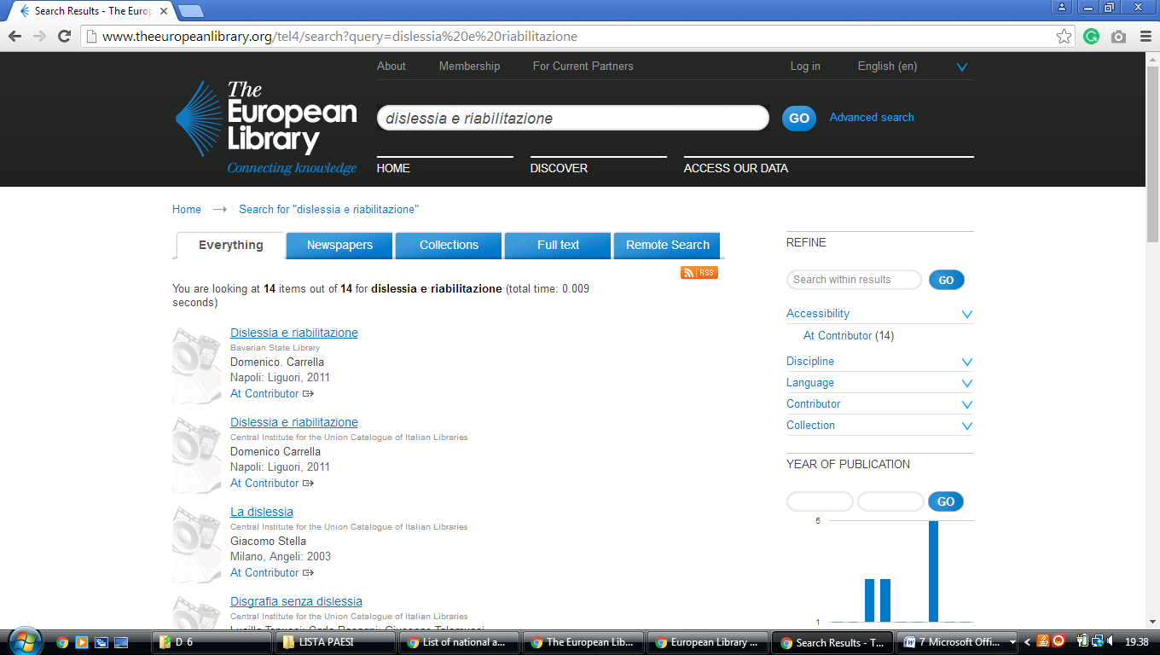

Glucksman Library University of Limerick

https://uol.primo.exlibrisgroup.com/discovery/search?query=any,contains,dislessia%20e%20riabilitazione&tab=TAB1&search_scope=MyInst_and_CI&vid=353UOL_INST:353UOL_VU1&lang=en&offset=0&pcAvailability=true

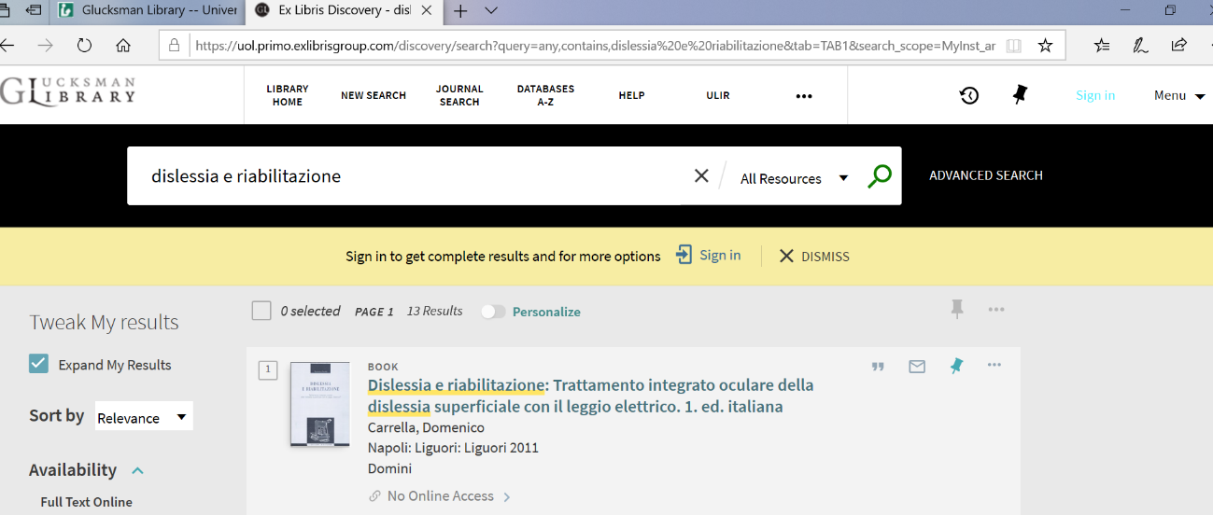

Maynooth University Library Kildare, IRELAND
Russell Library
nuim.summon.serialssolutions.com/search?spellcheck=true&keep_r=true&ho=t&s.q=dislessia+e+riabilitazione#!/search?ho=f&l=en&q=dislessia%20e%20riabilitazione

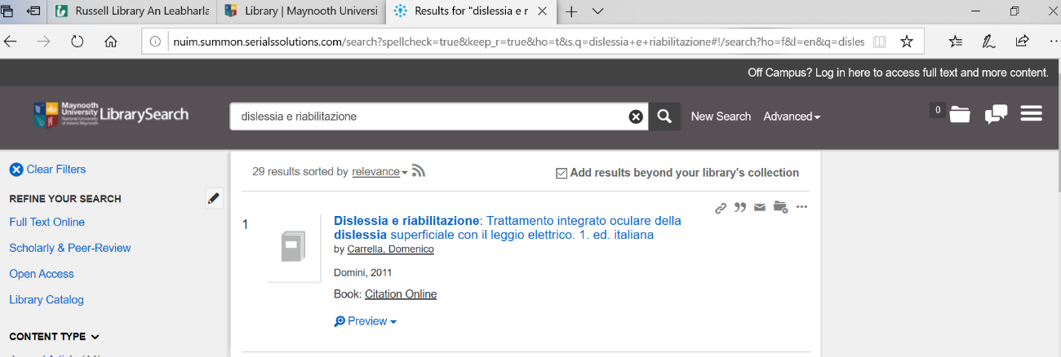

University College, Dublin Library

University College, Dublin
ucd.summon.serialssolutions.com/#!/search?ho=f&l=en&q=dislessia%20e%20riabilitazione
