NAZARBAYEV UNIVERSITY, Nur-Sultan, KAZAKHSTAN

Nazarbayev University Library
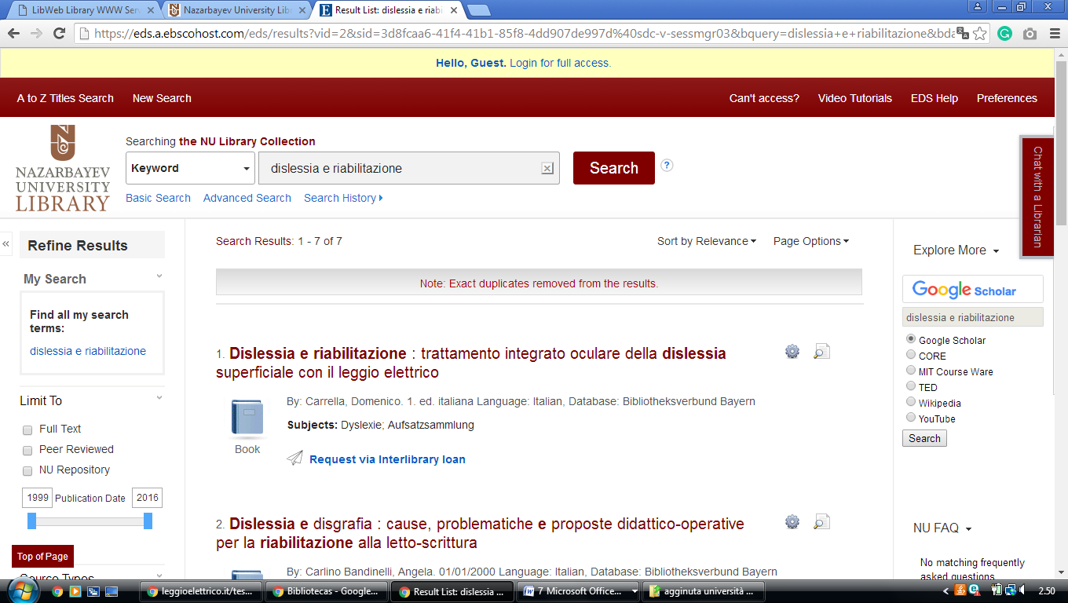

Nazarbayev University Library Astana, KAZAKHSTAN
https://eds.a.ebscohost.com/eds/results?vid=2&sid=3d8fcaa6-41f4-41b1-85f8-4dd907de997d%40sdc-v-sessmgr03&bquery=dislessia+e+riabilitazione&bdata=JnR5cGU9MCZzZWFyY2hNb2RlPUFuZCZzaXRlPWVkcy1saXZl

