1 GULF UNIVERSITY FOR SCIENCE AND TECHNOLOGY LIBRARY – (Kuwait)
https://eds.b.ebscohost.com/eds/results?vid=0&sid=8862e044-f42c-49ba-bff7-c6207dd473b5%40sessionmgr104&bquery=dislessia+e+riabilitazione&bdata=JmNsaTA9RlQmY2x2MD1ZJnR5cGU9MCZzaXRlPWVkcy1saXZl
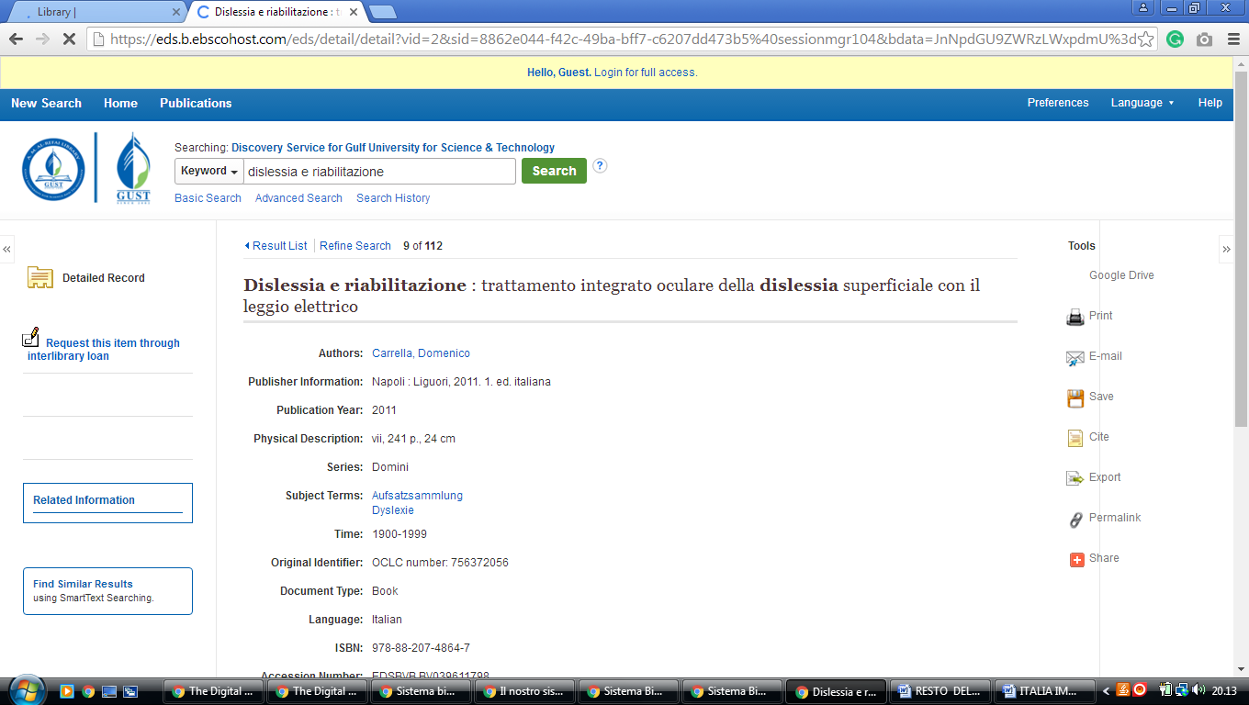

2 AUK: LIBRARY > ABOUT US - (Kuwait)
http://auk.summon.serialssolutions.com/?#!/search?ho=f&l=en&q=dislessia%20e%20riabilitazione
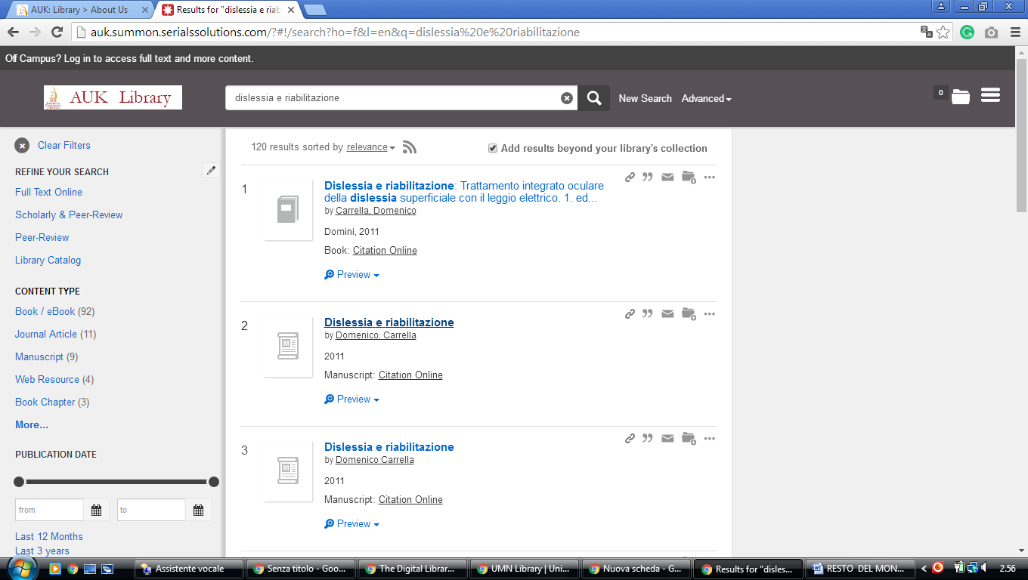

3. KU Library - Kuwait University
http://kuniv.summon.serialssolutions.com/?q=%20%20%20dislessia%20e%20riabilitazione#!/search?ho=f&l=it-IT&q=%20%20%20dislessia%20e%20riabilitazione
