1 LEBANESE AMERICAN UNIVERSITYLIBRARY - (Beirut, Lebanon)
http://lau.summon.serialssolutions.com/?#!/search?ho=f&l=en&q=DISLESSIA%20E%20RIABILITAZIONE

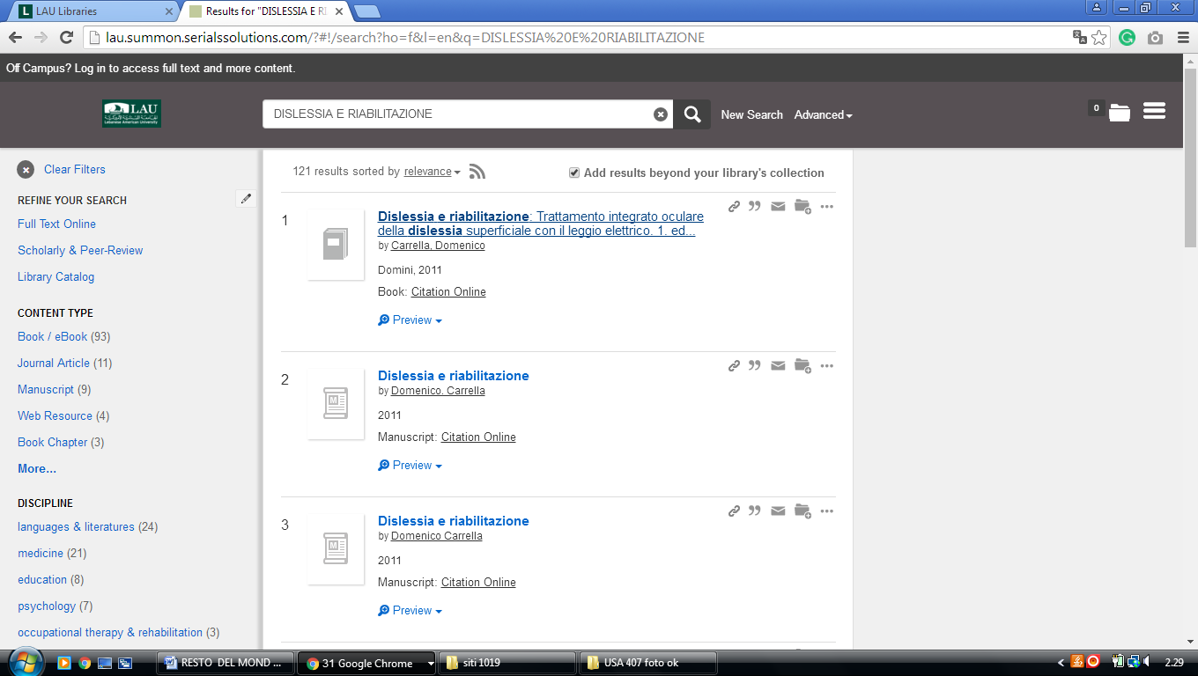
-------------------------------------------------------------------------------------------------------------------------------

2 AMERICAN UNIVERSITY OF BEIRUT - UNIVERSITY LIBRARIES - HOME
(Beirut, Lebanon)
http://aub.summon.serialssolutions.com/#!/search?ho=f&fvf=ContentType,Book%20Review,t&l=en&q=(dislessia%20e%20riabilitazione)

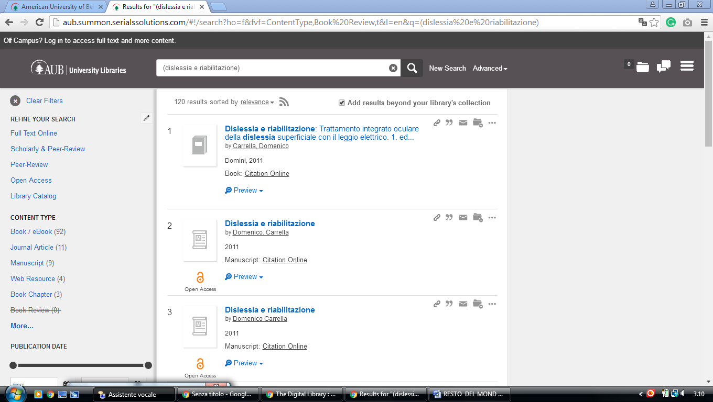

3 LAU LIBRARIES - (Beirut and Byblos, Lebanon)
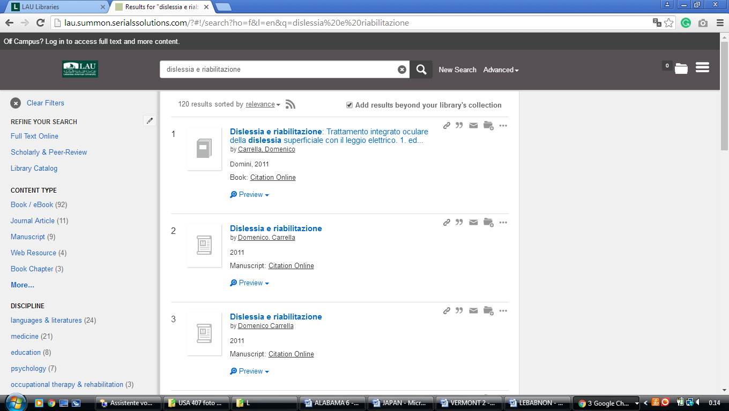
http://lau.summon.serialssolutions.com/?#!/search?ho=f&l=en&q=dislessia%20e%20riabilitazione

Lebanese American University, Beirut, Lebanon

LAU Libraries - Lebanese American University
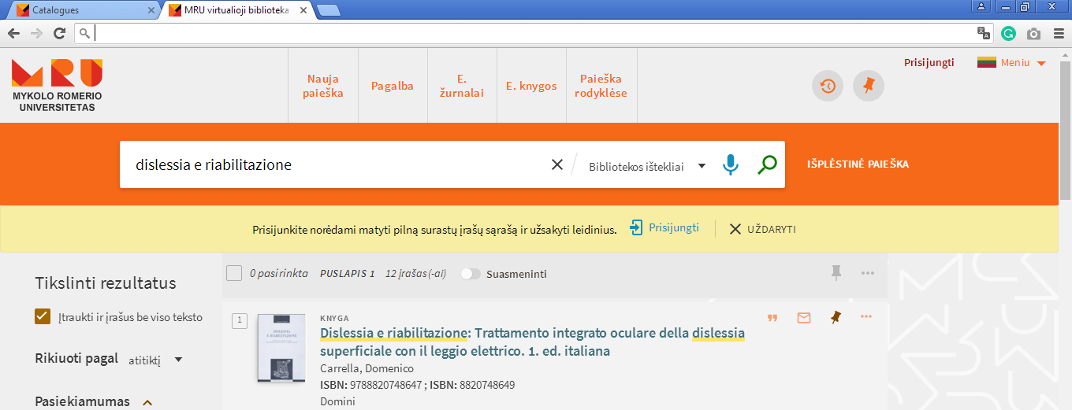

LEBANON

Issam Fares Library and Learning Center
جامعة البلمند
University of Balamand, Koura, LEBANON

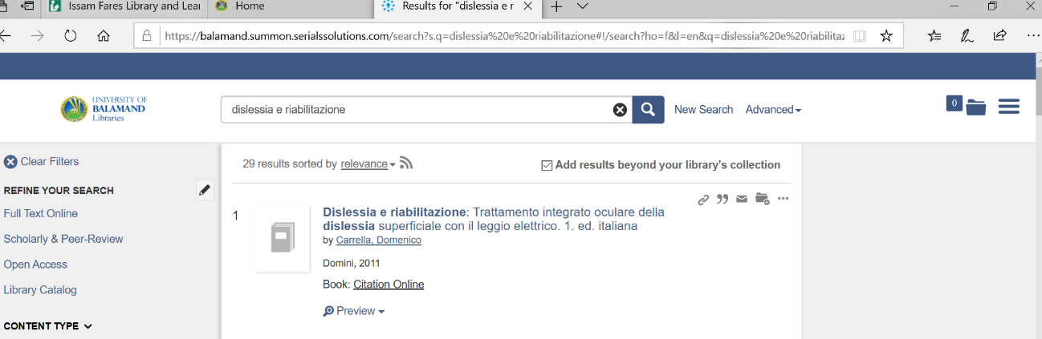
https://balamand.summon.serialssolutions.com/search?s.q=dislessia%20e%20riabilitazione#!/search?ho=f&l=en&q=dislessia%20e%20riabilitazione

