1 SARAWAK STATE LIBRARY – (Kuching, Sarawak, Malaysia)
http://pustaka.summon.serialssolutions.com/search/results?spellcheck=true&q=dislessia+e+riabilitazione#!/search?ho=f&l=en&q=dislessia%20e%20riabilitazione

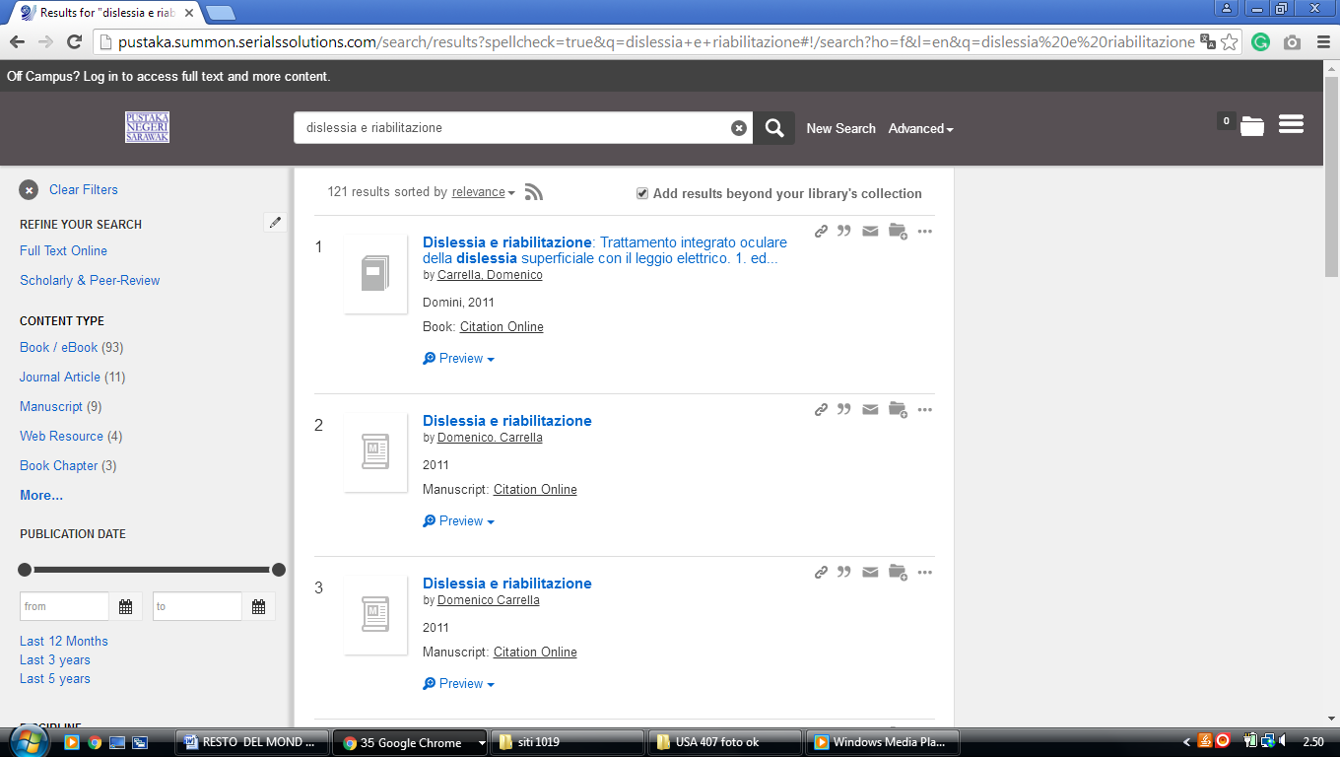

2 LIBRARY UNIVERSITI MALAYSIA PAHANG – (Pekan, Pahang, Malaysia)
https://ump.on.worldcat.org/search?databaseList=143%2C199%2C233%2C245%2C203%2C239%2C638%2C283%2C251%2C197%2C285&queryString=ti%3Adislessia+e+riabilitazione

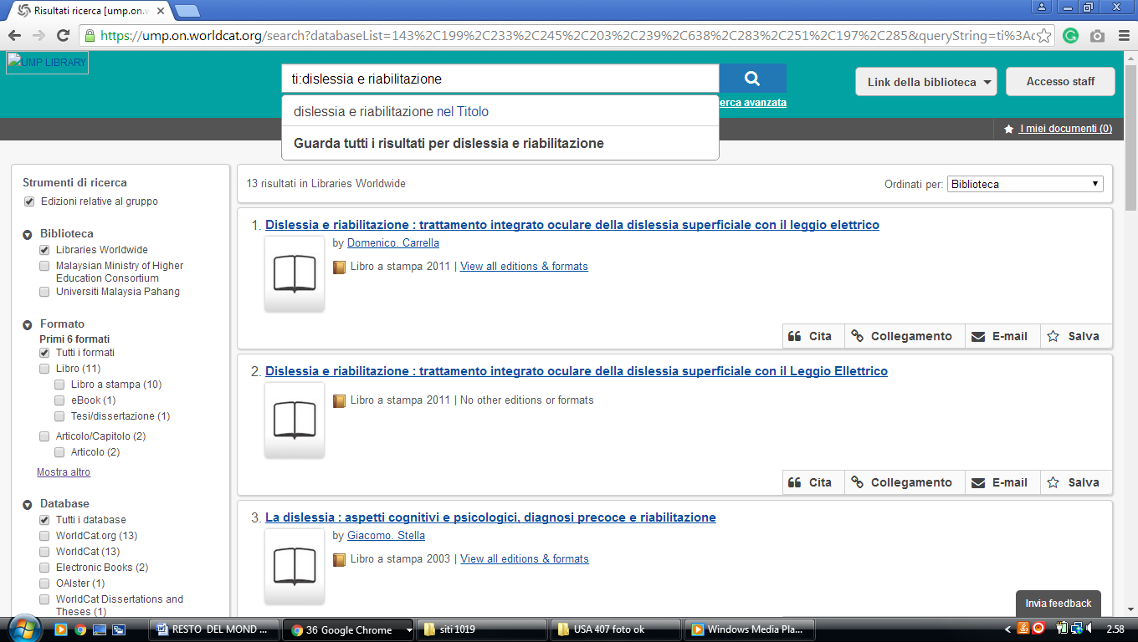

1 NEWSPAPERS IN MELANESIA - PACIFIC ISLANDS NEWSPAPERS - RESEARCH ... – (Melanesia)
https://uhawaii-primo.hosted.exlibrisgroup.com/primo-explore/search?institution=OUZ&vid=OUZ&tab=default_tab&displayMode=full&bulkSize=10&highlight=true&dum=true&query=any,contains,dislessia%20e%20riabilitazione&displayField=all&pcAvailabiltyMode=true
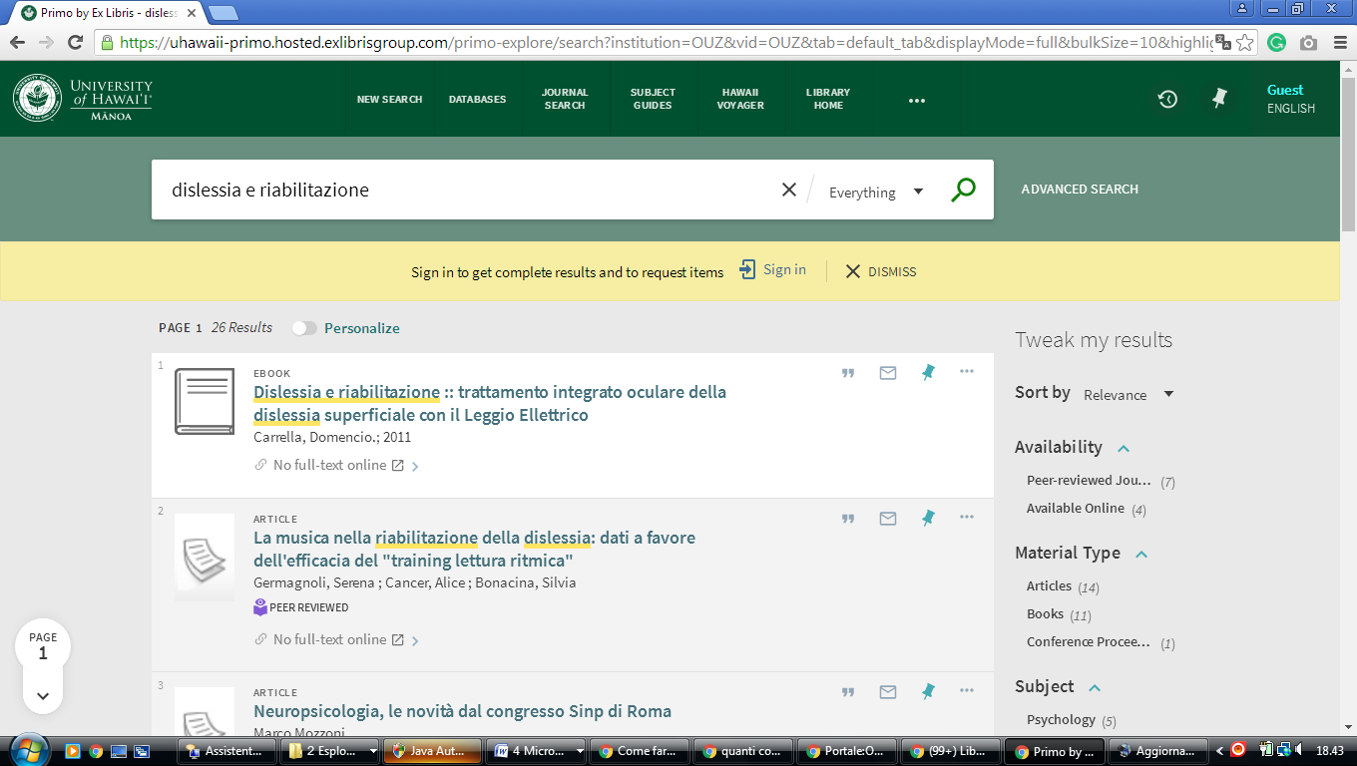

l

