1 UNIVERSITY OF NAMIBIA | LIBRARY – (Windhoek, Namibia)
http://unam.worldcat.org/title/dislessia-e-riabilitazione-trattamento-integrato-oculare-della-dislessia-superficiale-con-il-leggio-elettrico/oclc/878784487&referer=brief_results

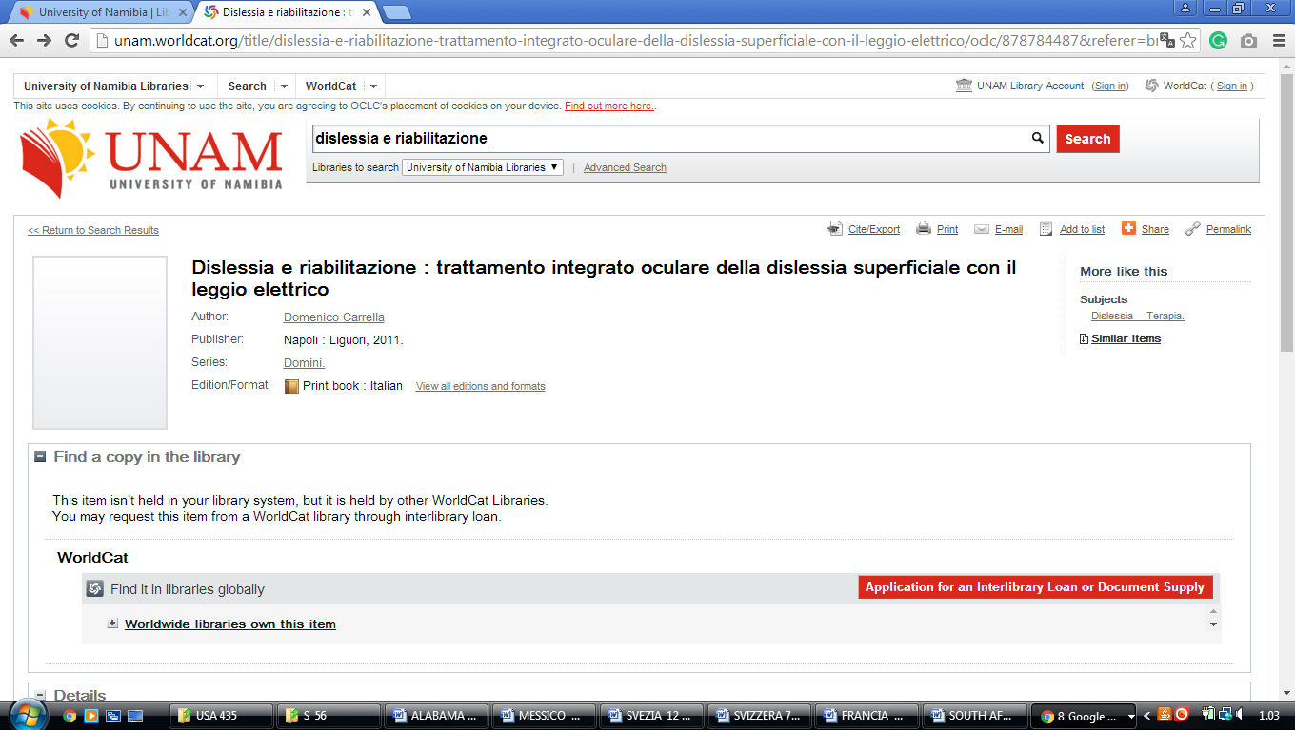

International University of Management (IUM) library, Namibia

IUM LIBRARY




