NORVERGIA = 114

PER LA RICERCA MANUALE TRAMITE IL SITO UFFICIALE DELLE UNIVERSITA’ NORVERGESI

Come entrare nel portale norvegese (Oria.no)

1 - Osserva l'immagine
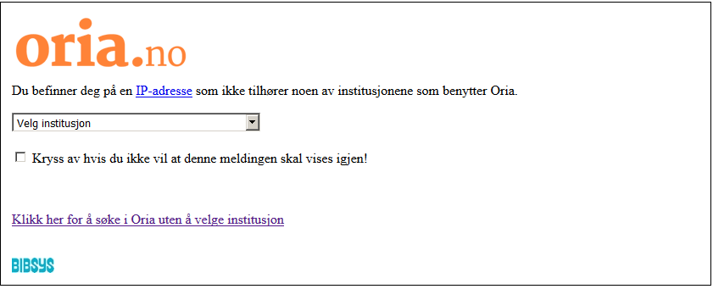

2 - Clicca qui
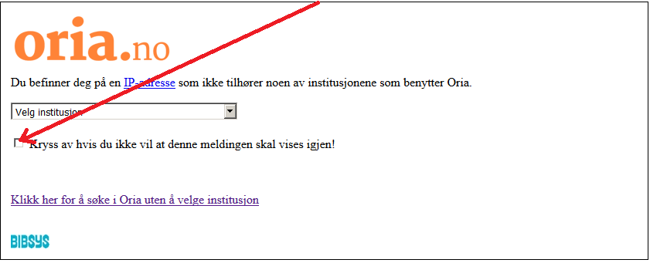

3 – Clicca sul menù
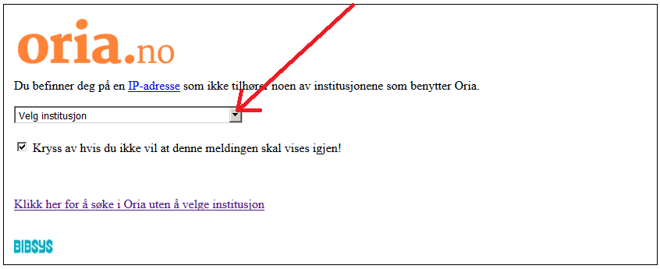

4 – Scegli l’Università
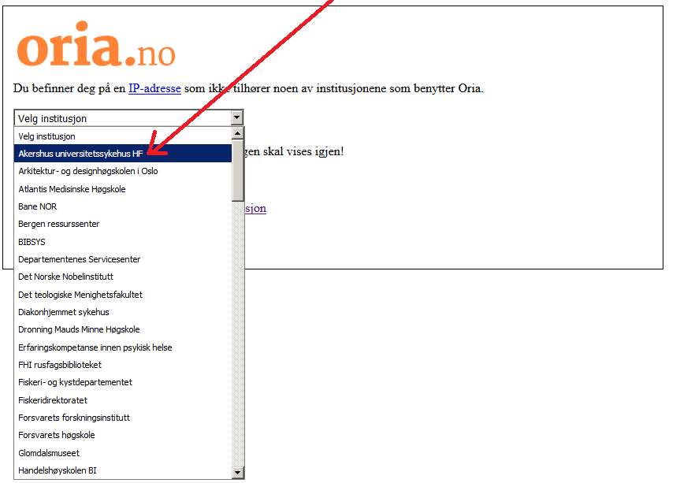

5 - Ecco l'Università scelta.
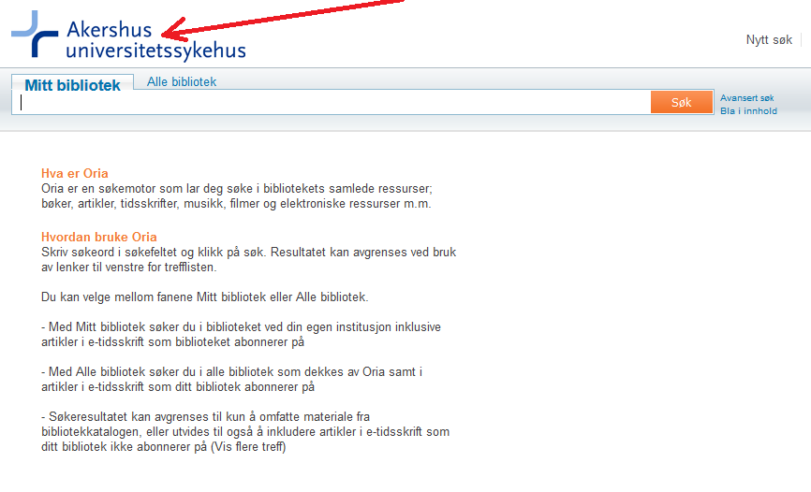

6 – Digita qui “Dislessia e Riabilitazione”
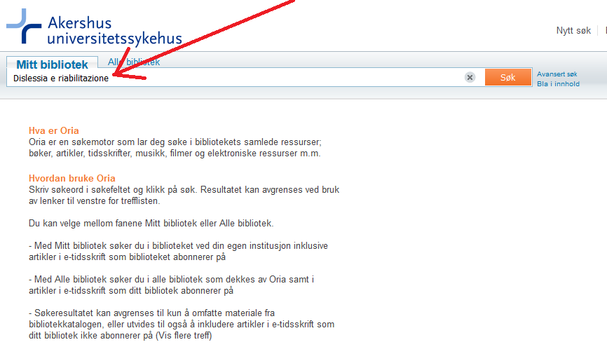

7 – Clicca qui
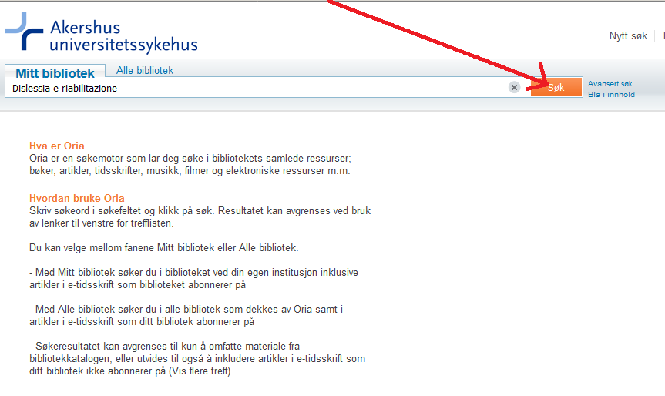

8 – Clicca qui per espandere la ricerca
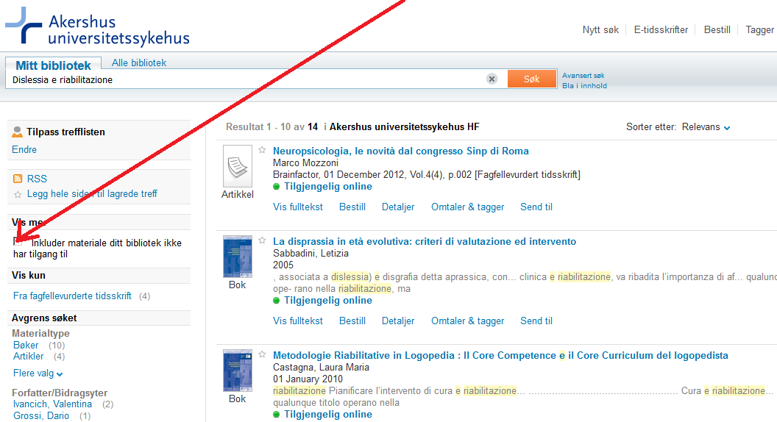

9 – Ecco il libro
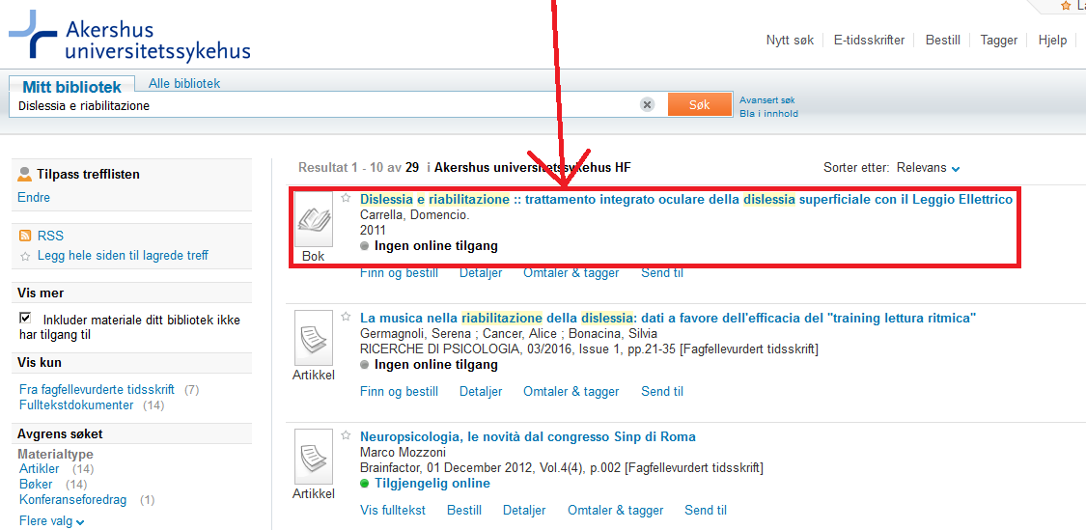

9 – Clicca sul link in basso per entrare su Oria.no

1) Oria.no

www.oria.no

-------------------------------------------------------------------------------------------------------------------------------

IN ALTERNATIVA, PER LA RICERCA VELOCE O AUTOMATICA, CLICCARE I SEGUENTI LINK DIRETTI


2) Akershus universitetssykehus HF

https://bibsys-almaprimo.hosted.exlibrisgroup.com/primo_library/libweb/action/display.do?tabs=viewOnlineTab&ct=display&fn=search&doc=TN_casalini_libriit02503952&indx=1&recIds=TN_casalini_libriit02503952&recIdxs=0&elementId=0&renderMode=poppedOut&displayMode=full&frbrVersion=&frbg=&pcAvailabiltyMode=true&dscnt=0&scp.scps=scope%3A%28SC_OPEN_ACCESS%29%2Cscope%3A%28%22AHUS%22%29%2Cprimo_central_multiple_fe&tb=t&vid=AHUS&mode=Basic&tab=default_tab&srt=rank&dum=true&vl(freeText0)=dislessia%20e%20riabilitazione&dstmp=1496254837634$$
--------------------------------------------------------------------------------------------------------------------------

3) architectur org.designhagskolen oslo

https://bibsys-almaprimo.hosted.exlibrisgroup.com/primo_library/libweb/action/search.do?ct=facet&pcAvailabiltyMode=true&pcAvailClicked=true&frbg=&&fn=search&indx=1&dscnt=0&scp.scps=scope%3A(%22AHO%22)%2Cscope%3A(SC_OPEN_ACCESS)%2CAHO_EbscoLocal%2Cprimo_central_multiple_fe&tb=t&mode=Basic&vid=AHO&ct=search&srt=rank&tab=default_tab&dum=true&vl(freeText0)=dislessia%20e%20riabilitazione&dstmp=1496532451424$$
----------------------------------------------------------------------------------------------------------------------
*OSLO*

4) Atlantis medisinske høgskole

Atlantis medisinske høgskole https://bibsys-almaprimo.hosted.exlibrisgroup.com/primo_library/libweb/action/display.do?tabs=viewOnlineTab&ct=display&fn=search&doc=TN_casalini_libriit02503952&indx=1&recIds=TN_casalini_libriit02503952&recIdxs=0&elementId=0&renderMode=poppedOut&displayMode=full&frbrVersion=&frbg=&pcAvailabiltyMode=true&dscnt=1&scp.scps=scope%3A%28SC_OPEN_ACCESS%29%2Cscope%3A%28AMH%29%2Cprimo_central_multiple_fe&tb=t&vid=AMH&mode=Basic&tab=default_tab&srt=rank&dum=true&vl(freeText0)=dislessia%20e%20riabilitazione&dstmp=1496254580233&gathStatIcon=true$$
-------------------------------------------------------------------------------------------------------------------------------

BERGEN


5) Bergen Ressourssenter

https://bibsys-almaprimo.hosted.exlibrisgroup.com/primo_library/libweb/action/display.do?tabs=viewOnlineTab&ct=display&fn=search&doc=TN_casalini_libriit02503952&indx=1&recIds=TN_casalini_libriit02503952&recIdxs=0&elementId=0&renderMode=poppedOut&displayMode=full&frbrVersion=&frbg=&pcAvailabiltyMode=true&dscnt=0&scp.scps=scope%3A%28SC_OPEN_ACCESS%29%2Cscope%3A%28%22BRC%22%29%2Cprimo_central_multiple_fe&tb=t&vid=BRC&mode=Basic&tab=default_tab&srt=rank&dum=true&vl(freeText0)=dislessia%20e%20riabilitazione&dstmp=1496254320299$$
------------------------------------------------------------------------------------------------------------------------------

Fredrik A. Dahls

6) Bioforsk plantehelse**

https://bibsys-almaprimo.hosted.exlibrisgroup.com/primo_library/libweb/action/display.do?tabs=viewOnlineTab&ct=display&fn=search&doc=TN_casalini_libriit02503952&indx=1&recIds=TN_casalini_libriit02503952&recIdxs=0&elementId=0&renderMode=poppedOut&displayMode=full&frbrVersion=&frbg=&pcAvailabiltyMode=true&dscnt=0&scp.scps=scope%3A%28%22PFP%22%29%2Cscope%3A%28SC_OPEN_ACCESS%29%2Cprimo_central_multiple_fe&tb=t&vid=PFP&mode=Basic&tab=default_tab&srt=rank&dum=true&vl(freeText0)=dislessia%20e%20riabilitazione&dstmp=1497114629614&gathStatIcon=true
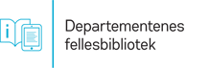
-------------------------------------------------------------------------------------------------------------------------------

7) Departementenes servicecenter OSLO

https://bibsys-almaprimo.hosted.exlibrisgroup.com/primo_library/libweb/action/display.do?tabs=viewOnlineTab&ct=display&fn=search&doc=TN_casalini_libriit02503952&indx=1&recIds=TN_casalini_libriit02503952&recIdxs=0&elementId=0&renderMode=poppedOut&displayMode=full&frbrVersion=&frbg=&pcAvailabiltyMode=true&dscnt=0&scp.scps=scope%3A%28SC_OPEN_ACCESS%29%2Cscope%3A%28%22DEPSS%22%29%2Cprimo_central_multiple_fe&tb=t&vid=DEPSS&mode=Basic&tab=default_tab&srt=rank&dum=true&vl(freeText0)=dislessia%20e%20riabilitazione&dstmp=1497114320659&gathStatIcon=true


8) Det Norske Nobelinstitutt

https://bibsys-almaprimo.hosted.exlibrisgroup.com/primo_library/libweb/action/display.do?tabs=viewOnlineTab&ct=display&fn=search&doc=TN_casalini_libriit02503952&indx=1&recIds=TN_casalini_libriit02503952&recIdxs=0&elementId=0&renderMode=poppedOut&displayMode=full&frbrVersion=&frbg=&pcAvailabiltyMode=true&dscnt=0&scp.scps=scope%3A%28%22NOBEL%22%29%2Cscope%3A%28SC_OPEN_ACCESS%29%2Cprimo_central_multiple_fe&tb=t&vid=NOBEL&mode=Basic&tab=default_tab&srt=rank&dum=true&vl(freeText0)=dislessia%20e%20riabilitazione&dstmp=1496256315574
-------------------------------------------------------------------------------------------------------------------------------



9) Det teologiscke menighetsfakultet OSLO

https://bibsys-almaprimo.hosted.exlibrisgroup.com/primo_library/libweb/action/display.do?tabs=viewOnlineTab&ct=display&fn=search&doc=TN_casalini_libriit02503952&indx=1&recIds=TN_casalini_libriit02503952&recIdxs=0&elementId=0&renderMode=poppedOut&displayMode=full&frbrVersion=&frbg=&pcAvailabiltyMode=true&dscnt=0&scp.scps=scope%3A%28SC_OPEN_ACCESS%29%2Cscope%3A%28%22MF%22%29%2Cprimo_central_multiple_fe&tb=t&vid=MF&mode=Basic&tab=default_tab&srt=rank&dum=true&vl(freeText0)=dislessia%20e%20riabilitazione&dstmp=1496256475073
------------------------------------------------------------------------------------------------------------------------------

OSLO


10) Diakonhjemmet Høgskole

https://bibsys-almaprimo.hosted.exlibrisgroup.com/primo_library/libweb/action/display.do?tabs=viewOnlineTab&ct=display&fn=search&doc=TN_casalini_libriit02503952&indx=1&recIds=TN_casalini_libriit02503952&recIdxs=0&elementId=0&renderMode=poppedOut&displayMode=full&frbrVersion=&frbg=&pcAvailabiltyMode=true&dscnt=0&scp.scps=scope%3A%28%22DIAKON%22%29%2Cscope%3A%28SC_OPEN_ACCESS%29%2Cprimo_central_multiple_fe&tb=t&vid=DIAKON&mode=Basic&tab=default_tab&srt=rank&dum=true&vl(freeText0)=dislessia%20e%20riabilitazione&dstmp=1497037426436&gathStatIcon=true
-------------------------------------------------------------------------------------------------------------------------------


OSLO

11) Diakonhjemmet Sykehus

https://bibsys-almaprimo.hosted.exlibrisgroup.com/primo_library/libweb/action/display.do?tabs=viewOnlineTab&ct=display&fn=search&doc=TN_casalini_libriit02503952&indx=1&recIds=TN_casalini_libriit02503952&recIdxs=0&elementId=0&renderMode=poppedOut&displayMode=full&frbrVersion=&frbg=&pcAvailabiltyMode=true&dscnt=0&scp.scps=scope%3A%28SC_OPEN_ACCESS%29%2Cscope%3A%28%22DIASYK%22%29%2Cprimo_central_multiple_fe&tb=t&vid=DIASYK&mode=Basic&tab=default_tab&srt=rank&dum=true&vl(freeText0)=dislessia%20e%20riabilitazione&dstmp=1496256883052
-------------------------------------------------------------------------------------------------------------------------------



12) Dronning Maud Minne Høgskole

https://bibsys-almaprimo.hosted.exlibrisgroup.com/primo_library/libweb/action/display.do?tabs=viewOnlineTab&ct=display&fn=search&doc=TN_casalini_libriit02503952&indx=1&recIds=TN_casalini_libriit02503952&recIdxs=0&elementId=0&renderMode=poppedOut&displayMode=full&frbrVersion=&frbg=&pcAvailabiltyMode=true&dscnt=0&scp.scps=scope%3A%28SC_OPEN_ACCESS%29%2Cscope%3A%28%22DMMH%22%29%2Cprimo_central_multiple_fe&tb=t&vid=DMMH&mode=Basic&tab=default_tab&srt=rank&dum=true&vl(freeText0)=dislessia%20e%20riabilitazione&dstmp=1496257035549
-----------------------------------------------------------------------------------------------------------------------------


13) Erfaringskompetanse Innen
Psykisk Helse

https://bibsys-almaprimo.hosted.exlibrisgroup.com/primo_library/libweb/action/display.do?tabs=viewOnlineTab&ct=display&fn=search&doc=TN_casalini_libriit02503952&indx=1&recIds=TN_casalini_libriit02503952&recIdxs=0&elementId=0&renderMode=poppedOut&displayMode=full&frbrVersion=&frbg=&pcAvailabiltyMode=true&dscnt=1&scp.scps=scope%3A%28SC_OPEN_ACCESS%29%2Cscope%3A%28%22ERFKOMP%22%29%2Cprimo_central_multiple_fe&tb=t&vid=ERFKOMP&mode=Basic&tab=default_tab&srt=rank&dum=true&vl(freeText0)=dislessia%20e%20riabilitazione&dstmp=1496257207286
-------------------------------------------------------------------------------------------------------------------------------



14) fiskeri-og Kystdepartmentet

https://bibsys-almaprimo.hosted.exlibrisgroup.com/primo_library/libweb/action/display.do?tabs=viewOnlineTab&ct=display&fn=search&doc=TN_casalini_libriit02503952&indx=1&recIds=TN_casalini_libriit02503952&recIdxs=0&elementId=0&renderMode=poppedOut&displayMode=full&frbrVersion=&frbg=&pcAvailabiltyMode=true&dscnt=0&scp.scps=scope%3A%28%22FIDEP%22%29%2Cscope%3A%28SC_OPEN_ACCESS%29%2Cprimo_central_multiple_fe&tb=t&vid=FIDEP&mode=Basic&tab=default_tab&srt=rank&dum=true&vl(freeText0)=dislessia%20e%20riabilitazione&dstmp=1496257387784
------------------------------------------------------------------------------------------------------------------------------

15) Fiskeridirektoratet

https://bibsys-almaprimo.hosted.exlibrisgroup.com/primo_library/libweb/action/display.do?tabs=viewOnlineTab&ct=display&fn=search&doc=TN_casalini_libriit02503952&indx=1&recIds=TN_casalini_libriit02503952&recIdxs=0&elementId=0&renderMode=poppedOut&displayMode=full&frbrVersion=&frbg=&pcAvailabiltyMode=true&dscnt=0&scp.scps=scope%3A%28%22FISKDIR%22%29%2Cscope%3A%28SC_OPEN_ACCESS%29%2Cprimo_central_multiple_fe&tb=t&vid=FISKDIR&mode=Basic&tab=default_tab&srt=rank&dum=true&vl(freeText0)=dislessia%20e%20riabilitazione&dstmp=1496257522084
-------------------------------------------------------------------------------------------------------------------------------



16) Forstvarets Forskningsinstitutt

https://bibsys-almaprimo.hosted.exlibrisgroup.com/primo_library/libweb/action/display.do?tabs=viewOnlineTab&ct=display&fn=search&doc=TN_casalini_libriit02503952&indx=1&recIds=TN_casalini_libriit02503952&recIdxs=0&elementId=0&renderMode=poppedOut&displayMode=full&frbrVersion=&frbg=&pcAvailabiltyMode=true&dscnt=0&scp.scps=scope%3A%28%22FFI_BIBL%22%29%2Cscope%3A%28SC_OPEN_ACCESS%29%2Cprimo_central_multiple_fe&tb=t&vid=FFI_BIBL&mode=Basic&tab=default_tab&srt=rank&dum=true&vl(freeText0)=dislessia%20e%20riabilitazione&dstmp=1496257725025&gathStatIcon=true

-------------------------------------------------------------------------------------------------------------------------------

17) Forstvaret Forstvarets Høgskole

https://bibsys-almaprimo.hosted.exlibrisgroup.com/primo_library/libweb/action/display.do?tabs=viewOnlineTab&ct=display&fn=search&doc=TN_casalini_libriit02503952&indx=1&recIds=TN_casalini_libriit02503952&recIdxs=0&elementId=0&renderMode=poppedOut&displayMode=full&frbrVersion=&frbg=&pcAvailabiltyMode=true&dscnt=0&scp.scps=scope%3A%28SC_OPEN_ACCESS%29%2Cscope%3A%28%22FHS%22%29%2Cprimo_central_multiple_fe&tb=t&vid=FHS&mode=Basic&tab=default_tab&srt=rank&dum=true&vl(freeText0)=dislessia%20e%20riabilitazione&dstmp=1496258080824
-------------------------------------------------------------------------------------------------------------------------------

18) Glomdalsmuseet

https://bibsys-almaprimo.hosted.exlibrisgroup.com/primo_library/libweb/action/display.do?tabs=viewOnlineTab&ct=display&fn=search&doc=TN_casalini_libriit02503952&indx=1&recIds=TN_casalini_libriit02503952&recIdxs=0&elementId=0&renderMode=poppedOut&displayMode=full&frbrVersion=&vid=GLOMDAL&mode=Basic&tab=alle_bibliotek&dscnt=0&vl(freeText0)=dislessia%20e%20riabilitazione&dstmp=1496258265392
-------------------------------------------------------------------------------------------------------------------------------


19) Handelshoyskolen BI

https://bibsys-almaprimo.hosted.exlibrisgroup.com/primo_library/libweb/action/display.do?tabs=viewOnlineTab&ct=display&fn=search&doc=TN_casalini_libriit02503952&indx=1&recIds=TN_casalini_libriit02503952&recIdxs=0&elementId=0&renderMode=poppedOut&displayMode=full&frbrVersion=&frbg=&pcAvailabiltyMode=true&dscnt=0&scp.scps=scope%3A%28BI%29%2Cprimo_central_multiple_fe&tb=t&vid=BI&mode=Basic&tab=default_tab&srt=rank&dum=true&vl(freeText0)=dislessia%20e%20riabilitazione&dstmp=1496258470256
-------------------------------------------------------------------------------------------------------------------------------


20) Haraldsplass diakonale Høgskole

https://bibsys-almaprimo.hosted.exlibrisgroup.com/primo_library/libweb/action/display.do?tabs=detailsTab&ct=display&fn=search&doc=TN_casalini_libriit02503952&indx=1&recIds=TN_casalini_libriit02503952&recIdxs=0&elementId=0&renderMode=poppedOut&displayMode=full&frbrVersion=&frbg=&pcAvailabiltyMode=true&dscnt=1&scp.scps=scope%3A%28BIBSYS_ILS%29%2Cscope%3A%28SC_OPEN_ACCESS%29%2Cscope%3A%28%22BIBSYS%22%29%2Cprimo_central_multiple_fe&vid=BIBSYS&mode=Basic&srt=rank&tab=default_tab&dum=true&vl(freeText0)=dislessia%20e%20riabilitazione&dstmp=1496258812675&gathStatIcon=true
-----------------------------------------------------------------------------------------------------------------------------

21) Helse Fonna HF

https://bibsys-almaprimo.hosted.exlibrisgroup.com/primo_library/libweb/action/display.do?tabs=viewOnlineTab&ct=display&fn=search&doc=TN_casalini_libriit02503952&indx=1&recIds=TN_casalini_libriit02503952&recIdxs=0&elementId=0&renderMode=poppedOut&displayMode=full&frbrVersion=&frbg=&pcAvailabiltyMode=true&dscnt=0&scp.scps=scope%3A%28SC_OPEN_ACCESS%29%2Cscope%3A%28%22FONNA%22%29%2Cprimo_central_multiple_fe&tb=t&vid=FONNA&mode=Basic&tab=default_tab&srt=rank&dum=true&vl(freeText0)=dislessia%20e%20riabilitazione&dstmp=1496259223583
-----------------------------------------------------------------------------------------------------------------------------

22) Helse More OG Romsdal HF Fagbiblioteket

https://bibsys-almaprimo.hosted.exlibrisgroup.com/primo_library/libweb/action/display.do?tabs=viewOnlineTab&ct=display&fn=search&doc=TN_casalini_libriit02503952&indx=1&recIds=TN_casalini_libriit02503952&recIdxs=0&elementId=0&renderMode=poppedOut&displayMode=full&frbrVersion=&frbg=&pcAvailabiltyMode=true&dscnt=0&scp.scps=scope%3A%28%22MOLDESYK%22%29%2Cscope%3A%28SC_OPEN_ACCESS%29%2Cprimo_central_multiple_fe&tb=t&vid=MOLDESYK&mode=Basic&tab=default_tab&srt=rank&dum=true&vl(freeText0)=dislessia%20e%20riabilitazione&dstmp=1496259372695
-------------------------------------------------------------------------------------------------------------------------------
23) Helsedirektoratet OSLO

https://bibsys-almaprimo.hosted.exlibrisgroup.com/primo_library/libweb/action/display.do?tabs=detailsTab&ct=display&fn=search&doc=TN_casalini_libriit02503952&indx=1&recIds=TN_casalini_libriit02503952&recIdxs=0&elementId=0&renderMode=poppedOut&displayMode=full&frbrVersion=&frbg=&pcAvailabiltyMode=true&dscnt=0&scp.scps=scope%3A%28BIBSYS_ILS%29%2Cscope%3A%28SC_OPEN_ACCESS%29%2Cscope%3A%28%22BIBSYS%22%29%2Cprimo_central_multiple_fe&vid=BIBSYS&mode=Basic&srt=rank&tab=default_tab&dum=true&vl(freeText0)=dislessia%20e%20riabilitazione&dstmp=1497040469063&gathStatIcon=true
----------------------------------------------------------------------------------------------------------------------------


24) HL-Senteret OSLO

https://bibsys-almaprimo.hosted.exlibrisgroup.com/primo_library/libweb/action/display.do?tabs=viewOnlineTab&ct=display&fn=search&doc=TN_casalini_libriit02503952&indx=1&recIds=TN_casalini_libriit02503952&recIdxs=0&elementId=0&renderMode=poppedOut&displayMode=full&frbrVersion=&frbg=&pcAvailabiltyMode=true&dscnt=1&scp.scps=scope%3A%28%22GRANDE%22%29%2Cscope%3A%28SC_OPEN_ACCESS%29%2Cprimo_central_multiple_fe&tb=t&vid=GRANDE&mode=Basic&tab=default_tab&srt=rank&dum=true&vl(freeText0)=dislessia%20e%20riabilitazione&dstmp=1496259547705
-------------------------------------------------------------------------------------------------------------------------------

25) Husbanken Drammen

https://bibsys-almaprimo.hosted.exlibrisgroup.com/primo_library/libweb/action/display.do?tabs=detailsTab&ct=display&fn=search&doc=TN_casalini_libriit02503952&indx=1&recIds=TN_casalini_libriit02503952&recIdxs=0&elementId=0&renderMode=poppedOut&displayMode=full&frbrVersion=&frbg=&pcAvailabiltyMode=true&dscnt=0&scp.scps=scope%3A%28BIBSYS_ILS%29%2Cscope%3A%28SC_OPEN_ACCESS%29%2Cscope%3A%28%22BIBSYS%22%29%2Cprimo_central_multiple_fe&vid=BIBSYS&mode=Basic&srt=rank&tab=default_tab&dum=true&vl(freeText0)=dislessia%20e%20riabilitazione&dstmp=1497040882794&gathStatIcon=true
----------------------------------------------------------------------------------------------------------------------------

26) Høgskolen Betanien Fyllingsdalen

https://bibsys-almaprimo.hosted.exlibrisgroup.com/primo_library/libweb/action/display.do?tabs=viewOnlineTab&ct=display&fn=search&doc=TN_casalini_libriit02503952&indx=1&recIds=TN_casalini_libriit02503952&recIdxs=0&elementId=0&renderMode=poppedOut&displayMode=full&frbrVersion=&frbg=&pcAvailabiltyMode=true&dscnt=0&scp.scps=scope%3A%28SC_OPEN_ACCESS%29%2Cscope%3A%28%22BDH%22%29%2Cprimo_central_multiple_fe&tb=t&vid=BDH&mode=Basic&tab=default_tab&srt=rank&dum=true&vl(freeText0)=dislessia%20e%20riabilitazione&dstmp=1496259742005
-----------------------------------------------------------------------------------------------------------------------------

27) Høgskolen I Bergen Bergen,

https://bibsys-almaprimo.hosted.exlibrisgroup.com/primo_library/libweb/action/display.do?tabs=viewOnlineTab&ct=display&fn=search&doc=TN_casalini_libriit02503952&indx=1&recIds=TN_casalini_libriit02503952&recIdxs=0&elementId=0&renderMode=poppedOut&displayMode=full&frbrVersion=&frbg=&pcAvailabiltyMode=true&dscnt=0&scp.scps=scope%3A%28%22HIB%22%29%2Cscope%3A%28SC_OPEN_ACCESS%29%2Cprimo_central_multiple_fe&tb=t&vid=HIB&mode=Basic&tab=default_tab&srt=rank&dum=true&vl(freeText0)=dislessia%20e%20riabilitazione&dstmp=1496259911981
-------------------------------------------------------------------------------------------------------------------------------

28) Høgskolen I Buskerud Kongsberg, Norvegia

https://bibsys-almaprimo.hosted.exlibrisgroup.com/primo_library/libweb/action/display.do?tabs=viewOnlineTab&ct=display&fn=search&doc=TN_casalini_libriit02503952&indx=1&recIds=TN_casalini_libriit02503952&recIdxs=0&elementId=0&renderMode=poppedOut&displayMode=full&frbrVersion=&frbg=&pcAvailabiltyMode=true&dscnt=0&scp.scps=scope%3A%28SC_OPEN_ACCESS%29%2Cscope%3A%28"HIBU"%29%2Cprimo_central_multiple_fe&tb=t&vid=HIBU&mode=Basic&tab=default_tab&srt=rank&dum=true&vl(freeText0)=dislessia%20e%20riabilitazione&dstmp=1496260052494
-------------------------------------------------------------------------------------------------------------------------------
29) Høgskolen I Finmmark Hammerfest,

https://bibsys-almaprimo.hosted.exlibrisgroup.com/primo_library/libweb/action/display.do?tabs=detailsTab&ct=display&fn=search&doc=TN_casalini_libriit02503952&indx=1&recIds=TN_casalini_libriit02503952&recIdxs=0&elementId=0&renderMode=poppedOut&displayMode=full&frbrVersion=&frbg=&pcAvailabiltyMode=true&dscnt=0&scp.scps=scope%3A%28BIBSYS_ILS%29%2Cscope%3A%28SC_OPEN_ACCESS%29%2Cscope%3A%28%22BIBSYS%22%29%2Cprimo_central_multiple_fe&vid=BIBSYS&mode=Basic&srt=rank&tab=default_tab&dum=true&vl(freeText0)=dislessia%20e%20riabilitazione&dstmp=1497041469746&gathStatIcon=true
------------------------------------------------------------------------------------------------------------------------------


30) Høgskolen Gjøvik Gjøvik

https://bibsys-almaprimo.hosted.exlibrisgroup.com/primo_library/libweb/action/display.do?tabs=viewOnlineTab&ct=display&fn=search&doc=TN_casalini_libriit02503952&indx=1&recIds=TN_casalini_libriit02503952&recIdxs=0&elementId=0&renderMode=poppedOut&displayMode=full&frbrVersion=&frbg=&pcAvailabiltyMode=true&dscnt=0&scp.scps=scope%3A%28%22HIG%22%29%2Cscope%3A%28SC_OPEN_ACCESS%29%2Cprimo_central_multiple_fe&tb=t&vid=HIG&mode=Basic&tab=default_tab&srt=rank&dum=true&vl(freeText0)=dislessia%20e%20riabilitazione&dstmp=1496260324416
------------------------------------------------------------------------------------------------------------------------------



31) Høgskolen I Harstad Harstad

https://bibsys-almaprimo.hosted.exlibrisgroup.com/primo_library/libweb/action/display.do?tabs=viewOnlineTab&ct=display&fn=search&doc=TN_casalini_libriit02503952&indx=1&recIds=TN_casalini_libriit02503952&recIdxs=0&elementId=0&renderMode=poppedOut&displayMode=full&frbrVersion=&frbg=&pcAvailabiltyMode=true&dscnt=0&scp.scps=scope%3A%28%22HIH%22%29%2Cscope%3A%28SC_OPEN_ACCESS%29%2Cprimo_central_multiple_fe&tb=t&vid=HIH&mode=Basic&tab=default_tab&srt=rank&dum=true&vl(freeText0)=dislessia%20e%20riabilitazione&dstmp=1496260451711
----------------------------------------------------------------------------------------------------------------------------



32) Høgskolen Hedmark Rena, Norvegia

https://bibsys-almaprimo.hosted.exlibrisgroup.com/primo_library/libweb/action/display.do?tabs=viewOnlineTab&ct=display&fn=search&doc=TN_casalini_libriit02503952&indx=1&recIds=TN_casalini_libriit02503952&recIdxs=0&elementId=0&renderMode=poppedOut&displayMode=full&frbrVersion=&frbg=&pcAvailabiltyMode=true&dscnt=0&scp.scps=scope%3A%28%22HH%22%29%2Cscope%3A%28SC_OPEN_ACCESS%29%2Cprimo_central_multiple_fe&tb=t&vid=HH&mode=Basic&tab=default_tab&srt=rank&dum=true&vl(freeText0)=dislessia%20e%20riabilitazione&dstmp=1496260569624
------------------------------------------------------------------------------------------------------------------------------

33) Høgskolen I Lillehammer Lillehammer,

https://bibsys-almaprimo.hosted.exlibrisgroup.com/primo_library/libweb/action/display.do?tabs=viewOnlineTab&ct=display&fn=search&doc=TN_casalini_libriit02503952&indx=1&recIds=TN_casalini_libriit02503952&recIdxs=0&elementId=0&renderMode=poppedOut&displayMode=full&frbrVersion=&frbg=&pcAvailabiltyMode=true&dscnt=0&scp.scps=scope%3A%28SC_OPEN_ACCESS%29%2Cscope%3A%28%22HIL%22%29%2Cprimo_central_multiple_fe&tb=t&vid=HIL&mode=Basic&tab=default_tab&srt=rank&dum=true&vl(freeText0)=dislessia%20e%20riabilitazione&dstmp=1496260704120
-------------------------------------------------------------------------------------------------------------------------


34) Høgskolen I Molde

https://bibsys-almaprimo.hosted.exlibrisgroup.com/primo_library/libweb/action/display.do?tabs=viewOnlineTab&ct=display&fn=search&doc=TN_casalini_libriit02503952&indx=1&recIds=TN_casalini_libriit02503952&recIdxs=0&elementId=0&renderMode=poppedOut&displayMode=full&frbrVersion=&frbg=&pcAvailabiltyMode=true&dscnt=0&scp.scps=scope%3A%28SC_OPEN_ACCESS%29%2Cscope%3A%28%22HIM%22%29%2Cprimo_central_multiple_fe&tb=t&vid=HIM&mode=Basic&tab=default_tab&srt=rank&dum=true&vl(freeText0)=dislessia%20e%20riabilitazione&dstmp=1496260854545
----------------------------------------------------------------------------------------------------------------------------


35) Høgskolen I Narvik

https://bibsys-almaprimo.hosted.exlibrisgroup.com/primo_library/libweb/action/display.do?tabs=viewOnlineTab&ct=display&fn=search&doc=TN_casalini_libriit02503952&indx=1&recIds=TN_casalini_libriit02503952&recIdxs=0&elementId=0&renderMode=poppedOut&displayMode=full&frbrVersion=&frbg=&pcAvailabiltyMode=true&dscnt=0&scp.scps=scope%3A%28%22HIN%22%29%2Cscope%3A%28SC_OPEN_ACCESS%29%2Cprimo_central_multiple_fe&tb=t&vid=HIN&mode=Basic&tab=default_tab&srt=rank&dum=true&vl(freeText0)=dislessia%20e%20riabilitazione&dstmp=1496260985705

------------------------------------------------------------------------------------------------------------------------------

36) Høgskolen I Nesna

https://bibsys-almaprimo.hosted.exlibrisgroup.com/primo_library/libweb/action/display.do?tabs=viewOnlineTab&ct=display&fn=search&doc=TN_casalini_libriit02503952&indx=1&recIds=TN_casalini_libriit02503952&recIdxs=0&elementId=0&renderMode=poppedOut&displayMode=full&frbrVersion=&frbg=&pcAvailabiltyMode=true&dscnt=0&scp.scps=scope%3A%28SC_OPEN_ACCESS%29%2Cscope%3A%28%22HINESNA%22%29%2Cprimo_central_multiple_fe&tb=t&vid=HINESNA&mode=Basic&tab=default_tab&srt=rank&dum=true&vl(freeText0)=dislessia%20e%20riabilitazione&dstmp=1496261108714
-----------------------------------------------------------------------------------------------------------------------------


37) Høgskolen I Nord Trøndelag

https://bibsys-almaprimo.hosted.exlibrisgroup.com/primo_library/libweb/action/display.do?tabs=viewOnlineTab&ct=display&fn=search&doc=TN_casalini_libriit02503952&indx=1&recIds=TN_casalini_libriit02503952&recIdxs=0&elementId=0&renderMode=poppedOut&displayMode=full&frbrVersion=&frbg=&pcAvailabiltyMode=true&dscnt=0&scp.scps=scope%3A%28%22HINT%22%29%2Cscope%3A%28SC_OPEN_ACCESS%29%2Cprimo_central_multiple_fe&tb=t&vid=HINT&mode=Basic&tab=default_tab&srt=rank&dum=true&vl(freeText0)=dislessia%20e%20riabilitazione&dstmp=1496261237613&gathStatIcon=true
------------------------------------------------------------------------------------------------------------------------------

38) Høgskolen I Olso OG Akershus OLSO

https://bibsys-almaprimo.hosted.exlibrisgroup.com/primo_library/libweb/action/display.do?tabs=viewOnlineTab&ct=display&fn=search&doc=TN_casalini_libriit02503952&indx=1&recIds=TN_casalini_libriit02503952&recIdxs=0&elementId=0&renderMode=poppedOut&displayMode=full&frbrVersion=&frbg=&pcAvailabiltyMode=true&dscnt=0&scp.scps=scope%3A%28%22HIOA%22%29%2Cscope%3A%28SC_OPEN_ACCESS%29%2Cprimo_central_multiple_fe&tb=t&vid=HIOA&mode=Basic&tab=default_tab&srt=rank&dum=true&vl(freeText0)=dislessia%20e%20riabilitazione&dstmp=1496261362426
-------------------------------------------------------------------------------------------------------------------------------


39) Høgskolen I sør Trøndelag

https://bibsys-almaprimo.hosted.exlibrisgroup.com/primo_library/libweb/action/display.do?tabs=viewOnlineTab&ct=display&fn=search&doc=TN_casalini_libriit02503952&indx=1&recIds=TN_casalini_libriit02503952&recIdxs=0&elementId=0&renderMode=poppedOut&displayMode=full&frbrVersion=&frbg=&pcAvailabiltyMode=true&dscnt=0&scp.scps=scope%3A%28%22HIST%22%29%2Cscope%3A%28SC_OPEN_ACCESS%29%2Cprimo_central_multiple_fe&tb=t&vid=HIST&mode=Basic&tab=default_tab&srt=rank&dum=true&vl(freeText0)=dislessia%20e%20riabilitazione&dstmp=1496261688513
-------------------------------------------------------------------------------------------------------------------------------


40) Høgskolen I Telemark

https://bibsys-almaprimo.hosted.exlibrisgroup.com/primo_library/libweb/action/display.do?tabs=viewOnlineTab&ct=display&fn=search&doc=TN_casalini_libriit02503952&indx=1&recIds=TN_casalini_libriit02503952&recIdxs=0&elementId=0&renderMode=poppedOut&displayMode=full&frbrVersion=&frbg=&pcAvailabiltyMode=true&dscnt=0&scp.scps=scope%3A%28%22HIT%22%29%2Cscope%3A%28SC_OPEN_ACCESS%29%2Cscope%3A%28DUO%29%2CHIT_EbscoLocal%2Cprimo_central_multiple_fe&tb=t&vid=HIT&mode=Basic&tab=default_tab&srt=rank&dum=true&vl(freeText0)=dislessia%20e%20riabilitazione&dstmp=1496261821951
-------------------------------------------------------------------------------------------------------------------------------

Gå til HSN-Oria >>
41) Høgskolen I Vestfold

https://bibsys-almaprimo.hosted.exlibrisgroup.com/primo_library/libweb/action/display.do?tabs=viewOnlineTab&ct=display&fn=search&doc=TN_casalini_libriit02503952&indx=1&recIds=TN_casalini_libriit02503952&recIdxs=0&elementId=0&renderMode=poppedOut&displayMode=full&frbrVersion=&frbg=&pcAvailabiltyMode=true&dscnt=0&scp.scps=scope%3A%28%22HIVE%22%29%2Cscope%3A%28SC_OPEN_ACCESS%29%2Cprimo_central_multiple_fe&tb=t&vid=HIVE&mode=Basic&tab=default_tab&srt=rank&dum=true&vl(freeText0)=dislessia%20e%20riabilitazione&dstmp=1496262054932

-------------------------------------------------------------------------------------------------------------------------------

42) Høgskolen I Stord Hugesund

https://bibsys-almaprimo.hosted.exlibrisgroup.com/primo_library/libweb/action/display.do?tabs=viewOnlineTab&ct=display&fn=search&doc=TN_casalini_libriit02503952&indx=1&recIds=TN_casalini_libriit02503952&recIdxs=0&elementId=0&renderMode=poppedOut&displayMode=full&frbrVersion=&frbg=&pcAvailabiltyMode=true&dscnt=0&scp.scps=scope%3A%28%22HSH%22%29%2Cscope%3A%28SC_OPEN_ACCESS%29%2Cprimo_central_multiple_fe&tb=t&vid=HSH&mode=Basic&tab=default_tab&srt=rank&dum=true&vl(freeText0)=dislessia%20e%20riabilitazione&dstmp=1496262199555
-------------------------------------------------------------------------------------------------------------------------------



43) Høgskolen I Sogn og Fjordane

https://bibsys-almaprimo.hosted.exlibrisgroup.com/primo_library/libweb/action/display.do?tabs=viewOnlineTab&ct=display&fn=search&doc=TN_casalini_libriit02503952&indx=1&recIds=TN_casalini_libriit02503952&recIdxs=0&elementId=0&renderMode=poppedOut&displayMode=full&frbrVersion=&frbg=&pcAvailabiltyMode=true&dscnt=0&scp.scps=scope%3A%28%22HSF%22%29%2Cscope%3A%28SC_OPEN_ACCESS%29%2Cprimo_central_multiple_fe&tb=t&vid=HSF&mode=Basic&tab=default_tab&srt=rank&dum=true&vl(freeText0)=dislessia%20e%20riabilitazione&dstmp=1496262309314
-------------------------------------------------------------------------------------------------------------------------------


44) Høgskolen i Østfold

https://bibsys-almaprimo.hosted.exlibrisgroup.com/primo_library/libweb/action/display.do?tabs=viewOnlineTab&ct=display&fn=search&doc=TN_casalini_libriit02503952&indx=1&recIds=TN_casalini_libriit02503952&recIdxs=0&elementId=0&renderMode=poppedOut&displayMode=full&frbrVersion=&frbg=&pcAvailabiltyMode=true&dscnt=0&scp.scps=scope%3A%28SC_OPEN_ACCESS%29%2Cscope%3A%28%22HIO%22%29%2Cprimo_central_multiple_fe&tb=t&vid=HIO&mode=Basic&tab=default_tab&srt=rank&dum=true&vl(freeText0)=dislessia%20e%20riabilitazione&dstmp=1496262425581
-------------------------------------------------------------------------------------------------------------------------


45) Høgskolen i Alesund

https://bibsys-almaprimo.hosted.exlibrisgroup.com/primo_library/libweb/action/display.do?tabs=viewOnlineTab&ct=display&fn=search&doc=TN_casalini_libriit02503952&indx=1&recIds=TN_casalini_libriit02503952&recIdxs=0&elementId=0&renderMode=poppedOut&displayMode=full&frbrVersion=&frbg=&pcAvailabiltyMode=true&dscnt=0&scp.scps=scope%3A%28SC_OPEN_ACCESS%29%2Cscope%3A%28%22HAL%22%29%2CHAL_EbscoLocal%2Cprimo_central_multiple_fe&tb=t&vid=HAL&mode=Basic&tab=default_tab&srt=rank&dum=true&vl(freeText0)=dislessia%20e%20riabilitazione&dstmp=1496262562029
-------------------------------------------------------------------------------------------------------------------------------


46) Høgskolen i Volda

https://bibsys-almaprimo.hosted.exlibrisgroup.com/primo_library/libweb/action/display.do?tabs=viewOnlineTab&ct=display&fn=search&doc=TN_casalini_libriit02503952&indx=1&recIds=TN_casalini_libriit02503952&recIdxs=0&elementId=0&renderMode=poppedOut&displayMode=full&frbrVersion=&frbg=&pcAvailabiltyMode=true&dscnt=0&scp.scps=scope%3A%28%22HVO%22%29%2Cscope%3A%28SC_OPEN_ACCESS%29%2Cprimo_central_multiple_fe&tb=t&vid=HVO&mode=Basic&tab=default_tab&srt=rank&dum=true&vl(freeText0)=dislessia%20e%20riabilitazione&dstmp=1496262699234
-------------------------------------------------------------------------------------------------------------------------------


47) Høyskolebiblioteket
ved Campus Knistiania

https://bibsys-almaprimo.hosted.exlibrisgroup.com/primo_library/libweb/action/display.do?tabs=detailsTab&ct=display&fn=search&doc=TN_casalini_libriit02503952&indx=1&recIds=TN_casalini_libriit02503952&recIdxs=0&elementId=0&renderMode=poppedOut&displayMode=full&frbrVersion=&frbg=&pcAvailabiltyMode=true&dscnt=0&scp.scps=scope%3A%28BIBSYS_ILS%29%2Cscope%3A%28SC_OPEN_ACCESS%29%2Cscope%3A%28%22BIBSYS%22%29%2Cprimo_central_multiple_fe&vid=BIBSYS&mode=Basic&srt=rank&tab=default_tab&dum=true&vl(freeText0)=dislessia%20e%20riabilitazione&dstmp=1497045799689&gathStatIcon=true
------------------------------------------------------------------------------------------------------------------------------


48) Høyskolen Diakonova

https://bibsys-almaprimo.hosted.exlibrisgroup.com/primo_library/libweb/action/display.do?tabs=detailsTab&ct=display&fn=search&doc=TN_casalini_libriit02503952&indx=1&recIds=TN_casalini_libriit02503952&recIdxs=0&elementId=0&renderMode=poppedOut&displayMode=full&frbrVersion=&frbg=&pcAvailabiltyMode=true&dscnt=0&scp.scps=scope%3A%28BIBSYS_ILS%29%2Cscope%3A%28SC_OPEN_ACCESS%29%2Cscope%3A%28%22BIBSYS%22%29%2Cprimo_central_multiple_fe&vid=BIBSYS&mode=Basic&srt=rank&tab=default_tab&dum=true&vl(freeText0)=dislessia%20e%20riabilitazione&dstmp=1497046092211&gathStatIcon=true
------------------------------------------------------------------------------------------------------------------------------


49) Institute for Energytekinikk

https://bibsys-almaprimo.hosted.exlibrisgroup.com/primo_library/libweb/action/display.do?tabs=viewOnlineTab&ct=display&fn=search&doc=TN_casalini_libriit02503952&indx=1&recIds=TN_casalini_libriit02503952&recIdxs=0&elementId=0&renderMode=poppedOut&displayMode=full&frbrVersion=&frbg=&pcAvailabiltyMode=true&dscnt=0&scp.scps=scope%3A%28SC_OPEN_ACCESS%29%2Cscope%3A%28%22IFE%22%29%2Cprimo_central_multiple_fe&tb=t&vid=IFE&mode=Basic&tab=default_tab&srt=rank&dum=true&vl(freeText0)=dislessia%20e%20riabilitazione&dstmp=1496263047189
-------------------------------------------------------------------------------------------------------------------------------

50) Jemanevereket

https://bibsys-almaprimo.hosted.exlibrisgroup.com/primo_library/libweb/action/display.do?tabs=viewOnlineTab&ct=display&fn=search&doc=TN_casalini_libriit02503952&indx=1&recIds=TN_casalini_libriit02503952&recIdxs=0&elementId=0&renderMode=poppedOut&displayMode=full&frbrVersion=&frbg=&pcAvailabiltyMode=true&dscnt=0&scp.scps=scope%3A%28SC_OPEN_ACCESS%29%2Cscope%3A%28"JBV"%29%2Cprimo_central_multiple_fe&tb=t&vid=JBV&mode=Basic&tab=default_tab&srt=rank&dum=true&vl(freeText0)=dislessia%20e%20riabilitazione&dstmp=1496272243074
-------------------------------------------------------------------------------------------------------------------------------


51) Justis Beredskapsdepartementet

https://bibsys-almaprimo.hosted.exlibrisgroup.com/primo_library/libweb/action/display.do?tabs=viewOnlineTab&ct=display&fn=search&doc=TN_casalini_libriit02503952&indx=1&recIds=TN_casalini_libriit02503952&recIdxs=0&elementId=0&renderMode=poppedOut&displayMode=full&frbrVersion=&frbg=&pcAvailabiltyMode=true&dscnt=0&scp.scps=scope%3A%28%22JUSDEP%22%29%2Cscope%3A%28SC_OPEN_ACCESS%29%2Cprimo_central_multiple_fe&tb=t&vid=JUSDEP&mode=Basic&tab=default_tab&srt=rank&dum=true&vl(freeText0)=dislessia%20e%20riabilitazione&dstmp=1496272456177

------------------------------------------------------------------------------------------------------------------------------

52) Konkurransetilsynet

https://bibsys-almaprimo.hosted.exlibrisgroup.com/primo_library/libweb/action/display.do?tabs=viewOnlineTab&ct=display&fn=search&doc=TN_casalini_libriit02503952&indx=1&recIds=TN_casalini_libriit02503952&recIdxs=0&elementId=0&renderMode=poppedOut&displayMode=full&frbrVersion=&frbg=&pcAvailabiltyMode=true&dscnt=0&scp.scps=scope%3A%28SC_OPEN_ACCESS%29%2Cscope%3A%28%22KT%22%29%2Cprimo_central_multiple_fe&tb=t&vid=KT&mode=Basic&tab=default_tab&srt=rank&dum=true&vl(freeText0)=dislessia%20e%20riabilitazione&dstmp=1497047333366&gathStatIcon=true
----------------------------------------------------------------------------------------------------------------------------


53) Kriminalomsorgens
Utdanningssenter Krus

https://bibsys-almaprimo.hosted.exlibrisgroup.com/primo_library/libweb/action/display.do?tabs=viewOnlineTab&ct=display&fn=search&doc=TN_casalini_libriit02503952&indx=1&recIds=TN_casalini_libriit02503952&recIdxs=0&elementId=0&renderMode=poppedOut&displayMode=full&frbrVersion=&frbg=&pcAvailabiltyMode=true&dscnt=1&scp.scps=scope%3A%28SC_OPEN_ACCESS%29%2Cscope%3A%28%22KRUS%22%29%2Cprimo_central_multiple_fe&tb=t&vid=KRUS&mode=Basic&tab=default_tab&srt=rank&dum=true&vl(freeText0)=dislessia%20e%20riabilitazione&dstmp=1496272672862
-------------------------------------------------------------------------------------------------------------------------------



54) Kunst-or desiognhøgskolen I Bergen

---------------------------------------------------------------------------------------------------------------------------


55) Kunsthøgskolen I Oslo

https://bibsys-almaprimo.hosted.exlibrisgroup.com/primo_library/libweb/action/display.do?tabs=viewOnlineTab&ct=display&fn=search&doc=TN_casalini_libriit02503952&indx=1&recIds=TN_casalini_libriit02503952&recIdxs=0&elementId=0&renderMode=poppedOut&displayMode=full&frbrVersion=&frbg=&pcAvailabiltyMode=true&dscnt=0&scp.scps=scope%3A%28SC_OPEN_ACCESS%29%2Cscope%3A%28KHIO%29%2CKHIO_EbscoLocal%2Cprimo_central_multiple_fe&tb=t&vid=KHIO&mode=Basic&tab=default_tab&srt=rank&dum=true&vl(freeText0)=dislessia%20e%20riabilitazione&dstmp=1496273006168&gathStatIcon=true
-------------------------------------------------------------------------------------------------------------------------------


56)

https://bibsys-almaprimo.hosted.exlibrisgroup.com/primo_library/libweb/action/display.do?tabs=viewOnlineTab&ct=display&fn=search&doc=TN_casalini_libriit02503952&indx=1&recIds=TN_casalini_libriit02503952&recIdxs=0&elementId=0&renderMode=poppedOut&displayMode=full&frbrVersion=&frbg=&pcAvailabiltyMode=true&dscnt=0&scp.scps=scope%3A%28%22LOVISHS%22%29%2Cscope%3A%28SC_OPEN_ACCESS%29%2Cprimo_central_multiple_fe&tb=t&vid=LOVISHS&mode=Basic&tab=default_tab&srt=rank&dum=true&vl(freeText0)=dislessia%20e%20riabilitazione&dstmp=1496273256318
----------------------------------------------------------------------------------------------------------------------------


57) Maihaugen

https://bibsys-almaprimo.hosted.exlibrisgroup.com/primo_library/libweb/action/display.do?tabs=viewOnlineTab&ct=display&fn=search&doc=TN_casalini_libriit02503952&indx=1&recIds=TN_casalini_libriit02503952&recIdxs=0&elementId=0&renderMode=poppedOut&displayMode=full&frbrVersion=&frbg=&pcAvailabiltyMode=true&dscnt=0&scp.scps=scope%3A%28%22MAIHAUG%22%29%2Cscope%3A%28SC_OPEN_ACCESS%29%2Cprimo_central_multiple_fe&tb=t&vid=MAIHAUG&mode=Basic&tab=default_tab&srt=rank&dum=true&vl(freeText0)=dislessia%20e%20riabilitazione&dstmp=1496273406100
-----------------------------------------------------------------------------------------------------------------------------


58) Misjonshøgskolen

https://bibsys-almaprimo.hosted.exlibrisgroup.com/primo_library/libweb/action/display.do?tabs=viewOnlineTab&ct=display&fn=search&doc=TN_casalini_libriit02503952&indx=1&recIds=TN_casalini_libriit02503952&recIdxs=0&elementId=0&renderMode=poppedOut&displayMode=full&frbrVersion=&frbg=&pcAvailabiltyMode=true&dscnt=0&scp.scps=scope%3A%28%22MISJON%22%29%2Cscope%3A%28SC_OPEN_ACCESS%29%2Cscope%3A%28MHS%29%2Cprimo_central_multiple_fe&tb=t&vid=MISJON&mode=Basic&tab=default_tab&srt=rank&dum=true&vl(freeText0)=dislessia%20e%20riabilitazione&dstmp=1496273545183
------------------------------------------------------------------------------------------------------------------------------

59) Museum Stavanger

https://bibsys-almaprimo.hosted.exlibrisgroup.com/primo_library/libweb/action/display.do?tabs=viewOnlineTab&ct=display&fn=search&doc=TN_casalini_libriit02503952&indx=1&recIds=TN_casalini_libriit02503952&recIdxs=0&elementId=0&renderMode=poppedOut&displayMode=full&frbrVersion=&frbg=&pcAvailabiltyMode=true&dscnt=0&scp.scps=scope%3A%28%22STAVMUS%22%29%2Cscope%3A%28SC_OPEN_ACCESS%29%2Cprimo_central_multiple_fe&tb=t&vid=STAVMUS&mode=Basic&tab=default_tab&srt=rank&dum=true&vl(freeText0)=dislessia%20e%20riabilitazione&dstmp=1496273666085&gathStatIcon=true
---------------------------------------------------------------------------------------------------------------------------


60) Nasjonalbiblioteket

https://bibsys-almaprimo.hosted.exlibrisgroup.com/primo_library/libweb/action/display.do?tabs=viewOnlineTab&ct=display&fn=search&doc=TN_casalini_libriit02503952&indx=1&recIds=TN_casalini_libriit02503952&recIdxs=0&elementId=0&renderMode=poppedOut&displayMode=full&frbrVersion=&frbg=&pcAvailabiltyMode=true&dscnt=0&scp.scps=scope%3A%28%22NB%22%29%2Cscope%3A%28SC_OPEN_ACCESS%29%2Cprimo_central_multiple_fe&tb=t&vid=NB&mode=Basic&tab=default_tab&srt=rank&dum=true&vl(freeText0)=dislessia%20e%20riabilitazione&dstmp=1496273840370&gathStatIcon=true
---------------------------------------------------------------------------------------------------------------------------


61) Nasjonal folkehelseinstittutet

https://bibsys-almaprimo.hosted.exlibrisgroup.com/primo_library/libweb/action/display.do?tabs=viewOnlineTab&ct=display&fn=search&doc=TN_casalini_libriit02503952&indx=1&recIds=TN_casalini_libriit02503952&recIdxs=0&elementId=0&renderMode=poppedOut&displayMode=full&frbrVersion=&frbg=&pcAvailabiltyMode=true&dscnt=0&scp.scps=scope%3A%28%22FOLKHELS%22%29%2Cscope%3A%28SC_OPEN_ACCESS%29%2Cprimo_central_multiple_fe&tb=t&vid=FOLKHELS&mode=Basic&tab=default_tab&srt=rank&dum=true&vl(freeText0)=dislessia%20e%20riabilitazione&dstmp=1496274319937&gathStatIcon=true


62) NIFU Biblioteket

https://bibsys-almaprimo.hosted.exlibrisgroup.com/primo_library/libweb/action/display.do?tabs=viewOnlineTab&ct=display&fn=search&doc=TN_casalini_libriit02503952&indx=1&recIds=TN_casalini_libriit02503952&recIdxs=0&elementId=0&renderMode=poppedOut&displayMode=full&frbrVersion=&frbg=&pcAvailabiltyMode=true&dscnt=1&scp.scps=scope%3A%28SC_OPEN_ACCESS%29%2Cscope%3A%28%22NIFU%22%29%2Cprimo_central_multiple_fe&tb=t&vid=NIFU&mode=Basic&tab=default_tab&srt=rank&dum=true&vl(freeText0)=dislessia%20e%20riabilitazione&dstmp=1496274459034&gathStatIcon=true
-------------------------------------------------------------------------------------------------------------------------------

63) NILU Norsk Institutt for lufforskining


https://bibsys-almaprimo.hosted.exlibrisgroup.com/primo_library/libweb/action/display.do?tabs=viewOnlineTab&ct=display&fn=search&doc=TN_casalini_libriit02503952&indx=1&recIds=TN_casalini_libriit02503952&recIdxs=0&elementId=0&renderMode=poppedOut&displayMode=full&frbrVersion=&frbg=&pcAvailabiltyMode=true&dscnt=0&scp.scps=scope%3A%28SC_OPEN_ACCESS%29%2Cscope%3A%28%22NILU%22%29%2Cprimo_central_multiple_fe&tb=t&vid=NILU&mode=Basic&tab=default_tab&srt=rank&dum=true&vl(freeText0)=dislessia%20e%20riabilitazione&dstmp=1496274597528
-------------------------------------------------------------------------------------------------------------------------------



64) NINA

https://bibsys-almaprimo.hosted.exlibrisgroup.com/primo_library/libweb/action/display.do?tabs=viewOnlineTab&ct=display&fn=search&doc=TN_casalini_libriit02503952&indx=1&recIds=TN_casalini_libriit02503952&recIdxs=0&elementId=0&renderMode=poppedOut&displayMode=full&frbrVersion=&frbg=&pcAvailabiltyMode=true&dscnt=0&scp.scps=scope%3A%28SC_OPEN_ACCESS%29%2Cscope%3A%28%22NINA_DN%22%29%2Cprimo_central_multiple_fe&tb=t&vid=NINA_DN&mode=Basic&tab=default_tab&srt=rank&dum=true&vl(freeText0)=dislessia%20e%20riabilitazione&dstmp=1496274775382
------------------------------------------------------------------------------------------------------------------------------


65) NLA høgskolen

https://bibsys-almaprimo.hosted.exlibrisgroup.com/primo_library/libweb/action/display.do?tabs=viewOnlineTab&ct=display&fn=search&doc=TN_casalini_libriit02503952&indx=1&recIds=TN_casalini_libriit02503952&recIdxs=0&elementId=0&renderMode=poppedOut&displayMode=full&frbrVersion=&frbg=&pcAvailabiltyMode=true&dscnt=0&scp.scps=scope%3A%28%22NLA%22%29%2Cscope%3A%28SC_OPEN_ACCESS%29%2Cprimo_central_multiple_fe&tb=t&vid=NLA&mode=Basic&tab=default_tab&srt=rank&dum=true&vl(freeText0)=dislessia%20e%20riabilitazione&dstmp=1496274931481&gathStatIcon=true
-------------------------------------------------------------------------------------------------------------------------------


66) Nofima A\S

https://bibsys-almaprimo.hosted.exlibrisgroup.com/primo_library/libweb/action/display.do?tabs=viewOnlineTab&ct=display&fn=search&doc=TN_casalini_libriit02503952&indx=1&recIds=TN_casalini_libriit02503952&recIdxs=0&elementId=0&renderMode=poppedOut&displayMode=full&frbrVersion=&frbg=&pcAvailabiltyMode=true&dscnt=0&scp.scps=scope%3A%28SC_OPEN_ACCESS%29%2Cscope%3A%28%22MATFORSK%22%29%2Cprimo_central_multiple_fe&tb=t&vid=MATFORSK&mode=Basic&tab=default_tab&srt=rank&dum=true&vl(freeText0)=dislessia%20e%20riabilitazione&dstmp=1496275151046

-------------------------------------------------------------------------------------------------------------------------------

67) Norges bank

https://bibsys-almaprimo.hosted.exlibrisgroup.com/primo_library/libweb/action/display.do?tabs=viewOnlineTab&ct=display&fn=search&doc=TN_casalini_libriit02503952&indx=1&recIds=TN_casalini_libriit02503952&recIdxs=0&elementId=0&renderMode=poppedOut&displayMode=full&frbrVersion=&frbg=&pcAvailabiltyMode=true&dscnt=0&scp.scps=scope%3A%28SC_OPEN_ACCESS%29%2Cscope%3A%28%22NBANK%22%29%2Cprimo_central_multiple_fe&tb=t&vid=NBANK&mode=Basic&tab=default_tab&srt=rank&dum=true&vl(freeText0)=dislessia%20e%20riabilitazione&dstmp=1496275267116&gathStatIcon=true
-------------------------------------------------------------------------------------------------------------------------------



68) Norges Forskningsradet

https://bibsys-almaprimo.hosted.exlibrisgroup.com/primo_library/libweb/action/display.do?tabs=viewOnlineTab&ct=display&fn=search&doc=TN_casalini_libriit02503952&indx=1&recIds=TN_casalini_libriit02503952&recIdxs=0&elementId=0&renderMode=poppedOut&displayMode=full&frbrVersion=&frbg=&pcAvailabiltyMode=true&dscnt=0&scp.scps=scope%3A%28SC_OPEN_ACCESS%29%2Cscope%3A%28%22NFR%22%29%2Cprimo_central_multiple_fe&tb=t&vid=NFR&mode=Basic&tab=default_tab&srt=rank&dum=true&vl(freeText0)=dislessia%20e%20riabilitazione&dstmp=1496275416669&gathStatIcon=true
---------------------------------------------------------------------------------------------------------------------------


69) Norges Handelshøyskole

https://bibsys-almaprimo.hosted.exlibrisgroup.com/primo_library/libweb/action/display.do?tabs=viewOnlineTab&ct=display&fn=search&doc=TN_casalini_libriit02503952&indx=1&recIds=TN_casalini_libriit02503952&recIdxs=0&elementId=0&renderMode=poppedOut&displayMode=full&frbrVersion=&frbg=&pcAvailabiltyMode=true&dscnt=0&scp.scps=scope%3A%28SC_OPEN_ACCESS%29%2Cscope%3A%28%22NHHB%22%29%2Cprimo_central_multiple_fe&tb=t&vid=NHHB&mode=Basic&tab=default_tab&srt=rank&dum=true&vl(freeText0)=dislessia%20e%20riabilitazione&dstmp=1496275559233&gathStatIcon=true
-----------------------------------------------------------------------------------------------------------------------------


70) Norges Idrettshøgskole

https://bibsys-almaprimo.hosted.exlibrisgroup.com/primo_library/libweb/action/display.do?tabs=viewOnlineTab&ct=display&fn=search&doc=TN_casalini_libriit02503952&indx=1&recIds=TN_casalini_libriit02503952&recIdxs=0&elementId=0&renderMode=poppedOut&displayMode=full&frbrVersion=&frbg=&pcAvailabiltyMode=true&dscnt=0&scp.scps=scope%3A%28SC_OPEN_ACCESS%29%2Cscope%3A%28%22NIH%22%29%2Cprimo_central_multiple_fe&tb=t&vid=NIH&mode=Basic&tab=default_tab&srt=rank&dum=true&vl(freeText0)=dislessia%20e%20riabilitazione&dstmp=1496275720590&gathStatIcon=true
https://bibsys-almaprimo.hosted.exlibrisgroup.com/primo_library/libweb/action/display.do?tabs=viewOnlineTab&ct=display&fn=search&doc=TN_casalini_libriit02503952&indx=1&recIds=TN_casalini_libriit02503952&recIdxs=0&elementId=0&renderMode=poppedOut&displayMode=full&frbrVersion=&frbg=&pcAvailabiltyMode=true&dscnt=0&scp.scps=scope%3A%28SC_OPEN_ACCESS%29%2Cscope%3A%28%22NIH%22%29%2Cprimo_central_multiple_fe&tb=t&vid=NIH&mode=Basic&tab=default_tab&srt=rank&dum=true&vl(freeText0)=dislessia%20e%20riabilitazione&dstmp=1496357188862
----------------------------------------------------------------------------------------------------------------------------

71) Norges Informajonsteknologiske Høgskole

https://bibsys-almaprimo.hosted.exlibrisgroup.com/primo_library/libweb/action/display.do?tabs=viewOnlineTab&ct=display&fn=search&doc=TN_casalini_libriit02503952&indx=1&recIds=TN_casalini_libriit02503952&recIdxs=0&elementId=0&renderMode=poppedOut&displayMode=full&frbrVersion=&frbg=&pcAvailabiltyMode=true&dscnt=0&scp.scps=scope%3A%28SC_OPEN_ACCESS%29%2Cscope%3A%28%22NITH%22%29%2Cprimo_central_multiple_fe&tb=t&vid=NITH&mode=Basic&tab=default_tab&srt=rank&dum=true&vl(freeText0)=dislessia%20e%20riabilitazione&dstmp=1497080396142&gathStatIcon=true
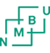
----------------------------------------------------------------------------------------------------------------------------

72) Norges miglio– og Biovitenskapelige universitet

https://bibsys-almaprimo.hosted.exlibrisgroup.com/primo_library/libweb/action/display.do?tabs=viewOnlineTab&ct=display&fn=search&doc=TN_casalini_libriit02503952&indx=1&recIds=TN_casalini_libriit02503952&recIdxs=0&elementId=0&renderMode=poppedOut&displayMode=full&frbrVersion=&frbg=&pcAvailabiltyMode=true&dscnt=0&scp.scps=scope%3A%28%22NMBU%22%29%2Cscope%3A%28SC_OPEN_ACCESS%29%2Cprimo_central_multiple_fe&tb=t&vid=NMBU&mode=Basic&tab=default_tab&srt=rank&dum=true&vl(freeText0)=dislessia%20e%20riabilitazione&dstmp=1497080674054&gathStatIcon=true
----------------------------------------------------------------------------------------------------------------------------

73) Norsk Folkemuseum

https://bibsys-almaprimo.hosted.exlibrisgroup.com/primo_library/libweb/action/display.do?tabs=viewOnlineTab&ct=display&fn=search&doc=TN_casalini_libriit02503952&indx=1&recIds=TN_casalini_libriit02503952&recIdxs=0&elementId=0&renderMode=poppedOut&displayMode=full&frbrVersion=&frbg=&pcAvailabiltyMode=true&dscnt=0&scp.scps=scope%3A%28SC_OPEN_ACCESS%29%2Cscope%3A%28%22FOLKEMUS%22%29%2Cprimo_central_multiple_fe&tb=t&vid=FOLKEMUS&mode=Basic&tab=default_tab&srt=rank&dum=true&vl(freeText0)=dislessia%20e%20riabilitazione&dstmp=1496357721555&gathStatIcon=true

74) Norsk Institutt for vannforskining


https://bibsys-almaprimo.hosted.exlibrisgroup.com/primo_library/libweb/action/display.do?tabs=viewOnlineTab&ct=display&fn=search&doc=TN_casalini_libriit02503952&indx=1&recIds=TN_casalini_libriit02503952&recIdxs=0&elementId=0&renderMode=poppedOut&displayMode=full&frbrVersion=&frbg=&pcAvailabiltyMode=true&dscnt=0&scp.scps=scope%3A%28SC_OPEN_ACCESS%29%2Cscope%3A%28%22NIVA%22%29%2Cprimo_central_multiple_fe&tb=t&vid=NIVA&mode=Basic&tab=default_tab&srt=rank&dum=true&vl(freeText0)=dislessia%20e%20riabilitazione&dstmp=1496358000297&gathStatIcon=true

-------------------------------------------------------------------------------------------------------------------------------


75) Norsk Oljmuseum

https://bibsys-almaprimo.hosted.exlibrisgroup.com/primo_library/libweb/action/display.do?tabs=viewOnlineTab&ct=display&fn=search&doc=TN_casalini_libriit02503952&indx=1&recIds=TN_casalini_libriit02503952&recIdxs=0&elementId=0&renderMode=poppedOut&displayMode=full&frbrVersion=&frbg=&pcAvailabiltyMode=true&dscnt=0&scp.scps=scope%3A%28%22NOM%22%29%2Cscope%3A%28SC_OPEN_ACCESS%29%2Cprimo_central_multiple_fe&tb=t&vid=NOM&mode=Basic&tab=default_tab&srt=rank&dum=true&vl(freeText0)=dislessia%20e%20riabilitazione&dstmp=1496358134701&gathStatIcon=true
-------------------------------------------------------------------------------------------------------------------------------

76) Norsk Polarinstitutt

https://bibsys-almaprimo.hosted.exlibrisgroup.com/primo_library/libweb/action/display.do?tabs=viewOnlineTab&ct=display&fn=search&doc=TN_casalini_libriit02503952&indx=1&recIds=TN_casalini_libriit02503952&recIdxs=0&elementId=0&renderMode=poppedOut&displayMode=full&frbrVersion=&frbg=&pcAvailabiltyMode=true&dscnt=0&scp.scps=scope%3A%28%22NPOLAR%22%29%2Cscope%3A%28SC_OPEN_ACCESS%29%2Cprimo_central_multiple_fe&tb=t&vid=NPOLAR&mode=Basic&tab=default_tab&srt=rank&dum=true&vl(freeText0)=dislessia%20e%20riabilitazione&dstmp=1497082739857&gathStatIcon=true
-------------------------------------------------------------------------------------------------------------------------------

77) Norsk Skogfinsk Museum



https://bibsys-almaprimo.hosted.exlibrisgroup.com/primo_library/libweb/action/display.do?tabs=viewOnlineTab&ct=display&fn=search&doc=TN_casalini_libriit02503952&indx=1&recIds=TN_casalini_libriit02503952&recIdxs=0&elementId=0&renderMode=poppedOut&displayMode=full&frbrVersion=&frbg=&pcAvailabiltyMode=true&dscnt=0&scp.scps=scope%3A%28%22SKOFIMUS%22%29%2Cscope%3A%28SC_OPEN_ACCESS%29%2Cprimo_central_multiple_fe&tb=t&vid=SKOFIMUS&mode=Basic&tab=default_tab&srt=rank&dum=true&vl(freeText0)=dislessia%20e%20riabilitazione&dstmp=1496358328548&gathStatIcon=true

---------------------------------------------------------------------------------------------------------------------------

78) Norsk Teknisk Museum

https://bibsys-almaprimo.hosted.exlibrisgroup.com/primo_library/libweb/action/display.do?tabs=viewOnlineTab&ct=display&fn=search&doc=TN_casalini_libriit02503952&indx=1&recIds=TN_casalini_libriit02503952&recIdxs=0&elementId=0&renderMode=poppedOut&displayMode=full&frbrVersion=&frbg=&pcAvailabiltyMode=true&dscnt=0&scp.scps=scope%3A%28%22TEKNMUS%22%29%2Cscope%3A%28SC_OPEN_ACCESS%29%2Cprimo_central_multiple_fe&tb=t&vid=TEKNMUS&mode=Basic&tab=default_tab&srt=rank&dum=true&vl(freeText0)=dislessia%20e%20riabilitazione&dstmp=1496358493690
------------------------------------------------------------------------------------------------------------------------------

79) Norsk Treteknisk institutt
https://bibsys-almaprimo.hosted.exlibrisgroup.com/primo_library/libweb/action/display.do?tabs=viewOnlineTab&ct=display&fn=search&doc=TN_casalini_libriit02503952&indx=1&recIds=TN_casalini_libriit02503952&recIdxs=0&elementId=0&renderMode=poppedOut&displayMode=full&frbrVersion=&frbg=&pcAvailabiltyMode=true&dscnt=0&scp.scps=scope%3A%28SC_OPEN_ACCESS%29%2Cscope%3A%28%22TRETEKN%22%29%2Cprimo_central_multiple_fe&tb=t&vid=TRETEKN&mode=Basic&tab=default_tab&srt=rank&dum=true&vl(freeText0)=dislessia%20e%20riabilitazione&dstmp=1497083516051&gathStatIcon=true
-------------------------------------------------------------------------------------------------------------------------------


80) NTNU Universitetsbiblioteket

https://bibsys-almaprimo.hosted.exlibrisgroup.com/primo_library/libweb/action/display.do?tabs=viewOnlineTab&ct=display&fn=search&doc=TN_casalini_libriit02503952&indx=1&recIds=TN_casalini_libriit02503952&recIdxs=0&elementId=0&renderMode=poppedOut&displayMode=full&frbrVersion=&frbg=&pcAvailabiltyMode=true&dscnt=0&scp.scps=scope%3A%28NTNU_DELRES%29%2Cscope%3A%28%22NTNU_UB%22%29%2Cscope%3A%28SC_OPEN_ACCESS%29%2Cprimo_central_multiple_fe&tb=t&vid=NTNU_UB&mode=Basic&tab=default_tab&srt=rank&dum=true&vl(freeText0)=dislessia%20e%20riabilitazione&dstmp=1496358717424&gathStatIcon=true
-----------------------------------------------------------------------------------------------------------------------



81) Nynorsk Kultursentrum

https://bibsys-almaprimo.hosted.exlibrisgroup.com/primo_library/libweb/action/display.do?tabs=viewOnlineTab&ct=display&fn=search&doc=TN_casalini_libriit02503952&indx=1&recIds=TN_casalini_libriit02503952&recIdxs=0&elementId=0&renderMode=poppedOut&displayMode=full&frbrVersion=&frbg=&pcAvailabiltyMode=true&dscnt=0&scp.scps=scope%3A%28%22AASENTUN%22%29%2Cscope%3A%28SC_OPEN_ACCESS%29%2Cprimo_central_multiple_fe&tb=t&vid=AASENTUN&mode=Basic&tab=default_tab&srt=rank&dum=true&vl(freeText0)=dislessia%20e%20riabilitazione&dstmp=1496358913985&gathStatIcon=true
-----------------------------------------------------------------------------------------------------------------------------

82) Olso Universitessykehus

https://bibsys-almaprimo.hosted.exlibrisgroup.com/primo_library/libweb/action/search.do?ct=facet&pcAvailabiltyMode=true&pcAvailClicked=true&frbg=&&indx=1&fn=search&dscnt=0&scp.scps=scope%3A(BIBSYS_ILS)%2Cscope%3A(SC_OPEN_ACCESS)%2Cscope%3A(%22BIBSYS%22)%2Cprimo_central_multiple_fe&mode=Basic&vid=BIBSYS&ct=search&srt=rank&tab=default_tab&vl(freeText0)=dislessia%20e%20riabilitazione&dum=true&dstmp=1497083958825
------------------------------------------------------------------------------------------------------------------------------


83) Politihøgsokolen

https://bibsys-almaprimo.hosted.exlibrisgroup.com/primo_library/libweb/action/display.do?tabs=detailsTab&ct=display&fn=search&doc=TN_casalini_libriit02503952&indx=1&recIds=TN_casalini_libriit02503952&recIdxs=0&elementId=0&renderMode=poppedOut&displayMode=full&frbrVersion=&frbg=&pcAvailabiltyMode=true&dscnt=0&scp.scps=scope%3A%28BIBSYS_ILS%29%2Cscope%3A%28SC_OPEN_ACCESS%29%2Cscope%3A%28%22BIBSYS%22%29%2Cprimo_central_multiple_fe&vid=BIBSYS&mode=Basic&srt=rank&tab=default_tab&dum=true&vl(freeText0)=dislessia%20e%20riabilitazione&dstmp=1497084606987&gathStatIcon=true


84) Regionsenter for barn a gunges
psykiske helse

https://bibsys-almaprimo.hosted.exlibrisgroup.com/primo_library/libweb/action/display.do?tabs=viewOnlineTab&ct=display&fn=search&doc=TN_casalini_libriit02503952&indx=1&recIds=TN_casalini_libriit02503952&recIdxs=0&elementId=0&renderMode=poppedOut&displayMode=full&frbrVersion=&frbg=&&dscnt=0&scp.scps=scope%3A%28SC_OPEN_ACCESS%29%2Cscope%3A%28%22RBUP_OS%22%29%2Cprimo_central_multiple_fe&tb=t&mode=Basic&vid=RBUP_OS&srt=rank&tab=default_tab&dum=true&vl(freeText0)=dislessia%20e%20riabilitazione&dstmp=1496359374714
------------------------------------------------------------------------------------------------------------------------------


85) Riksantikvaren

https://bibsys-almaprimo.hosted.exlibrisgroup.com/primo_library/libweb/action/display.do?tabs=viewOnlineTab&ct=display&fn=search&doc=TN_casalini_libriit02503952&indx=1&recIds=TN_casalini_libriit02503952&recIdxs=0&elementId=0&renderMode=poppedOut&displayMode=full&frbrVersion=&frbg=&pcAvailabiltyMode=true&dscnt=0&scp.scps=scope%3A%28%22RIKSANT%22%29%2Cscope%3A%28SC_OPEN_ACCESS%29%2Cprimo_central_multiple_fe&tb=t&vid=RIKSANT&mode=Basic&tab=default_tab&srt=rank&dum=true&vl(freeText0)=dislessia%20e%20riabilitazione&dstmp=1496359539930
-------------------------------------------------------------------------------------------------------------------------------


86) Samedikki girjeradju\Sametingets biblitek

https://bibsys-almaprimo.hosted.exlibrisgroup.com/primo_library/libweb/action/display.do?tabs=viewOnlineTab&ct=display&fn=search&doc=TN_casalini_libriit02503952&indx=1&recIds=TN_casalini_libriit02503952&recIdxs=0&elementId=0&renderMode=poppedOut&displayMode=full&frbrVersion=&frbg=&pcAvailabiltyMode=true&dscnt=0&scp.scps=scope%3A%28SC_OPEN_ACCESS%29%2Cscope%3A%28%22SAMBIB%22%29%2Cprimo_central_multiple_fe&tb=t&vid=SAMBIB&mode=Basic&tab=default_tab&srt=rank&dum=true&vl(freeText0)=dislessia%20e%20riabilitazione&dstmp=1496359695621
-------------------------------------------------------------------------------------------------------------------------------


87) Sami Allakuvla\Sami University College

https://bibsys-almaprimo.hosted.exlibrisgroup.com/primo_library/libweb/action/display.do?tabs=viewOnlineTab&ct=display&fn=search&doc=TN_casalini_libriit02503952&indx=1&recIds=TN_casalini_libriit02503952&recIdxs=0&elementId=0&renderMode=poppedOut&displayMode=full&frbrVersion=&frbg=&pcAvailabiltyMode=true&dscnt=0&scp.scps=scope%3A%28SC_OPEN_ACCESS%29%2Cscope%3A%28%22SAMALL%22%29%2Cprimo_central_multiple_fe&tb=t&vid=SAMALL&mode=Basic&tab=default_tab&srt=rank&dum=true&vl(freeText0)=dislessia%20e%20riabilitazione&dstmp=1496445338002&gathStatIcon=true
-------------------------------------------------------------------------------------------------------------------------------

88) Sørlandet Sykehus

https://bibsys-almaprimo.hosted.exlibrisgroup.com/primo_library/libweb/action/display.do?tabs=viewOnlineTab&ct=display&fn=search&doc=TN_casalini_libriit02503952&indx=1&recIds=TN_casalini_libriit02503952&recIdxs=0&elementId=0&renderMode=poppedOut&displayMode=full&frbrVersion=&frbg=&pcAvailabiltyMode=true&dscnt=0&scp.scps=scope%3A%28SC_OPEN_ACCESS%29%2Cscope%3A%28%22SSHF%22%29%2Cprimo_central_multiple_fe&tb=t&vid=SSHF&mode=Basic&tab=default_tab&srt=rank&dum=true&vl(freeText0)=dislessia%20e%20riabilitazione&dstmp=1496445701409&gathStatIcon=true
-------------------------------------------------------------------------------------------------------------------------------

89) Sintef Biblioteket Fvn 1



https://bibsys-almaprimo.hosted.exlibrisgroup.com/primo_library/libweb/action/display.do?tabs=viewOnlineTab&ct=display&fn=search&doc=TN_casalini_libriit02503952&indx=1&recIds=TN_casalini_libriit02503952&recIdxs=0&elementId=0&renderMode=poppedOut&displayMode=full&frbrVersion=&frbg=&pcAvailabiltyMode=true&dscnt=0&scp.scps=scope%3A%28%22SINTEF%22%29%2Cscope%3A%28SC_OPEN_ACCESS%29%2Cprimo_central_multiple_fe&tb=t&vid=SINTEF&mode=Basic&tab=default_tab&srt=rank&dum=true&vl(freeText0)=dislessia%20e%20riabilitazione&dstmp=1496445819744&gathStatIcon=true
------------------------------------------------------------------------------------------------------------------------------


90) Sintef Byggforsk

https://bibsys-almaprimo.hosted.exlibrisgroup.com/primo_library/libweb/action/display.do?tabs=viewOnlineTab&ct=display&fn=search&doc=TN_casalini_libriit02503952&indx=1&recIds=TN_casalini_libriit02503952&recIdxs=0&elementId=0&renderMode=poppedOut&displayMode=full&frbrVersion=&frbg=&pcAvailabiltyMode=true&dscnt=0&scp.scps=scope%3A%28SC_OPEN_ACCESS%29%2Cscope%3A%28%22NBI%22%29%2Cprimo_central_multiple_fe&tb=t&vid=NBI&mode=Basic&tab=default_tab&srt=rank&dum=true&vl(freeText0)=dislessia%20e%20riabilitazione&dstmp=1497085799008&gathStatIcon=true

-------------------------------------------------------------------------------------------------------------------------------

91) Sintef Energi AS

https://bibsys-almaprimo.hosted.exlibrisgroup.com/primo_library/libweb/action/display.do?tabs=viewOnlineTab&ct=display&fn=search&doc=TN_casalini_libriit02503952&indx=1&recIds=TN_casalini_libriit02503952&recIdxs=0&elementId=0&renderMode=poppedOut&displayMode=full&frbrVersion=&frbg=&pcAvailabiltyMode=true&dscnt=0&scp.scps=scope%3A%28%22NBI%22%29%2Cscope%3A%28SC_OPEN_ACCESS%29%2Cscope%3A%28%22SINTEF%22%29%2Cscope%3A%28%22SINTEF_E%22%29%2Cprimo_central_multiple_fe&tb=t&vid=SINTEF_E&mode=Basic&tab=default_tab&srt=rank&dum=true&vl(freeText0)=dislessia%20e%20riabilitazione&dstmp=1497086069765&gathStatIcon=true
-------------------------------------------------------------------------------------------------------------------------------


92) Skog og landskap

https://bibsys-almaprimo.hosted.exlibrisgroup.com/primo_library/libweb/action/display.do?tabs=viewOnlineTab&ct=display&fn=search&doc=TN_casalini_libriit02503952&indx=1&recIds=TN_casalini_libriit02503952&recIdxs=0&elementId=0&renderMode=poppedOut&displayMode=full&frbrVersion=&frbg=&pcAvailabiltyMode=true&dscnt=0&scp.scps=scope%3A%28%22NISK%22%29%2Cscope%3A%28SC_OPEN_ACCESS%29%2Cprimo_central_multiple_fe&tb=t&vid=NISK&mode=Basic&tab=default_tab&srt=rank&dum=true&vl(freeText0)=dislessia%20e%20riabilitazione&dstmp=1496446166868&gathStatIcon=true
-----------------------------------------------------------------------------------------------------------------------

93) Statens institutt for forbruksforskning SIFO

https://bibsys-almaprimo.hosted.exlibrisgroup.com/primo_library/libweb/action/display.do?tabs=viewOnlineTab&ct=display&fn=search&doc=TN_casalini_libriit02503952&indx=1&recIds=TN_casalini_libriit02503952&recIdxs=0&elementId=0&renderMode=poppedOut&displayMode=full&frbrVersion=&frbg=&pcAvailabiltyMode=true&dscnt=0&scp.scps=scope%3A%28%22FORBRUK%22%29%2Cscope%3A%28SC_OPEN_ACCESS%29%2Cprimo_central_multiple_fe&tb=t&vid=FORBRUK&mode=Basic&tab=default_tab&srt=rank&dum=true&vl(freeText0)=dislessia%20e%20riabilitazione&dstmp=1497096466151&gathStatIcon=true
------------------------------------------------------------------------------------------------------------------------------

94) ) Statens institutt for rusmiddelforskning

https://bibsys-almaprimo.hosted.exlibrisgroup.com/primo_library/libweb/action/display.do?tabs=viewOnlineTab&ct=display&fn=search&doc=TN_casalini_libriit02503952&indx=1&recIds=TN_casalini_libriit02503952&recIdxs=0&elementId=0&renderMode=poppedOut&displayMode=full&frbrVersion=&frbg=&pcAvailabiltyMode=true&dscnt=0&scp.scps=scope%3A%28SC_OPEN_ACCESS%29%2Cscope%3A%28%22SIRUS%22%29%2Cprimo_central_multiple_fe&tb=t&vid=SIRUS&mode=Basic&tab=default_tab&srt=rank&dum=true&vl(freeText0)=dislessia%20e%20riabilitazione&dstmp=1496446342826&gathStatIcon=true
------------------------------------------------------------------------------------------------------------------------------


95) Statistisk setralbyrà

https://bibsys-almaprimo.hosted.exlibrisgroup.com/primo_library/libweb/action/display.do?tabs=viewOnlineTab&ct=display&fn=search&doc=TN_casalini_libriit02503952&indx=1&recIds=TN_casalini_libriit02503952&recIdxs=0&elementId=0&renderMode=poppedOut&displayMode=full&frbrVersion=&frbg=&pcAvailabiltyMode=true&dscnt=0&scp.scps=scope%3A%28SC_OPEN_ACCESS%29%2Cscope%3A%28%22SSB%22%29%2Cprimo_central_multiple_fe&tb=t&vid=SSB&mode=Basic&tab=default_tab&srt=rank&dum=true&vl(freeText0)=dislessia%20e%20riabilitazione&dstmp=1496446457225&gathStatIcon=true
------------------------------------------------------------------------------------------------------------------------------


96) Stadped bibliotek

https://bibsys-almaprimo.hosted.exlibrisgroup.com/primo_library/libweb/action/search.do?ct=facet&pcAvailabiltyMode=true&pcAvailClicked=true&frbg=&&fn=search&indx=1&dscnt=0&scp.scps=scope%3A(SC_OPEN_ACCESS)%2Cscope%3A(%22BREDK%22)%2Cprimo_central_multiple_fe&tb=t&mode=Basic&vid=BREDK&ct=search&srt=rank&tab=default_tab&dum=true&vl(freeText0)=dislessia%20e%20riabilitazione&dstmp=1496446591011
-----------------------------------------------------------------------------------------------------------------------

97) Stavanger Universitetssjukehus

https://bibsys-almaprimo.hosted.exlibrisgroup.com/primo_library/libweb/action/search.do?ct=facet&pcAvailabiltyMode=true&pcAvailClicked=true&frbg=&&fn=search&indx=1&dscnt=0&scp.scps=scope%3A(%22UBIS%22)%2Cscope%3A(SC_OPEN_ACCESS)%2Cprimo_central_multiple_fe&tb=t&mode=Basic&vid=UBIS&ct=search&srt=rank&tab=default_tab&dum=true&vl(freeText0)=dislessia%20e%20riabilitazione&dstmp=1496446714354
------------------------------------------------------------------------------------------------------------------------------

98) Sykehuset Østfold HF

https://bibsys-almaprimo.hosted.exlibrisgroup.com/primo_library/libweb/action/display.do?tabs=viewOnlineTab&ct=display&fn=search&doc=TN_casalini_libriit02503952&indx=1&recIds=TN_casalini_libriit02503952&recIdxs=0&elementId=0&renderMode=poppedOut&displayMode=full&frbrVersion=&frbg=&pcAvailabiltyMode=true&dscnt=0&scp.scps=scope%3A%28SC_OPEN_ACCESS%29%2Cscope%3A%28%22OSTFSYK%22%29%2Cprimo_central_multiple_fe&tb=t&vid=OSTFSYK&mode=Basic&tab=default_tab&srt=rank&dum=true&vl(freeText0)=dislessia%20e%20riabilitazione&dstmp=1496446855142&gathStatIcon=true
-----------------------------------------------------------------------------------------------------------------
99) Sykehuset Telemark HF

https://bibsys-almaprimo.hosted.exlibrisgroup.com/primo_library/libweb/action/display.do?tabs=viewOnlineTab&ct=display&fn=search&doc=TN_casalini_libriit02503952&indx=1&recIds=TN_casalini_libriit02503952&recIdxs=0&elementId=0&renderMode=poppedOut&displayMode=full&frbrVersion=&frbg=&pcAvailabiltyMode=true&dscnt=0&scp.scps=scope%3A%28%22TELSYK%22%29%2Cscope%3A%28SC_OPEN_ACCESS%29%2Cprimo_central_multiple_fe&tb=t&vid=TELSYK&mode=Basic&tab=default_tab&srt=rank&dum=true&vl(freeText0)=dislessia%20e%20riabilitazione&dstmp=1497097628965&gathStatIcon=true
-------------------------------------------------------------------------------------------------------------------------------


100) Universitetetsbibllioteket I Agder

https://bibsys-almaprimo.hosted.exlibrisgroup.com/primo_library/libweb/action/display.do?tabs=viewOnlineTab&ct=display&fn=search&doc=TN_casalini_libriit02503952&indx=1&recIds=TN_casalini_libriit02503952&recIdxs=0&elementId=0&renderMode=poppedOut&displayMode=full&frbrVersion=&frbg=&pcAvailabiltyMode=true&dscnt=0&scp.scps=scope%3A%28BIBSYS_ILS%29%2Cprimo_central_multiple_fe&tb=t&vid=UBA&mode=Basic&tab=alle_bibliotek&srt=rank&dum=true&vl(freeText0)=dislessia%20e%20riabilitazione&dstmp=1496447129650&gathStatIcon=true


101) Universitetsbiblioteket I Bergen

https://bibsys-almaprimo.hosted.exlibrisgroup.com/primo_library/libweb/action/display.do?tabs=viewOnlineTab&ct=display&fn=search&doc=TN_casalini_libriit02503952&indx=1&recIds=TN_casalini_libriit02503952&recIdxs=0&elementId=0&renderMode=poppedOut&displayMode=full&frbrVersion=&frbg=&pcAvailabiltyMode=true&dscnt=0&scp.scps=scope%3A%28SC_OPEN_ACCESS%29%2Cscope%3A%28UBB_MARCUS%29%2Cscope%3A%28%22UBB%22%29%2Cprimo_central_multiple_fe&tb=t&vid=UBB&mode=Basic&tab=default_tab&srt=rank&dum=true&vl(freeText0)=dislessia%20e%20riabilitazione&dstmp=1496447304486&gathStatIcon=true
------------------------------------------------------------------------------------------------------------------------------


102) Universitetsbiblioteket i Nordland

https://bibsys-almaprimo.hosted.exlibrisgroup.com/primo_library/libweb/action/display.do?tabs=viewOnlineTab&ct=display&fn=search&doc=TN_casalini_libriit02503952&indx=1&recIds=TN_casalini_libriit02503952&recIdxs=0&elementId=0&renderMode=poppedOut&displayMode=full&frbrVersion=&frbg=&pcAvailabiltyMode=true&dscnt=0&scp.scps=scope%3A%28%22UBIN%22%29%2Cscope%3A%28SC_OPEN_ACCESS%29%2Cprimo_central_multiple_fe&tb=t&vid=UBIN&mode=Basic&tab=default_tab&srt=rank&dum=true&vl(freeText0)=dislessia%20e%20riabilitazione&dstmp=1496447437099&gathStatIcon=true


103) Universitetsbiblioteket i Oslo

https://bibsys-almaprimo.hosted.exlibrisgroup.com/primo_library/libweb/action/display.do?tabs=detailsTab&ct=display&fn=search&doc=TN_casalini_libriit02503952&indx=1&recIds=TN_casalini_libriit02503952&recIdxs=0&elementId=0&renderMode=poppedOut&displayMode=full&frbrVersion=&frbg=&pcAvailabiltyMode=true&dscnt=0&scp.scps=scope%3A%28SC_OPEN_ACCESS%29%2Cscope%3A%28DUO%29%2Cscope%3A%28%22UBO%22%29%2Cprimo_central_multiple_fe&tb=t&vid=UBO&mode=Basic&tab=default_tab&srt=rank&dum=true&vl(freeText0)=dislessia%20e%20riabilitazione&dstmp=1496447559560&gathStatIcon=true

-----------------------------------------------------------------------------------------------------------------------------

104) Universitetsbiblioteket i Stavanger

https://bibsys-almaprimo.hosted.exlibrisgroup.com/primo_library/libweb/action/display.do?tabs=viewOnlineTab&ct=display&fn=search&doc=TN_casalini_libriit02503952&indx=1&recIds=TN_casalini_libriit02503952&recIdxs=0&elementId=0&renderMode=poppedOut&displayMode=full&frbrVersion=&frbg=&pcAvailabiltyMode=true&dscnt=0&scp.scps=scope%3A%28%22UBIS%22%29%2Cscope%3A%28SC_OPEN_ACCESS%29%2Cprimo_central_multiple_fe&tb=t&vid=UBIS&mode=Basic&tab=default_tab&srt=rank&dum=true&vl(freeText0)=dislessia%20e%20riabilitazione&dstmp=1496447752593&gathStatIcon=true

------------------------------------------------------------------------------------------------------------------------------


105) UiT Norges Arktiske Universitet

https://bibsys-almaprimo.hosted.exlibrisgroup.com/primo_library/libweb/action/display.do?tabs=viewOnlineTab&ct=display&fn=search&doc=TN_casalini_libriit02503952&indx=1&recIds=TN_casalini_libriit02503952&recIdxs=0&elementId=0&renderMode=poppedOut&displayMode=full&frbrVersion=&frbg=&pcAvailabiltyMode=true&dscnt=0&scp.scps=scope%3A%28%22UBTO%22%29%2Cscope%3A%28SC_OPEN_ACCESS%29%2Cprimo_central_multiple_fe&tb=t&vid=UBTO&mode=Basic&tab=default_tab&srt=rank&dum=true&vl(freeText0)=dislessia%20e%20riabilitazione&dstmp=1496447869935&gathStatIcon=true


-----------------------------------------------------------------------------------------------------------------------------

107) Vea – Statens Fagskole

https://bibsys-almaprimo.hosted.exlibrisgroup.com/primo_library/libweb/action/display.do?tabs=viewOnlineTab&ct=display&fn=search&doc=TN_casalini_libriit02503952&indx=1&recIds=TN_casalini_libriit02503952&recIdxs=0&elementId=0&renderMode=poppedOut&displayMode=full&frbrVersion=&frbg=&pcAvailabiltyMode=true&dscnt=0&scp.scps=scope%3A%28%22VEA%22%29%2Cscope%3A%28SC_OPEN_ACCESS%29%2Cprimo_central_multiple_fe&tb=t&vid=VEA&mode=Basic&tab=default_tab&srt=rank&dum=true&vl(freeText0)=dislessia%20e%20riabilitazione&dstmp=1496448288378&gathStatIcon=true
-------------------------------------------------------------------------------------------------------------------------

108) Vegdirektoratet

https://bibsys-almaprimo.hosted.exlibrisgroup.com/primo_library/libweb/action/display.do?tabs=detailsTab&ct=display&fn=search&doc=TN_casalini_libriit02503952&indx=1&recIds=TN_casalini_libriit02503952&recIdxs=0&elementId=0&renderMode=poppedOut&displayMode=full&frbrVersion=&frbg=&pcAvailabiltyMode=true&dscnt=0&scp.scps=scope%3A%28BIBSYS_ILS%29%2Cscope%3A%28SC_OPEN_ACCESS%29%2Cscope%3A%28%22BIBSYS%22%29%2Cprimo_central_multiple_fe&vid=BIBSYS&mode=Basic&srt=rank&tab=default_tab&dum=true&vl(freeText0)=dislessia%20e%20riabilitazione&dstmp=1497113245205&gathStatIcon=true
----------------------------------------------------------------------------------------------------------------------------

109) Vestre Viken HF – Baerum Sykehus

https://bibsys-almaprimo.hosted.exlibrisgroup.com/primo_library/libweb/action/display.do?tabs=viewOnlineTab&ct=display&fn=search&doc=TN_casalini_libriit02503952&indx=1&recIds=TN_casalini_libriit02503952&recIdxs=0&elementId=0&renderMode=poppedOut&displayMode=full&frbrVersion=&frbg=&pcAvailabiltyMode=true&dscnt=0&scp.scps=scope%3A%28SC_OPEN_ACCESS%29%2Cscope%3A%28%22SABHF%22%29%2Cprimo_central_multiple_fe&tb=t&vid=SABHF&mode=Basic&tab=default_tab&srt=rank&dum=true&vl(freeText0)=dislessia%20e%20riabilitazione&dstmp=1496448576981&gathStatIcon=true
-------------------------------------------------------------------------------------------------------------------------------
110) Vestre Viken HF – Drammen Sykehus

https://bibsys-almaprimo.hosted.exlibrisgroup.com/primo_library/libweb/action/display.do?tabs=viewOnlineTab&ct=display&fn=search&doc=TN_casalini_libriit02503952&indx=1&recIds=TN_casalini_libriit02503952&recIdxs=0&elementId=0&renderMode=poppedOut&displayMode=full&frbrVersion=&frbg=&pcAvailabiltyMode=true&dscnt=1&scp.scps=scope%3A%28SC_OPEN_ACCESS%29%2Cscope%3A%28%22SABHF%22%29%2Cscope%3A%28%22BUSKSYK%22%29%2Cprimo_central_multiple_fe&tb=t&vid=BUSKSYK&mode=Basic&tab=default_tab&srt=rank&dum=true&vl(freeText0)=dislessia%20e%20riabilitazione&dstmp=1497113723369&gathStatIcon=true
--------------------------------------------------------------------------------------------------------------------------


111) Westerdals Hayskole

https://bibsys-almaprimo.hosted.exlibrisgroup.com/primo_library/libweb/action/display.do?tabs=viewOnlineTab&ct=display&fn=search&doc=TN_casalini_libriit02503952&indx=1&recIds=TN_casalini_libriit02503952&recIdxs=0&elementId=0&renderMode=poppedOut&displayMode=full&frbrVersion=&frbg=&pcAvailabiltyMode=true&dscnt=1&scp.scps=scope%3A%28%22WSOC%22%29%2Cscope%3A%28SC_OPEN_ACCESS%29%2Cprimo_central_multiple_fe&tb=t&vid=WSOC&mode=Basic&tab=default_tab&srt=rank&dum=true&vl(freeText0)=dislessia%20e%20riabilitazione&dstmp=1496448802742&gathStatIcon=true
-------------------------------------------------------------------------------------------------------------------------------



112) NORWAY UNION CAT

https://bibsys-almaprimo.hosted.exlibrisgroup.com/primo_library/libweb/action/display.do?tabs=detailsTab&ct=display&fn=search&doc=TN_casalini_libriit02503952&indx=1&recIds=TN_casalini_libriit02503952&recIdxs=0&elementId=0&renderMode=poppedOut&displayMode=full&frbrVersion=&frbg=&pcAvailabiltyMode=true&dscnt=0&scp.scps=scope%3A%28BIBSYS_ILS%29%2Cscope%3A%28SC_OPEN_ACCESS%29%2Cscope%3A%28%22BIBSYS%22%29%2Cprimo_central_multiple_fe&vid=BIBSYS&mode=Basic&srt=rank&tab=default_tab&dum=true&vl(freeText0)=dislessia%20e%20riabilitazione&dstmp=1489920788289&gathStatIcon=true

-------------------------------------------------------------------------------------------------------------------------------

113) Bioforsk

https://bibsys-almaprimo.hosted.exlibrisgroup.com/primo_library/libweb/action/display.do?tabs=viewOnlineTab&ct=display&fn=search&doc=TN_casalini_libriit02503952&indx=1&recIds=TN_casalini_libriit02503952&recIdxs=0&elementId=0&renderMode=poppedOut&displayMode=full&frbrVersion=&frbg=&pcAvailabiltyMode=true&dscnt=0&scp.scps=scope%3A%28%22PFP%22%29%2Cscope%3A%28SC_OPEN_ACCESS%29%2Cprimo_central_multiple_fe&tb=t&vid=PFP&mode=Basic&tab=default_tab&srt=rank&dum=true&vl(freeText0)=dislessia%20e%20riabilitazione&dstmp=1496255138672
------------------------------------------------------------------------------------------------------------------------------


114) **Olso** Departementenes servicesenter**

https://bibsys-almaprimo.hosted.exlibrisgroup.com/primo_library/libweb/action/display.do?tabs=detailsTab&ct=display&fn=search&doc=TN_casalini_libriit02503952&indx=1&recIds=TN_casalini_libriit02503952&recIdxs=0&elementId=0&renderMode=poppedOut&displayMode=full&frbrVersion=&frbg=&pcAvailabiltyMode=true&dscnt=0&scp.scps=scope%3A%28BIBSYS_ILS%29%2Cscope%3A%28SC_OPEN_ACCESS%29%2Cscope%3A%28%22BIBSYS%22%29%2Cprimo_central_multiple_fe&vid=BIBSYS&mode=Basic&srt=rank&tab=default_tab&dum=true&vl(freeText0)=dislessia%20e%20riabilitazione&dstmp=1496537360474&gathStatIcon=true$$

