1 LIBRARY | UNIVERSITY OF CANTERBURY - (New Zealand)

http://canterbury.summon.serialssolutions.com/search?q=dislessia%20e%20riabilitazione&fvf=ContentType,Newspaper%20Article,t%7CContentType,Book%20Review,t%7CContentType,Trade%20Publication%20Article,t%7CContentType,Trade%20Publication,t#!/search?ho=f&fvf=ContentType,Newspaper%20Article,t%7CContentType,Book%20Review,t%7CContentType,Trade%20Publication%20Article,t%7CContentType,Trade%20Publication,t&l=en-NZ&q=dislessia%20e%20riabilitazione
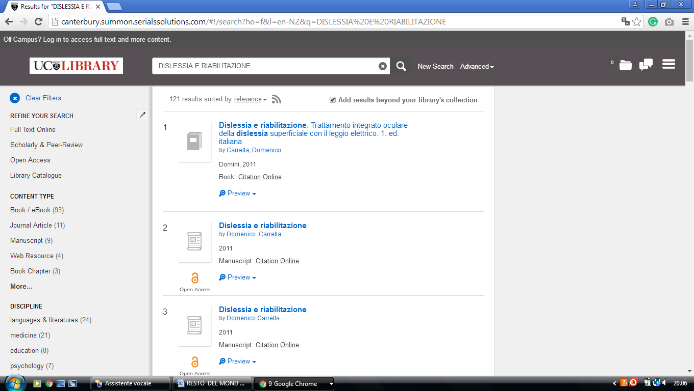

2 LIBRARY UNIVERSITY OF AUCKLAND - (Auckland, New Zealand)
http://librarysearch.auckland.ac.nz/primo_library/libweb/action/search.do?ct=facet&pcAvailabiltyMode=true&pcAvailClicked=true&vid=UOA2_A&mode=Basic&tab=everything&fn=search&indx=1&dscnt=0&vl(freeText0)=dislessia%20e%20riabilitazione&dstmp=1518378198784

