1 HCT LIBRARIES - HOME
http://hct.summon.serialssolutions.com/?#!/search?ho=f&l=en&q=dislessia%20e%20riabilitazione
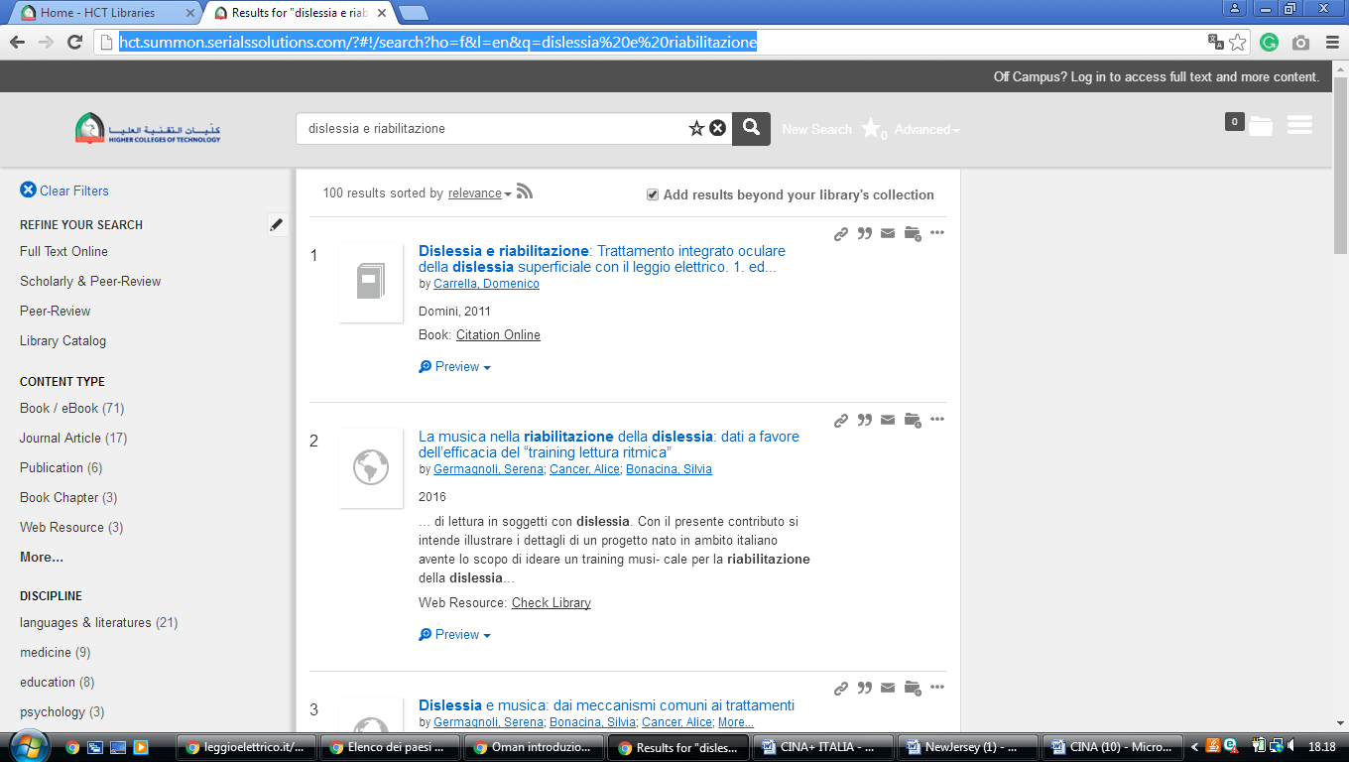

HIGHER COLLEGE OF TECHNOLOGY (HCT) LIBRARIES, Muscat, OMAN

HCT Libraries: Home

