1 HECPK.SUMMON.SERIALSSOLUTIONS.COM - (Higher Education Commission, Pakistan)
http://hecpk.summon.serialssolutions.com/#!/search?ho=f&l=en&q=DISLESSIA%20E%20RIABILITAZIONE

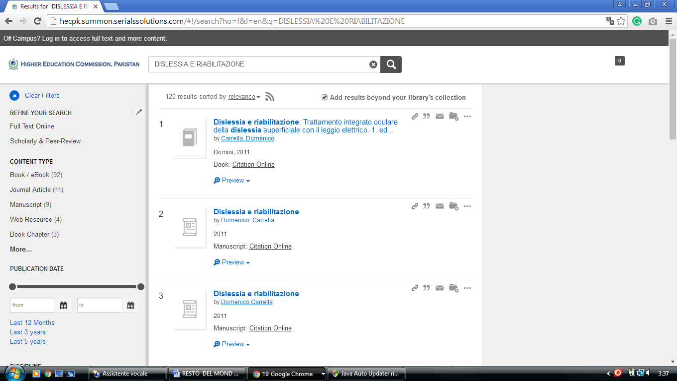

Dr Razi-ud-din Siddiqui Memorial Library, Quaid-i-Azam... - Islamabad , Pakistan
http://hecpk.summon.serialssolutions.com/?#!/search?ho=f&l=en&q=dislessia%20e%20riabilitazione
