1 LBW.LUBLIN.EU – (Library Catholic University Of Lublin, Poland)
http://lbw.lublin.eu/primo_library/libweb/action/search.do?ct=facet&pcAvailabiltyMode=true&dscnt=0&indx=1&tab=default_tab&dstmp=1518379859984&vl(freeText0)=dislessia%20e%20riabilitazione&fn=search&vid=48LBW_ALL_VIEW&mode=Basic

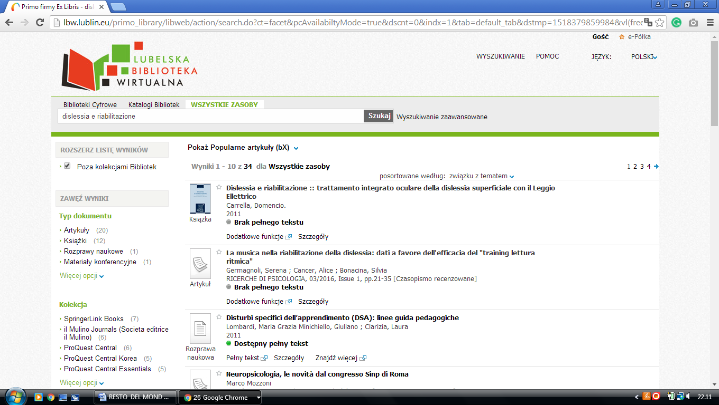

2 LIBRARY MARIE CURIE-SKLODOWSKA UNIVERSITY – (Lublin, Poland)
http://lbw.lublin.eu/primo_library/libweb/action/search.do?ct=facet&pcAvailabiltyMode=true&dscnt=0&onCampus=false&query=any%2Ccontains%2Cdislessia%20e%20riabilitazione&scp.scps=scope%3A(48LBW_UMCS_ibuk)%2Cscope%3A(48LBW_UMCS_nasbi)%2Cscope%3A(48LBW_UMCS)%2Cscope%3A(48LBW_UMCS_dLibra)%2Cscope%3A(48LBW_UMCS_ejournals)%2Cprimo_central_multiple_fe&frbg=&tab=default_tab&dstmp=1518380488351&dym=true&srt=rank&ct=search&mode=Basic&dum=true&search_scope=all_scope&indx=1&tb=t&group=GUEST&vl(freeText0)=dislessia%20e%20riabilitazione&prefLang=en_US&vid=48LBW_UMCS_VIEW&fn=search&vl(17811416UI0)=any&institution=48LBW_UMCS

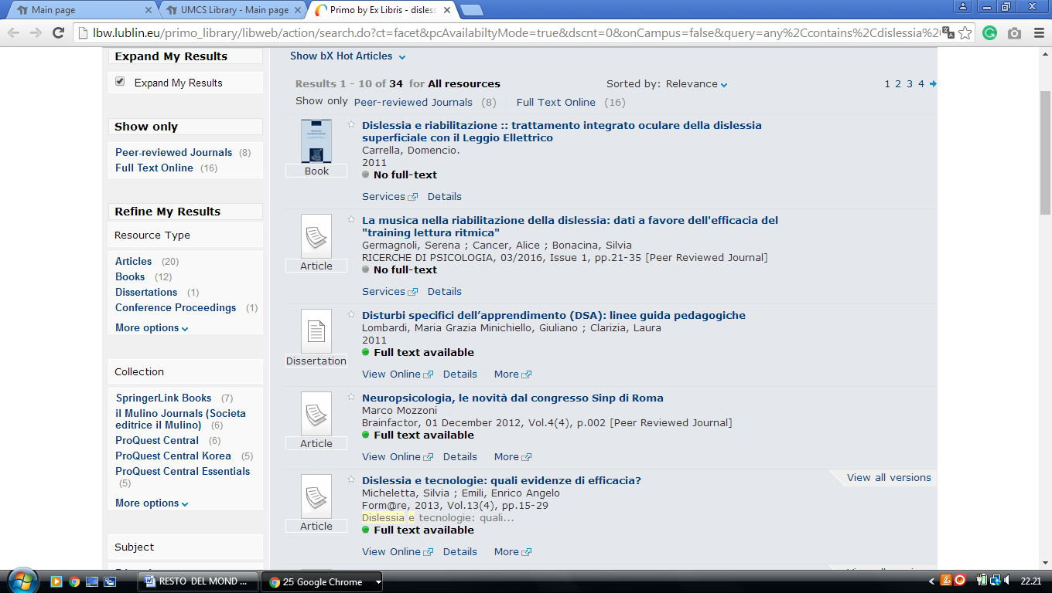

3 NICOLAUS COPERNICUS UNIVERSITY LIBRARY - BIBLIOTEKA UNIWERSYTECKA W – (Torun, Poland)
https://eds.b.ebscohost.com/eds/results?vid=0&sid=f0286be9-9603-4035-bbaa-e8f60c3e21d9%40pdc-v-sessmgr01&bquery=dislessia+e+riabilitazione&bdata=JmNsaTA9RlQxJmNsdjA9WSZ0eXBlPTAmc2l0ZT1lZHMtbGl2ZSZzY29wZT1zaXRl
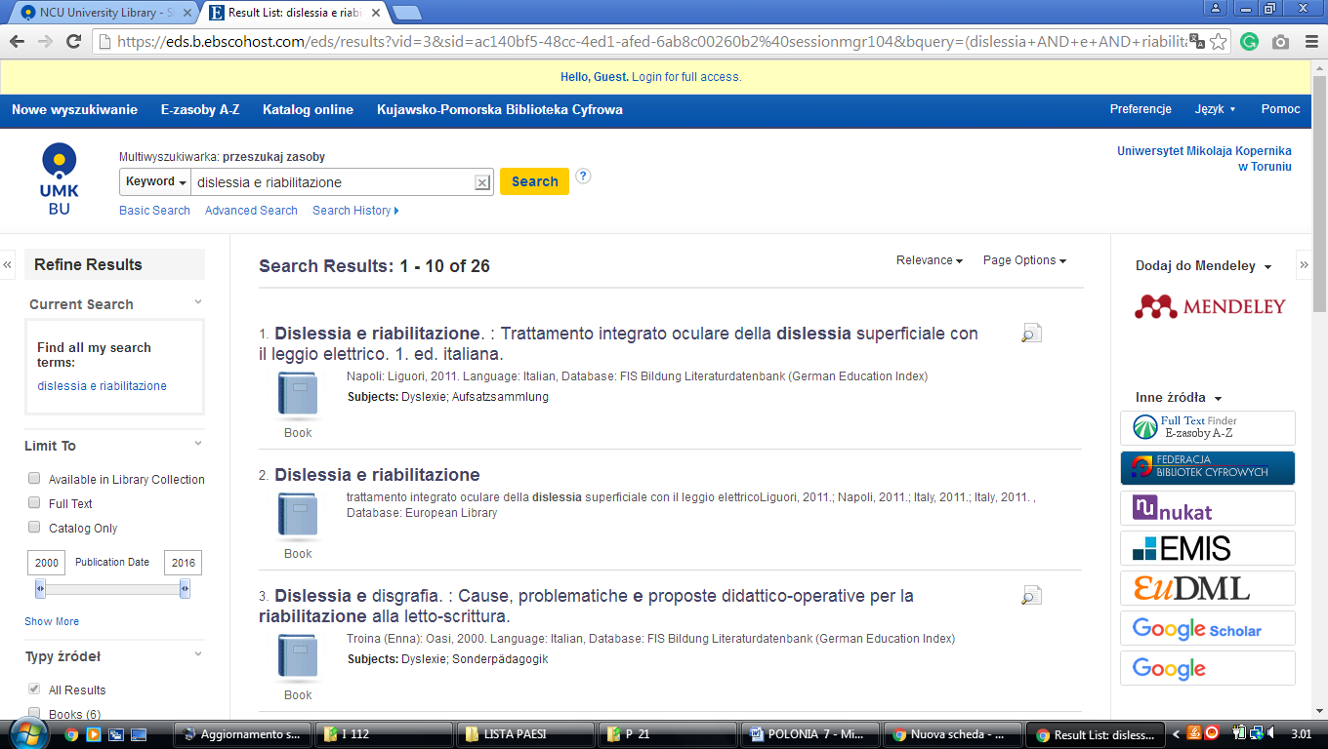

4 LIBRARY OF WROCŁAW UNIVERSITY OF SCIENCE AND TECHNOLOGY
(Poland)
https://primo.bg.pwr.edu.pl/primo_library/libweb/action/search.do?ct=facet&pcAvailabiltyMode=true&pcAvailClicked=true&query=any%2Ccontains%2Cdislessia%20e%20riabilitazione&fn=search&indx=1&vl(1UI0)=contains&dscnt=1&search_scope=all_scope&scp.scps=scope%3A(48TUR_ibuk)%2Cscope%3A(48TUR_TUR03)%2Cscope%3A(48TUR_TUR01)%2Cscope%3A(48TUR_dlibra)%2Cscope%3A(48TUR_ejournals)%2Cscope%3A(48TUR_nasbi)%2Cprimo_central_multiple_fe&displayMode=full&vid=48TUR_VIEW&mode=Basic&ct=search&highlight=true&institution=48TUR&bulkSize=10&tab=all_tab&prefLang=en_US&displayField=all&vl(freeText0)=dislessia%20e%20riabilitazione&vl(2235027UI0)=any&dum=true&fromLogin=true&dstmp=1518385579876&fromDL
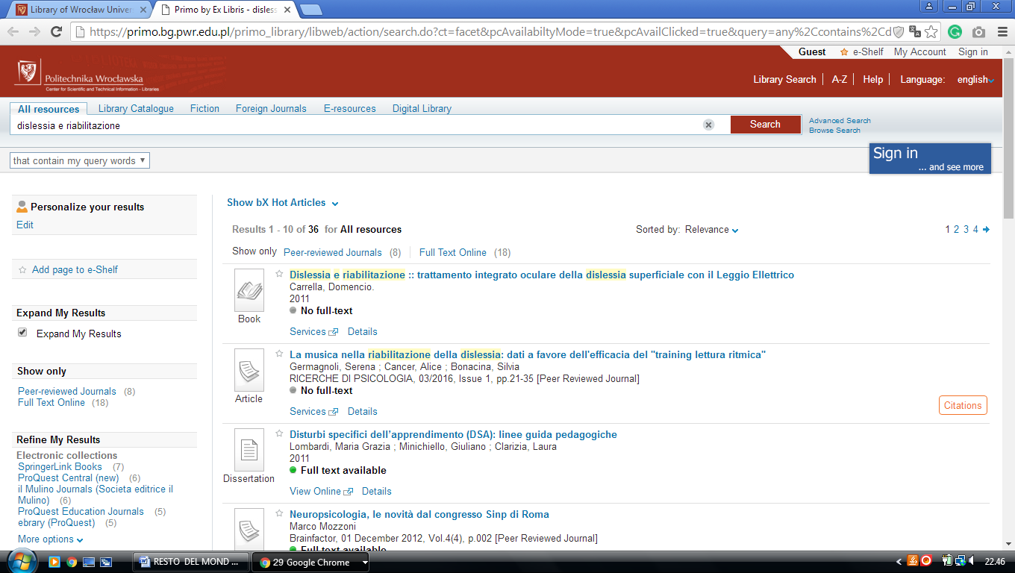

5 LIBRARY UNIVERSITY OF WROCLAW (Wroclaw, Poland)
https://wroclaw.summon.serialssolutions.com/#!/search?ho=f&l=en&q=DISLESSIA%20E%20RIABILITAZIONE

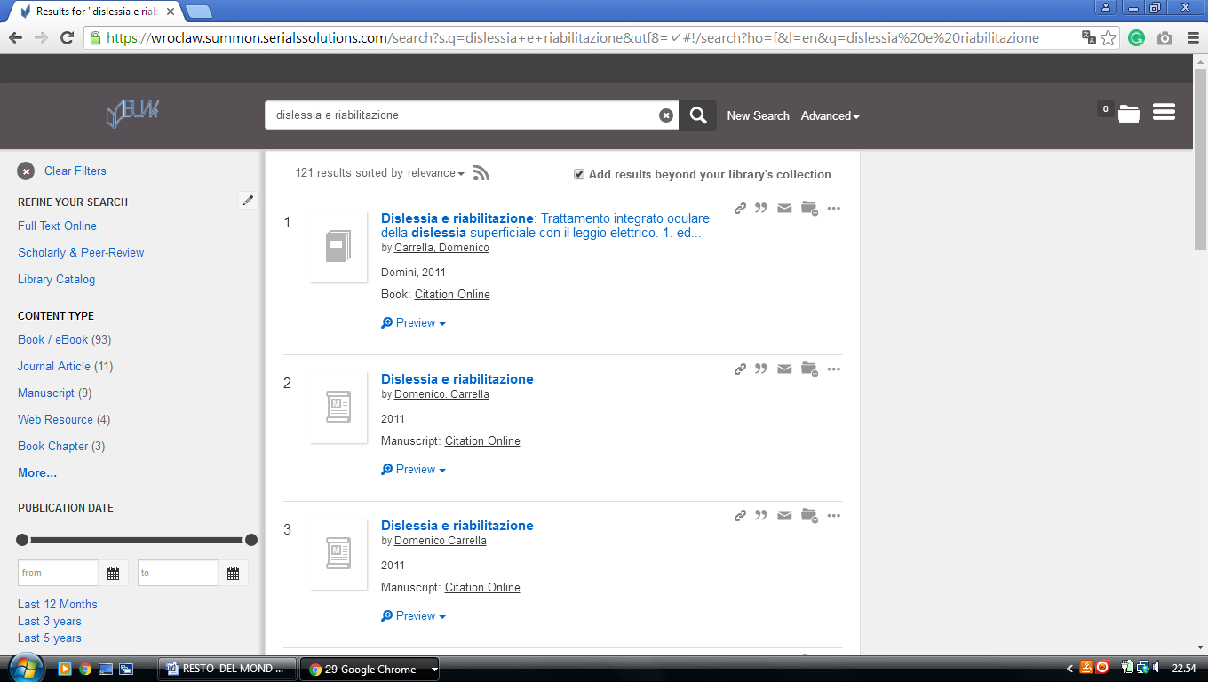

6 MAIN LIBRARY OF WARSAW UNIVERSITY OF TECHNOLOGY – (Poland)
http://primo-48tuw.hosted.exlibrisgroup.com/primo_library/libweb/action/search.do?ct=facet&pcAvailabiltyMode=true&pcAvailClicked=true&frbg=&vl(47969851UI0)=any&query=any%2Ccontains%2Cdislessia%20e%20riabilitazione&fn=search&indx=1&dscnt=0&search_scope=primo_all_scope&scp.scps=scope%3A(48TUW_SYM01)%2Cscope%3A(48TUW_FOT01)%2Cscope%3A(48TUW_dlibra)%2Cscope%3A(48TUW_WTU01)%2Cscope%3A(48TUW_WTU03)%2Cscope%3A(48TUW_ejournals)%2Cscope%3A(48TUW_ibuk)%2Cscope%3A(bw_pdf)%2Cscope%3A(48TUW_nasbi)%2Cprimo_central_multiple_fe&tb=t&vid=48TUW_VIEW&mode=Basic&onCampus=false&ct=search&institution=48TUW&srt=rank&tab=default_tab&prefLang=en_US&dym=true&vl(freeText0)=dislessia%20e%20riabilitazione&dum=true&group=GUEST&dstmp=1518387076621&fromDL

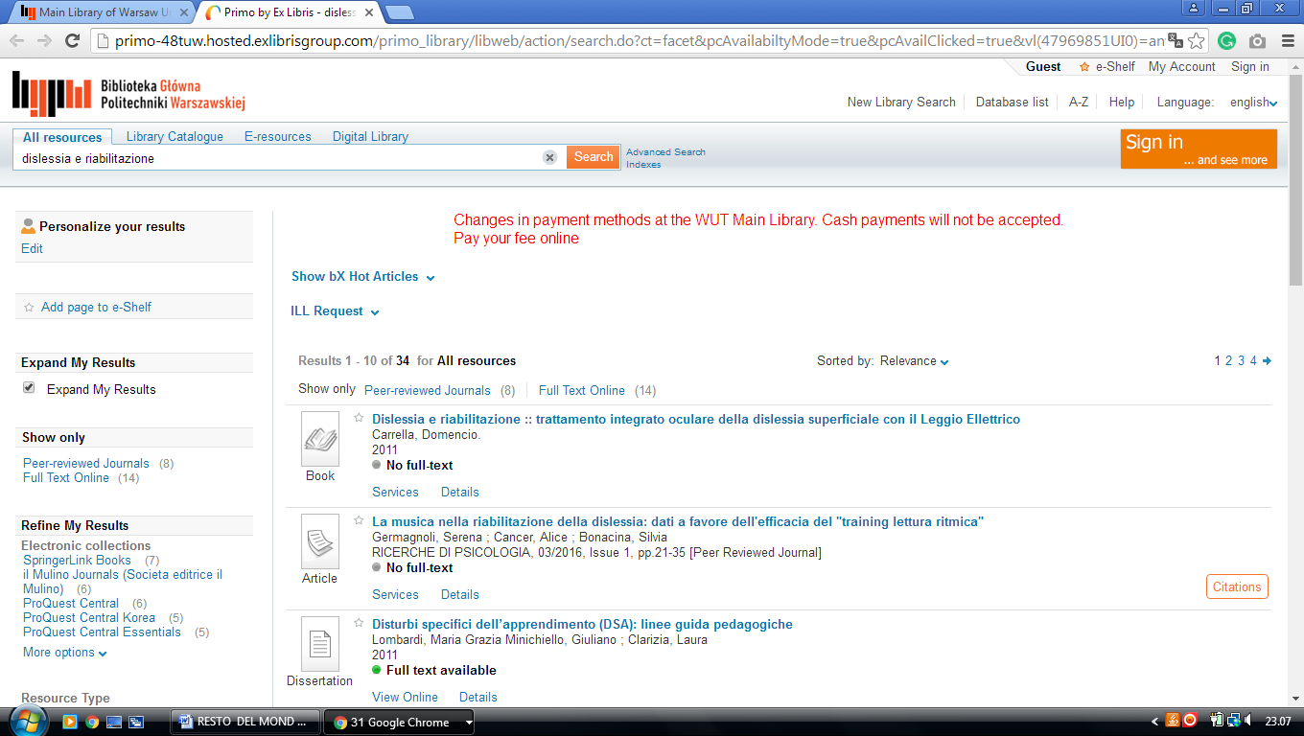

Biblioteka Główna Śląskiego Uniwersytetu Medycznego w Katowicach
Śląski Uniwersytet Medyczny w Katowicach

Medical University of Silesia

https://primo-48slam.hosted.exlibrisgroup.com/primo-explore/search?fn=search&dym=true&query=any,contains,dislessia%20e%20riabilitazione&group=GUEST&institution=48SLAM&onCampus=false&mode=Basic&indx=1&dum=true&srt=rank&vid=48SLAM_VIEW&frbg=&tab=default_tab&search_scope=all_scope&tb=t&vl(freeText0)=dislessia%20e%20riabilitazione&lang=pl_PL&pcAvailability=true

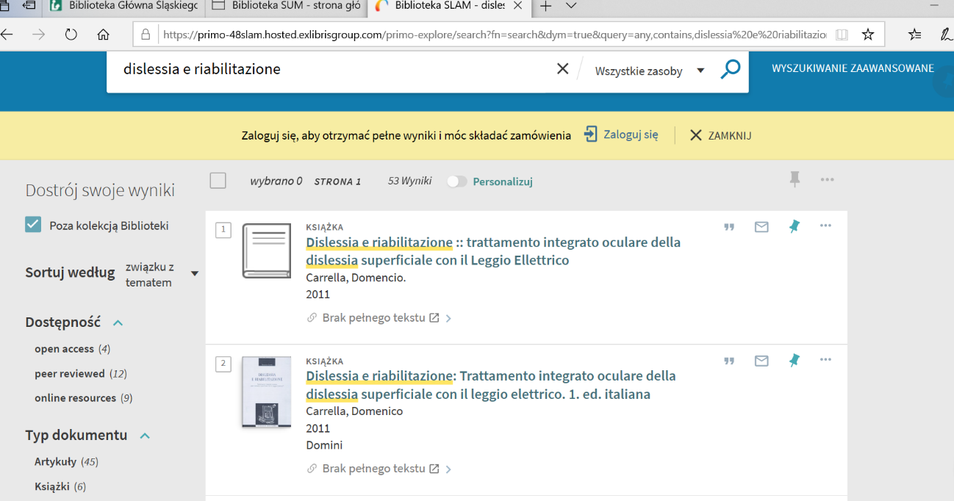

Nicholas Copernicus University Toruń, Kuyavian-Pomeranian

Biblioteka Uniwersytecka w Toruniu Uniwersytet Mikołaja Kopernika w Toruniu

https://www.bu.umk.pl/
