EDUCATION CITY, GEORGETOWN UNIVERSITY, QATAR

Requesting Materials from the Georgetown University in Qatar ...
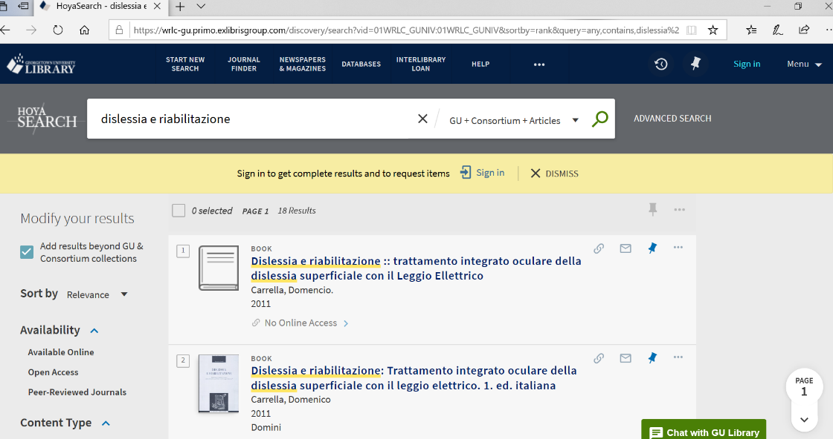

College of North Atlantic Qatar Library

College of North Atlantic Qatar
Doha, Qatar
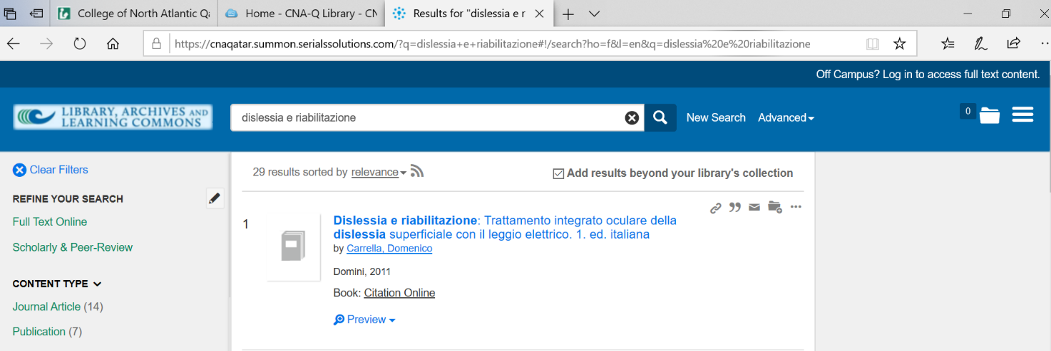
https://cnaqatar.summon.serialssolutions.com/?q=dislessia+e+riabilitazione#!/search?ho=f&l=en&q=dislessia%20e%20riabilitazione

