1 GPNTB – (Russian National Public Library For Science And Technology
Moscow, Russia)
http://gpntb.summon.serialssolutions.com/search?s.q=dislessia+e+riabilitazione#!/search?ho=f&l=en&q=dislessia%20e%20riabilitazione

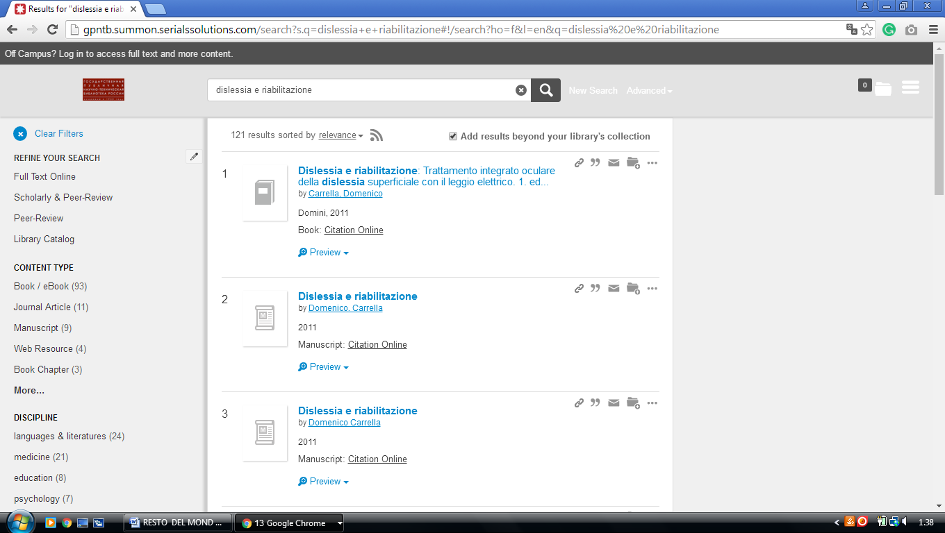

2 NATIONAL LIBRARY OF RUSSIA - THE EUROPEAN LIBRARY

(Russia)

http://www.theeuropeanlibrary.org/tel4/contributor/P01230
