1 GLASGOW CALEDONIAN UNIVERSITY LIBRARY - (Glasgow, Scotland)
https://discover.gcu.ac.uk/primo-explore/search?institution=44GLCU&vid=44GLCU_VU1&tab=default_tab&search_scope=default_scope&mode=Basic&displayMode=full&highlight=true&dum=true&query=any,contains,dislessia%20e%20riabilitazione&displayField=all&sortby=rank&lang=en_US&pcAvailability=true

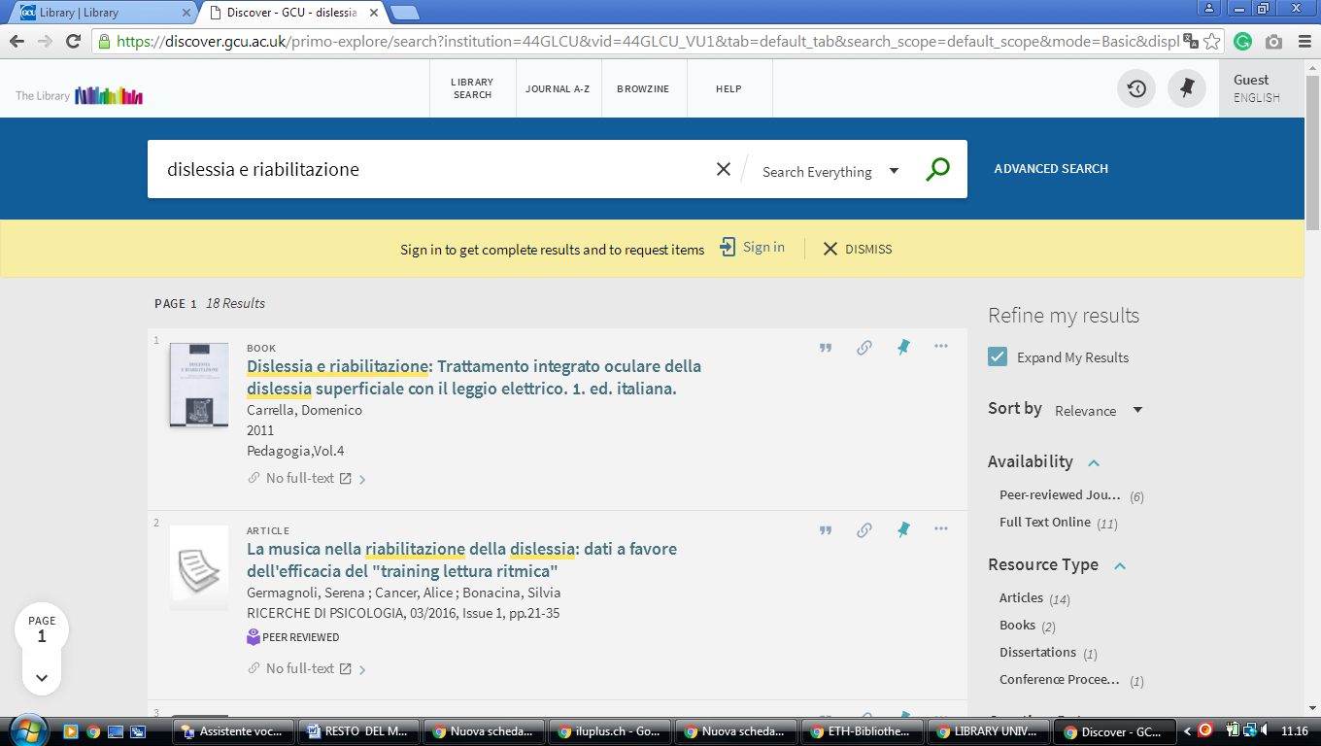

2 NATIONAL LIBRARY OF SCOTLAND – (Edinburgh, Scotland)
https://nls.summon.serialssolutions.com/search?s.q=dislessia+e+riabilitazione#!/search?ho=f&l=it-IT&q=dislessia%20e%20riabilitazione

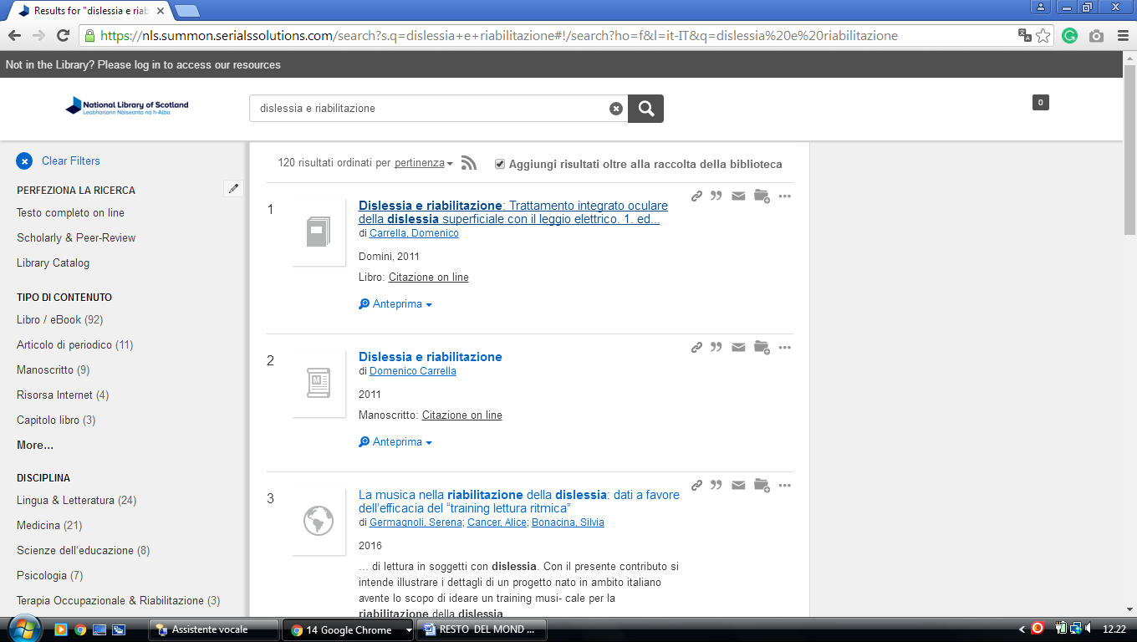

3 UNIVERSITY OF GLASGOW LIBRARY – (Glasgow, Scotland)
https://glasgow.summon.serialssolutions.com/?s.q=dislessia+e+riabilitazione&s.cmd=addFacetValueFilters%28ContentType%2CNewspaper+Article%2Ct%7CContentType%2CBook+Review%2Ct%29#!/search?ho=f&fvf=ContentType,Newspaper%20Article,t%7CContentType,Book%20Review,t&l=en-UK&q=dislessia%20e%20riabilitazione

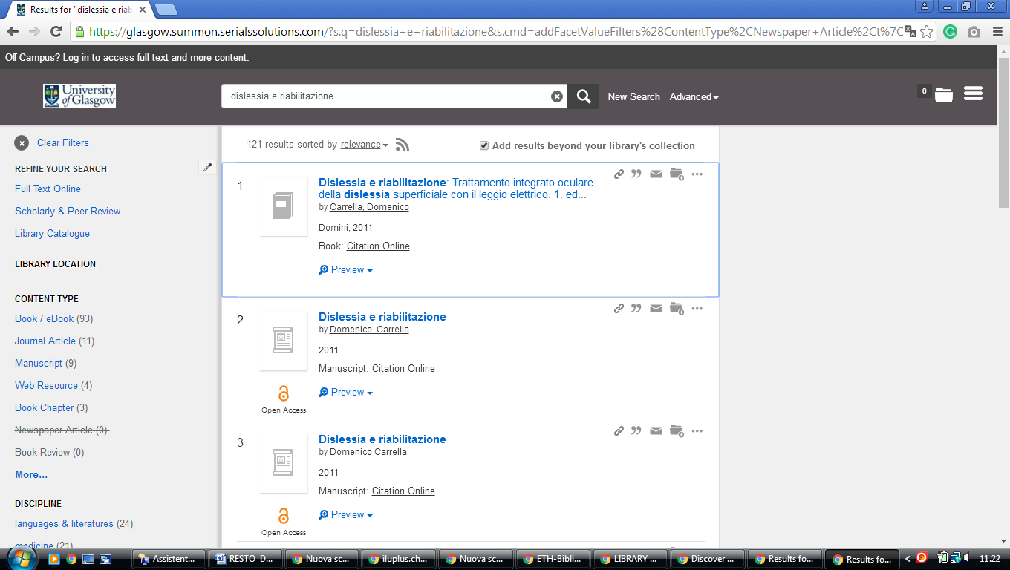

4 LIBRARY UNIVERSITY OF EDINBURGH - (South Bridge, Edinburgh, Scozia)

https://discovered.ed.ac.uk/primo-explore/search?institution=44UOE&vid=44UOE_VU2&search_scope=default_scope&query=any,contains,dislessia%20e%20riabilitazione&pcAvailabiltyMode=true&sortby=rank&pcAvailability=true

