1 NSU UNIVERSITY OF SINGAPORE LIBRARY – (Singapore)
http://nus.summon.serialssolutions.com/search?s.q=DISLESSIA%20E%20RIABILITAZIONE&s.fvf%5B%5D=ContentType,Newspaper%20Article,t&s.fvf%5B%5D=ContentType,Book%20Review,t#!/search?ho=f&fvf=ContentType,Newspaper%20Article,t%7CContentType,Book%20Review,t&l=en&q=DISLESSIA%20E%20RIABILITAZIONE
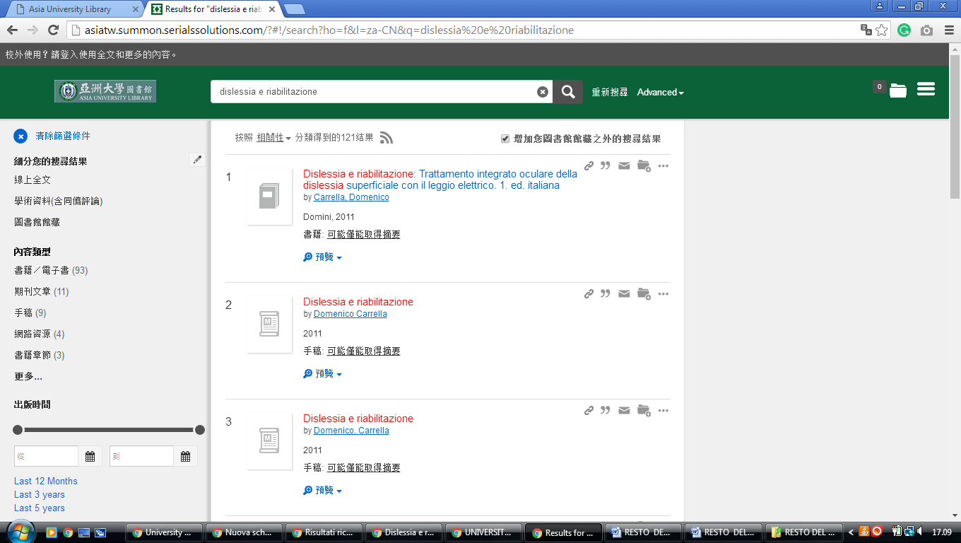

2 US LIBRARIES - HOME - (Università Nazionale Di Singapore, Nus)
http://nus.summon.serialssolutions.com/search?s.q=DISLESSIA%20E%20RIABILITAZIONE&s.fvf%5B%5D=ContentType,Newspaper%20Article,t&s.fvf%5B%5D=ContentType,Book%20Review,t#!/search?ho=f&fvf=ContentType,Newspaper%20Article,t%7CContentType,Book%20Review,t&l=en&q=DISLESSIA%20E%20RIABILITAZIONE

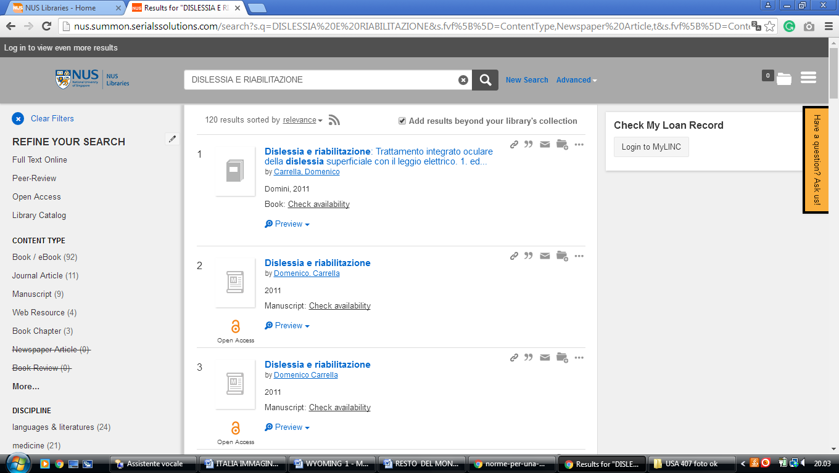

3 LIBRARY NATIONAL UNIVERSITY OF SINGAPORE – (Singapore)
http://nus.summon.serialssolutions.com/search?s.q=DISLESSIA%20E%20RIABILITAZIONE&s.fvf%5B%5D=ContentType,Newspaper%20Article,t&s.fvf%5B%5D=ContentType,Book%20Review,t#!/search?ho=f&fvf=ContentType,Newspaper%20Article,t%7CContentType,Book%20Review,t&l=en&q=DISLESSIA%20E%20RIABILITAZIONE

