1 IE BUSINESS SCHOOLLIBRARY - (Madrid, Spagna)
https://ie.on.worldcat.org/search?lang=en&queryString=dislessia+e+riabilitazione&scope=

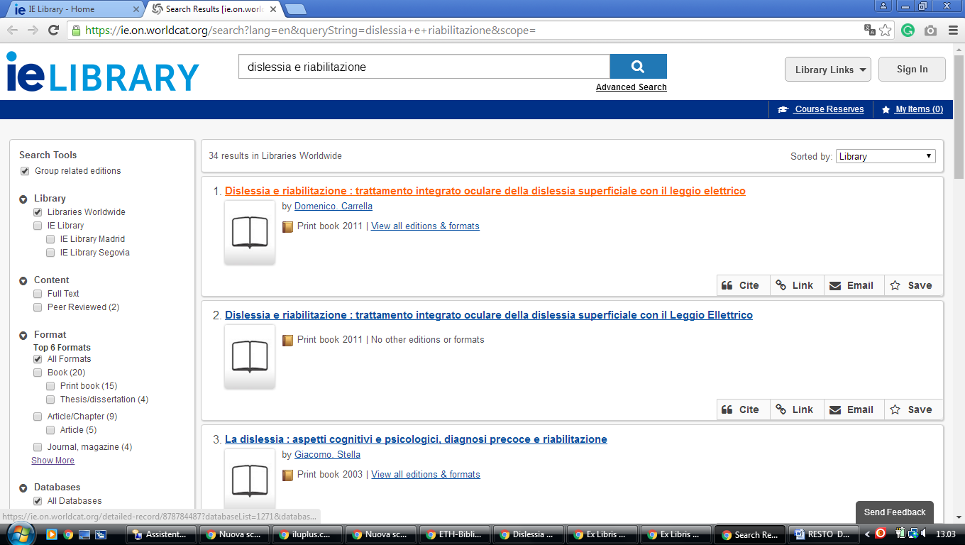

2 LIBRARY UNIVEERSIDAD COMPLUTENSE MADRID – (Madrid, Spagna)
http://ucm.summon.serialssolutions.com/en/#!/search?ho=f&fvf=ContentType,Newspaper%20Article,t&l=en&q=dislessia%20e%20riabilitazione

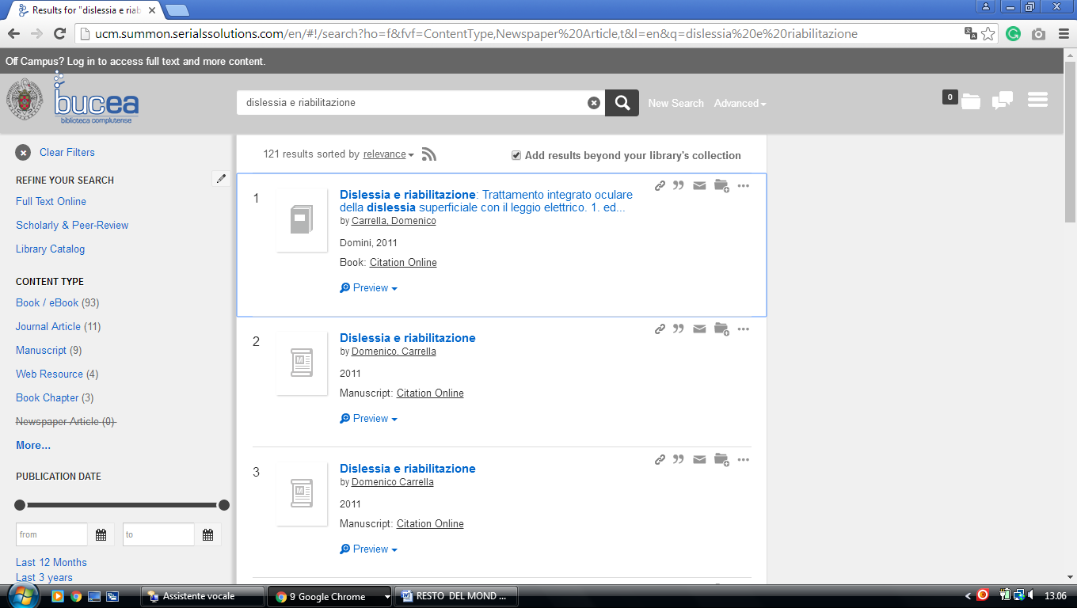

3 NATIONAL LIBRARY UNIVERSITY OF DISTANCE EDUCATION – (Madrid, Spain)
http://uned.summon.serialssolutions.com/search/results?s.fvf%5B%5D=ContentType%2CNewspaper+Article%2Ct&s.q=dislessia+e+riabilitazione#!/search?ho=f&fvf=ContentType,Newspaper%20Article,t&l=es-ES&q=dislessia%20e%20riabilitazione

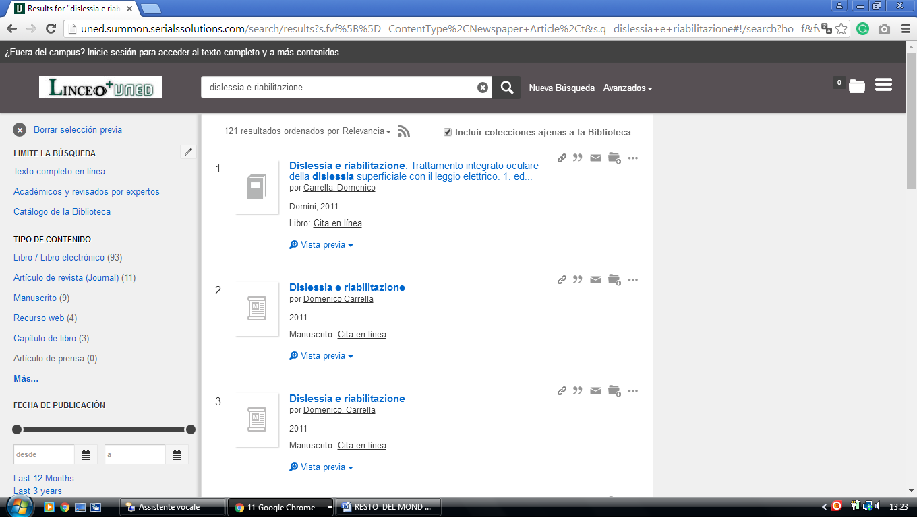

4 UOC (Universitat Oberta de Catalunya) - Barcelona, Spain
http://uoc.summon.serialssolutions.com/search?ho=t&l=ca&q=dislessia+e+riabilitazione#!/search?ho=f&l=ca&q=dislessia%20e%20riabilitazione
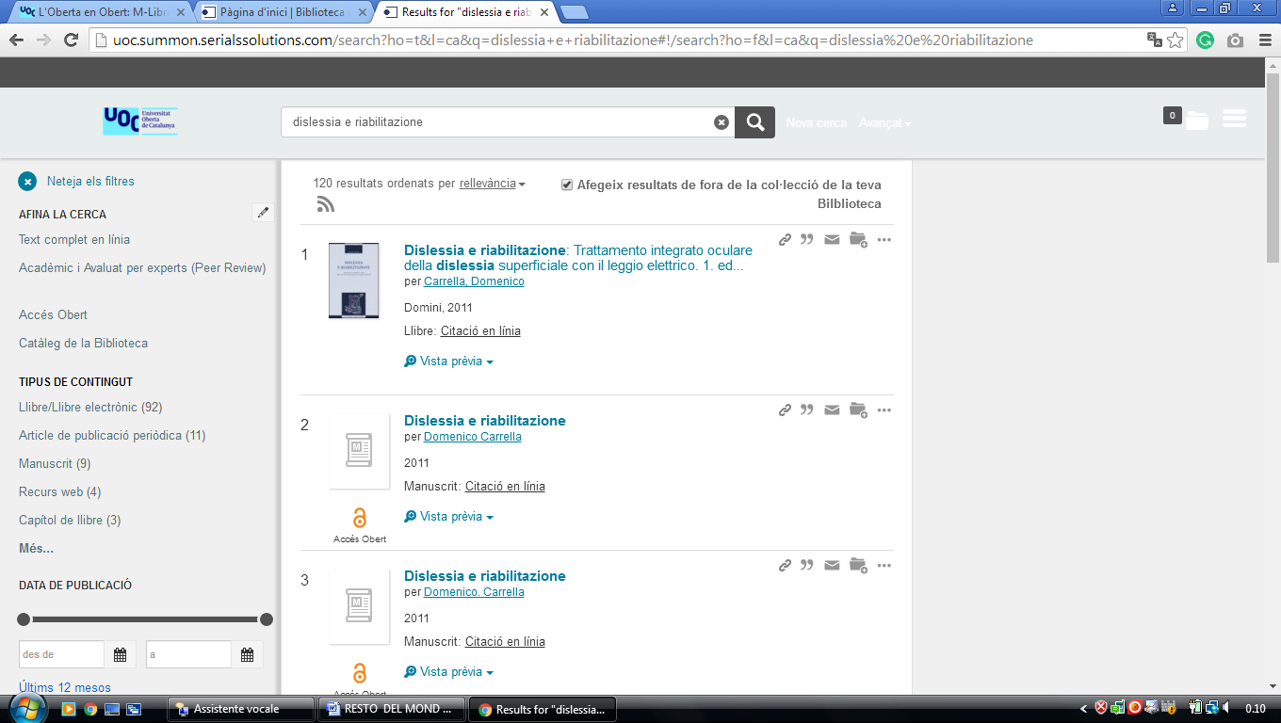

5 BIBLIOTEK PABLO DE OLAVIDE UNIVERSITY - (Seville, Spain)
http://upo.summon.serialssolutions.com/?q=dislessia+e+riabilitazione&searchImageSumbitComponent=Buscar#!/search?ho=f&l=en&q=dislessia%20e%20riabilitazione&searchImageSumbitComponent=Buscar

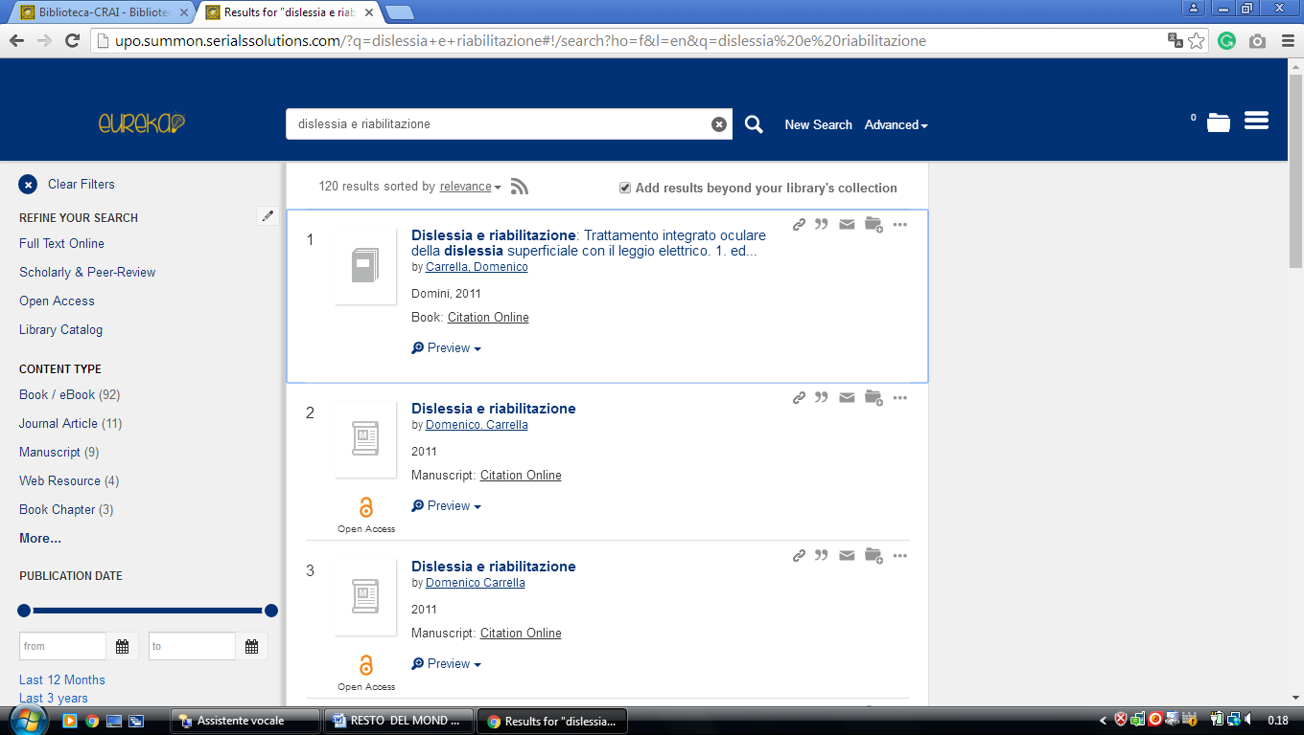

6 BIBLIOTECA-CRAI - BIBLIOTECACRAI - UPO, - (Sevilla, España)
http://upo.summon.serialssolutions.com/?q=dislessia+e+riabilitazione#!/search?ho=f&l=en&q=dislessia%20e%20riabilitazione

7 BIBLIOTECA DE LA UNIVERSIDAD DE ALCALÁ - UAH MADRID – (Spain)
https://uah.summon.serialssolutions.com/search?s.q=dislessia+e+riabilitazione&s.fvf%5B%5D=ContentType%2CNewspaper+Article%2Ct&keep_r=true#!/search?ho=f&fvf=ContentType,Newspaper%20Article,t&l=es-ES&q=dislessia%20e%20riabilitazione

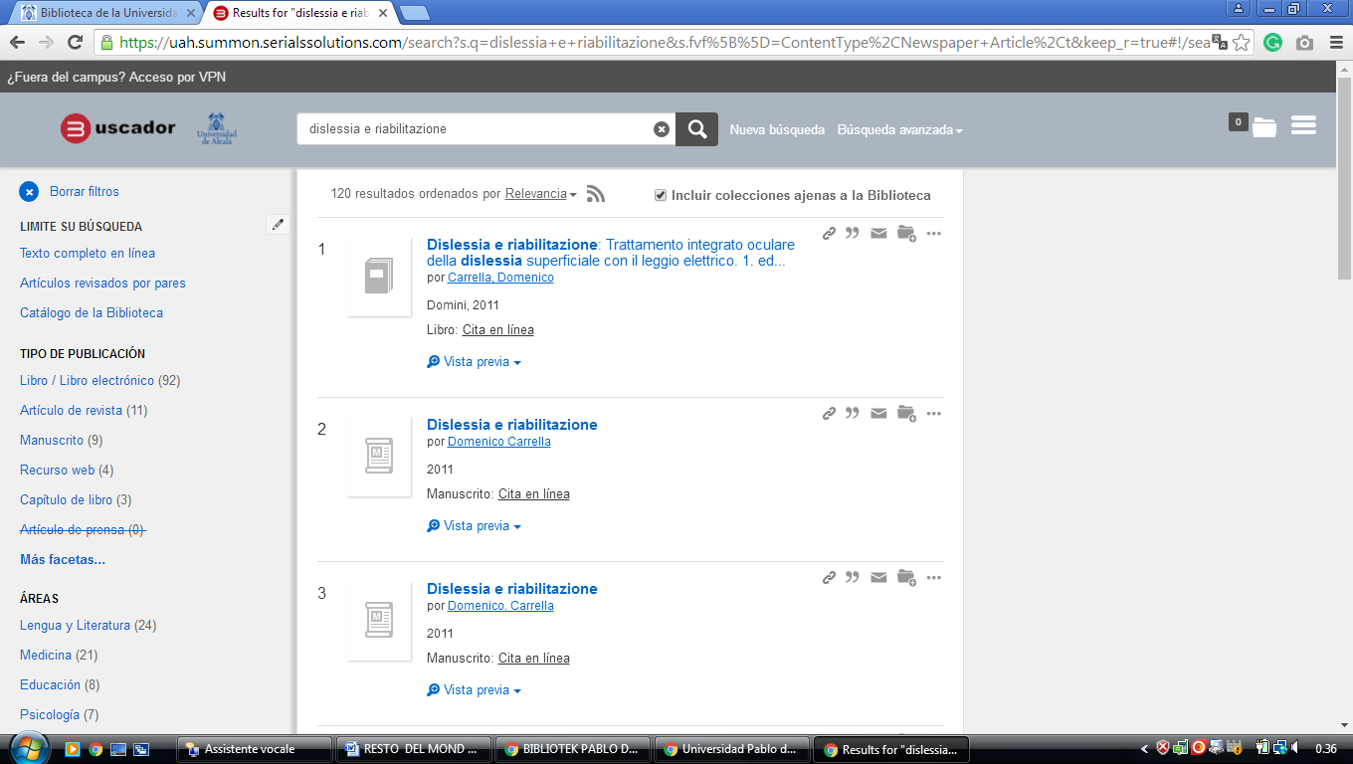

8 BUC - UNICAN - (Biblioteca University Of Cantabria, Santander, Spain)
http://unican.summon.serialssolutions.com/search?q=dislessia+e+riabilitazione#!/search?ho=f&l=es-ES&q=dislessia%20e%20riabilitazione

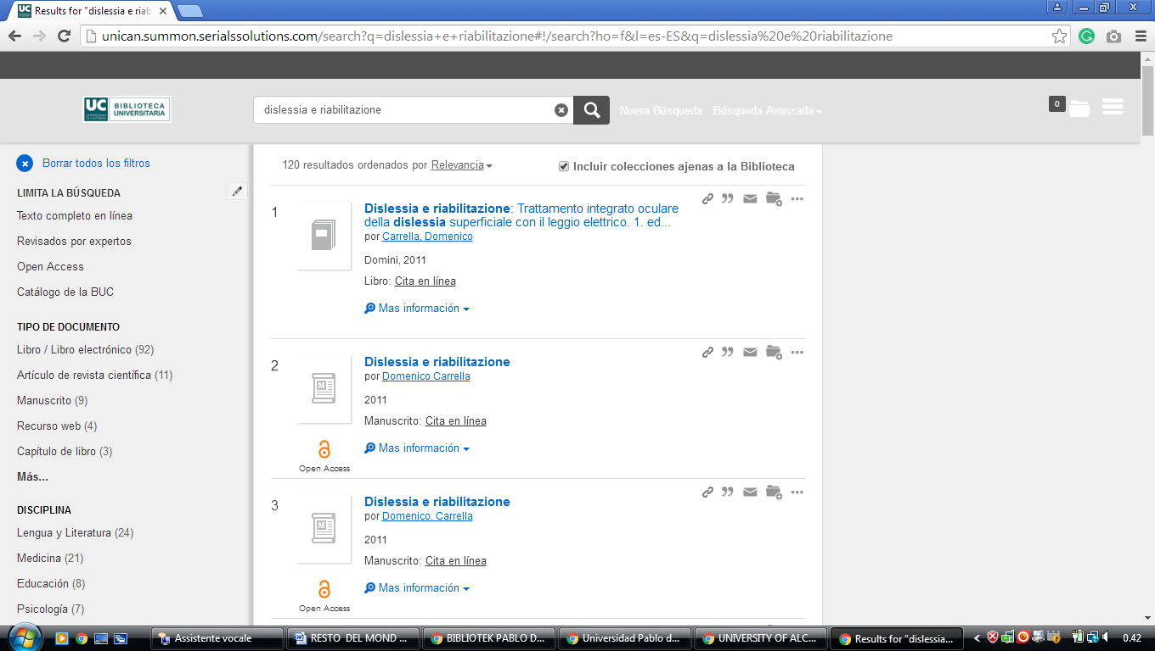

9 BIBLIOTECA UNIVERSIDAD DE CÓRDOBA - UCO - (Spain)
http://uco.summon.serialssolutions.com/search?utf8=%3F&s.q=DISLESSIA+E+RIABILITAZIONE&submit=Buscar#!/search?ho=f&l=es-ES&q=DISLESSIA%20E%20RIABILITAZIONE

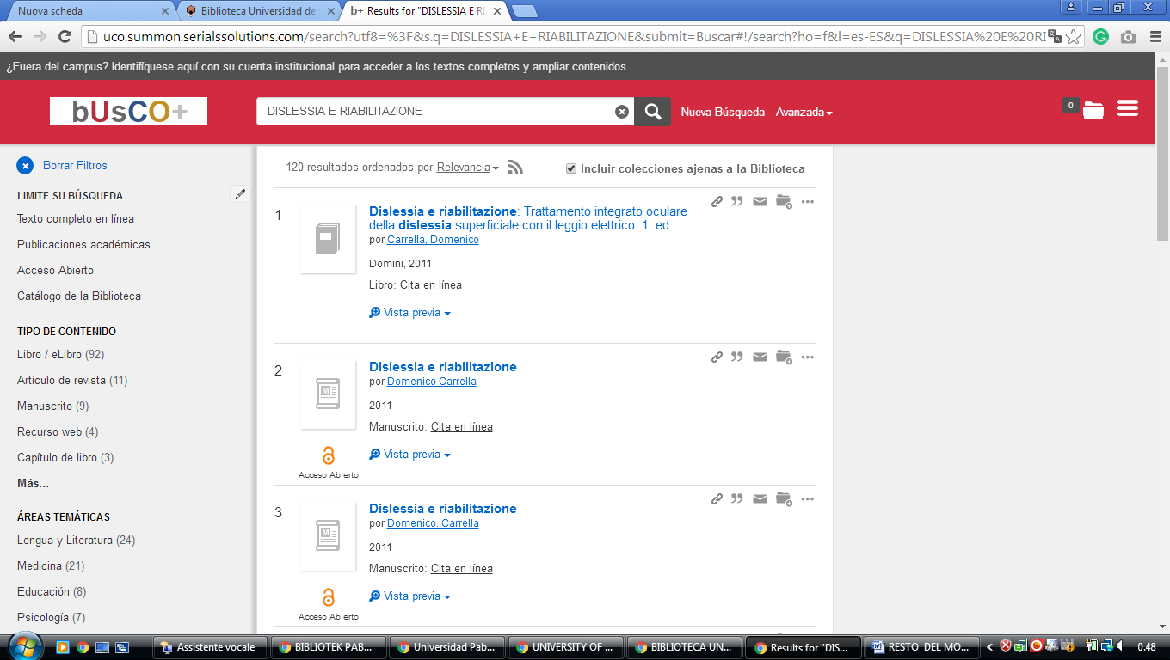

10 CATALOGOBIBLIOTECA.UCLM.ES - (EDSCO Discovery Service -
Spain)
https://catalogobiblioteca.uclm.es/cgi-bin/abnetopac/O7068/ID3dc1af34/NT5?ACC=170&DOC=1

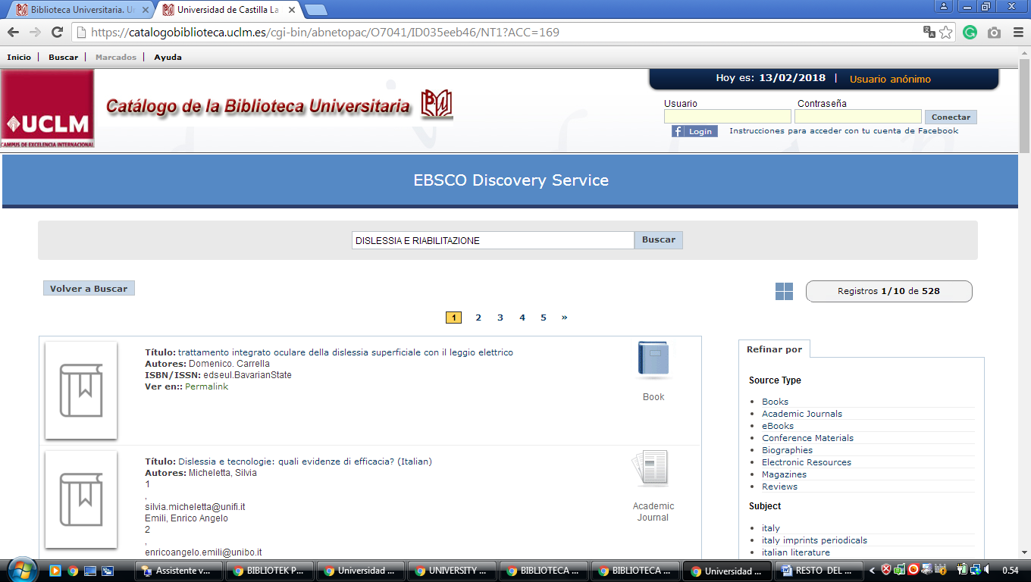

11 BIBLIOTECA UNIVERSITY OF LA RIOJA – (La Rioja, Spain)
http://eds.b.ebscohost.com/eds/results?vid=0&sid=afd01368-0c39-444c-8589-b43e3535aba9%40sessionmgr120&bquery=dislessia+e+riabilitazione&bdata=Jmxhbmc9ZXMmdHlwZT0wJnNpdGU9ZWRzLWxpdmU%3d

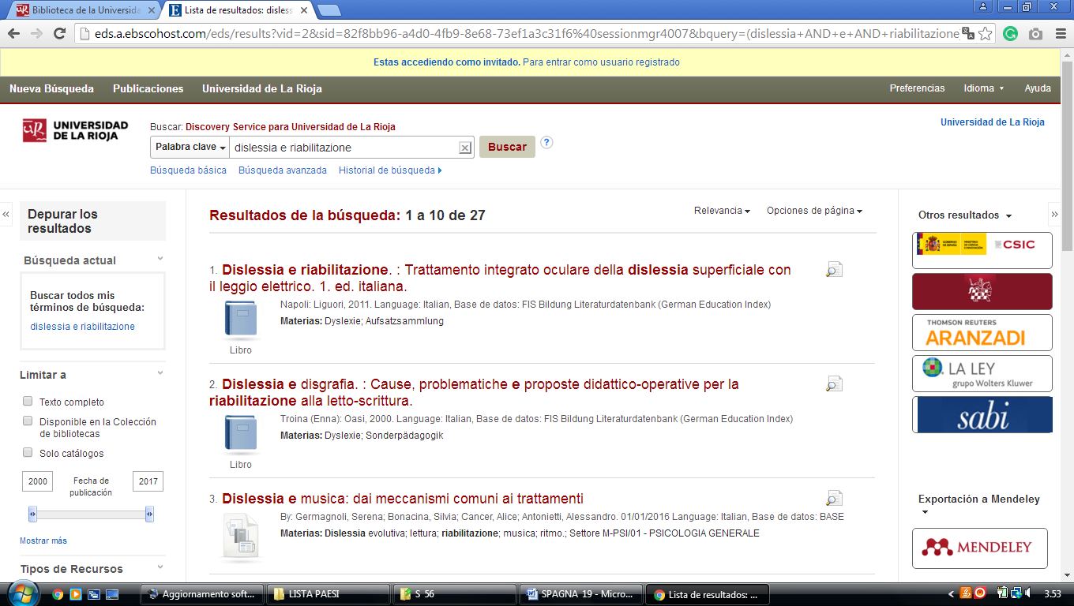

12 BIBLIOTECA UNIVERSITY OF SALAMANCA - (Salamanca, Spain)
http://usal.worldcat.org/title/dislessia-e-riabilitazione-trattamento-integrato-oculare-della-dislessia-superficiale-con-il-leggio-elettrico/oclc/878784487&referer=brief_results
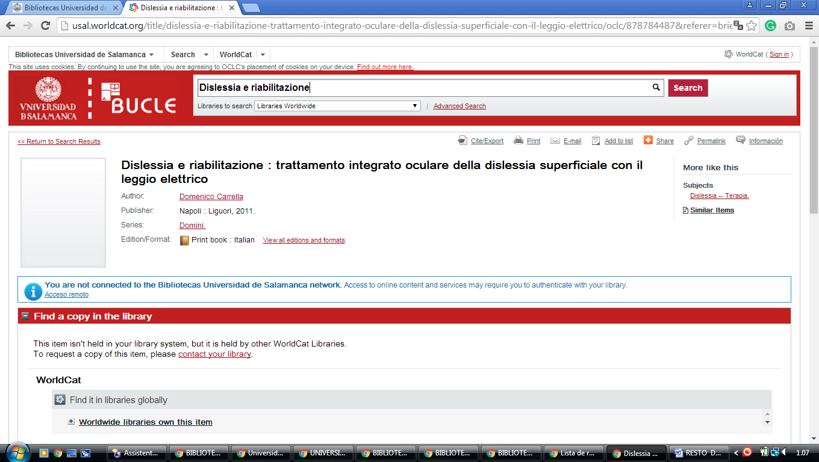

13 BIBLIOTECA UNIVERSITY OF BURGOS LIBRARY - (Burgos, Spain)
https://ubu.on.worldcat.org/search?databaseList=&queryString=dislessia%20riabilitazione#/oclc/941217209

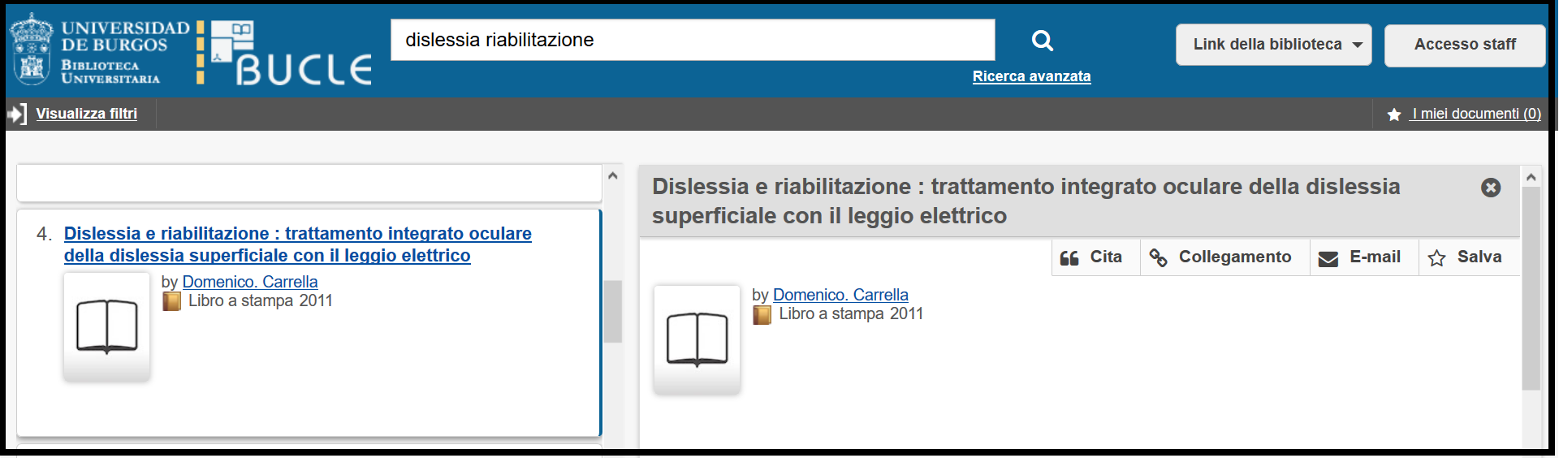

14 CATALOCO COLECTIVO MADRONO - (Spagna)
https://consorciomadrono.summon.serialssolutions.com/?#!/search?ho=f&l=es&q=DISLESSIA%20E%20RIABILITAZIONE
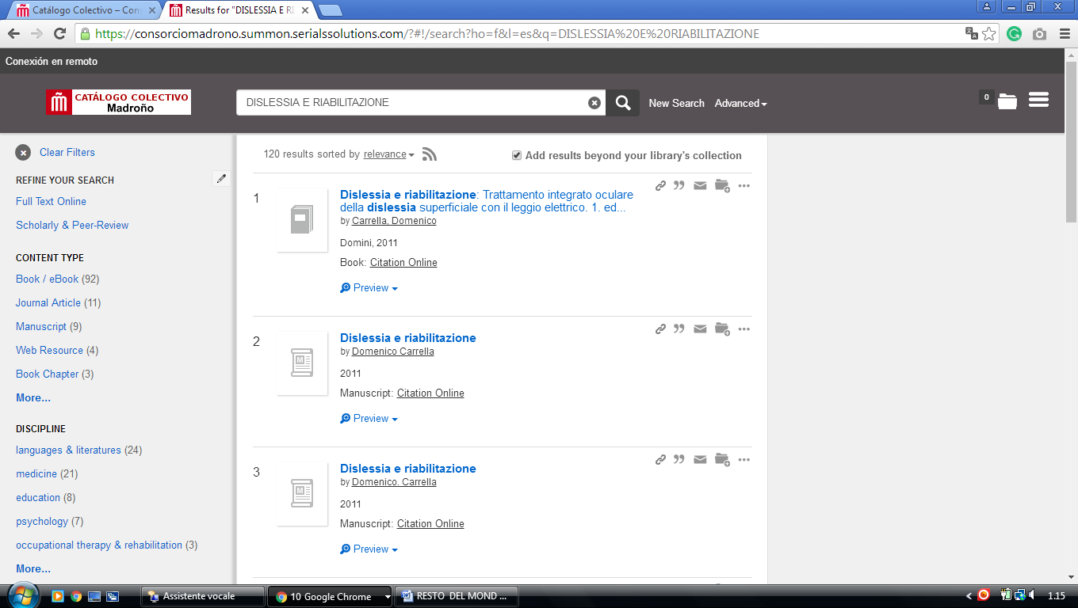
-------------------------------------------------------------------------------------------------------------------------------

15 BIBLIOTECA UAM - UNIVERSIDAD AUTÓNOMA DE MADRID – (SPAIN)
http://uam.summon.serialssolutions.com/?#!/search?ho=f&l=es-ES&q=DISLESSIA%20E%20RIABILITAZIONE
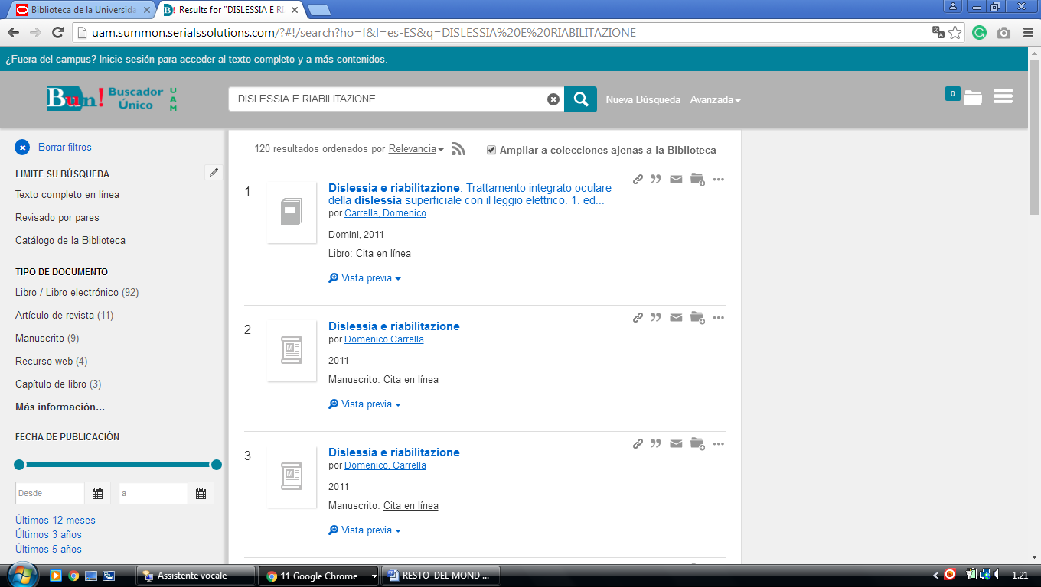

16 UNIVERSIDAD DE ZARAGOZA – BIBLIOTECA - (Spain)
http://eds.a.ebscohost.com/eds/results?vid=0&sid=4b4d53f8-66ec-4cf5-aa1f-c9d17bd65632%40sessionmgr4007&bquery=dislessia+e+riabilitazione&bdata=Jmxhbmc9ZXMmdHlwZT0wJnNpdGU9ZWRzLWxpdmU%3d

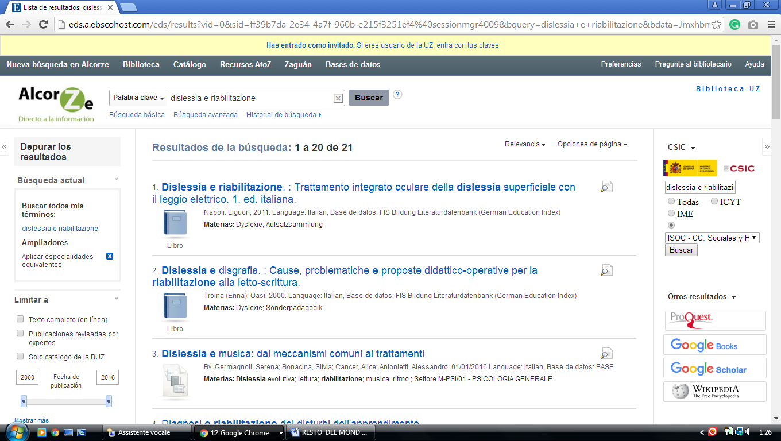

17 LIBRARY | UC3M - (Carlos Iii University Library Service Madrid, Spain)

http://uc3m.summon.serialssolutions.com/#!/search?ho=f&l=es&q=dislessia%20e%20riabilitazione
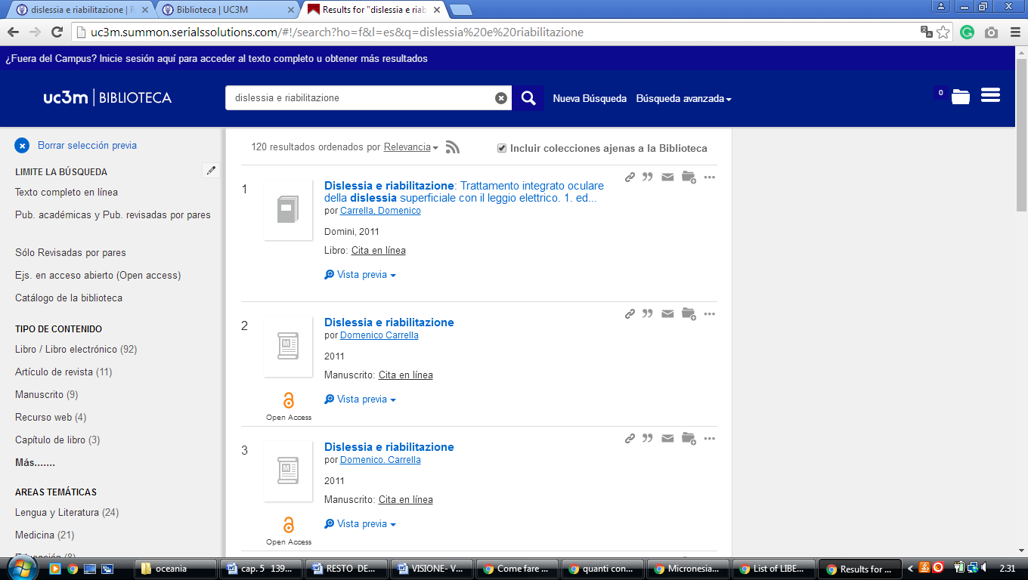

18 LIBRARY OF THE UNIVERSITY OF ALICANTE. UNIVERSITY LIBRARY, (Spagna)
https://ua.on.worldcat.org/external-search?queryString=dislessia+e+riabilitazione#/oclc/878784487

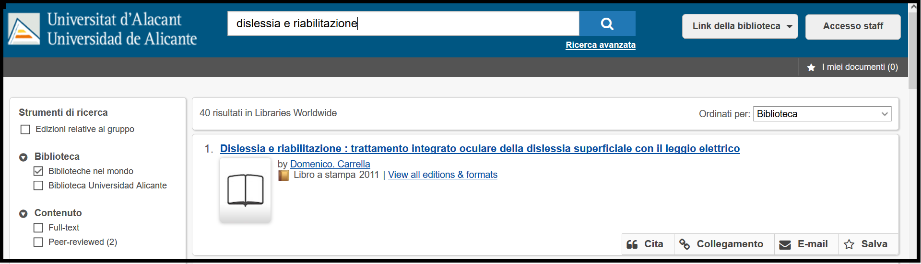

19 THE EUROPEAN LIBRARY - BIBLIOTECA UCM - UNIVERSIDAD COMPLUTENSE ... (Library of Madrid)
http://www.theeuropeanlibrary.org/tel4/search?query=advanced((ANY%2Cdislessia+e+riabilitazione)AND(CONTRIBUTOR%2CP01364))&locale=es
http://www.theeuropeanlibrary.org/tel4/search?query=dislessia%20e%20riabilitazione&locale=es
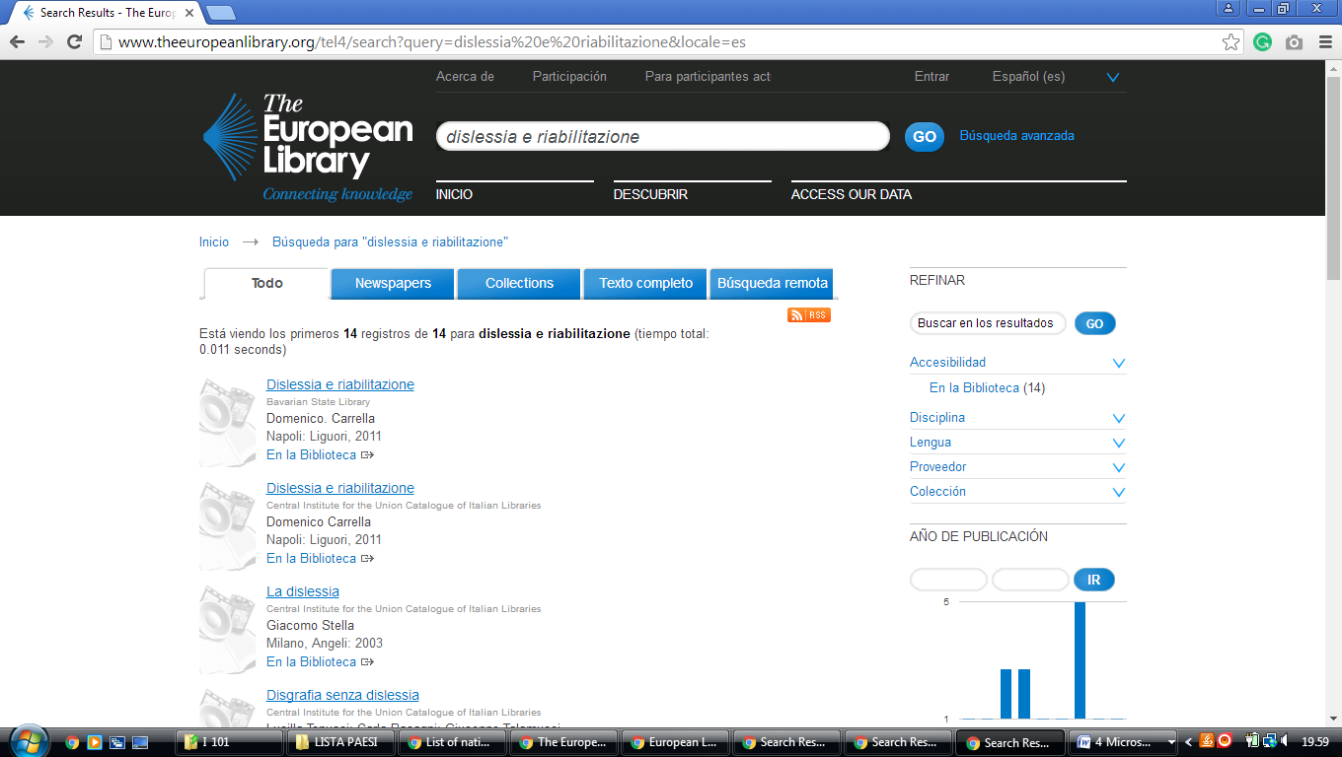

20 UNED | BIBLIOTECA DE LA UNED - (Universidad Nacional de Educación a Distancia, universidad pública Madrid de España)
http://uned.summon.serialssolutions.com/search/results?s.fvf%5B%5D=ContentType%2CNewspaper+Article%2Ct&s.q=dislessia+e+riabilitazione#!/search?ho=f&fvf=ContentType,Newspaper%20Article,t&l=es-ES&q=dislessia%20e%20riabilitazione
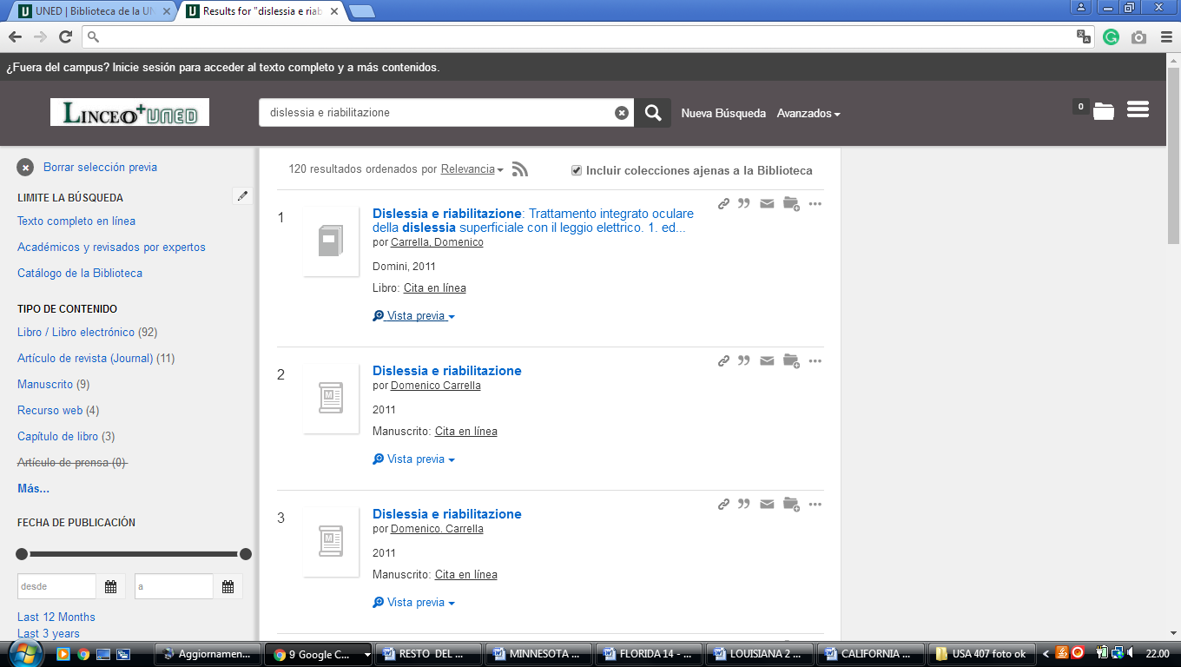

Library Services | University of Granada

https://granatensis.ugr.es/discovery/search?query=any,contains,dislessia%20e%20riabilitazione&tab=Granada&search_scope=CentralIndex&vid=34CBUA_UGR:VU1&lang=es&offset=0&

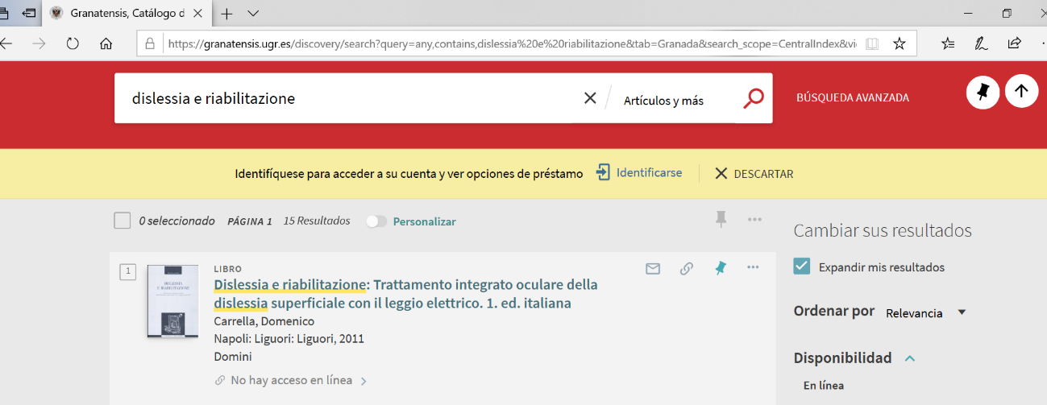

Joan Lluís Vives Virtual Library UNIVERSITÀ DI VALENCIA

https://uves.summon.serialssolutions.com/search?l=es&ho=t&q=dislessia+e+riabilitazione#!/search?ho=f&l=es&q=dislessia%20e%20riabilitazione

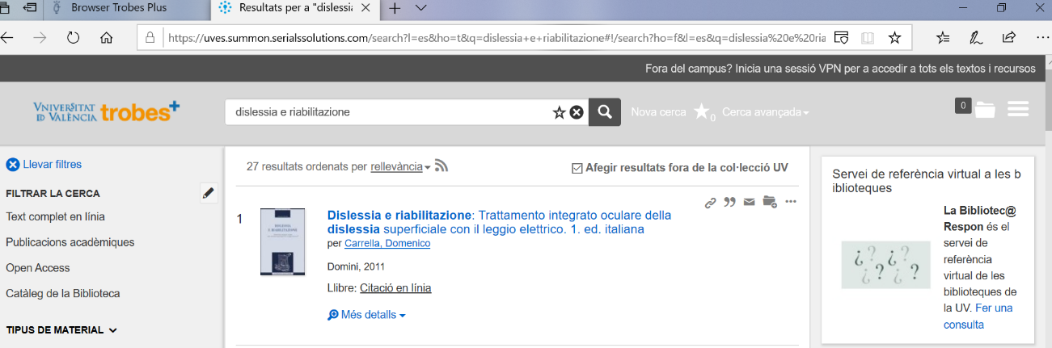

Library - UNM-Valencia - University of New Mexico
https://vclibrary.on.worldcat.org/search?sortKey=BEST_MATCH&databaseList=&queryString=dislessia+e+riabilitazione&changedFacet=scope&overrideStickyFacetDefault=&selectSortKey=BEST_MATCH&scope=&scope=wz%3A21413&format=all&year=all&yearFrom=&yearTo=&author=all&database=all&language=all&materialtype=all
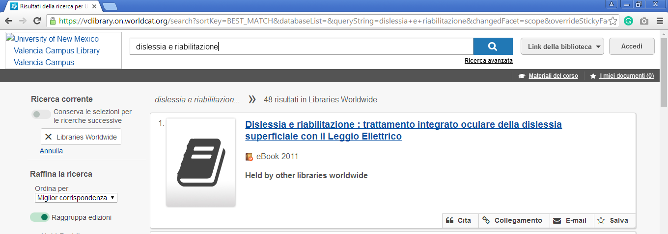

Universidad Complutense of Madrid - Ucm-Library

Biblioteca de la Facultad de Medicina

Universidad Complutense de Madrid
https://ucm.on.worldcat.org/search?sortKey=LIBRARY&databaseList=&queryString=dislessia+e+riabilitazione&changedFacet=scope&overrideStickyFacetDefault=&stickyFacetsChecked=on&selectSortKey=LIBRARY&clusterResults=off&scope=&scope=sz%3A37703&scope=sz%3A37628&format=all&year=all&yearFrom=&yearTo=&author=all&language=all&database=all
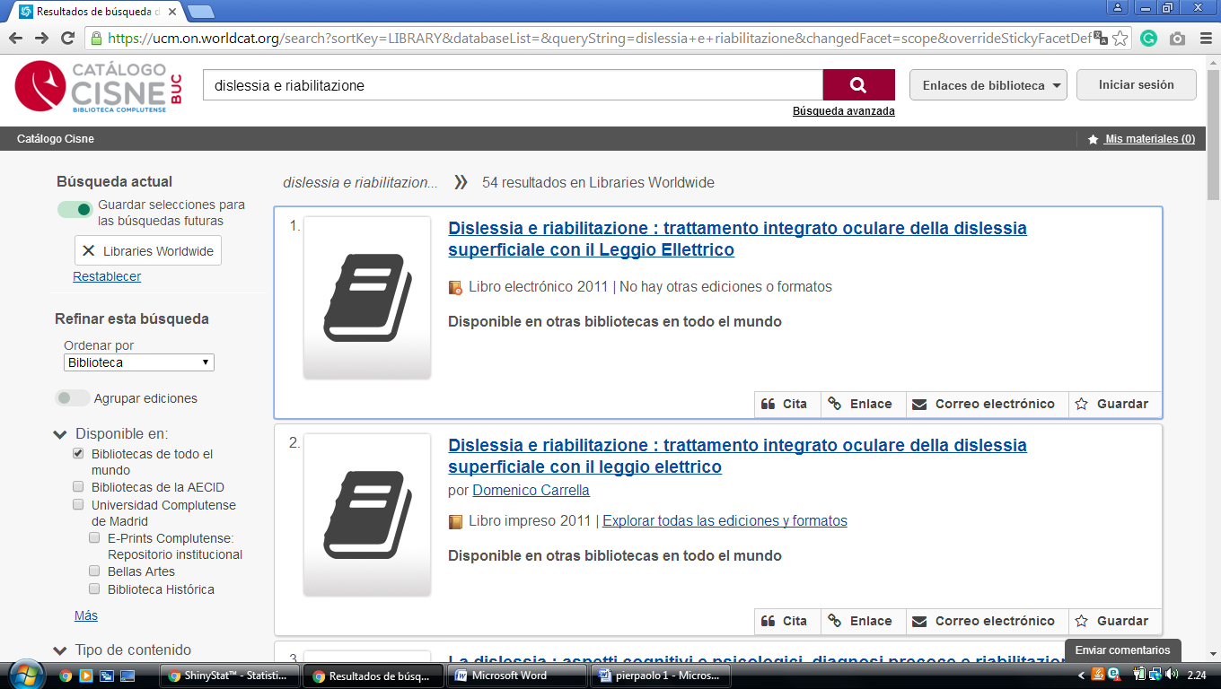

95 nazioni + 5 (color

