1 UCT LIBRARIES - (University Of Cape Town, South Africa)
https://uct.primo.exlibrisgroup.com/discovery/search?query=any,contains,dislessia%20e%20riabilitazione&tab=Everything&search_scope=MyInst_and_CI&vid=27UCT_INST:27UCT&offset=0&sortby=rank&pcAvailability=true

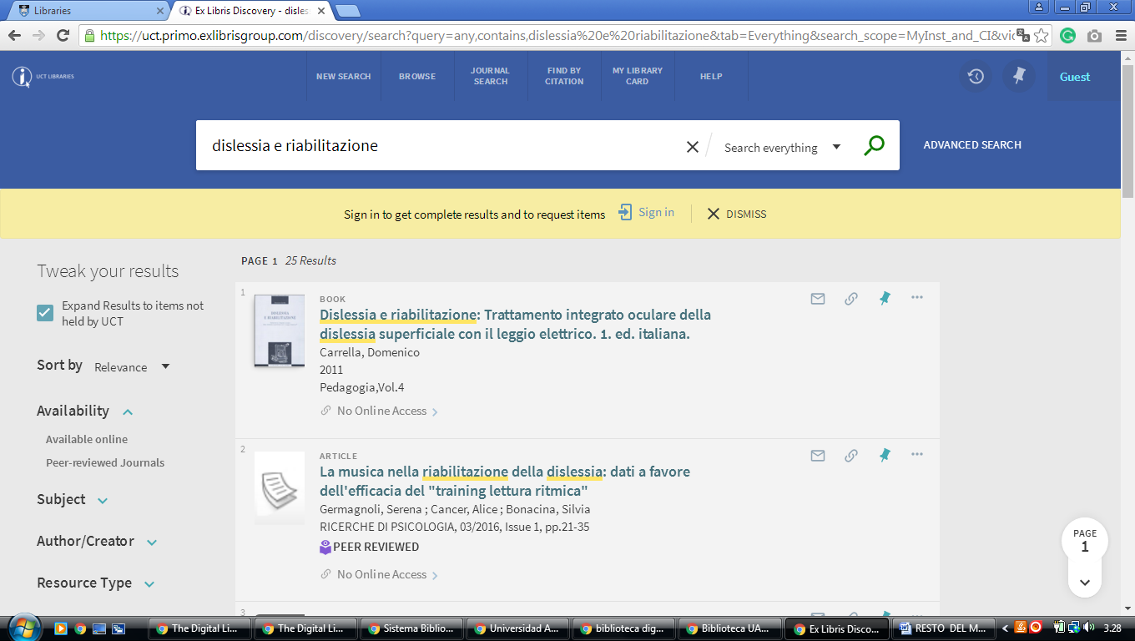

2 NELSON MANDELA METROPOLITAN UNIVERSITY LIBRARY – (Port
Elizabeth, South Africa)
https://nmmu.on.worldcat.org/search?sortKey=LIBRARY&databaseList=&queryString=dislessia+e+riabilitazione&changedFacet=scope&scope=&scope=sz%3A33861&format=all&database=all&author=all&year=all&yearFrom=&yearTo=&language=all
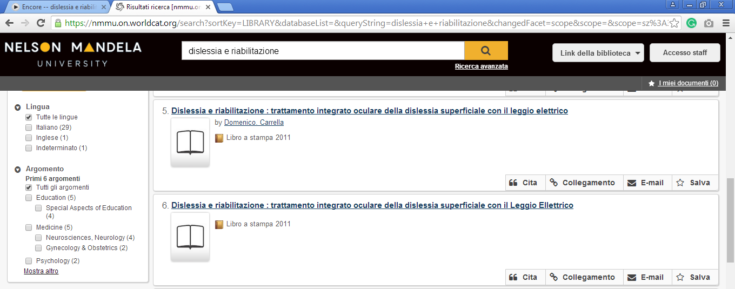

3 LIBRARY UNIVERSITY OF PRETORIA – (Pretoria, South Africa)
https://univofpretoria.on.worldcat.org/search?sortKey=LIBRARY&databaseList=&queryString=dislessia+e+riabilitazione&changedFacet=scope&scope=&scope=sz%3A33860&format=all&database=all&author=all&year=all&yearFrom=&yearTo=

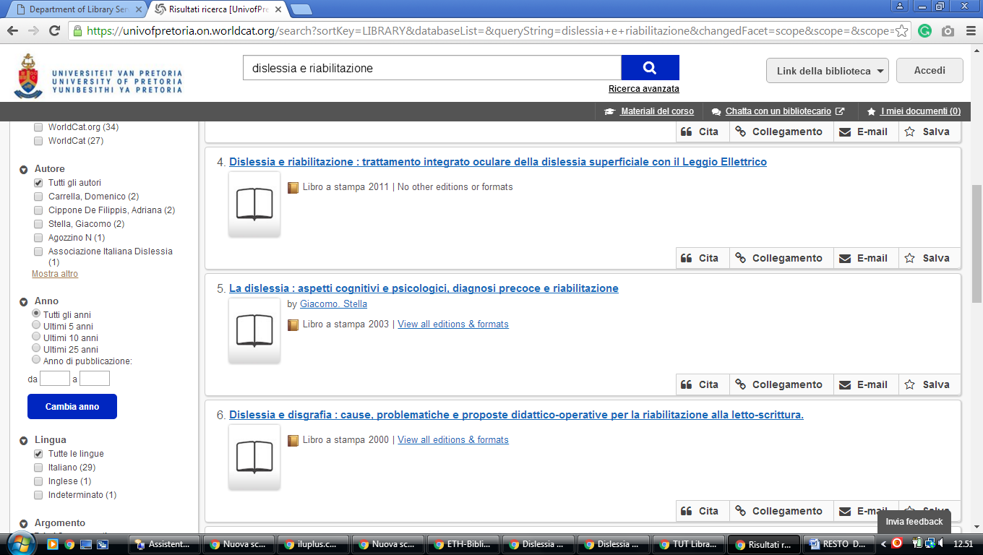

4 UNIVERSITY OF THE WESTERN CAPE LIBRARY – (Bellville, South Africa)
https://uwc.primo.exlibrisgroup.com/discovery/search?institution=27UWC_INST&vid=27UWC_INST:UWC&tab=Everything&search_scope=MyInst_and_CI&mode=Basic&displayMode=full&bulkSize=10&highlight=true&dum=true&query=any,contains,dislessia%20e%20riabilitazione&displayField=all&pcAvailabiltyMode=true&sortby=rank&pcAvailability=true
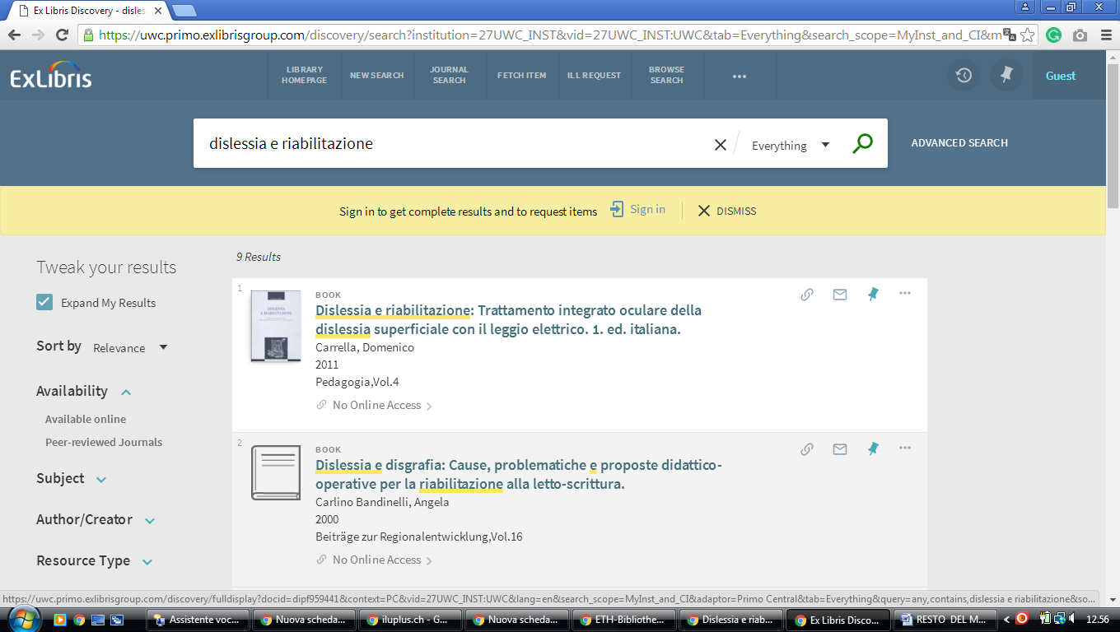

5 UNIVERSITY OF CAPE TOWN LIBRARIES - (South Africa)
https://uct.primo.exlibrisgroup.com/discovery/search?query=any,contains,dislessia%20e%20riabilitazione&tab=Everything&search_scope=MyInst_and_CI&vid=27UCT_INST:27UCT&offset=0&sortby=rank&pcAvailability=true

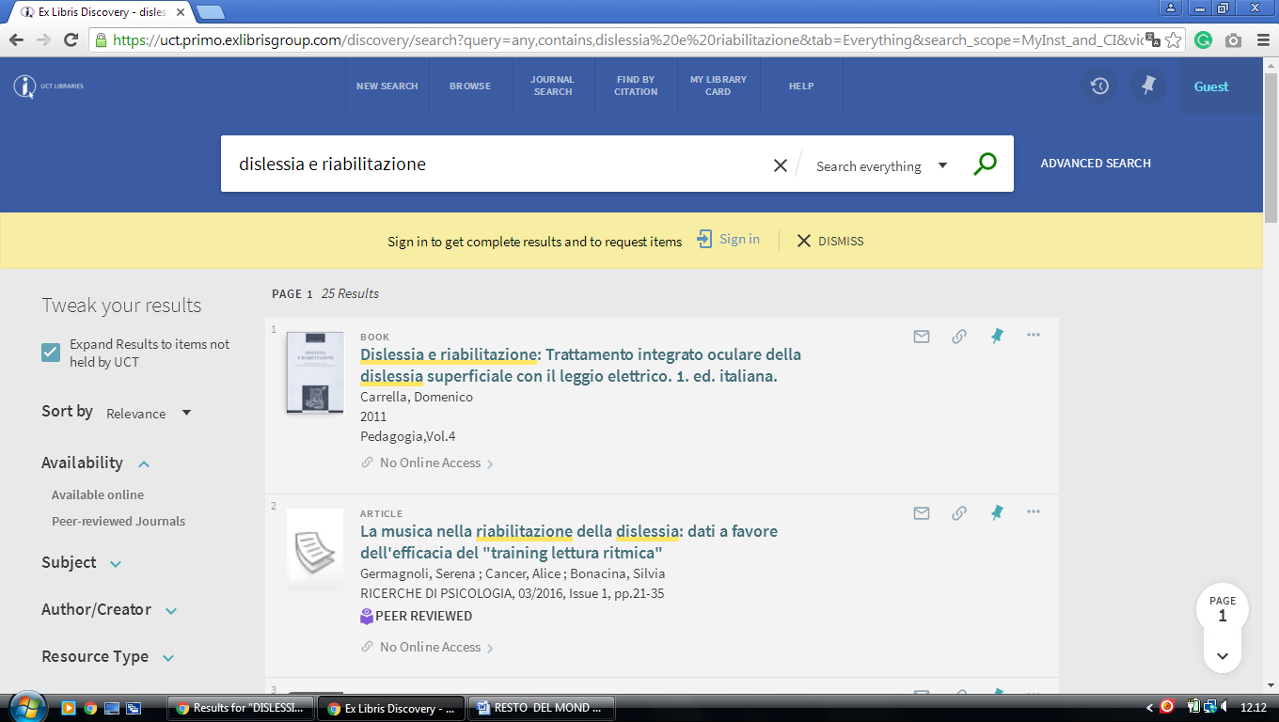

6 UKZN LIBRAR, Kwazulu-Natal - (South Africa)
http://ukzn.worldcat.org/title/dislessia-e-riabilitazione-trattamento-integrato-oculare-della-dislessia-superficiale-con-il-leggio-elettrico/oclc/878784487&referer=brief_results

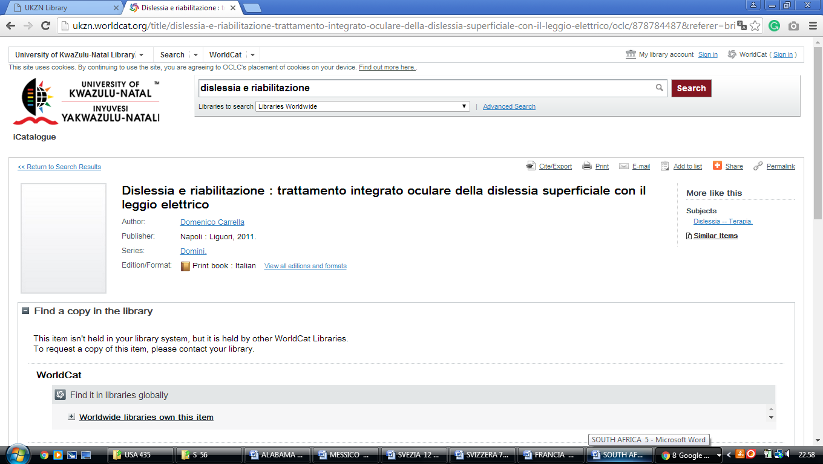

7 LIBRARY HOME - UWC Library - (Cape Town, Western Cape, South Africa)
https://uwc.primo.exlibrisgroup.com/discovery/search?institution=27UWC_INST&vid=27UWC_INST:UWC&tab=Everything&search_scope=MyInst_and_CI&mode=Basic&displayMode=full&bulkSize=10&highlight=true&dum=true&query=any,contains,dislessia%20e%20riabilitazione&displayField=all&pcAvailabiltyMode=true&sortby=rank&pcAvailability=true

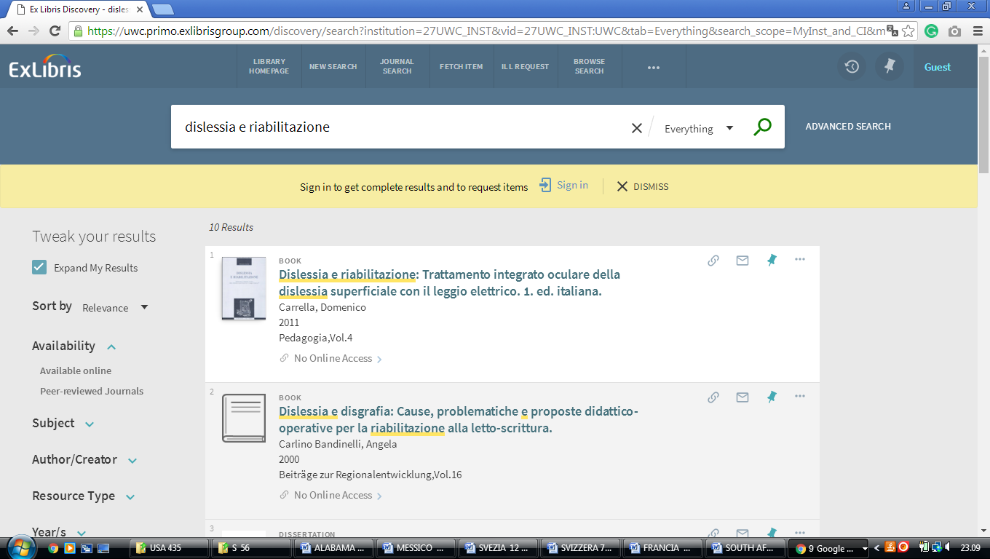

8 LIBRARY CATALOGUE | UNIVERSITY OF FORT HARE LIBRARIES - (Eastern Cape,South Africa)
http://ufh.worldcat.org/search?q=dislessia+e+riabilitazione&qt=results_page&scope=0&oldscope=0

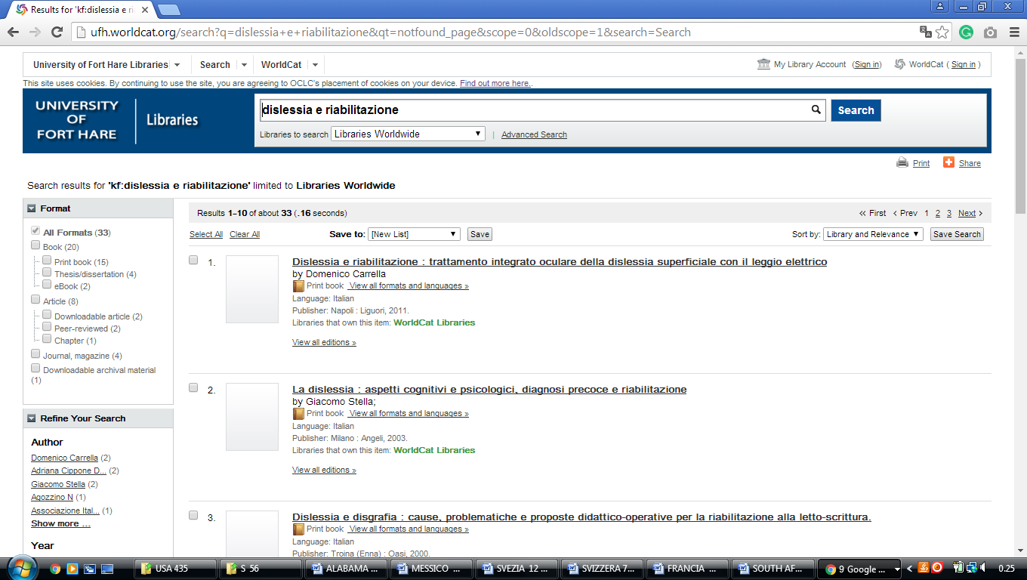

9 CENTRAL UNIVERSITY OF TECHNOLOGY FREE STATE – (Librarycut, South Africa)
https://centralunivoftechlib.on.worldcat.org/external-search?queryString=dislessia+e+riabilitazione&wcsbtn2w.x=9&wcsbtn2w.y=23#/oclc/878784487

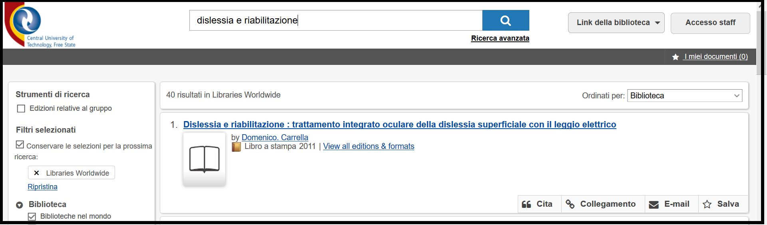

Libraries - Libraries – CPUT Cape Peninsula University of Technology, Cape Town, SUD AFRICA
https://cput.primo.exlibrisgroup.com/discovery/search?query=any,contains,%20dislessia%20e%20riabilitazione&tab=WorldCat&search_scope=Worldcat&vid=27CPUT_INST:CPUT&offset=0&pcAvailability=true
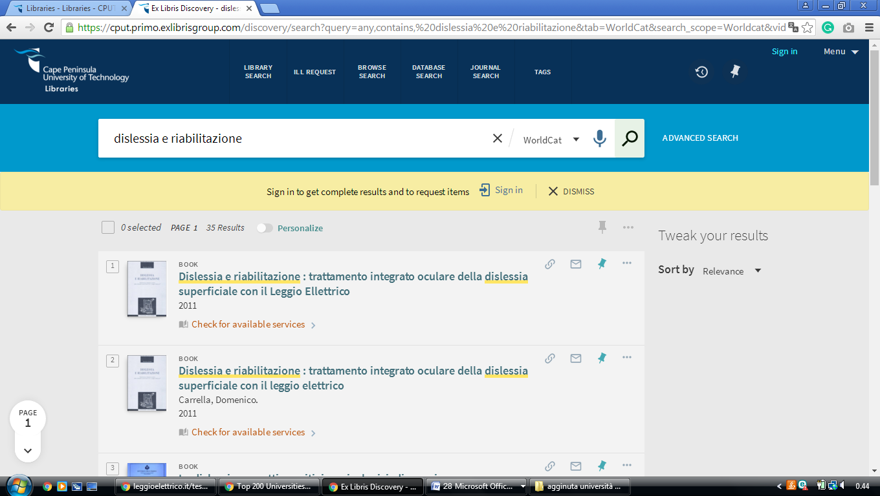

Cape Peninsula University of Technology Library

Cape Peninsula University of Technology
Cape Town, South Africa
https://cput.on.worldcat.org/search?queryString=dislessia%20e%20riabilitazione&databaseList=283,1666,638&sortKey=LIBRARY&clusterResults=true&scope=&page=2

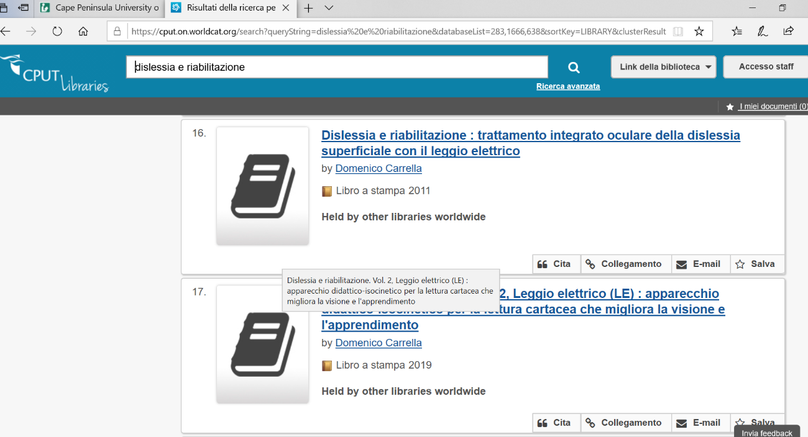

Libraries - Libraries – CPUT Cape Peninsula University of Technology, Cape Town, SUD AFRICA
https://cput.primo.exlibrisgroup.com/discovery/search?query=any,contains,%20dislessia%20e%20riabilitazione&tab=WorldCat&search_scope=Worldcat&vid=27CPUT_INST:CPUT&offset=0&pcAvailability=true

