1 NATIONAL LIBRARY OF SWEDEN – (Stockholm, Svezia)
http://libris.kb.se/bib/16164839

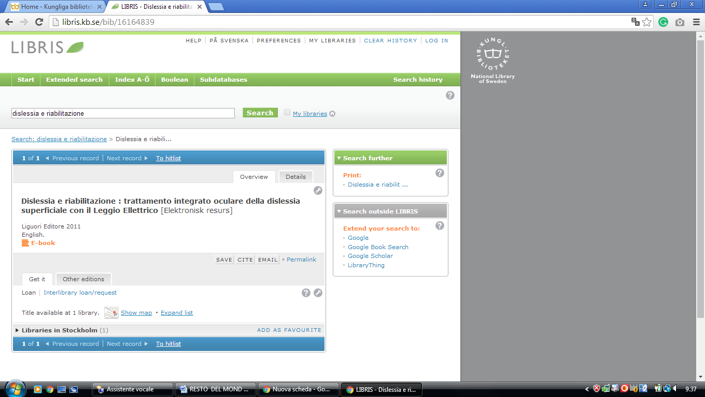

2 LIBRARY BLEKINGE INSTITUTE OF TECHNOLOGY – (Karlskrona, Sweden)
http://bth.summon.serialssolutions.com/en/search?ho=t&l=en&q=DISLESSIA+E+RIABILITAZIONE#!/search?ho=f&l=en&q=DISLESSIA%20E%20RIABILITAZIONE

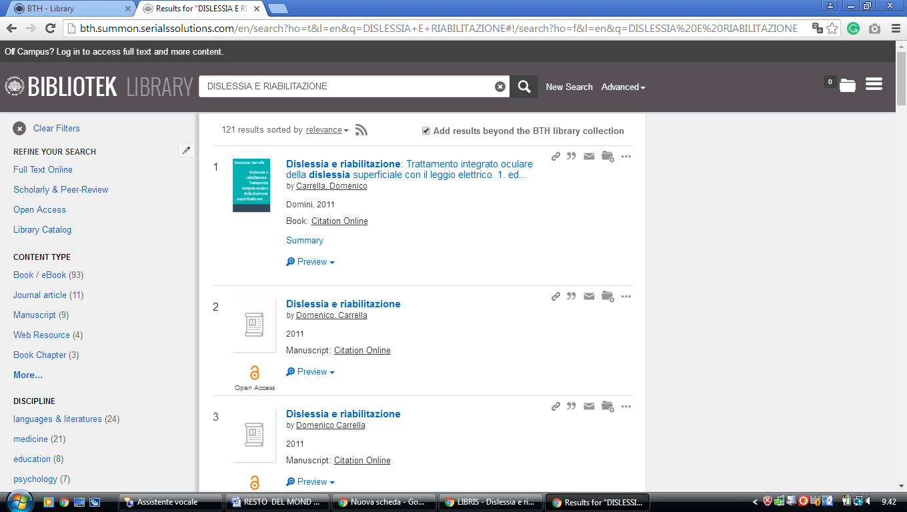

3 Library | HKR.se - (Kristianstad Libraries Scania, Sweden)
http://hkr.summon.serialssolutions.com/?s.q=dislessia+e+riabilitazione#!/search?ho=f&l=it-IT&q=dislessia%20e%20riabilitazione

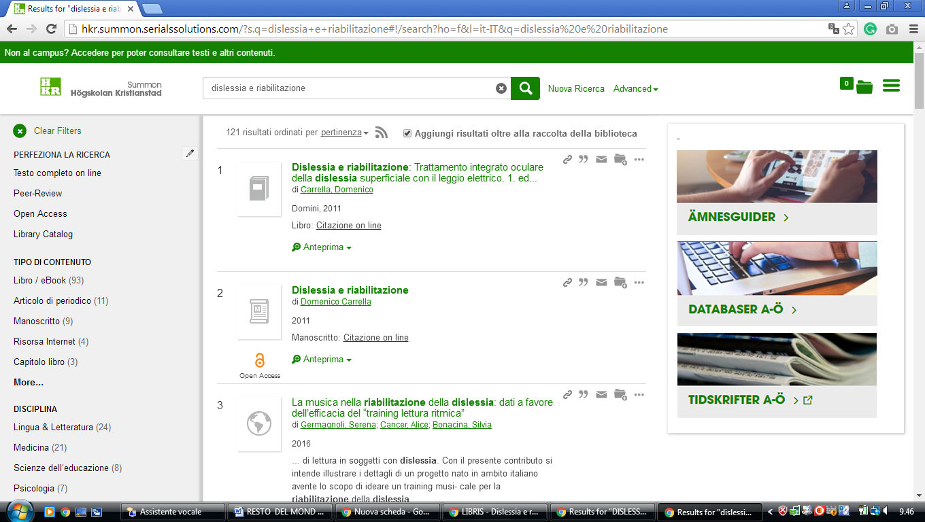

4 UMEÅ UNIVERSITY LIBRARY - (Umeå, Sweden)
https://umea-primo.hosted.exlibrisgroup.com/primo-explore/search?institution=UMUB&vid=UmUB&tab=default_tab_umub&search_scope=default_scope&mode=Basic&displayMode=full&bulkSize=10&highlight=true&dum=true&query=any,contains,dislessia%20e%20riabilitazione&displayField=all&lang=en_US&pcAvailabiltyMode=true

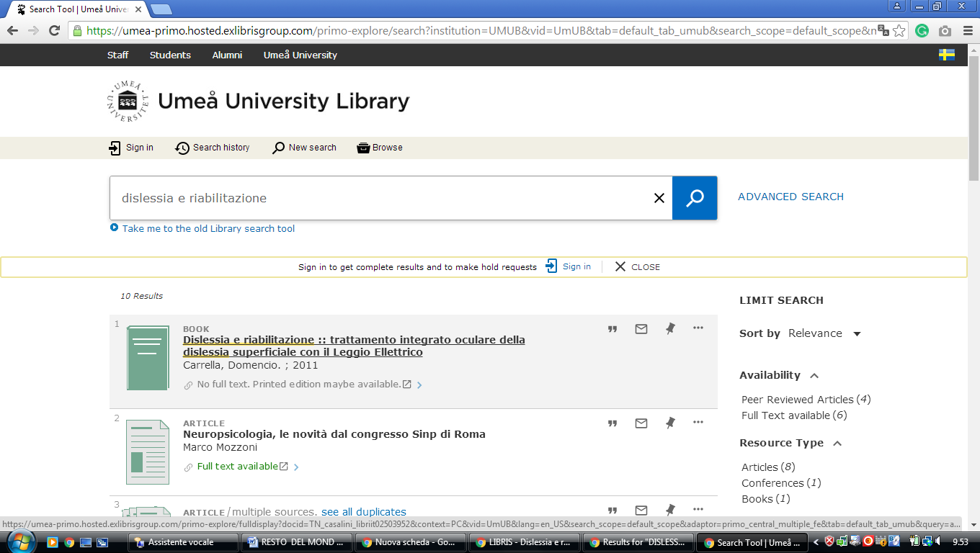

5 LIBRARY SPOTLIGHT - UNIVERSITY OF SKÖVDE – (Skövde, Sweden)
https://his.on.worldcat.org/search?sortKey=LIBRARY&databaseList=233%2C1875%2C1842%2C1697%2C203%2C1672%2C239%2C2375%2C1708%2C638%2C1847%2C1834&queryString=DISLESSIA+E+RIABILITAZIONE&changedFacet=scope&scope=&scope=wz%3A65324&format=all&database=all&author=all&year=all&yearFrom=&yearTo=#/oclc/878784487

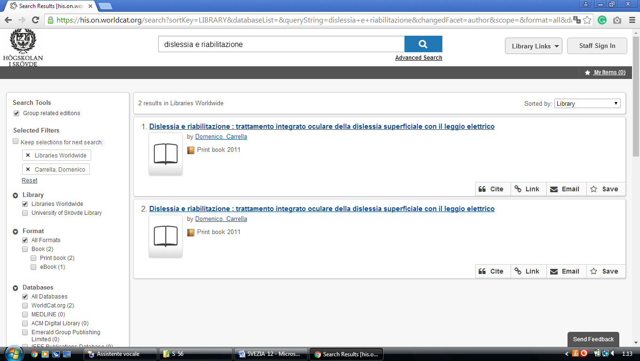

6 ANNA LINDH LIBRARY - (Stockholm, Sweden)
https://annalindh-primo.hosted.exlibrisgroup.com/primo-explore/search?query=any,contains,DISLESSIA%20E%20RIABILITAZIONE&tab=default_tab&search_scope=default_scope&sortby=rank&vid=46ALB_VU1&lang=us_EN&offset=0&pcAvailability=true

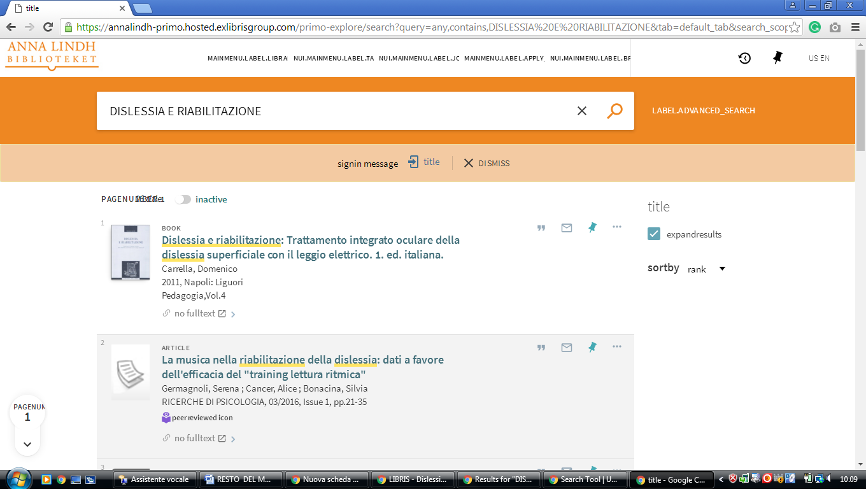

7 Library - Dalarna University – (Falun and Borlänge,Dalarna, Sweden)

http://dalarna.summon.serialssolutions.com/en/search?ho=t#!/search?ho=f&l=en&q=DISLESSIA%20E%20RIABILITAZIONE

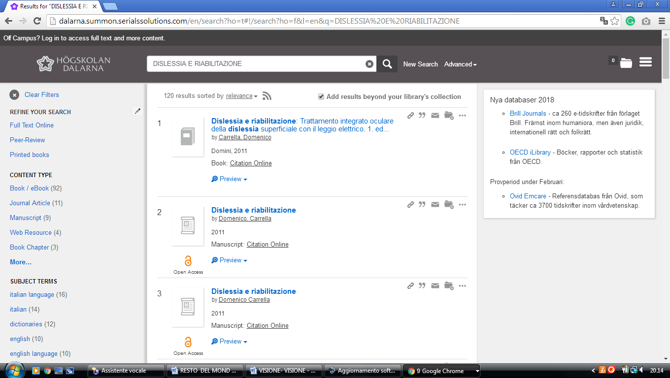

8 LIBRARY GÖTEBORG UNIVERSITY – (Göteborg, Sweden)
https://gu-se-primo.hosted.exlibrisgroup.com/primo-explore/search?query=any,contains,dislessia%20e%20riabilitazione&vid=46GUB_VU1&search_scope=default_scope&sortby=rank&lang=sv_SE&pcAvailability=true

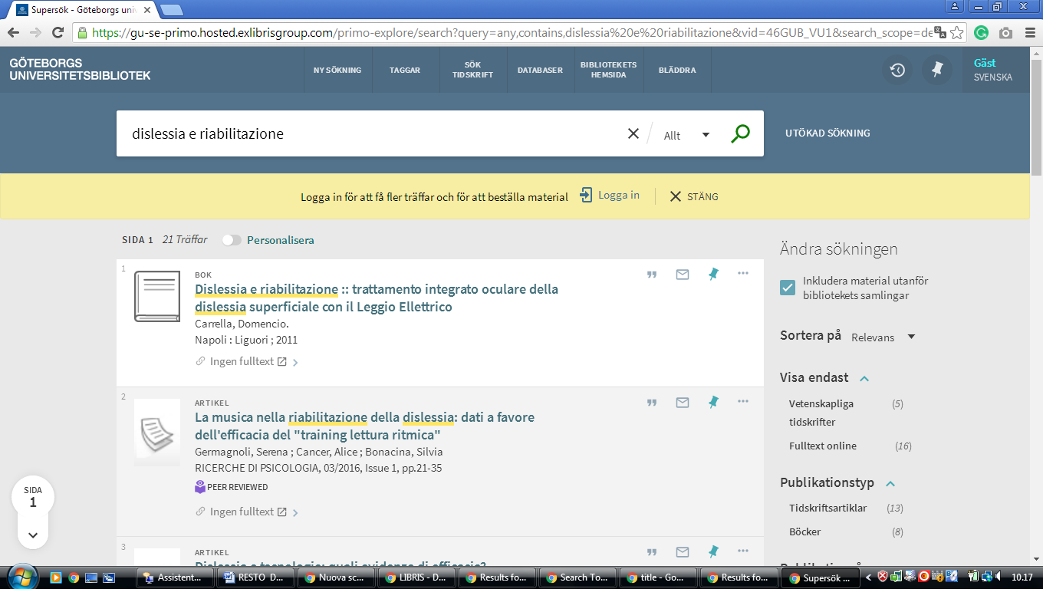

9 UPPSALA: UNIVERSITY LIBRARY – (Uppsala, Svezia)
https://uu.summon.serialssolutions.com/sv-SE/search?fvf=ContentType,Book%20Review,t%7CContentType,Newspaper%20Article,t&q=DISLESSIA%20E%20RIABILITAZIONE#!/search?ho=f&fvf=ContentType,Book%20Review,t%7CContentType,Newspaper%20Article,t&l=sv-SE&q=DISLESSIA%20E%20RIABILITAZIONE

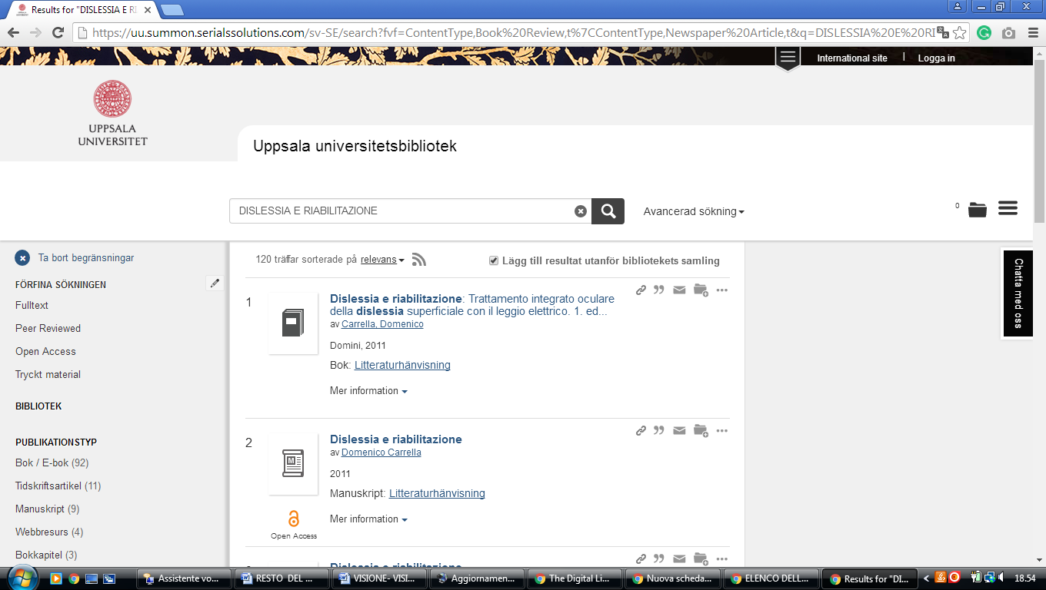

10 karlstad university library - (Karlstad, Svezia)
https://eds.a.ebscohost.com/eds/results?vid=1&sid=ca2b258a-fc21-46ee-87c0-2ae0c6cc46e7%40sessionmgr4010&bquery=(dislessia+AND+e+AND+riabilitazione)&bdata=JnR5cGU9MCZzaXRlPWVkcy1saXZl
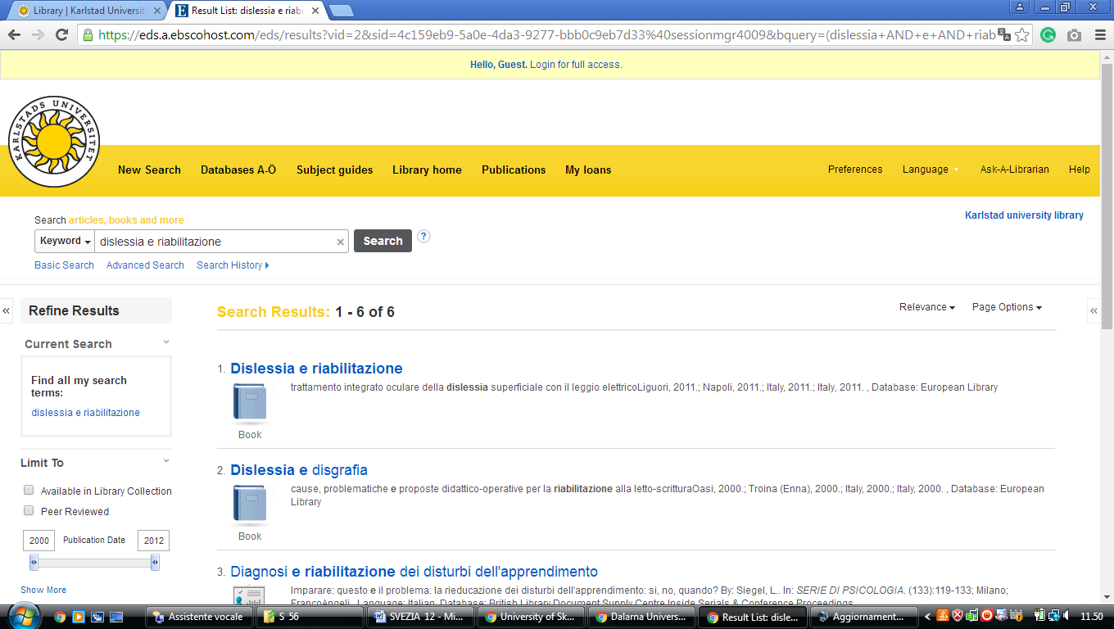

11 CHALMERS BIBLIOTEK – (University of Technology Library Göteborg, Svezia)
https://chalmers.summon.serialssolutions.com/en/search?ho=t&q=dislessia%20e%20riabilitazione#!/search?ho=f&l=en&q=dislessia%20e%20riabilitazione

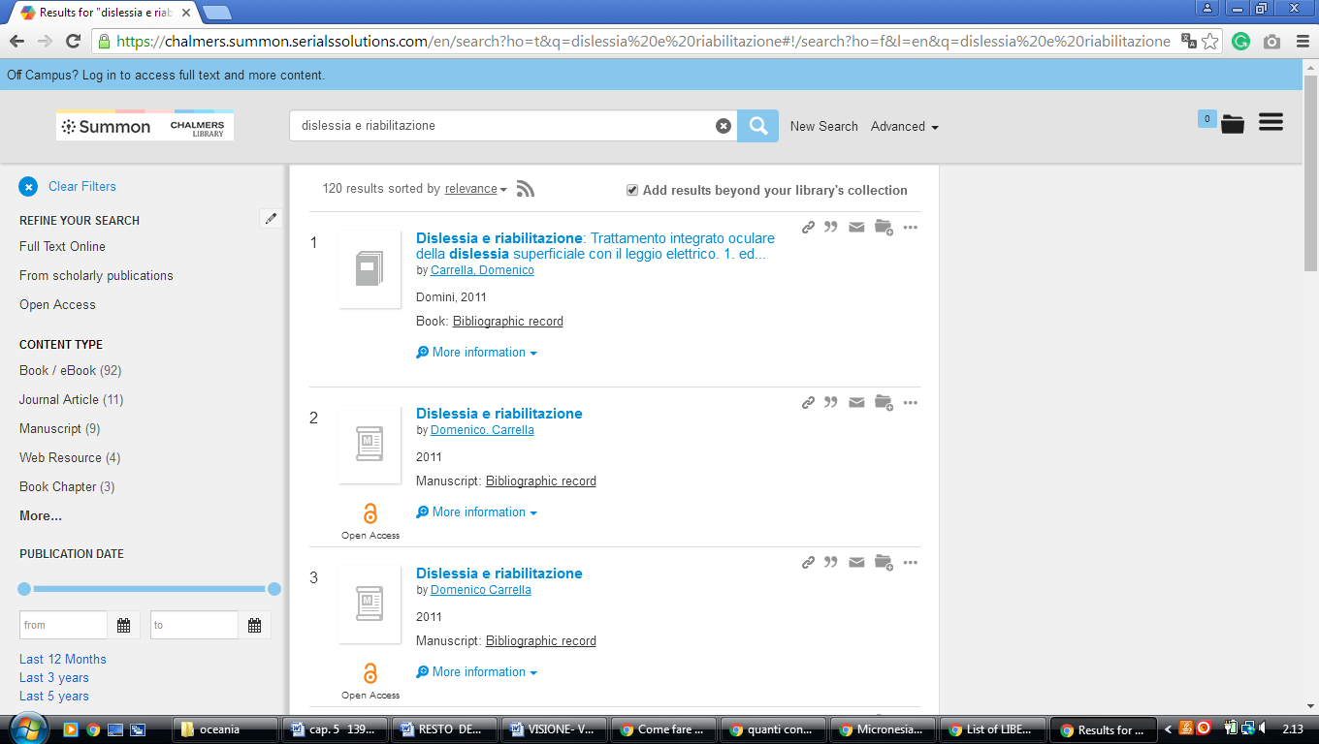

12 LUND UNIVERSITY - LAW - THE EUROPEAN LIBRARY - (Svezia)
http://www.theeuropeanlibrary.org/tel4/search?query=dislessia%20e%20riabilitazione

