1 NATIONAL TAIWAN UNIVERSITY LIBRARYT – (Aipei, Taiwan)
http://primo.lib.ntu.edu.tw/primo_library/libweb/action/search.do?ct=facet&pcAvailabiltyMode=true&pcAvailClicked=true&indx=1&fn=search&vl(1UI0)=contains&dscnt=0&tb=t&mode=Basic&vid=NTU&srt=rank&tab=default_tab&SUBMIT=&vl(56823557UI0)=any&dum=true&vl(freeText0)=dislessia%20e%20riabilitazione&dstmp=1518513208854

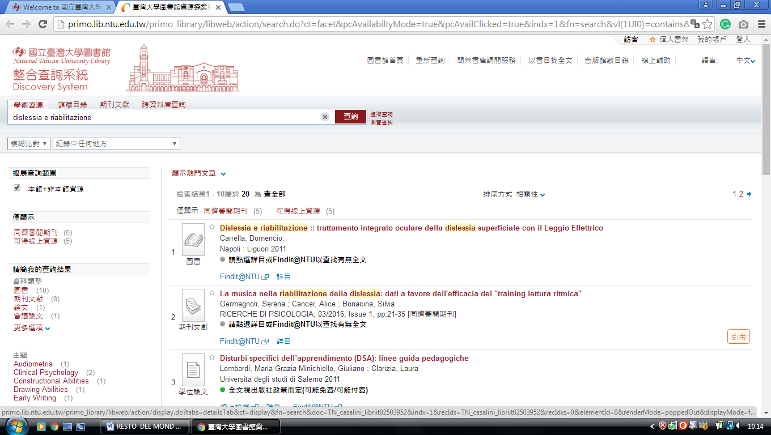

2 ACADEMIA SINICA LIFE SCIENCE LIBRARY – (TaipeiTaiwan)
http://sinica.summon.serialssolutions.com/search?s.q=dislessia+e+riabilitazione#!/search?ho=f&l=en&q=dislessia%20e%20riabilitazione

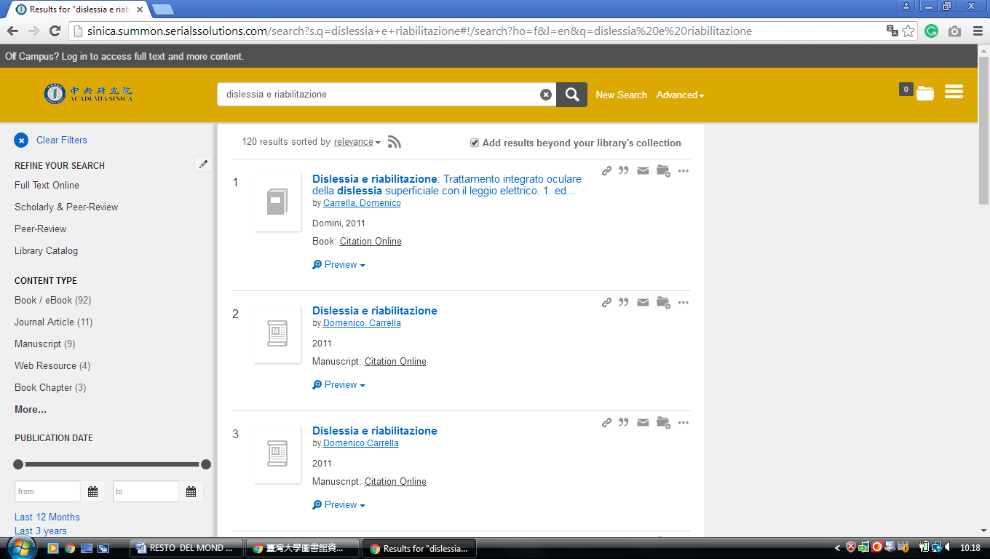

3 CHANG GUNG UNIVERSITY LIBRARY – (Guishan, Taoyuan City, Taiwan)
http://primo.lib.cgu.edu.tw/primo_library/libweb/action/search.do?fn=search&mode=Basic&tab=default_tab&indx=1&dum=true&srt=rank&frbg=&vid=CGU&vl%28freeText0%29=dislessia+e+riabilitazione

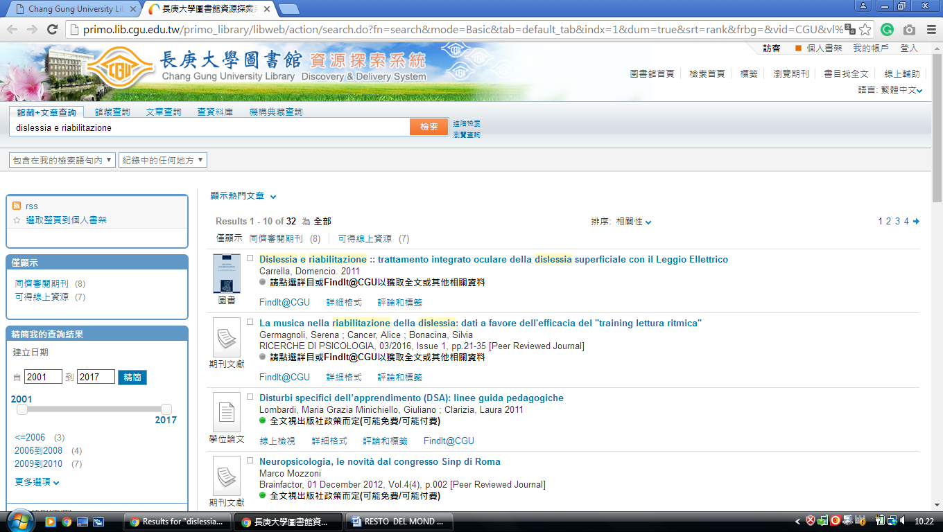

4 CHUNG HUA UNIVERSITY LIBRARY - (Guishan, Taoyuan City, Taiwan)
http://ustcate.lib.nctu.edu.tw/primo_library/libweb/action/search.do?ct=facet&pcAvailabiltyMode=true&dscnt=0&scp.scps=scope%3A(NTHU)%2Cprimo_central_multiple_fe&frbg=&tab=pc_ils&dstmp=1518513997287&srt=rank&ct=search&mode=Basic&vl(147200900UI0)=any&dum=true&indx=1&tb=t&vl(147200899UI1)=all_items&vl(1UIStartWith0)=contains&vl(freeText0)=dislessia%20e%20riabilitazione&fn=search&vid=NTHU

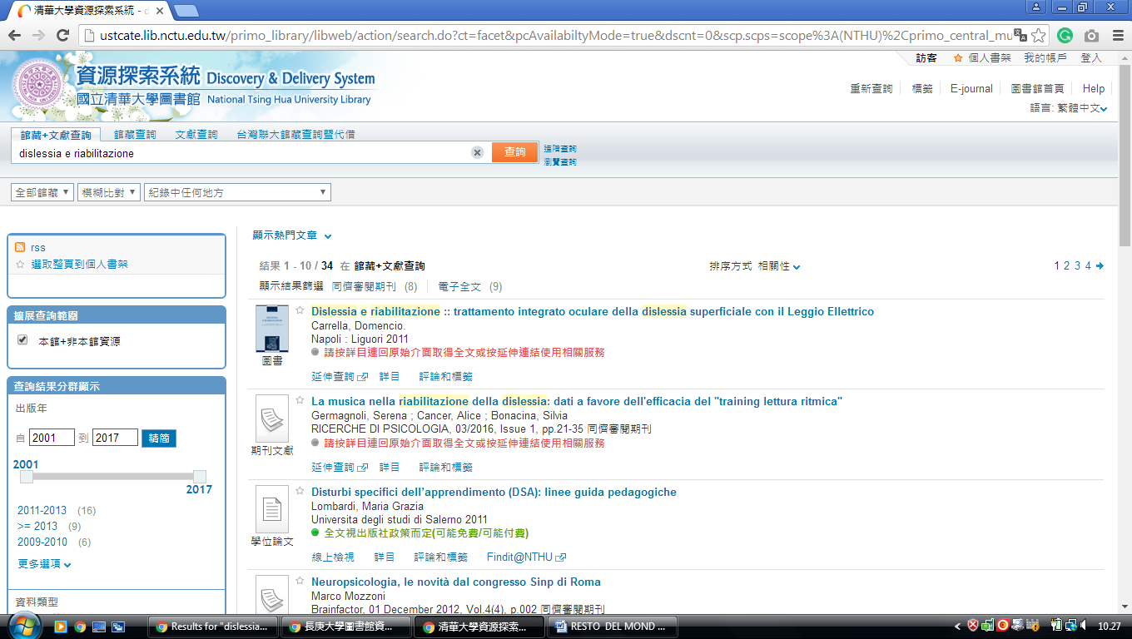
-------------------------------------------------------------------------------------------------------------------------------

5 CHUNG YUAN CHRISTIAN UNIVERSITY CHANG CHING YU MEMORIAL LIBRARY - (Taoyuan City, Taiwan)
http://eds.a.ebscohost.com/eds/detail/detail?vid=2&sid=8f9bddd8-fa5f-40b2-8d87-5bb5d00129a8%40sessionmgr4008&bdata=Jmxhbmc9emgtdHcmc2l0ZT1lZHMtbGl2ZQ%3d%3d#AN=EDSBVB.BV039611798&db=edsbvb

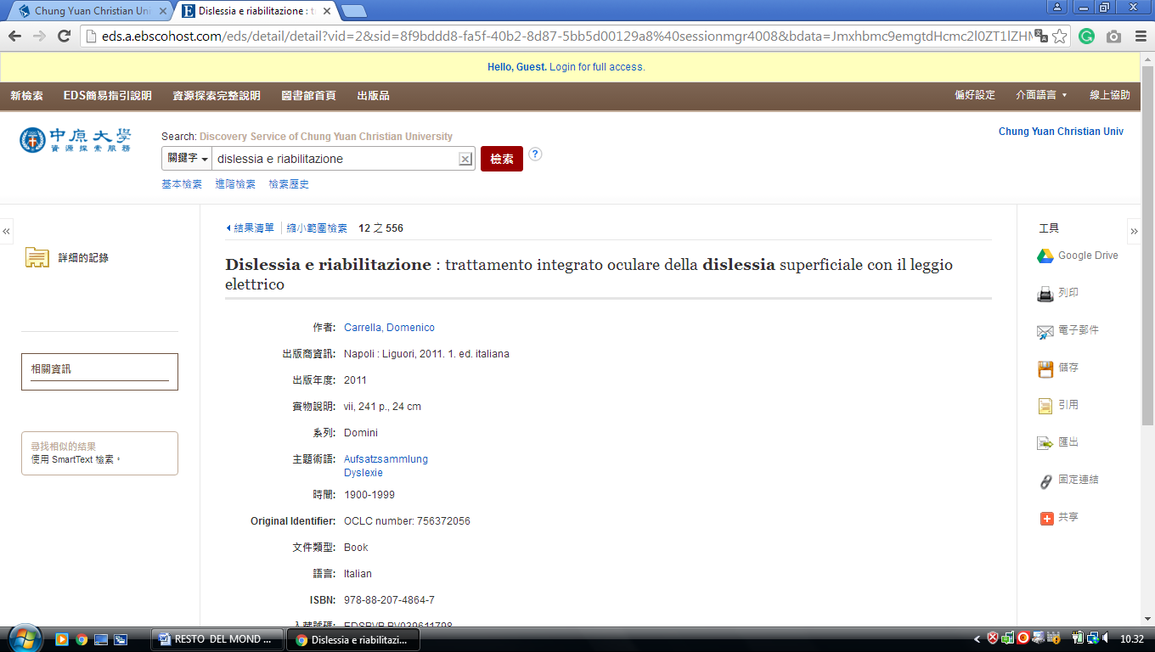

6 PRIMO.LIB.CCU.EDU.TW - (Ling Tung University Nantun, Taichung, Taiwan)
http://primo.lib.ccu.edu.tw/primo_library/libweb/action/search.do?ct=facet&pcAvailabiltyMode=true&pcAvailClicked=true&vid=CCU&mode=Basic&pcAvailabiltyMode=false&tab=default_tab&fn=search&indx=1&dscnt=0&vl(freeText0)=DISLESSIA%20E%20RIABILITAZIONE&scp.scps=primo_central_multiple_fe&adjacent1=Y&dstmp=1501549993940

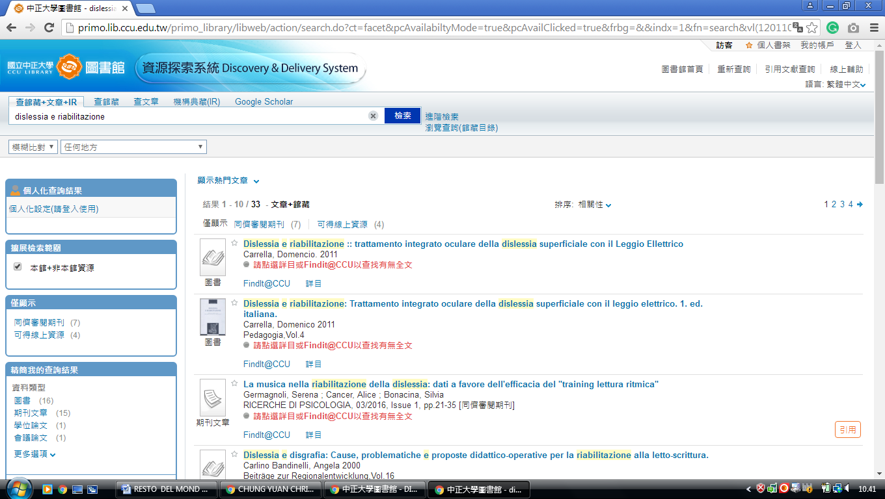

7 NATIONAL CHUNG HSING UNIVERSITY LIBRARY – (South District,Taichung,
Taiwan)
http://primo.lib.ccu.edu.tw/primo_library/libweb/action/search.do?ct=facet&pcAvailabiltyMode=true&pcAvailClicked=true&vid=CCU&mode=Basic&pcAvailabiltyMode=false&tab=default_tab&fn=search&indx=1&dscnt=0&vl(freeText0)=dislessia%20e%20riabilitazione&scp.scps=primo_central_multiple_fe&adjacent1=Y&dstmp=1518515345400

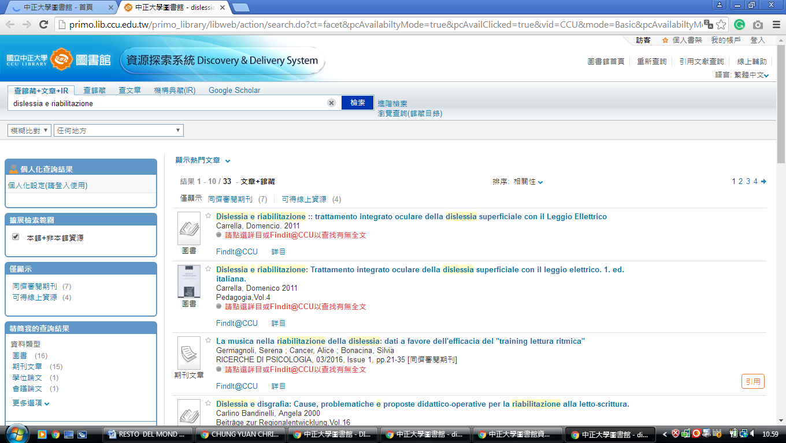

8 NATIONAL CHUNG CHENG UNIVERSITY LIBRARY - (Chiayi County, Taiwan)
http://primo.lib.ccu.edu.tw/primo_library/libweb/action/search.do?ct=facet&pcAvailabiltyMode=true&pcAvailClicked=true&vid=CCU&mode=Basic&pcAvailabiltyMode=false&tab=default_tab&fn=search&indx=1&dscnt=0&vl(freeText0)=dislessia%20e%20riabilitazione&scp.scps=primo_central_multiple_fe&adjacent1=Y&dstmp=1518515783709
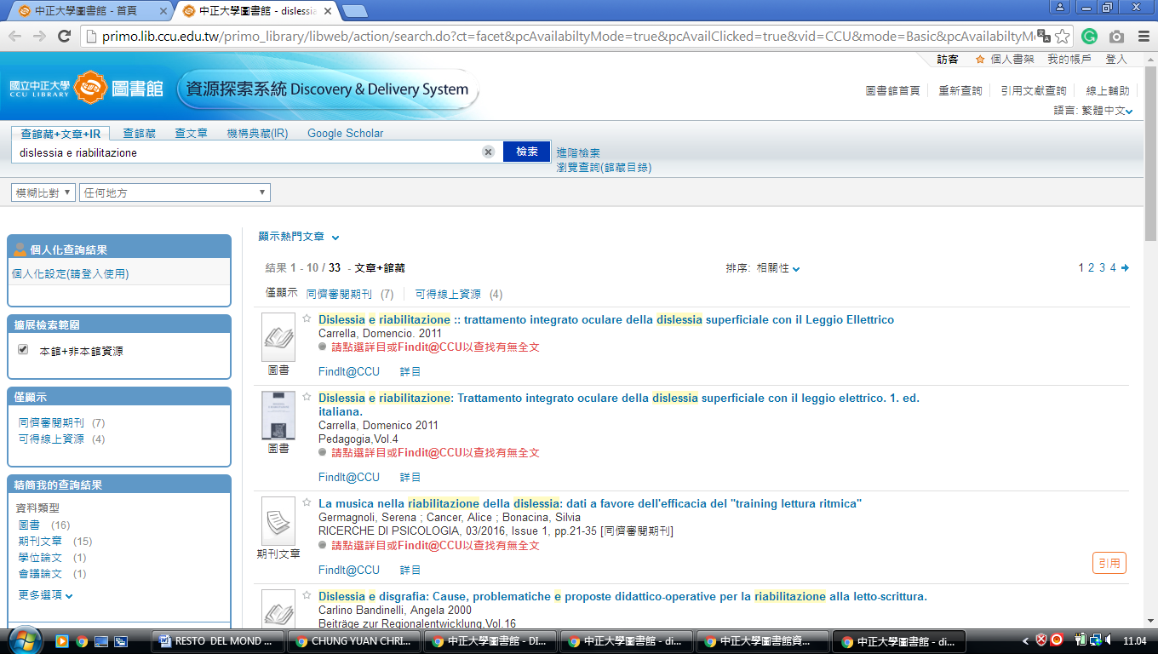

9 Chang Jung Christian University Library - (Guiren, Tainan, Taiwan)
http://discovery.lib.cjcu.edu.tw/primo_library/libweb/action/search.do?ct=facet&pcAvailabiltyMode=true&dscnt=0&dum=true&indx=1&frbg=&tab=ils_pc&dstmp=1518515739399&srt=rank&vl(freeText0)=dislessia%20e%20riabilitazione&vid=CJCU&fn=search&mode=Basic
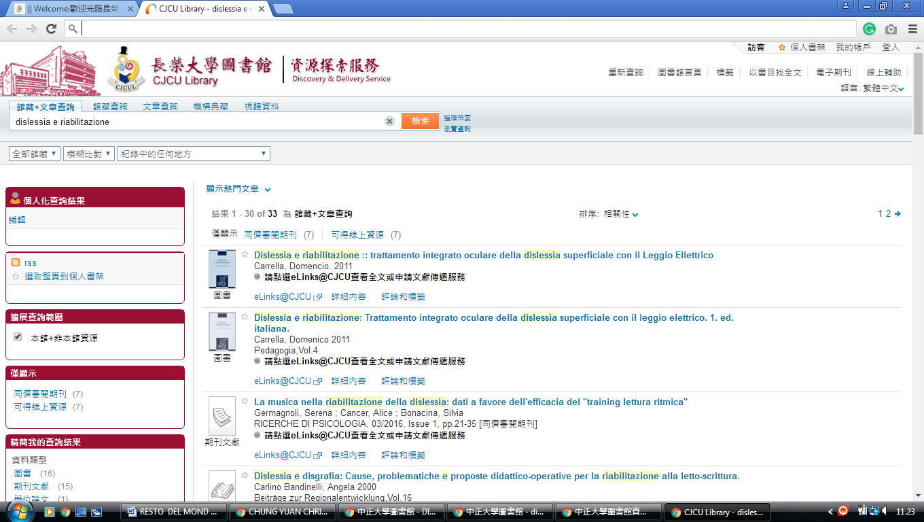

10 NATIONAL CHIAO TUNG UNIVERSITY LIBRARY - (Hsinchu City, Taiwan)
http://ustcate.lib.nctu.edu.tw/primo_library/libweb/action/search.do?vl%28freeText0%29=dislessia+e+riabilitazione&prefLang=en_US&vl%281UI0%29=contains&scp.scps=scope%3A%28NCTU%29%2Cprimo_central_multiple_fe&tb=t&frbg=&vid=NCTU&srt=rank&dum=true&index=1&tab=ils_article&mode=Basic&initialSearch=true&ct=search&fn=search
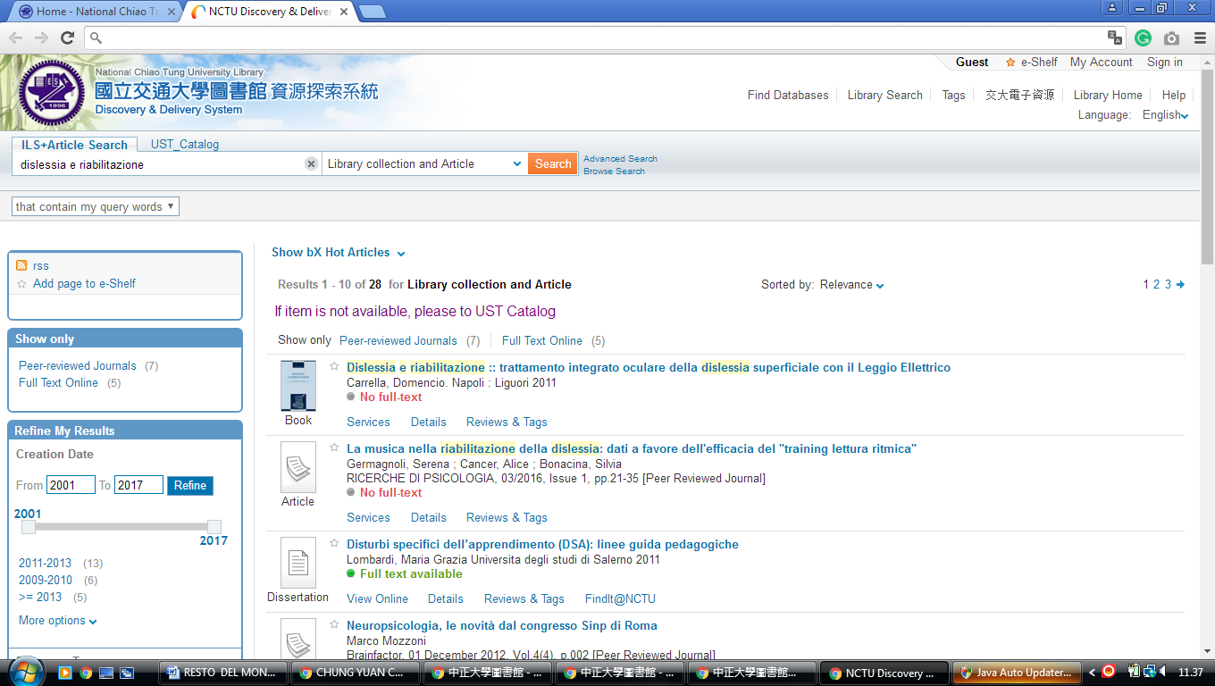

11 NATIONAL TSING HUA UNIVERSITY LIBRARY - (Hsinchu City, Taiwan)
http://ustcate.lib.nctu.edu.tw/primo_library/libweb/action/search.do?ct=facet&pcAvailabiltyMode=true&dscnt=0&scp.scps=scope%3A(NTHU)%2Cprimo_central_multiple_fe&frbg=&tab=pc_ils&dstmp=1518518457171&srt=rank&ct=search&mode=Basic&vl(147200900UI0)=any&dum=true&indx=1&tb=t&vl(147200899UI1)=all_items&vl(1UIStartWith0)=contains&vl(freeText0)=dislessia%20e%20riabilitazione&fn=search&vid=NTHU
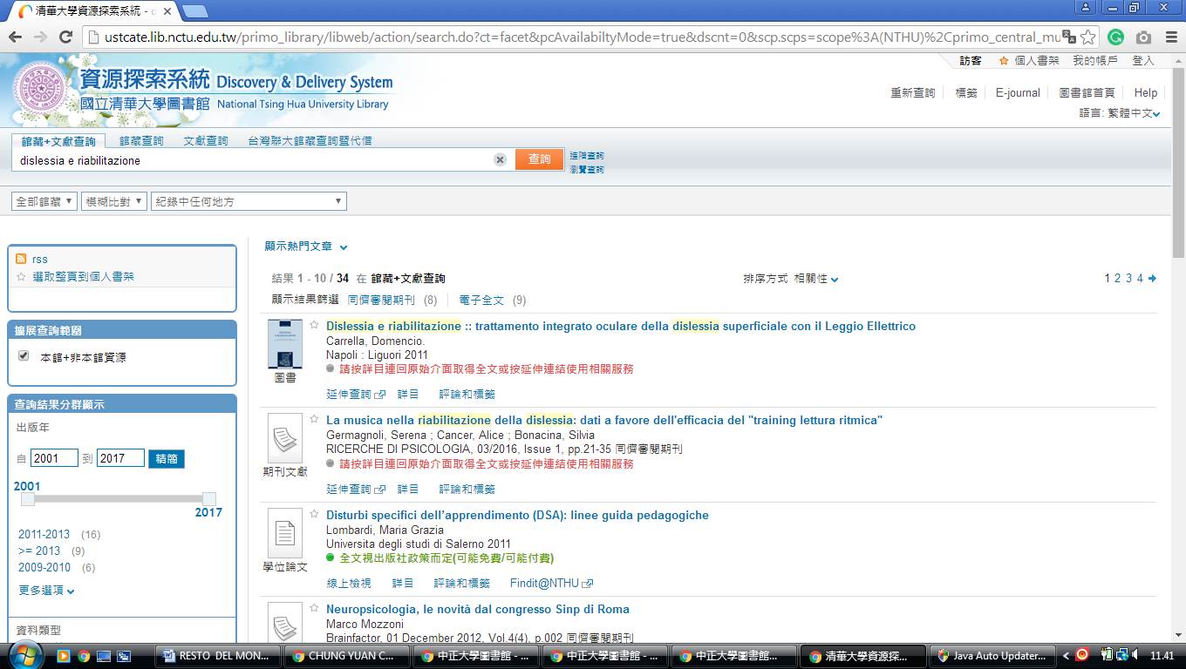

12 PRIMO.LIB.CCU.EDU.TW - (National Changhua University Of Education Library Changhua City, Taiwan)
http://primo.lib.ccu.edu.tw/primo_library/libweb/action/search.do?ct=facet&pcAvailabiltyMode=true&pcAvailClicked=true&frbg=&&indx=1&fn=search&vl(12011063UI0)=any&dscnt=0&scp.scps=scope%3A(%22CCU%22)%2Cscope%3A(CCU_IR_NCL)%2Cscope%3A(CCU_ALEPH)%2Cscope%3A(CCU_SFX)%2Cprimo_central_multiple_fe&vl(1UIStartWith0)=contains&tb=t&vid=CCU&mode=Basic&ct=search&srt=rank&tab=default_tab&dum=true&vl(freeText0)=dislessia%20e%20riabilitazione&dstmp=1518603134682

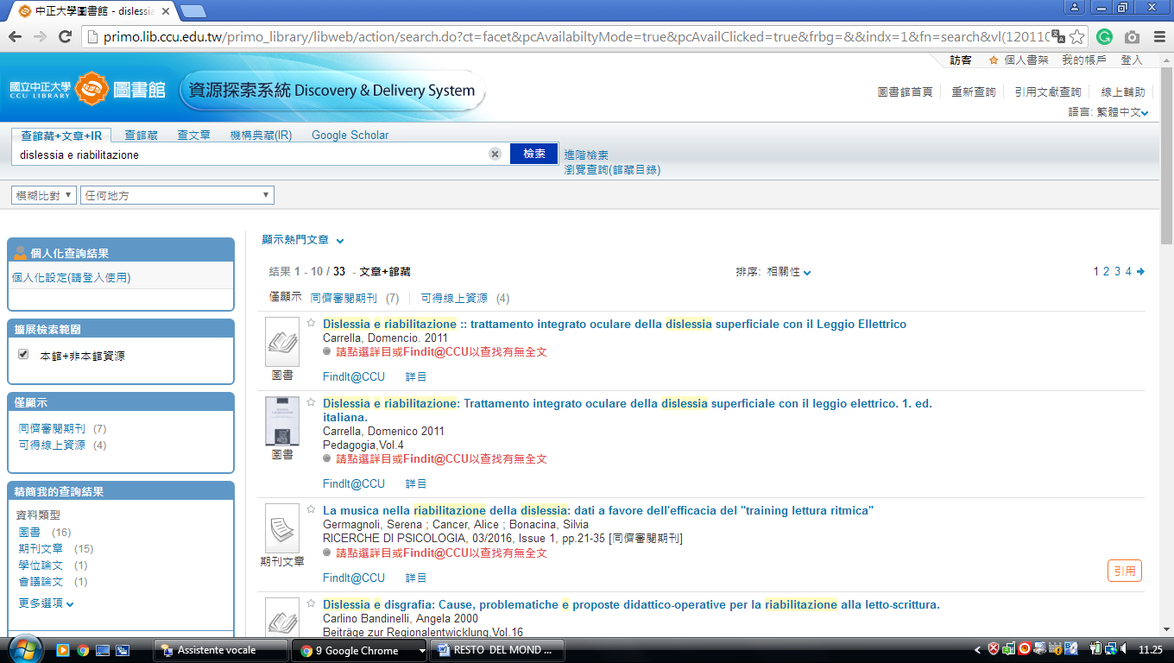

13 NATIONAL CHIAO TUNG UNIVERSITY LIBRARY - (Hsinchu, Taiwan)
http://ustcate.lib.nctu.edu.tw/primo_library/libweb/action/search.do?vl%28freeText0%29=dislessia+e+riabilitazione&prefLang=en_US&vl%281UI0%29=contains&scp.scps=scope%3A%28NCTU%29%2Cprimo_central_multiple_fe&tb=t&frbg=&vid=NCTU&srt=rank&dum=true&index=1&tab=ils_article&mode=Basic&initialSearch=true&ct=search&fn=search

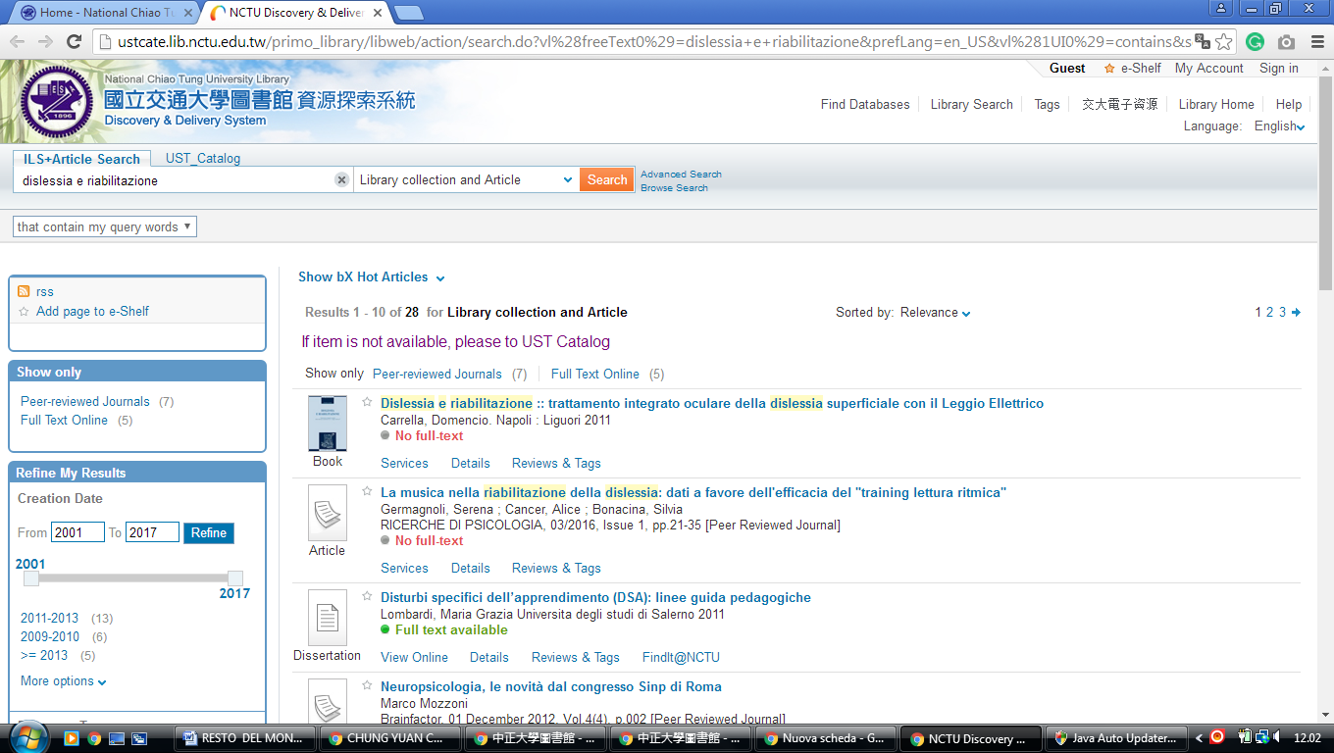

14 NATIONAL TSING HUA UNIVERSITY LIBRARY - (Hsinchu City, Taiwan)
http://ustcate.lib.nctu.edu.tw/primo_library/libweb/action/search.do?ct=facet&pcAvailabiltyMode=true&dscnt=0&scp.scps=scope%3A(NTHU)%2Cprimo_central_multiple_fe&frbg=&tab=pc_ils&dstmp=1518519883269&srt=rank&ct=search&mode=Basic&vl(147200900UI0)=any&dum=true&indx=1&tb=t&vl(147200899UI1)=all_items&vl(1UIStartWith0)=contains&vl(freeText0)=dislessia%20e%20riabilitazione&fn=search&vid=NTHU

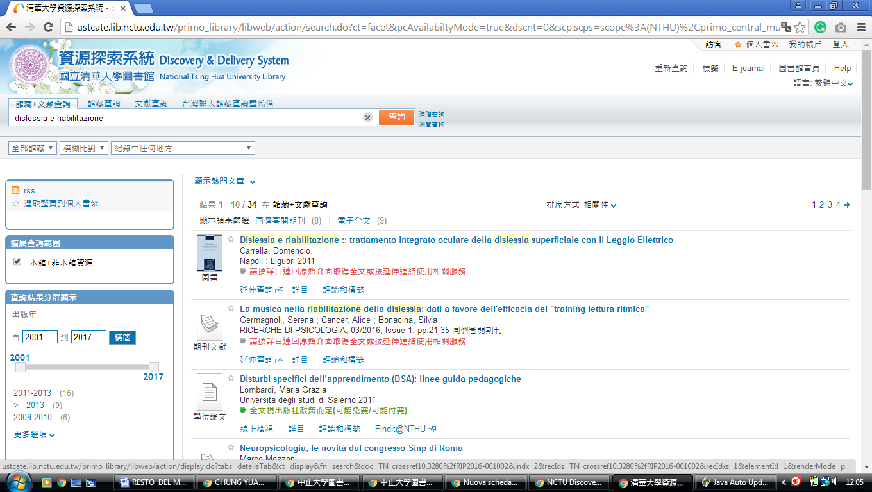

Providence University Library
Distretto di shalu, taichung city,
ds.b.ebscohost.com/eds/results?vid=0&sid=73bebe4e-5a8d-41b4-b5ed-418a2c41dacd%40pdc-v-sessmgr01&bquery=dislessia%2Be%2Briabilitazione&bdata=Jmxhbmc9ZW5nJnR5cGU9MCZzZWFyY2hNb2RlPUFuZCZzaXRlPWVkcy1saXZl
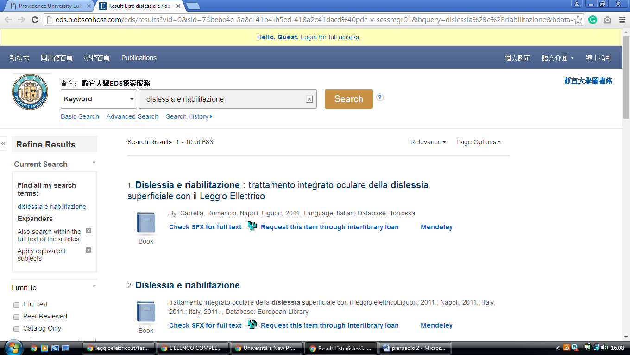

National Chiao Tung University Library, TAIWAN
https://ustcate0.lib.nctu.edu.tw/primo_library/libweb/action/search.do?ct=facet&pcAvailabiltyMode=true&pcAvailClicked=true&frbg=&&indx=1&fn=search&index=1&vl(1UI0)=contains&dscnt=0&scp.scps=scope%3A(NCTU_AV)%2Cscope%3A(NCTU_BOOK)%2Cscope%3A(NCTU_DT)%2Cscope%3A(NCTU_JOURNAL)%2Cscope%3A(NCTU)%2Cprimo_central_multiple_fe&tb=t&vid=NCTU&mode=Basic&ct=search&srt=rank&tab=ils_article&prefLang=en_US&dum=true&vl(freeText0)=dislessia%20e%20riabilitazione&dstmp=1582230878966
