1 ASSUMPTION UNIVERSITY LIBRARY - (Bangkok, Samut Prakan,Thailand)
http://au.summon.serialssolutions.com/?#!/search?ho=f&l=en&q=DISLESSIA%20E%20RIABILITAZIONE

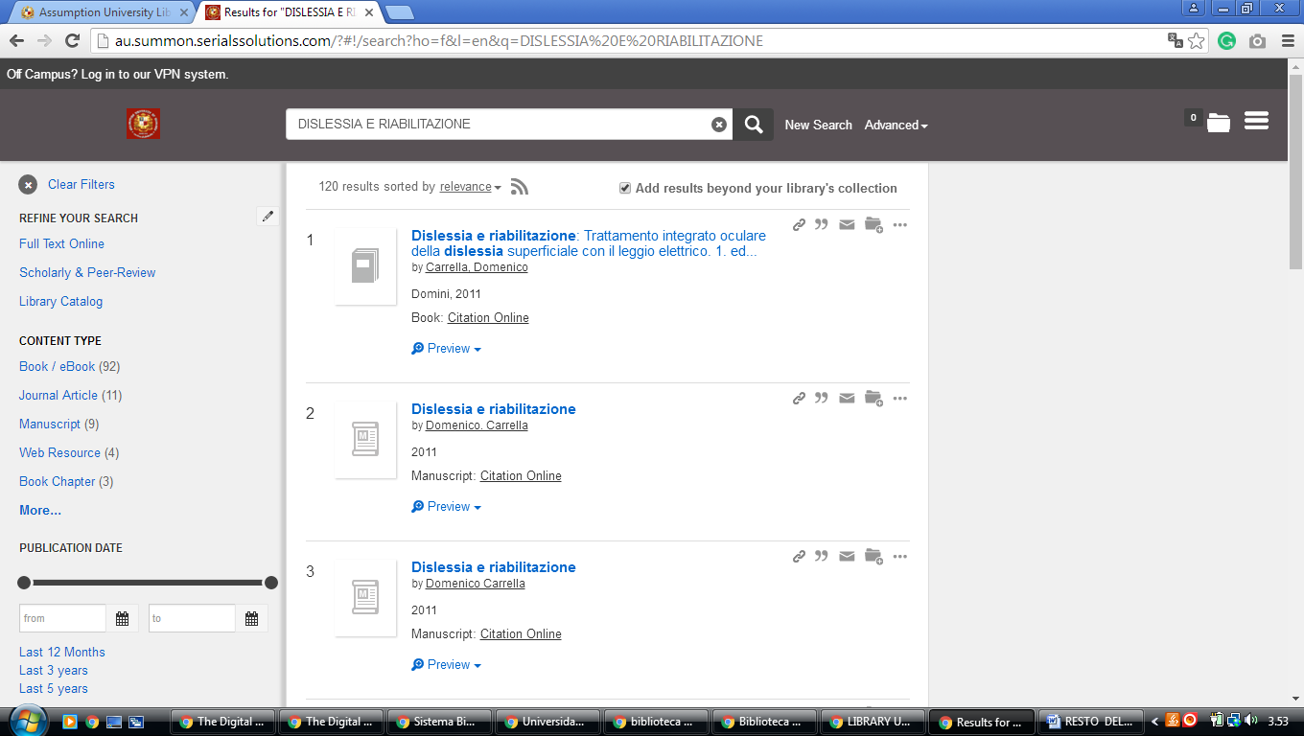

LLLLLLLLLLLLLLL

2 CHULA.ON.WORLDCAT.ORG/ - (Chulalongkorn University Library, Bangkok, Thailand)
https://chula.on.worldcat.org/search?databaseList=&queryString=dislessia+e+riabilitazione

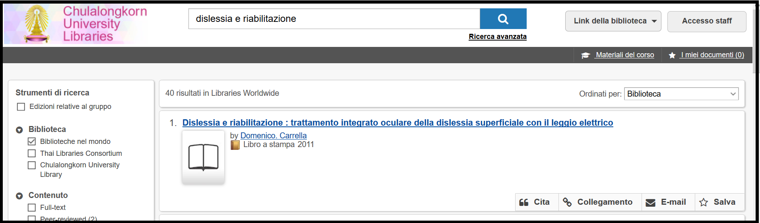
3 MAHASARAKHAMUNIV.WORLDCAT.ORG/ - (Mahasarakham University Library, Mahasarakham, Thailand)
http://mahasarakhamuniv.worldcat.org/title/dislessia-e-riabilitazione-trattamento-integrato-oculare-della-dislessia-superficiale-con-il-leggio-elettrico/oclc/878784487&referer=brief_results

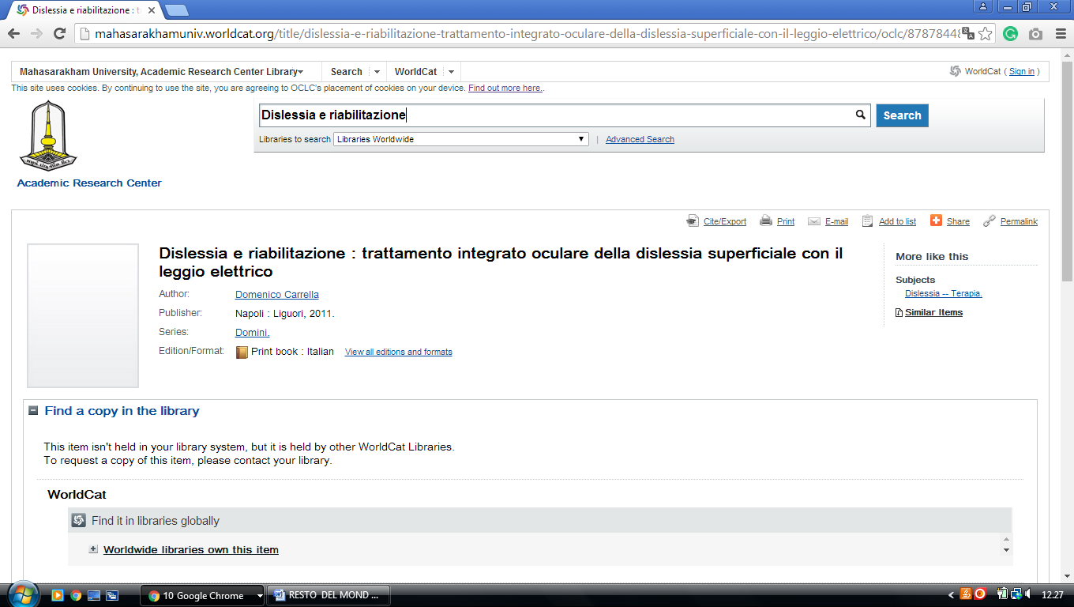

4 PRINCE OF SONGKLA UNIVERSITY LIBRARY - PHUKET - (Phuket, Thailand)
http://eds.b.ebscohost.com/eds/detail/detail?vid=1&sid=4165f2fd-92ce-4236-b867-2aa5b414ea17%40pdc-v-sessmgr01&bdata=JnNpdGU9ZWRzLWxpdmU%3d#AN=EDSBVB.BV039611798&db=edsbvb

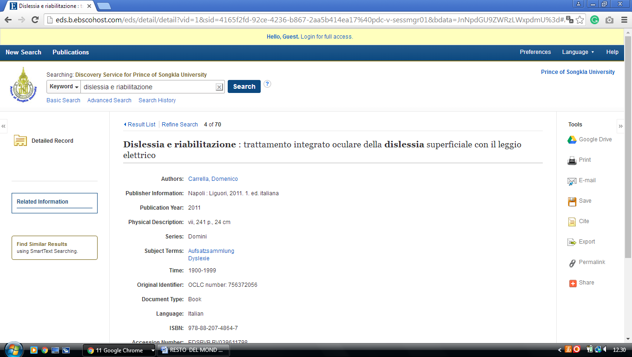

5 SRINAKHARINWIROT UNIVERSITY LIBRARY - (Bangkok, Thailand)
http://search.swu.ac.th:1701/primo-explore/search?vid=SWU&query=any,contains,dislessia%20e%20riabilitazione&search_scope=default_scope&sortby=rank&lang=en_US&pcAvailability=true

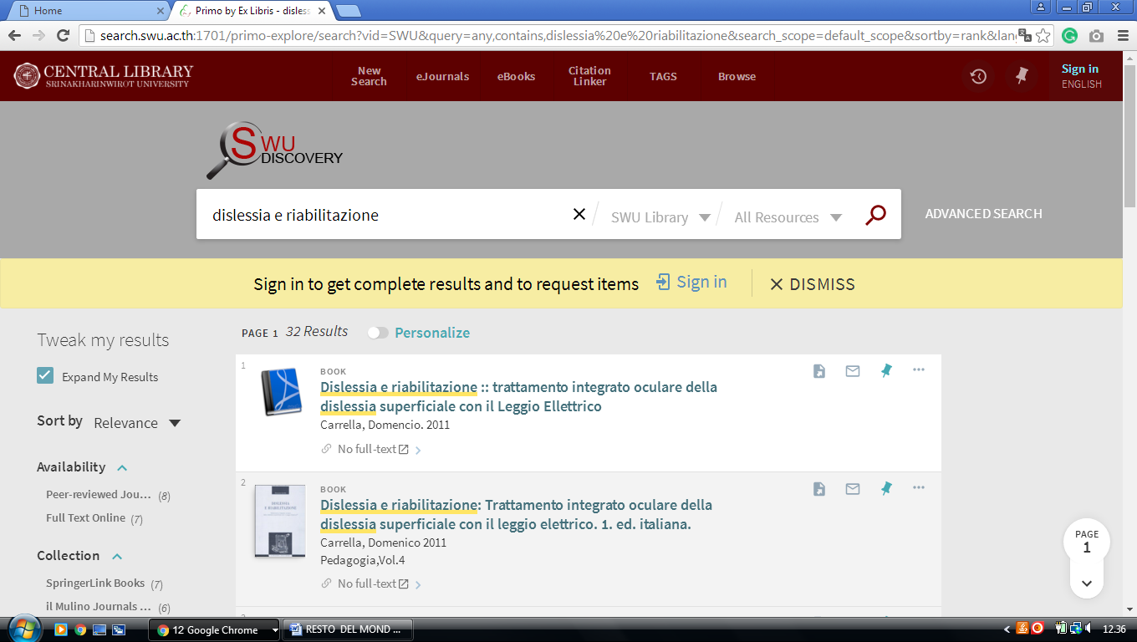
-------------------------------------------------------------------------------------------------------------------------------

6 KHON KAEN UNIVERSITY, MEDICAL LIBRARY – (Khon Kaen, Thailand)
http://eds.b.ebscohost.com/eds/results?vid=2&sid=81bfe53c-6467-4fde-b4b3-1f4286b350ab%40sessionmgr101&bquery=(dislessia+AND+e+AND+riabilitazione)&bdata=JnR5cGU9MCZzaXRlPWVkcy1saXZl

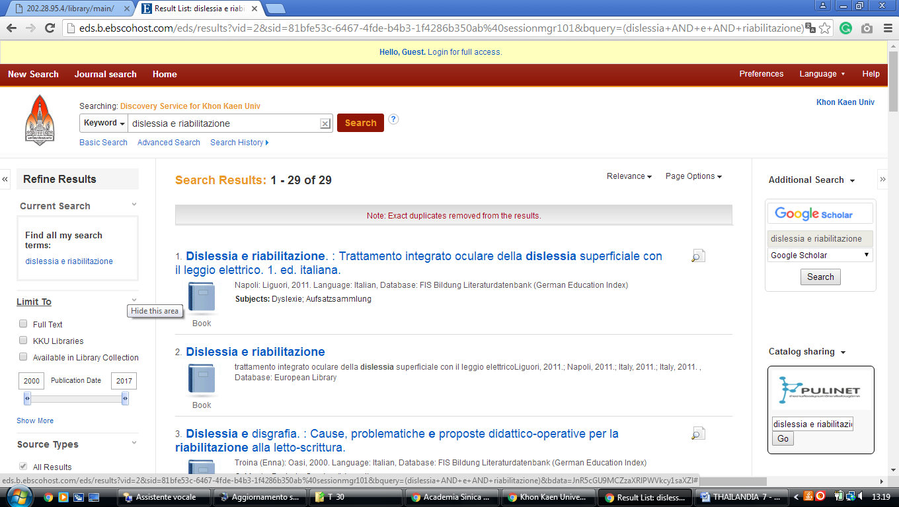



Huachiew Chalermprakiet University Library

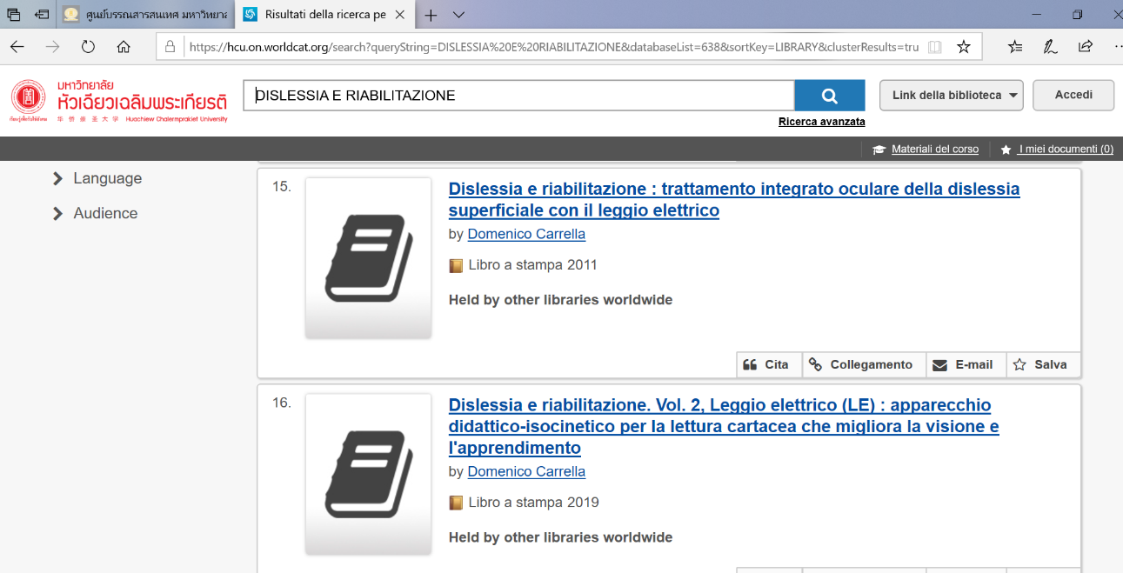
https://hcu.on.worldcat.org/search?queryString=DISLESSIA%20E%20RIABILITAZIONE&databaseList=638&sortKey=LIBRARY&clusterResults=true&scope=&page=2

BUU LIBRARY.. Burapha University Library

http://eds.b.ebscohost.com/eds/results?vid=4&sid=ec9be98e-fe4a-4bc7-9fe6-2510097583e2%40sessionmgr102&bquery=TI+dislessia+e+riabilitazione&bdata=Jmxhbmc9aXQmdHlwZT0wJnNlYXJjaE1vZGU9QW5kJnNpdGU9ZWRzLWxpdmU%3d
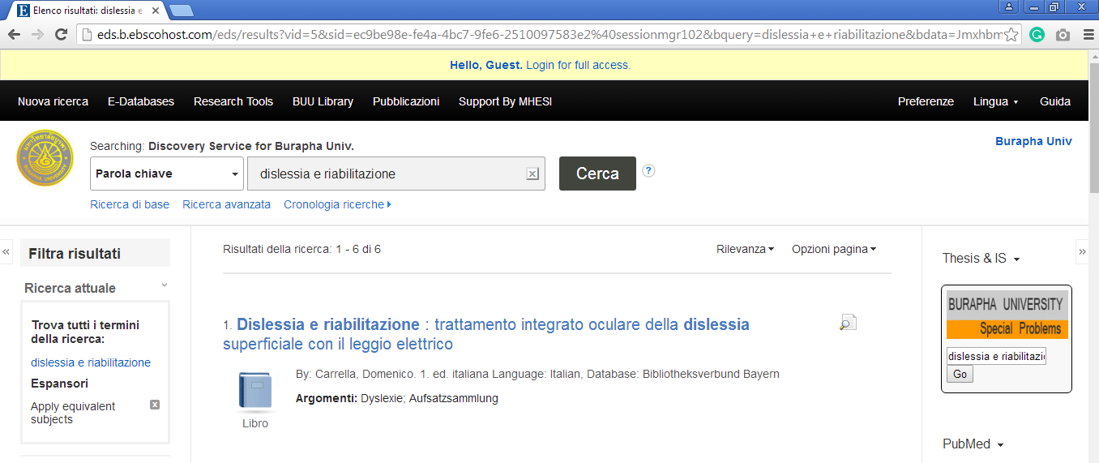

Huachiew Chalermprakiet University Library,
https://hcu.on.worldcat.org/search?queryString=dislessia+e+riabilitazione&submit=Search

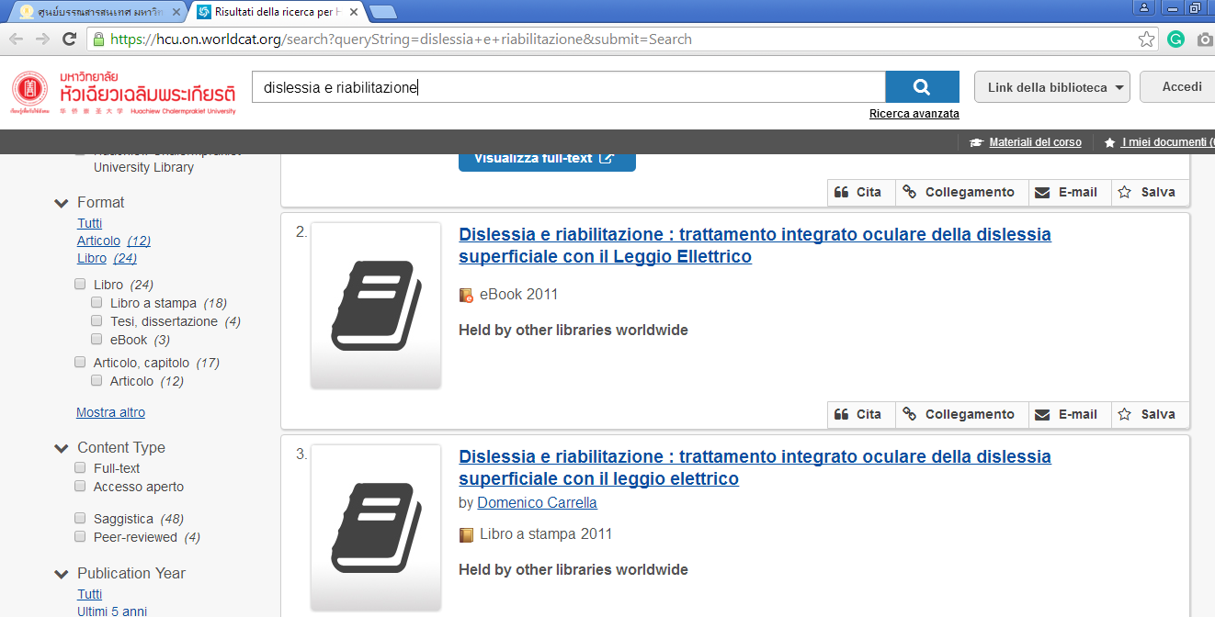

Kasetsart University Library / Learning Center (KULC) สำนัก .

https://kasetsartunivlibrary.worldcat.org/title/dislessia-e-riabilitazione-trattamento-integrato-oculare-della-dislessia-superficiale-con-il-leggio-elettrico/oclc/878784487&referer=brief_results
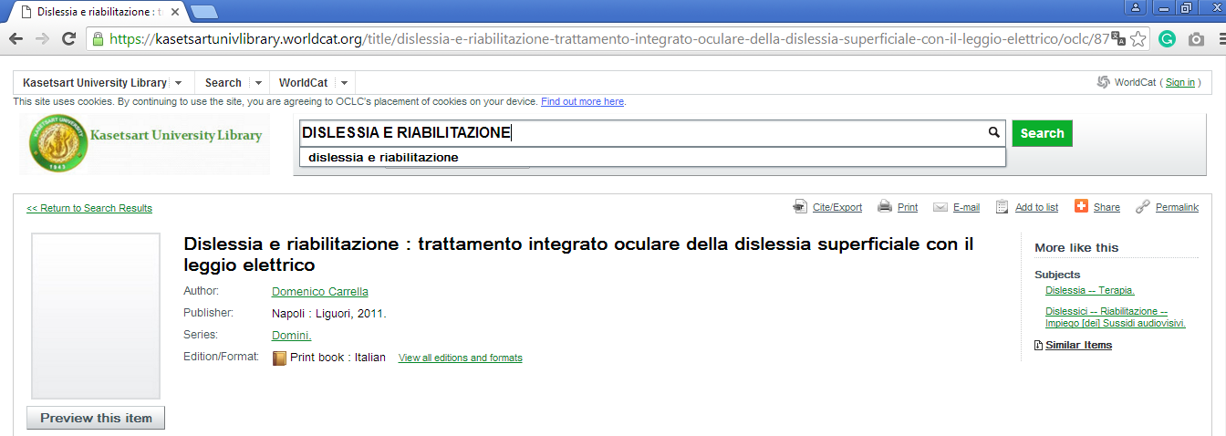

Mahidol University Library and Information Center,
http://eds.a.ebscohost.com/eds/detail/detail?vid=6&sid=9c14734c-aa82-46ea-a71e-e16c4009ec16%40sessionmgr4008&bdata=JnNpdGU9ZWRzLWxpdmU%3d#AN=edsbvb.BV039611798&db=edsbvb
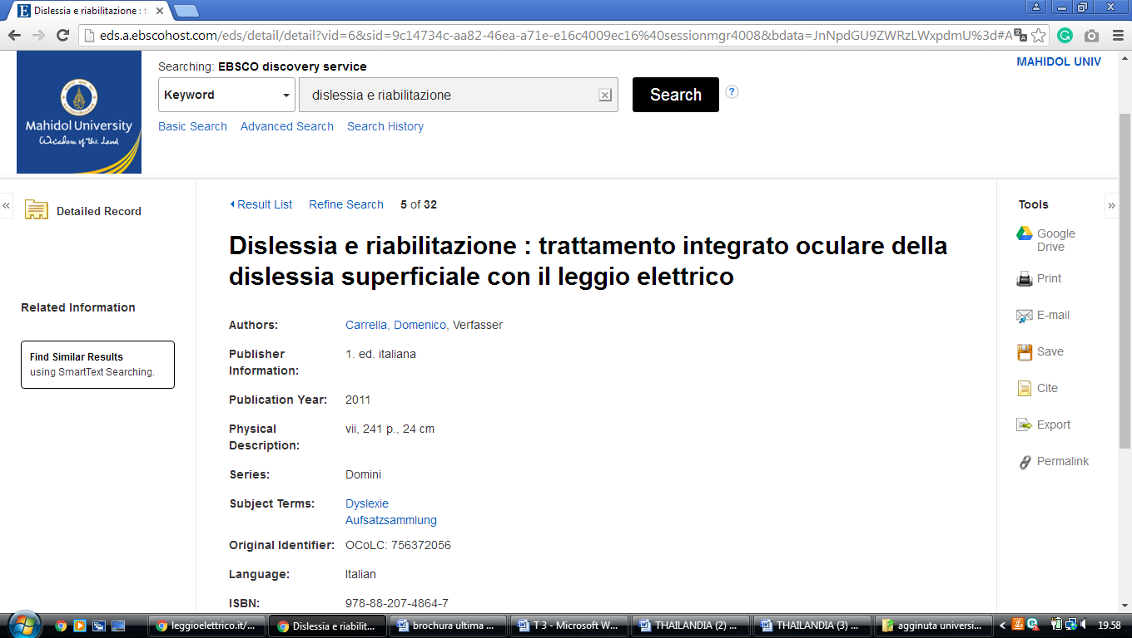

Silpakorn University Central Library ,
http://eds.a.ebscohost.com/eds/results?vid=3&sid=9ee2c278-eff6-483d-a79e-0c597094c00e%40sdc-v-sessmgr02&bquery=dislessia+e+riabilitazione&bdata=JnR5cGU9MCZzZWFyY2hNb2RlPUFuZCZzaXRlPWVkcy1saXZl
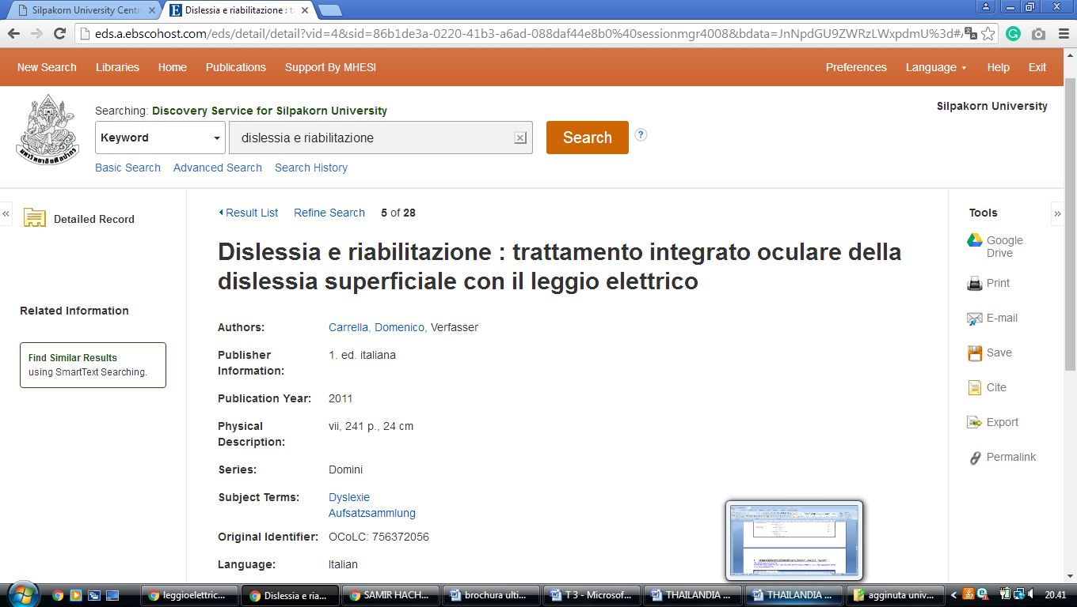

Srinakharinwirot University, Central Library,
http://lib.swu.ac.th
http://search.swu.ac.th:1701/primo-explore/search?institution=SWULIBRARY&vid=SWU&tab=default_tab&mode=Basic&displayMode=full&bulkSize=10&highlight=true&dum=true&query=any,contains,dislessia%20e%20riabilitazione&displayField=all&pcAvailabiltyMode=true&search_scope=default_scope&sortby=rank&lang=en_US&pcAvailability=true
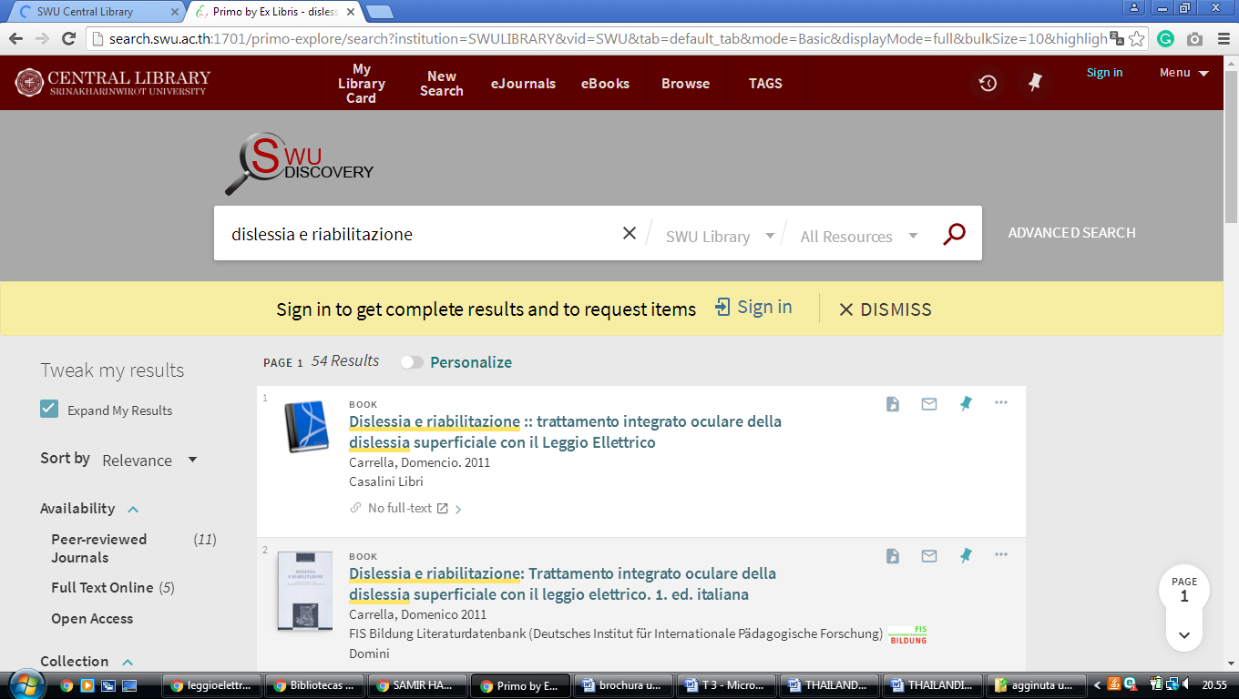

Thammasat University Library System,
https://thammasatuniv.on.worldcat.org/search?queryString=dislessia+e+riabilitazione&scope=
