1 ANADOLU ÜNIVERSITESI KÜTÜPHANESI – (Eskisehir, Turkey)
http://eds.b.ebscohost.com/eds/results?vid=0&sid=7cdb1c5b-1f22-4a0c-889b-60a29033720d%40sessionmgr102&bquery=dislessia+e+riabilitazione&bdata=JmNsaTA9RlQxJmNsdjA9WSZsYW5nPXRyJnR5cGU9MCZzaXRlPWVkcy1saXZl

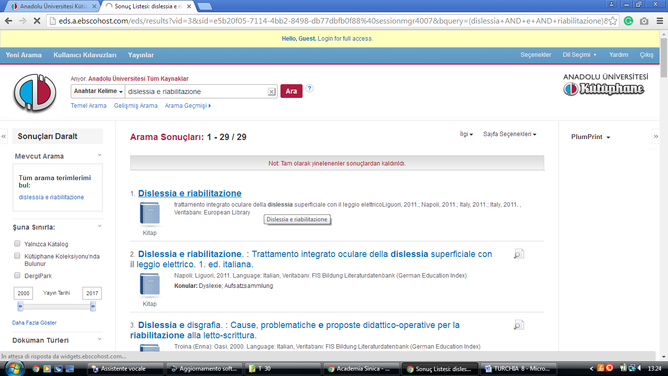

2 BILKENT UNIVERSITY LIBRARY– (Ankara, Turkey)
http://eds.a.ebscohost.com/eds/results?vid=1&sid=07959a15-bfb0-4f25-9cd5-f495867914cf%40sessionmgr4008&bquery=(dislessia+AND+e+AND+riabilitazione)&bdata=JnR5cGU9MCZzaXRlPWVkcy1saXZl

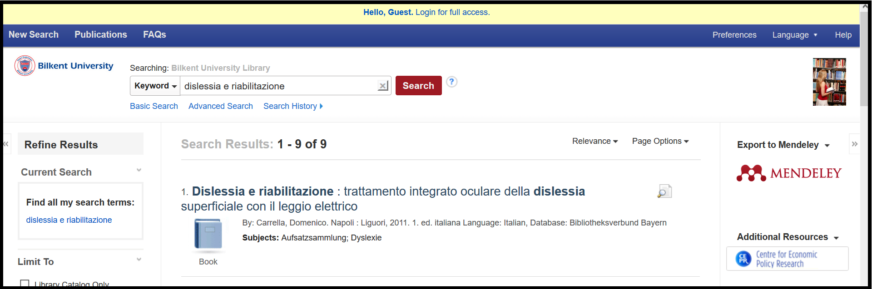
3 BOGAZICI UNIVERSITY LIBRARY– (Istanbul,Turkey)
http://boun.summon.serialssolutions.com/search?s.q=dislessia+e+riabilitazione#!/search?ho=f&l=en&q=dislessia%20e%20riabilitazione

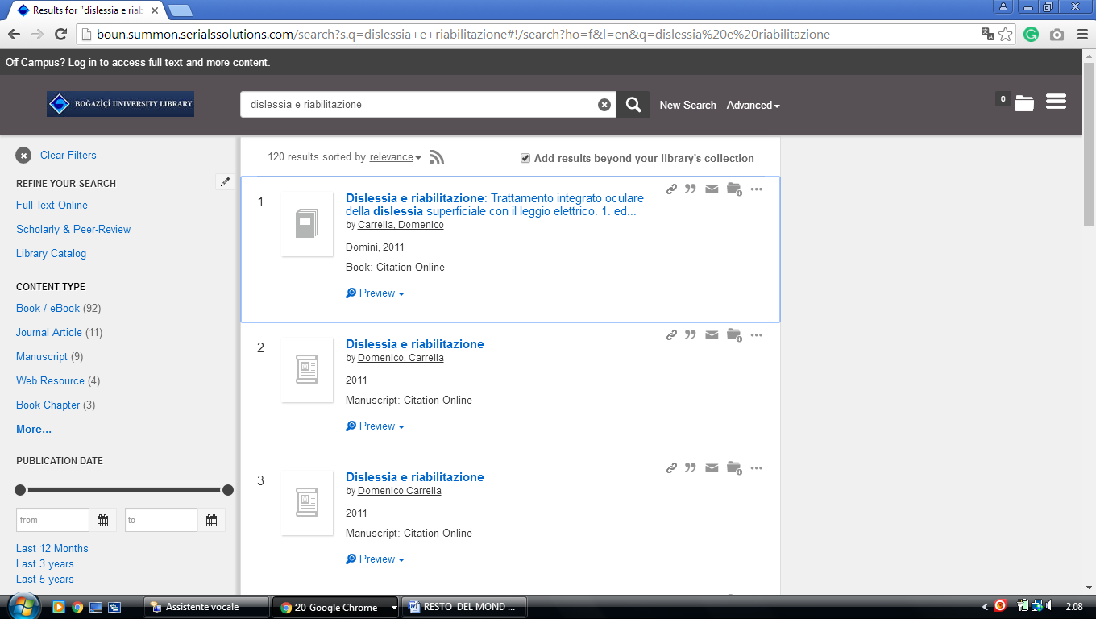

4 ISTANBUL TECHNICAL UNIVERSITY - (Istanbul, Turkey)
http://eds.a.ebscohost.com/eds/results?vid=0&sid=00184404-db85-4829-b83a-c1ca7cef8c05%40sessionmgr4007&bquery=dislessia+e+riabilitazione&bdata=JmNsaTA9RlQxJmNsdjA9WSZ0eXBlPTAmc2l0ZT1lZHMtbGl2ZQ%3d%3d

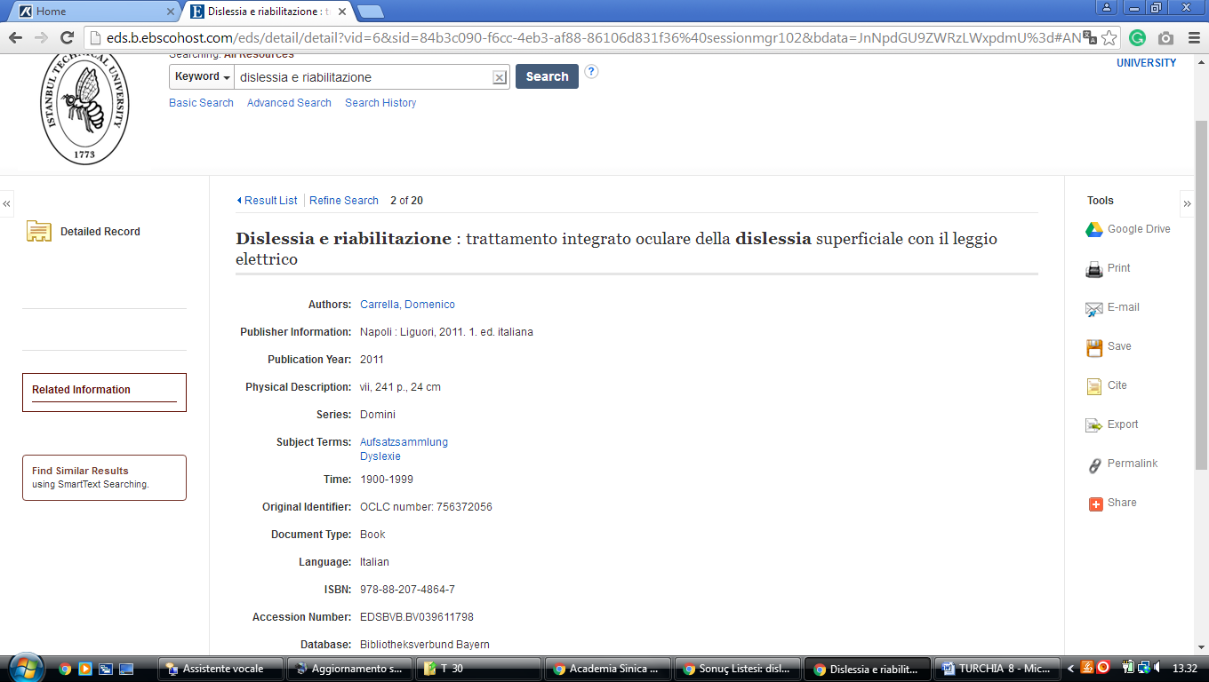

5 SAKARYA UNIVERSITY LIBRARY – (Adapazari, Sakarya, Turkey)
http://eds.a.ebscohost.com/eds/results?vid=1&sid=c7637ec6-5cc2-40d5-ae20-3e31f30d0b52%40sessionmgr4008&bquery=(dislessia+AND+e+AND+riabilitazione)&bdata=Jmxhbmc9dHImdHlwZT0wJnNpdGU9ZWRzLWxpdmUmc2NvcGU9c2l0ZQ%3d%3d

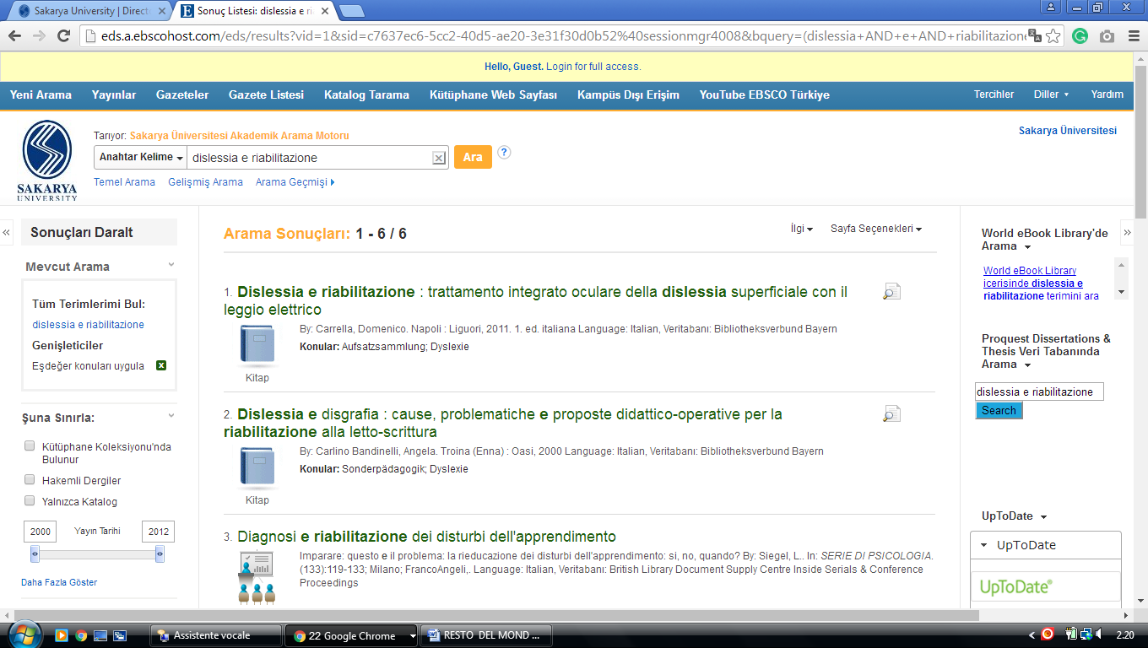

6 COMÜ - KÜTÜPHANE VE DOKÜMANTASYON D.BŞK. – (Erzioğlu Campus (Main Campus), Çanakkale, Çomüturkey)
http://eds.b.ebscohost.com/eds/results?vid=1&sid=af017453-8894-46b3-96fa-e602b99b043d%40pdc-v-sessmgr01&bquery=(dislessia+AND+e+AND+riabilitazione)&bdata=Jmxhbmc9dHImdHlwZT0wJnNpdGU9ZWRzLWxpdmU%3d
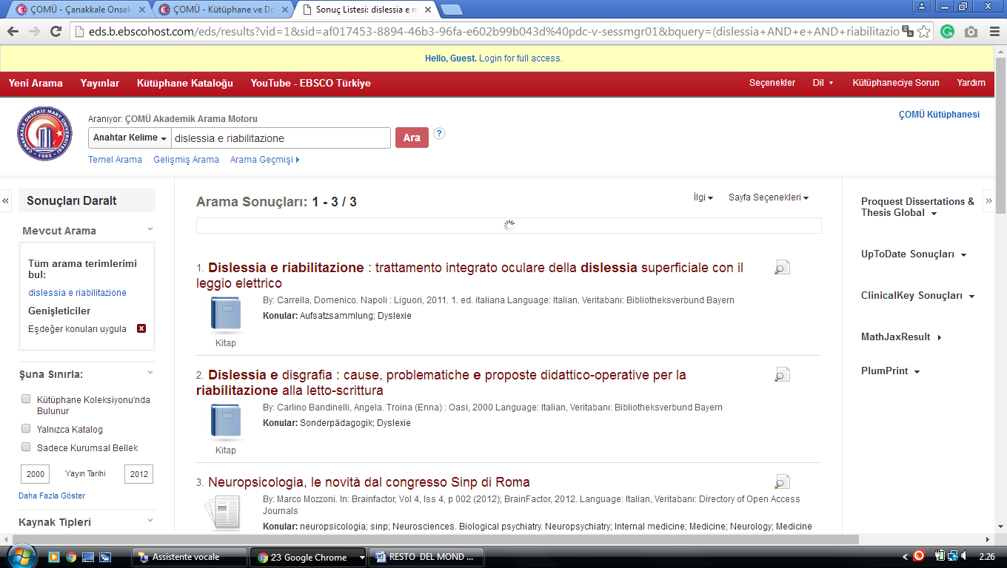

7 YAŞAR ÜNİVERSİTESİ – Bilgi Merkezi - (Izmir, Turkey)
http://eds.b.ebscohost.com/eds/results?vid=1&sid=fe965ed4-cf7c-4dd1-9c6e-8442d5549860%40sessionmgr120&bquery=(dislessia+AND+e+AND+riabilitazione)&bdata=JnR5cGU9MCZzaXRlPWVkcy1saXZl

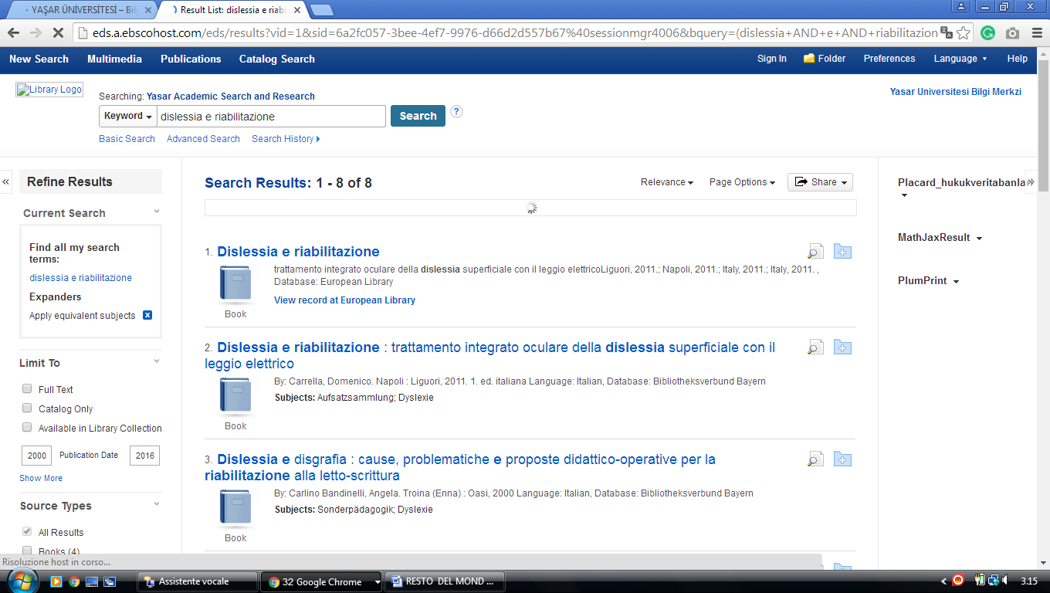

Özay Oral Library - EMU, TURCHIA

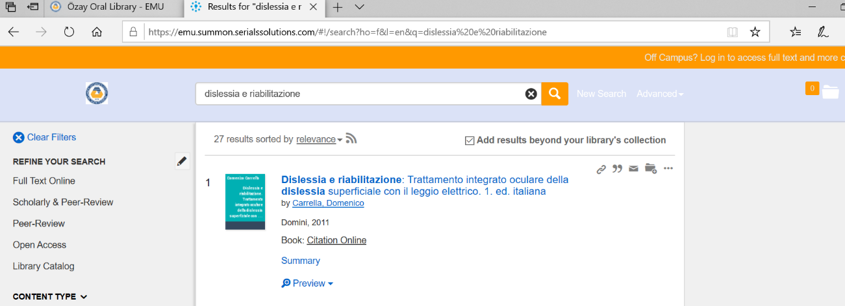
https://emu.summon.serialssolutions.com/#!/search?ho=f&l=en&q=dislessia%20e%20riabilitazione

Süleyman Demirel Üniversitesi Bilgi Merkezi Isparta, Turkey

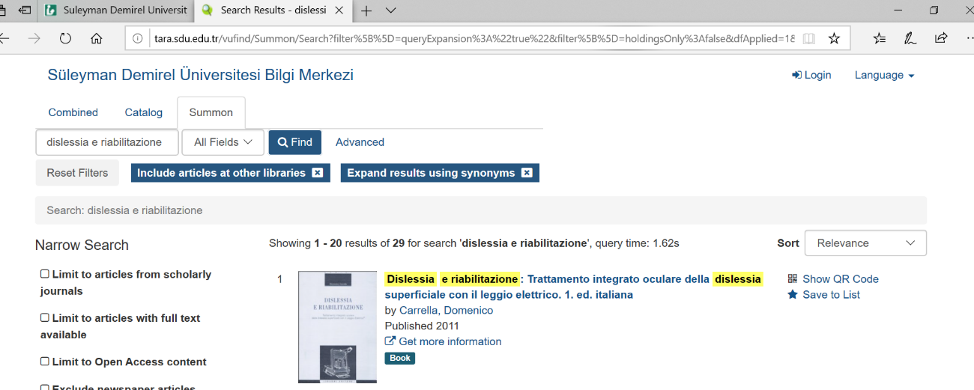
tara.sdu.edu.tr/vufind/Summon/Search?filter%5B%5D=queryExpansion%3A%22true%22&filter%5B%5D=holdingsOnly%3Afalse&dfApplied=1&lookfor=dislessia+e+riabilitazione&type=AllFields

