1 SZEGED UNIVERSITY LIBRARY – (Szeged, Hungary) http://eds.a.ebscohost.com/eds/results?vid=0&sid=eb83b99a-984b-46b4-b9b0-9ae359cf4819%40sessionmgr4007&bquery=dislessia+e+riabilitazione&bdata=JnR5cGU9MCZzaXRlPWVkcy1saXZl
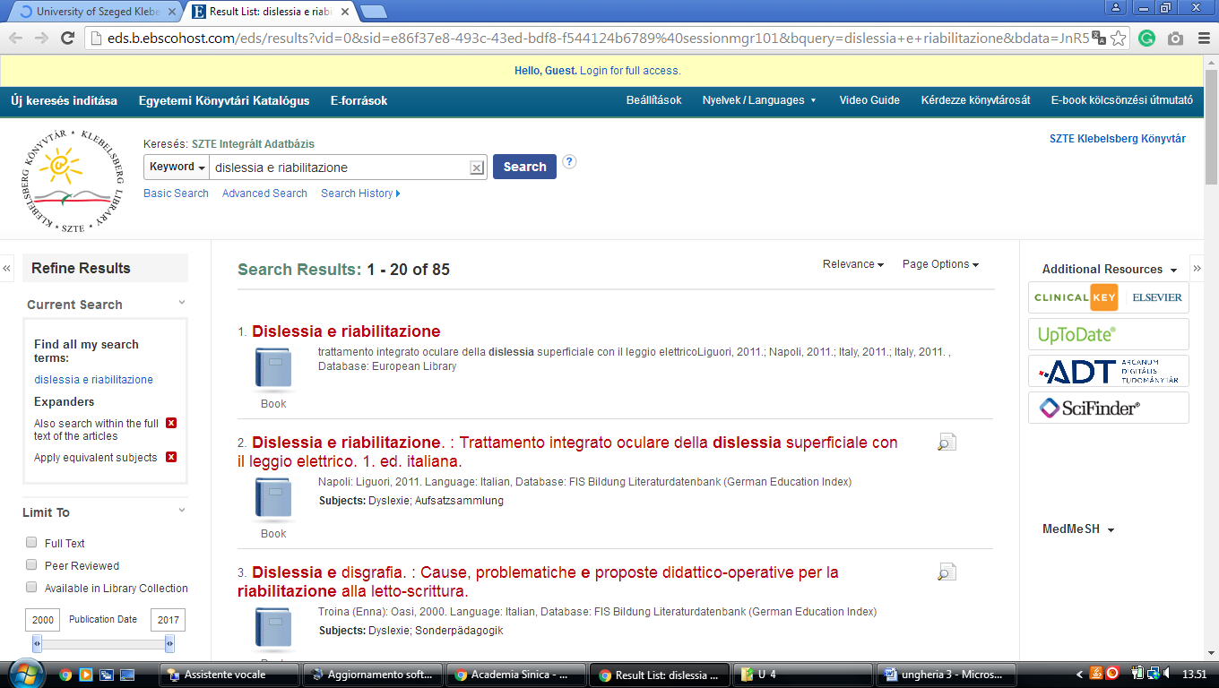

2 LIBRARY - BUDAPESTI CORVINUS EGYETEM EGYETEMI KÖNYVTÁR (Budapest Ungheria)
http://eds.a.ebscohost.com/eds/results?vid=0&sid=5c2d75d7-8ac0-4c2a-b39d-eb9ea68a8583%40sessionmgr4009&bquery=dislessia+e+riabilitazione&bdata=JnR5cGU9MCZzaXRlPWVkcy1saXZl
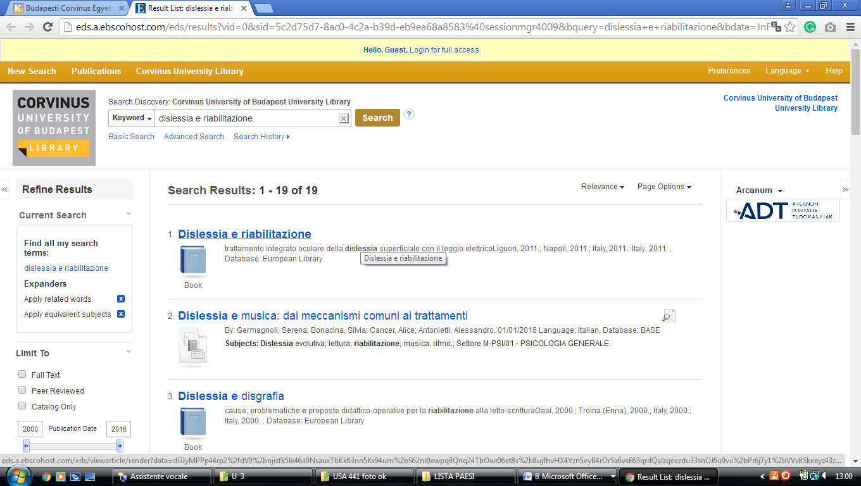

3 LIBRARY OF THE HUNGARIAN PARLIAMENT - THE EUROPEAN LIBRARY

(Hungary)
http://www.theeuropeanlibrary.org/tel4/contributor/P01356
http://www.theeuropeanlibrary.org/tel4/search?query=dislessia%20e%20riabilitazione
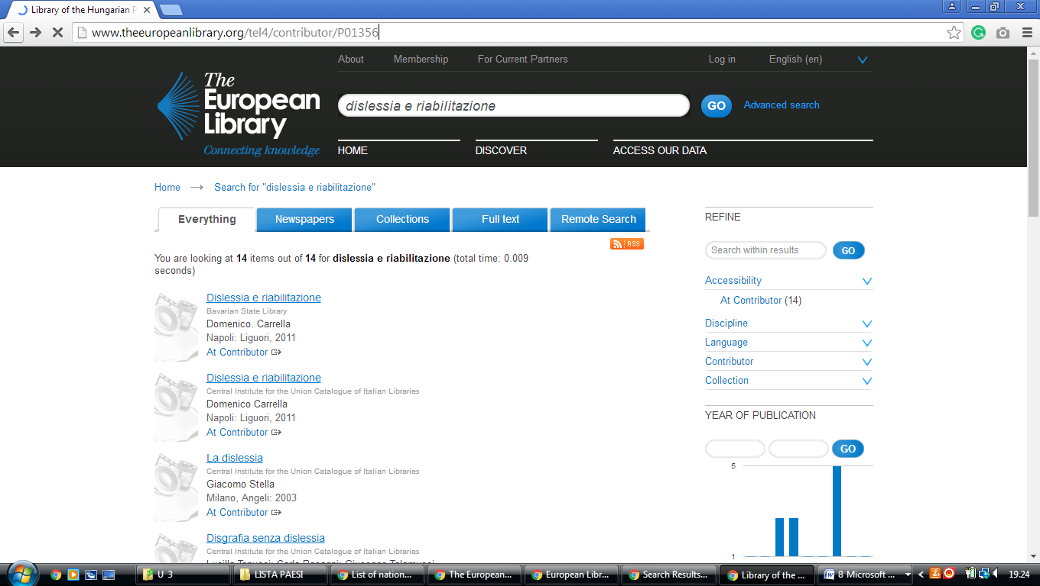

1. SZTE KLEBELSBERG LIBRARY, Szeged, UNGHERIA

Szegedi Tudományegyetem Klebelsberg Kuno Könyvtára

http://www.ek.szte.hu/?lang=en

- utilizza Online resources nel quadro
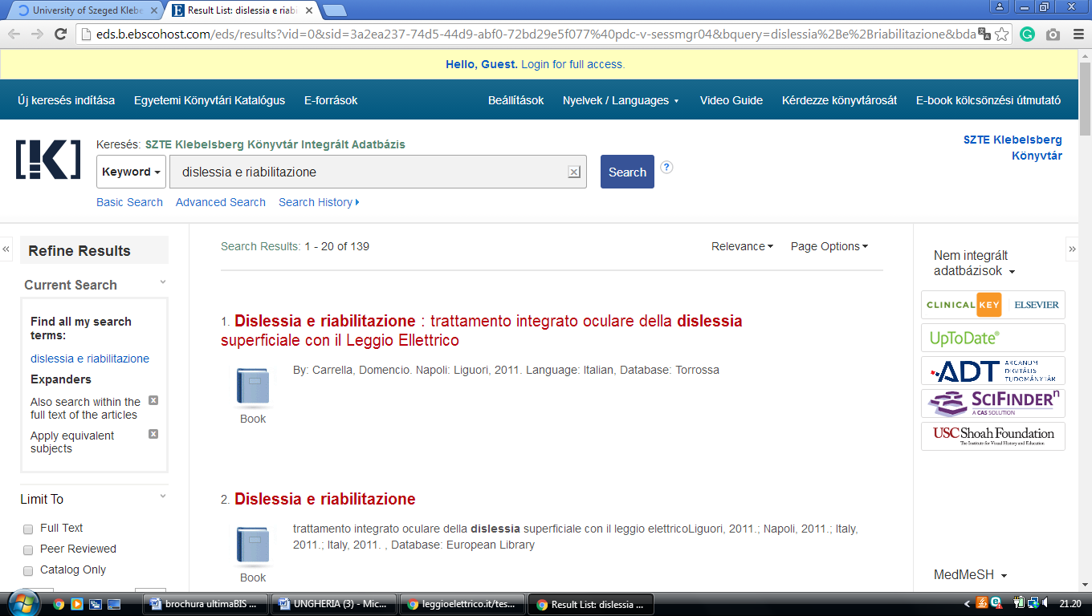

,

LIBRARY UNIVERSITY OF DEBRECEN, HUNGARY

library University of Debrecen
https://lib.unideb.hu/en/search/deenk/DISLESSIA%20E%20RIABILITAZIONE
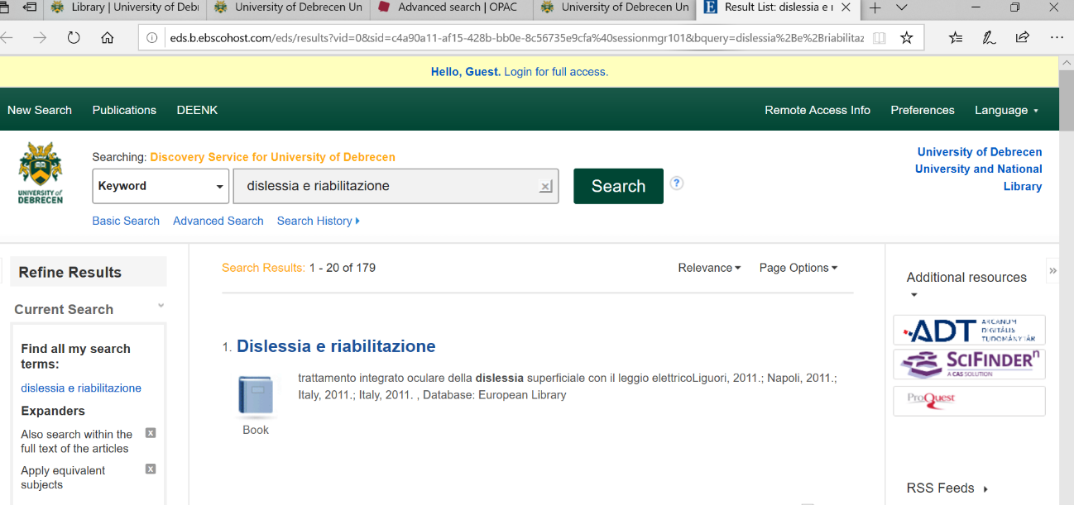

Debrecen University Library, UNGHERIA
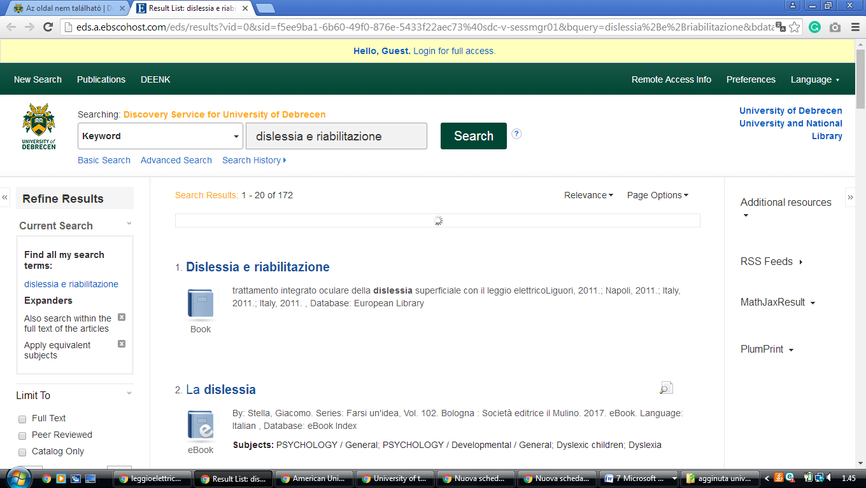
http://eds.b.ebscohost.com/eds/results?vid=0&sid=b2e99a48-100c-4cf6-b399-603a39763167%40sessionmgr102&bquery=dislessia%2Be%2Briabilitazione&bdata=JkF1dGhUeXBlPWlwLHVpZCZ0eXBlPTAmc2VhcmNoTW9kZT1BbmQmc2l0ZT1lZHMtbGl2ZQ%3d%3d

