ALABAMA = 9

1 ALABAMA STATE UNIVERSITY, LIBRARY – (Montgomery, Alabama, Usa)
https://alasu.on.worldcat.org/search?sortKey=BEST_MATCH&databaseList=638&queryString=dislessia+e+riabilitazione&changedFacet=scope&clusterResults=on&scope=&scope=wz%3A2801

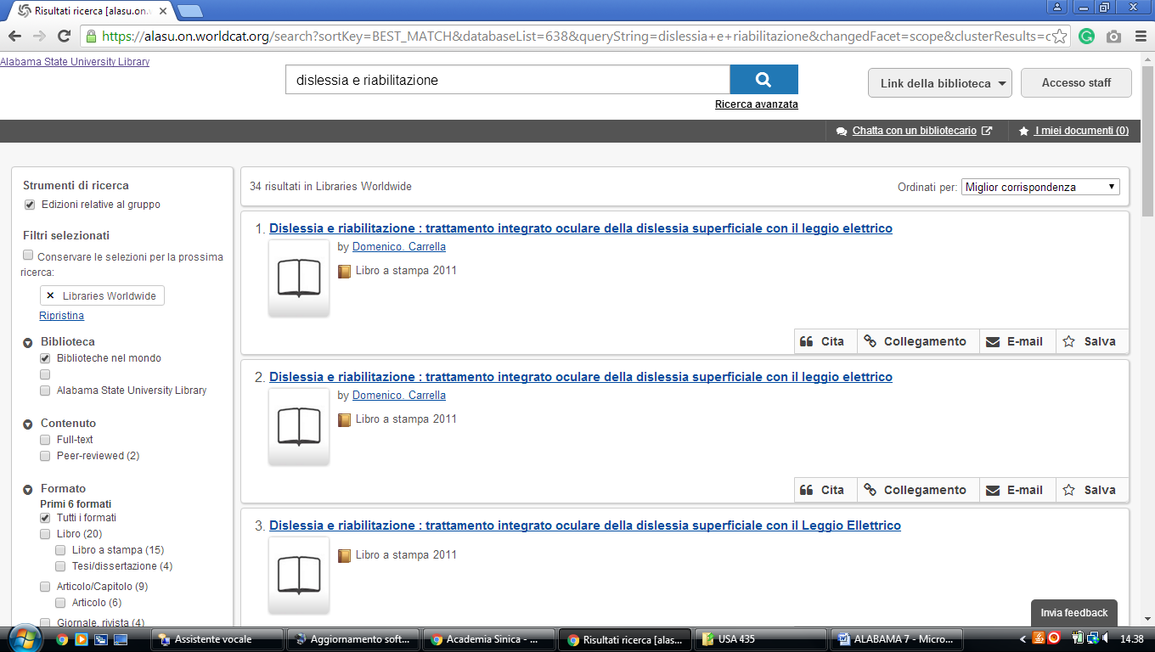

2 BURKE MEMORIAL LIBRARY – (Mobile, Alabama, Usa)
http://shclibrary.worldcat.org/title/dislessia-e-riabilitazione-trattamento-integrato-oculare-della-dislessia-superficiale-con-il-leggio-elettrico/oclc/878784487&referer=brief_results
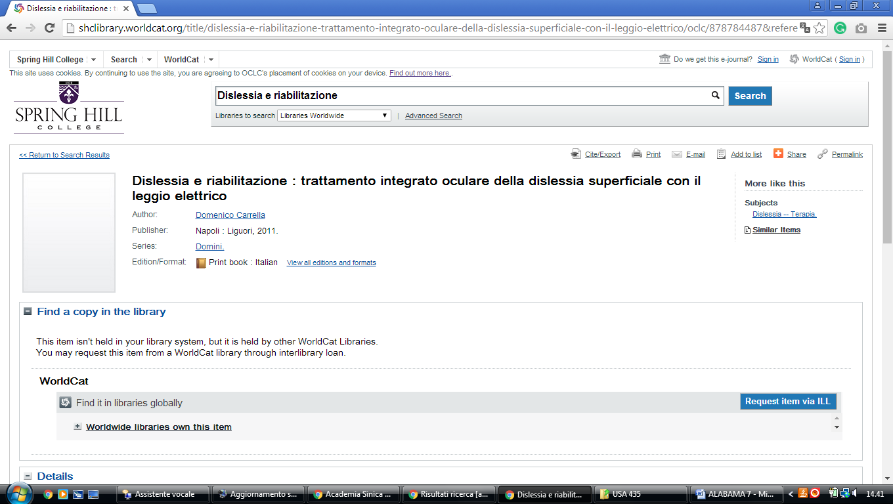

3 HUNTINGDON COLLEGE LIBRARY – (Montgomery, Alabama, Usa)
https://huntingdoncollege.on.worldcat.org/external-search?queryString=dislessia+e+riabilitazione#/oclc/878784487
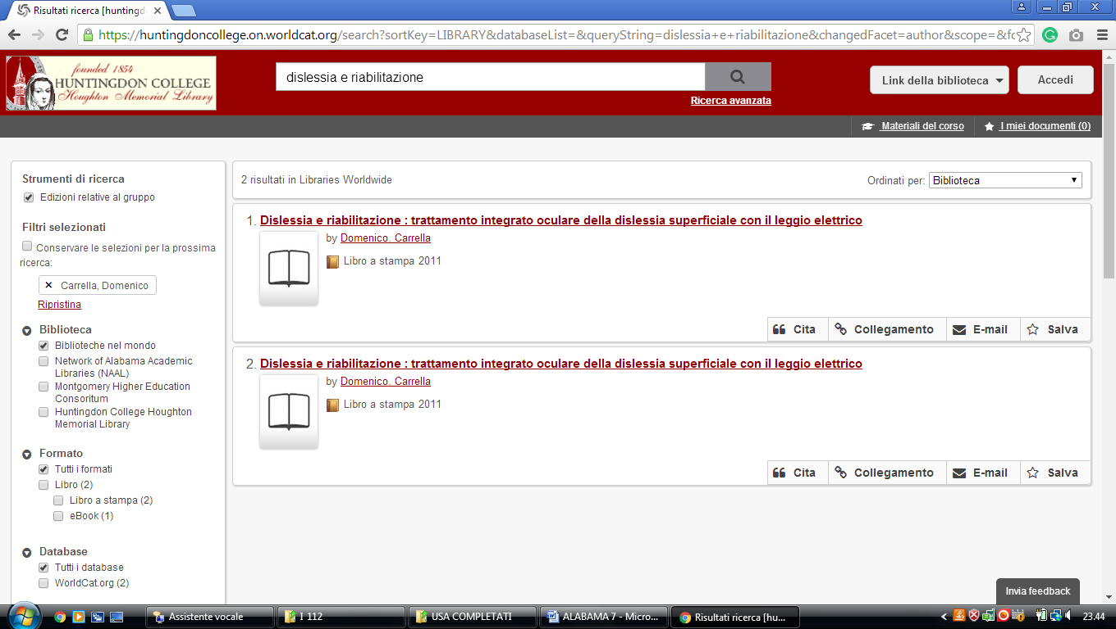

4 UNIVERSITY OF MONTEVALLO,LIBRARY WORDLCAT – (Alabama, Usa)
http://montevallo.worldcat.org/title/dislessia-e-riabilitazione-trattamento-integrato-oculare-della-dislessia-superficiale-con-il-leggio-elettrico/oclc/878784487&referer=brief_results

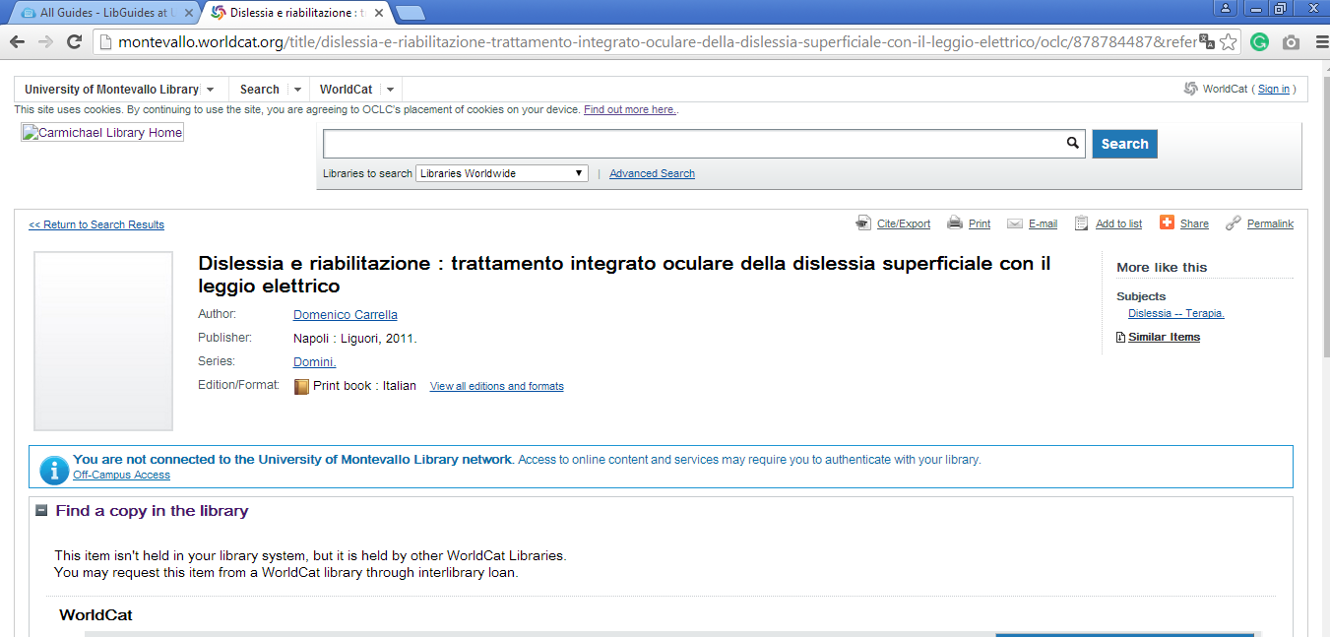

5 UNIVERSITY OF ALABAMA AT BIRMINGHAM'S LISTER HILL LIBRARY OF
THE HEALTH SCIENCES – (Birmingham, Alabama, Usa)
https://uab-primo.hosted.exlibrisgroup.com/primo-explore/search?institution=01UALB&vid=Lister_Hill&mode=Basic&displayMode=full&bulkSize=10&highlight=true&dum=true&query=any,contains,dislessia%20e%20riabilitazione&displayField=all&pcAvailabiltyMode=true&search_scope=EVERYTHING&sortby=rank&lang=en_US&pcAvailability=true

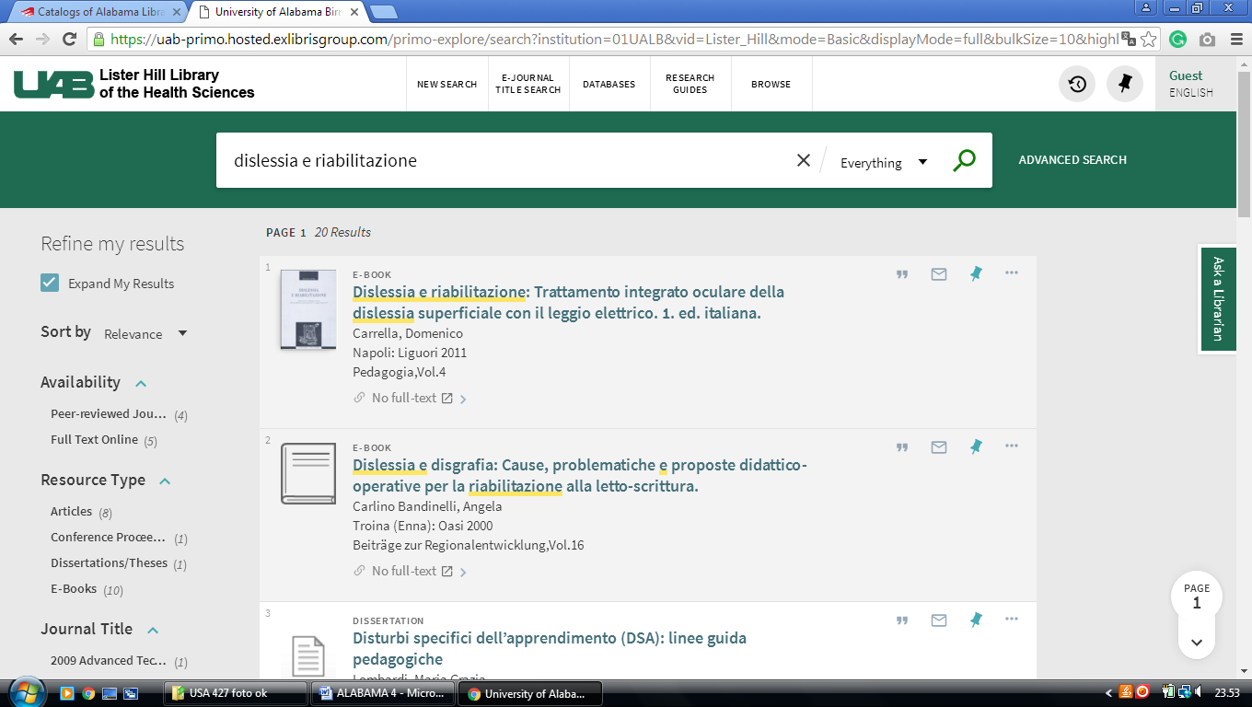

6 Alabama State University Library - (Montgomery, Alabama, Usa)
https://alasu.on.worldcat.org/search?sortKey=BEST_MATCH&databaseList=&queryString=dislessia+e+riabilitazione&changedFacet=scope&clusterResults=on&scope=&scope=wz%3A2801
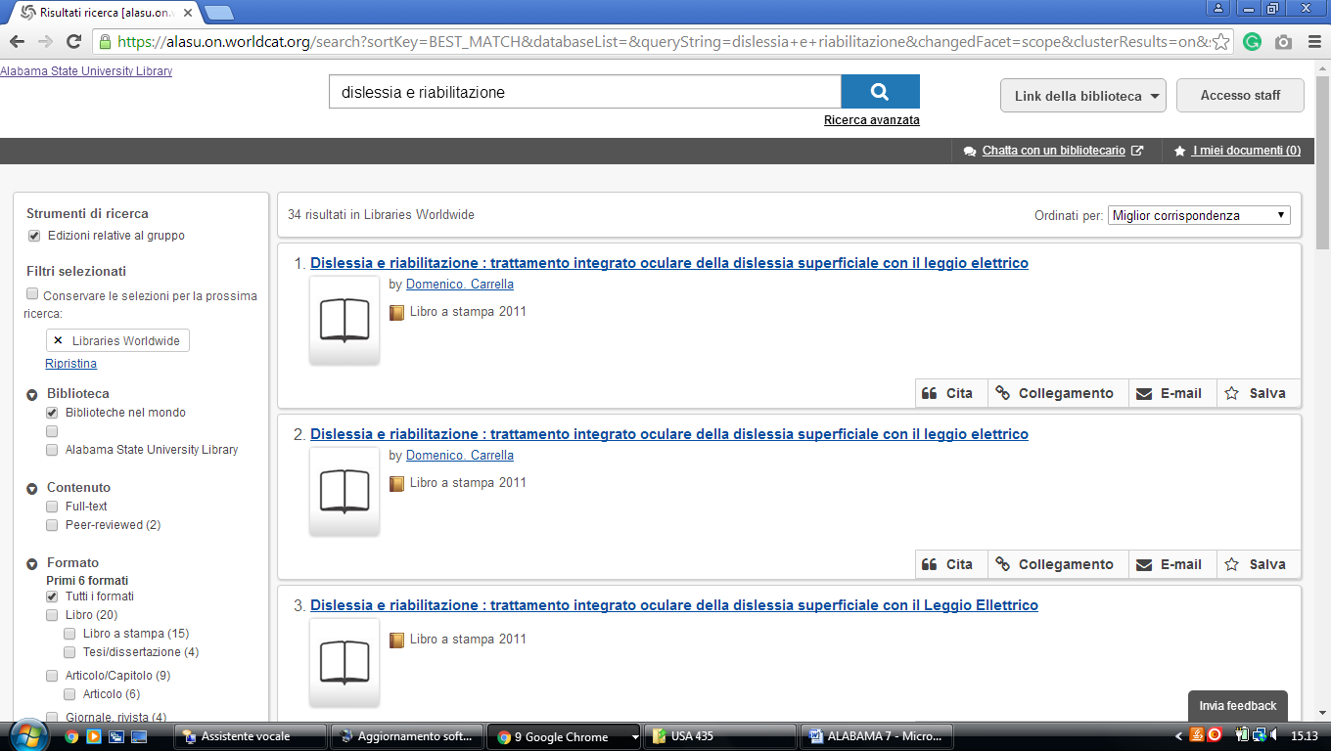

alabama College of Osteopathic Medicine Acom Library |,

http://acom.summon.serialssolutions.com/?s.q=dislessia+e+riabilitazione#!/search?ho=f&l=en&q=dislessia%20e%20riabilitazione
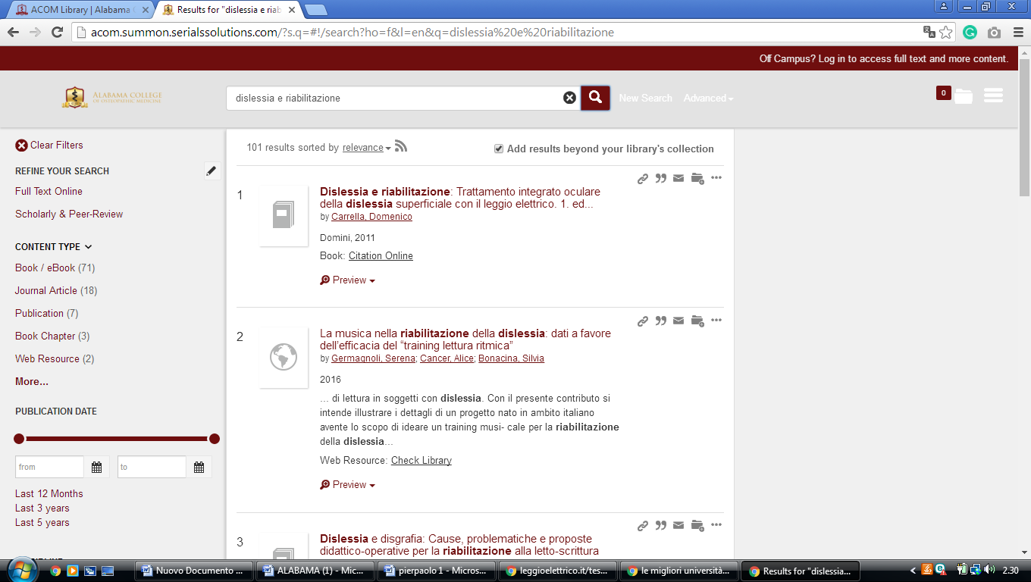

Auburn University Libraries,

https://eds.b.ebscohost.com/eds/results?vid=0&sid=9d05d2d3-277e-4289-822b-72180a8c906a%40pdc-v-sessmgr05&bquery=TI%2B%28dislessia%2Be%2Briabilitazione%29&bdata=JnR5cGU9MCZzZWFyY2hNb2RlPUFuZCZzaXRlPWVkcy1saXZlJnNjb3BlPXNpdGU%3d
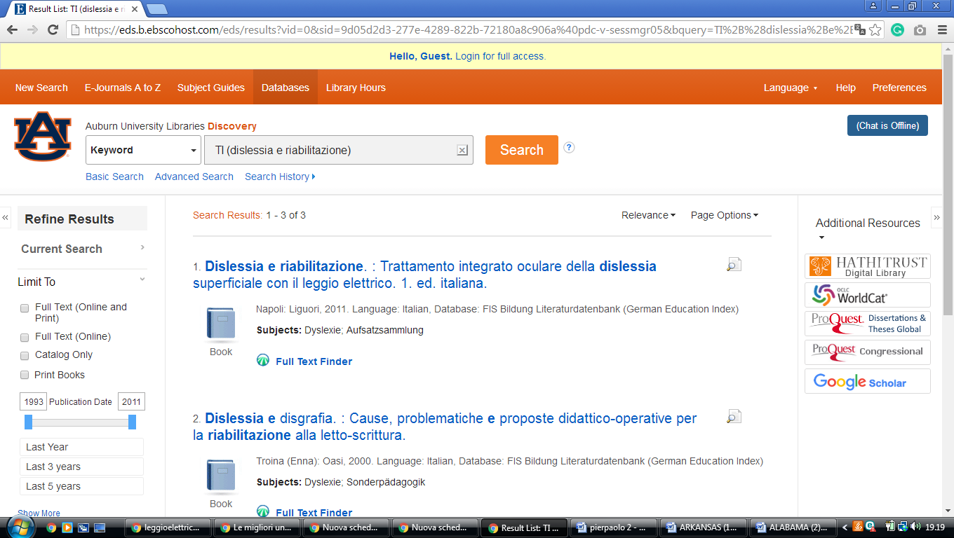

Auburn University Libraries,
Troy University Libraries
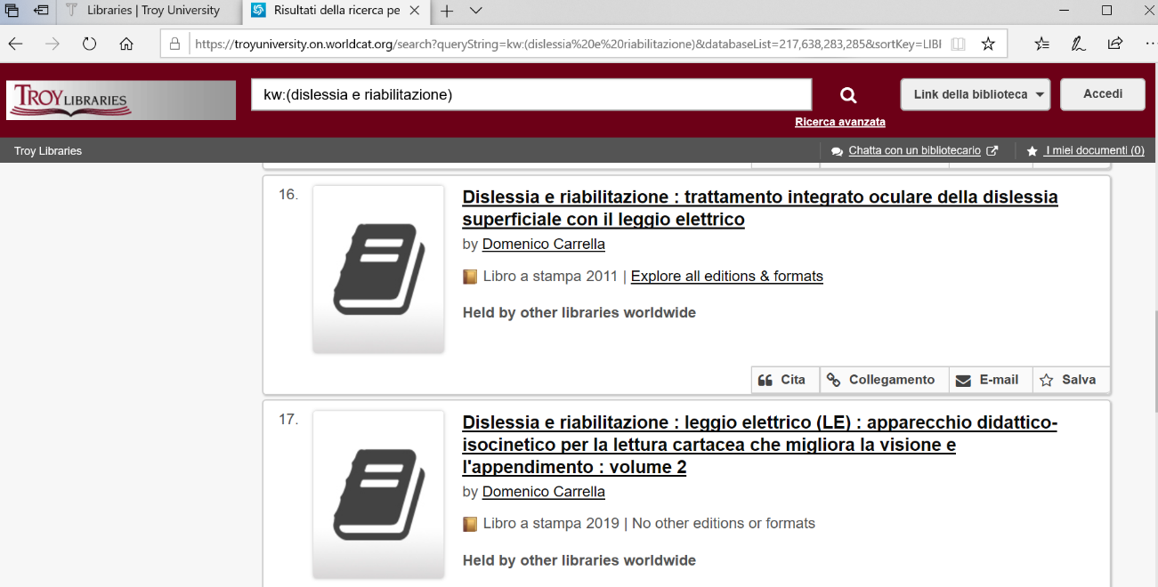
https://troyuniversity.on.worldcat.org/search?queryString=kw:(dislessia%20e%20riabilitazione)&databaseList=217,638,283,285&sortKey=LIBRARY&clusterResults=true&translateSearch=false&queryTranslationLanguage=en&expandSearch=false&scope=&page=2

