COLORADO = 3

1 KRAEMER FAMILY LIBRARY - (Colorado Springs, Colorado, Usa)
https://uccs.summon.serialssolutions.com/search?s.q=dislessia+e+riabilitazione&spellcheck=true&keep_r=true&x=35&y=22#!/search?ho=f&l=en&q=dislessia%20e%20riabilitazione

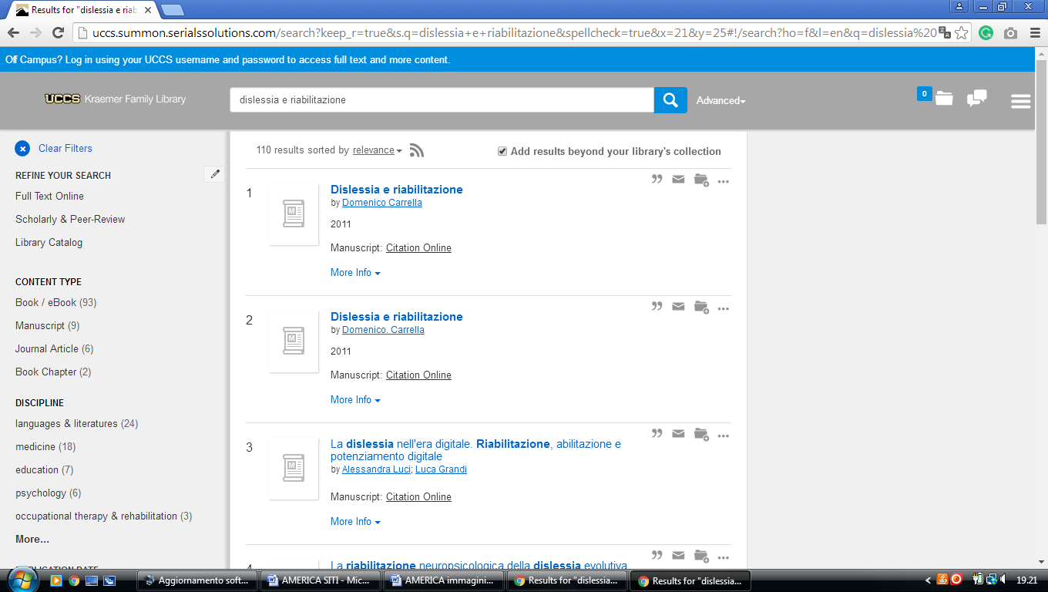

2 UNIVERSITY OF COLORADO BOULDLER LIBRARIES - (Pleasant St. Boulder, Usa)
http://ucblibraries.summon.serialssolutions.com/#!/search?ho=f&l=en&q=dislessia%20e%20riabilitazione

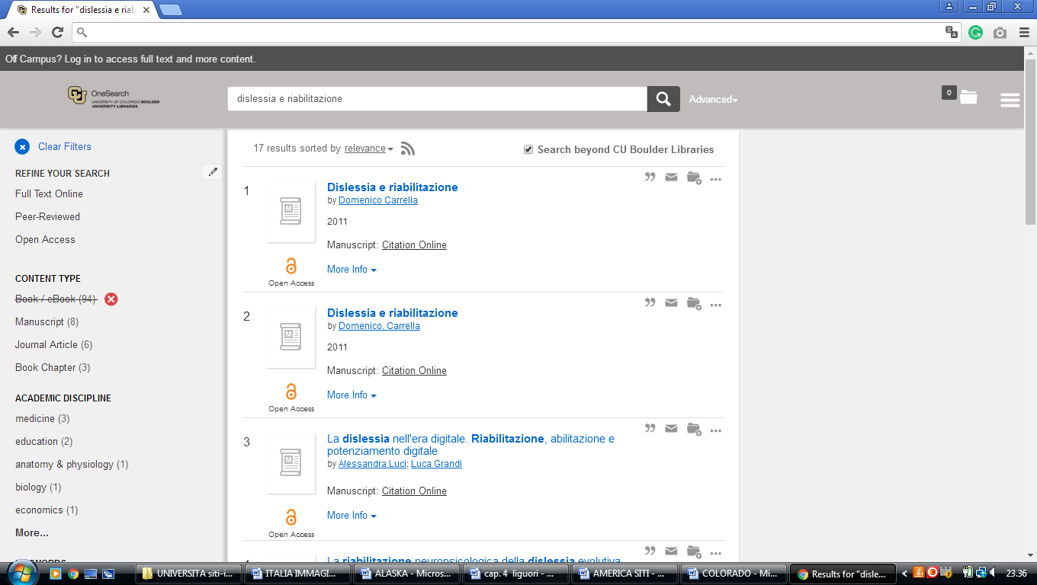

3 Libraries - University of Northern Colorado - (Greeley, Usa)
http://unco.summon.serialssolutions.com/search?s.fvf%5B%5D=ContentType%2CNewspaper+Article%2Ct&s.q=dislessia+e+riabilitazione#!/search?ho=f&fvf=ContentType,Newspaper%20Article,t&l=en&q=dislessia%20e%20riabilitazione

