CONNECTICUT = 11

1 CENTRAL CONNECTICUT STATE UNIVERSITY LIBRARY - (New Britain, Usa)
https://cscu-ccsu-primo.hosted.exlibrisgroup.com/primo-explore/search?institution=CCSU&vid=CCSU_V1&tab=default_tab&search_scope=CCSU&mode=Basic&displayMode=full&bulkSize=25&highlight=true&dum=true&query=any,contains,dislessia%20e%20riabilitazione&displayField=all&pcAvailabiltyMode=true&sortby=rank&lang=en_US&pcAvailability=true

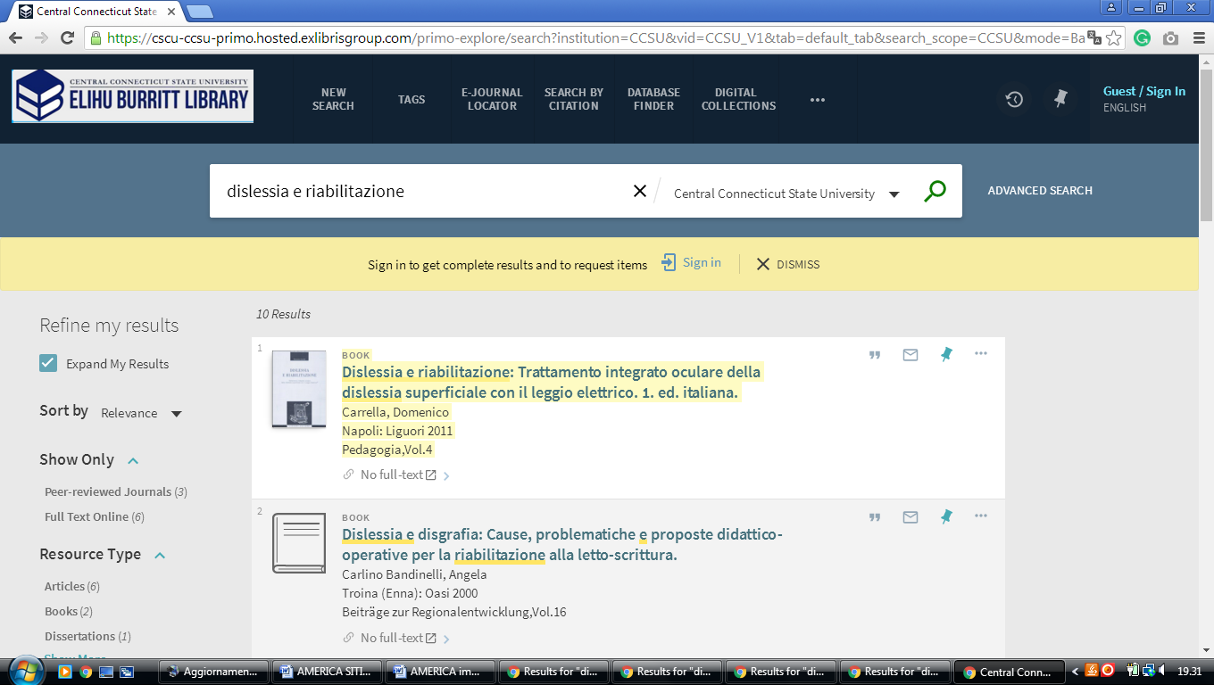

2 EASTERN CONNECTICUT STATE UNIVERSITY LIBRARY – (Willimantic, Usa)
https://cscu-ecsu-primo.hosted.exlibrisgroup.com/primo-explore/search?institution=01CSCU_ECSU&vid=ECSU_V1&tab=default_tab&search_scope=ECSU&mode=Basic&displayMode=full&bulkSize=10&highlight=true&dum=true&query=any,contains,%20DISLESSIA%20E%20RIABILITAZIONE&displayField=all&pcAvailabiltyMode=true&sortby=rank&lang=en_US&pcAvailability=true

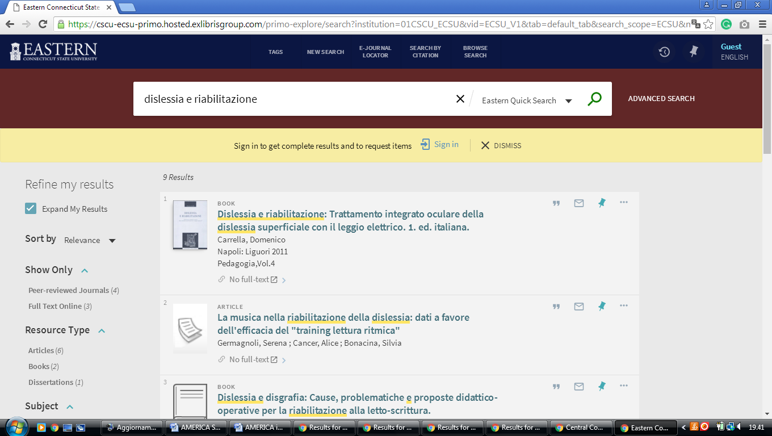

3 TRINITY COLLEGE LIBRARY - CONNECTICUT - (Hartford, Connecticut, Usa)
https://trincoll-primo.hosted.exlibrisgroup.com/primo-explore/search?query=any,contains,dislessia%20e%20riabilitazione&institution=01CTW_TC&vid=CTWTC&tab=default_tab&search_scope=default_scope&displayMode=full&bulkSize=10&highlight=true&dum=true&primoQuery=hidden&displayField=all&sortby=rank

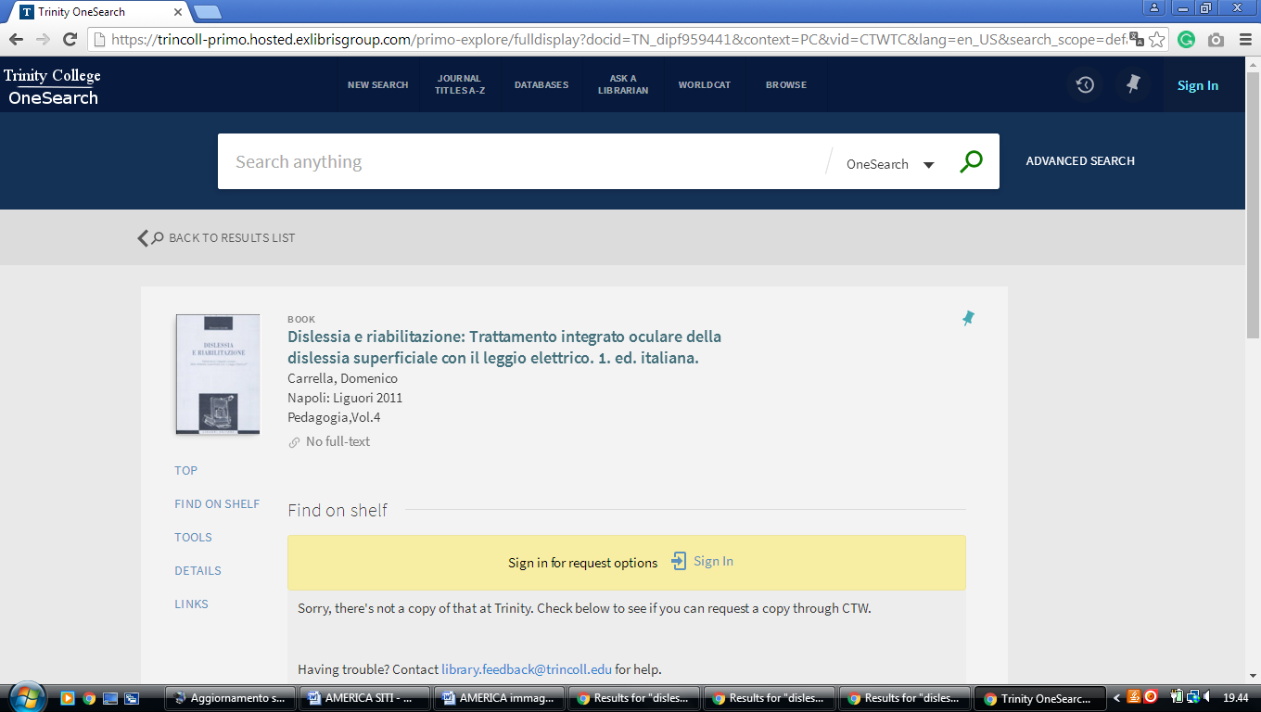

4 US COAST GUARD ACADEMY LIBRARY - (New London, Connecticut, Usa)
https://uscga.summon.serialssolutions.com/search?s.q=dislessia+e+riabilitazione&s.cmd=addFacetValueFilters%28ContentType%2CNewspaper+Article%2Ct%7CContentType%2CBook+Review%2Ct%29#!/search?ho=f&fvf=ContentType,Newspaper%20Article,t%7CContentType,Book%20Review,t&l=en&q=dislessia%20e%20riabilitazione
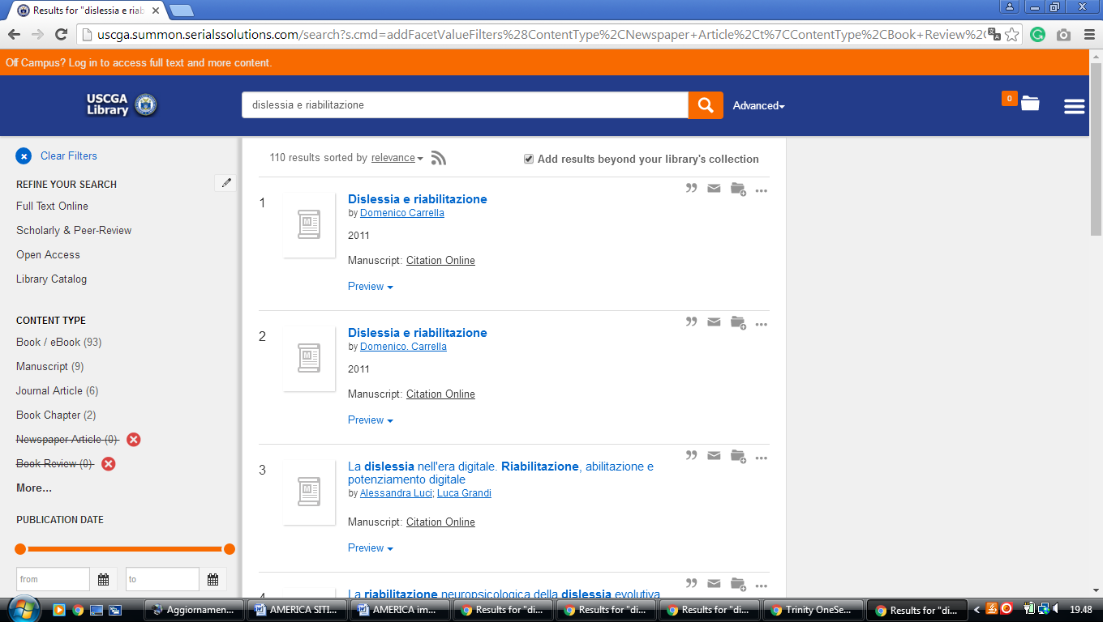

5 UNIVERSITY OF CONNECTICUT LIBRARIES - (Storrs, Connecticut, Usa)
https://uconn.on.worldcat.org/search?fn=search&ct=search&initialSearch=true&institution=01UCT&mode=Basic&search_scope=EVERYTHING&displayMode=full&bulkSize=10&highlight=true&displayField=all&pcAvailabiltyMode=true&tab=default_tab&indx=1&dum=true&srt=rank&vid=01UCT&frbg=&queryString=dislessia+e+riabilitazione

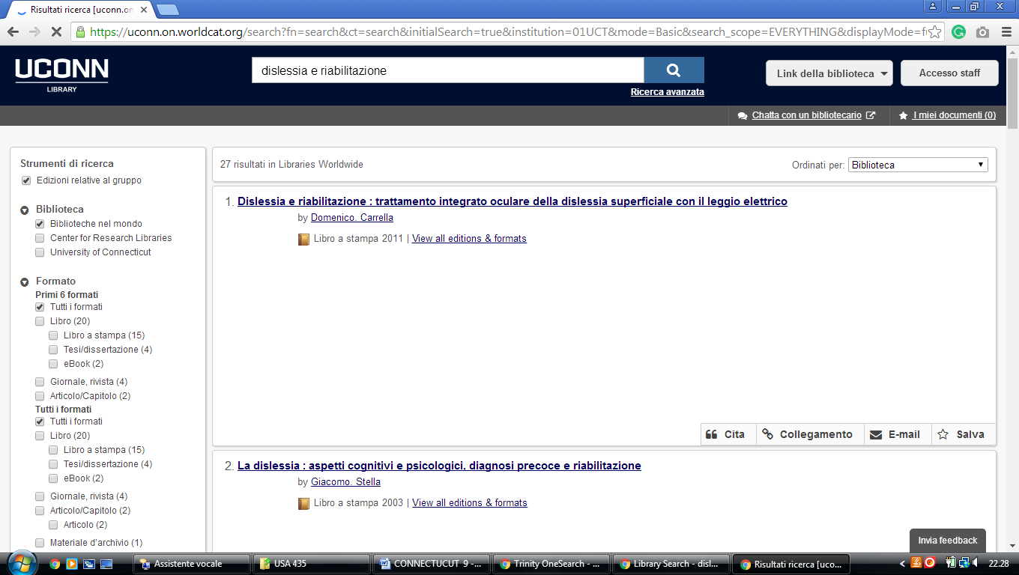

6 WESTERN CONNECTICUT STATE UNIVERSITY LIBRARY DANBURY,
(Danbury, Connecticut, Usa)
https://cscu-wcsu-primo.hosted.exlibrisgroup.com/primo-explore/search?displayMode=full&bulkSize=%3C25%3E&highlight=true&dum=true&query=any,contains,dislessia%20e%20riabilitazione&displayField=all&pcAvailabiltyMode=true&institution=01CSCU-WCSU&vid=WCSU_V1&tab=default_tab&search_scope=WCSU&mode=Basic&sortby=rank&lang=en_US&pcAvailability=true

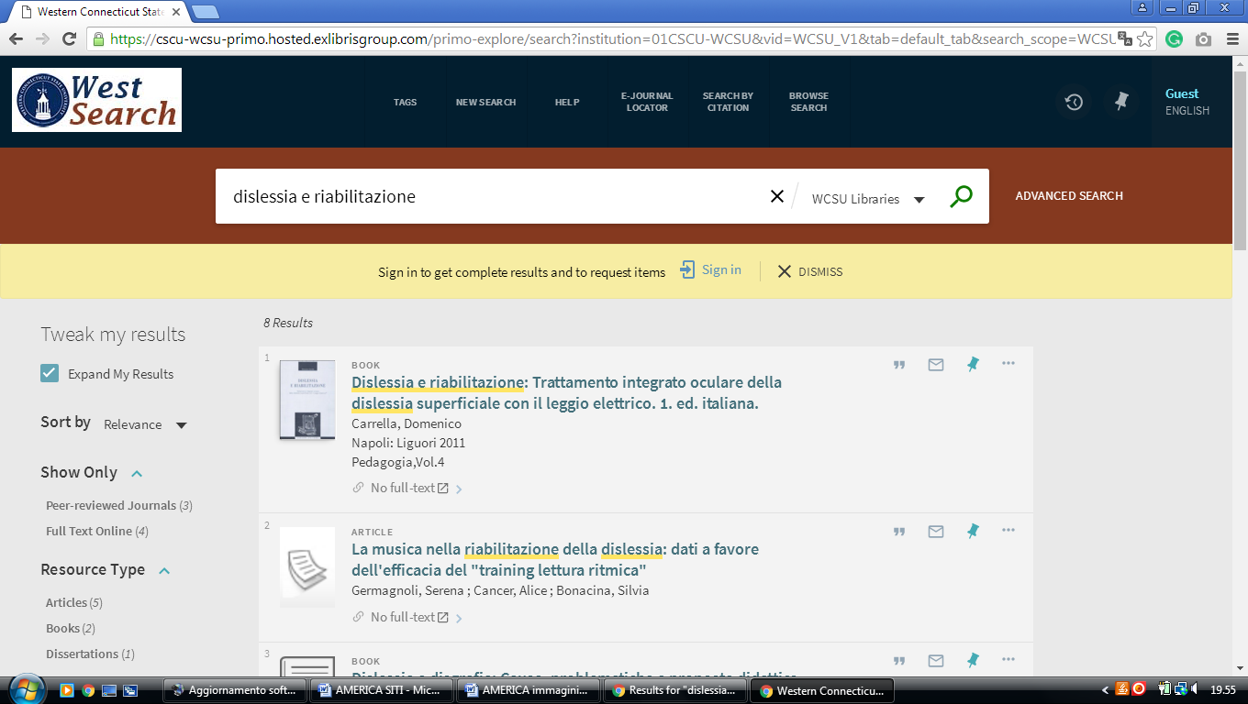

7 UNIVERSITY OF YALE CUSHING/WHITNEY MEDICAL LIBRARY – (New Haven, Connecticut, Usa)
http://elibrary.med.yale.edu/catalog?utf8=%E2%9C%93&search_field=everything&q=dislessia+e+riabilitazione

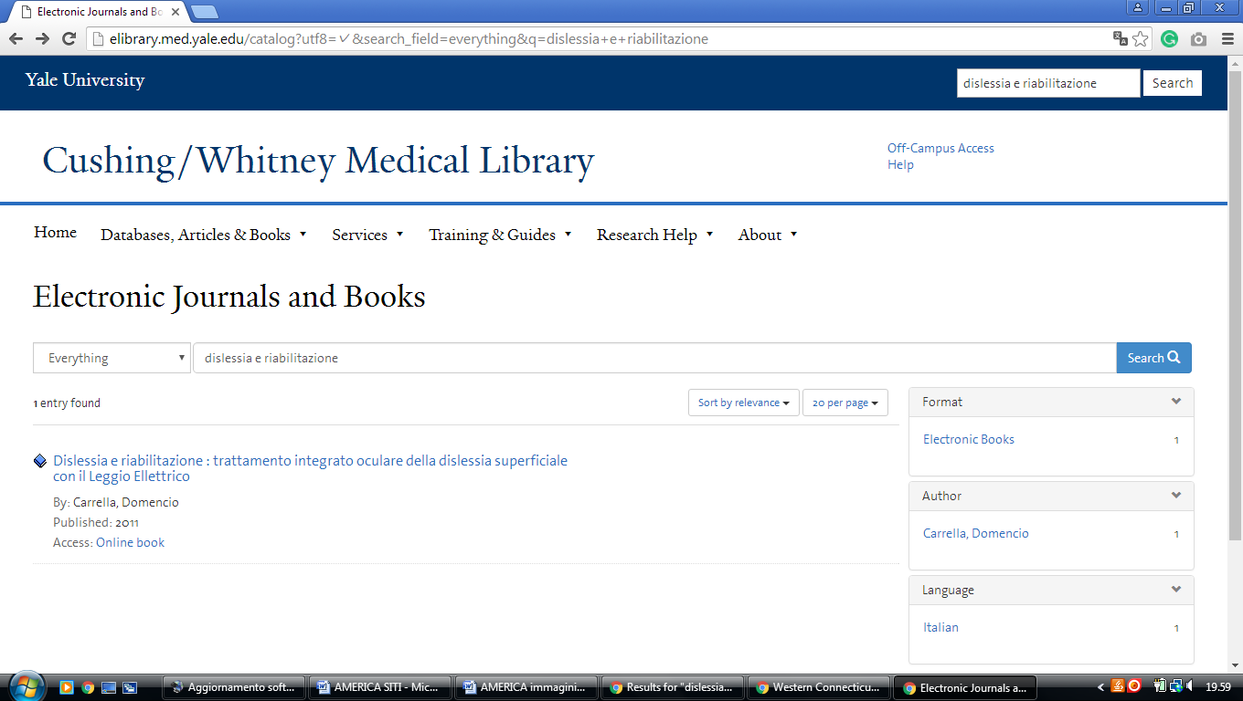

8 CUSHING/WHITNEY MEDICAL LIBRARY - YALE UNIVERSITY - (New Haven, Connecticut, Usa)
http://yale.summon.serialssolutions.com/#!/search?ho=f&l=it-IT&q=dislessia%20e%20riabilitazione
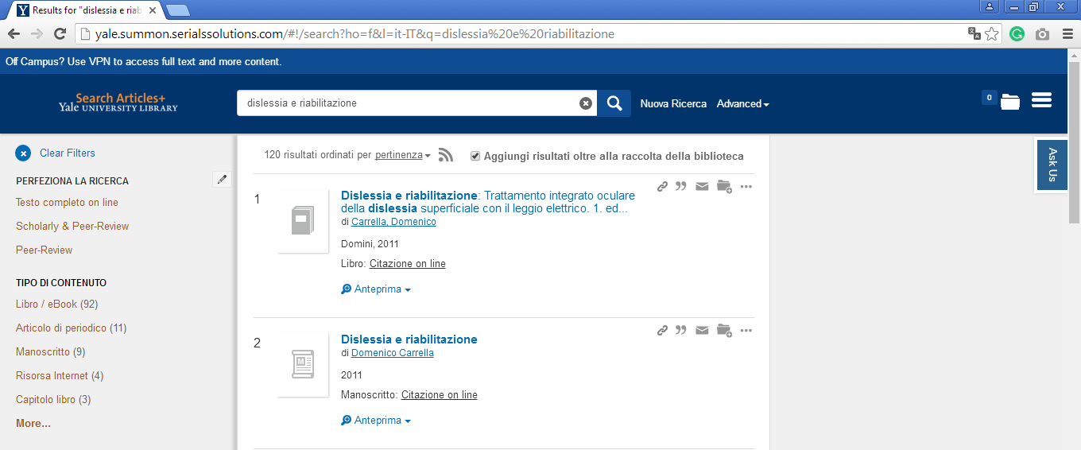

9 UNIVERSITY OF YALE LIBRARY - (New Haven, Connecticut, Usa)
http://search.library.yale.edu/catalog/11669996?counter=1

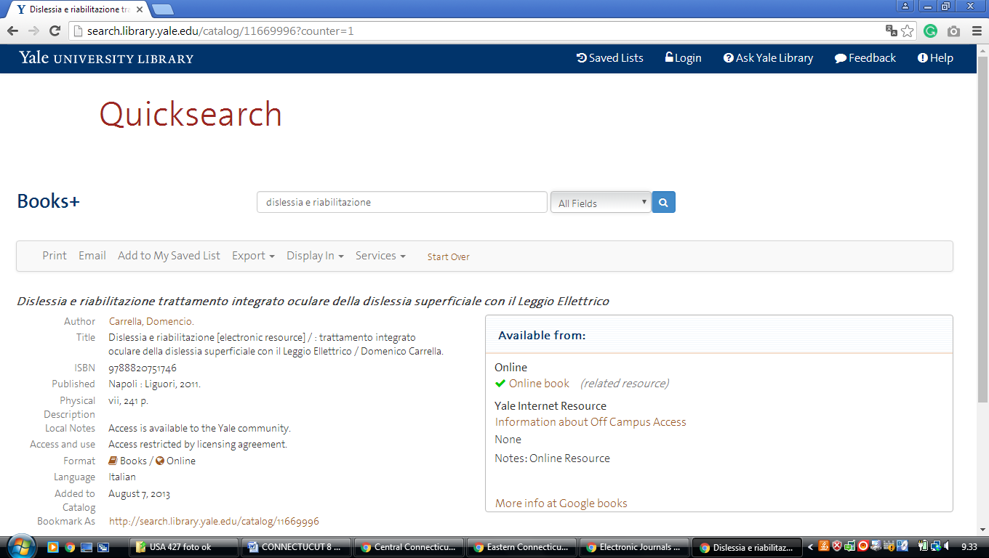

10 YALE UNIVERSITY LIBRARY | THE HEART OF THE UNIVERSITY - (New Haven, Connecticut, Usa)
http://search.library.yale.edu/articles?s.cmd=setHoldingsOnly%28false%29&s.ff%5B%5D=ContentType%2Cand%2C1%2C20&s.ff%5B%5D=Discipline%2Cand%2C1%2C20&s.ff%5B%5D=Language%2Cand%2C1%2C20&s.ho=t&s.pn=1&s.q=dislessia+e+riabilitazione&s.secure=f&search_field=&spellcheck=true
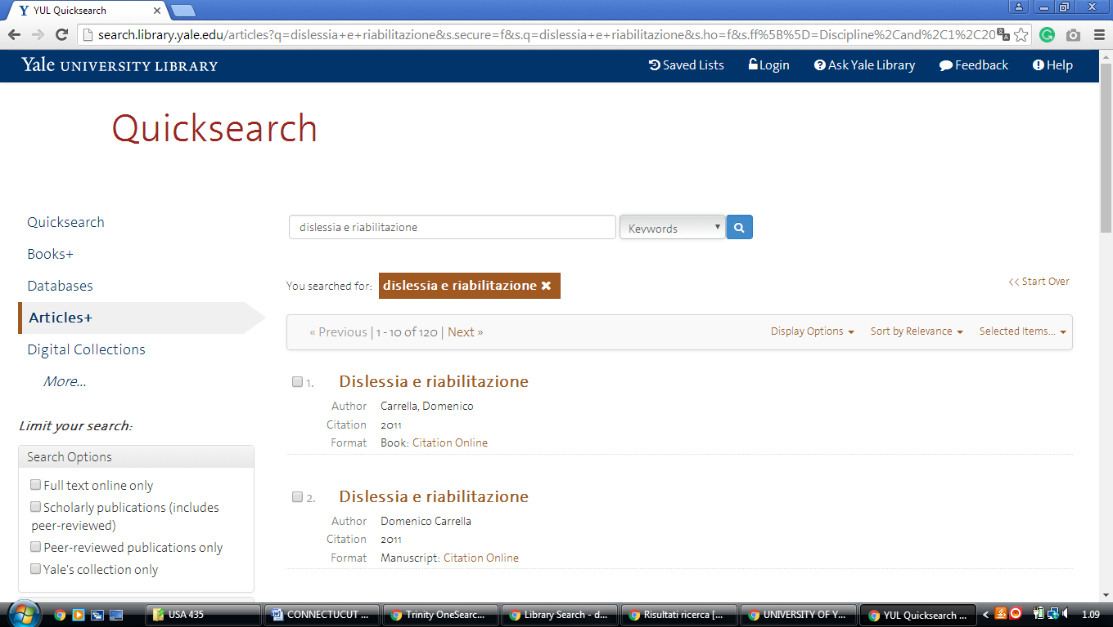

Hilton C. Buley Library
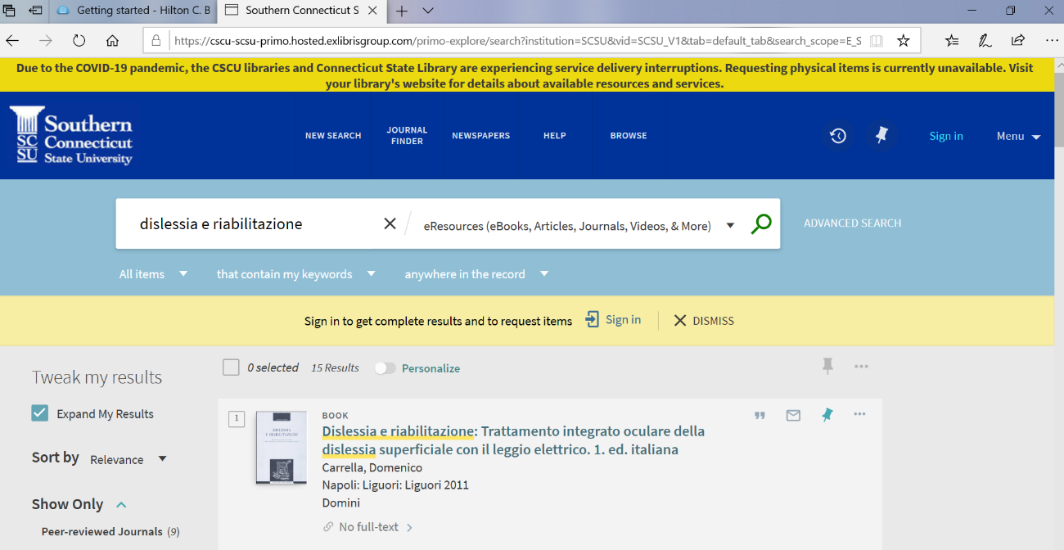
https://cscu-scsu-primo.hosted.exlibrisgroup.com/primo-explore/search?institution=SCSU&vid=SCSU_V1&tab=default_tab&search_scope=E_SCSU&mode=Basic&displayMode=full&bulkSize=25&highlight=true&dum=true&query=any,contains,%20%20dislessia%20e%20riabilitazione&displayField=all&pcAvailabiltyMode=true&lang=en_US&pcAvailability=true

