DELAWARE = 3

1 DELCAT DISCOVERY • UNIVERSITY OF DELAWARE LIBRARY - (Newark Delaware, Usa)
http://delcat.worldcat.org/title/dislessia-e-riabilitazione-trattamento-integrato-oculare-della-dislessia-superficiale-con-il-leggio-elettrico/oclc/878784487&referer=brief_results

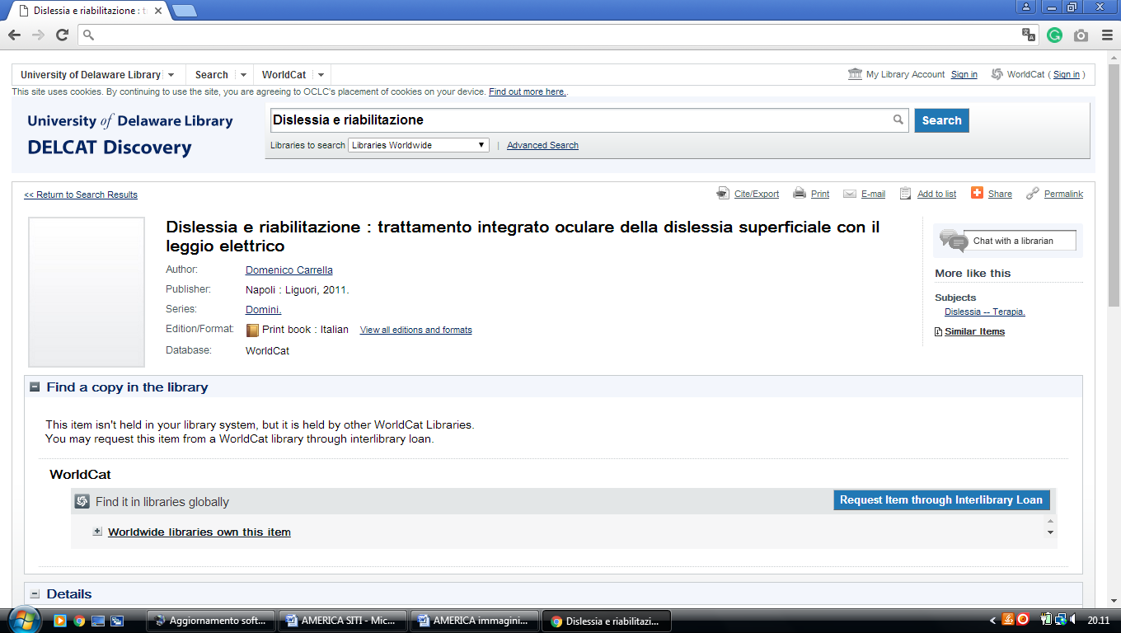

2 DELAWARE STATE UNIVERSITY LIBRARY - (Dover, Delaware, Usa)
https://desu.on.worldcat.org/search?queryString=kw%3A%28DISLESSIA+E+RIABILITAZIONE%29&databaseList=638&origPageViewName=pages%2Fadvanced-search-page&clusterResults=true&scope=

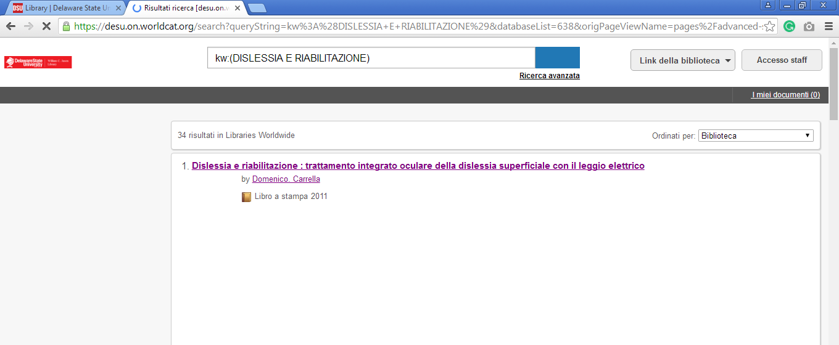

3 LIBRARY | DELAWARE STATE UNIVERSITY - (Dover, Delaware Usa)
https://desu.summon.serialssolutions.com/search?fvf=ContentType%2CBook+%2F+eBook&q=dislessia+e+riabilitazione&spellcheck=true#!/search?ho=f&fvf=ContentType,Book%20%2F%20eBook,f&l=it-IT&q=dislessia%20e%20riabilitazione

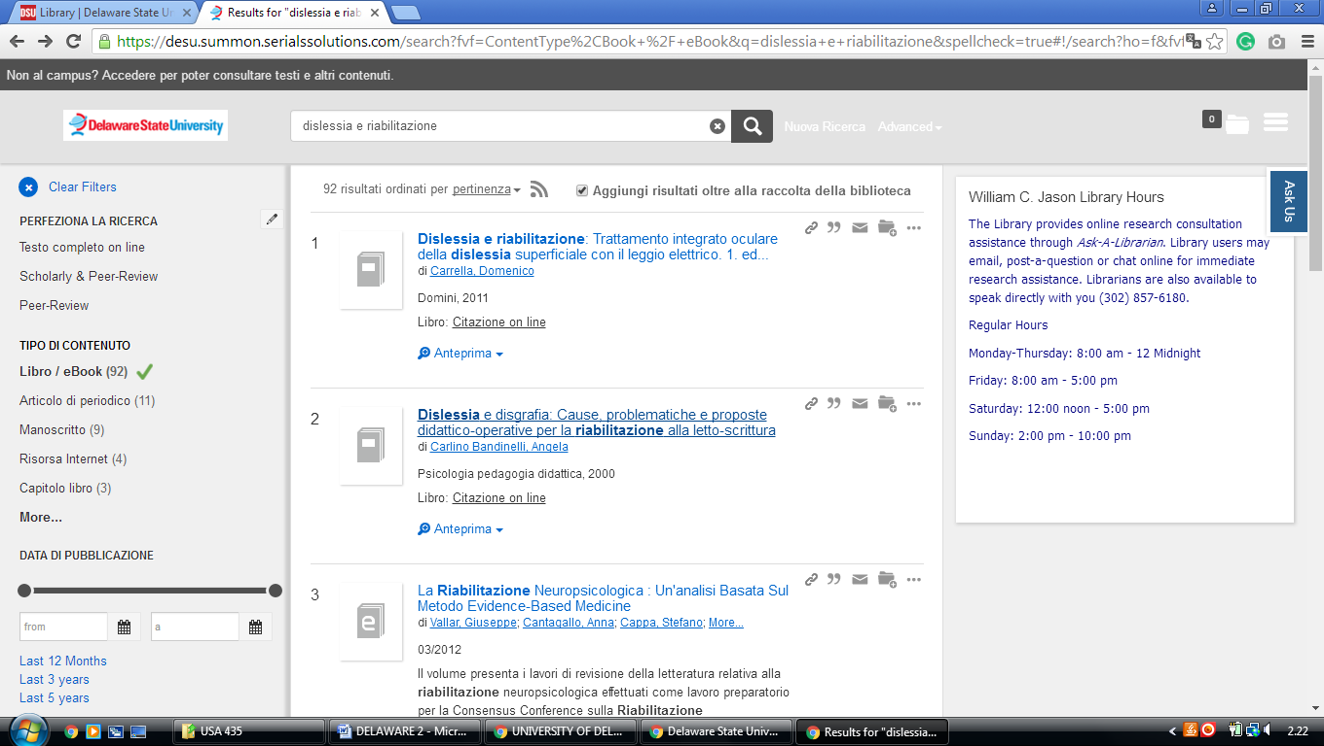

Wilmington University Library,

https://wilmu.on.worldcat.org/search?queryString=kw:dislessia%20e%20riabilitazione
