DISTRECT OF COLUMBIA = 8

1 AMERICAN UNIVERSITY LIBRARY WASHINGTON – (District of Columbia, Usa)
https://american.summon.serialssolutions.com/search?s.q=dislessia+e+riabilitazione#!/search?ho=f&l=en&q=dislessia%20e%20riabilitazione

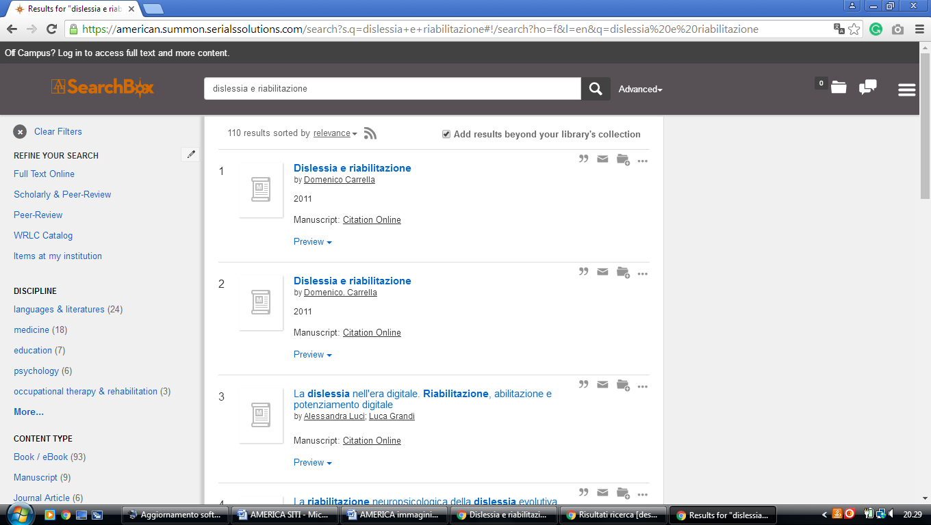

2 GALLAUDET UNIVERSITY LIBRARY WASHINGTON – (District of Columbia, Usa)
http://gallaudet.summon.serialssolutions.com/search?s.q=dislessia+e+riabilitazione&s.fvf%5B%5D=ContentType%2CBook+Review%2Ct&s.fvf%5B%5D=ContentType%2CNewspaper+Article%2Ct#!/search?ho=f&fvf=ContentType,Book%20Review,t%7CContentType,Newspaper%20Article,t&l=en&q=dislessia%20e%20riabilitazione

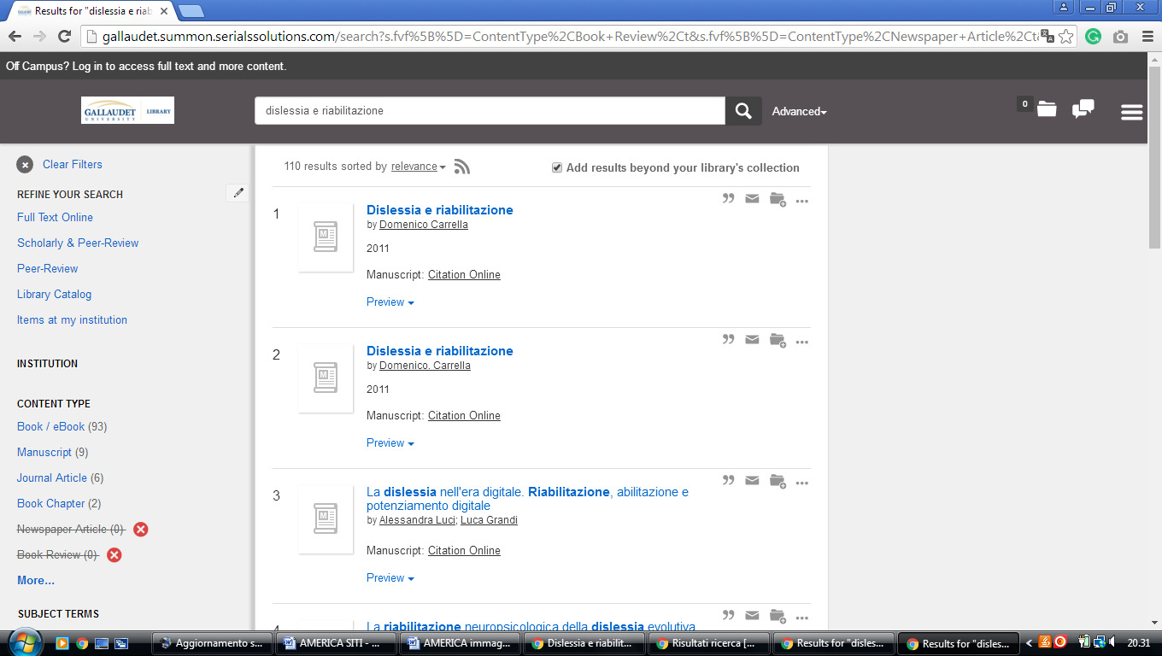

3 GEORGETOWN UNIVERSITY LIBRARY WASHINGTON – (District of Columbia, Usa)
https://gt.summon.serialssolutions.com/?q=dislessia+e+riabilitazione#!/search?ho=f&l=en&q=dislessia%20e%20riabilitazione
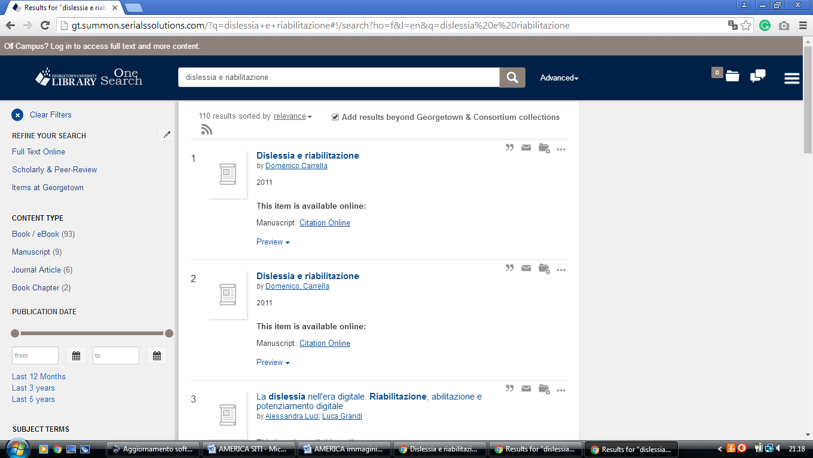

4 HOWARD UNIVERSITY LIBRARIES WASHINGTON – (District of Columbia, Usa)
http://hu.summon.serialssolutions.com/search/results?spellcheck=true&q=dislessia+e+riabilitazione#!/search?ho=f&l=en&q=dislessia%20e%20riabilitazione

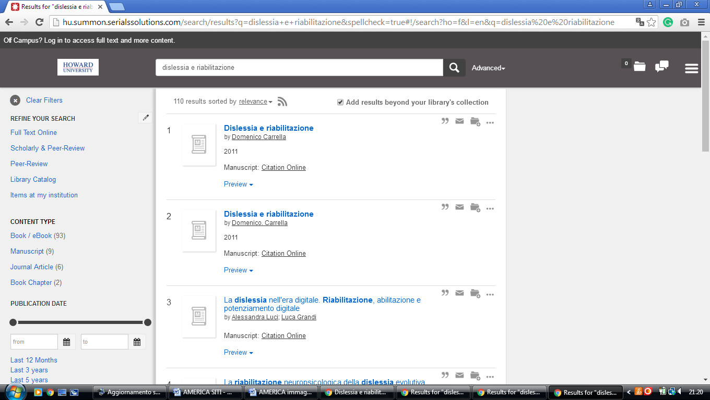

5 THE CATHOLIC UNIVERSITY OF AMERICA LIBRARY – (Washington, Usa)
http://cua.summon.serialssolutions.com/search?keep_r=true&s.fvf%5B%5D=ContentType%2CJournal+Article&s.q=dislessia+e+riabilitazione&x=0&y=0#!/search?ho=f&l=en&q=dislessia%20e%20riabilitazione

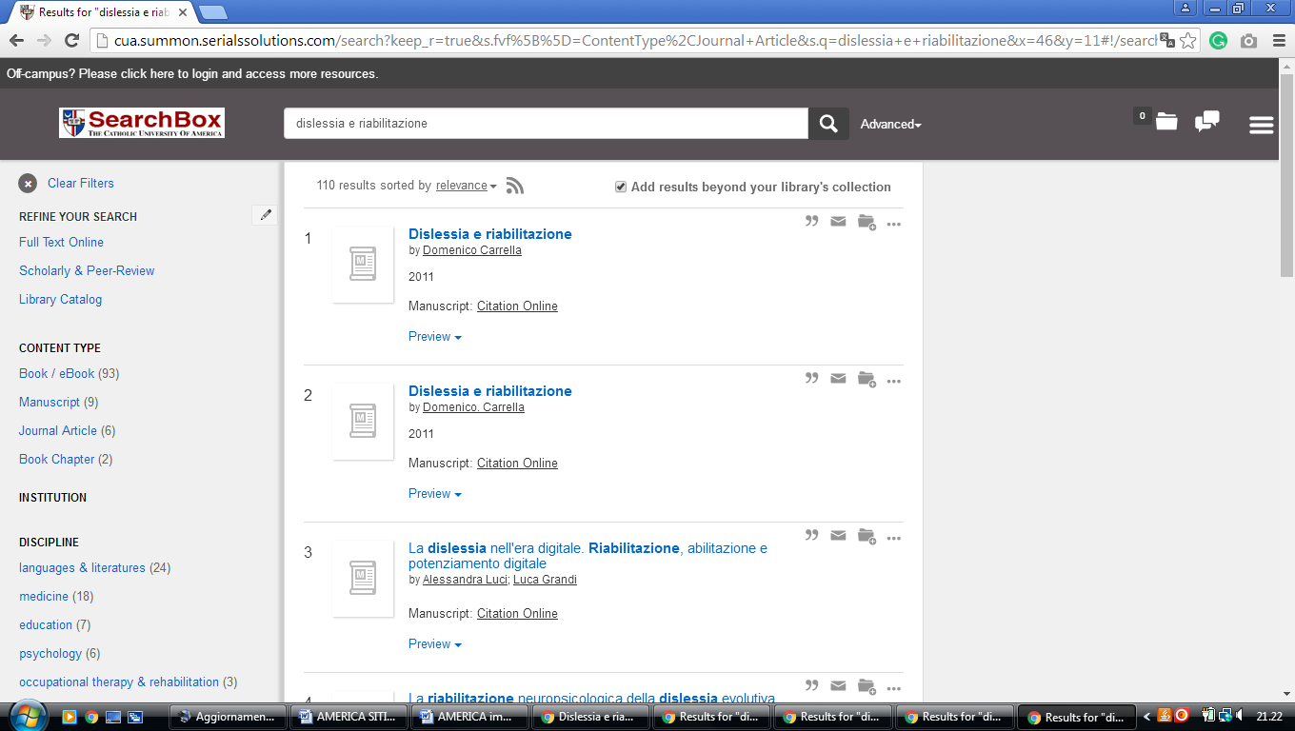

6 THE GEORGE WASHINGTON UNIVERSITY - (Washington, Usa)
http://gw.summon.serialssolutions.com/#!/search?ho=f&l=en&q=dislessia%20e%20riabilitazione

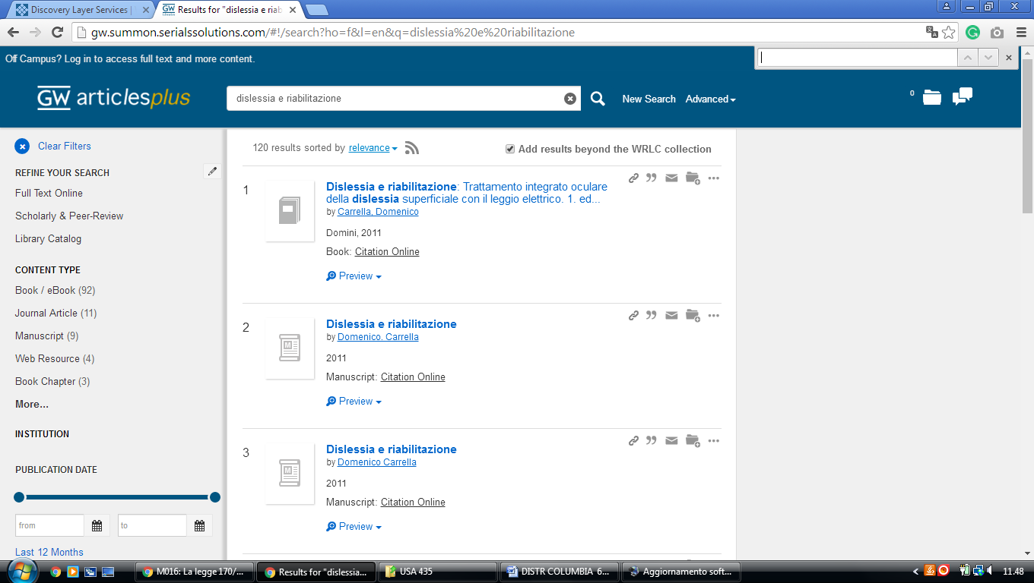

7 MARYMOUNT UNIVERSITY – (Arlington County, Virginia,Usa)
http://marymount.summon.serialssolutions.com/#!/search?ho=f&l=en&q=dislessia%20e%20riabilitazione

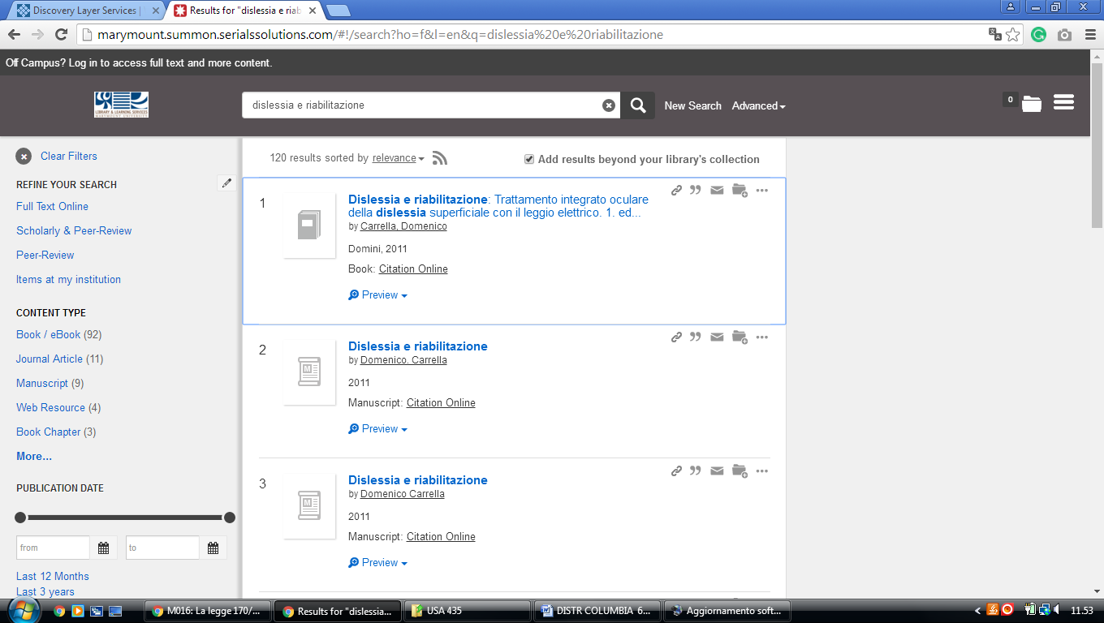

8 THE UNIVERSITY OF THE DISTRICT OF COLUMBIA - (Washington, D.C., Usa)
http://udc.summon.serialssolutions.com/#!/search?ho=f&l=en&q=dislessia%20e%20riabilitazione

