GEORGIA = 6

1 BERRY COLLEGE MEMORIAL LIBRARY - (Mount Berry, Georgia, Usa)
https://berry.on.worldcat.org/search?queryString=DISLESSIA%20E%20RIABILITAZIONE
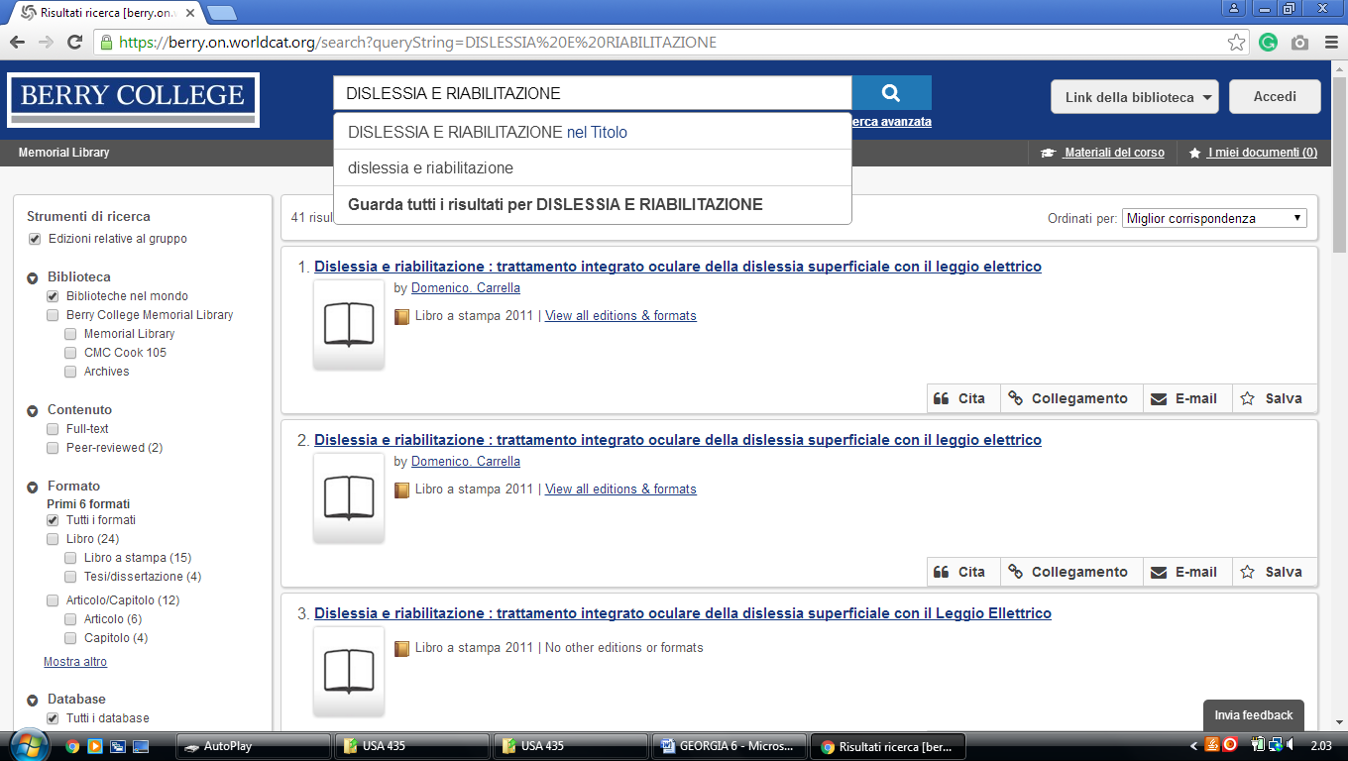

2 BRENAU TRUSTEE LIBRARY – (Gainesville, Georgia, Usa)
https://brenau.on.worldcat.org/search?sortKey=LIBRARY_PLUS_RELEVANCE&databaseList=&queryString=dislessia+e+riabilitazione&changedFacet=author&scope=&format=all&database=all&author=Carrella%2C+Domenico&year=all&yearFrom=&yearTo=&language=all&topic=all

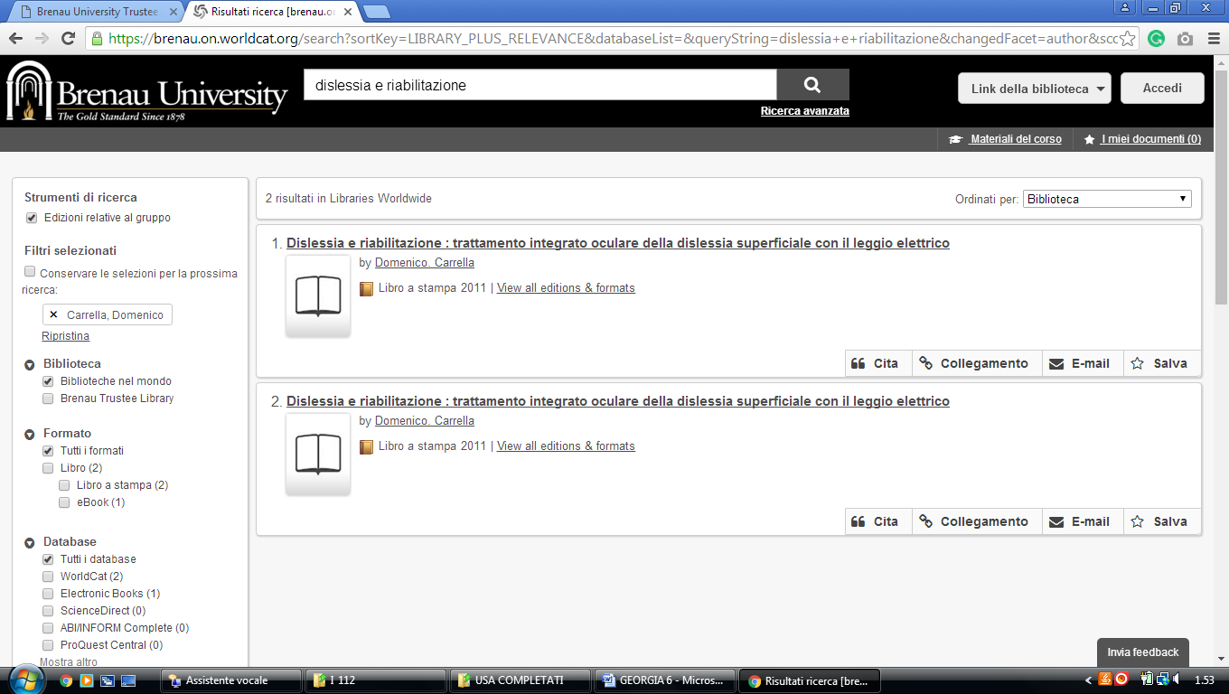

3 ROBERT W. W. LIBRARY ATLANTA UNIVERSITY CENTER - (Georgia, Usa)
https://auctr.on.worldcat.org/search?sortKey=LIBRARY&databaseList=&queryString=dislessia+e+riabilitazione&changedFacet=format&scope=&database=all&author=all&year=all&yearFrom=&yearTo=&language=all&topic=all

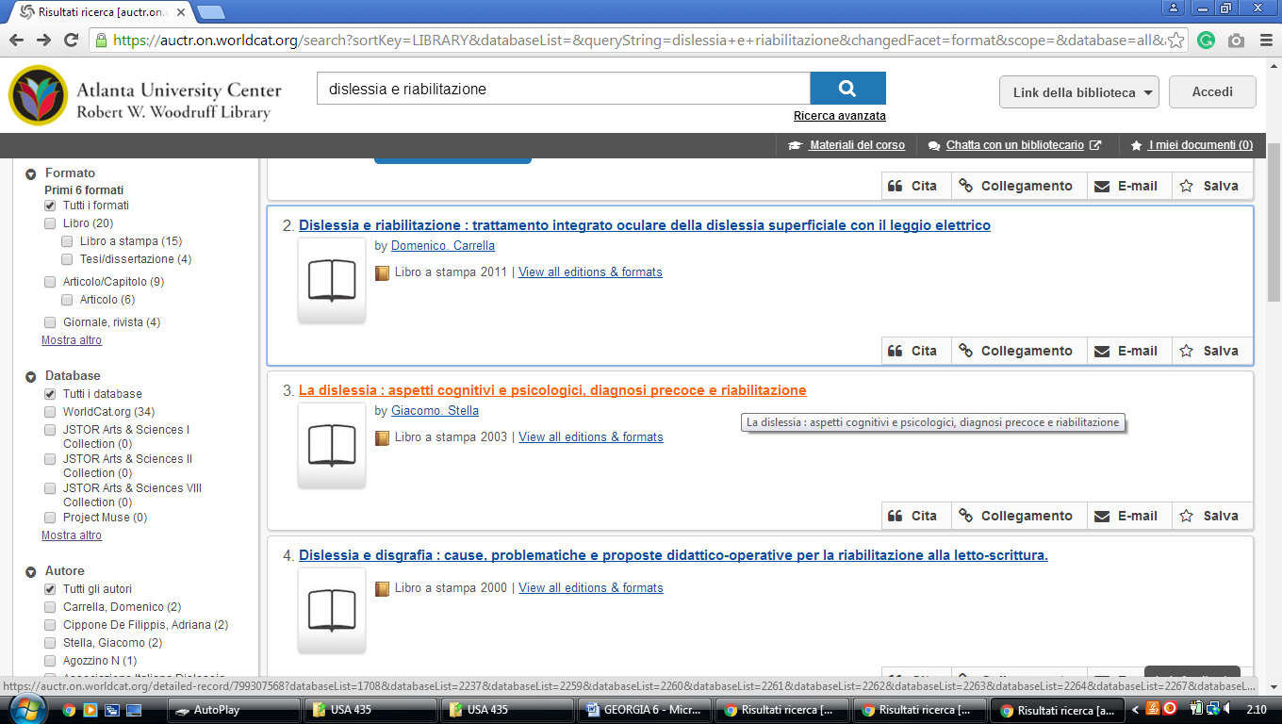

4 SCAD LIBRARIES - Savannah College Of Art And Design Libraries – (Georgia, Usa)
http://scad.summon.serialssolutions.com/?#!/search?ho=f&l=en&q=dislessia%20e%20riabilitazione

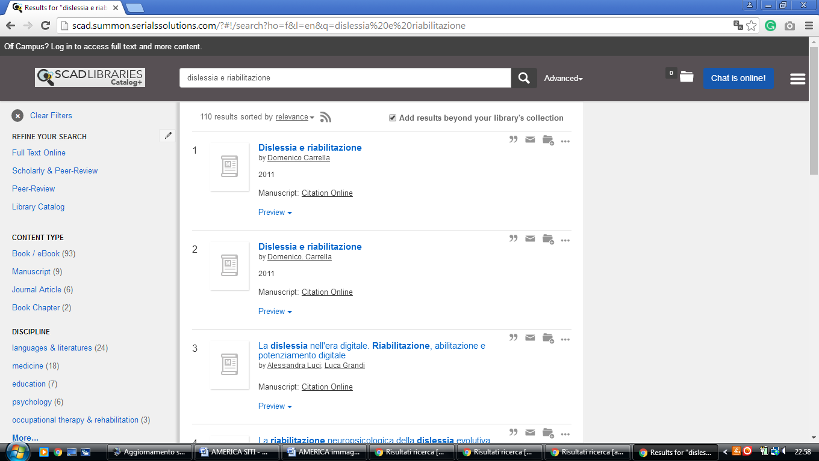

5 THOMAS UNIVERSITY LIBRARY - (Thomasville, Georgia, Usa)
https://thomasu.on.worldcat.org/search?databaseList=&queryString=dislessia+e+riabilitazione
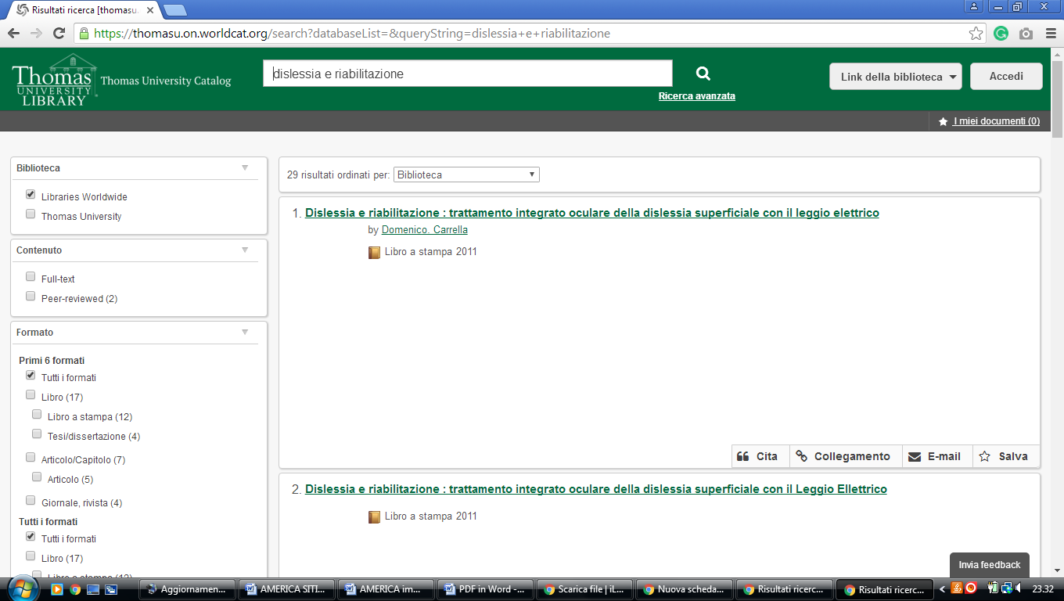

6 ZACH S. HENDERSON LIBRARY - (Statesboro, Georgia, Usa)
http://eds.a.ebscohost.com/eds/results?vid=4&sid=63f8ee48-99a8-46e0-b3b8-73c5e1fcc980%40sessionmgr4008&bquery=(dislessia+AND+e+AND+riabilitazione)&bdata=JnR5cGU9MA%3d%3d

