ILLINOIS = 21

1 BUSWELL LIBRARY - (Wheaton, Illinois, Usa)
https://buswell.on.worldcat.org/search?sortKey=LIBRARY&databaseList=&queryString=dislessia+e+riabilitazione&changedFacet=scope&scope=&format=all&database=all&author=all&year=all&yearFrom=&yearTo=&language=all&topic=all

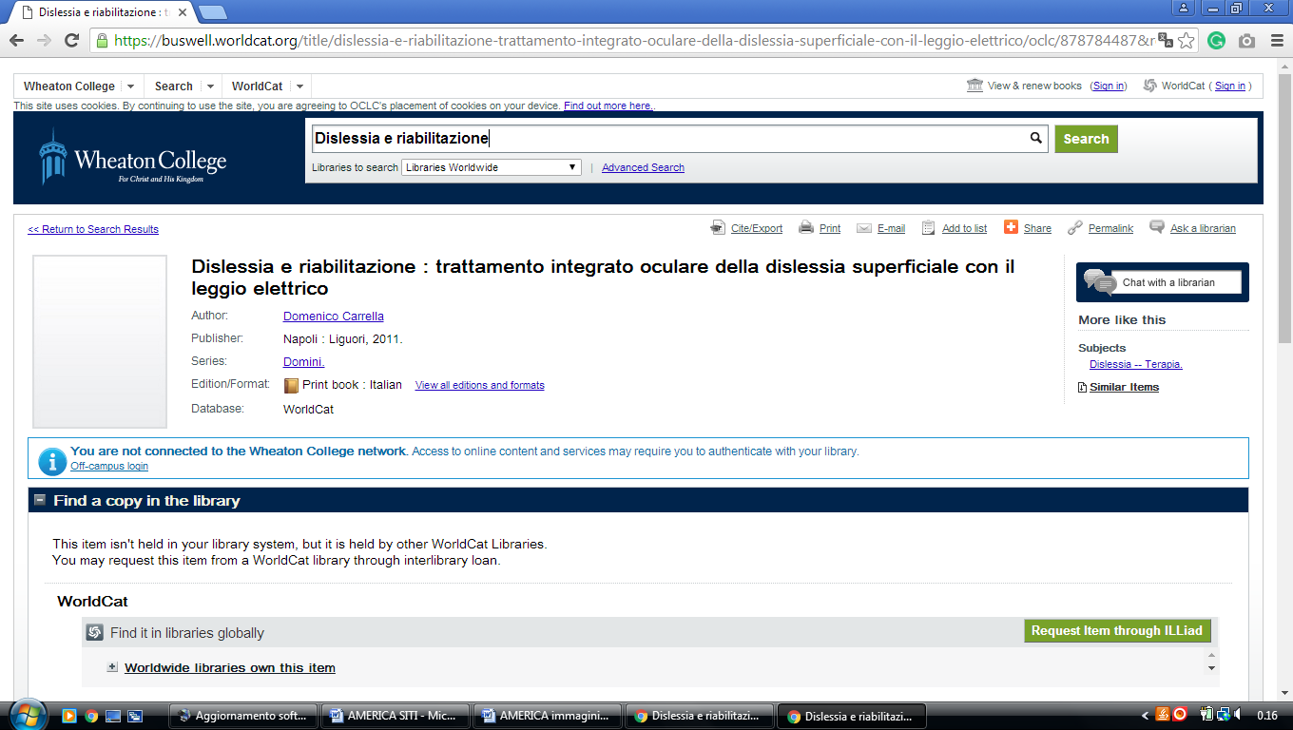

2 THE LIBRARY AT CATHOLIC THEOLOGICAL UNION – A GRADUATE SCHOOL OF ... – (Illinois, Usa)
https://ctulibrary.on.worldcat.org/search?sortKey=LIBRARY&databaseList=&queryString=dislessia+e+riabilitazione&changedFacet=author&scope=&format=all&database=all&author=Carrella%2C+Domenico&year=all&yearFrom=&yearTo=&language=all&topic=all

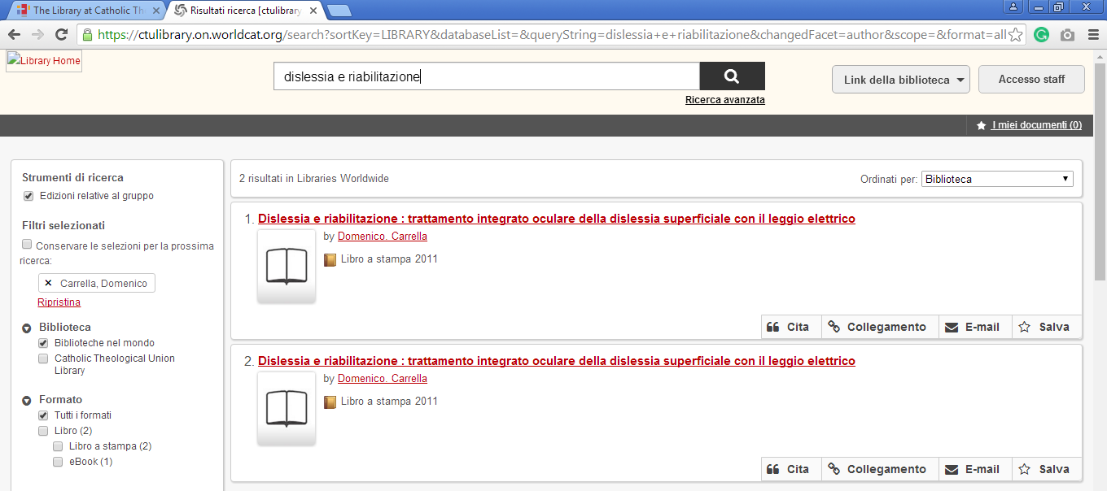

3 LIBRARY - THE CHICAGO SCHOOL OF PROFESSIONAL PSYCHOLOGY

(Chicago Library, Usa)
https://thechicagoschool-chi.worldcat.org/title/dislessia-e-riabilitazione-trattamento-integrato-oculare-della-dislessia-superficiale-con-il-leggio-elettrico/oclc/878784487&referer=brief_results

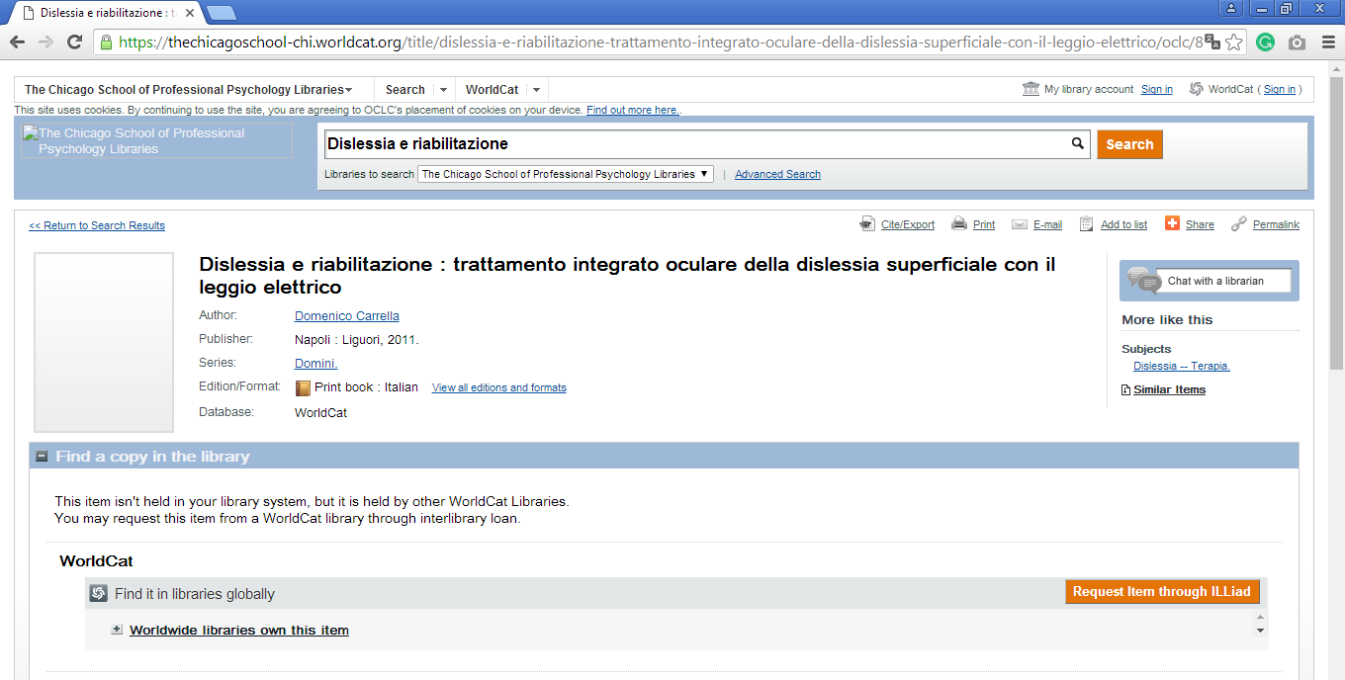

4 COLLEGE OF DUPAGE LIBRARY - (Glen Ellyn, Illinois, Usa)
https://cod.on.worldcat.org/search?sortKey=BEST_MATCH&databaseList=&queryString=dislessia+e+riabilitazione&changedFacet=author&clusterResults=on&stickyFacetsChecked=on&scope=&subformat=Book%3A%3Abook_printbook&subformat=Book%3A%3Abook_digital&subformat=Book%3A%3Abook_largeprint&subformat=Book%3A%3Abook_braille&subformat=Book%3A%3Abook_continuing&format=Jrnl&format=Audiobook&subformat=Video%3A%3Avideo_dvd&subformat=Video%3A%3Avideo_vhs&subformat=Video%3A%3Avideo_film&subformat=Video%3A%3Avideo_digital&subformat=Video%3A%3Avideo_bluray&database=all&author=Carrella%2C+Domenico&year=all&yearFrom=&yearTo=&language=all&topic=all

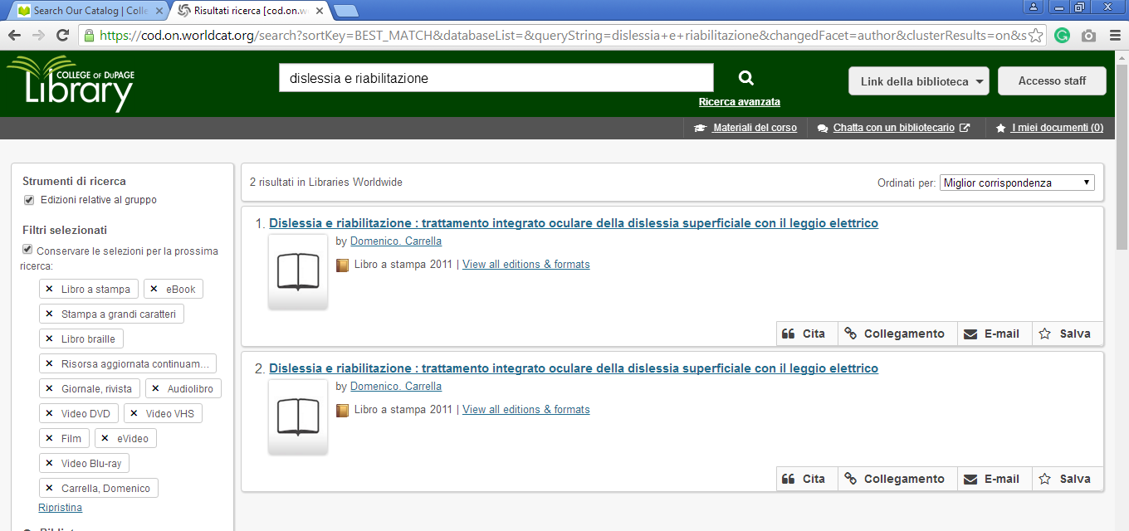

5 DOMINICAN UNIVERSITY LIBRARY - (River Forest, Illinois, Usa)
http://dom.worldcat.org/search?q=dislessia+e+riabilitazione&qt=results_page&dblist=638&scope=0&oldscope=2

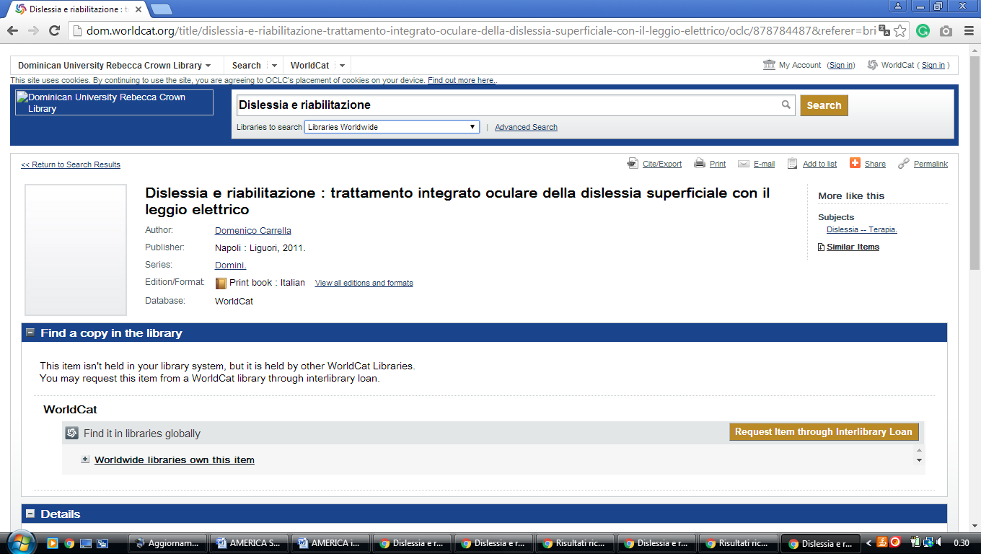

6 HARPER COLLEGE LIBRARY - (Palatine, Illinois, Usa)
http://harpercollege.summon.serialssolutions.com/search?s.q=dislessia+e+riabilitazione#!/search?ho=f&l=en&q=dislessia%20e%20riabilitazione

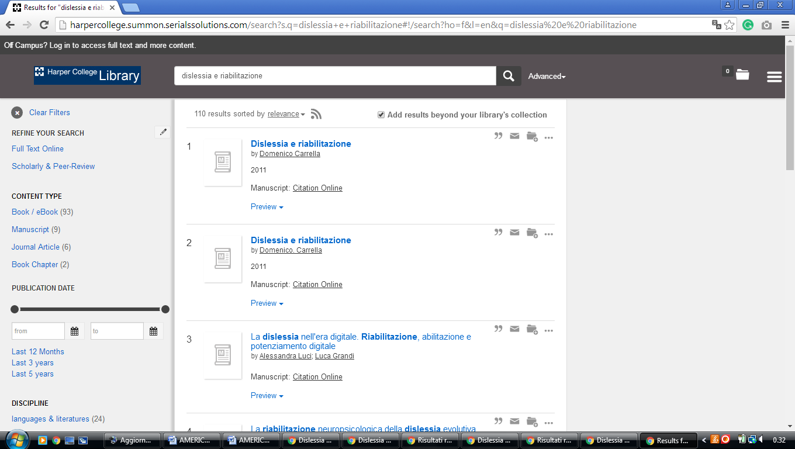

7 LAKE LAND COLLEGE LIBRARY - (Mattoon, Illinois, Usa)
http://lakelandcollege.summon.serialssolutions.com/search?s.q=dislessia+e+riabilitazione&submit=Search+SUMMON#!/search?ho=f&l=en&q=dislessia%20e%20riabilitazione

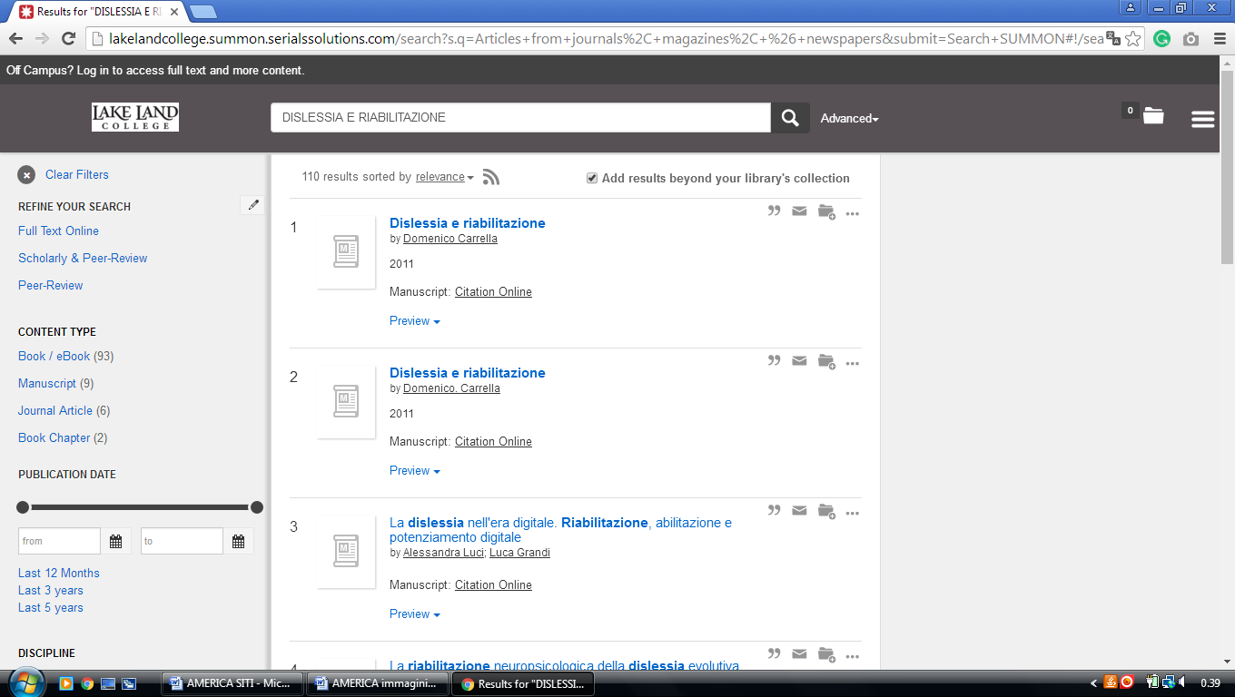

8 LEWIS UNIVERSITY LIBRARY - (Romeoville, Illinois, Usa)
http://lewisu.summon.serialssolutions.com/?#!/search?ho=f&l=en&q=dislessia%20e%20riabilitazione

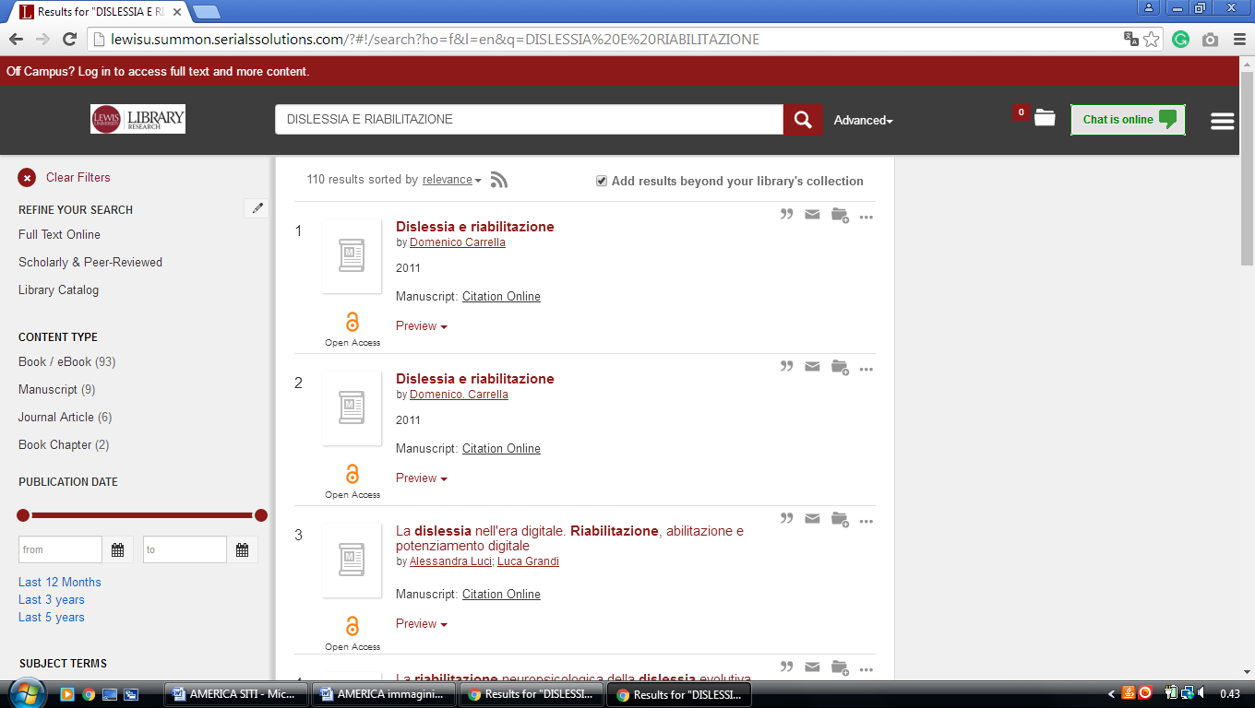

9 LOYOLA UNIVERSITY CHICAGO LIBRARIES – (Chicago, Illinois, Usa)
http://luclibrary.worldcat.org/search?qt=wc_org_luclibrary&q=dislessia+e+riabilitazione&scope=0&oldscope=&wcsbtn2w=Search&dblist=283

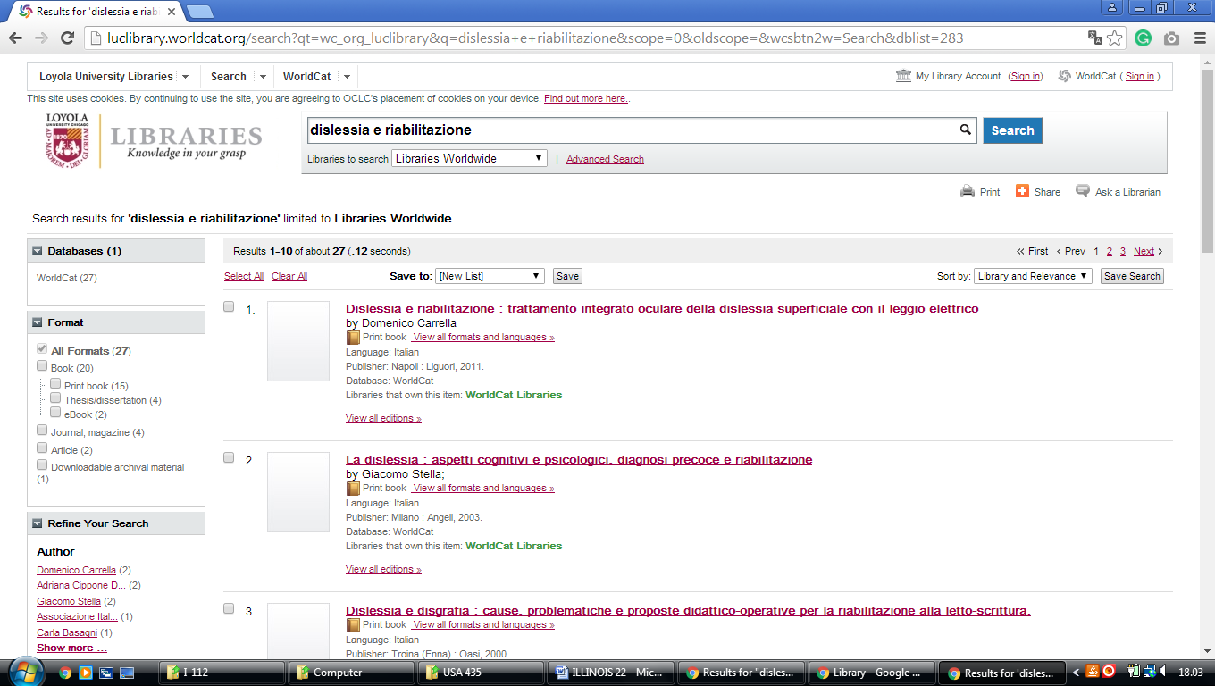

10 NEIU RONALD WILLIAMS LIBRARY – (Chicago, Illinois, Usa)
https://neiulibrary.worldcat.org/search?q=dislessia+e+riabilitazione

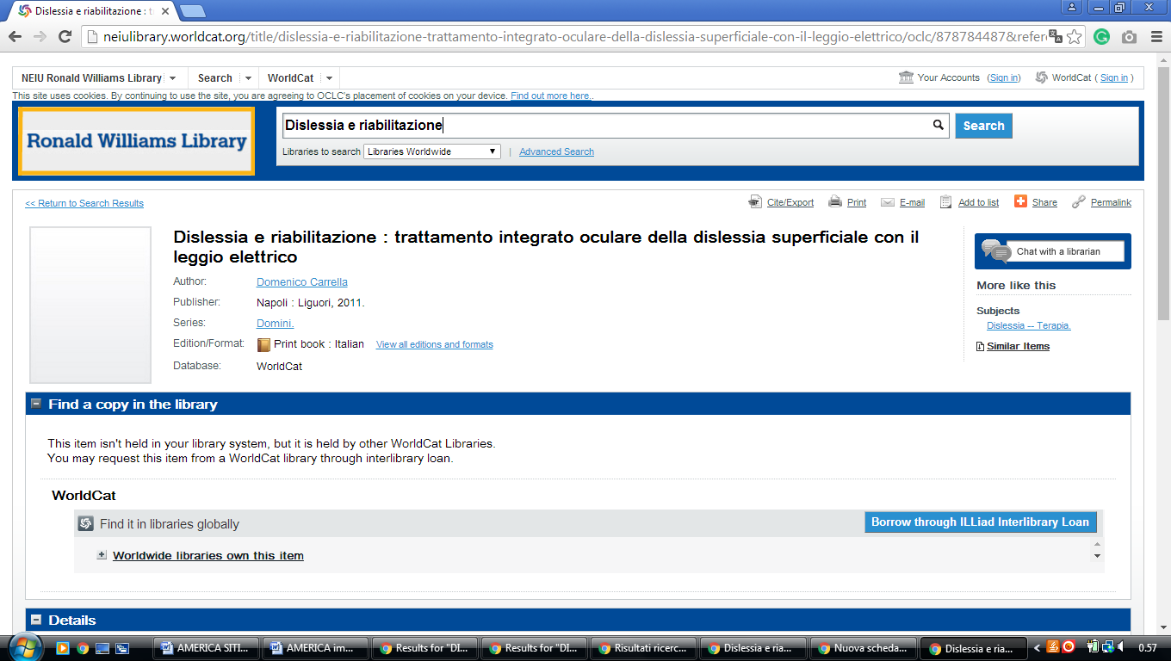

11 BROOKENS LIBRARY: HOME – (Springfield, Illinois, Usa)
https://uisbrookenslibrary.on.worldcat.org/search?sortKey=LIBRARY&databaseList=&queryString=dislessia+e+riabilitazione&changedFacet=author&scope=&format=all&database=all&author=Carrella%2C+Domenico&year=all&yearFrom=&yearTo=&language=all&topic=all
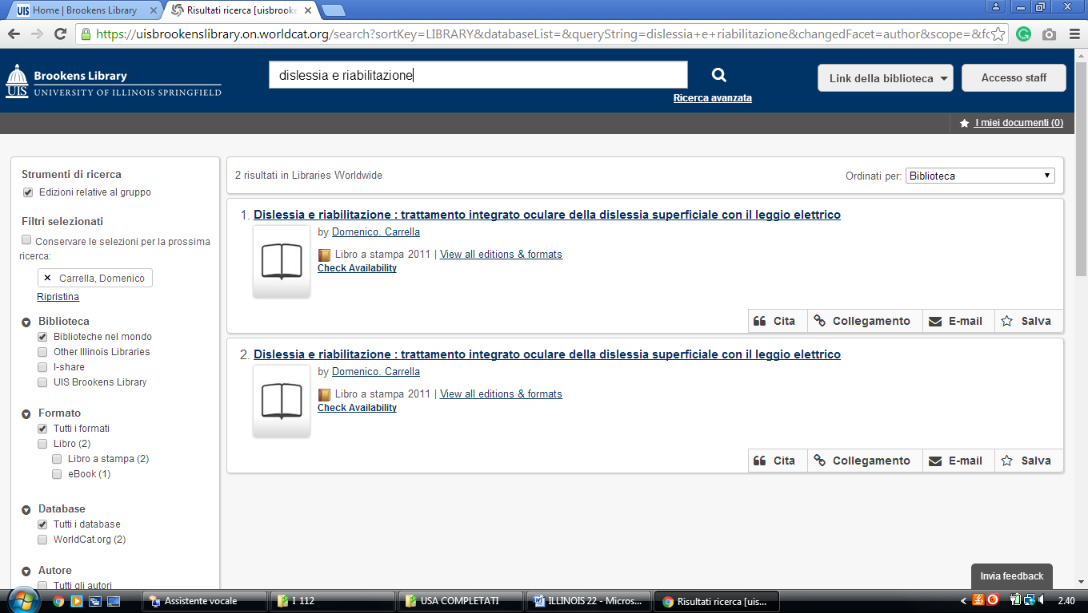

12 LIBRARY & LEARNING SUPPORT - NATIONAL LOUISS UNIVERSITY WHEATON – (ILL. Usa)
https://national.worldcat.org/search?qt=affiliate&ai=wclocal_national&q=dislessia+e+riabilitazione&wcsbtn2w=Go&scope=0&oldscope=

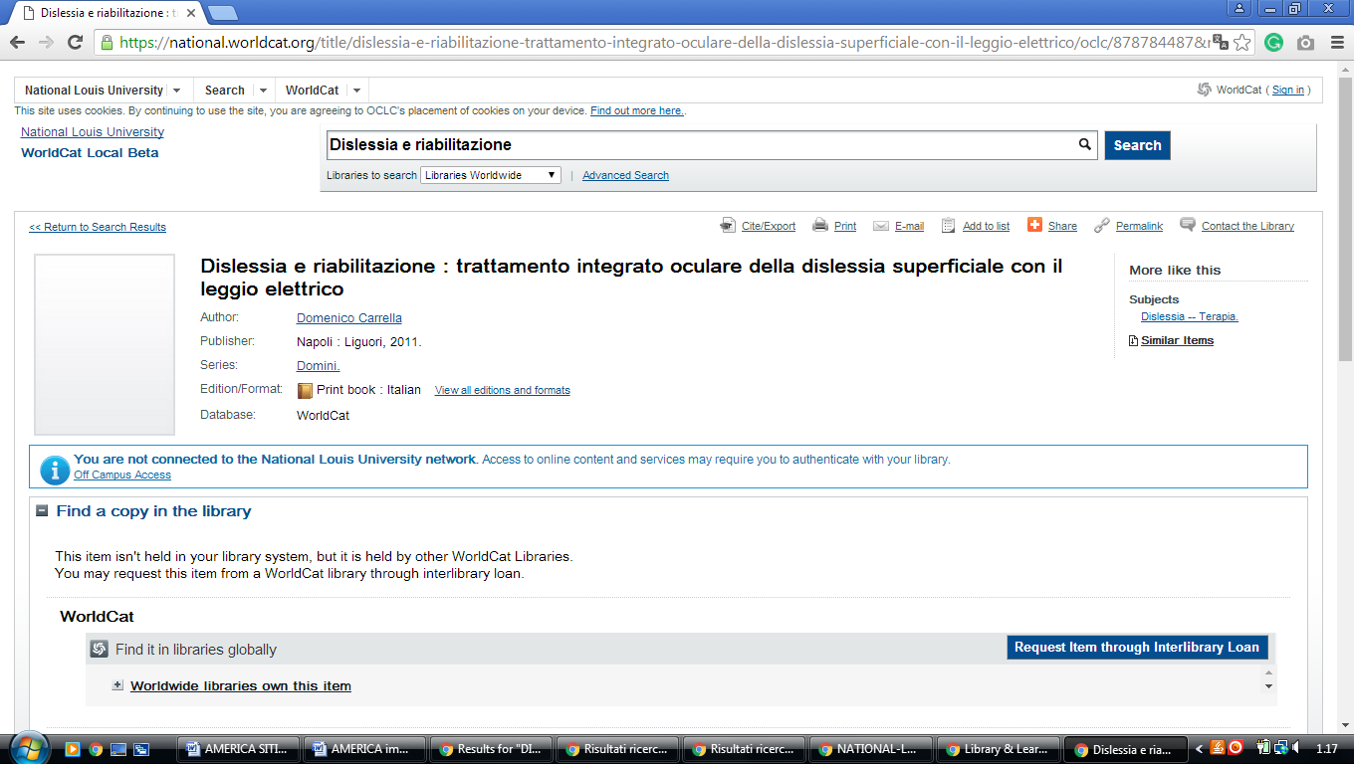

13 ROOSEVELT UNIVERSITY LIBRARY – (Chicago, Illinois, Usa)
http://roosevelt.summon.serialssolutions.com/search?s.q=dislessia+e+riabilitazione&fvf=#!/search?ho=f&l=en&q=dislessia%20e%20riabilitazione

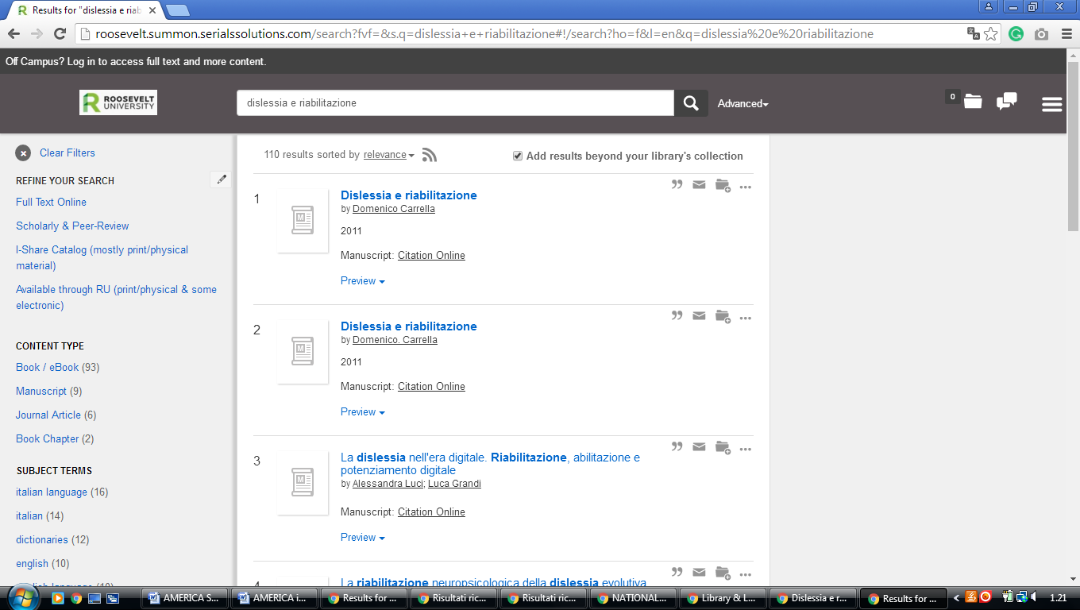

14 SOUTHERN ILLINOIS UNIVERSITY EDWARDSVILLE LOVEJOY LIBRARY - WORLDCAT - (Edwardsville, Illinois, Usa)

http://siue.worldcat.org/search?qt=wc_org_siue&q=dislessia++e+riabilitazione&scope=0&oldscope=&wcsbtn2w=Search&dblist=638

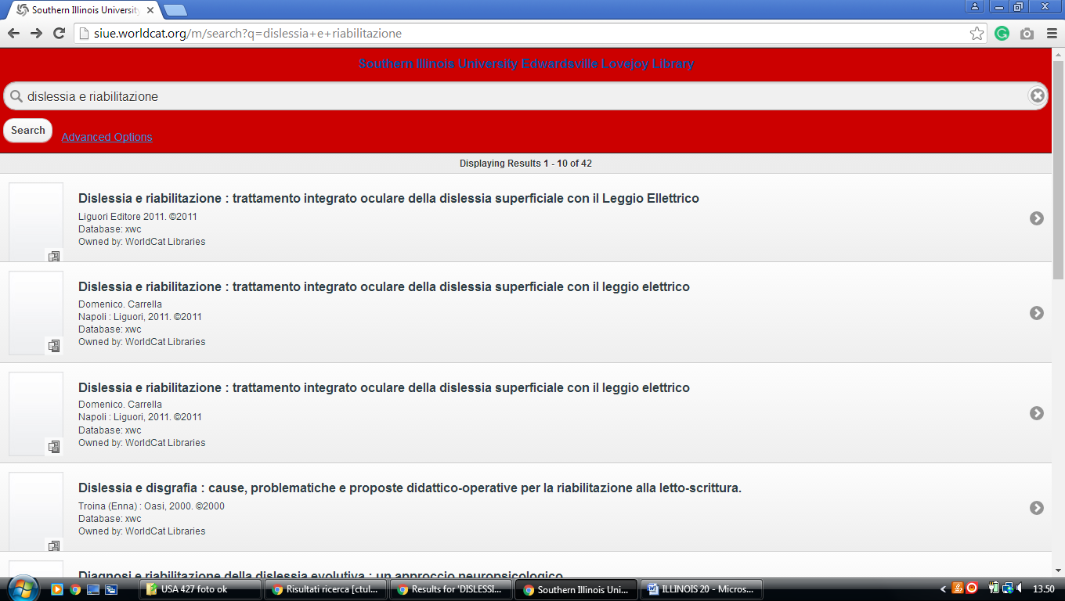

15 UNIVERSITY OF ILLINOIS LIBRARY URBANA-CHAMPAIGN -

https://uiuclib.on.worldcat.org/search?databaseList=&queryString=dislessia+e+riabilitazione
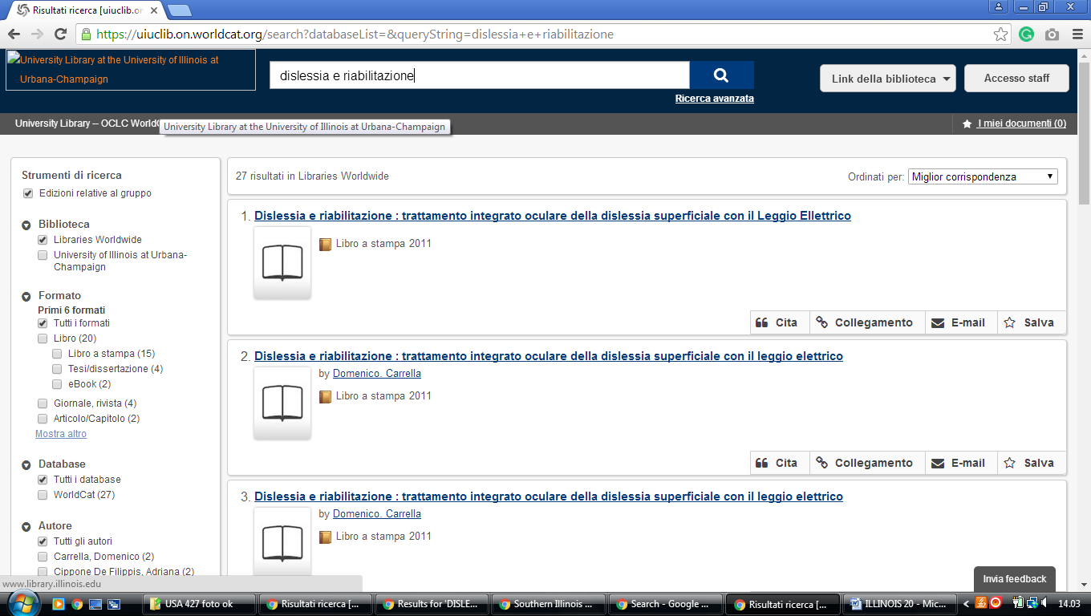

16 WIULIBRARIES.WORLDCAT.ORG - (Western Illinois University Libraries Macomb, ILL)

http://wiulibraries.worldcat.org/search?qt=wc_org_wiulibraries&q=dislessia+e+riabilitazione&scope=0&oldscope=&wcsbtn2w=Search

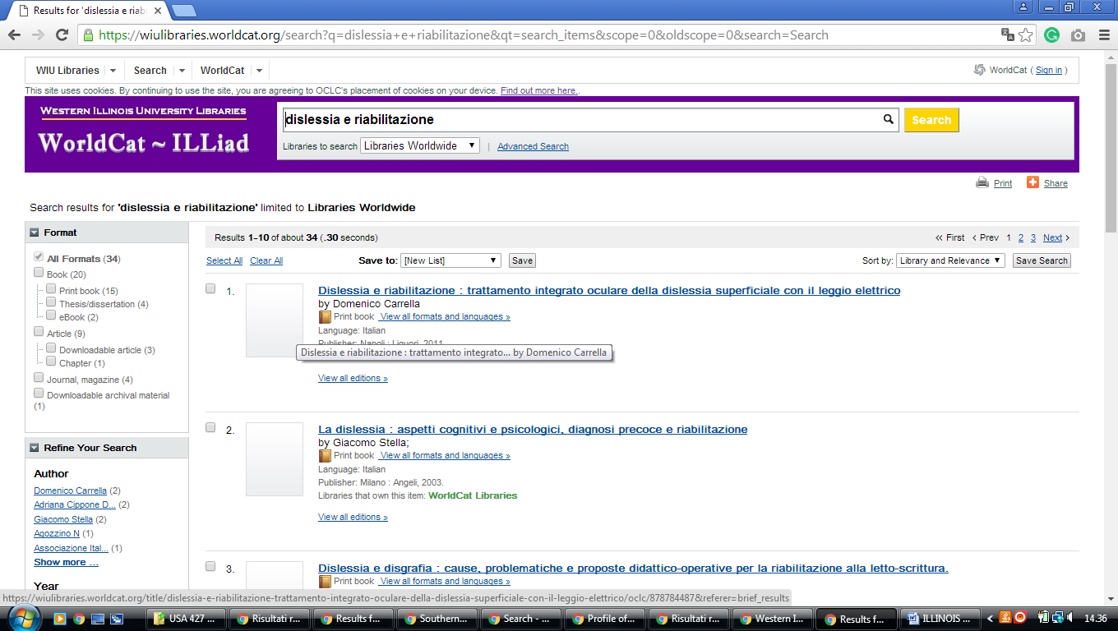

17 INTERLIBRARY LOAN - RESEARCH GUIDES AT BRANDEIS UNIVERSITY - (Brandeis University Libraries Peoria, illinois Usa)
https://brandeis.on.worldcat.org/search?sortKey=LIBRARY&databaseList=&queryString=dislessia+e+riabilitazione&changedFacet=author&scope=&format=all&database=all&author=Carrella%2C+Domenico&year=all&yearFrom=&yearTo=&language=all&topic=all

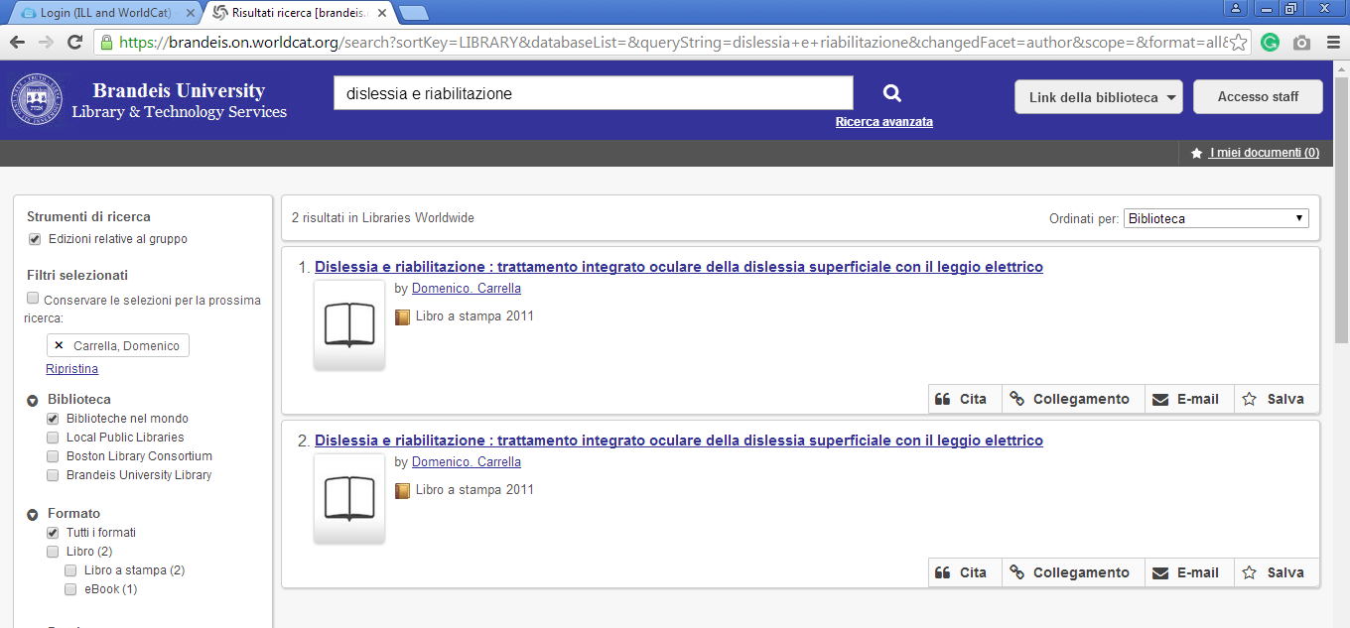

18 CHICAGO STATE UNIVERSITY LIBRARY – (Illinois, Usa)
http://csulibrary.worldcat.org/title/dislessia-e-riabilitazione-trattamento-integrato-oculare-della-dislessia-superficiale-con-il-leggio-elettrico/oclc/878784487&referer=brief_results

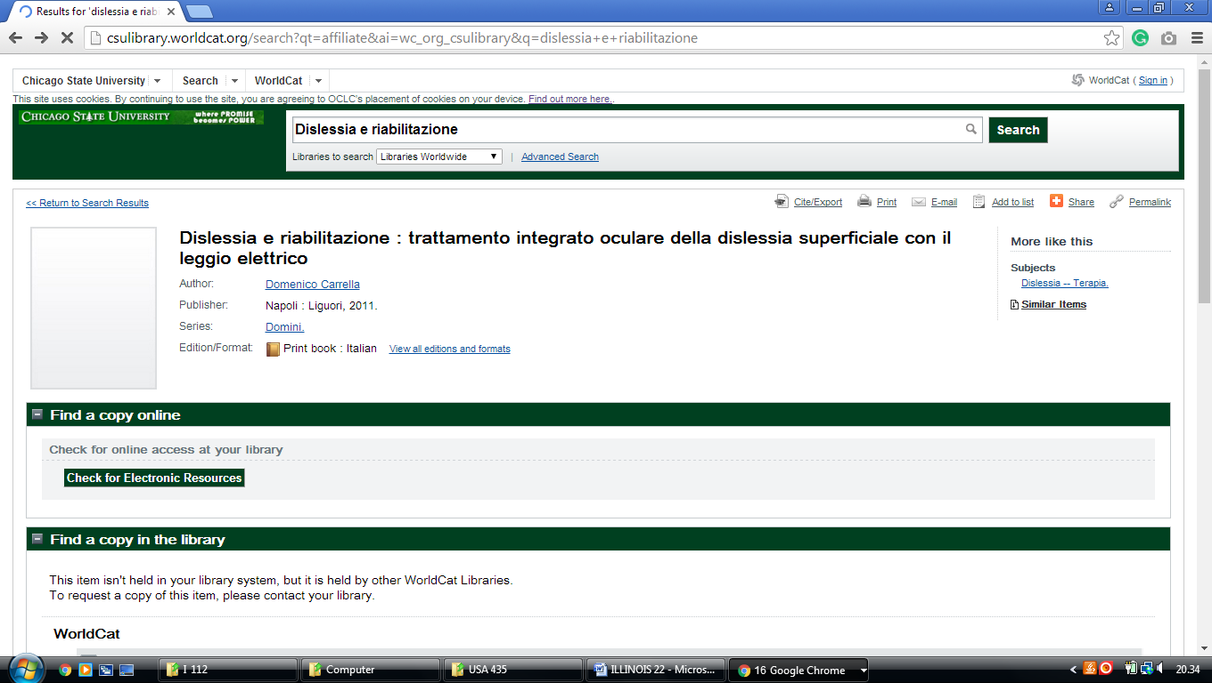

19 DEPAUL UNIVERSITY LIBRARIES - (Chicago, Illinois, Usa)
https://depaul.worldcat.org/wcpa/servlet/org.oclc.lac.search.SearchServlet?dblist=2572%2C1708%2C1271%2C1711%2C1953%2C1941%2C1725%2C239%2C1672%2C638&q=dislessia%20e%20riabilitazione&qt=affiliate&scope=0&ai=wclocal_813&fq=

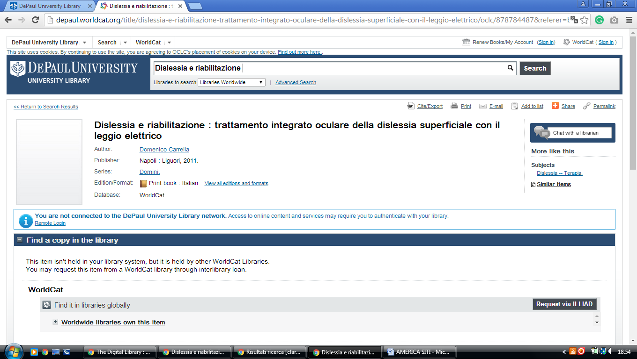

20 HOLMAN LIBRARY | LEBANON, ILLINOIS | MCKENDREE UNIVERSITY
(Lebanon, Illinois, Usa).
http://holman.worldcat.org/search?qt=wc_org_holman&q=dislessia+e+riabilitazione&scope=0&oldscope=&wcsbtn2w=Search&dblist=638
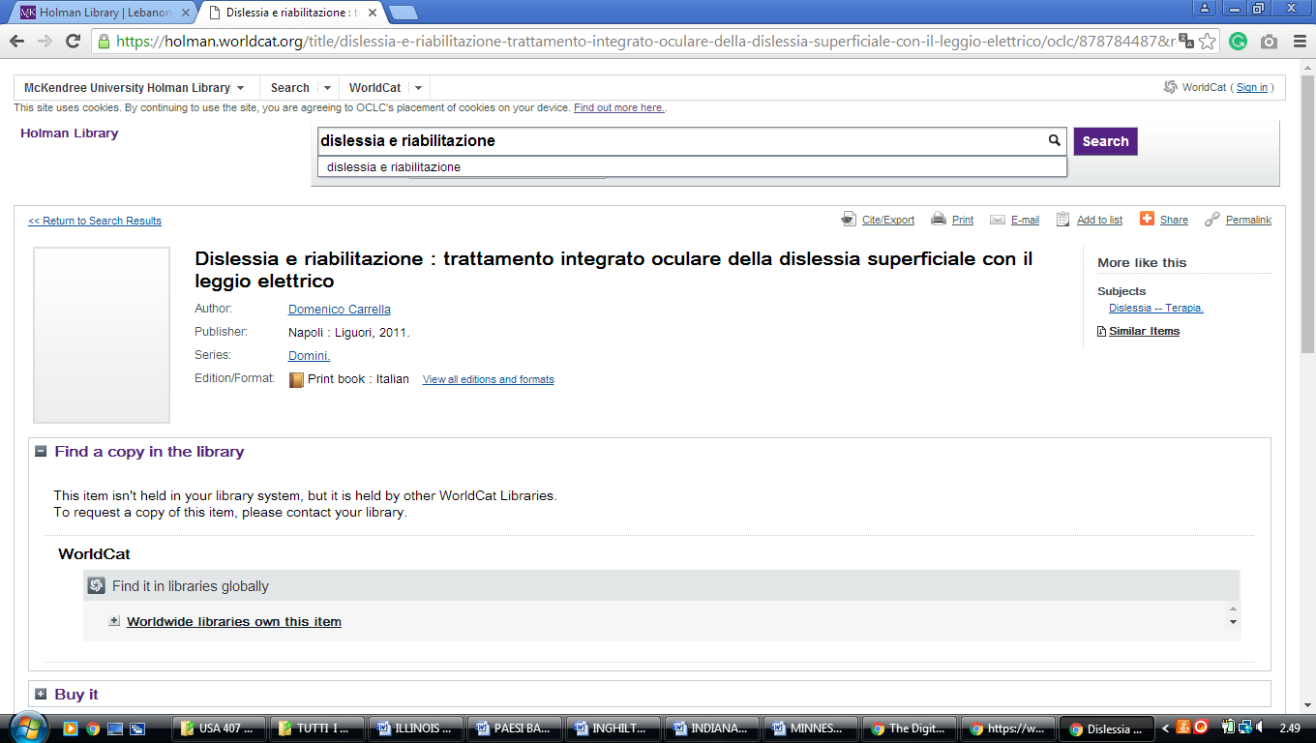

21 HOME - LIBRARY HOME - MWU LIBRARY AT MIDWESTERN UNIVERSITY.
(Downers Grove, Illinois,Usa)

https://midwestern.summon.serialssolutions.com/search?s.q=dislessia+e+riabilitazione&spellcheck=true&keep_r=true#!/search?ho=f&l=en&q=dislessia%20e%20riabilitazione
