INDIANA = 22

1 LIBRARY AMBS LIBRARY-ANABAPTIST MENNONITE BIBLICAL SEMINARY - (Elkhart, Indiana, Usa)
https://ambslibrary.on.worldcat.org/search?queryString=dislessia+e+riabilitazione

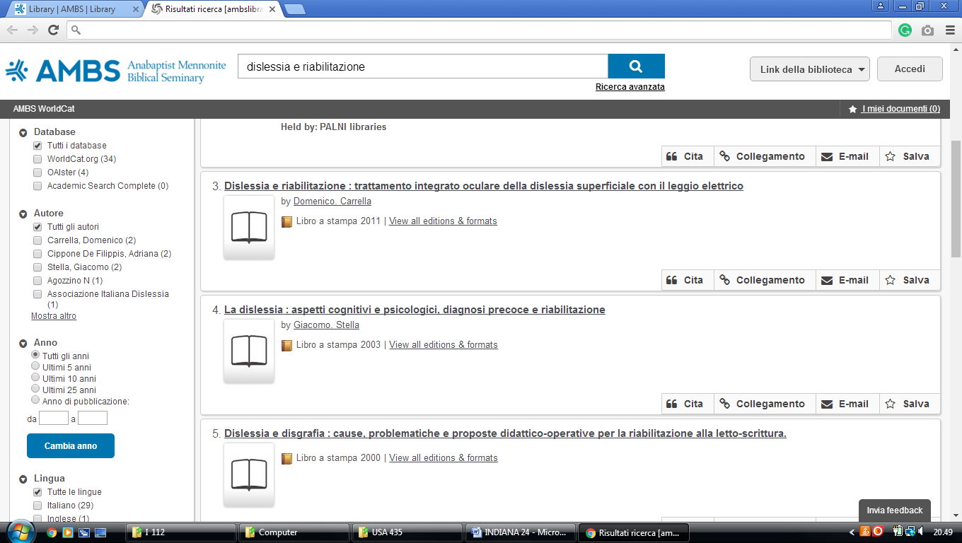

2 BUTLER UNIVERSITY LIBRARIES - (Indianapolis, Indiana, Usa)
https://ambslibrary.on.worldcat.org/search?queryString=dislessia+e+riabilitazione

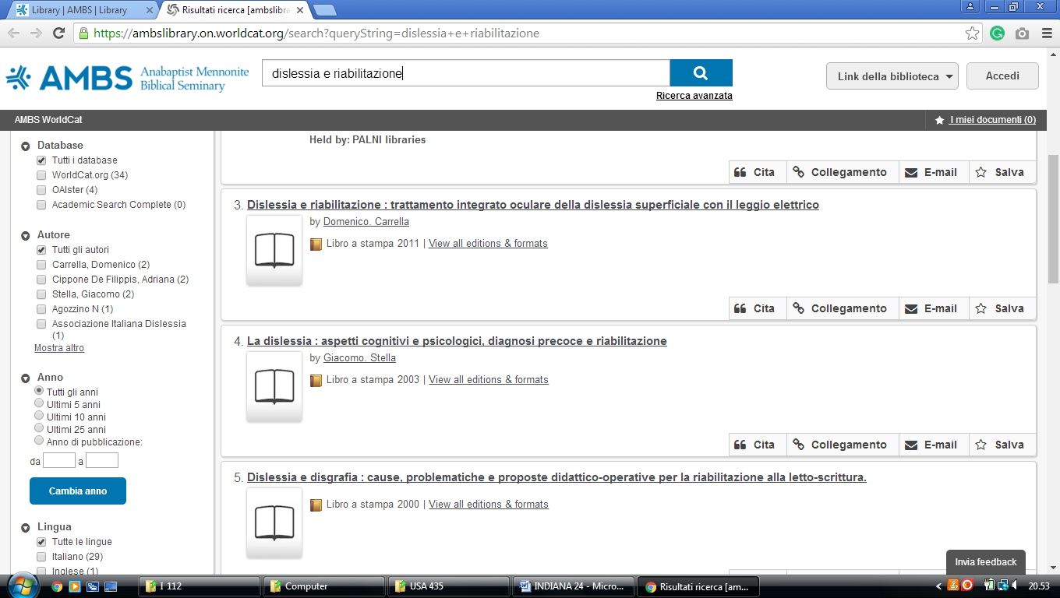

3 CUNNINGHAM MEMORIAL LIBRARY - (Terre Haute, Indiana, Usa)
http://indstate.summon.serialssolutions.com/?#!/search?ho=f&l=en&q=dislessia%20e%20riabilitazione

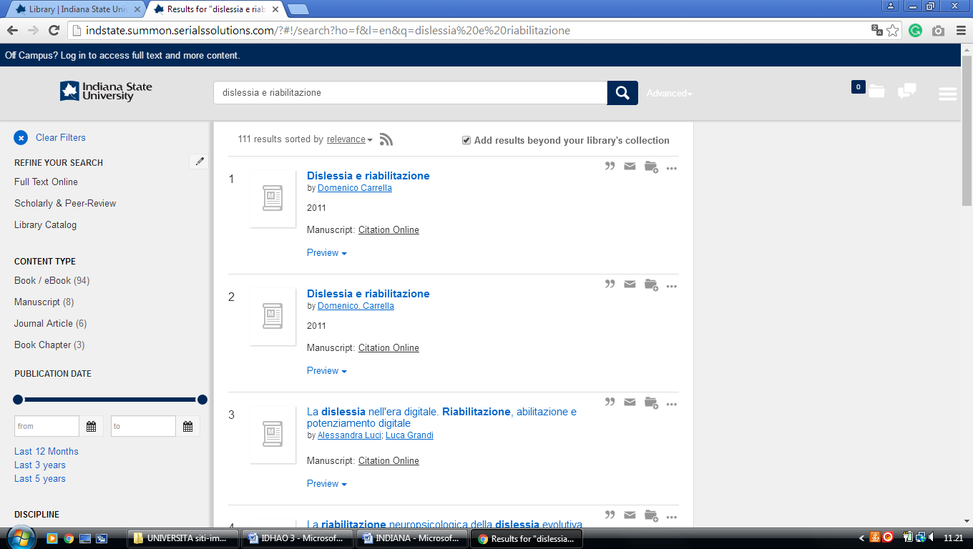

4 GRACE COLLEGE MORGAN LIBRARY - (Winona Lake, Indiana, Usa)
https://grace.on.worldcat.org/search?sortKey=LIBRARY&databaseList=&queryString=dislessia+e+riabilitazione&changedFacet=author&scope=&format=all&database=all&author=Carrella%2C+Domenico&year=all&yearFrom=&yearTo=&language=all&topic=all

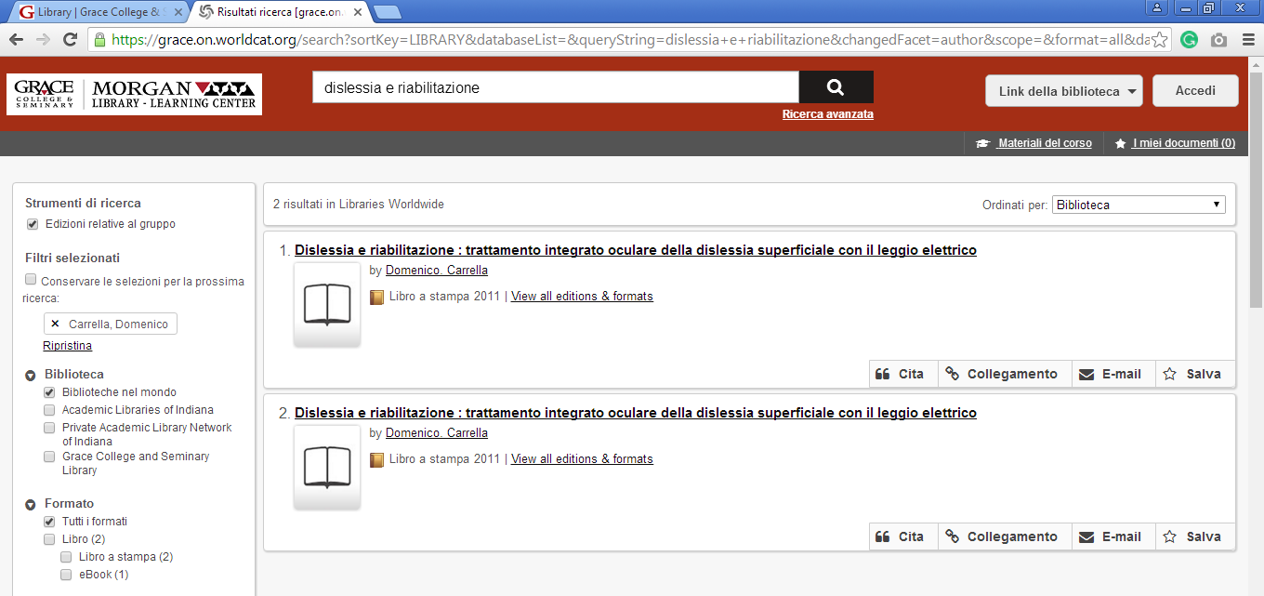

5 HAMILTON LIBRARY HOME - FRANKLIN COLLEGE - (Franklin, Indiana, Usa)
https://franklincollege.on.worldcat.org/search?sortKey=LIBRARY&databaseList=&queryString=dislessia+e+riabilitazione&changedFacet=author&scope=&format=all&database=all&author=Carrella%2C+Domenico&year=all&yearFrom=&yearTo=&language=all&topic=all

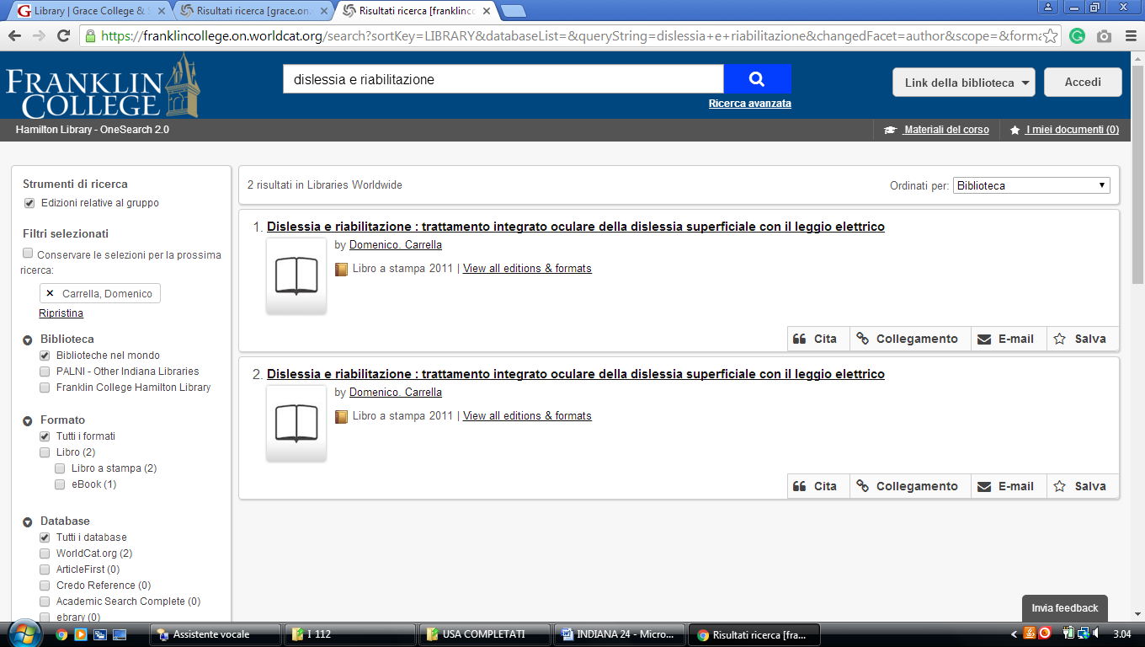

6 CHRISTOPHER CENTER LIBRARY SERVICES – (Valparaiso, Indiana, Usa)
http://valpo.summon.serialssolutions.com/search?s.q=dislessia+e+riabilitazione#!/search?ho=f&l=en&q=dislessia%20e%20riabilitazione

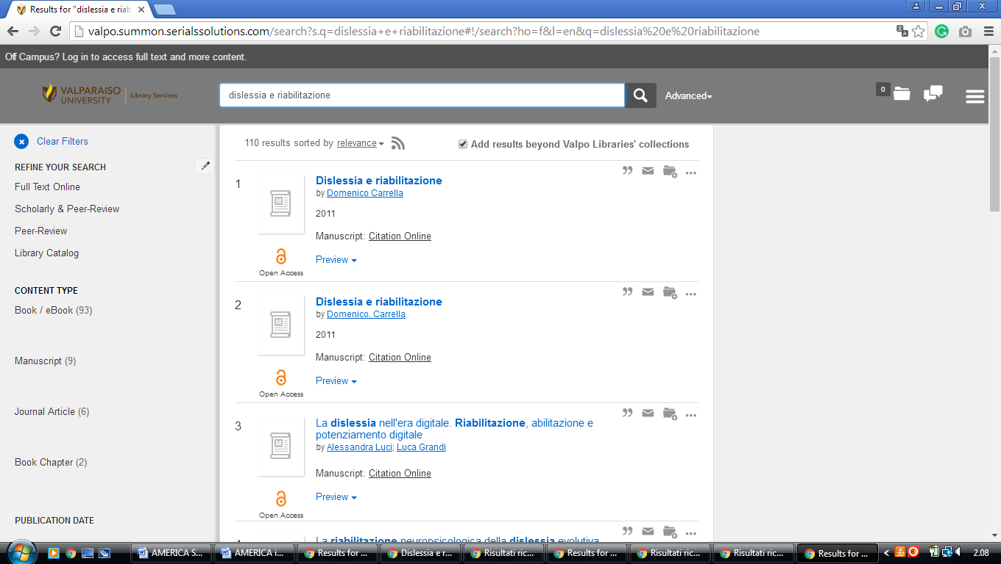

7 CUNNINGHAM MEMORIAL LIBRARY – (Terre Haute, Indiana, Usa)
http://indstate.summon.serialssolutions.com/?#!/search?ho=f&l=en&q=dislessia%20e%20riabilitazione
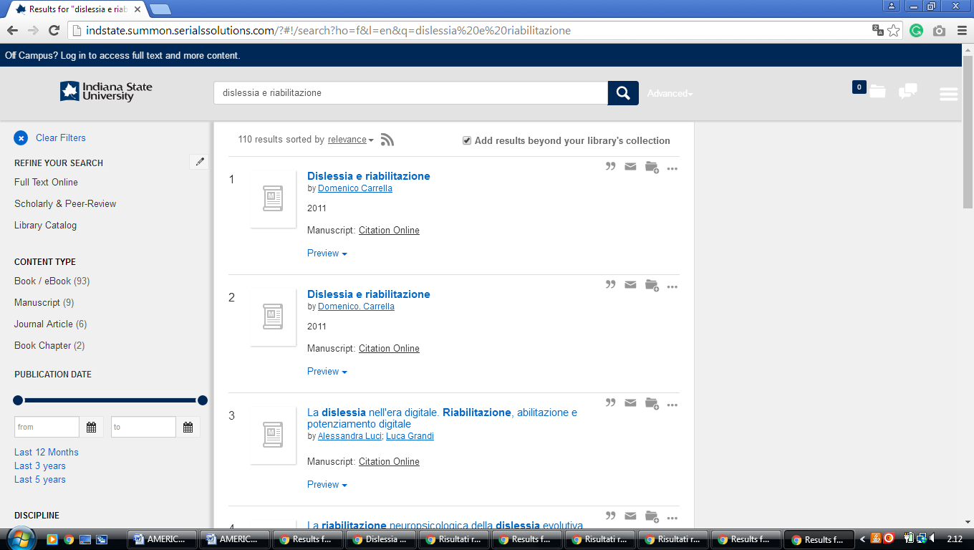

8 DEPAUW LIBRARIES – (Greencastle, Indiana, Usa)
https://940.on.worldcat.org/search?sortKey=LIBRARY&databaseList=&queryString=dislessia+e+riabilitazione&changedFacet=author&scope=&format=all&database=all&author=Carrella%2C+Domenico&year=all&yearFrom=&yearTo=&language=all&topic=all

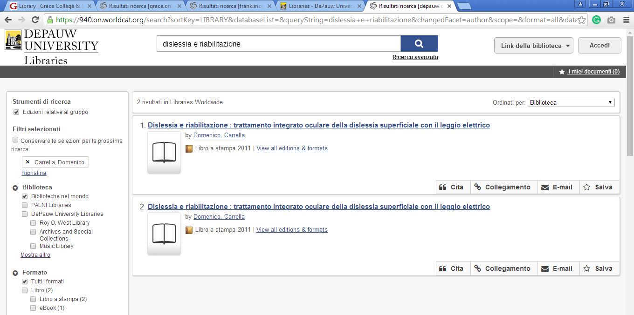

9 DUGGAN LIBRARY - (Hanover, Indiana, Usa)
https://hanover.on.worldcat.org/search?sortKey=BEST_MATCH&databaseList=&queryString=dislessia+e+riabilitazione&changedFacet=scope&clusterResults=off&stickyFacetsChecked=on&scope=&scope=wz%3A1076

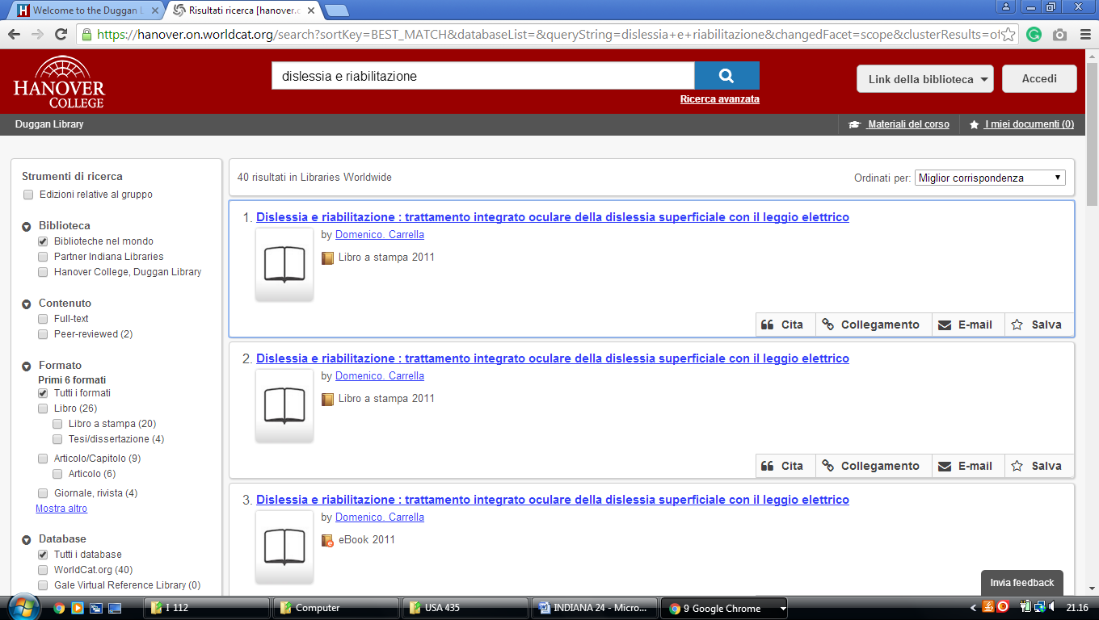

10 EARLHAM COLLEGE LIBRARIES – (Richmond, Indiana, Usa)
http://earlham.worldcat.org/search?qt=affiliate&ai=wclocal_earlham&q=dislessia+e+riabilitazione&scope=0&oldscope=

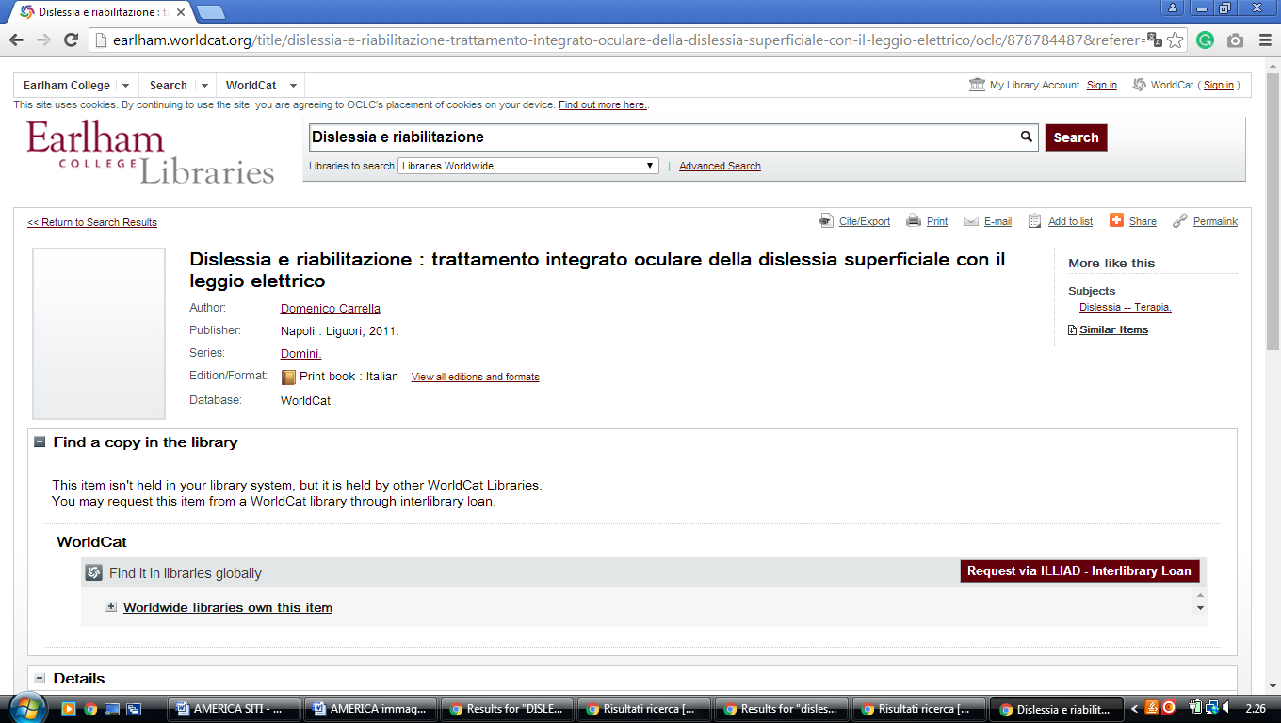

11 Good Library - Goshen College – (Goshen, Indiana, Usa)
https://goshen.on.worldcat.org/search?sortKey=LIBRARY&databaseList=638&queryString=dislessia+e+riabilitazione&changedFacet=author&scope=&format=all&database=all&author=Carrella%2C+Domenico&year=all&yearFrom=&yearTo=&language=all&topic=all

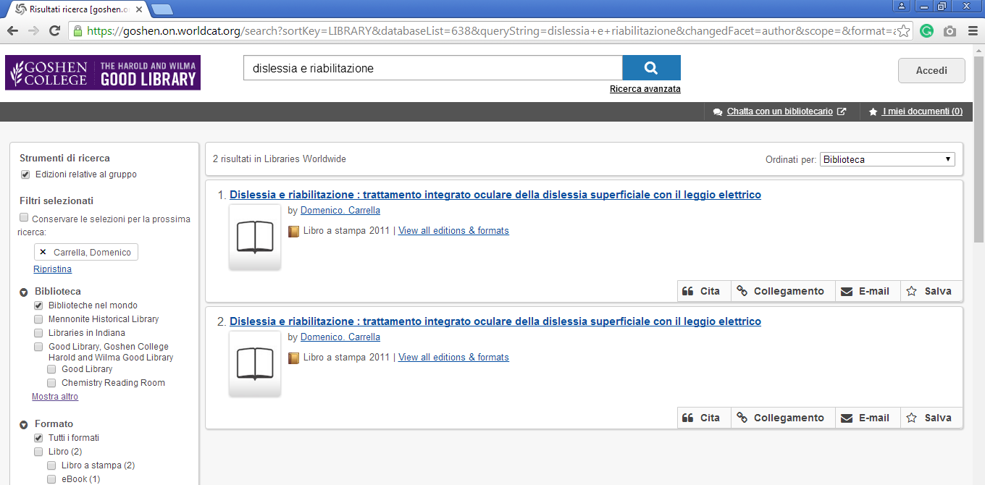

12 HAMILTON LIBRARY HOME - FRANKLIN COLLEGE - (Indiana, Usa)
https://franklincollege.on.worldcat.org/search?sortKey=LIBRARY&databaseList=&queryString=dislessia+e+riabilitazione&changedFacet=author&scope=&format=all&database=all&author=Carrella%2C+Domenico&year=all&yearFrom=&yearTo=&language=all&topic=all

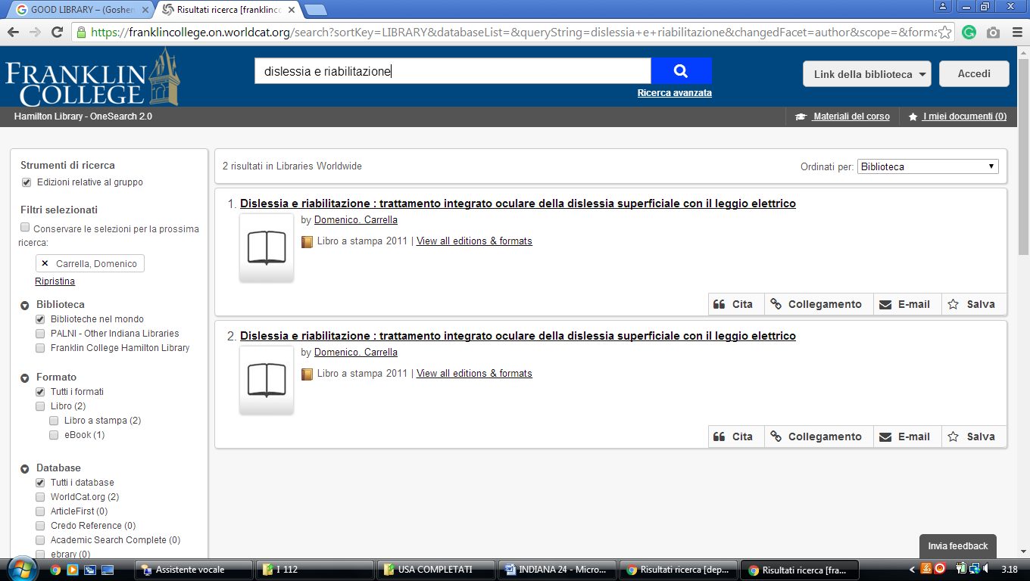

13 KRANNERT MEMORIAL LIBRARY - UINDY – (Indianapolis, Indiana, Usa)
https://uindy.on.worldcat.org/search?sortKey=LIBRARY_PLUS_RELEVANCE&queryString=dislessia+e+riabilitazione&scope=&format=Book&subformat=Book%253A%253Abook_printbook&subformat=Book%3A%3Abook_digital&subformat=Book%3A%3Abook_thsis&subformat=Book%3A%3Abook_mic&subformat=Book%3A%3Abook_largeprint&subformat=Book%3A%3Abook_braille&subformat=Book%3A%3Abook_continuing

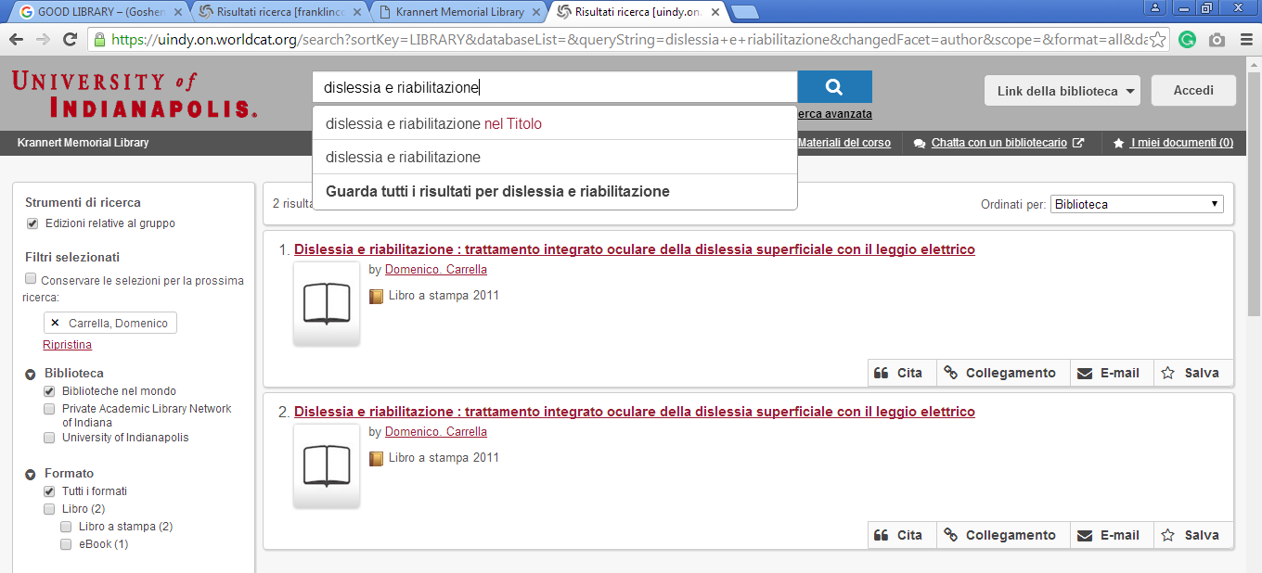

14 LEE AND JIM VANN LIBRARY - (Fort Wayne, Indiana, Usa)
https://uindy.on.worldcat.org/search?sortKey=LIBRARY&databaseList=&queryString=dislessia+e+riabilitazione&changedFacet=author&scope=&format=all&database=all&author=Carrella%2C+Domenico&year=all&yearFrom=&yearTo=&language=all&topic=all

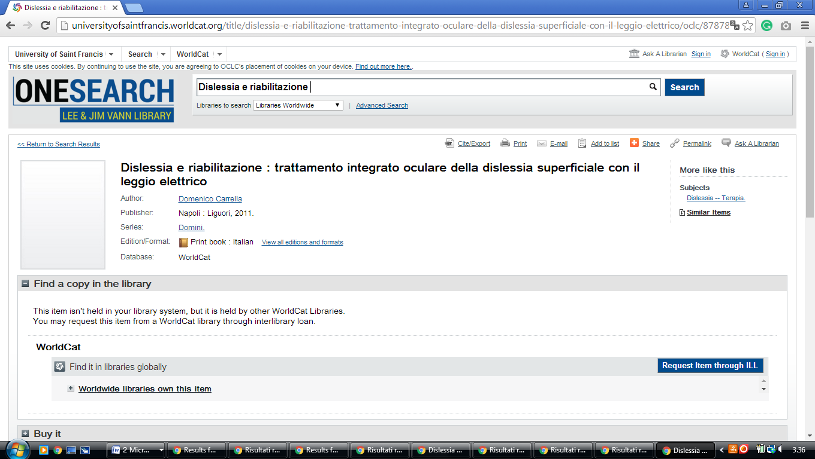

15 MANCHESTER UNIVERSITY FUNDERBURG LIBRARY - (Indiana, Usa)
https://manchester.on.worldcat.org/search?queryString=dislessia+e+riabilitazione&databaseList=283

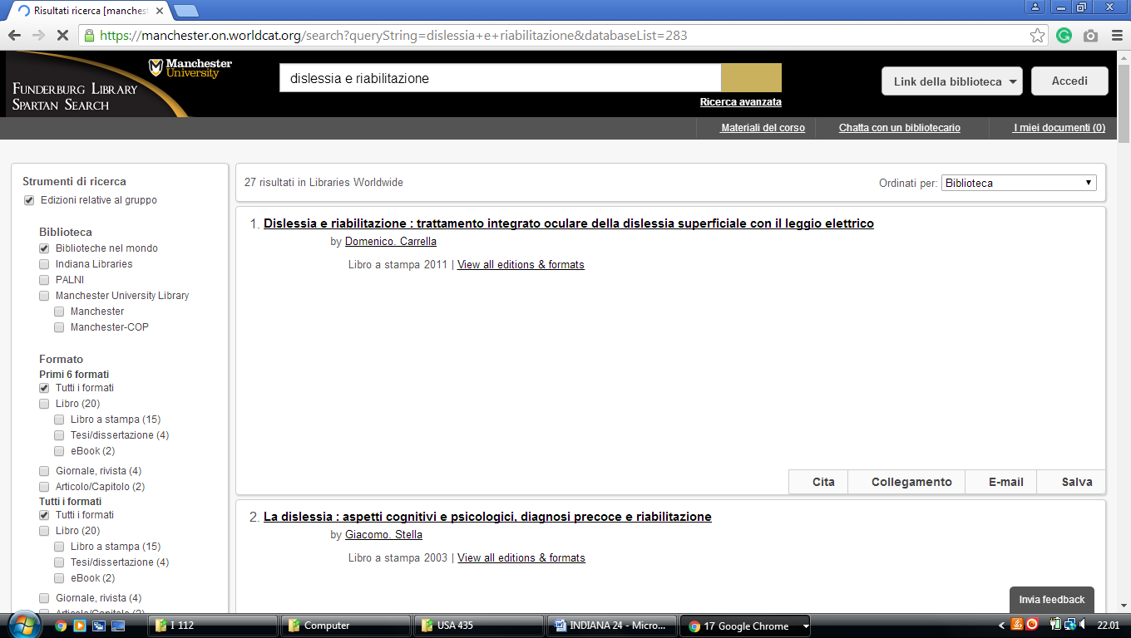

16 MOTHER THERESA HACKELMEIER LIBRARY MEMORIAL - (Indiana, Usa)
https://marianunivindianapolis.on.worldcat.org/search?sortKey=LIBRARY&databaseList=&queryString=dislessia+e+riabilitazione&changedFacet=author&scope=&format=all&database=all&author=Carrella%2C+Domenico&year=all&yearFrom=&yearTo=&language=all&topic=all

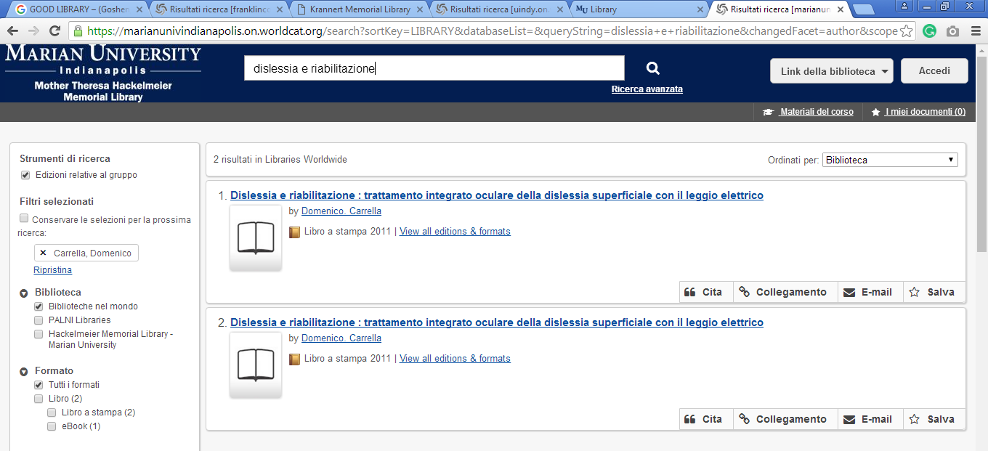

17 NICHOLSON LIBRARY - (Indiana, Usa)
https://anderson.on.worldcat.org/search?sortKey=LIBRARY_PLUS_RELEVANCE&databaseList=1708%2C1920%2C2513%2C197%2C2175%2C1978%2C1736%2C638%2C283%2C1279%2C1719&queryString=dislessia+e+riabilitazione&format=Book&format=Msscr&format=Jrnl&subformat=Book%3A%3Abook_printbook&subformat=Book%3A%3Abook_digital&subformat=Book%3A%3Abook_thsis&subformat=Book%3A%3Abook_mic&subformat=Book%3A%3Abook_largeprint&subformat=Book%3A%3Abook_braille&author=all&year=all&yearFrom=&yearTo=&language=all&scope=

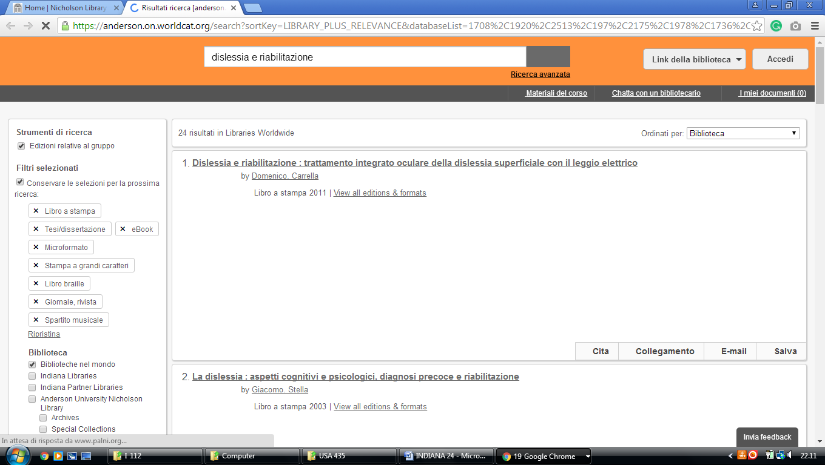

18 RICHLYN LIBRARY - (Huntington, Indiana, Usa)
http://huntington.worldcat.org/search?qt=wc_org_huntington&q=dislessia+e+riabilitazione&scope=0&oldscope=&wcsbtn2w=Search&fq=&dblist=638

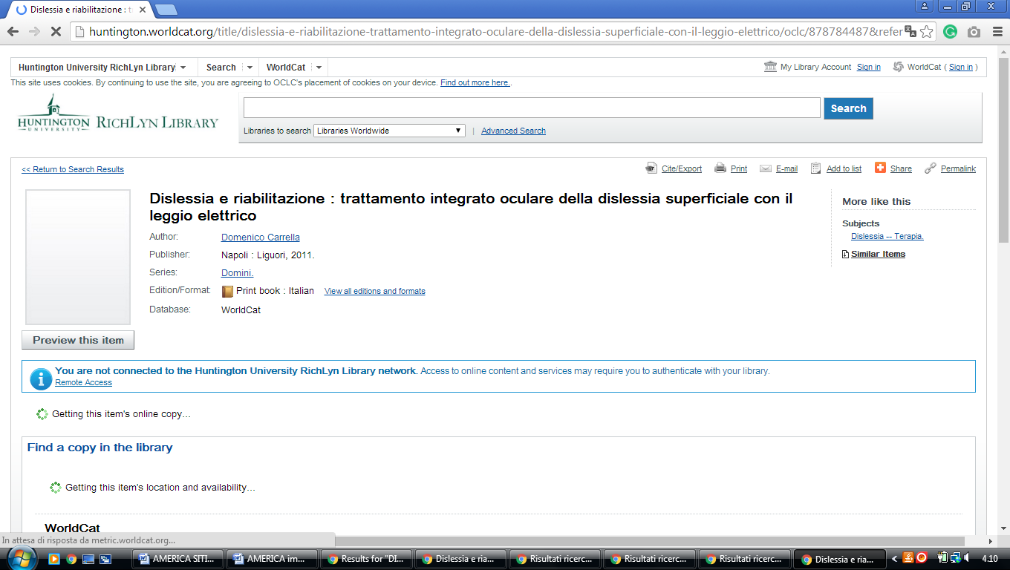

19 VINCENNES UNIVERSITY LIBRARIES – (Vincennes, Indiana, Usa)
https://vinu.worldcat.org/search?q=dislessia+e+riabilitazione&qt=results_page&dblist=638&scope=0&oldscope=3&fq=

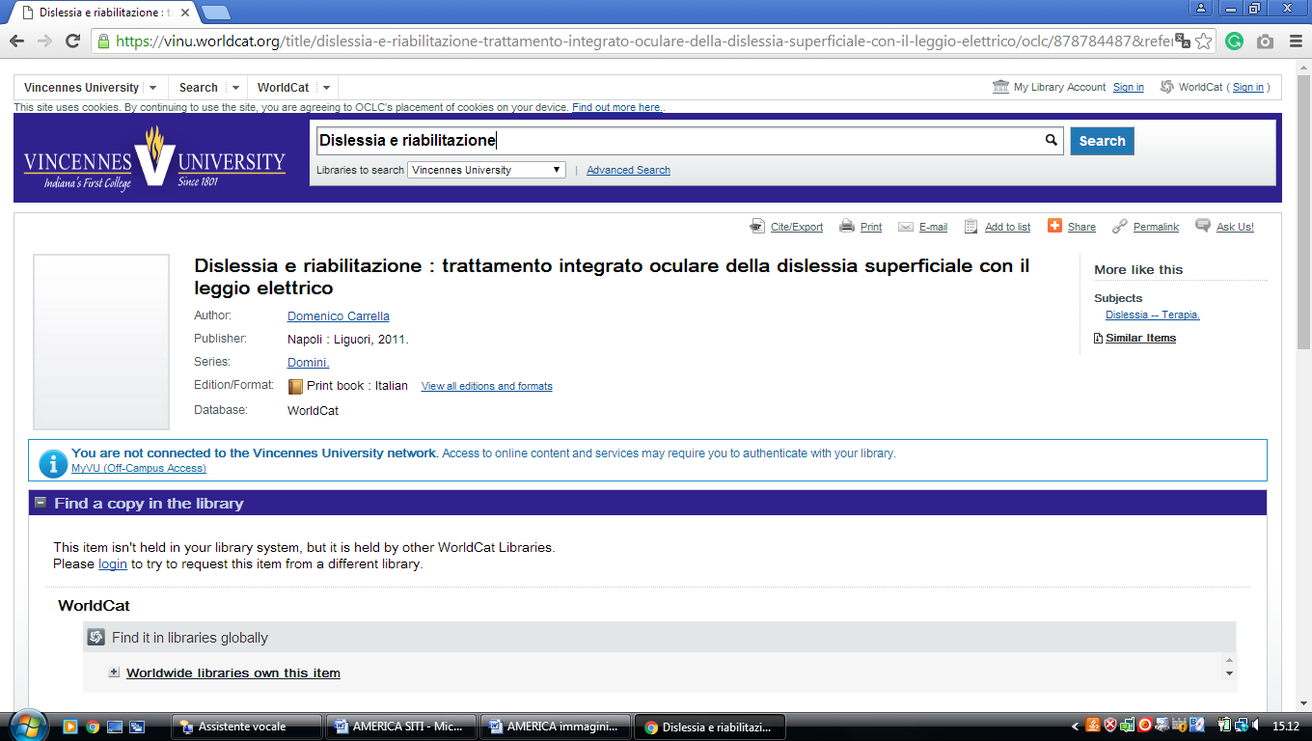

20 WALTHER LIBRARY – (Ft. Wayne, Indiana, Usa)
https://ctsfw.on.worldcat.org/search?sortKey=LIBRARY&databaseList=&queryString=dislessia+e+riabilitazione&changedFacet=author&scope=&format=all&database=all&author=Carrella%2C+Domenico&year=all&yearFrom=&yearTo=&language=all&topic=all

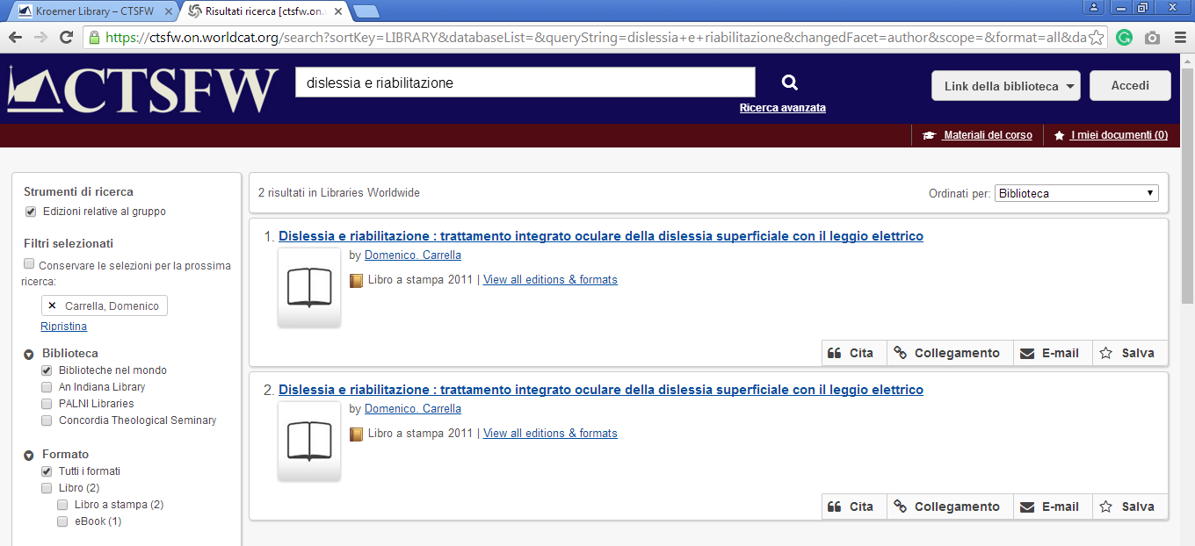

21 ZONDERVAN LIBRARY - (Upland, Indiana, Usa)
http://taylor.worldcat.org/search?dblist=283&q=dislessia+e+riabilitazione&Search=Search

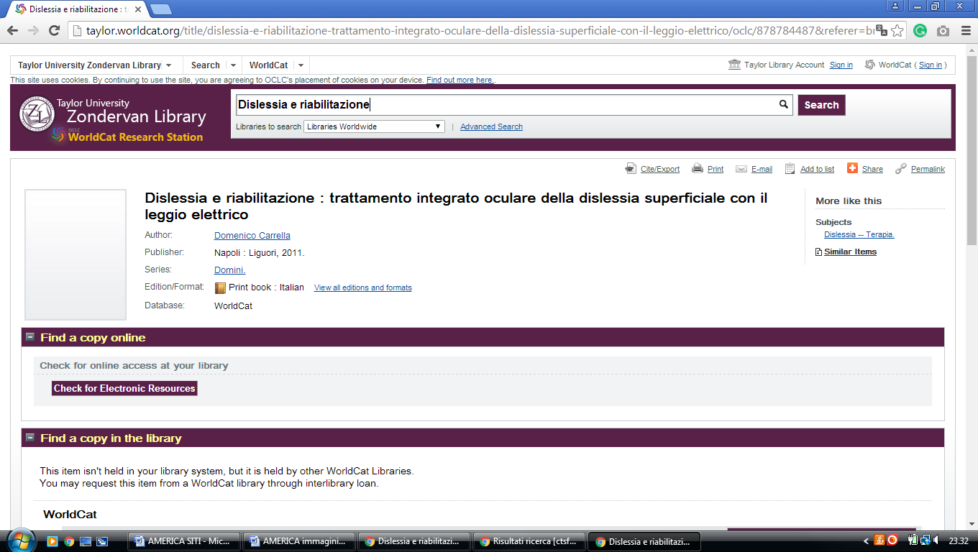

22 COLE LIBRARY - (Mount Vernon, Indiana, Usa)
http://colelibrary.worldcat.org/search?q=dislessia+e+riabilitazione

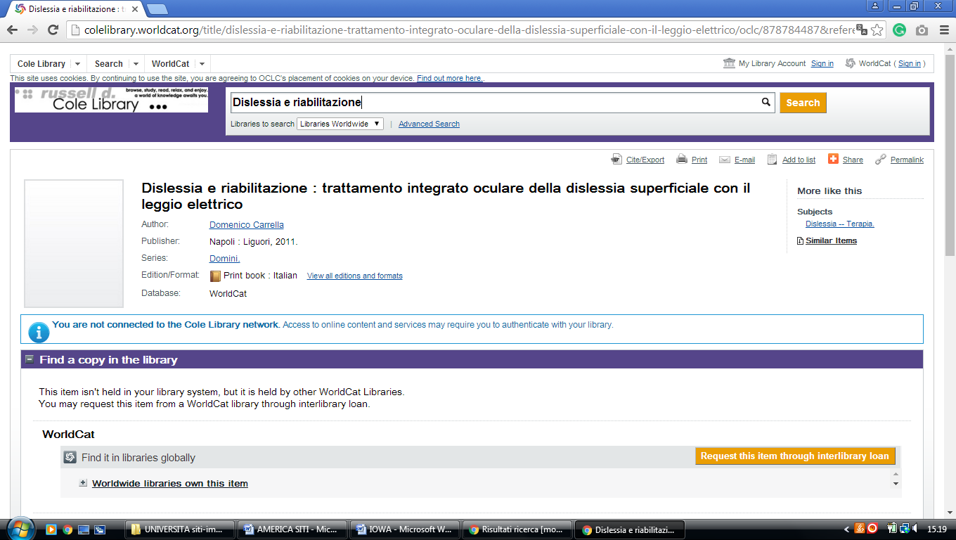

Purdue Libraries - Purdue University West Lafayette

https://purdueuniversity.on.worldcat.org/search?databaseList=&queryString=dislessia%20e%20riabilitazione
