IOWA = 3

1 BUSSE LIBRARY | MOUNT MERCY UNIVERSITY – (Cedar Rapids, Iowa, Usa)
https://mountmercy.on.worldcat.org/search?sortKey=BEST_MATCH&databaseList=&queryString=dislessia+e+riabilitazione&changedFacet=author&scope=&format=all&database=all&author=Carrella%2C+Domenico&year=all&yearFrom=&yearTo=&language=all&topic=all

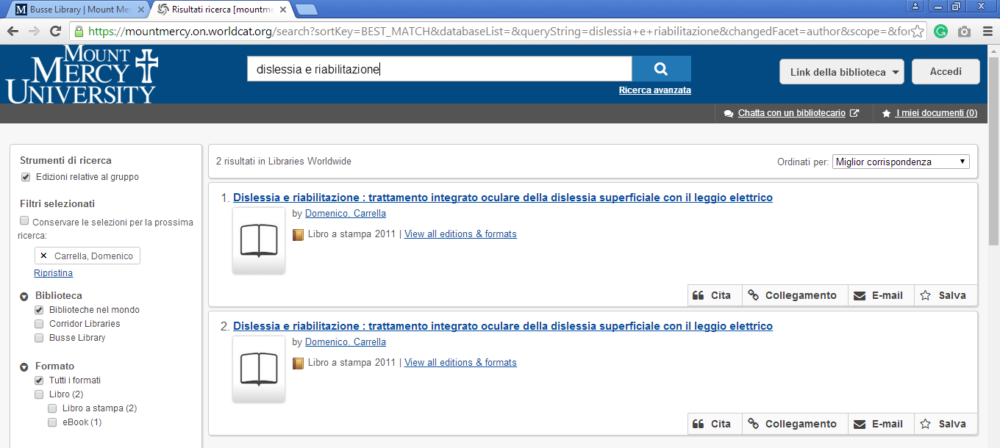

2 BUSSE LIBRARY | MOUNT MERCY UNIVERSITY– (Decorah, Iowa, Usa)
https://luther.on.worldcat.org/search?sortKey=LIBRARY&databaseList=&queryString=dislessia+e+riabilitazione&changedFacet=author&scope=&format=all&database=all&author=Carrella%2C+Domenico&year=all&yearFrom=&yearTo=&language=all&topic=all

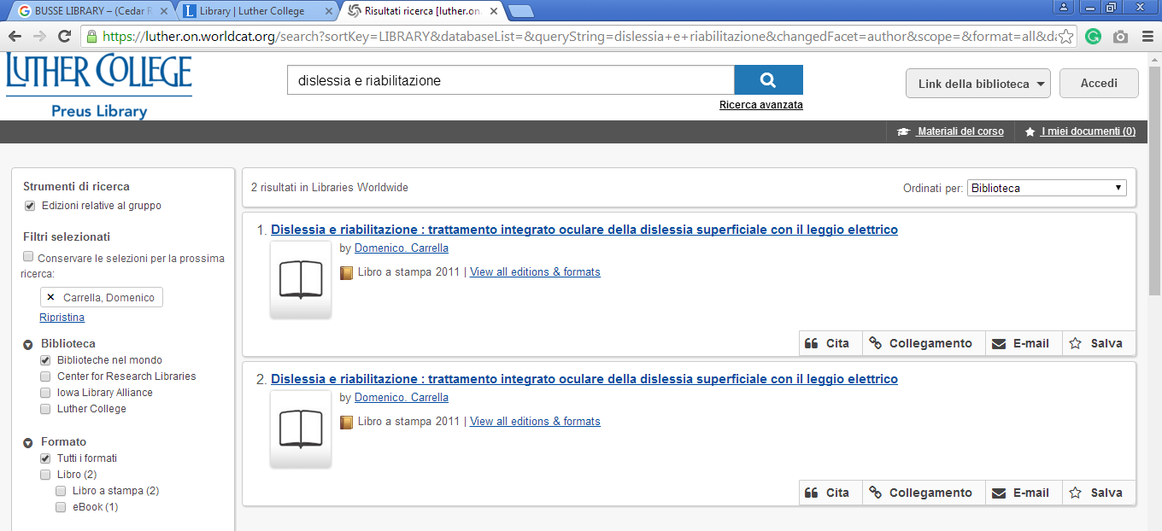

3 RAMAKER LIBRARY - (Orange City, Iowa, Usa)
https://nwciowa.on.worldcat.org/search?queryString=dislessia+e+riabilitazione

