KANSAS = 3

1 EMPORIA STATE UNIVERSITY LIBRARIES – (Emporia, Kansas, Usa)
http://eds.a.ebscohost.com/eds/results?vid=5&sid=3a95c0da-1e29-4074-8abc-a66eeec649b3%40sessionmgr4007&bquery=AU+carrella+domenico&bdata=JnR5cGU9MCZzaXRlPWVkcy1saXZl

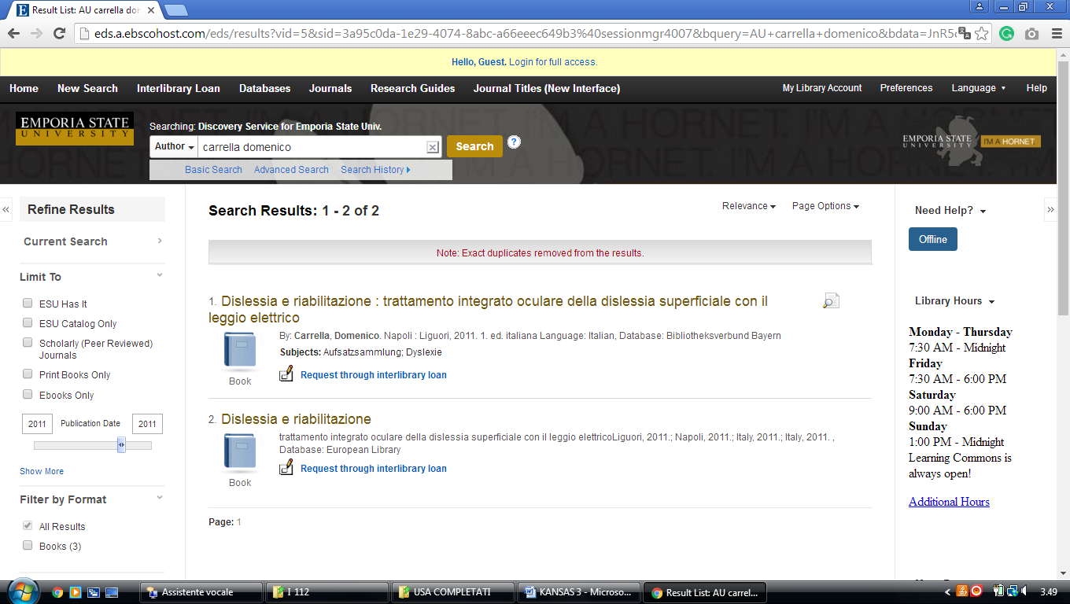

2 LIBRARY HOME - UNIVERSITY LIBRARIES & ARCHIVES | EMPORIA STATE UNIVERSITY – (Kansas, Usa)
http://eds.b.ebscohost.com/eds/detail/detail?vid=3&sid=cd92f46d-983b-42d1-9252-bf5ac29c1a5e%40sessionmgr103&bdata=JnNpdGU9ZWRzLWxpdmU%3d#AN=edsfis.959441&db=edsfis

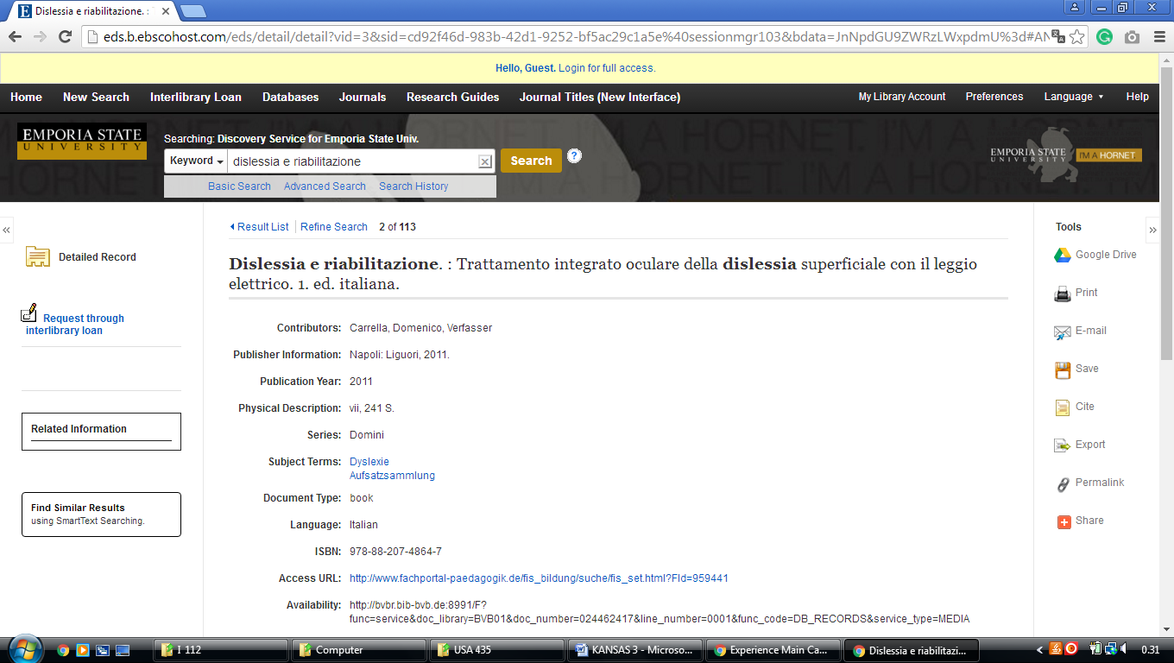

3 LEONARD H. AXE LIBRARY – (Pittsburg, Kansas, Usa)
http://pittsburgstate.summon.serialssolutions.com/search?s.q=dislessia+e+riabilitazione#!/search?ho=f&l=en&q=dislessia%20e%20riabilitazione

