LOUISIANA = 3

1 THE UNIVERSITY of NEW ORLEANS LIBRARY - (New Orleans, Louisiana, Usa)
http://eds.a.ebscohost.com/eds/results?vid=0&sid=edad883e-7077-4a91-a852-d017c48ccf09%40sessionmgr4006&bquery=dislessia+e+riabilitazione&bdata=JnR5cGU9MCZzaXRlPWVkcy1saXZlJnNjb3BlPXNpdGU%3d

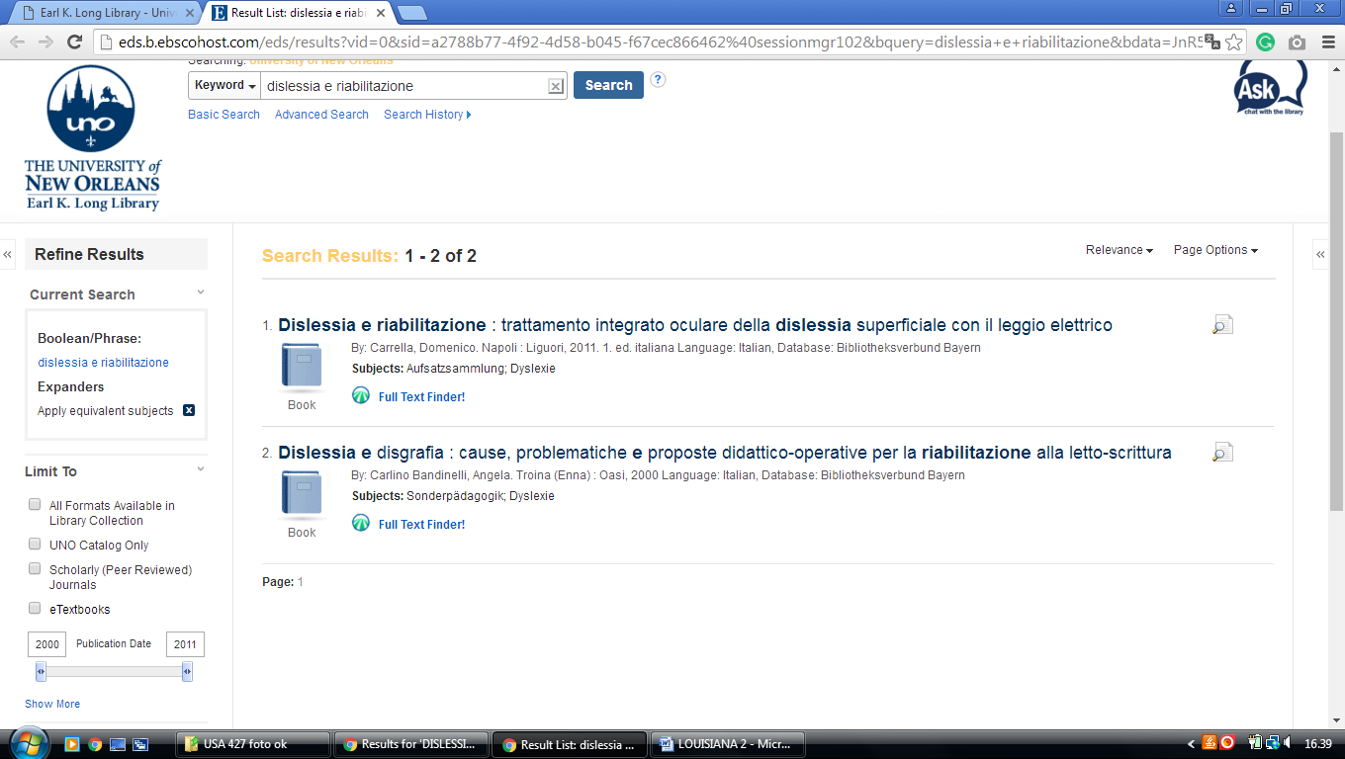
2 HOWARD-TILTON MEMORIAL LIBRARY - (New Orleans, Louisiana, Usa)
http://tulprimo.hosted.exlibrisgroup.com/primo_library/libweb/action/search.do?mode=Basic&vid=tref&vl(freeText0)=dislessia%20e%20riabilitazione&fn=search&tab=articles&

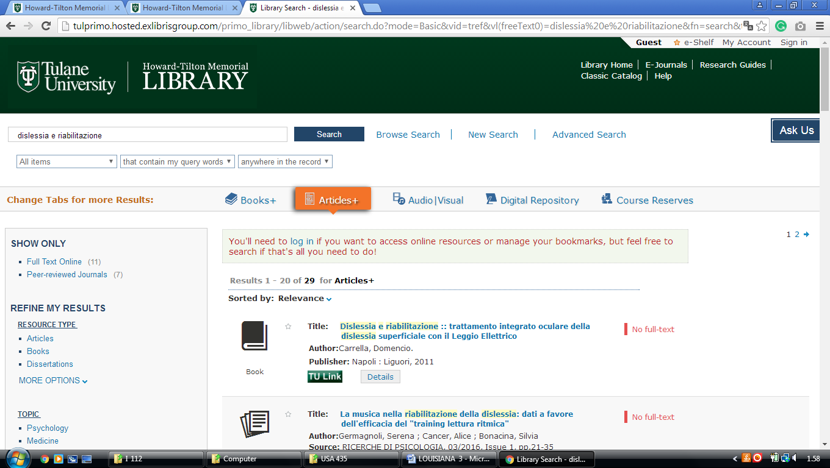

3 THE LATIN AMERICAN LIBRARY - TULANE UNIVERSITY – (Luisiana, Usa)
http://tulprimo.hosted.exlibrisgroup.com/primo_library/libweb/action/search.do?mode=Basic&vid=tref&vl(freeText0)=dislessia%20e%20riabilitazione&fn=search&tab=articles&
