MAINE = 7

1 BATES COLLEGE LIBRARY – (Lewiston, Maine, Usa)
https://bates.summon.serialssolutions.com/search?s.fvf%5B%5D=ContentType%2CNewspaper+Article%2Ct&s.fvf%5B%5D=ContentType%2CBook+Review%2Ct&s.q=dislessia+e+riabilitazione#!/search?ho=f&fvf=ContentType,Newspaper%20Article,t%7CContentType,Book%20Review,t&l=en&q=dislessia%20e%20riabilitazione
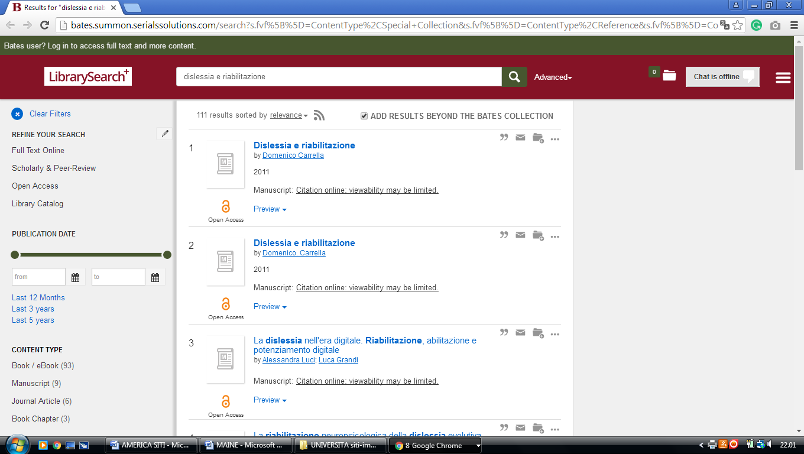

2 BLAKE LIBRARY (Fort Kent , Maine, Usa)
https://umfk.summon.serialssolutions.com/?#!/search?ho=f&l=en&q=dislessia%20e%20riabilitazione

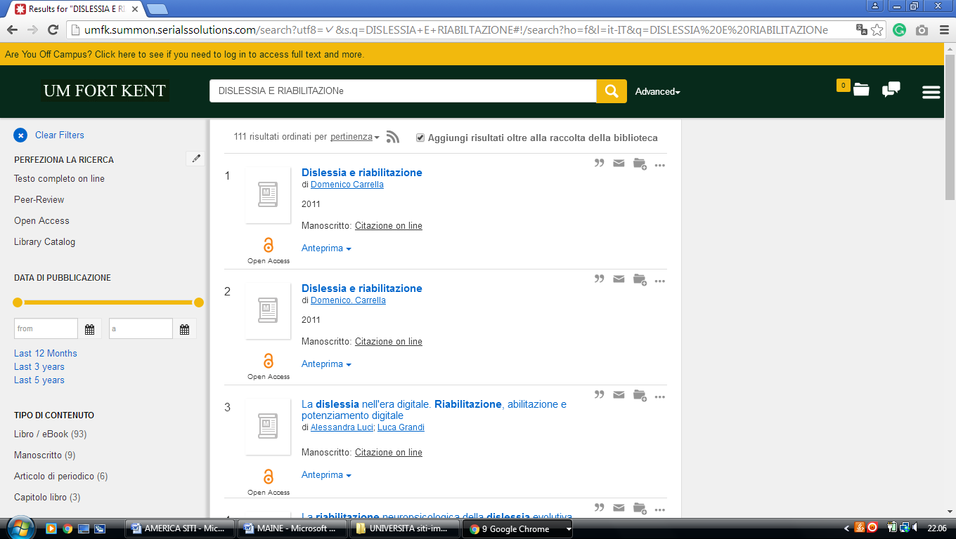

3 BOWDOIN COLLEGE LIBRARY – (Brunswick, Maine, Usa)
https://bowdoin.summon.serialssolutions.com/search?s.q=dislessia+e+riabilitazione&s.fvf%5B%5D=ContentType%2CNewspaper+Article%2Ct&keep_r=true&onesearchsubmit=#!/search?ho=f&fvf=ContentType,Newspaper%20Article,t&l=en&q=dislessia%20e%20riabilitazione

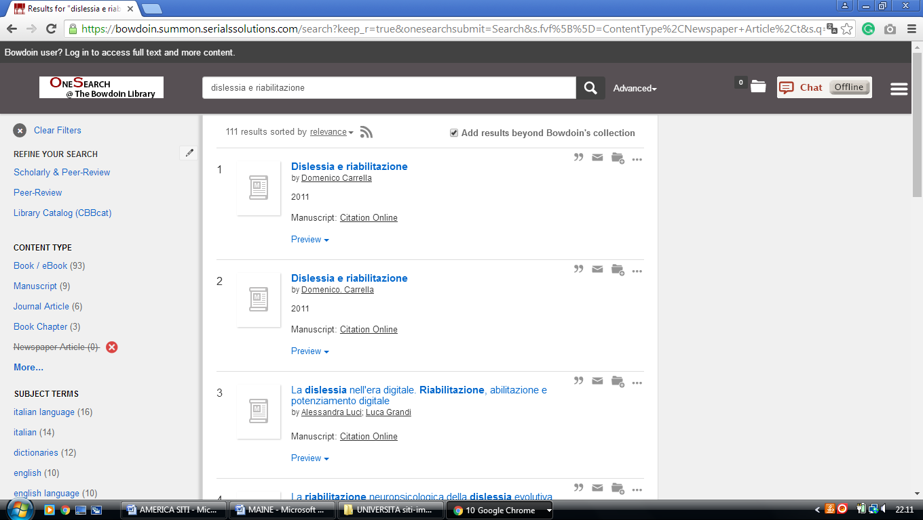

4 FOGLER LIBRARY – (Orono, Maine, Usa)
http://umaine.summon.serialssolutions.com/search?s.fvf%5B%5D=ContentType%2CNewspaper+Article%2Ct&s.q=dislessia+e+riabilitazione#!/search?ho=f&fvf=ContentType,Newspaper%20Article,t&l=en&q=dislessia%20e%20riabilitazione

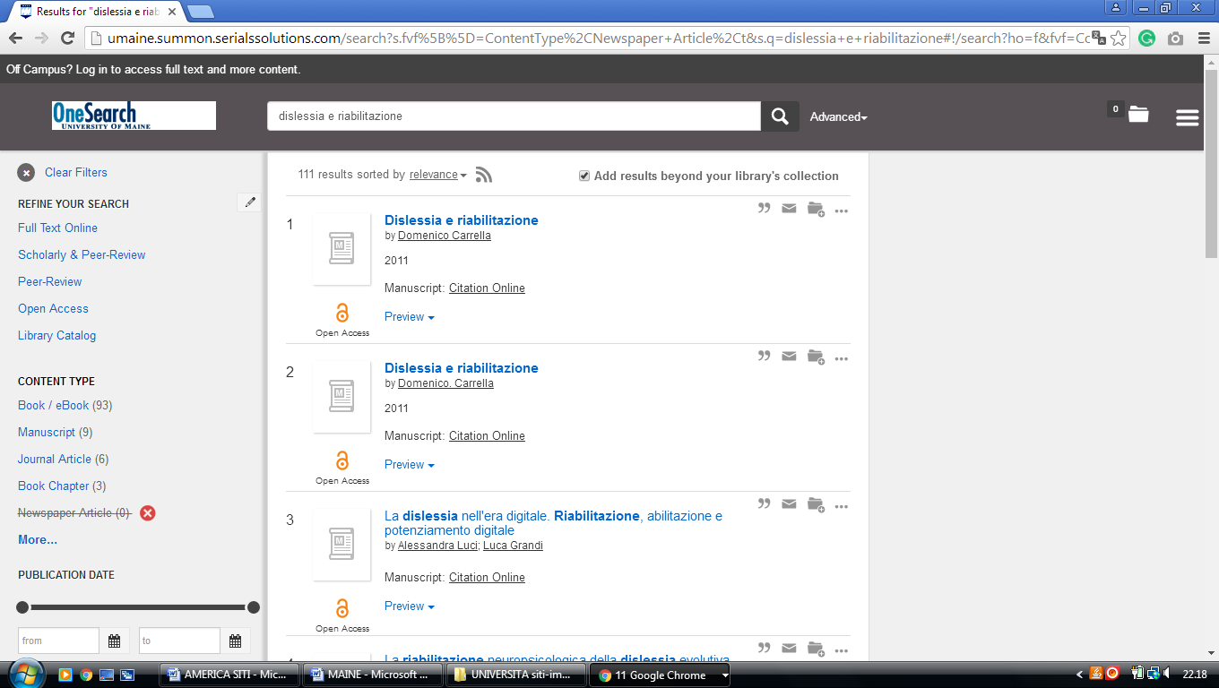

5 MANTOR LIBRARY - (Farmington, Maine, Usa)
http://umfarm.summon.serialssolutions.com/search?s.q=dislessia+e+riabilitazione&spellcheck=true#!/search?ho=f&l=en&q=dislessia%20e%20riabilitazione

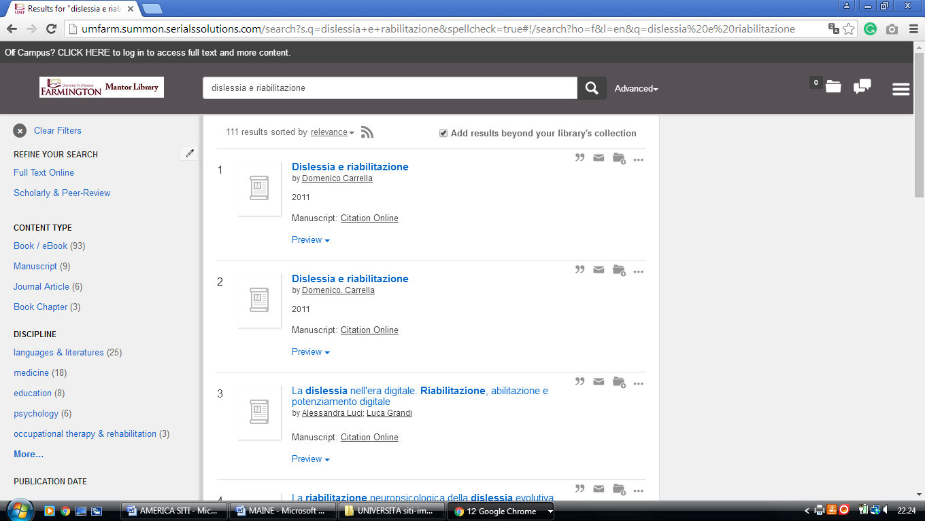

6 UNIVERSITY OF NEW ENGLAND LIBRARY - (Biddeford, Maine, Usa)
https://une.summon.serialssolutions.com/search?utf8=%E2%9C%93&s.q=dislessia+e+riabilitazione&s.fvf%5B%5D=ContentType%2CNewspaper+Article%2Ct&s.fvf%5B%5D=ContentType%2CBook+Review%2Ct&keep_r=true#!/search?ho=f&fvf=ContentType,Newspaper%20Article,t%7CContentType,Book%20Review,t&l=en&q=dislessia%20e%20riabilitazione

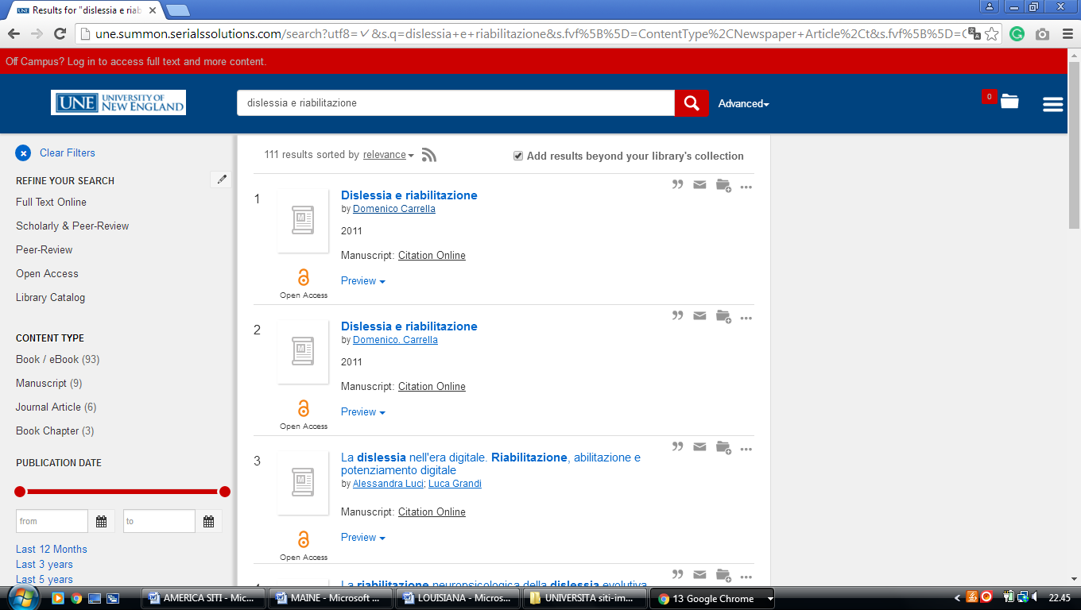

7 USM LIBRARIES | UNIVERSITY OF SOUTHERN MAINE - (Portland, Maine, Usa)
https://usm.summon.serialssolutions.com/search?s.q=dislessia+e+riabilitazione&s.fvf%5B%5D=ContentType%2CNewspaper+Article%2Ct%7CContentType%2CBook+Review%2Ct#!/search?ho=f&fvf=ContentType,Newspaper%20Article,t%7CContentType,Book%20Review,t&l=en&q=dislessia%20e%20riabilitazione
